Seniors Lifestyle Victoria
Stakeholder pack
OFFICIAL

Contents
Seniors Lifestyle Victoria 1
Program background 1
Program key messages 1
Resources 3
Social media 4
Print ready poster 6
Print ready DL flyer 6
Frequently asked questions and answers 7

Program background
The Seniors Lifestyle Victoria pilot program is part of the Strengthening Medicare Supporting Older Australians package, which aims to reduce avoidable hospital presentations and admissions while improving the health and healthcare outcomes of older Australians.
Commissioned to commence in early financial year 2025–26 and running through to 30 June 2028, the program supports older Victorians to stay active, strong and connected. Delivered through selected community health service providers across metropolitan and regional Victoria, the program helps older Victorians navigate the healthcare system and access tailored services to improve their overall health and wellbeing.

Program key messages

Messaging to the public
- The Seniors Lifestyle Victoria program is for people aged 65 years or older, or 50 and older for Aboriginal and Torres Strait Islander people, who are living in the community and may benefit from support to stay active, strong and connected.
- The Seniors Lifestyle Victoria program is delivered by community health services in metropolitan and regional Victoria.

- The program offers access to a range of services to support you to stay active, strong and connected. This might include supports focused on physical activity, nutrition, medication management, and social connection.
- A coordinator will work with you to develop a personalised plan, with local services tailored to meet your individual needs and goals.
- A coordinator will help you develop a plan to support your overall health and wellbeing to help you stay active, stay strong and stay connected within your community.
- Participation in the Seniors Lifestyle Victoria program is free.
- Seniors Lifestyle Victoria is a program that will be available through selected community health services until June 2028.
Call to action: Talk to your GP, or trusted health professional to see if the Seniors Lifestyle Victoria program is right for you.

Messaging to the healthcare sector
- The Seniors Lifestyle Victoria program is part of the Strengthening Medicare Supporting Older Australians package.
- The Strengthening Medicare package seeks to reduce avoidable hospital presentations and admissions, improving the overall health and healthcare outcomes of people aged 65 and over.
- The Seniors Lifestyle Victoria program is delivered by community health services in metropolitan and regional Victoria.
- Referrals can be made for people aged 65 years or older, or 50 and older for Aboriginal and Torres Strait Islander people, who are living in the community and meet the program criteria.
- The program helps older Victorians navigate the healthcare system, and access tailored services to improve their health and wellbeing. Services aim to support participants to stay active, strong and connected and may include supports focused on physical activity, nutrition, medication management, and social prescribing.
- If you have a patient who could benefit from extra support to stay active, stay strong and stay connected, refer them onto a participating Seniors Lifestyle Victoria service provider. Referrals are simple and participation is free of charge.
- Service providers will work with participants to develop a personalised plan, with services tailored to meet their individual needs and goals.
- The Seniors Lifestyle Victoria program is available through participating community health services until June 2028.
- Call to action: Encourage eligible people to participate by referring them to your local Seniors Lifestyle Victoria provider. Program information, referral criteria and provider contacts are available on the Department of Health website. <https://www.health.vic.gov.au/ageing-and-aged-care/seniors-lifestyle-victoria>

Resources
The Department of Health has developed new resources to help you promote the Seniors Lifestyle Victoria program to potential participants.

Newsletter or email copy
The following copy may be adapted for use in emails or newsletters to share the news about the Seniors Lifestyle Victoria program.

Community focus
Heading: Stay active, strong and connected with Seniors Lifestyle Victoria
Body: Looking for extra support to look after your health and wellbeing? Seniors Lifestyle Victoria is here to help.
Seniors Lifestyle Victoria is for people aged 65 years or older, or 50 years and older for Aboriginal and Torres Strait Islander people, who are living in the community, not in aged care, and may benefit from some support to stay active, strong and connected.

What the program provides
Through Seniors Lifestyle Victoria, you can access a range of local services to support your health and wellbeing. This might include help with physical activity, nutrition, medication management and social connection.
You will work with a dedicated coordinator who will get to know you, your health, and what matters most to you. Together, you will develop a personalised plan tailored to your individual needs and goals.
The program is available through selected community health services until June 2028. Participation in the Seniors Lifestyle Victoria program is free.

Want to know more?
Contact us to talk about how the program can benefit you.

Healthcare sector focus
Heading: Seniors Lifestyle Victoria – a new program to support older Victorians
Body: Seniors Lifestyle Victoria is a new pilot program designed to support older people to maintain their health, wellbeing and independence in the community. It is part of the Strengthening Medicare - Supporting Older Australians package, which aims to reduce avoidable hospital presentations and admissions and improve the overall health and healthcare outcomes of older Australians.
The program is delivered by selected community health services across metropolitan and regional Victoria until June 2028.
You can refer patients who:
- are 65 years or older, or 50 years or older if they are Aboriginal or Torres Strait Islander
- live in the community (not in aged care)
- are experiencing mild to moderate symptoms commonly associated with frailty, such as:
  - reduced mobility, strength, balance, endurance
  - unintentional weight loss
  - fall or unplanned hospital presentation in the past 12 months.
What the program provides
Through Seniors Lifestyle Victoria, participants can access tailored services such as physical activity and nutrition support, medication management and social prescribing to strengthen social connection. Service providers work directly with participants to understand their health needs, priorities and goals, and to develop a personalised action plan.
Referrals
Referrals can be directed to any participating community health service delivering the program. The referral process is simple, and participation is free for eligible patients.

Social media
The copy below may be adapted to use on your social media channels to share the news about the new Seniors Lifestyle Victoria program. Please feel free to update the copy in line with the provided key messages to suit your audience.

Suggested social media tile | Suggested social media caption
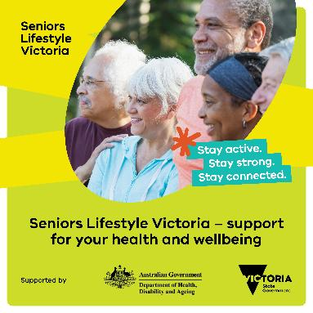 | Looking for support to stay active, strong, and connected?  Seniors Lifestyle Victoria offers free support for people aged 65+ or 50+ for Aboriginal and Torres Strait Islander people, who are living in the community (not in aged care).  A coordinator will work with you to create a plan tailored to your goals which might include support with physical activity, nutrition, medication management, and social connection.  The program is offered at participating community health services until June 2028, participation in the program is free.  Ask your GP or trusted health professional if the program is right for you or you can contact a participating community health service directly.  For more information visit:https://www.betterhealth.vic.gov.au/seniors-lifestyle-victoria
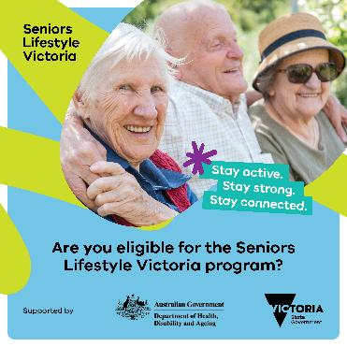 | The Seniors Lifestyle Victoria program is for those who:  - are 65 years+ or 50 years+ for Aboriginal and Torres Strait Islander people  - are living at home, not in aged care  - are looking to improve their overall health and wellbeing, to stay active, strong and connected.  A coordinator will work with you to develop a personalised plan, with local services tailored to meet your individual needs and goals.  For more information on the program and how you can get involved, visit: https://www.betterhealth.vic.gov.au/seniors-lifestyle-victoria
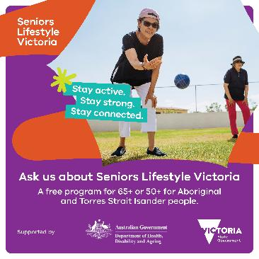 | The Seniors Lifestyle Victoria program offers access to a range of services to support you to stay active, strong and connected.  This might include supports focused on:  - physical activity and nutrition  - medication management  - social connection.  This program will be running until June 2028 and is free for eligible participants.  Speak to us to learn more about the program and how you can get involved.

Print ready poster
We invite you to print this poster for use in your waiting rooms and share with possible referrers to help spread awareness of the Seniors Lifestyle Victoria program.
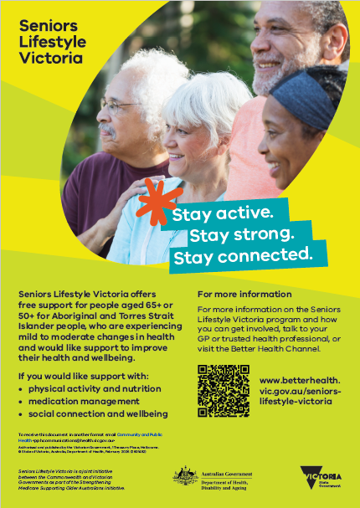

Print ready DL flyer
We invite you to print this flyer and share it with potential program participants and referrers to help spread awareness of the Seniors Lifestyle Victoria program.
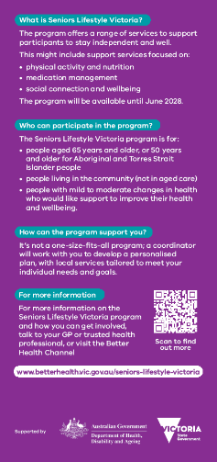
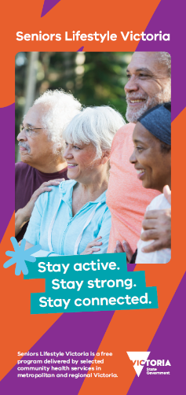

Frequently asked questions and answers

Patient focused questions

What will happen once I’m referred?
Once you’re referred, a program coordinator will get in touch to learn about your health and wellbeing needs. Together, you’ll create a personalised plan that outlines your goals and the types of support that could help you reach them. Your coordinator will then help you access these supports — which may include physical activity, nutrition guidance, medication support, social connection, and other services tailored to you. The aim is to help you stay active, strong, independent, and connected in your community.

What if I already see an allied health professional - can I still join?
Yes. The program complements existing care. Your coordinator will work with you and your current health care team to ensure the program supports your goals without duplicating services.

Will participating interfere with my current treatments or medications?
No. The program is designed to work alongside your current treatments. Medication management support is available, but any changes will always be discussed with your healthcare team.

What happens if I start the program and decide it’s not for me?
Participation is voluntary. If you choose to stop, you can withdraw at any time.

What happens after the program finishes?
Your coordinator will help you plan next steps, which may include ongoing community support or referrals to other services to maintain your health and independence.

Who do I contact if I have questions or need help with my referral?
You can speak to your GP, trusted health professional, or contact your local participating community health service. Program details and service locations are available on the Better Health Channel.
For more information about the Seniors Lifestyle Victoria program, visit the Better Health Channel webpage: <https://www.health.vic.gov.au/ageing-and-aged-care/seniors-lifestyle-victoria>

Healthcare sector focused questions

Who is eligible for the program
The program is designed to support older people aged 65 years and over, or 50 years and over for Aboriginal and Torres Strait Islander people, who are living in the community and experiencing mild to moderate changes commonly associated with frailty. These may include reduced mobility, strength, balance or endurance, unintentional weight loss, a fall, or an unplanned hospital presentation within the past 12 months.

Do patients need a formal diagnosis of frailty?
No, a formal frailty assessment is not required at the point of referral. Referrers are encouraged to use their clinical judgement in identifying individuals who may benefit from the program. Tools such as the Clinical Frailty Scale (CFS) may be useful but are not required.

Who is not eligible for the program
The program is not suitable for people outside the age criteria, those requiring urgent or acute care, individuals with complex or high-level needs that exceed the scope of the program or would prevent meaningful participation, or clients already receiving comprehensive care coordination through another funded service.

How do I make a referral?
Referrals can be made by health professionals, pharmacists, hospitals, community and social care providers, multicultural and Aboriginal services, or by the individual or their support person.

Is there a cost for patients?
No. Participation in the Seniors Lifestyle Victoria program is free for eligible participants.

Can hospitals refer to the program?
Yes. Hospitals are encouraged to refer patients, particularly those recently discharged or at risk of readmission.

How is care coordinated?
A dedicated coordinator works with the participant and their care team to develop a personalised plan, ensuring services complement existing care and support continuity.

What outcomes does the program focus on?
The program focuses on improving participants’ functional capacity, enhancing wellbeing, and promoting independence. It supports older Victorians living in the community who are experiencing mild to moderate symptoms commonly associated with frailty, with the aim of reducing, slowing, or reversing these symptoms. In doing so, the program seeks to reduce the risk of avoidable emergency department presentations and hospitalisations.
For more information about the Seniors Lifestyle Victoria program, visit the Better Health Channel webpage: <https://www.health.vic.gov.au/ageing-and-aged-care/seniors-lifestyle-victoria>

To receive this document in another format, email pph.communications@health.vic.gov.au <pph.communications@health.vic.gov.au >.

