

How to submit a Notification of Acquisition.
Victorian Radiation Management Licence – Online Licensing Portal.
OFFICIAL

When do I need to submit a Notification of Acquisition?
You need to submit a notification of acquisition when you take possession of a radiation source.

Submitting a Notification of Acquisition
Step 1: Go to the online licensing portal <https://licensing.health.vic.gov.au>

Step 2: Click on the three dots on the top right of the licence tile and select View Details.

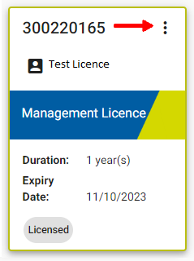

Step 3: There are now two ways to find the correct Authorisation Number:

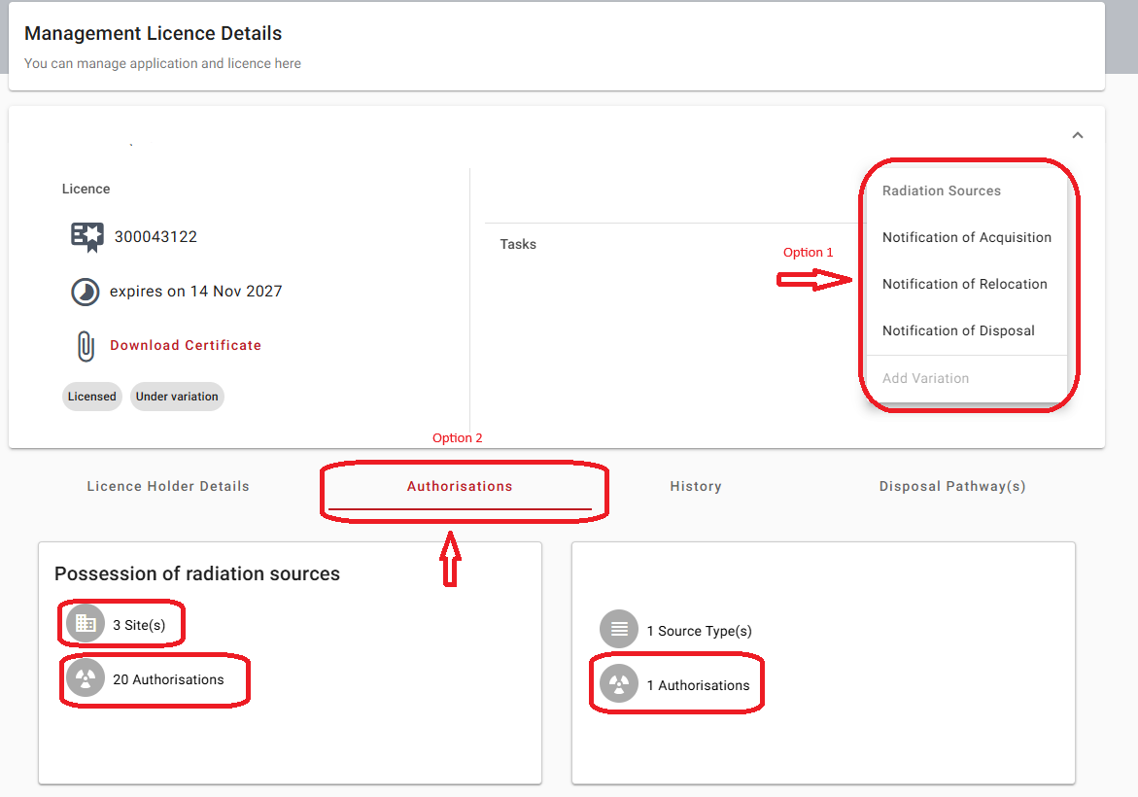

Option A: This is a quicker way if you know the Authorisation Number. Click on the three dots in the top right-hand section then select Notification of Acquisition. A window will open. Enter the Authorisation Number (starting with A).

Option B: Click on the Authorisations tab then navigate to the correct authorisation by selecting the site and Authorisation Number (starting with A). You can only acquire a radiation source into an empty authorisation that has the status Awaiting acquisition.

Step 4: Once you have found the Authorisation number you wish to acquire a radiation source into:
- Click on the three dots then select Notification of Acquisition.
- Complete the details in the pop-up window.
- To select Manufacturer & Model, click on the pencil icon and search for the correct Manufacturer then Model.
- Click Save then Next.
- Add Source Details (e.g. Serial Number, Volts, Amps) then click Next.
- Add the Date acquired and any additional details, then click Save.

A confirmation message will be shown.
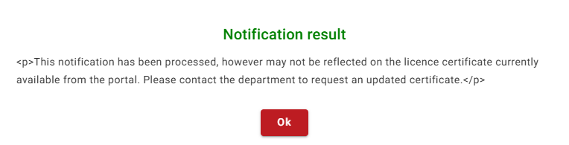

If you would like an updated licence certificate generated and made available on the portal, please send a request via email to Radiation.Safety@health.vic.gov.au.

To receive this document in another format email Radiation Safety via email <radiation.safety@health.vic.gov.au> or via the ⁠online enquiry form <https://survey.forms.health.vic.gov.au/form-response/dc2e188e-9862-4d4c-a6b9-1305a490ed68/1>
Authorised and published by the Victorian Government, 1 Treasury Place, Melbourne.
© State of Victoria, Australia, Department of Health, May 2026.

