
Secretary’s handbook
Guidance for Class B cemetery trust secretaries
June 2025
OFFICIAL

To receive this document in another format, phone 1800 034 280, using the National Relay Service 13 36 77 if required, or email the department <cemeteries@health.vic.gov.au>.
Authorised and published by the Victorian Government, 1 Treasury Place, Melbourne.
© State of Victoria, Australia, Department of Health, June 2025.
ISBN 978-1-76096-866-3 (pdf/online/MS word)
Available at health.vic <https://www.health.vic.gov.au/cemeteries-and-crematoria/cemetery-trusts-governance>

Contents
Introduction 5
Key documents 6
Manual for Victorian Class B cemetery trusts 6
Cemeteries and Crematoria Act 2003 6
Cemeteries and Crematoria Regulations 2025 6
Rights of interment 7
What is a right of interment? 7
Who is the right of interment holder? 7
What happens to the right when the holder dies? 7
Further information 7
Interment services 8
Booking procedure 8
Forms 9
Mandatory form 9
Recommended forms 9
Fees 11
Right of interment fees 11
Interment fees 11
Memorial fees 11
Administration fees 11
Financial management 12
Abstract of accounts 12
Budget and review of fees 12
Making payments 12
Assets 12
Bank reconciliation processes 13
Invoicing and receivables 13
Trust meetings 14
Role of the secretary 14
Meeting agendas 14
Templates 14
Effective and sensitive communication 15
Communication strategies 15
Culturally appropriate communication 15
Communication with distressed or aggressive customers 15
Communicating by email 16
Email etiquette 16
Using email safely 16
Responding to enquiries 17
Enquiries about family history 17
Complaints management 18
Strategies for managing complaints 18
Complaints management policy 18
Escalation of complaints 18
Role of the department 18
Records management 19
Where can I get help? 20
Class A cemetery trusts 20
Sector peak body 20
Department of Health 20

Introduction
Victoria has a proud tradition of caring for its forebears in public cemeteries. People working and volunteering in the cemetery sector perform a vital service by managing these crucial public assets on behalf of their local communities.
Secretaries of Class B cemetery trusts undertake a unique and complex role with responsibilities that span a wide range of governance and operational duties.
This handbook has been developed to introduce the essential parts of the secretary’s role. It is designed to assist with the induction of new secretaries and provide a useful resource for existing secretaries.
The responsibilities of secretaries vary from trust to trust. It is important to note that this handbook does not necessarily cover all parts of the role. The handbook contains summaries of information that is provided in more detail in other departmental resources including the Manual for Victorian cemetery trusts <https://www.health.vic.gov.au/cemeteries-and-crematoria/class-b-cemetery-trust-governance>, face-to-face and online training programs, and the health.vic website <https://www.health.vic.gov.au/public-health/cemeteries-and-crematoria>.
By reading this handbook, secretaries will gain an understanding of the essential parts of the role and be ready to expand their knowledge and skills in this multifaceted and rewarding position.

Key documents
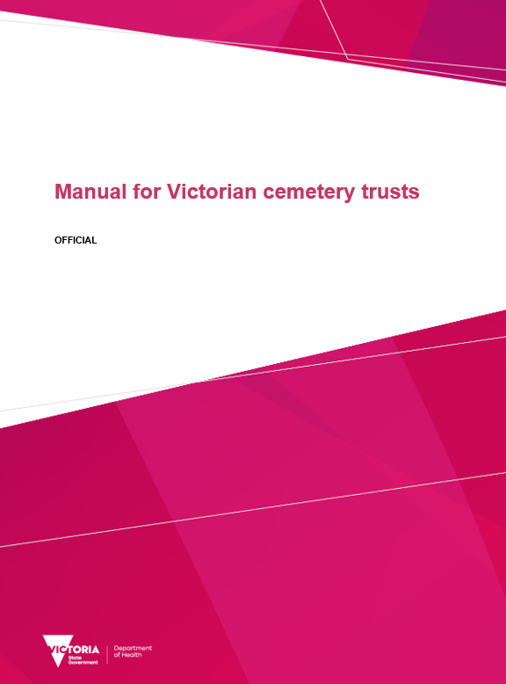 | Manual for Victorian cemetery trusts  <https://www.health.vic.gov.au/cemeteries-and-crematoria/class-b-cemetery-trust-governance>
 | Cemeteries and Crematoria Act 2003  <https://www.legislation.vic.gov.au/in-force/acts/cemeteries-and-crematoria-act-2003>
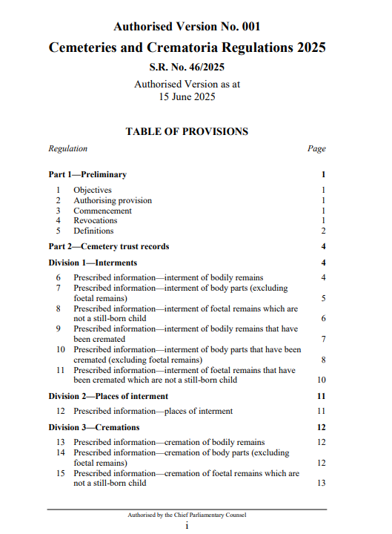 | Cemeteries and Crematoria Regulations 2025  <https://www.legislation.vic.gov.au/in-force/statutory-rules/cemeteries-and-crematoria-regulations-2025>

Rights of interment

What is a right of interment?
A right of interment permits the holder/s to determine who can be interred in a place of interment and the type of memorialisation (if any) to be established at the place of interment (subject to any trust memorialisation policies or specifications). A right of interment relates to a specific place of interment, for example a grave, mausoleum crypt or ashes niche.

Who is the right of interment holder?
The right of interment holder is the person identified in trust records as the right of interment holder for a specific place of interment within a public cemetery. The right of interment holder is not necessarily the same person as the applicant who completed and signed a form or the person who paid the relevant fee to purchase the right of interment. There can be one right of interment holder (sole holder) or more than one holder (joint holders) for a place of interment.

What happens to the right when the holder dies?

Joint holder
When a joint right of interment holder dies, the right will likely be transferred to the surviving right holder(s) in accordance with the right of survivorship.
Example: A right of interment was issued in 1920 to three brothers. Two of the brothers died in the 1930s and the surviving brother became the sole holder of the right.

Sole holder
When a sole right of interment holder dies, the right of interment will likely be transferred to the beneficiary of a will, or if no such arrangements have been made, the right of interment is transferred in accordance with the rules of intestacy. In lieu of a specific bequest leaving the right of interment to an identified person or persons, the right typically forms part of the deceased’s estate and is inherited by the beneficiary or beneficiaries of the estate. This could mean transfer of the right to one or multiple people.
Example: Following on from the example above, the third brother who became the sole holder of the right of interment had two daughters who inherited his estate when he died. He did not leave a specific bequest identifying who should inherit the right of interment. His two daughters became joint holders of the right.

Further information
Detailed information about rights of interment is provided in Topic 22 of the Manual for Victorian cemetery trusts and on the health.vic website <https://www.health.vic.gov.au/cemeteries-and-crematoria/rights-of-interment>.

Interment services

Booking procedure
- Record the details of the funeral director or applicant, the name of the deceased, the type of interment and the proposed date and time for the interment.
- Advise the person making the booking of the documentation requirements (see Forms).
- If the right of interment has been purchased in advance (pre-need), confirm with the funeral director or applicant that the right of interment holder for the place of interment, as recorded in the trust’s records, consents to the interment taking place.
- If the recorded right of interment holder is deceased, the trust will require documentation to establish who the current right of interment holder is so it can update its records and ensure the current holder consents to the interment taking place.
- On receiving the required documentation from the funeral director or applicant, the trust should undertake a physical inspection of the place of interment to check:
- the proposed place of interment matches the trust’s records
- the receptacle (for example, coffin, casket, urn) will fit inside the place of interment
- if there is an existing memorial at the place of interment or an existing interment in the place of interment
- the place of interment can be accessed safely with required equipment.
- After the site inspection and before the interment booking is accepted and confirmed, any issues relating to erecting monuments, placing ledgers or confirming the dimensions of the receptacle should be communicated to the funeral director in writing.
- The trust should advise the funeral director of all costs associated with the booking, including the cost of the right of interment (if it is being purchased at-need), the interment service and any other related costs charged by the trust. The trust should also advise of their preferred payment method.
Before issuing confirmation for an interment booking, the trust should determine:
- if any part of the proposed funeral ceremony and/or interment (for example, motorcycle escort, music, public address system) may cause disturbance to other funerals or cemetery visitors
- if the receptacle will need to be opened at the place of interment
- whether the funeral director or the trust will be providing a lowering device for an interment of bodily remains (if the trust is providing the lowering device, this should be in place before the funeral begins)
- whether the trust will be expected to provide equipment to enable a receptacle to be hand-lowered into a grave for an interment of bodily remains.
Once all the above information has been verified, the interment booking should be confirmed in writing, listing all relevant details, and be provided to the funeral director or applicant.

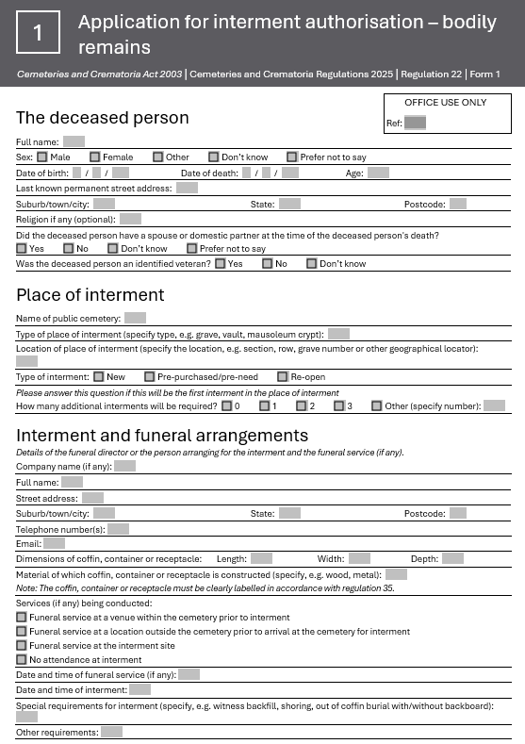
Forms

Mandatory form

Form 1 - Application for interment authorisation - bodily remains
The Application for interment authorisation - bodily remains (Form 1) must be used for applications for authorisation to inter bodily remains in Victorian public cemeteries (for example, in a grave, vault or mausoleum crypt).
This form is mandatory for the interment of bodily remains and must be accompanied by supporting documentation (see page 3 of the form for the list of documents).
See Topic 23 of the Manual for Victorian cemetery trusts for more information about documentation requirements.

Recommended forms

Form 3 - Application for interment authority - body parts (excluding foetal remains)
Applications for authority to inter body parts that are not foetal remains must include prescribed information from a prescribed person. Form 3 is used for applications for authority to inter body parts that are not foetal remains. Download the form from the health.vic website <https://www.health.vic.gov.au/cemeteries-and-crematoria/interments>.

Form 4 - Application for interment authority - foetal remains which are not a still-born child
Applications for authority to inter foetal remains which are not a still-born child must include prescribed information from a prescribed person. Form 4 is used for applications for authority to inter foetal remains which are not a still-born child. Download the form from the health.vic website <https://www.health.vic.gov.au/cemeteries-and-crematoria/interments>.

Form A - Application for right of interment
To meet record keeping requirements, the department recommends trusts use Form A when a right of interment is purchased. This form is completed by applicants and submitted to the trust. The most important section of this form is where the details of the right of interment holder(s) are provided. It is the right of interment holder(s) who have the right to make decisions about the place of interment, not the person listed as the applicant. Download the form from the health.vic website <https://www.health.vic.gov.au/cemeteries-and-crematoria/applying-for-a-right-of-interment>.

Form B - Application for approval to inter cremated human remains
To meet record keeping requirements, the department recommends trusts use the Application for approval to inter cremated human remains for the interment of cremated remains. This form is completed by applicants and submitted to the trust. The trust should always satisfy itself that the person wishing to use the place of interment is the holder of the right of interment, or that they have the permission of the holder of the right of interment to inter remains in the place of interment.

Application to establish or alter a memorial or place of interment
The Cemeteries and Crematoria Association of Victoria (CCAV) developed the Application to establish or alter a memorial or place of interment to assist trusts with the memorialisation approval process. The form includes useful information about the Australian Standard for headstones and cemetery monuments (AS 4204:2019).

Fees
Trusts can only charge fees that have been approved by the department and published in the Victorian Government Gazette. The approved list of fees for each trust can be accessed via the cemetery search on the health.vic website <https://www.health.vic.gov.au/cemeteries-and-crematoria/cemetery-search>.
Secretaries must familiarise themselves with the trust’s approved list of fees. Trusts should contact the department if the trust is using fees other than what is on the approved list. Information about the process to increase existing fees and add new fees is available on the health.vic website <https://www.health.vic.gov.au/cemeteries-and-crematoria/class-b-cemetery-trust-finance>.

Right of interment fees
Right of interment fee | Fee for the purchase of a right of interment. The right of interment may be purchased when arranging an interment (at need) or purchased in advance (pre-need). This fee is paid once and the holder of the right of interment is recorded at the time of purchase.

Interment fees
Interment services fee | Fee for the interment of remains in a place of interment, for example the burial of bodily remains in a grave, or placement of cremated remains in a niche wall. This fee is paid for each interment.  It is common for interment service fees to be the amount charged by the contractor/gravedigger plus a percentage kept by the trust.  Some trusts have separate fees for first, second and subsequent interments, oversized graves, interments outside of standard hours, and the removal of stone ledgers.

Memorial fees
Memorial permit fee | Fee for providing a permit to establish or alter a memorial, or fee for the trust to affix plaques or install other types of memorials. This fee is paid with each application to establish, install or alter a memorial.
Memorialisation fee | Fee for the supply of a memorial. Not all trusts offer this.

Administration fees
Interment administration | Some trusts have a separate fee for ‘interment administration’ if their interment service fee does not recover the cost of paperwork or arranging the gravedigger.
Other | Some trusts will have separate fees for services such as re-issuing a certificate, conducting a record search, or the hire of equipment.

Financial management

Abstract of accounts
Under s. 52 of the Cemeteries and Crematoria Act, trusts are required to submit a financial report to the department by 1 September each year. The report, known as the Abstract of accounts, is used to give a true and fair view of the financial position and performance of a trust for the reporting period.
In June/July, a blank copy of the Abstract of accounts is sent to each trust along with a checklist to assist the trust.
Trusts with an annual income or expenditure of $250,000 or above are required to submit additional documents which are detailed in the checklist.

Budget and review of fees
It is recommended that trusts prepare their own budget statement for the coming financial year and discuss this at a trust budget meeting held in April or May. A budget template and budget strategy guidelines are available on the health.vic website <https://www.health.vic.gov.au/cemeteries-and-crematoria/class-b-cemetery-trust-finance>.
Once a budget has been agreed, trusts can determine whether their current fees are appropriate to meet forward expenditure. It is recommended that fees be set to reflect the actual cost of operating a cemetery, including funds to meet the trust’s perpetual maintenance obligations under the Cemeteries and Crematoria Act.

Making payments
Payments should only be made against tax invoices or a statement that has first been reconciled to supporting documents (for example, invoices, quotes, agreements).
All payments should require either two online authorisations or two cheque signatories. Paperwork supporting the payment must be provided to the second authoriser to enable them to check the payment to be made.
Before an invoice is paid:
- the trust should ensure the goods or services have been fully and properly received and are fit for the ordered purpose
- the invoice should be checked for mathematical accuracy
- the trust should check to confirm that the invoice is not a duplicate payment.

Assets
Although many trusts have limited assets (such as general gardening equipment), it is important that any assets are protected and accounted for. An asset register should be maintained for insurance and assessment purposes.

Bank reconciliation processes
Bank reconciliations should be performed monthly, even when there have only been a few transactions.
The completed bank reconciliation (including supporting bank statements) should be reviewed and signed off by an independent trust member before being presented to all trust members for review and endorsement at the following trust meeting.

Invoicing and receivables
Complete and accurate invoicing is essential to ensure that trusts receive the correct fees in a timely manner for services they have provided. Although some trusts issue detailed receipts instead of raising invoices, and some raise invoices and issue receipts, the same control principles apply:
- Invoices should be raised as soon as possible after a service has been provided or arranged, with one copy to the customer and another retained by the trust.
- Invoices should be raised at the correct gazetted fee amount. They should be checked before being issued to ensure they are complete and accurate.
When the trust receives payment for its services, the following controls should apply:
- A duplicate receipt should be issued for all invoices paid. If the trust does not raise invoices, an itemised duplicate receipt should be issued.
- All revenue should be banked in a timely manner.
- All revenue should be recorded in the cashbook or general ledger in a timely manner.

Trust meetings

Role of the secretary
Secretaries play an important role in ensuring trust meetings are well run and productive. Key responsibilities relating to meetings include:
- preparing meeting papers including the agenda, reports and previous meeting minutes
- organising meetings including confirming location, attendance and apologies
- minute taking including recording conflicts of interest, decisions and actions
- maintaining trust policies including trust meeting rules and decision-making processes
- supporting compliance with legislative requirements for meetings including quorums and the number of meetings per year.
Note: If the secretary is a ‘non-member secretary’ (not an appointed member of the trust) they do not participate in voting on trust decisions.

Meeting agendas
The agenda can include:
- Scheduled start and finish times
- Minutes of previous meeting (presented for endorsement)
- Outstanding major action items
- Declarations of conflicts of interest
- Standing agenda items such as Workplace Health and Safety
- Matters for decision, which may include recommendations and reports from committees
- Strategic, operational and performance issues
- Financial reports including year-to-date budget and expenditure, and financial forecasts
- Correspondence/complaints received (including recommended actions, if relevant)
- Other items for discussion

Templates
The following meeting templates have been developed by the Institute of Community Directors Australia for not-for-profit organisations. The templates can be modified to suit the trust’s needs or used as a starting point for the trust to develop its own templates.
- Meeting agenda template <https://communitydirectors.com.au/tools/agenda-template>
- Meeting minutes template <https://communitydirectors.com.au/tools/minutes-template>
- Decision-making tool <https://communitydirectors.com.au/tools/decision-making-tool>

Effective and sensitive communication
Grieving people are often experiencing heightened stress which can impact their ability to communicate, process information and make decisions. Accordingly, secretaries are required to use effective and sensitive communication when interacting with customers.

Communication strategies
- Communication should be clear and simple.
- Communicate with customers in a compassionate and sensitive way.
- Try not to take on the role of providing emotional support or counselling.
- Explain available cemetery products and services and be upfront about fees.
- Provide customers with copies of relevant trust policies.
- Ask the right questions and listen carefully to what the customer needs.

Culturally appropriate communication
The way people experience and express grief can be informed by their background, circumstance and beliefs. Many cultural and religious groups have their own beliefs and rituals around death. It is important to acknowledge and respect the diverse needs of customers and, where possible, accommodate these needs.

Communication with distressed or aggressive customers
When experiencing loss, customers may not behave as they would in normal circumstances. Some customers may become angry or aggressive. Secretaries should follow the procedures set out in the trust’s workplace health and safety policy, ask for help and support, and identify and report all incidents of violence and aggression to the trust.
Tips for interacting with aggressive customers:
- Try to stay calm
- Listen
- Control your body language
- Tell the customer you are feeling uncomfortable or threatened
- Stay out of the customer’s personal space
- Ask the customer to leave
- Call the police if necessary

Communicating by email
Email is a fast and effective way of communicating. It is recommended that secretaries use email as the preferred method of communication where possible.
Email is the department’s preferred method for communicating with trusts. Accordingly, secretaries are expected to check trust email accounts regularly and distribute information from the department to trust members as appropriate.

Email etiquette
Email etiquette refers to the principles of behaviour you should consider when writing or answering emails. Email etiquette depends on who you are sending an email to. Keep the following in mind:
- Avoid vague subject lines – keep subject lines descriptive and short.
- Use an appropriate salutation.
- Match your tone to your audience – use a polite and professional tone in emails.
- Use punctuation and good grammar.
- Use diplomatic language and be considerate of the recipient.
- Read through your email carefully before sending.

Using email safely
Tips for using email safely:
- Change your password regularly and keep it in a safe place.
- Don’t share your password with anyone.
- Don’t open attachments from anyone you don’t know.
- Log out or sign off from your account when you’ve finished using it.
- Don’t reply to spam or forward ‘chain’ emails.
- Make sure you have antivirus software installed and keep it up to date.
- Keep your personal information personal – never share bank or credit card information by email.
- Your bank will not discuss your private finances by email. If you receive any correspondence that claims to come from your bank, telephone your branch to verify it and discuss the matter over the telephone instead.
- Look out for malicious emails (they may look like they have come from a financial institution, lawyer, business or government agency). Be especially wary of emails that ask for personal information, financial information, financial assistance, donations and payment of fees or fines that have not been verified.

Responding to enquiries
Secretaries respond to a wide range of enquiries. All enquiries received should be resolved in a professional and timely manner. Responding to enquiries will usually require secretaries to assess the enquiry, gather information, consult with the trust as necessary and provide a response.
Enquiries include requests for information, advice, products and services. See page 18 for information about managing complaints.
Tips for managing enquiries effectively:
- Clarify what is being asked if the enquiry is complex or unclear.
- If an enquiry made by telephone or in person is complex or unclear, ask the enquirer to put their request in writing.
- Provide a holding response (written or verbal) if it is anticipated that the enquiry will take more than a few days to resolve.
- Provide realistic timeframes for when responses are likely to be provided.
- Generally, the same contact method used by the enquirer should be used to respond – for example, if an enquiry is received by mail, respond by mail. Do not respond by email unless previously agreed with the enquirer. In some cases, it may be appropriate for a written response to be provided to an enquiry made by telephone or in person.
- Keep records of enquiries and responses. If an enquiry is made and resolved by telephone or in person, keep a written record of what was discussed.
- Use effective and sensitive communication (see page 15).
- If unable to resolve an enquiry, refer the enquirer to relevant resources and contacts if available.

Enquiries about family history
Secretaries may be asked to assist community members with family history research. While trust records may provide some relevant information, secretaries are not expected to conduct research outside of the information held by the trust. See page 21 for information about privacy considerations when searching trust records.
There are many resources and contacts available to assist enquirers with family history research including:
- Public Records Office Victoria <https://prov.vic.gov.au/explore-collection/explore-topic/family-history>
- Registry of Births, Deaths and Marriages Victoria <https://www.bdm.vic.gov.au/research-and-family-history/search-your-family-history>
- State Library Victoria <https://guides.slv.vic.gov.au/familyhistoryguides>
- National Archives of Australia <https://www.naa.gov.au/explore-collection/search-people/researching-your-family>
- National Library of Australia <https://www.nla.gov.au/research-guides/family-history>

Complaints management

Strategies for managing complaints
- Listen and acknowledge the person’s perspective
- Identify the person’s underlying concerns
- Manage expectations and then follow through
- Provide a response
- Mediation
Trusts should log all complaints received, monitor the approach taken to resolve them and update its complaints management policy in response to changing customer and community needs.

Complaints management policy
Trusts are encouraged to develop and implement a complaints management policy to:
- guide day-to-day operations and decision-making
- support prompt, consistent, fair and objective complaints management
- streamline internal processes.
A complaints policy template is available on the health.vic website <https://www.health.vic.gov.au/cemeteries-and-crematoria/policy-templates>.

Escalation of complaints
If a customer is not satisfied with the trust’s attempts to resolve a complaint, the customer should be advised that they can escalate their complaint by contacting the Victorian Ombudsman. The Victorian Ombudsman investigates complaints about Victorian public organisations including Victorian trusts.

Role of the department
As trust’s are independent statutory bodies, the department does not have the power to direct a trust’s day-to-day business activities. For this reason, if a customer wishes to escalate a complaint, the trust should refer them to the Victorian Ombudsman rather than the department.
If someone has serious concerns about governance failings within a trust, for example fraud or misappropriation of trust funds, they should inform the department. If a customer is not satisfied with the trust’s attempts to resolve a complaint, the trust is encouraged to contact the department for advice.

Records management
The Cemeteries and Crematoria Act requires trusts to keep records for the cemeteries for which they are responsible. Part 2 of the Cemeteries and Crematoria Regulations prescribes in detail the information that must be recorded by trusts. Trusts manage a range of important records including:
- right of interment and interment registers
- cemetery plans
- applications for rights of interment
- applications for interment authorisations
- applications for approval to inter cremated human remains
- applications to establish or alter memorials or places of interment
- trust records such as meeting minutes, correspondence, financial statements, policies and procedures.
The Records management handbook has been developed in consultation with the Office of the Victorian Information Commissioner, Public Record Office Victoria and Cemeteries and Crematoria Association of Victoria to provide guidance for Class B cemetery trusts on the following topics:
- Types of cemetery trust records
- Prescribed information
- Interment register
- Retention timeframes
- Storage
- Information security
- Privacy
- Public access to cemetery trust records
- Freedom of information
- Digital record keeping
- Copyright
- Archiving cemetery trust records
Download the Records management handbook from the health.vic website <https://www.health.vic.gov.au/cemeteries-and-crematoria/cemetery-trust-records-management>.

Where can I get help?

Class A cemetery trusts
- Ballarat General Cemeteries Trust <http://www.ballaratcemeteries.com.au>
- Geelong Cemeteries Trust <https://www.gct.net.au>
- Greater Metropolitan Cemeteries Trust <https://www.gmct.com.au>
- Remembrance Parks Central Victoria <https://www.rpcv.com.au>
- Southern Metropolitan Cemeteries Trust <https://smct.org.au>

Sector peak body
- Cemeteries and Crematoria Association of Victoria <https://ccav.org.au>

Department of Health
- Cemeteries and Crematoria <https://www.health.vic.gov.au/public-health/cemeteries-and-crematoria>

For a trust to be able to meet and make decisions, there must be a majority of current appointed trust members participating. An easy way to determine the minimum number of trust members needed for a quorum is “half plus one”.

