
Non-emergency patient transport clinical practice protocols
2026
OFFICIAL

To receive this document in another format, email the Regulated Services team <NEPTFirstAidRegulation@health.vic.gov.au>.
Authorised and published by the Victorian Government, 1 Treasury Place, Melbourne.
© State of Victoria, Australia, Department of Health, March 2026
ISBN/ISSN 978-1-76131-975-4 (online/PDF/Word)
Available at the NEPT legislation and Clinical Practice Protocols webpage <https://www.health.vic.gov.au/patient-care/nept-legislation-and-clinical-practice-protocols>

Contents
Purpose 6
2026 review 6
Guide to using the CPPs 6
‘Memory items’ and ‘checklist items’ 7
Paediatric and maternity/obstetric patients 7
Inter-facility transport (IFT) management – including high-acuity services 7
Limitation of treatment and patient review 8
Administering medicines not included in scope of practice 8
Clinical staff qualifications and crew mix 8
Scope of practice 11
Assessment tools 15
NEPT perfusion status assessment (PSA) – adult 15
NEPT respiratory status assessment (RSA) – adult 15
Not suitable for NEPT 17
Pain assessment tools 20
Acceptable paediatric VSS 21
Paediatric definitions and weight guide 22
Glasgow coma scale (adult) 22
Glasgow coma scale (paediatric) 23
AVPU scale 23
Time critical guidelines 24
Sedation assessment tool (SAT) score 25
Mental status assessment (MSA) 26
CPP001: Clinical approach to assessment – unplanned medical presentation 27
CPP002: Clinical approach to assessment – unplanned major trauma presentation 29
CPP003: Clinical approach to inter-facility transport (IFT) 30
CPP004: Cardiac arrest – adult 33
Signs of life 33
High-quality CPR principles 33
Compression ratio 33
Defibrillation pad placement 33
General notes 33
CPP005: Cardiac arrest – paediatric 36
Signs of life 36
High-quality CPR principles 36
Compression ratio, rate and technique 36
Defibrillation pad placement 36
General notes 37
Hypothermic cardiac arrest < 30°C 37
CPP006: Clinical escalation 38
CPP007: Oxygen therapy 39
CPP008: Narrow complex tachycardia (NCT) 41
CPP009: Wide complex tachycardia (WCT) 43
CPP010: Bradycardia 45
CPP011: Sepsis recognition and escalation 47
CPP012: Undifferentiated shock 49
CPP013: Cardiogenic shock 52
CPP014: Acute cardiogenic pulmonary oedema (ACPO) 54
CPP015: Stroke 56
CPP016: Headache 58
CPP017: Seizures 59
CPP018: Asthma – adult 61
Thunderstorm asthma 63
CPP019: Asthma – paediatric 64
CPP020: Chronic obstructive pulmonary disease (COPD) exacerbation 66
CPP021: Anaphylaxis – adult 68
Recognition of anaphylaxis (RASH criteria) 68
CPP022: Anaphylaxis – paediatric 70
CPP023: Acute coronary syndrome (ACS) – cardiac chest pain 72
CPP024: Hypoglycaemia 74
CPP025: Hyperglycaemia 76
CPP026: Nausea and vomiting 77
CPP027: Foreign body airway obstruction (FBAO) 78
CPP028: Laryngectomy and tracheostomy care 80
CPP029: Pain relief 82
Pain assessment 82
Non-pharmacological management 82
Chronic pain 82
General notes 82
CPP030: Burns 84
CPP031: Fractures or dislocations 86
CPP032: Traumatic head injury 87
CPP033: Potential spinal injury 88
Appendix 1: Abbreviations and definitions 90
Appendix 2: Withholding or ceasing resuscitation 93
Withholding resuscitation 93
Ceasing resuscitation 93
Appendix 3: Advance care directives and end-of-life care 94
Appendix 4: Mental health patients 96
Appendix 5: ‘Double-loading’ 98
Appendix 6: Mandatory equipment list 99
Appendix 7: Prolonged transport 101
Appendix 8: Medication pharmacology reference material 103
Adrenaline 104
Amiodarone 106
Aspirin 107
Atropine 108
Glucagon 109
Glucose paste 110
Glyceryl Trinitrate (GTN) 111
Nitrous Oxide (Entonox®) 113
Ipratropium Bromide 114
Methoxyflurane 116
Metaraminol 118
Ondansetron 119
Paracetamol 120
Salbutamol 121

Purpose
The purpose of the non-emergency patient transport (NEPT) clinical practice protocols (the CPPs) is to provide practice requirements, treatment recommendations and mandatory equipment levels that apply to licensed NEPT providers when assessing, managing and transporting patients.
In accordance with the Non-Emergency Patient Transport and First Aid Services Act 2003 (the Act) and the associated Regulations (the Regulations), the CPPs set out additional practices that NEPT providers must follow. These additional requirements assist licensed NEPT providers, health services and other organisations to make decisions about the use of NEPT services for patients with a variety of clinical conditions and in a range of acuities.
The NEPT CPPs do not dictate management for every condition or diagnosis (with some exceptions such as anaphylaxis) that NEPT is likely to provide transport services for, rather the CPPs provide direction for management of symptoms that may present as complications during service delivery.

2026 review
The 2026 edition of the CPPs have been updated to reflect the Regulations.
This review sought to:
- Clarify workforce requirements and crew mix based on patient acuity levels.
- Refine existing protocols and update terminology used in the CPPs to maintain consistency with the Regulations.
For a comprehensive list of all changes, please refer to the change log.
Where medicines are included with doses it is because they have received secretarial approval <https://www.health.vic.gov.au/drugs-and-poisons/medicines-and-poisons-secretary-approvals> for independent possession and administration by NEPT providers or are likely to be approved for purchase and possession under a revised secretarial approval. Please consider medicines available for purchase, possession and administration by a NEPT service when planning management. Refer to the mandatory equipment list in Appendix 6 for details on suggested medication stockholding levels.

Guide to using the CPPs
Where treatment recommendations are provided within a CPP, it includes all levels of NEPT crew members and clinical scope of practice. NEPT licence holders have a responsibility to ensure processes are in place to support NEPT crew members to familiarise themselves with and not exceed their credentialled and defined scope of practice, detailed in Table 3, when delivering patient care. For any condition described in the CPPs, the NEPT crew members must consider their scope of practice prior to initiating the recommended treatment. This is a departure from previously formatted iterations of the CPPs, which contained different coloured boxes used to indicate different levels of NEPT crew member.
Where a skill, procedure or medicine is accredited for use by a NEPT crew member, this refers to independent initiation. This does not prevent a NEPT crew member undertaking a procedure, skill or administering a medication which they may reasonably be expected to be proficient to perform under the direct supervision and/or authorisation of an appropriately credentialled, registered health practitioner.
NEPT crew members are reminded of the responsibility and availability of seeking clinical consult in case of a need to operate outside their credentialled scope of practice including consultation with the AV clinician, NEPT provider clinician, and any applicable registered health practitioner involved in a patient’s care at either a sending or receiving facility.
It is acknowledged that the information provided in the CPPs has been selected for its relevance to licensed NEPT providers and may not be suitable for use in other clinical situations. References to management options and medications including use, contraindications, side effects and dose ranges are specific to the types of conditions seen by licensed NEPT providers and may differ from other reference material available. Where applicable, management and pharmacology have been aligned to AV’s clinical practice guidelines (CPGs) where any variance would cause confusion or a delay in escalation or transition in care.

‘Memory items’ and ‘checklist items’
NEPT crew members rarely action the majority of the CPPs. Therefore, there is no expectation that the NEPT CPPs should be committed to memory verbatim. NEPT crew members should consider the items that are required to be ‘memory items’ requiring immediate attention to preserve life and refer to the CPPs for guidance on specific management options.
Memory items – are designed to give a trained response to certain situations. This will be from training received through foundational formal pre-employment education.
Checklist items – are tasks that should be completed once memory items are completed and will be the continuation of management. The CPPs should be referred to when completing these items.
Example: A patient is apnoeic -
- Memory item is to follow the primary survey and provide intermittent positive pressure ventilation (IPPV)
- Checklist items are the continuation in the applicable CPP, including check of tidal volume and ventilation rates as appropriate and trouble-shooting the cause of apnoea.

Paediatric and maternity/obstetric patients
The majority of patients treated and transported by NEPT services are adult patients. Paediatric or maternity patients being transported are likely to be clinically well for the duration of the episode of care. As such, doses for medicines have been included within generic management of some conditions (for example, anaphylaxis) where it is possible that NEPT services will encounter paediatric patients and where intervention is likely and/or required to preserve life.
For further information beyond the material in the CPP on how to manage paediatric or maternity patients in an emergency (including childbirth), contact the Paediatric Infant Perinatal Emergency Retrieval (PIPER) service on 1300 137 650.

Inter-facility transport (IFT) management – including high-acuity services
Not every condition or deterioration management option will be presented in the CPPs. Where applicable, any management initiated by a sending facility in the case of IFT should be adhered to and a documented medical care plan developed prior to departure in case of deterioration. These plans may conflict with the CPPs. Where there is conflict, the sending facility / agreed medical care plan takes precedence over the CPPs where it is reasonable and in the best interest of the patient. If NEPT crew members are uncertain about the medical care plan initiated by a sending facility, they should contact the provider or AV clinician. Where there is uncertainty or a final determination cannot be reached, further advice may be obtained by contacting the relevant retrieval service:
- Adult Retrieval Victoria (ARV) – 1300 368 661
- PIPER – 1300 137 650

Limitation of treatment and patient review
NEPT providers should conduct patient care reviews as detailed in the Regulations utilising the structure of the clinical oversight committee. Following an adverse outcome or significant presentation requiring management under these CPPs this should be conducted within the ‘just-culture’ framework. Further information on conducting patient reviews can be found through Safer Care Victoria (SCV) <https://www.safercare.vic.gov.au/support-and-training/review-and-response>
The department does not imply any responsibility on the part of NEPT crew members to undertake any treatment or management option that they have not been authorised for or are unable to reasonably perform due to circumstances out of control of the individual crew member.

Administering medicines not included in scope of practice
In the event patients are being transferred with medicines between hospitals/health facilities which fall outside the scope of practice contained in Table 3, arrangements should be made to ensure that these medicines are dispensed. For a medicine to be dispensed to a patient it must be labelled by a relevant prescribing health practitioner in accordance with Appendix L of the Poisons Standard (the SUSMP). Once a medicine has been dispensed, any carer of a patient (including a NEPT crew member) may assist in the administration of the medicine.
Note that currently only Registered Nurses (RNs) working as crew members for NEPT services may administer medication based on an order (not prescribed to the specific patient) from a prescribing health practitioner.

Clinical staff qualifications and crew mix
The Regulations require NEPT providers to ensure that whenever a patient is transported there are at least two suitably qualified and competent crew members crewing the vehicle, that a suitably qualified and competent crew member travels in the patient compartment with the patient, and that a suitably qualified and competent crew member is actively able to monitor and care for the patient for the duration of the episode of care.
Regardless of the acuity, the minimum requirement to be a crew member on a NEPT vehicle is a PTO (see Table 1). Patient acuity will dictate the crew member required to travel in the patient compartment and is detailed in Table 2. NEPT providers can engage staff with varying clinical expertise divided into different crew member levels. The scope of practice of these crew members is contained in Table 3.

Table 1. NEPT crew member qualifications
Crew member title | Base qualification
Patient Transport Officer (PTO) | HLT31120 Certificate III Non-Emergency Patient Transport (or equivalent)
(Endorsed) Enrolled Nurse (EN/EEN) | HLT54121 Diploma of Nursing (or equivalent)
Ambulance Transport Attendant (ATA) | HLT51020 Diploma of Emergency Health Care (or equivalent)
Registered Nurse (RN) | Bachelor of Nursing
Critical Care Registered Nurse (CCRN) | Bachelor of Nursing and post-graduate certificate and experience in a critical care area

Table 2. Patient acuity and NEPT crew mix
Acuity | Definition (see the Regulations) | Minimum crew member required to travel in patient compartment
Low | A patient who is not a medium or high acuity patient and has  - a condition requiring monitoring during an episode of care; or  - a condition requiring ambulatory assistance requiring a stretcher; or  - impaired cognitive functioning requiring direct supervision; or  - if the patient is not transported by an aeromedical service, chronic diagnosed shortness of breath in relation to which there has been no recent change. | PTO
Medium | A patient who is not a high acuity patient and who requires or is likely to require one or more of the following:  - active management for the duration of the episode of care or an intervention;  - monitoring with specialised equipment;  - observation and monitoring of an intravenous infusion that does not contain any vasoactive agent other than glyceryl trinitrate. (GTN) | ATA (unplanned ambulance or IFT)  EN/EEN (IFT or if trained and endorsed (TE) unplanned ambulance)  RN (IFT or if TE unplanned ambulance)
High | A patient who requires or is likely to require —  - active management for the duration of the episode of care or an intervention; and  - one or more of the following—  - cardiorespiratory support;  - a level of care specified in the CPPs as requiring high acuity transport;  - observation and monitoring of an intravenous infusion that contains vasoactive agents other than GTN;  - transport by PIPER's neonatal emergency transport service, PIPER's paediatric emergency transport service or ARV, other than for the purposes of being returned home or transported to another facility after receiving treatment. | CCRN

Scope of practice
Table 3. Scope of practice for NEPT crew members
Protocol or skill | PTO | EN | ATA | RN | CCRN
Cardiac arrest
Defibrillation - automatic external defibrillator (AED) | ü | ü | ü | ü | ü
Defibrillation - manual |  | TE | TE | TE | ü
Oropharyngeal airway | ü | ü | ü | ü | ü
Nasopharyngeal airway |  | TE | ü | ü | ü
Supra-Glottic airway |  | TE | ü | TE | ü
Bag valve mask (BVM) ventilation | ü | ü | ü | ü | ü
Intravenous (IV) cannulation |  |  |  | TE | ü
Adrenaline (IV) |  |  |  |  | ü
Amiodarone (IV) |  |  |  |  | ü
Narrow complex tachycardias
Assist patient to perform Valsalva if part of own regular management |  |  |  | TE | ü
Wide complex tachycardia
Amiodarone (IV infusion) |  |  |  |  | TE
Bradycardia
Atropine |  |  |  |  | TE
Undifferentiated shock
IV fluid (normal Saline) |  |  |  | TE | ü
Metaraminol IV |  |  |  |  | TE
Cardiogenic shock
Supportive care (positioning) | ü | ü | ü | ü | ü
Adrenaline infusion |  |  |  |  | TE
Anaphylaxis (adult and paediatric)
Adrenaline (via auto injector) intra-muscular (IM) | ü | ü | ü | ü | ü
Adrenaline 1:1000 drawn from ampoule (IM) |  | TE | TE | ü | ü
Normal Saline bolus doses |  |  |  | TE | ü
Glucagon for refractory anaphylaxis |  | ü | TE | ü | ü
Adrenaline via nebuliser mask (Neb) for stridor |  | TE | ü | ü | ü
Salbutamol (pressurised Metered Dose Inhaler (pMDI)) | ü | ü | ü | ü | ü
Salbutamol (Neb) |  | TE | ü | ü | ü
Ipratropium Bromide (Atrovent) (pMDI) |  | ü | ü | ü | ü
Ipratropium Bromide (Atrovent) (Neb) |  | TE | ü | ü | ü
Adrenaline IV bolus |  |  |  |  | ü
Breathing difficulties (hypoxia management)
Oxygen saturation monitoring | ü | ü | ü | ü | ü
Oxygen (nasal prongs/face mask) | ü | ü | ü | ü | ü
Titrated oxygen care based on oxygen saturation | ü | ü | ü | ü | ü
Bag valve mask (BVM) ventilation | ü | ü | ü | ü | ü
Asthma (adult and paediatric)
Salbutamol (pMDI) | ü | ü | ü | ü | ü
Salbutamol (Neb) |  | TE | ü | ü | ü
Ipratropium Bromide (Atrovent) (pMDI) |  | ü | ü | ü | ü
Ipratropium Bromide (Atrovent) (Neb) |  | TE | ü | ü | ü
Adrenaline (1:1000) (IM) |  | TE | TE | ü | ü
Adrenaline (auto-injector) | ü | ü | ü | ü | ü
COPD exacerbation
Salbutamol (pMDI) | ü | ü | ü | ü | ü
Salbutamol (Neb) |  | TE | ü | ü | ü
Ipratropium Bromide (Atrovent) (pMDI) |  | ü | ü | ü | ü
Ipratropium Bromide (Atrovent) (Neb) |  | TE | ü | ü | ü
Laryngectomy/tracheostomy care
Transport of non-recent insertion (no complications forecast) | ü | ü | ü | ü | ü
Transport of recent (>5 days) insertion |  |  |  |  | ü
Suction/oxygenation | ü | ü | ü | ü | ü
Acute cardiogenic pulmonary oedema
GTN (Sublingual S/L) |  | ü | ü | ü | ü
Oxygen therapy | ü | ü | ü | ü | ü
Choking
Back blows/chest thrusts | ü | ü | ü | ü | ü
Laryngoscopy/Magills forceps |  |  |  |  | TE
Acute coronary syndrome
3 lead ECG monitoring |  | ü | ü | ü | ü
12 lead ECG acquisition (not diagnostic) |  | ü | ü | ü | ü
Aspirin (oral) | ü | ü | ü | ü | ü
GTN (S/L |  | ü | ü | ü | ü
Hypoglycaemia
Glucose paste (oral) | ü | ü | ü | ü | ü
Blood glucose level (BGL) | ü | ü | ü | ü | ü
Glucagon (IM) |  | TE | ü | ü | ü
Dextrose 10% |  |  |  |  | ü
Nausea and vomiting
Ondansetron (oral) |  | ü | ü | ü | ü
Ondansetron IV/IM |  |  |  | ü | ü
Fracture management
Anatomical splinting | ü | ü | ü | ü | ü
Traction splints | TE | TE | ü | TE | ü
Pelvic splinting | ü | ü | ü | ü | ü
Pain management
Ice/warm pack | ü | ü | ü | ü | ü
Formable splint | ü | ü | ü | ü | ü
Anatomical splint | ü | ü | ü | ü | ü
Paracetamol (oral) | ü | ü | ü | ü | ü
Methoxyflurane (inhaled) |  | ü | ü | ü | ü
Entonox (inhaled) |  | ü | ü | ü | ü
Spinal injuries
C-collar | ü | ü | ü | ü | ü
Prophylactic ondansetron |  | TE | ü | ü | ü
Major trauma management
Arterial tourniquets | ü | ü | ü | ü | ü
Pressure dressings | ü | ü | ü | ü | ü
Maintenance of medication administration
Narcotic infusion (S/C) | TE | TE | ü | ü | ü
IV Crystalloid |  | TE | ü | ü | ü
GTN infusion |  | TE | ü | ü | ü
Heparin infusion |  | TE | ü | ü | ü
Blood products |  | TE | ü | ü | ü
IV Crystalloid with potassium added |  | TE | ü | ü | ü
Antibiotic infusion maintenance |  | TE | ü | ü | ü
Narcotic infusion (IV) |  |  |  | ü | ü
Other vasoactive medications (e.g. inotropes) |  |  |  |  | ü
Anti-arrhythmic medications |  |  |  |  | ü
Other treatments
Capped central venous catheter (CVC) for low acuity patients | ü | ü | ü | ü | ü
Peripherally inserted central catheter (PICC) that is not in active use | ü | ü | ü | ü | ü
Total parenteral nutrition (TPN) via PICC |  | TE | ü | ü | ü
Bladder washout |  | TE | TE | ü | ü
Chemotherapy infusion |  | TE | TE | TE | TE
CVC infusion (including TPN) |  |  |  | ü | ü
Inter-costal catheter (ICC) |  |  |  | TE | ü
Insulin infusion |  |  |  | ü | ü
IV cannula insertion |  |  |  | TE | ü
Arterial line monitoring (not insertion) |  |  |  |  | ü
Intra-aortic balloon pump management |  |  |  |  | ü
Pacing wire management (not insertion) |  |  |  |  | ü
Transport Acuity
Low acuity (IFT) | ü | ü | ü | ü | ü
Low acuity (unplanned ambulance) | ü | ü | ü | ü | ü
Medium acuity (IFT) |  | ü | ü | ü | ü
Medium acuity (unplanned ambulance) |  | TE | ü | TE | ü
High acuity (IFT only) |  |  |  |  | ü

Assessment tools

NEPT perfusion status assessment (PSA) – adult
Perfusion relates to the ability of the cardiovascular system to provide tissues with an adequate oxygenated blood supply to meet the functional demands at that time, and to effectively remove the associated metabolic waste products.
It is important not to view perfusion as an isolated vital sign (for example blood pressure (BP)), rather the picture the patient presents as a collection of vital signs. It is important to contextualise perfusion with the patient’s presenting condition and any significant past medical history.
Table 4. NEPT PSA
 | Skin | Pulse | BP | Conscious state | Capillary refill
Adequate perfusion | Warm, pink, dry | 60-100 BPM | > 100 systolic | Alert | Central and distal  < 2 seconds
Borderline perfusion | Warm, pink, dry/cool, pale, clammy | 50-100 BPM | 80-100 systolic | Alert | Central < 2 seconds  Distal > 2 seconds
Inadequate perfusion | Cool, pale, clammy | < 50 BPM  or  > 100 BPM | 60-80 systolic | Alert or altered | Central < 2 seconds or > 2 seconds  Distal > 2 seconds
Extremely poor perfusion | Cool, pale, clammy | < 50 BPM  or  > 110 BPM | < 60 systolic or unrecordable | Altered or unconscious | Central > 2 seconds  Distal > 2 seconds
No perfusion | Cyanotic, cool, pale, clammy | No palpable pulse | Unrecordable | Unrecordable | Extremely delayed central and distal refill or none

NEPT respiratory status assessment (RSA) – adult
Respiratory status refers to the movement of air in and out of the lungs (ventilation – V) and the exchange of carbon dioxide (CO₂) and oxygen (O₂) at the alveolar level (perfusion – Q).
This means that respiratory effort measures two important components – the physical effort of moving air in and out of the lungs and the effectiveness of gas exchange within the lungs. It is important to consider these two components when assessing respiratory status as some conditions which require oxygen or ventilation support may not have any adventitious sounds on auscultation – for example, pulmonary embolus or cystic fibrosis.
No single sign or symptom constitutes the respiratory status of a patient. Signs and symptoms referred to in Table 5 should be considered when they directly correlate to a patient’s respiratory function, for example somebody who is mildly anxious in isolation with no respiratory component does not automatically have mild respiratory distress. Likewise, a patient who is obviously fighting to breathe but does not have an easily measured respiratory rate (RR) may be critical.
Some general and accepted respiratory values and markers correlating to an assessment of the respiratory status of a patient are summarised in Table 5. Table 5 relates only to an otherwise well person and should be assessed against the normal respiratory status of the patient. For example, a patient with Chronic Obstructive Pulmonary Disease (COPD) may present with scattered wheezing as their ‘normal’ respiratory status however persistent wheeze could indicate a deterioration or acute presentation of their condition.
Table 5. NEPT RSA
 | No respiratory distress | Mild distress | Moderate distress | Severe distress | Critical
General appearance | Calm or quiet | Mildly anxious | Distressed or anxious | Distressed, anxious | Fighting to breathe, catatonic
Speech | Clear and steady sentences | Full sentences | Short phrases | Words only | Unable to speak or single word or grunting
Breath sounds and auscultation | Bronchospasm: Usually quiet with no wheeze  Oedema: No crackles or scattered fine crackles | Able to cough  Bronchospasm: Mild expiratory wheeze  Oedema: crackles at base of lungs | Able to cough  Bronchospasm: expiratory wheeze +/- inspiratory wheeze  Oedema: crackles at base to mid-zone | Unable to cough  Bronchospasm: expiratory and inspiratory wheeze  Oedema: crackles full-field +/- possible wheeze | Unable to cough  Bronchospasm: Little to not air movement – ‘silent chest’.  Oedema: Full field crackles +/- possible wheeze OR little to no air movement
Respiratory rate (RR) | 12-16 | 16-20 | > 20 | > 20 | > 30 or < 8
Respiratory rhythm | Regular even cycles | Slight increase in normal chest movement | Bronchospasm: prolonged expiratory phase  Oedema: short sharp breaths | Bronchospasm: Prolonged expiratory phase  Oedema: short sharp breaths | Bronchospasm: Prolonged expiratory phase  Oedema: short sharp breaths
Work of breathing | Normal chest movement | Slight increase in normal effort | Marked chest movement +/- use of accessory muscles | Marked chest movement with accessory muscle use, intercostal retraction +/- tracheal tugging | Marked chest movement with accessory muscle use, intercostal retraction +/- tracheal tugging  Or  Reduced respiratory effort due to fatigue
Heart Rate | 60-100 | 60-100 | 100-120 | > 120 | > 120 or bradycardic (late stage)
Skin | Normal | Normal | Pale and sweaty | Pale and sweaty +/- cyanosis | Pale and sweaty, peripheral cyanosis may be central cyanosis (late sign)
Conscious state | Alert | Alert | May be altered | Altered | Altered or catatonic (no purposeful movements or interaction)

Not suitable for NEPT
NEPT providers must take reasonable steps to clarify a patient’s physiological status and suitability for transport prior to the arrival of a NEPT crew.
Time Critical
It is a requirement of the Regulations that NEPT providers do not transport a patient if their condition is time critical or is likely to become time critical during the episode of care
Before loading a patient, a crew member of a NEPT service may request clinical advice from the NEPT provider if the crew member reasonably believes that the patient’s vital signs indicate that the patient's condition may become time critical.
The time critical guidelines as referred to in the Regulations are outlined later in the CPPs.
Patients not suitable for NEPT
Table 6 summarises vital signs survey (VSS) that may indicate a person is not suitable for NEPT. When considering the physiological parameters in Table 6, they should be contextualised against the patient’s normal physiological state and likelihood of deterioration and expected clinical trajectory. For example:
- A small frame patient may have a ‘normal’ BP of 90/50, where the NEPT crew member can be reasonably satisfied that no other aspect of perfusion is compromised and this is normal for the patient.
- A patient who has just completed a dialysis appointment may present with mild hypotension and this has been considered by the health practitioner administering dialysis.
NEPT transport may then be authorised following clinical advice or assessment by a person authorised under the Regulations to assess the patient as being haemodynamically stable for the duration of the episode of care or IFT. Specifically, persons authorised to assess the patient are a registered medical practitioner, RN or registered paramedic.

Table 6. Not suitable for NEPT
NEPT transport criteria | Acuity
NEPT transport criteria | Low | Medium | High
Heart rate | < 60  >100 | < 50 (with no other signs of altered perfusion)  > 110 | < 45 (with no other signs of altered perfusion)  > 120
Systolic blood pressure | < 100 | < 100 | < 90  Or MAP < 60
Glasgow Coma Scale (GCS) | Any reduction to normal GCS | Reduction in GCS > 2 points from patient’s normal baseline conscious state | Reduction in GCS > 2 points from patient’s normal baseline conscious state (excluding mechanically ventilated patient with escort)
Respiratory status | < Normal respiratory status | Mild respiratory distress that does not respond to management  OR  Moderate, severe, critical respiratory distress | Mild respiratory distress that does not respond to management  OR  Moderate, severe, critical respiratory distress (excluding patient well established on non-invasive ventilation (NIV) with escort)
Cardiac-related chest pain | Not within 2 hours of transport | Not within 2 hours of transport | Not within 2 hours of transport
Major trauma  (as described in major trauma criteria) | Not by NEPT | Not by NEPT | Not by NEPT
Acute stroke symptoms | Not by NEPT | Not routinely by NEPT unless outside of stroke treatment window or not for acute management. | Not routinely by NEPT unless outside of stroke treatment window or not for acute management
Severe acute abdominal pain (no diagnosis) | Not by NEPT | Not by NEPT | Not by NEPT
Pain unable to be controlled by NEPT | Escalate care | Escalate care | Escalate care
Clinical agitation | Sedation assessment tool (SAT) Score >0  SAT score <0 | SAT score > +1  SAT score < -1 | SAT score > +1  SAT score < -1
Burns (acute phase) | Not by NEPT | - Superficial burns not affecting a single local area, or involving a sensitive location  - Partial thickness burns  - Full thickness burns  - Burns meeting major trauma criteria | - Superficial burns not affecting a single local area, involving a sensitive location  - Partial thickness burns  - Full thickness burns  - Burns meeting major trauma criteria  Unless determined by sending facility in consultation with ARV
Headache | Headache not normal presentation for patient | Headache not normal presentation for patient | Headache not normal presentation for patient
Escalation of Care
NEPT crew members may be directed to transport a patient outside of the parameters in Table 6 by a medical practitioner, registered nurse or registered paramedic working in the AV communications centre when it is necessary to avoid the possibility of a patient dying or suffering an adverse event were the patient required to wait for alternative transport.
IFT
During IFT a patient must meet the requirements outlined in Table 6 and have a plan and medicines provided prior to transport to allow to manage reasonably predictable deterioration (for example, order and supply of vasopressors). Consideration should be given to optimising patient presentation and VSS at the sending facility prior to commencing transport and contact with ARV established.

Pain assessment tools

Pain scales

Numeric rating scale
The patient is asked to scale a number between 0-10 that best describes the amount of pain experienced with zero being ‘no pain’ and 10 being the ‘worst pain imaginable’.

Verbal rating scale
The verbal rating scale asks the patient to choose a phrase that best describes the pain, usually mild, moderate, severe.

Wong-Baker FACES pain scale
A visual representation of faces that best describes a pain. The scale is intended to be used to measure how a paediatric patient feels, not necessarily how they look.
In the following instructions, the words ‘hurt’ or ‘pain’ can be interchanged. Select whichever seems right for a particular child. Do not use words like ‘happy’ and ‘sad.’
‘These faces show how much something can hurt. This face [point to left-most face] shows no pain. The faces show more and more pain [point to each from left to right] up to this one. [point to right-most face] It shows very much pain. Point to the face that shows how much you hurt [right now].’
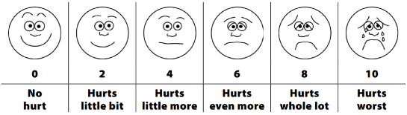

Pain assessment mnemonics

O P Q R S T
- Onset, provocation, quality, radiation, severity, time

D O L O R
- Description, onset, location, other, radiation

Paediatric assessment triangle
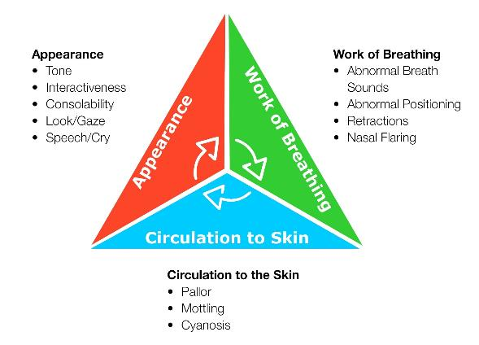
The paediatric assessment triangle provides a quick visual reference guide to assist NEPT crew members in determining if a paediatric patient is ‘unwell’. Where a paediatric patient is considered ‘unwell’, care must be escalated.
Figure 1. Paediatric assessment triangle
Parent or caregiver concern should also serve as a strong prompt for clinical escalation, even in the absence of other identifiable markers of a child being unwell. NEPT crew members must take the concerns of parents seriously, discuss concerns with a parent and ensure that the parent or caregiver feels able and comfortable to speak up if they are concerned about their child.

Acceptable paediatric VSS
Table 7 summarises acceptable VSS for children in care. The table should be referred to when assessing a paediatric patient as a checklist item with no expectation this is to be memorised. Where paediatric patients have VSS outside of these numbers and/or are unwell when scaled against the paediatric assessment triangle, care must be escalated.
Table 7. Acceptable paediatric VSS by age
Age | Approximate weight (kg) | Systolic BP (mmHg) | Heart rate  (BPM) | RR  (breaths per minute)
Term | 3.5 | 60-95 | 120-185 | 25-60
3 months | 6 | 60-105 | 115-180 | 25-60
6 months | 8 | 75-105 | 110-180 | 20-55
1 year | 10 | 70-105 | 105-180 | 20-45
2 years | 12 | 70-105 | 95-175 | 20-40
4 years | 15 | 75-110 | 80-150 | 17-30
6 years | 20 | 80-115 | 75-140 | 16-30
8 years | 25 | 80-115 | 70-130 | 16-30
10 years | 30 | 85-120 | 60-130 | 15-25
12 years | 40 | 90-120 | 65-120 | 15-25
14 years | 50 | 90-125 | 60-115 | 14-25
16 years | 60 | 90-130 | 60-115 | 14-25

Signs of paediatric respiratory distress
Paediatric patients should be assessed using Table 7. However, paediatric patients may be unwell in a more subtle way or with respiratory rates which are unable to be reliably measured by visual means alone. The following should be assessed when determining paediatric respiratory distress:
- Tachypnoea (fast breathing rate)
- Chest wall retraction
- Use of accessory muscles
- Tracheal tugging
- Abdominal protrusion.

Paediatric definitions and weight guide
The paediatric definition and weight guide Table 8 assists NEPT crew members to determine which management options to follow for conditions where clinical practice varies between age groups and provides an indication for weight-based doses of medicines.
Paediatric patients aged ≥12 years of age should be managed using the applicable adult CPP.
Table 8. Paediatric age/weight definitions
Age group | Age definition | Weight guide
Newborn | Birth to 24 hours | 3.5 kg
Small infant | < 3 months | 6 kg
Large infant | 3-12 months | 8-10 kg
Small child | 1-4 years | Weight (kg) = [Age] x 2 + 8
Medium child | 5-11 years | Weight (kg) = [Age] x 3.3

Glasgow coma scale (adult)
The GCS is used to objectively describe the extent of impaired consciousness in all types of acute medical and trauma patients. Any change in the patient’s GCS score should be noted, and care should be escalated as appropriate. GCS should be expressed as a sum of the following scores with a lower number representing a patient with a lower level of consciousness.
Best eye response (4)
- No eye opening - 1
- Eye opening to pain - 2
- Eye opening to sound - 3
- Eyes open spontaneously - 4
Best verbal response (5)
- No verbal response - 1
- Incomprehensible sounds - 2
- Inappropriate words - 3
- Confused - 4
- Orientated - 5
Best motor response (6)
- No motor response - 1
- Abnormal extension to pain - 2
- Abnormal flexion to pain - 3
- Withdrawal from pain - 4
- Localising pain - 5
- Obeys commands - 6

Glasgow coma scale (paediatric)
The following paediatric GCS should be used to assess children ≤4 years of age. Children > 4 years of age will be assessed against the adult GCS.
Best eye response (4)
- No eye opening - 1
- Eye opening to pain - 2
- Eye opening to sound - 3
- Eyes open spontaneously - 4
Best verbal response (5)
- No verbal response - 1
- Moans to pain - 2
- Persistently irritable - 3
- Cries but consolable - 4
- Appropriate words/social smile - 5
Best motor response (6)
- No motor response - 1
- Abnormal extension to pain - 2
- Abnormal flexion to pain - 3
- Withdrawal from pain - 4
- Localising pain - 5
- Obeys commands - 6

AVPU scale
AVPU is a straightforward scale used to rapidly assess a patient’s neurological and physiological status by assessing the patient’s level of consciousness, responsiveness and mental status.
- Alert: The patient is aware of the examiner and can respond to the environment around them independently. The patient can also follow commands, open their eyes spontaneously, and track objects
- Verbally Responsive: The patient's eyes do not open spontaneously. The patient's eyes open only in response to a verbal stimulus directed toward them. The patient can react to that verbal stimulus directly and in a meaningful way
- Painfully Responsive: The patient's eyes do not open spontaneously. The patient will only respond to the application of painful stimuli by an examiner. The patient may move, moan, or cry out directly in response to the painful stimuli
- Unresponsive: The patient does not respond spontaneously. The patient does not respond to verbal or painful stimuli.

Time critical guidelines
The Victorian time critical guidelines are designed to prompt expeditious transport to the highest level of trauma service accessible within 60 minutes. NEPT crew members should use the guidelines to determine whether a patient is trauma time critical. Where a patient is trauma time critical, the use of NEPT as a routine transport option is not endorsed.
NEPT resources may be used to transport trauma time critical patients at the request of a registered nurse, registered paramedic or medical practitioner working in the AV communications centre to avoid the possibility of a patient suffering an adverse event or dying. Where this occurs, NEPT crew members must receive a destination hospital at the time such an authorisation or request is provided.

Actual time critical
Vital signs indicating time criticality following potential major trauma
- HR < 60 or > 120
- RR < 10 or > 30
- Systolic BP < 90mmHg
- SpO₂ < 90%
- If ≥ 16 years - GCS <13
- If ≤15 years - GCS <15
- Patient > 65 years old who suffered a fall < 1 m in the metropolitan region with an isolated reduction in GCS

Potential time critical
Specific injuries that may meet potential major trauma criteria if found in combination with high-risk criteria.

Blunt injuries
- Serious injury to a single body region such that specialised care or intervention may be required or such that life, limb or long-term quality of life may be at risk
- Significant injuries involving more than one body region.

Specific injuries
- Limb amputation or limb threatening injury
- Suspected spinal cord injury or spinal fracture
- Burns > 20% total body surface area (TBSA) (> 10% if ≤ 15 years old or suspected respiratory tract burns)
- High voltage (>1000 volts) burn injury
- Serious crush injury
- Major compound fracture or open dislocation
- Fracture to 2 or more femur/tibia/humerus
- Fractured pelvis.
Assess the above and if present in combination with the following high-risk criteria, manage as major trauma.

Mechanism of injury
- Motor/cyclist impact > 30kph
- High speed MCA
- Pedestrian impact
- Ejection from vehicle
- Prolonged extrication
- Fall from height > 3m
- Struck on head by object falling > 3m
- Explosion.

Co-morbidities
- Age < 12 or > 55, OR
- Pregnant, OR
- Significant underlying medical condition.

Sedation assessment tool (SAT) score
Occasions may arise where NEPT services are engaged to transport an agitated patient or a patient suffering from an acute mental health episode. The SAT score should be used as a guide to determine whether transport is able to be facilitated by NEPT services. See Appendix 4: Mental Health patients for further information.
Undifferentiated agitation (that is, not linked to a known mental health condition or past history of behaviour) is unlikely to be NEPT suitable and should prompt concern as this may be due to physiological distress, and care should be escalated.
NEPT crew members should conduct a risk assessment prior to transport and escalate concerns if there is a reasonable belief that transport cannot be safely undertaken. The administration of sedation is not authorised for NEPT, however NEPT may transport patients who have received sedation.
Table 9. Sedation assessment tool
Score | Responsiveness | Speech
+3 | Combative, violent out of control | Continual loud outbursts
+2 | Very anxious and agitated | Loud outbursts
+1 (medium-high acuity cut-off) | Anxious or restless | Normal or talkative
0 (low-acuity cut-off) | Awake, and calm or cooperative | Speaks normally
-1 (medium-high acuity cut-off) | Asleep, but rouses if name is called | Slurring or prominent slowing
-2 | Responds to physical stimulation | Few recognisable words
-3 | No response to stimulation | Nil

Mental status assessment (MSA)
Look for, listen to and ask about all categories listed in Table 10. The patient may be suffering from some of the following.
Remember verbal de-escalation strategies, active listening and calm/open body language.
Table 10. Mental status assessment tool
Observe | Listen | Discuss
Safety  NEPT crew member, patient and bystander “safety first” is the priority. Assess the scene for dangers, that is, location or weapon. Obtain police support early if required. Maintain vigilant reassessment of scene safety. | Speech  Take note of rate, volume, quantity, tone, content, excessive talking, difficulty engaging, tangential, flat, inflections et cetera. | Thought content  May be dominated by delusions, obsessions, preoccupations, phobias, suicidal/depressed or homicidal thoughts, compulsions or superstitions.
Appearance  Look for signs indicative of mental health issues or poor self-caring; uncleanliness, dishevelled, malnourished, signs of addiction (injection marks or nicotine stains), posture, pupil size or odour. | Thought process  May be altered, can be perceived by patient jumping irrationally between thoughts, sounding vague, unsteady through-flow when communicating verbally. | Self-harm  Ask patient directly if they have attempted self-harm, suicide or are thinking about or planning these. Ask about previous attempts.
Behaviour  Patient may display odd mannerisms, impaired gait, avoidance or overuse of eye contact, threatening or violent behaviour, unusual motor activity or activity level (that is, wired or buzzing), bizarre or inappropriate responses to stimuli, or pacing. | Cognition  May be exhibiting signs of impairment such as poor ability to organise thoughts, short attention span, poor memory, disorientation, impaired judgement or lack of insight. | Perceptions  Patient may be suffering from hallucinations (ask specifically about auditory, visual and command hallucinations), disassociation, that is, ‘I feel detached from my body’, ‘my surroundings aren’t real’ or ‘I am not in control of my actions’.
Affect  Observed to be flat, depressed, agitated, excited, hostile, argumentative, violent, irritable, morose, reactive, unbalanced, bizarre, withdrawn, et cetera. |  | Environment  Risk factors include lack of familial and social support, addiction or substance abuse, low socio-economic status, life experiences, recent stressors, sleeping problems or comorbidities (either physical or mental health conditions).

CPP001: Clinical approach to assessment – unplanned medical presentation
Generally, unplanned events will present following calls to the emergency phone line (Triple Zero ‘000’), State health emergency management plan (SHEMP – replaced SHERP) activations, or incidentally when conducting other NEPT duties.
This approach, outlined in Figure 2 should also be applied by NEPT crew members when conducting an IFT and the patient presents with an unexpected deterioration or with a different complaint or condition than the IFT was originally requested for.
Where NEPT crew members suspect a significant underlying condition or are concerned with patient presentation regardless of patient VSS, refer to CPP006 Clinical escalation. NEPT crew members should be suspicious of signs and symptoms that cannot be explained.
Figure 2. Clinical approach to assessment - unplanned medical presentation
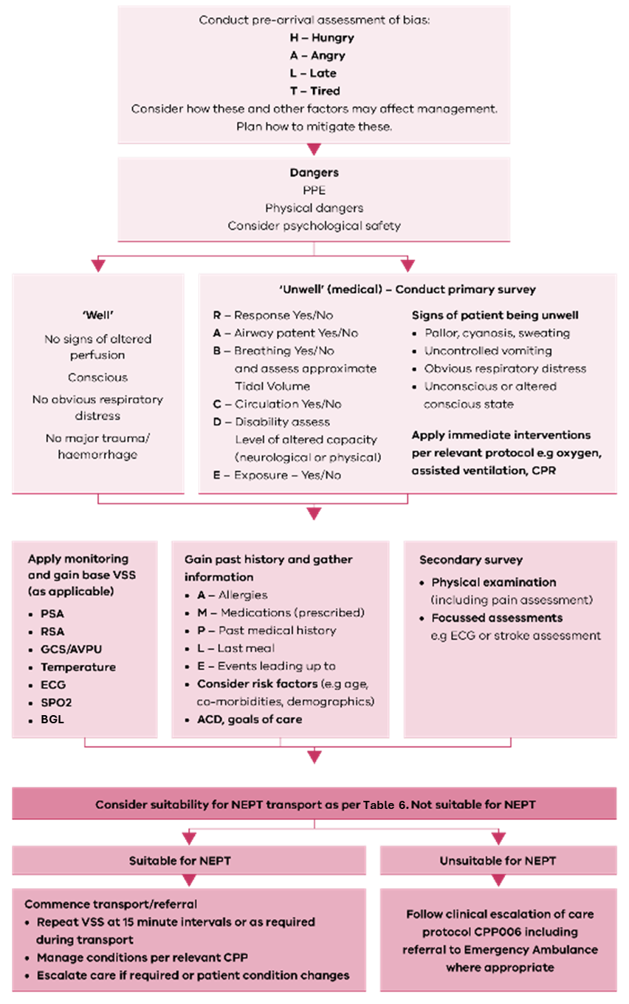

CPP002: Clinical approach to assessment – unplanned major trauma presentation
Trauma presentations should be assessed in the first instance with these considerations before moving on to injury specific assessment and management. The priorities listed in Figure 3 are the priorities in managing immediate life threat in major trauma and are a departure from traditional order of ‘ABC’.
Figure 3. Clinical approach to assessment - unplanned major trauma presentation
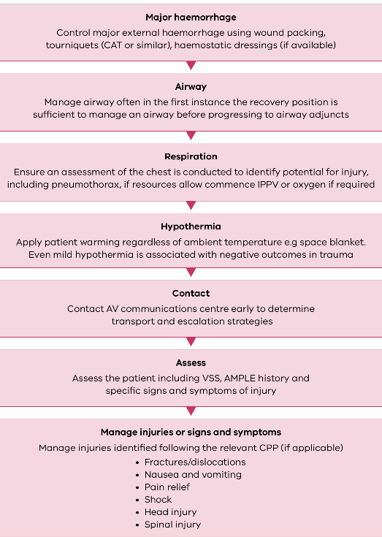

CPP003: Clinical approach to inter-facility transport (IFT)
IFT is defined as the transport of patients between healthcare facilities. IFT is a crucial part of today's healthcare system that allows facilities to transfer patients needing specialised assessment or care that cannot be adequately provided at their current health facility.
Prior to conducting an IFT, NEPT crew members should ascertain the exact clinical condition of the patient and determine the potential for deterioration before commencing transport. Refer to Table 6 ‘not suitable for NEPT’, to determine patient eligibility for transport.
During an IFT, NEPT crew members are required to reassess the patient appropriately and clearly document any changes in the patient’s condition or any interventions that have been undertaken.
At a minimum, a set of VSS must be obtained within 30 minutes prior to transfer from a sending facility. Additional sets of VSS should be recorded as required and with respect to patient acuity. Patients receiving active management should receive 15-minutely VSS or more frequently as dictated by patient condition.
Minimum observations include:
- GCS or AVPU
- RSA
- PSA
- Oxygen saturation (SpO₂)
- Pain assessment (where appropriate)
- BGL (where appropriate)
- Temperature (where appropriate).
The following checklist may be completed as a memory aid by NEPT crew members prior to transport commencing.
Table 11. Checklist for completion prior to transport
Item | Yes | No | N/A
Handover provided and transfer paperwork provided
- Confirm receiving facility
Is the patient time critical or likely to become time critical during the episode of care
If yes, not suitable for NEPT
Has the patient, within the two hours immediately before the proposed transport:
- been assessed by the registered health practitioner treating the patient as having likely experienced, or as experiencing, cardiac-related chest pain; or
- if no such assessment has occurred, had cardiac-related chest pain?
If yes, not suitable for NEPT
Has the patient been assessed by a registered paramedic, RN or registered medical practitioner as being haemodynamically stable for the duration of the episode of care?
- If no, not suitable for NEPT
Gain details of authorising health practitioner.
Advanced care directive (ACD) provided (where an ACD exists)
Plan for clinical management/deterioration agreed on and ongoing management identified, including:
- Frequency of VSS stipulated
- Clinical trajectory
- Infusion doses established
- Medication and other care required as needed (PRN) during transfer established
- Pressure injury assessment or prevention plan
Does patient acuity at time of dispatch match patient acuity at time of transfer?
If no, and patient acuity not within scope of NEPT crew, not suitable for NEPT.
Is the patient ready for transfer?
- Toileted
- Hydrated
- Fed
- Analgesia provided (if applicable)
- Sedation provided (if applicable)
Confirm 3 points of patient identification, for example:
- Medical ID bracelet
- Health care record
- Patient stating name and identifying features
Is all equipment required for transport present, for example (as applicable):
- Cardiac monitoring
- Non-invasive BP (NIBP)
- SpO₂
- BGL
- End Tidal CO₂ (ETCO₂₎
- Infusion pump(s)
- Arterial line established
- Indwelling catheter (IDC) in situ
Have all medications required for transport been prepared and supplied?
Have all medications or prescriptions required for ongoing care been provided and included as part of handover documentation?
Have all patient belongings been accounted for and are they able to be transported?
Is the patient aware of the reasons for transfer and do they consent to the transfer (where appropriate)?

Table 12. Post transport checklist
Item | Yes | No | N/A
Has verbal handover been provided to receiving facility?
Has a patient care record (PCR) been completed?
Has a PCR been provided to the receiving facility (medium-high acuity only)?
Have patient belongings, medication and clinical notes been transferred to the receiving facility?

CPP004: Cardiac arrest – adult

Signs of life
Any patient who is unconscious and not breathing normally (for example, gasping, agonal breathing) should be presumed to be in cardiac arrest. Palpation of a pulse is unreliable, if any doubt exists as to the presence of a pulse, chest compressions must be commenced.

High-quality CPR principles
- Rate: 100-120 compressions per minute
- Depth: ≥ 5 cm, allow for full recoil
- Ventilation duration: 1 second per ventilation (aiming to see rise and fall of the chest)
- Two-minute rotations of compressor
- Minimise interruptions to chest compressions (including while pad placement occurs)
- Optimal defibrillation pad positioning
- Resume compressions immediately after defibrillation or disarm/no shock delivered.

Compression ratio:

No SGA (OPA/NPA/BVM)
- 30 compressions : 2 ventilations
- Pause for ventilations.

SGA or ETT in situ
- 15 compressions : 1 ventilation
- 6-8 ventilations per minute
- No pause for ventilations.

Defibrillation pad placement
Optimal defibrillation pad positioning ensures transmyocardial current density is maximised when defibrillation occurs.
- Apex pad is positioned on the left, at the mid axillary line, 6th intercostal space
- Sternal pad rolled on laterally from right sternal margin on the patient’s right chest, under the right clavicle and above the right nipple.

General notes
- For the purposes of the protocols, an AED is regarded as being the same as a semi-automatic external defibrillator (SAED)
- High-quality ECC and defibrillation are the cornerstone of resuscitation – this must be prioritised over all other interventions
- If CPR is commenced, CPP006 escalation of care is required as early as practicable.

Hypothermic cardiac arrest < 30°C
- The primary goal is to prevent further heat loss prior to return of spontaneous circulation (ROSC) or transport - significant improvement in temperature from prehospital intervention is unlikely
- Double the interval for Adrenaline and Amiodarone dose.

Traumatic cardiac arrest
Where trauma is the suspected cause of cardiac arrest, prioritise control of major haemorrhage over all other interventions. Follow management in CPP002 Clinical approach to assessment - unplanned major trauma presentation.

Withholding or ceasing resuscitation
Refer to Appendix 2: Withholding or ceasing resuscitation.
Figure 4. Cardiac arrest algorithm
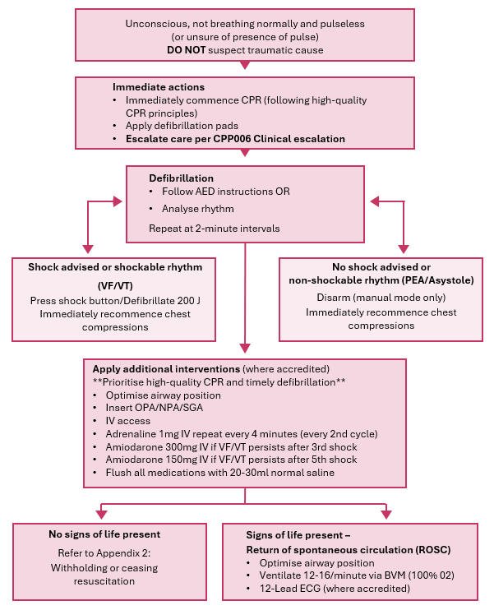

CPP005: Cardiac arrest – paediatric
This guideline applies to patients <12 years of age. See also: CPP004 Cardiac arrest: adult for patients ≥ 12 years.
Effective airway control and adequate ventilation with oxygen supplementation is the cornerstone of paediatric resuscitation.

Signs of life
Patients < 12 years of age who are unresponsive, not breathing normally and pulseless; or HR < 60 bpm (infants); or HR < 40 bpm (children) are presumed to be in cardiac arrest.

High-quality CPR principles
- 1/3 chest depth, allow for full recoil
- Ventilation duration: 1 second per ventilation (aiming to see rise and fall of the chest)
- Two-minute rotations of compressor
- Minimise interruptions to chest compressions (including while pad placement occurs)
- Optimal defibrillation pad positioning
- Resume compressions immediately after defibrillation or disarm/no shock delivered.

Compression ratio, rate and technique
Table 13. Paediatric CPR compression ratio and rates
Age | CPR ratio | Compression rate | Technique
Newborn (birth up to 24 hours) | 3 compressions : 1 ventilation | 90 compressions per minute with 0.5 second pause for ventilation | 2 finger or 2 thumbs  One third of the depth of chest
Infants  (1 day up to 1 year) | 30 compressions : 2 ventilations (one rescuer)  15 compressions : 2 ventilations (two rescuers) | 100-120 compressions per minute | 2 finger or 2 thumbs  One third of the depth of chest
Small and medium child (1 to 11 years) | 30 compressions : 2 ventilations (one rescuer)  15 compressions : 2 ventilations (two rescuers) | 100-120 compressions per minute | One hand or 2 hands  One third of the depth of chest

Defibrillation pad placement
Optimal defibrillation pad positioning ensures transmyocardial current density is maximised when defibrillation occurs.
- Defibrillation pad placement should be as close as possible to adult placement
- The ‘anterior’ pad is placed on the left side, mid-axillary line (same as adult placement)
- The ‘posterior’ pad is placed on the right upper chest/clavicle (same as adult placement)
- Wrapping over the shoulder is permissible to ensure sufficient gap between the pads. Avoid the neck.

General notes
- Cardiac arrest in children and infants is commonly caused by hypoxia. This guideline prioritises airway and ventilatory support
- Respiratory arrest followed by bradycardic cardiac arrest may be corrected with ventilation prior to commencing chest compressions
- Small children, infants and newborns may need a small amount of padding beneath the shoulders to keep the occiput from causing too much flexion of the head and compressing the neck. Be cautious with head and neck extension in children < 8 years
- For the purposes of the CPPs, an AED is regarded as being the same as an SAED.
- An AED can be used in children if the appropriate settings and attachments are available. If not accredited in manual defibrillation and an AED without paediatric settings/attachments is the only option, it should be applied and utilized until further assistance arrives. If defibrillation is required, delivering a higher shock energy than the standard is less harmful than failing to defibrillate
- If accredited in manual defibrillation, 4 joules per kg should be delivered rounded up to the nearest setting.

Hypothermic cardiac arrest < 30°C
The primary goal is to prevent further heat loss prior to ROSC or transport – significant improvement in temperature from prehospital intervention is unlikely.
Figure 5. Cardiac arrest algorithm - paediatric
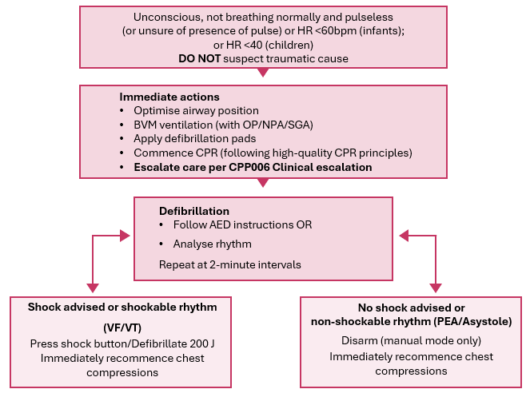

CPP006: Clinical escalation
While the Regulations stipulate that NEPT providers are to not routinely transport haemodynamically unstable patients and the CPPs present VSS which would indicate the transport is not suitable for NEPT, situations may arise where this occurs.
Presented below are some options NEPT crew members may consider to escalate care if the patient presentation no longer falls within their scope to manage.
- Escalate to AV care via provider communications or through Triple Zero ‘000’
- If conducting IFT from a medical facility or hospital and NEPT crew members still at facility, consider what management options available at sending facility and escalate care using normal means within facility, for example, ‘MET call’
- If unable to contact AV or other relevant communications centre in the case of significant event, emergency or disaster that is likely to overwhelm communications systems (for example, thunderstorm asthma or bushfire emergencies), NEPT providers and crew members may commence transport to the closest emergency department (ED) or other source of higher-level clinical care or support.
Once this is completed, consider the following actions:
- Change type of VSS gained, for example, consider manual BP vs automatic BP
- Change crew members if clinical grade is different or tasks overwhelm initial crew member
- Refer to CPPs to pre-empt management options
- Apply extra equipment where required or in anticipation of deterioration – for example, defibrillator pads or preparing resuscitation equipment
- Contact for consultation with provider clinician OR AV clinician
- Contact for consultation sending or receiving facility for management advice OR if still at sending facility assist with continued management of patient to optimise prior to transport
- Consult with poisons information line in case of suspected toxicology presentation by calling
13 11 26
- Pre-empting and communicating specialist resources that may be required following contact to AV – for example, MICA, AAV, Manual Handling assistance, Mobile Stroke Unit (MSU)
- Fax or picture messaging of ECG to appropriate consult for diagnostic cross-checking
- Consult with specialist service (ARV or PIPER) for IFT. If contacting ARV or PIPER, state clearly that calling from a NEPT service
  - ARV: 1300 368 661
  - PIPER: 1300 137 650
- Consider upgrade to ‘Code 1 driving’ to reach transport destination or other appropriate health service.
NEPT providers are required to establish a clinical oversight committee to review instances where clinical escalation is required. NEPT crew members should submit instances of clinical escalation to the NEPT provider for consideration as part of the committee to determine root cause and whether variation to practice needs to be considered. Clinical escalation implies no fault on the part of a NEPT crew member and is a cornerstone of patient safety.

CPP007: Oxygen therapy
Oxygen therapy should be directed toward correcting hypoxaemia and not resolving a feeling of breathlessness. Patients should not be routinely administered oxygen in the presence of normal SpO₂, except in the case of critical illnesses including:
- cardiac arrest
- major trauma/head injury
- undifferentiated (or septic) shock
- anaphylaxis
- seizures
- Diabetic ketoacidosis (DKA) and hyperosmolar hyperglycaemic state (HHS) .
For critical illnesses, High flow 100% oxygen should be administered regardless of SpO₂ via non-rebreather mask (NRB).
Oxygen targets are as follows:
- Most patients should receive a target SpO₂ of 94-98%
- Chronically hypoxaemic patients (including COPD, cystic fibrosis, neuromuscular disorders, bronchiectasis, severe obesity) should receive oxygen titrated to achieve an SpO₂ of 88-92%. Care must be taken to avoid the over-administration of oxygen in this patient cohort
- Chronically hypoxaemic patients who also present with a critical illness should have oxygen applied until haemodynamically stable.
Where SpO₂ is unavailable or unreliable and a patient appears short of breath, initial oxygen delivered by nasal cannula or face mask at 6-8L is appropriate until a reliable SpO₂ level can be acquired. Situations where SpO₂ may be unreliable include:
- peripheral vascular disease
- suspected carbon monoxide (CO) poisoning – the SpO₂ measurement will not differentiate between carboxyhaemoglobin and oxyhaemoglobin and will present an artificially high reading. Where CO poisoning is suspected high flow oxygen should be applied
- severely shocked patients with poor peripheral perfusion
- cold extremities.
As a general rule, when managing a hypoxic patient, a low SpO₂ reading dictates selecting an oxygen delivery system with a higher fraction of inspired Oxygen (FiO₂). The suggest flow rate and FiO₂ of oxygen delivery systems are detailed in Table 14.
Table 14. FiO₂ and oxygen delivery system guide
Mask | FiO₂ | Flow rate
Nasal cannulae | > 21-35 % | 1-6 L/min
Simple face mask (Hudson mask) | 40-60% | 6-8 L/min
NRB | > 60% | 10-15 L/min
BVM | 100% (with good seal) | 15 L/min or enough to inflate reservoir bag
Neb | 40-50% | 8 L/min
Figure 6. Oxygen administration guidance
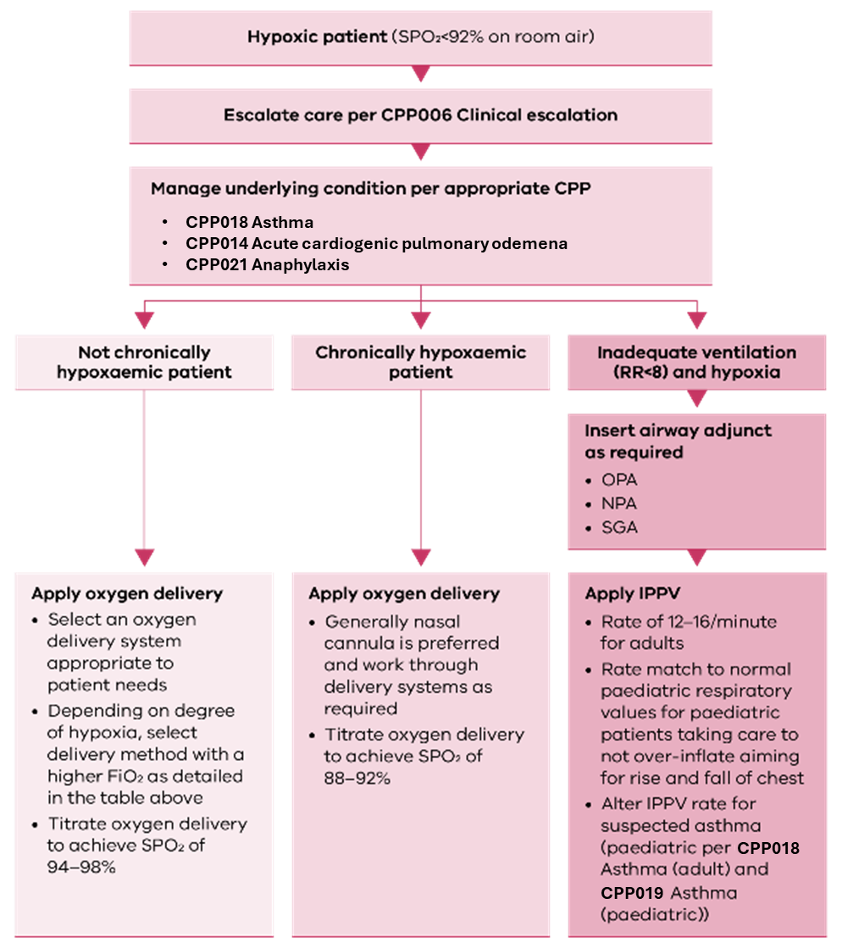

CPP008: Narrow complex tachycardia (NCT)
Typically, tachyarrhythmias will present to high acuity services undertaking cardiac-related IFT, however, may present as an incidental finding. Where there is an agreed management plan or medical order, in the case of a tachyarrhythmia this takes precedence over the management options presented below.
NCT present when a pacemaker site above the ventricles is firing abnormally. NCT ECG strips will have differences depending on the rhythm but share the characteristic of having a QRS complex < 0.12s and a rate > 100. NCT are generally divided into the following types which may be identifiable by NEPT crew members.
- Sinus tachycardia (STach)
- (Rapid) atrial fibrillation (R-AF)
- Paroxysmal supraventricular tachycardia (PSVT/SVT)
- Atrial flutter (AFlutter)
- Atrial tachycardia
- Junctional tachycardia.
NEPT crew members should be suspicious of unexplained sinus tachycardias as this may be a sign of physiological distress.
Some common medicines that may be provided by sending health services to high acuity NEPT provider include:
- Adenosine
- Calcium channel blockers (for example, diltiazem or verapamil)
- Beta blockers (for example, metoprolol or sotolol)
- Anti-arrhythmic medicines (for example, amiodarone or flecainide).
Synchronised cardioversion is not to be authorised for routine use by NEPT crew members.
Figure 7. Management of NCT
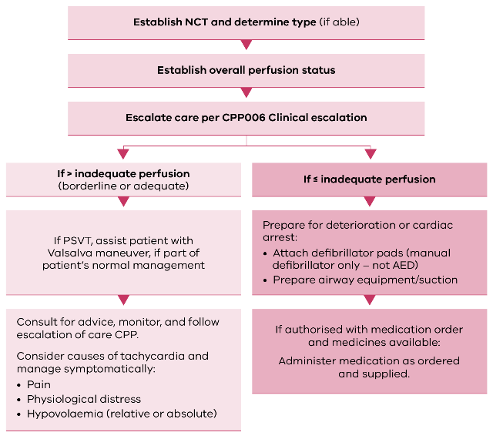

CPP009: Wide complex tachycardia (WCT)
NEPT providers are not authorised to routinely commence transfer of a patient with a current WCT at time of transfer from a facility, however situations may arise where a WCT presents during the episode of care.
WCT is defined as:
- Lasting > 30 seconds
- Rate > 100
- QRS > 0.12 seconds
- Regular
- Atrioventricular (AV) dissociation or absence of P waves.
WCT may present for a number of reasons, including:
- cardiomyopathy
- acidosis
- coronary artery disease
- drug toxicity
- hyperkalaemia.
In the out-of-hospital environment without access to further diagnostic facilities a WCT should always be presumed to be a ventricular tachycardia (VT) and managed with anti-arrhythmics unless specifically planned for (for example, transfer of a patient with known hyperkalaemia).
All WCT should be managed with a high degree of caution and with the assumption of deterioration regardless of perfusion status at time of presentation.
The majority of NEPT services will not require the management options contained within this protocol. Management of WCT will be an infrequent occurrence and therefore clinical consult as part of escalation is strongly recommended.
Figure 8. Management of WCT
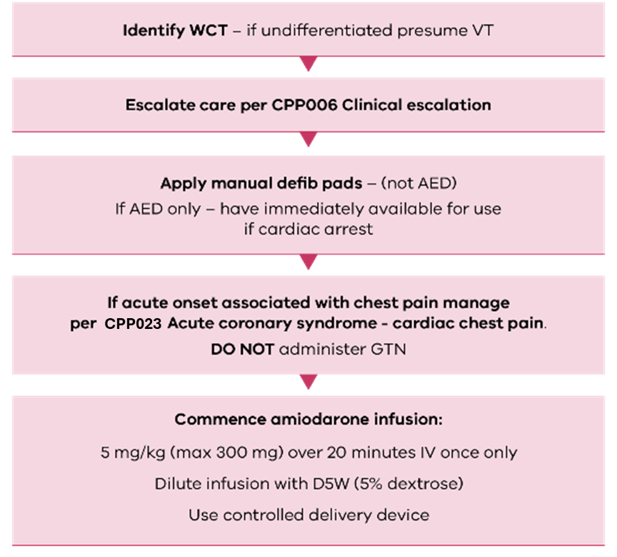

CPP010: Bradycardia
Bradycardia may be defined as a heart rate < 60 bpm however many people may have a heart rate between 50-60 bpm in their day-to-day lives.
Escalation of care and decision to transport should be guided by the ‘not suitable for NEPT’ criteria. The management indicated in this protocol relates to an unplanned presentation of symptomatic bradycardia during transport. Unstable symptomatic bradycardia requiring intervention is defined as the following:
- Less than adequate perfusion (for example hypotension or altered mentation)
- HR < 20 regardless of overall perfusion status
- Persistent ventricular escape rhythms or runs of VT in between bradycardia.
Note that atropine may not be effective in the case of a complete or 2nd degree type II heart block, however, should still be administered.
Occasionally high acuity NEPT may be required to transport patients who are undergoing investigation for bradycardia who have active management. Common medication infusions which may be encountered include:
- Isoprenaline
- Dopamine
- Adrenaline (epinephrine).
External transcutaneous pacing is not routinely authorised for use by NEPT crew members.
The majority of NEPT services will not require the management options contained within this protocol. Management of symptomatic bradycardia will be an infrequent occurrence and therefore clinical consult as part of escalation is strongly recommended.

Figure 9. Management of bradycardia
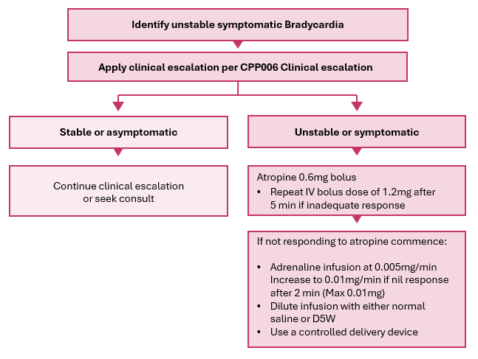

CPP011: Sepsis recognition and escalation
Sepsis is a condition which spans a clinical continuum with a complex series of interactions of inflammatory responses and microvascular injury which ultimately may lead to a state of septic shock and is one of the leading causes of preventable death worldwide.
NEPT services are often the transport means for vulnerable members of the community with the potential for any infective process to progress into sepsis. The following are some risk factors for infection progressing to sepsis:
- Elderly patients
- Compromised immune system including patients undergoing chemotherapy treatment
- Chronic kidney or liver disease
- Admission to hospital for a significant length
- Recent antibiotic administrations
- Invasive devices, for example an in-dwelling catheter (IDC).
For this reason, an NEPT specific sepsis recognition and escalation pathway has been developed (Figure 10) to assist NEPT crew members to identify and escalate care. While management options may be limited in NEPT services, early identification and escalation of care is aimed at preventing severe complications of sepsis.
Criteria have been developed based on a modified systemic inflammatory response syndrome (SIRS) criteria and a modified sepsis related organ failure (qSOFA) criteria with the recognition that blood analysis, in particular blood lactate and white cell count (WCC), is not feasible in the NEPT environment.
Figure 10. Sepsis recognition and management
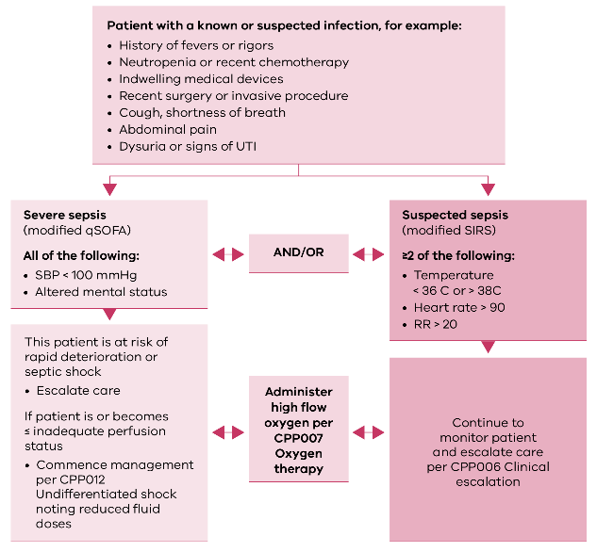

CPP012: Undifferentiated shock
NEPT crew members may encounter patients who are in a state of shock as an incidental finding during the course of unplanned NEPT activities, such as when responding to cases generated by Triple Zero ‘000’ or SHEMP activations or as an acute deterioration during IFT.
Shock can be defined as a state of cellular and tissue hypoxia due to either reduced oxygen delivery, increased oxygen consumption, inadequate oxygen utilization or a combination of these processes.
It is important to consider a patient’s overall perfusion status when determining shock. The most visible marker of shock is profound hypotension and for this reason may be the decision point to initiate intervention. Overall perfusion status should be established using the PSA in Table 4.
Shock is divided into different types based on the cause. Table 14 lists the types of shock and common examples:
Table 14. Shock types
Shock type | Example cause(s)
Obstructive shock  (unlikely during NEPT service delivery) | - Tension pneumothorax  - Haemothorax  - Cardiac tamponade
Cardiogenic shock | - Acute myocardial Infarction  - Tachyarrhythmias  - Bradyarrhythmias
Distributive shock | - Sepsis  - Anaphylaxis  - Neurogenic shock
Hypovolaemic shock  (unlikely during NEPT service delivery) | - Lack of blood volume (haemorrhage)  - Lack of systemic volume  (vomiting, diarrhoea, burns)
NEPT crew members should consider management of specific conditions relevant, which may
lead to a shocked state, and manage these as per the applicable CPP, for example:
- Anaphylaxis should prioritise management with adrenaline (epinephrine) according to
CPP021 Anaphylaxis
- Bradycardia should prioritise management to increase heart rate according to CPP010 Bradycardia
- Tachyarrthymias should prioritise a decrease in heart rate according to CPP008 Narrow complex tachycardia or CPP009 Wide complex tachycardia
- Cardiogenic shock associated with acute coronary syndrome (ACS) should be managed according to CPP013 Cardiogenic shock.
NEPT high acuity services may transport patients who have a condition that would lead to a shocked state provided that these patients are not expected to deteriorate enroute and are stable at time of transfer. Prior to departure from the sending facility a plan for deterioration needs to be agreed on with a medication order and infusion schedule prepared.

Some common vasopressors:
- Noradrenaline (norepinephrine)
- Adrenaline (epinephrine)
- Metaraminol
- Vasopressin
- Dopamine
- Phenylephrine
- Dobutamine.
Management options presented in Figure 11 represent management of an undifferentiated acute shock state and/or following initial unsuccessful management of a presumed cause for which no other management option is presented.
The majority of NEPT services will not require the management options contained within this protocol. Management of undifferentiated shock will be an infrequent occurrence and therefore clinical consult as part of escalation is strongly recommended.

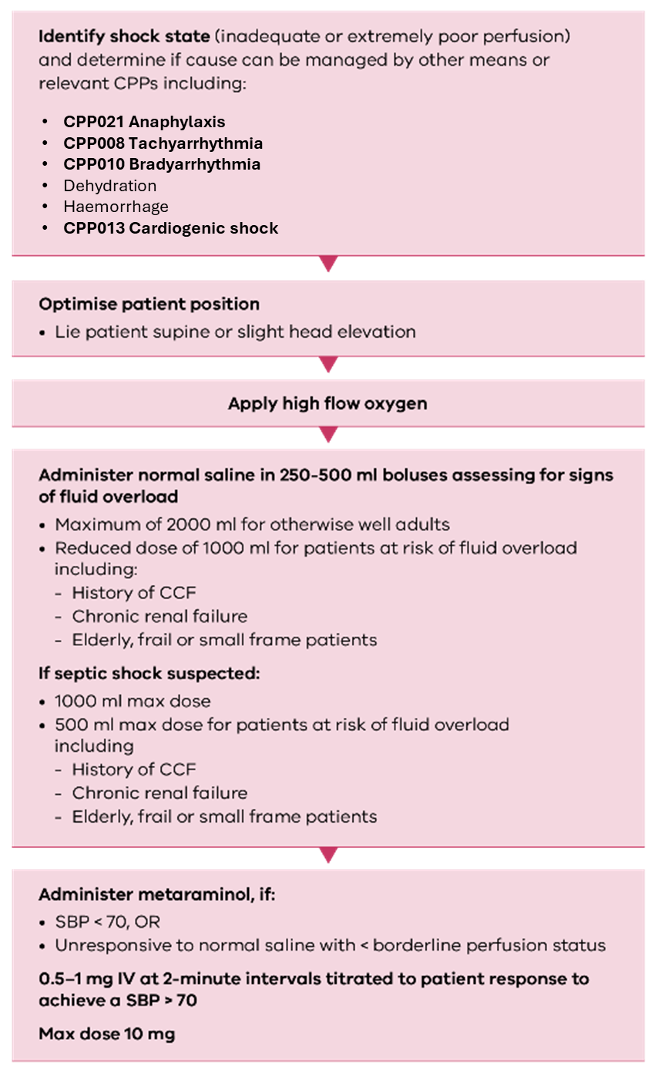
Figure 11. Management of undifferentiated shock

CPP013: Cardiogenic shock
Cardiogenic shock can be defined as a shock state (SBP <90 mmHg) from a primary cardiac disorder. For purposes of intervention, this CPP refers to a patient with ≤ inadequate perfusion as defined in Table 4. The most common causes of cardiogenic shock likely to be recognised by NEPT crew members and encountered during NEPT service delivery, and that this CPP applies to, include:
- acute myocardial infarction (AMI)
- pulmonary embolus
- right ventricular failure
- overdose of cardiotoxic trugs, medication overdoses (beta/calcium channel blockers).
The Regulations state that a NEPT provider must not transport a patient if, within the two hours immediately before the proposed transport, the registered health practitioner treating the patient has assessed the patient as having likely experienced, or as experiencing, cardiac-related chest pain, or, if no such assessment has occurred, the patient has cardiac-related chest pain. Other causes of shock should be managed per CPP012 Undifferentiated shock. For tachy/brady-arrhythmias this should be managed per the relevant CPP.
Care should be applied by high acuity services when managing with adrenaline (epinephrine) as the effects will increase myocardial workload and consequently metabolic demand. The majority of NEPT services will not require the management options contained within this protocol. Management of cardiogenic shock will be an infrequent occurrence and is therefore clinical consult as part of escalation is strongly recommended.
Figure 12. Management of cardiogenic shock
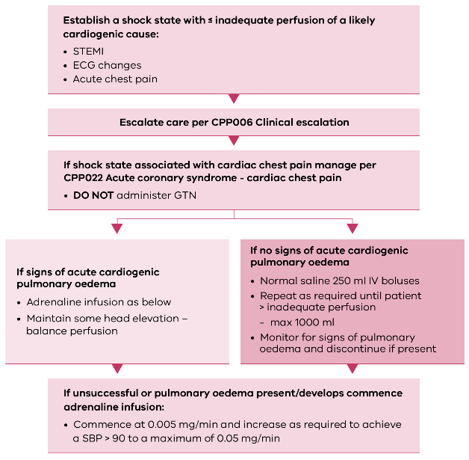

CPP014: Acute cardiogenic pulmonary oedema (ACPO)
Acute pulmonary oedema can be defined as an accumulation of excessive fluid in the alveolar walls and alveolar spaces of the lung. This manifests in the following ways.
- Compromised respiratory status
- Hypoxia
- Orthopnoea (increasing shortness of breath or feeling of drowning whilst supine).
Pulmonary oedema can be classified as cardiogenic (resulting from an issue with the heart) or non-cardiogenic. Non-cardiogenic pulmonary oedema usually results from direct injury to the lung parenchyma (tissue) or vasculature or as a result of volume (fluid) overload and is not covered by this CPP. If non-cardiogenic pulmonary oedema is encountered and recognised, management should be targeted to correct hypoxia as described in CPP007 Oxygen therapy.
ACPO is likely to be seen during NEPT service delivery as an incidental finding whilst conducting unplanned (non-IFT) service delivery or during the transport of patients with chronic issues such as:
- coronary artery disease with left ventricular failure
- congestive heart failure
- cardiomyopathy
- valvular heart diseases
- cardiac dysrhythmias
- right to left shunts.
Clinical indicators that may assist a provisional diagnosis of ACPO include:
- excessive shortness of breath on exertion
- excessive sweating or diaphoresis
- blood-tinged or pink sputum in severe presentations
- chest pain – if associated with an acute cardiac event
- significant hypertension – and if present, is an indication of severe left ventricular systolic dysfunction and patient may require management per CPP013 Cardiogenic shock
- dependent oedema
- ‘crackles’ heard on chest auscultation.
NEPT crew members may transport patients with chronic pulmonary oedema provided there is no acute deterioration present or forecast, no recent change in patient condition and the patient’s physiological status would not otherwise make the patient ineligible for NEPT transport.
The use of non-invasive ventilation (CPAP/Bi-Level) is not authorised for routine use by NEPT services but may be considered by high acuity services if an escort is provided or the attending NEPT crew member is endorsed and a clinical plan is developed with the sending facility prior to transport. In this unusual circumstance the patient should be stable on the NIV prior to transfer. The use of NIV must not occur during air transport.
The management of ACPO in NEPT service delivery is targeted at reducing blood pressure and improving hypoxia and is detailed in Figure 13.

Figure 13. Management of acute cardiogenic pulmonary oedema
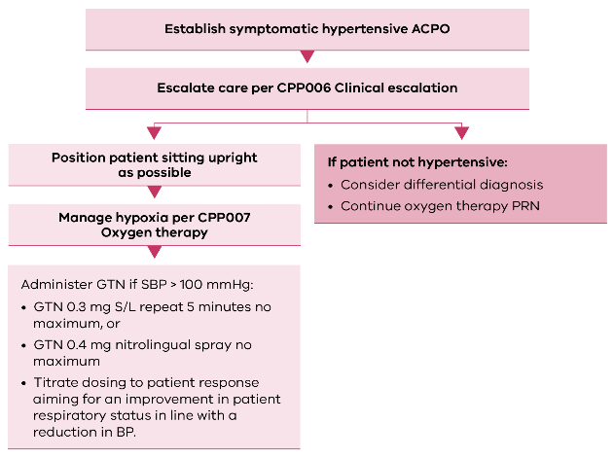

CPP015: Stroke
Acute stroke is the second leading cause of death worldwide and the leading cause of disability. There are two main types of stroke – ischaemic and haemorrhagic. Both types of stroke are time-critical and very difficult to differentiate in the out-of-hospital environment without access to medical imaging services. The key objective is identification of stroke symptoms and rapid transfer.
For the purposes of this CPP, stroke is defined as a set of neurological signs and symptoms that together would indicate a stroke even if symptoms are improving or have improved.

Melbourne ambulance stroke screen (MASS)
In the setting of a normal BGL, an abnormal finding in one or more of the following, in Table 15, is MASS positive for suspicion of stroke.
Table 15. Stroke symptoms
 | Instruction | Normal finding | Abnormal finding
Facial droop | Patient to show teeth or smile | Both sides of the face move | One side of the face does not move as well as the other
Speech | Patient to repeat ‘you can’t teach an old dog new tricks’ | Patient says the correct words with no slurring | Patient slurs words, says incorrect words or is unable to speak or understand
Hand grip | Patient to squeeze your fingers | Equal grip strength | Unilateral weakness

Alternatively, any concerning acute-onset unexpected symptom(s) which cannot be explained should be escalated. Such symptoms include:
- prolonged gaze toward one side of the body
- favouring one side of the body and/or uneven gait
- disinhibition of speech (that is, inappropriate words)
- impaired judgement
- spontaneous urinary incontinence
- vertigo not normal presentation
- ataxia (clumsy involuntary movements)
- visual field disturbances
- altered conscious state or acute onset confusion.
Presumed time of stroke should be from when patient was last seen well. Stroke treatment timeframes are longer than previously thought.
- Thrombolysis up to 12-hours post-stroke
- Endovascular Clot Retrieval (ECR) up to 24 hours post-stroke.
All patients who present to NEPT services that are MASS positive or display concerning neurological signs and symptoms must have care escalated.
NEPT services may be directed to transport stroke patients if it is outside the window for management or the patient is unlikely to receive further management, for example, if the patient relies on others for all activities of daily living.
The use of NEPT to transport confirmed stroke patients for ECR from a facility that has initiated thrombolysis is not routinely endorsed. If this occurs on direction of the AV communications centre, NEPT crew members are to ensure that management priorities and escalation points are discussed prior to departure from the sending facility.

CPP016: Headache
Headaches may present during NEPT service delivery and be characterised in a number of ways. It is not possible or realistic to classify different headache types during NEPT service delivery and as such the goal should be identification of symptoms of concern which may indicate a serious cause for the headache, escalation of care where these symptoms are identified and analgesia to provide relief from symptoms.
NEPT services are not authorised to routinely transport patients experiencing an undiagnosed headache which is not typical for the patient.
In addition to standard assessment, symptoms of concern include:
- Sudden onset
- Significant pain at time of initial presentation
- Visual disturbances
- Significant hypertension
- Other abnormal neurological signs or symptoms
- Unilateral headache
- Nausea and vomiting
If these symptoms present NEPT services should escalate care as per CPP006 Clinical escalation.
Management of pain should be as per CPP029 Pain relief with a preference to commence management with oral paracetamol.

CPP017: Seizures
Seizures are a sign of abnormal brain activity and involve a complex relationship of neurotransmitters. It is important to be aware that not every seizure presents the same. Seizures can be classified in the following ways, which NEPT crew members may recognise:
- Generalised
- Tonic-clonic (generalised convulsive seizure) - involves rhythmic muscle jerking with a loss of consciousness
- Absent seizures – patient presents with a vacant look and is unresponsive, generally self-limiting
- Myoclonic – results in a sudden jerking of a part of the body
- Atonic – involves a sudden loss of muscular control,
- Partial
- Simple focal – a seizure that involves one part of the brain, leaving the person with awareness but unable to respond
- Complex focal – seizure activity in one part of the brain, where the person is not aware, may lose focus, appear dazed or confused
Seizures may present due to a number of causes, such as:
- stroke
- infective process including encephalitis or meningitis
- brain tumour
- drugs and medications
- epilepsy
- head injury
- febrile seizures (paediatric)
- pregnancy (eclampsia).
For NEPT services the recognition of any type of seizure activity or concerning neurological sign(s) or symptom(s) should lead to prompt clinical escalation and supportive care. NEPT crew members should note the time of seizure activity commencing and its duration. It is important to recognise that ongoing seizure activity may have pronounced effects on BP, airway tone and oxygenation.
NEPT crew members should not attempt to control or physically restrain somebody experiencing a seizure or attempt to place anything in the patient’s mouth. Suction is rarely required and should only be used if the airway is occluded, when applied it is to be short duration (<5 seconds in any one attempt) and confined to the oropharynx.
Figure 14. Management of seizures
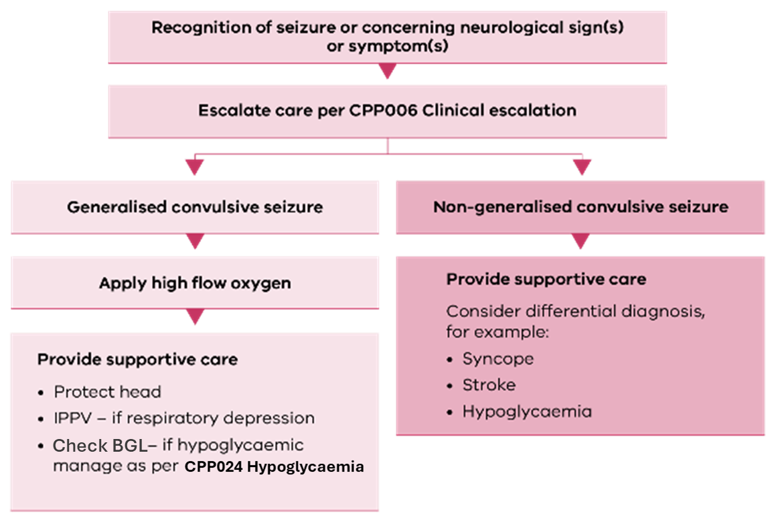

CPP018: Asthma – adult
Bronchospasm is defined as a spasm of bronchial smooth muscle leading to narrowing of the bronchi and consequently a reduction in air moving in (reduced oxygen intake) and out of the lungs (reduced removal of carbon dioxide).
Bronchospasm is managed in different ways depending on the underlying condition. Management is targeted towards the resolution of spasm and a reduction in inflammatory mediators which lead to bronchospasm.
Asthma causes the muscles in the airways to tighten and the lining of the airway to become swollen and inflamed, producing sticky mucous. These changes cause the airways to become narrow, making it difficult to breathe. Asthma may have a number of triggers including:
- allergy triggers such as house dust mites, pollens, pets and moulds
- cigarette smoke
- viral infections – for example, colds and flu
- cold air or changes in the weather
- work-related triggers – for example, wood dust, chemicals, metal salts
- some medication.
In Australia, asthma is usually a well-controlled condition, and most patients will be aware of an asthma exacerbation. Clinically, asthma may present with the following signs and symptoms signifying an exacerbation.
- Increased shortness of breath
- Wheezing on auscultation or audible without auscultation
- Tachycardia
- Sweating.
Where patients experience an acute exacerbation of their asthma, management is dictated by the patient’s respiratory status. Patients that respond to management of mild to moderate asthma with a complete resolution of symptoms may continue transport with a NEPT service provided no physiological parameter would otherwise make the patient ineligible for NEPT transport.
Where patients present with bronchospasm of a cause other than asthma (for example, smoke inhalation) or for which no other protocol exists (for example, COPD) they should be managed using interventions detailed in this protocol, except for the use of IM adrenaline.

Figure 15. Management of asthma
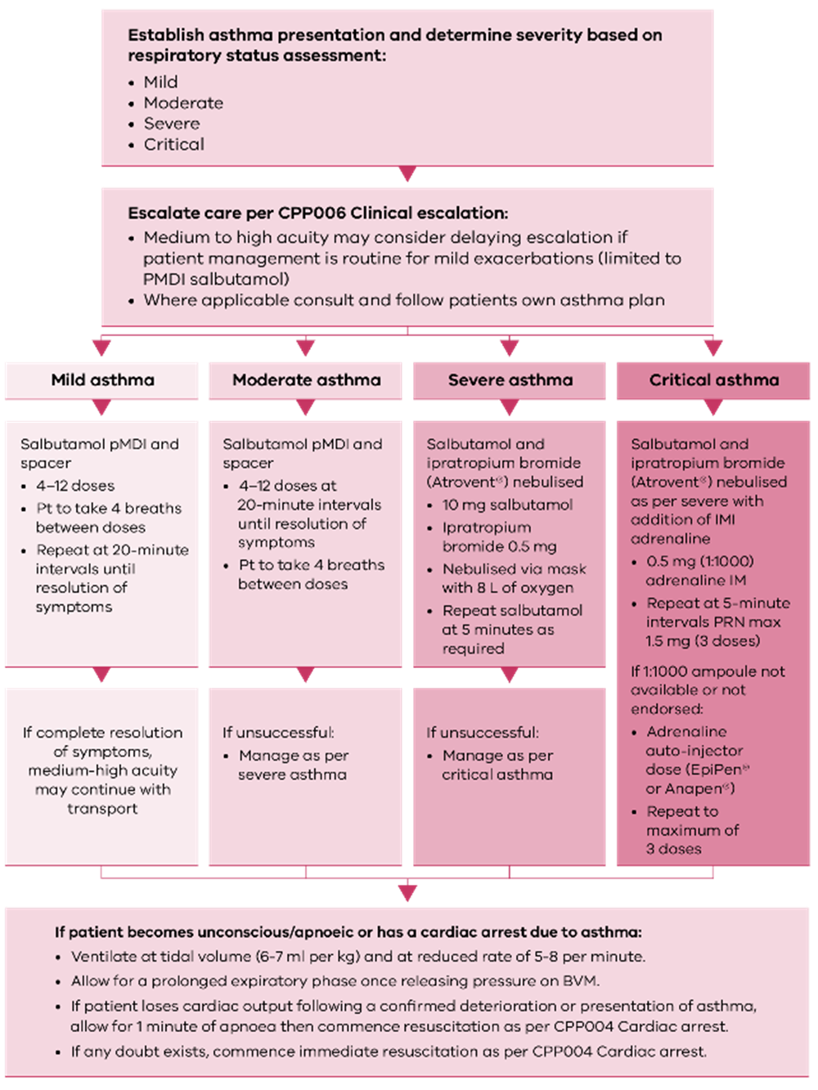

Thunderstorm asthma
Thunderstorm asthma poses a significant risk in Victoria during defined time periods, usually commencing in October and ending in December or early January annually.
The department releases high risk mapping and guidance for thunderstorm asthma <https://www.health.vic.gov.au/environmental-health/epidemic-thunderstorm-asthma-risk-forecast>.
NEPT providers may be activated as part of a SHEMP response to manage significant escalations relating to thunderstorm asthma and NEPT service providers should subscribe to alerts.
Where NEPT crew members suspect a thunderstorm asthma event or are entering a declared thunderstorm asthma event, consideration should be given to early IMI adrenaline delivery (either from a 1:1000 ampoule or from an auto-injector device). If there is a delay to normal means of clinical escalation including emergency ambulance services, NEPT crew members are authorised and encouraged to commence transport (instead of remaining on scene) to an appropriate ED if escalation through normal means is not possible.

CPP019: Asthma – paediatric
The general background and identification of asthma is similar to that of adult patients and management goals the same with the following considerations:
- Asthma exacerbations may be more dynamic with a lower threshold for clinical escalation required
- Nebulised therapy should be reserved for paediatric patients who present as severely unwell
- Early consideration should be given to IM adrenaline for severely unwell children
- Any exacerbation of paediatric asthma should involve an escalation of care.
Paediatric patients should be assessed using Table 16 (based on the paediatric assessment triangle) to determine severity prior to initiation of therapy.
Table 16. Paediatric asthma severity clinical features
 | Mild/moderate | Severe | Critical
Conscious state | Normal | Distressed | Altered
Work of breathing | Increased | Markedly increased | Maximal
Tachycardia | Tachycardia | Tachycardia | Marked tachycardia
Speech | Phrase/sentence | Words | Unable to speak
Table 17. Paediatric IM adrenaline doses
Age (years) | ≥ 2 | 3 | 4 | 5 | 6 | 7 | 8 | 9 | 10 | 11
Dose of 1:1000 adrenaline (IM) | 0.12 mg  (0.12 ml) | 0.14 mg  (0.14 ml) | 0.16 mg  (0.16 ml) | 0.18 mg  (0.18 ml) | 0.2 mg  (0.2 ml) | 0.22 mg  (0.22 ml) | 0.24 mg  (0.24 ml) | 0.26 mg  (0.26 ml) | 0.33 mg  (0.33 ml) | 0.36 mg  (0.36 ml)

Figure 16. Management of asthma - paediatric
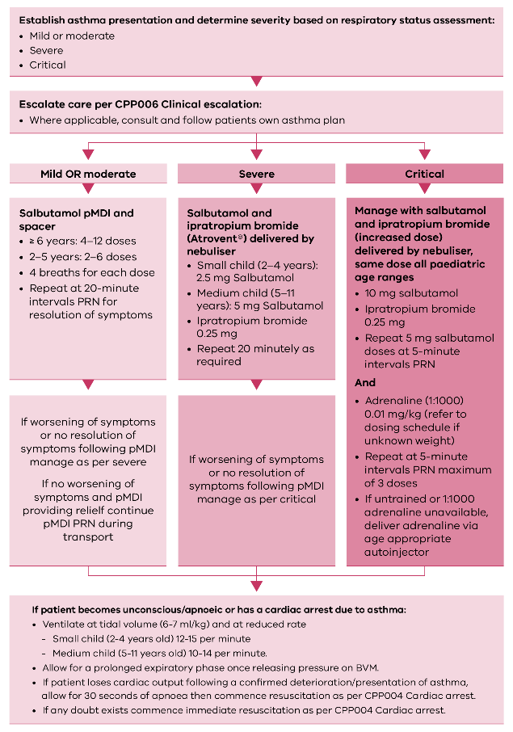

CPP020: Chronic obstructive pulmonary disease (COPD) exacerbation
COPD can be defined as an irreversible chronic inflammatory lung disease causing an obstructed airflow to and from the lungs which may present to NEPT services as a periodic exacerbation. Chronic bronchitis and emphysema are the two most common conditions contributing to COPD, and management of an exacerbation is targeted to relieve symptoms associated with this including bronchoconstriction and hypoxia.
It is important to avoid the over-administration of oxygen to patients suffering from an exacerbation of COPD and generally an SpO₂ target of 88% should be accepted.
COPD should be suspected in the patients over 40 years of age with:
- smoking history
- progressively worsening dyspnoea (difficulty breathing) that has become worse
- poor exercise tolerance
- chronic cough or sputum production.
An exacerbation of COPD should be considered and managed in patients who present with:
- increased dyspnoea (worse than base level)
- increasing cough and sputum production
- increased wheeze.
NEPT crew members must take care to not cause an exacerbation of COPD. Patients with COPD who are to be transported can have the risk of exacerbation reduced by:
- minimising exercise or effort during transfer
- slow, deliberate and careful planning of transfers
- use of wheelchair or stretcher to reduce effort.
Figure 17. Management of acute exacerbation of chronic obstructive pulmonary disease
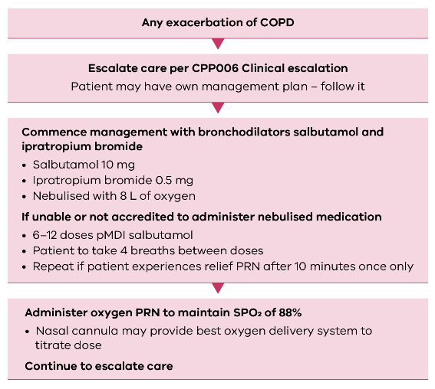

CPP021: Anaphylaxis – adult
Anaphylaxis may be defined as a severe, potentially life-threatening, systemic hypersensitivity reaction characterised by rapid onset of a life-threatening airway, breathing or circulatory problem(s) with usual (but not always) skin and mucosal changes. Anaphylaxis is becoming more prevalent within the Australian population and NEPT providers and crew members must be vigilant to ensure anaphylaxis is recognised and managed where it presents.
Some common triggers of anaphylaxis:
- Insect stings
- Food – commonly nuts, eggs, shellfish, fish, soy and wheat
- Medications – including parenteral, enteral and topical
- Physical exercise or cold
- Biological triggers – idiopathic (no known cause), latex and antivenoms

Recognition of anaphylaxis (RASH criteria)
Anaphylaxis can be suspected using the following criteria (‘RASH +’):
- Sudden onset of symptoms (usually < 30 min or up to 4 hours),
AND
- Two or more of RASH
  - R: Respiratory distress
  - A: Abdominal symptoms (vomiting, nausea, diarrhoea)
  - S: Skin or mucosal symptoms (rash, discolouration or mucous secretion)
  - H: Hypotension (SBP < 90)
OR
  - Isolated hypotension (SBP < 90mmHg) following exposure to a known antigen,
OR
  - Isolated respiratory distress following exposure to a known antigen.
Where doubt exists about the diagnosis of anaphylaxis in the absence of any definitive other differential diagnosis, manage as per anaphylaxis and escalate care early.
Anaphylaxis management is centred around early intervention with IM adrenaline. Other considerations should follow and not interrupt regular IM adrenaline doses.
Figure 18. Management of anaphylaxis - adult
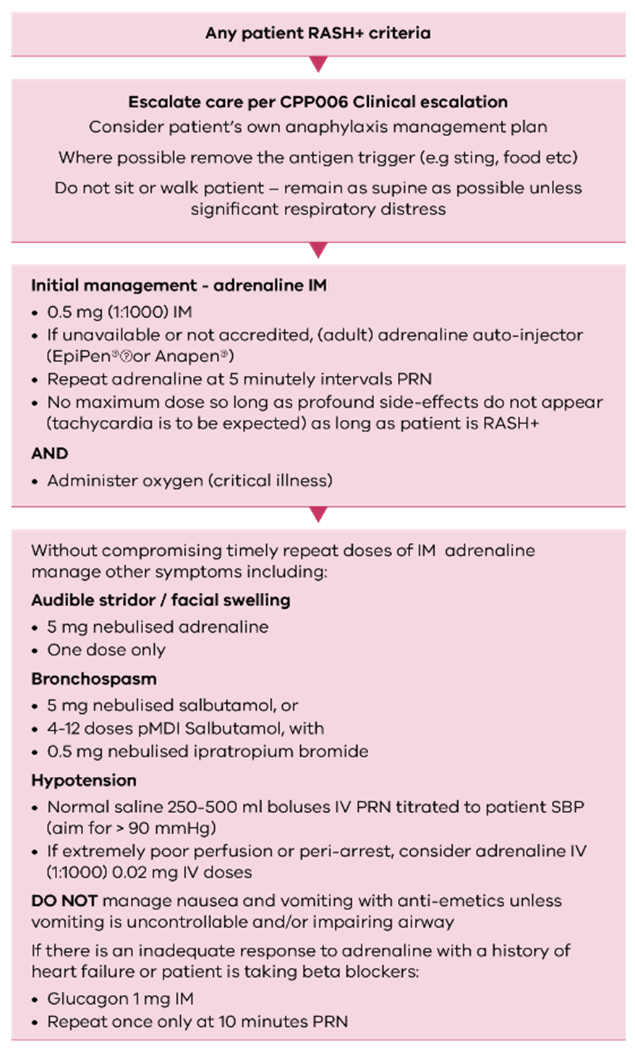

CPP022: Anaphylaxis – paediatric
The background information, recognition (RASH+ criteria) and management goals of anaphylaxis are broadly similar to the adult population. Below is a modified protocol for paediatric anaphylaxis:

Recognition of anaphylaxis (RASH criteria)
Anaphylaxis can be reasonably suspected using the following criteria (‘RASH +’):
- Sudden onset of symptoms (usually < 30 min or up to 4 hours)
AND
- Two or more of RASH. If two or more symptoms, consider differential diagnosis. If nothing obvious or easy to confirm, manage as anaphylaxis.
  - R: Respiratory distress
  - A: Abdominal symptoms (vomiting, nausea, diarrhoea)
  - S: Skin or mucosal symptoms (rash, discolouration or mucous secretion)
  - H: Hypotension (SBP < 90)
OR
  - Isolated hypotension (SBP < 90mmHg) following exposure to a known antigen
OR
  - Isolated respiratory distress following exposure to a known antigen.
Where doubt exists about the diagnosis of anaphylaxis in the absence of any definitive other differential diagnosis, manage as per anaphylaxis and escalate care early.
Anaphylaxis management is centred around early intervention with IM adrenaline. Other considerations should follow and not interrupt regular IM adrenaline doses.
Contact PIPER on 1300 137 650 for guidance for ongoing management. Clearly state position and that the call is coming from a NEPT service.

Figure 19. Management of anaphylaxis - paediatric
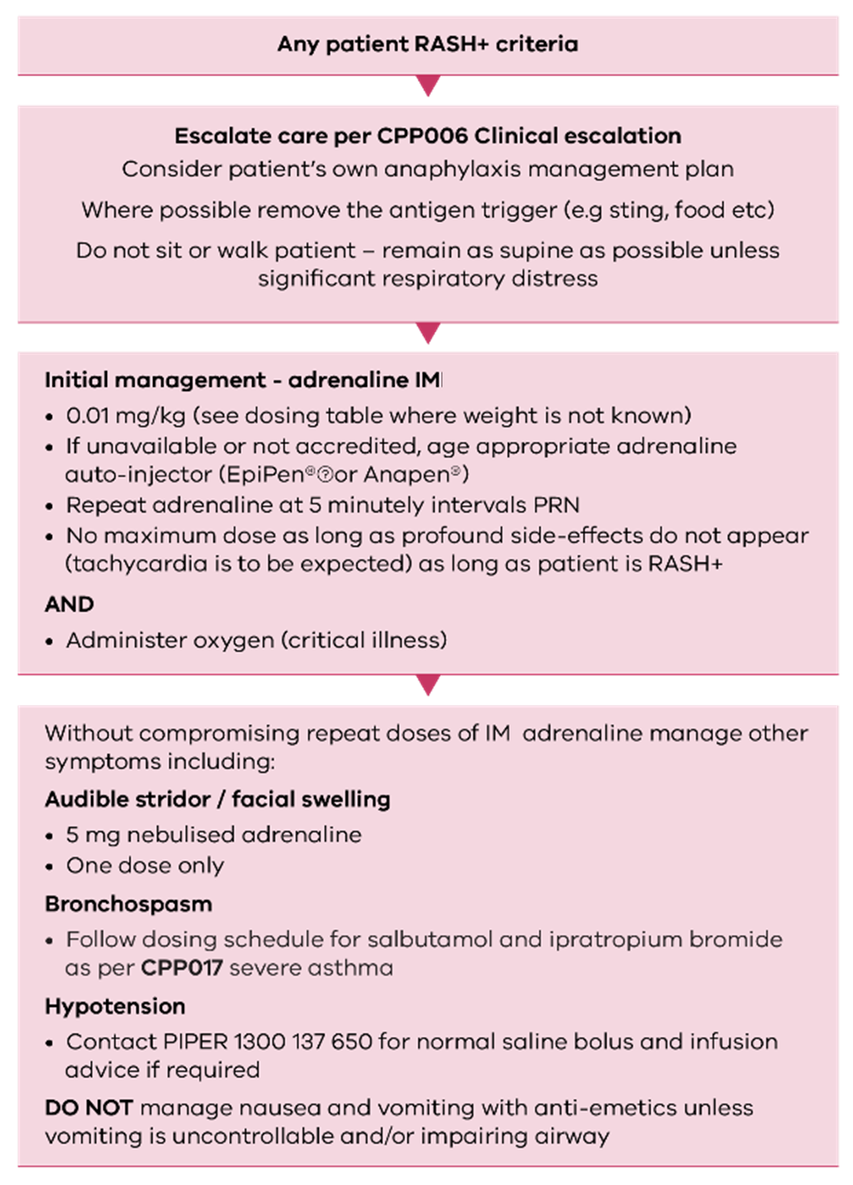

CPP023: Acute coronary syndrome (ACS) – cardiac chest pain
ACS can be defined as a group of diseases in which blood flow to the heart is decreased. Specifically, ACS that this protocol applies to include:
- ST-elevation myocardial Infarction (STEMI)
- non-ST elevation acute coronary syndrome (NSTEAC), including non-ST elevation myocardial infarction (NSTEMI) and unstable angina
- persistently increasing angina without definitive evidence of myonecrosis (heart muscle damage).
For the purposes of NEPT service delivery, the presence of suspicious acute central chest pain or epigastric pain which cannot be explained by other definitive diagnosis, should lead NEPT crew members to suspect ACS and manage accordingly.
Some other symptoms of concern include:
- nausea or vomiting
- diaphoresis
- ECG abnormalities
- pain radiating to jaw or back
- pain in chest or epigastric region that is described as aching, pressure, tightness or burning
- dyspnoea.
The goal of NEPT management of ACS is to reduce platelet aggregation through the administration of aspirin, rapid clinical escalation, a reduction in myocardial workload by reducing hypertension with GTN, and pain relief.
In the case of ACS, the complete removal of pain is unlikely. The goal of analgesia should be to provide a level of pain relief which the patient considers mild.
12-lead ECGs may be acquired by NEPT services where there is capacity and appropriate equipment. Where an ECG is abnormal, has changes of concern or suggestive of pathology, this must be communicated as part of clinical escalation.
Management of associated symptoms (for example, nausea and vomiting, pain relief, acute cardiogenic pulmonary oedema) should be conducted as per the appropriate CPP.

Figure 20. Management of acute coronary syndrome
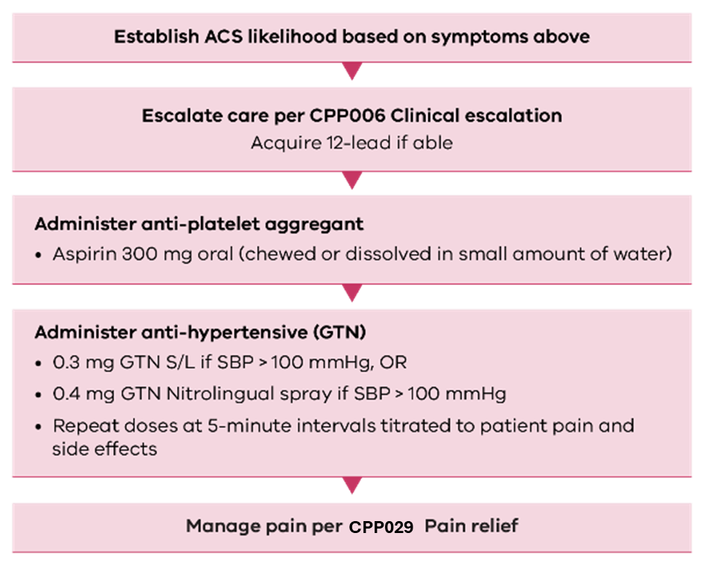

CPP024: Hypoglycaemia
Hypoglycaemia is defined as BGL concentration less than 4 mmol/L. Signs and symptoms of hypoglycaemia may not occur until levels lower than this and may include:
- altered level of consciousness (or unconscious)
- agitation
- dizziness
- increased appetite
- sweating.
Hypoglycaemia is usually found in patients who have diabetes and are undergoing management with insulin, meglitinides and sulfonylureas. Accidental overdoses of medication (usually relative to the amount of energy intake the person is consuming) are the most common cause of hypoglycaemic episodes. Hypoglycaemia may also be found in certain patient cohorts who are not diabetics including:
- alcoholic patients
- patient with critical illness or trauma
- patients suffering from counter-regulatory hormone deficiencies
- patients with some cancers.
Hypoglycaemia management is aimed toward correcting the low BGL and supportive care including airway security (if required).
It is important to note that glucagon may not be effective in patients who have low stores of glycogen, including:
- frail or elderly
- people on low carbohydrate diets
- alcoholic patients.
For patients who present with any of the symptoms of hypoglycaemia listed above but who have a BGL great than 4 mmol/L, it is important to consider other potential causes including:
- stroke
- seizure (absent seizure)
- shock-state
- tumour.
If a patient presents able to swallow and obeying commands, medium-high acuity services may attempt management with oral glucose prior to escalating care. If correction of symptoms and BGL occurs after one dose and physiological parameters do not preclude transport by NEPT, continue transport.

Figure 21. Management of hypoglycaemia
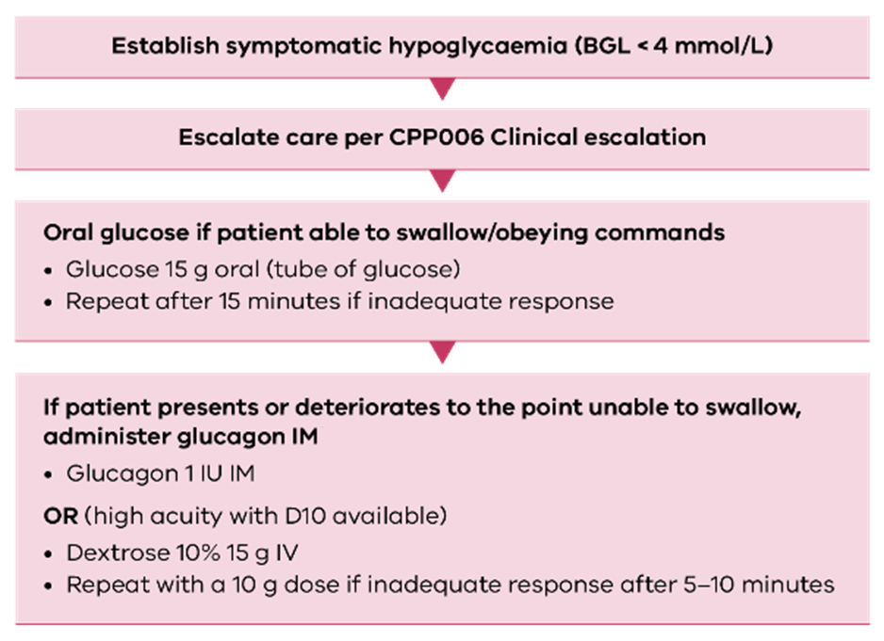

CPP025: Hyperglycaemia
Hyperglycaemia is defined as BGL concentration greater than 11 mmol/L.
DKA and HHS represent the extreme in the spectrum of hyperglycaemia. DKA and HHS are classified as medical emergencies and are a leading cause of mortality among diabetic patients.
DKA and HHS may occur in both type 1 and type 2 diabetes mellitus. DKA typically evolves within a few hours, whereas HHS has a slower onset of days to weeks.
Signs and symptoms of hyperglycaemic presentations include:
- altered level of consciousness (or unconscious)
- agitation
- dizziness
- seizure
- sweating
- polydipsia
- polyuria
- presence of ketones.
There is limited value in differentiating between hyperglycaemic crises during NEPT service delivery. Care for the hyperglycaemic patient, in the NEPT context, centres around general supportive care, clinical escalation and fluid replacement where indicated and within scope.
Figure 22. Management of hyperglycaemia
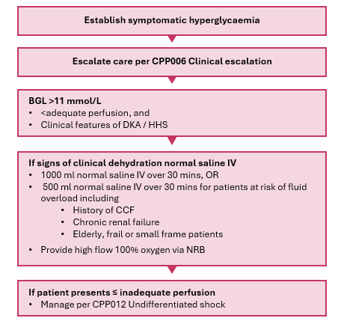

CPP026: Nausea and vomiting
Nausea and vomiting are caused by a complex series of interactions between different nervous system pathways with different causes including:
- vestibular nausea
- medications in particular chemotherapy
- allergies
- migraines and headaches
- ocular injury
- acute coronary syndrome.
It is important to note that severe, uncontrollable and undifferentiated nausea and vomiting may be a sign of critical illness and care should be escalated.
The aim of this CPP is to provide management with an anti-emetic (ondansetron) that has an effect on both the vomiting centres within the nervous system and in the gastro-intestinal system to reduce negative side effects of uncontrollable nausea and vomiting. Often simple nausea and single-episode vomiting that is able to be tolerated does not require the administration of an anti-emetic.
Figure 23. Management of nausea and vomiting
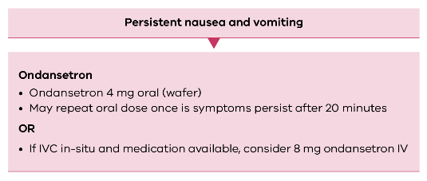

CPP027: Foreign body airway obstruction (FBAO)
FBAO is a life-threatening emergency that is more common in the paediatric population, but with a higher mortality rate for adults in the out-of-hospital environment. FBAOs may be partial or complete obstructions. FBAO may result in inadequate or complete air flow to or from the lungs leading to insufficient oxygen exchange at a cellular level.
Key indicators of a partial airway obstruction include:
- clutching at throat
- cough
- crying or verbal response
- stridor or wheeze
- adequate or altered perfusion status
- normal or altered CGS
- respiratory difficulty.
Key indicators of a complete airway obstruction include:
- clutching at throat
- ineffective or absent cough
- absence of crying or verbal response
- absence of stridor or wheeze
- inadequate perfusion status
- lack of consciousness
- absence of ventilation
- cyanosis.

Figure 24. Management of suspected FBAO

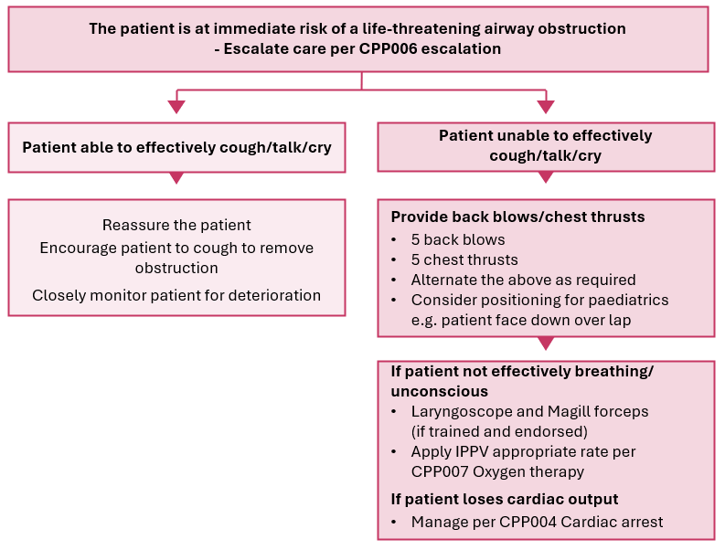

CPP028: Laryngectomy and tracheostomy care
This CPP is not for the purpose of creating a surgical airway. Its purpose is to give guidance in the event of airway emergencies associated with patients who have an existing tracheostomy or laryngectomy that NEPT services are likely to encounter. NEPT services are not authorised to transport patients where difficulty with an airway is forecast.
A tracheostomy is a surgical opening in the anterior neck and trachea to allow direct access into the trachea to facilitate ventilation for a variety of reasons. Tracheostomy patients can breathe through their stoma and through their mouth or nose to some extent. A tracheotomy tube with or without an inner tube may be present.
A laryngectomy is the surgical removal of the larynx and separation of the airway from the mouth, nose and oesophagus. Ventilation will be facilitated though a tracheotomy stoma. Importantly, patients with a laryngectomy cannot be ventilated or oxygenated via the mouth. A tube is usually not present. Other devices such as laryngeal buttons or speaking valves may be in situ.
- all NEPT acuity levels may transport a patient who lives daily with a surgical airway in situ provided no complications are forecast
- NEPT high acuity services may transport patients with a recent surgical airway insertion > 5 days prior to transport
- patients with a surgical airway which has been inserted within 5 days prior to transport must be transported with a suitably qualified medical practitioner escort.
Figure 25. Placement of different surgical airway types
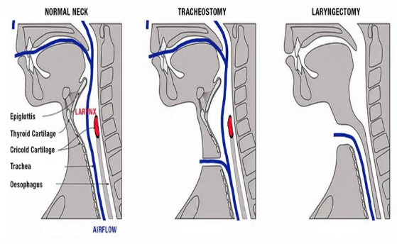

Figure 26. Management of surgical airway emergencies
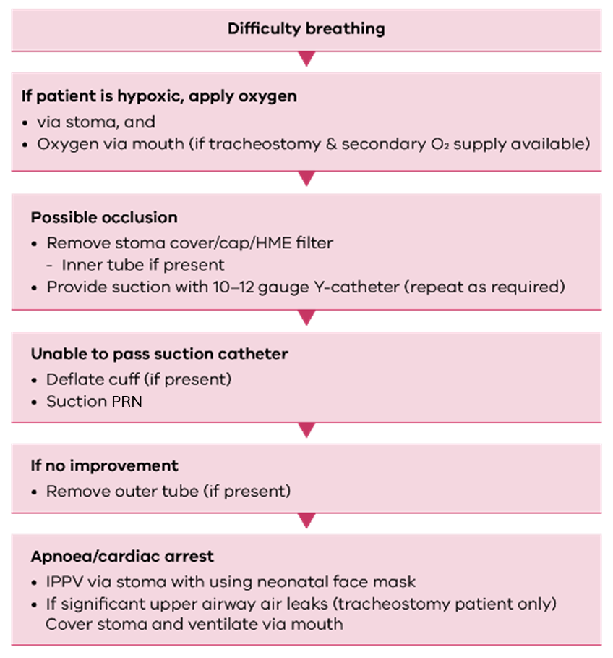

CPP029: Pain relief
The key areas of appropriate pain management include:
- pain assessment
- provision of appropriate analgesia based on pain assessment
- re-assessment and management of pain following analgesia.

Pain assessment
Assess pain using the most appropriate pain assessment tool(s) such as OPQRST/DOLOR, verbal rating scale, numeric rating scale and Wong-Baker FACES pain scale.
An inability to report or rate pain (for example, dementia, intellectual disability, neurodiversity, non-English speaking background) should not preclude analgesia. Where discomfort is evident in the setting of possible pain producing stimuli, analgesia may be indicated.

Non-pharmacological management
Basic care and non-pharmacological management of pain is fundamental and should be considered prior to pharmacological management. This includes:
- reassurance
- posture
- splinting
- cooling of burns
- occlusive dressings
- control of temperature
- ice packs
- warm pack.

Chronic pain
- Exclude a new aetiology
- Ensure pain management plan followed
- Partial relief may be a more realistic goal.

General notes
- For IFTs, ensure adequate analgesia has been given prior to commencing transport or request analgesia for transport
- Consider dose reductions or longer dose intervals in small, elderly and frail patients.
- Entonox® and Methoxyflurane must be self-administered. Maximise ventilation in the space it is administered.
- Dose commercial paracetamol syrup carefully as available in several strengths.
- Paracetamol is not an appropriate analgesic for suspected acute coronary syndrome.

Table 18. Analgesic medication doses – adult
Medication | Dose | Route | Repeat dose | Maximum dose
Paracetamol | 500 mg – 1 g | oral | 4-6/24 | 4000 mg daily
Methoxyflurane | 3 ml | inhaled | 3 ml | 6 ml daily
Entonox | Titrate to pain | inhaled | as required | NA
Table 19. Analgesic medication doses – paediatric
Medication | Dose | Route | Repeat dose | Maximum dose
Paracetamol (syrup) | > 1 month  15 mg/kg (max 1g) | oral | 4-6/24 | 4 g daily
Methoxyflurane | 3 ml | inhaled | 3 ml | 6 ml daily
Entonox | NA | NA | NA | NA
Figure 27. Pain management
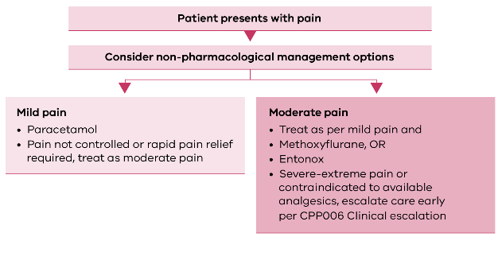

CPP030: Burns
This CPP refers to the management of acute burns. Where NEPT services are undertaking a transfer of a patient with pre-existing burns receiving management, these goals should be clearly articulated prior to transport with analgesia, wound management and fluid therapy (if any) in place prior to departure.
NEPT services are unlikely to encounter significant acute burn injuries during routine service-delivery, however, may encounter presentations in the event of an activation under SHEMP. NEPT services may attend and manage patients with minor (superficial, not large total body surface area) acute burns.
Burn management principles include the following:
- Undertake cooling for at least 20 minutes. (Cool the burn and warm the patient). Stop cooling the burn if the patient begins shivering or has a temperature < 35C. Consider cooling length that has occurred prior to management by NEPT
- Cooling should be undertaken with ambient temperature water from a tap. Do not apply ice, iced water or dirty water (water not suitable for drinking)
- If running water is not available, the affected limb or body part may be immersed in water using a spray bottle or applying moist towels
- Chemical burns should be irrigated and cooled if pain persists. Take care to avoid washing chemicals into eyes or other sensitive areas and to avoid spreading chemicals further on the patient, bystanders or NEPT crew member. This may require very large volumes of water
- Remove burnt clothing, clothing containing chemicals or hot liquid when safe to do so. Do not attempt to remove clothing that is adhered to underlying tissue
- Minimise heat loss by applying blankets or thermal blankets and continuing to monitor patient temperature
- After receiving cooling therapy, apply cling-wrap longitudinally to the affected area to provide a barrier for infection. Applying cling-wrap longitudinally allows for swelling of the affected area.
NEPT crew members should apply particular caution if attending a patient who has been involved in an explosive or flash fire event where there is potential for airway burns. Signs of airway burns include the following:
- Evidence of burns to upper torso, neck, face
- Facial and upper airway oedema (swelling)
- Sooty sputum
- Burns that occurred in an enclosed space
- Singed facial hair
- Respiratory distress (including audible stridor)
- Hypoxia.
The following burns must have care escalated and require assessment and transport by emergency ambulance:
- All significant burns (partial or full thickness)
- Superficial burns involving more than a localised area of the body
- Burns that meet major trauma criteria
- Burns in sensitive areas (genitals, hands, feet, face).

Classification of burns:
- Superficial – involves the epidermal (outer) layer of the skin
- Reddened tender skin
- Painful to touch
- Skin is intact
- Includes sunburn, hot water scalds

- Partial thickness – can be classified further but involves all of the inner layers of the skin
- Divided into superficial partial thickness, and deep partial thickness
- Blistering and skin loss
- Sensation present
- Painful
- Will bleed to pinprick

- Full thickness – involves a burn that destroys both layers of skin and may penetrate more deeply into underlying structures.
- Dry
- White or blackened skin
- Absent sensation
- No bleeding to pinprick

Figure 28. Management of burns
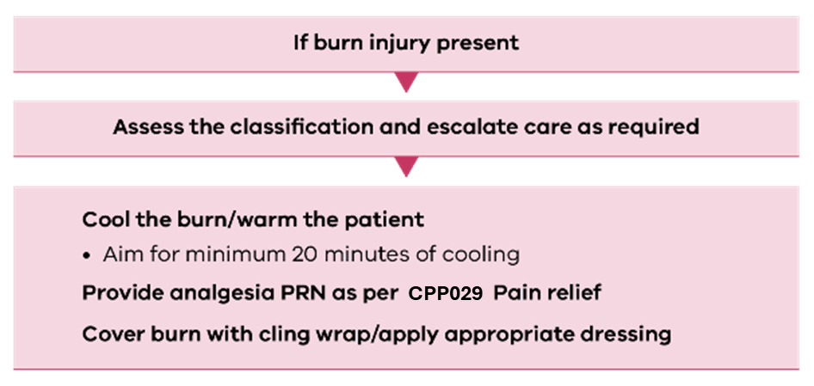

CPP031: Fractures or dislocations
The principles of sound fracture and dislocation management in NEPT service delivery revolve around the following points:
- Irrigate and dress open wounds
- Assess distal neurovascular observations:
  - Pulse and capillary refill
  - Colour
  - Warmth
  - Movement
  - Sensation
- Pad natural hollows (for example, between thighs), deformities and bony prominences to maintain natural alignment
- Secure above and below injury sites with correct splint type, for example,
  - Traction splint for femoral and upper 2/3 lower leg fracture
  - Anatomical splint for neck of femur (NOF) fractures
- Constant reassessment of neurovascular observations
- Adequate analgesia as per CPP029 Pain relief.
Altered sensation, loss of a pulse or cold/dusky skin in a limb distal to a fracture or dislocation are indicators of neurological or vascular compromise, constitutes a limb threatening injury and is considered time critical.
Where NEPT services attend patients with simple closed fractures, transport is authorised provided the NEPT service can appropriately splint and adequately control pain.

CPP032: Traumatic head injury
Traumatic head injury in this CPP refers to an injury as a result of physical trauma causing actual or potential damage to the brain and can result from a blunt or penetrating injury mechanism.
Any patient with a GCS reduction of 2 or more than normal GCS should be considered time critical and care escalated.
Patients with a GCS of 13-15 with any of the following factors should be considered as time critical and care must be escalated regardless of NEPT acuity level:
- Any loss of consciousness exceeding 5 minutes
- Skull fracture (depressed, open or base of skull)
- Vomiting more than once
- Neurological deficit
- Seizure at any time associated with head injury
- Any other concerning neurological symptom following a fall.
In addition to this:
- Any patient that presents with a GCS < 15 following a blunt head injury mechanism should be escalated for advice prior to NEPT commencing transport. NEPT low acuity is not authorised to commence transport in any patient with a GCS that is not normal for the patient.
- Medium-high acuity may be authorised to commence transport with a patient who has a GCS no more than 2 points lower than normal following clinical advice.
NEPT crew members should also consider the following:
- Elderly patients who have had a standing-height fall and are anti-coagulated, on anti-platelet agents or have bleeding disorders should be transported to a neurosurgical capable facility
- Intoxicated patients with a relatively minor mechanism of action may mask critical signs of head injury with intoxication. If assessment is unclear escalate care.
Figure 29. Management of traumatic head injury
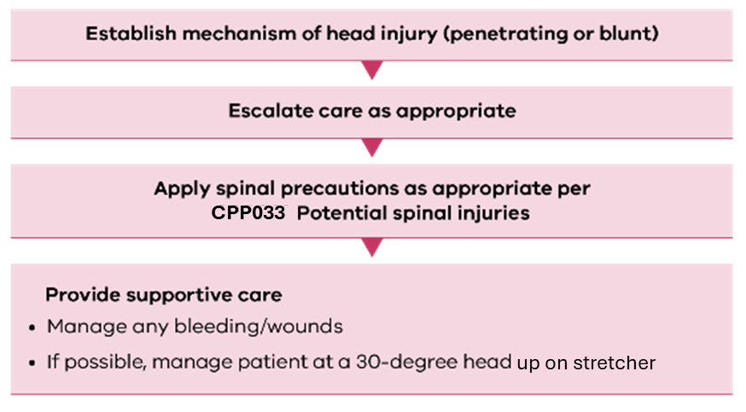

CPP033: Potential spinal injury
Spinal cord injury (SCI) is a serious condition which often results in severe morbidity and permanent disability. SCI occurs when the axons of nerves running through the spinal cord are disrupted by a traumatic event. This disruption leads to a loss of motor and sensory tone below the level of injury, which is the defining feature of an SCI and may have profound effects on other aspects of the patient’s physiological parameters, including blood pressure.
NEPT services may be utilised to transport patients with an established SCI for ongoing management.
NEPT services may encounter patients with acute SCI following a traumatic injury (penetrating or blunt). If SCI is suspected, the patient should be considered time critical and care must be escalated.
It is important to highlight that not every traumatic injury involving the spinal region is considered an SCI. The majority of injuries to the spinal region do not involve a loss of motor and sensory tone or, if present, are transient in nature and not associated with permanent disability. For patients without confirmed or suspected SCI but who may have an injury (including vertebral fracture) that may lead to an SCI, the objective is to restrict spinal motion of the patient and apply support including a soft cervical collar.
The use of a screening checklist to determine whether to undertake spinal precautions in the adult population is approved for medium-high acuity NEPT. Where there is doubt about the presence of a spinal injury or in the case of paediatric patients presenting with a relevant mechanism of injury, NEPT crew members should apply a soft cervical collar and spinal motion restriction (SMR) techniques.
NEPT may be utilised to transport patients with an acute injury/mechanism where SMR is applied but where there is no strong suspicion of associated SCI.
Where a soft collar is indicated, a rigid cervical collar may be used in place of a soft cervical collar until supply of rigid collars is exhausted by NEPT providers.
Prophylactic administration of an anti-emetic (ondansetron) should occur in the case of patients who are managed with SMR.
Example mechanisms of injury which may indicate spinal injury include:
- motor vehicle collision
- falls (standing height or greater)
- object falling on patient head
- blast injuries
- sports injuries.

Figure 30. Management of suspected SCI
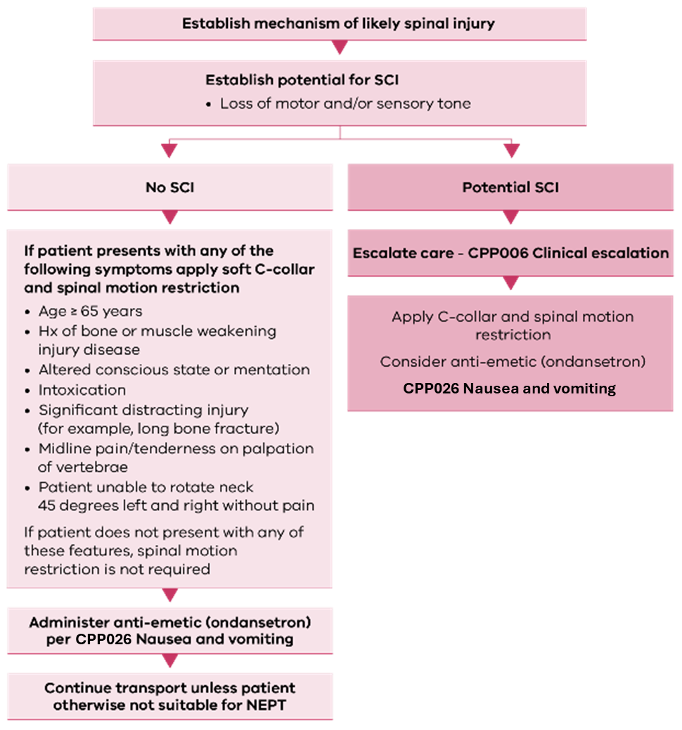

Appendix 1: Abbreviations and definitions
Table 20. Abbreviations and definitions
Abbreviation | Description
AAV | Air Ambulance Victoria
ACD | Advance care directive
AED | Automatic external defibrillator
AMPLE history | Allergies, Medications (prescribed), Past medical history, Last meal, Event leading up to
ARV | Adult Retrieval Victoria
ATA | Ambulance Transport Attendant
AV | Ambulance Victoria
AV clinician | Paramedic working in the communications centre
BGL | Blood glucose level
BP | Blood pressure
BPM | Beats per minute
BVM | Bag valve mask
CCF | Congestive cardiac failure
CCRN | Registered nurse with critical care qualification and endorsed as such
Code 1 driving | Driving using blue and red lights with siren to expediate patient movement under CP006
COPD | Chronic obstructive pulmonary disease
CPR | Cardiopulmonary resuscitation
CVC | Central venous catheter
DKA | Diabetic ketoacidosis
ECC | External cardiac compression
ECG | Electrocardiograph
ECR | Endovascular clot retrieval
ED | Emergency Department
EN | Enrolled nurse (Note: ENs may only administer medicines in accordance with their scope of practice and registration requirements as specified by the Nursing and Midwifery Board of Australia, Ahpra)
Episode of care | Episode of care means the period of care provided by the provider of a non-emergency transport service to a patient, commencing on the first interaction between the patient and a crew member and ending on the completion of the service. For example, commencing at the bedside assessment, progressing to loading, time spent in transit, and in the waiting lounge before a hospital bed is available, the episode concludes when the handover is complete.
ETCO₂ | End Tidal CO₂
ETT | Endotracheal tube
GCS | Glasgow Coma Scale
GTN | Glyceryl trinitrate
Hg | Mercury
HHS | Hyperosmolar hyperglycaemic state
ICC | Inter-costal catheter
IDC | Indwelling catheter
IFT | Inter-facility transport
IM | Intra-muscular
IPPV | Intermittent Positive Pressure Ventilation
IV | Intravenous
IVC | Inferior vena cava
kg | Kilograms
L | Litre
L/min | Litres per minute
m | Metre
MAP | Mean arterial pressure (expressed in mmHg)
MCA | Motor Car Accident
MET call | Medical Emergency team call
mg | Milligrams
MICA | Mobile Intensive Care Ambulance
min | Minute
mL | Millilitre
mm | Millimetres
Neb | Nebuliser mask
NEPT | Non-emergency patient transport
NEPT crew member | Any level of clinical staff member engaged or employed by a NEPT service
NIBP | Non-invasive blood pressure
NIV | Non-invasive ventilation
NPA | Nasopharyngeal airway
NRB | Non-rebreather mask
NSTEAC | Non-ST elevation acute coronary syndrome
NSTEMI | Non-ST segment elevation myocardial infarction
ODT | Orally disintegrating tablet
OPA | Oropharyngeal Airway
PCI | Percutaneous coronary intervention
PCR | Patient care record
PEA | Pulseless electrical activity
pMDI | Pressurised metered dose inhaler
PICC | Peripherally inserted central catheter
PIPER | Paediatric Infant Perinatal Emergency Retrieval
PO | Per oral (delivery of medication)
PPE | Personal protective equipment
PRN | (Pro re nata) When necessary
PSA | Perfusion status assessment
PSVT | Paroxysmal supraventricular tachycardia
PTO | Patient transport officer
RN | Registered nurse
ROSC | Return of spontaneous circulation
RR | Respiratory rate
RSA | Respiratory status assessment
SAT | Sedation assessment tool
SBP | Systolic blood pressure
S/C | Subcutaneous
SCI | Spinal cord injury
Secs | Seconds
SGA | Supra-glottic airway
SHEMP | State health emergency management plan (replaced SHERP)
SIRS | Systemic inflammatory response syndrome
S/L | Sublingual
SMR | Spinal motion restriction
SpO2 | Peripheral Oxygen saturation level
STEMI | ST-elevation myocardial Infarction
SUSMP | Standard for the Uniform Scheduling of Medicines and Poisons
TB | Tuberculosis
TBSA | Total body surface area
TE | Trained and endorsed – This implies a requirement for a NEPT crew member to receive specific training by a NEPT licence holder in the skill, medication or procedure as part of credentialling for the applicable NEPT crew member.
TPN | Total parenteral nutrition
VF | Ventricular fibrillation
VSS | Vital signs survey
VT | Ventricular tachycardia
VVED | Victorian Virtual Emergency Department

Appendix 2: Withholding or ceasing resuscitation

Withholding resuscitation
The following are reasons to withhold resuscitation:

Advance care directive (ACD)
ACD states that cardiopulmonary resuscitation be withheld. Refer to Appendix 3: Advance care directive and end-of-life care.

Obvious death or death verified by a registered medical practitioner, registered nurse or registered paramedic
Resuscitation may be withheld where there is an obvious death or death has been verified by a registered medical practitioner, registered nurse or registered paramedic. Signs of obvious death include:
- rigor mortis
- postmortem lividity
- putrefaction/decomposition
- injuries incompatible with life.
Injuries incompatible with life are injuries where survival is impossible (for example, decapitation, incineration, cranial and cerebral destruction, hemicorporectomy) and are combined with the absence of signs of life. This is distinct from injuries that are believed to be not survivable due to severity.

Ceasing resuscitation
Resuscitation may be ceased in circumstances where the scene is unsafe.
Where possible, a registered paramedic, registered nurse or registered medical practitioner should decide when resuscitation efforts are to be ceased. If this support is not available, NEPT crews may consult with either the provider clinician or the AV clinician. Factors that may prompt consultation for cessation of resuscitation include but are not limited to:
- crew exhaustion
- prolonged resuscitation effort (> 45 minutes) with initial rhythm non shockable (no shock advised/asystole).

Appendix 3: Advance care directives and end-of-life care
No set timeline defines end-of-life care, but due to illness or old age, many people will require responsive care as they approach death. High-quality, end-of-life care relies on open communication, informed decision-making and collaboration among healthcare providers, families and carers, this includes the NEPT sector in Victoria.

ACD
NEPT crew members may provide or withhold treatment based on an ACD if the documentation is sighted or accepted in good faith by those present at the scene that the documentation exists.
NEPT crew members must document the details of any decisions made based on the ACD in the NEPT patient care record.

Documentation: Inter-facility transport and health facility-to-home transfers
- NEPT crew members transporting a patient from a health facility must request a copy of any ACD (or any not for resuscitation request made by the patient) to be provided by the sending health facility before commencing transport
- The ACD must be included in the NEPT PCR
- Where a copy is not obtained, the NEPT crew must advise the sending health facility that they will treat the patient according to their CPPs should it be necessary.

Documentation: Home-to-health facility transfer
For home-to-health facility transfers, documentation of an ACD may be sighted, or it may be accepted in good faith by those present at the scene that this document exists.
If copies of such documentation are available, they should be included in the NEPT PCR. If documentation is not available, the NEPT crew members must:
- record full details of the information given to them (where possible, ascertain and differentiate both instructional and values directives)
- record the full details of the person providing the information (where possible advice should be sought from the patient’s medical treatment decision-maker – where they are appointed).
If there is any doubt about the patient’s wishes, the default position is to treat, as appropriate.

Other
Regardless of time critical criteria (including abnormal vital signs), palliative care patients with a pre-existing terminal illness and not for advanced life support, may still be transported by a NEPT crew, provided the ACD is sighted by the NEPT crew members.
If such documentation is not sighted, then NEPT crew members must advise the sending health facility they will treat the patient with usual care should it be necessary and must pay particular attention to whether a patient is suitable for NEPT transport.
If the patient dies in transit (and where a decision has been made and documented not to treat/resuscitate), contact the AV Clinician who will assist with advice on patient care and transport destination.
NEPT crew members other than registered nurse, registered paramedic or medical practitioner, are unable to verify life is extinct.

Supporting information
The Medical Treatment Planning and Decisions Act 2016 (the MTPD Act) provides a framework for making medical treatment decisions when people do not have capacity to make their own decisions. Advance care planning allows people to clearly express their values and preferences to inform clinical decision-making when they are unable to directly participate.

ACD
An ACD allows a person to document their preferences for future medical treatment, should they lose decision-making capacity. There are two forms of statement a person may include in their ACD:
- An instructional directive
- A values directive.

Instructional directive
A person may either consent to or refuse a particular medical treatment. If there is a relevant instructional directive, this must be complied with just as if the person has consented to, or refused, the treatment. Refusal of treatment certificates made prior to the commencement of the MTPD Act on 12 March 2018 are to be treated as instructional directives.

Values directive
A person may make more general statements about their preferences and values and what matters to them.

Medical treatment decision maker
If an adult does not have decision-making capacity, the medical treatment decision maker represents the patient and advocates for them. The medical treatment decision maker is the first willing and available person from the list below (there can only be one medical treatment decision maker at a time):
- An appointed medical treatment decision maker
- A guardian appointed by the Victorian Civil and Administrative Tribunal (VCAT)
- The first of the following with a close and continuing relationship with the person:
  - The spouse or domestic partner
  - The primary carer of the person
  - The first of the following and, if more than one person fits the description in the subparagraph, the oldest of those persons:
an adult child of the person
a parent of the person
an adult sibling of the person.
If a child does not have decision-making capacity, their medical treatment decision maker will be a parent, guardian or other person with parental responsibility. Previous enduring power of attorney and guardianship appointments remain valid under the MTPD Act.

Voluntary assisted dying
A person cannot request voluntary assisted dying in an ACD. People requesting voluntary assisted dying need to have decision-making ability throughout the entire process to make sure their decision remains voluntary and consistent.

Appendix 4: Mental health patients

Key message
The objective of the Mental Health and Wellbeing Act 2022 (the MHW Act) is to ensure that assessment and treatment of persons with mental illness are provided in the least restrictive way possible. Transport for persons with a mental illness should be arranged in the most timely and least restrictive way possible. This includes travelling in a private vehicle or mental health agency car rather than a stretcher vehicle, if appropriate, and travelling in an NEPT vehicle rather than an emergency ambulance, if appropriate. NEPT providers are not authorised to administer sedation for the transport of mental health patients however may transport patients who have received sedation provided they are suitable for NEPT.

Bodily restraint for safe transport
Under the MHW Act, authorised persons are registered paramedics working for AV, police officers, Protective services officers (PSOs), registered medical practitioners employed or engaged by a designated mental health service and authorised mental health practitioners. An authorised mental health practitioner is any of the following who is employed or engaged by a designated mental health service: a registered psychologist; registered nurse; social worker; or registered occupational therapist.
Authorised persons have particular powers under the MHW Act to:
- use bodily restraint on a person in their care and control to enable a person to be safely taken to or from a designated mental health service or any other place. Bodily restraint may only be used if all reasonable and less restrictive options have been tried or considered and have been found to be unsuitable and the restraint is necessary to prevent serious and imminent harm to the person or to another person. The use of bodily restraint must be documented by the person who used the restraint in accordance with their organisation’s records management practices.

Searches for safe transport
Authorised persons have particular powers under the MHW Act to:
- search a person in their care and control to enable a person to be safely taken to or from a designated mental health service or any other place. A search may only be conducted if they reasonably suspect that the person is carrying something that presents a danger to the health and safety of any person. Before searching, the authorised person must, to the extent that is reasonable in the circumstances explain the purpose of the search and whether the person will be required to remove clothing during the search and if so, why it is necessary. The authorised person must seek the person's cooperation and conduct the search—
  - in a way that provides reasonable privacy for the person searched; and
  - as quickly as is reasonably practicable; and
  - if the person being searched is of or under the age of 16 years, in the presence of—
a parent of the person; or
a carer or supporter of the person; or
if it is not reasonably practicable for a parent, carer or supporter to be present, another adult.
- The authorised person must conduct the least invasive kind of search practicable in the circumstances. So far as is reasonably practicable in the circumstances, a search that involves running the hands over the person's outer clothing must be conducted by—
  - an authorised person of the gender nominated by the person to be searched; or
  - an authorised person nominated by the person; or
  - a person of the gender nominated by the person to be searched under the direction of an authorised person; or
  - a person nominated by the person to be searched under the direction of an authorised person.
- Seize and secure an item found as a result of a search if reasonably satisfied that the thing represents a danger to the health and safety of any person. The authorised person must make a written record of the thing seized, the date and name of the person from whom it was seized and securely store it. However, the thing seized must be given to a police officer as soon as practicable when it is a:
  - controlled weapon, dangerous article or prohibited weapon within the meaning of the Control of Weapons Act 1990; or
  - drug of dependence within the meaning of the Drugs, Poisons and Controlled Substances Act 1981 or a substance, material, document or equipment used for the purpose of trafficking in a drug of dependence within the meaning of that Act; or
  - firearm within the meaning of the Firearms Act 1996; or
  - the authorised person reasonably believes the thing would present a danger to the health and safety of the person or another person if the thing were returned to the person.
The authorised person must take reasonable steps to return the thing seized to the person from whom it was seized when the reason for the seizure of the thing no longer applies (unless it has been required to be given to a police officer).

Sedation for safe transport
Under the MHW Act, sedation is described as a form of chemical restraint. A registered medical practitioner (who may not necessarily be an authorised person) can administer sedation to enable a person to be safely taken to or from a designated mental health service or any other place if all reasonable and less restrictive options have been tried or considered and found to be unsuitable and if the sedation is necessary to prevent serious and imminent harm to the person or to another person. The registered medical practitioner may direct a registered nurse (who may not necessarily be an authorised person) or registered paramedic employed by AV to administer the sedation.
The use of sedation must be documented by both the person prescribing and the person administering the sedation in accordance with their organisation’s records management practices.

Appendix 5: ‘Double-loading’
The Regulations stipulate that only patients classified as low acuity (Table 2) may be ‘double-loaded’ (two patients requiring transport in a single vehicle).
However, the Regulations specify patient conditions or situations where double-loading is prohibited even if a patient would otherwise be classified as low acuity. These include if either patient:
- is behaving in a way that may distress or endanger the other patient.
- is immuno-suppressed.
- has a condition that is likely to cause offence or distress to the other patient.
- is at high risk of dying during transport (for example, palliative patient).
- has or is suspected of having an infectious disease that has a high risk of being transmitted to the other patient.
- reasonably requires privacy due to the patient’s medical condition.
- requires the use of therapeutic or monitoring devices that would prevent or inhibit ready access to either patient.
The Regulations stipulate that a suitably qualified and competent NEPT crew member remain with the patient during the episode of care and that the patient not be left unattended in the patient compartment.
In some circumstances two patients may have the same pickup location (hospital ward, or transit lounge) and a common destination within the same facility.
However, double-loading in these situations is only appropriate when:
- the pick-up or destination points are not geographically dispersed,
- the arrangement will not be likely to cause distress or uncertainty for the patient who is not immediately going to their final destination, and,
- patients are not being taken through multiple areas of a health facility or destination to facilitate supervision.
Prior to authorising and commencing a double-load transport, NEPT crew members and providers are also encouraged to take note of any relevant occupational health and safety (OH&S) legislation or considerations or manufacturer’s instructions regarding minimum operator levels or instructions relating to the use of stretchers when planning double-loaded transports.

Aeromedical exemptions
A provider may transport a medium acuity patient with another low acuity or medium acuity patient in a vehicle, if an additional suitably qualified and competent crew member travels in the compartment with the patient for the duration of the episode of care, and the additional crew member is actively able to monitor and care for the additional patient for the duration of the episode of care.

Appendix 6: Mandatory equipment list
A licence holder must ensure that any vehicle used to transport a patient carries the equipment specified in this Appendix 6. The equipment carried must match the acuity level of the patient for the duration of the episode of care. The NEPT licence holder is responsible for ensuring that all required equipment is available and maintained in accordance with the manufacturer’s instructions.
Table 21 assists NEPT providers to ensure that the requisite equipment is located on NEPT vehicles relative to the acuity level serviced. This list does not prescribe the number of each item or quantity of consumables however this must be sufficient based on likely operational need. Any equipment which is required by contractual arrangement or which NEPT licence holders have identified as being necessary may be carried in addition to this list.
Table 21. Mandatory equipment list
Low acuity | Medium acuity – (all of low acuity) plus: | High acuity – all of medium acuity plus:
- AED  - BVM- adult and paediatric including different size face masks  - Arterial tourniquet(s)  - Shears  - Pulse Oximetry  - Thermometer  - Sphygmomanometer (manual or auto) with cuffs for small adult/paediatric, 'normal', bariatric  - Oxygen (portable and in vehicle)  - Linen  - Hudson O2 mask - paediatric + adult  - Nasal cannula O2  - Infectious disease PPE (gloves, gown, glasses, surgical mask, P2 mask)  - Suction (in vehicle) with yankauer sucker  - Emesis bag(s)  - Infection waste bags  - Vehicle cleaning equipment (wipes, spray)  - Spill kit as applicable in vehicle cleaning plan  - GPS and/or mounting suitable for securing mobile phone  - Soft C-collars  - Sharps container  First aid kit - minimum contents below  - Gauze  - Combine dressings  - Arterial Tourniquet - CAT  - Roller Bandages  - triangular bandages  - Saline (Sodium chloride)  - Lifting cushion  - Glucometer  - Copy of Clinical Practice Protocols (electronic or printed)  - Alcohol swabs/wipes  - Oropharyngeal airway  - Manual handling equipment as appropriate (for example, slide sheet)  - Bed pan  - Equipment likely to be required as part of SHEMP activation e.g. high visibility safety vests, helmets etc  Medicines approved for PTO level  - Adrenaline delivery device (auto-injector)  - Aspirin  - Paracetamol  - Salbutamol pMDI  - Glucose paste. | - Cardiac monitor (3/5 lead minimum)  - ECG dots  - Manual defibrillator with spare pads - paediatric and adult  - Suction catheter including 'Y' suction catheter 6fr-14fr  - SGA/LMA  - NRB mask - paediatric and adult  - NEB mask - paediatric and adult  - Suction - portable  - Pelvic binder  - Formable splint  - Stethoscope  - 1ml syringe with IM needles  Medicines approved for ATA level  - Inhaled analgesia S4 - Methoxyflurane and/or Entonox  - GTN  - Glucagon  - Adrenaline 1:1000 and/or autoinjector device  - Ondansetron (wafers)  - Ipratropium bromide poly-ampoule  - Salbutamol poly-ampoule. | - 12 lead capable ECG  - Syringe driver(s)  - Arterial pressure bag  - Arterial forceps  - IV pole and attachment point  - Arterial line transducer set and cable/s  - ETCO2 filter line (adult)  - PEEP valve(s)  - Consumables for IVC and administration of medicines/infusions (for example, giving sets)  - 50 ml syringe(s) for infusions  - 20 ml syringe(s)  - 10 ml syringe(s)  - Normal saline IV bags  Medicines approved for high acuity level (CCRN)*  - Metaraminol  - Atropine  - Amiodarone  - Adrenaline 1:1000 or 1:10000  - Ondansetron (ampoule for IV/IM administration)  - D10W  - D5W (infusion dilutant)  *High acuity services may choose to not stock the complete list of medicines depending on anticipated service demand, for example a high acuity service working within metropolitan Melbourne with ready access to emergency ambulance escalation may not have the same requirements as a rural or air high acuity transfer service. A clinical risk assessment should be undertaken by the licence holder when determining medication stock holding levels.

Appendix 7: Prolonged transport
NEPT services may provide patient care episodes of a prolonged nature. This is often due to transport destinations, extended off-load times and caring for patients across multiple episodes of care, for example, multiple IFT transports.
It is essential when looking after patients for a prolonged period of time, in addition to routine monitoring and management of the patient (for example, vital signs survey, pain management) that the longer-term needs of the patient are considered. These include:
- hydration, for example, oral fluids
- last meal or likely timeframe before next meal
- toileting needs
- repositioning
- patient’s own regular medication.
It is acceptable to delay transport of a patient to facilitate their long-term needs. For example, delay loading and transport of a patient to enable a meal to be eaten, pulling over regularly to facilitate toileting.
Where appropriate, NEPT crews should request information relating to the long-term needs of the patient when receiving a handover, including any modification to needs, for example, soft diet. This information should be documented on the patient care record.

Pressure injuries
Pressure injuries can happen to older patients or patients of any age who have one or more of the following risk factors: immobility, lack of sensory perception, poor nutrition or hydration, excess moisture or dryness, poor skin integrity, reduced blood flow, limited alertness, or muscle spasms. Even short duration of stasis may cause or contribute to a pressure injury.
Bariatric patients present an increased risk of developing pressure injuries due to increased body habitus and should be treated with increased care.
Repositioning of a patient must occur at a minimum of every 2 hours. Any documentation relating to an existing pressure injury or screening for pressure injury should be documented on the patient care record.
The Braden Scale is used to assess the risk of developing a pressure ulcer or injury. The scale uses scores from 6 to 23, with lower scores indicating a greater risk of developing a pressure ulcer or injury.
The following is a breakdown of the scores:
- Very High Risk: Total Score 9 or less
- High Risk: Total Score 10-12
- Moderate Risk: Total Score 13-14
- Mild Risk: Total Score 15-18
- No Risk: Total Score 19-23

Braden Scale
Table 22. Braden Scale for predicting pressure score risk
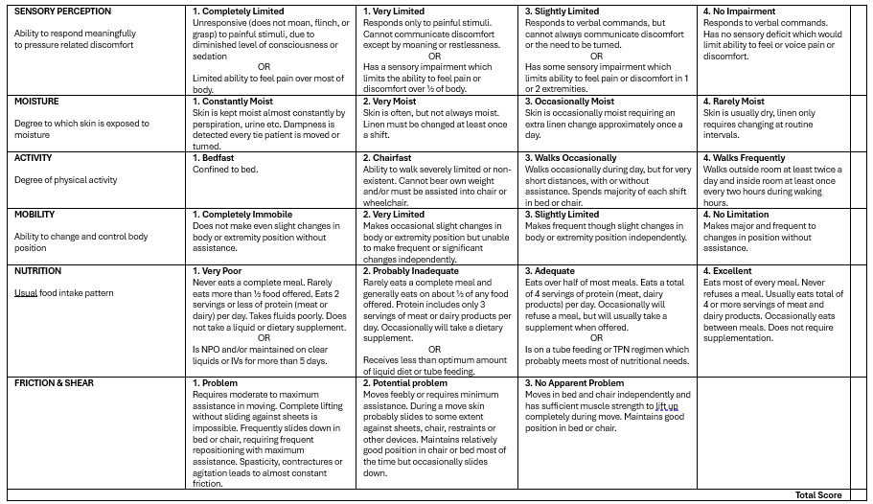

Appendix 8: Medication pharmacology reference material
Always check if the patient has had the medication within the last 24 hours and administer accordingly.
These pages contain information about the medications only. Refer to the relevant CPP for dosing guides.
For further information on the medications, refer to a published pharmaceutical reference guide, for example:
- MIMS Annual with MIMS Abbreviated, e-MIMS, MIMS Online
- Standardised inotrope and vasopressor guidelines, Safer Care Victoria
- AusDI Advanced / AusDI
- Australian Medicines Handbook (AMH)
- AMH Children’s Dosing Companion
- Australian Don’t Rush to Crush Handbook
- Australian Immunisation Handbook
- Australian Pharmaceutical Formulary and Handbook (APF)
- Therapeutic Guidelines series
- Merck Manual (Professional Version) (Merck Sharp and Dohme).
- Drug interactions via the following additional references:
- Drug Interaction Facts – Facts and Comparisons
- Micromedex
- Stockley’s Drug Interactions Online, or
- Lexicomp Interactions
- Evidence-based reference work on complementary and alternative medicines via:
    - Herbs and Natural Supplements: An evidence-based guide. Braun and Cohen
    - Herbal Medicines. Barnes, Anderson and Phillipson
    - Herbal Medicines and Dietary Supplements package (each resource can be independently accessed through Medicines Complete)
    - MedlinePlus: Drugs, Supplements, and Herbal Information (available free online)
    - Natural & Alternative Treatments: EBSCO, or Natural Medicines (formerly Natural Standard and Natural Medicines Comprehensive Database).

Adrenaline
Presentations | - 1 mg adrenaline (1 ml of 1:1000 = 1 mg/ml) glass vial  - 1mg adrenaline (10ml of 1:10,000 = 100microg/ml) glass vial  - EpiPen ® (300 microgram) autoinjector is recommended for adults and children over 20 kg (aged around 5 years or over)  - EpiPen Jr ® (150 microgram) autoinjector is recommended for children 7.5 to 20 kg (aged around 1 to 5 years)  - Anapen 500 ® (500 microgram) autoinjector is recommended for adults and children over 50 kg (aged around 12 or over)  - Anapen 300 ® (300 microgram) autoinjector is recommended for adults and children over 20 kg (aged around 5 years or over)  - Anapen Jr ® (150 microgram) autoinjector is recommended for children 7.5 to 20 kg (aged around 1 to 5 years)
Primary emergency indications | - Cardiac arrest - VF/VT, Asystole or PEA  - Cardiogenic shock  - Anaphylaxis  - Critical asthma  - Stridor due to inflammation
Contraindications  (Known hypersensitivity plus) | - Contraindications are relative as this product is intended for use in life threatening emergencies  - Hypovolaemic shock without adequate fluid replacement
Precautions | - Consider reduced doses for:  Elderly / frail patients  Patients with cardiovascular disease  Patients on monoamine oxidase inhibitors  Higher doses may be required for patients on beta blockers
Key timings | - IM effects: Onset: 30 – 90 seconds, Peak: 4 – 10 minutes, Duration: 5 – 10 minutes  - IV effects: Onset: 30 seconds, Peak: 3 – 5 minutes, Duration: 5 – 10 minutes
Special notes and important interactions | - All patients receiving adrenaline for possible anaphylaxis are to be transported to a health service provider for ongoing care  - The ideal location for IM injection is the mid-outer thigh. Other suitable sites include the midline upper arm (deltoid)  - IM adrenaline has a short duration and patients must be closely monitored for reoccurrence of symptoms  - There is an increased the risk of hypotension and tachycardia with patients taking αlpha-blocking drugs  - Severe hypertension and bradycardia may occur with patients taking nonselective beta-blocking drugs
Side effects | - Tachycardia  - Arrhythmias  - Hypertension  - Dilated pupils  - Feeling of anxiety/palpitations  Note: May increase size of myocardial infarction
Pharmacology or actions | - A naturally occurring alpha and beta-adrenergic stimulant  - Increases heart rate by increasing SA node firing rate (Beta 1) and conduction velocity through the A-V node (Beta 1)  - Increases myocardial contractility (Beta 1)  - Increases the irritability of the ventricles (Beta 1)  - Causes bronchodilatation (Beta 2)  - Causes peripheral vasoconstriction (Alpha)

Amiodarone
Presentations | - 150 mg in 3mL vials / glass ampoules
Primary emergency indication(s) | - Ventricular fibrillation  - Pulseless ventricular tachycardia refractory to defibrillation  - Sustained or recurrent ventricular tachycardia
Contraindications  (Known hypersensitivity plus) | Contraindications are relative as this product is intended for use in cardiac emergencies  VT – Pregnancy  Do not administer Amiodarone if VT follows Ondansetron administration  TCA OD
Precautions | Nil of significance in the above indications
Key timings | - IV effects (bolus): Onset: 2 minutes, Peak: 20 minutes, Duration: 2 hours
Special notes / (and important interactions) | - Amiodarone is only to be administered by trained and endorsed staff.  - Amiodarone is incompatible with normal saline.  - Glucose 5% must be used as diluent when preparing an IV infusion.  - An IV infusion of amiodarone may be required during interhospital transfer. This will be prescribed by the referring medical practitioner and will normally be at a dose of 10 -20 mg/kg run over 24 hours.  - An infusion for acute WCT is different and is 5mg/kg up to 300mg run over 20 minutes.  - Interactions:  - Some antiarrhythmic agents  - Cyclosporin  - Phenytoin  - Warfarin and other anticoagulant agents
Side effects | - Hypotension  - Bradycardia
Pharmacology / Actions | - Class III anti-arrhythmic agent

Aspirin
Presentations | - 300mg chewable tablets  - 300 mg soluble or water dispersible tablets
Primary emergency indication(s) | - Chest pain/discomfort  - Acute Coronary Syndrome (ACS)
Contraindications  (Known hypersensitivity plus) | Haemophilia or other bleeding disorders  Erosive actively bleeding gastritis or peptic ulcer  Hypersensitivity to other salicylates  Suspected dissecting aortic aneurysm  Chest pain associated with psychostimulant overdose if SBP >160 mmHg  Acute febrile illness in children and adolescents  Severe hepatic or renal disease
Precautions | Active peptic ulcer  Asthma  Patients on anticoagulants
Key timings | - Onset: for emergency indication n/a, Peak: n/a, Duration: 8 - 10 days
Special notes / (and important interactions) | - Aspirin is not to be administered by NEPT for any condition other than chest pain/discomfort of a cardiac nature  - The anti-platelet effects of Aspirin persist for the natural life of platelets
Side effects | - Heartburn, nausea, gastrointestinal bleeding  - Increased bleeding time  - Hypersensitivity reactions
Pharmacology / Actions | - An analgesic, antipyretic, anti-inflammatory and antiplatelet aggregation agent  - Actions:  - To minimise platelet aggregation and thrombus formation to retard the progression of coronary artery thrombosis in ACS  - Inhibits synthesis of prostaglandins - anti-inflammatory actions

Atropine
Presentations | - 0.6 ml in 1ml polyamp  - 1.2 mg in 1 ml polyamp
Primary emergency indication(s) | - Unstable bradycardia
Contraindications  (Known hypersensitivity plus) | Previous heart transplant
Precautions | Atrial flutter  Atrial Fibrillation  Myocardial infarction  Glaucoma
Key timings | - Onset: < 2 min, Peak: < 5 min, Duration: 2-6 hours
Special notes / (and important interactions) | - Do not increase HR > 100  - If administering adrenaline after atropine ensure line/cannula is flushed with at least 10 ml of Normal Saline/D5W  - No severe interactions
Side effects | - Palpitations  - Tachycardia  - Dry mouth  - Dilated pupils  - Visual blurring  - Retention of urine  - Confusion/restlessness (in large doses)
Pharmacology / Actions | - Inhibition of acetylcholine on post-ganglionic cholinergic nerve potentiating sympathetic effect to increase HR by increasing SA node rate and increasing conduction velocity through A-V node

Glucagon
Presentations | - Vial with 1mg of powder for reconstitution prior to injection (and if in kit, 1 pre-filled syringe with 1 mL sterile water for reconstitution)
Primary emergency indication(s) | - Diabetic hypoglycaemia (BGL < 4 mmol/L) in patients with an altered conscious state who are unable to self-administer oral glucose, or is unavailable  - Anaphylaxis (adult) where patients remain hypotensive following adrenaline therapy with history of heart failure or patients taking beta-blocker medication
Contraindications  (Known hypersensitivity plus) | Nil of significance in the above indication
Precautions | Nil of significance in the above indication
Key timings | - Onset: 3-5 minutes, Duration: 12-25 minutes
Special notes / (and important interactions) | - Patients taking beta-blockers might be expected to have a greater increase in both pulse and blood pressure  - Not all patients will respond to glucagon (e.g., those with inadequate glycogen stores in the liver (alcoholics, malnourished))  - It is important to ensure early transport/activation of paramedic back-up in all cases of hypoglycaemia
Side effects | - Nil significant  - Nausea and vomiting (rare)
Pharmacology / Actions | - A hormone normally secreted by the pancreas which raises blood glucose level  - Actions:  - Causes an increase in blood glucose concentration by converting stored liver glycogen to glucose

Glucose paste
Presentations | - Oral Glucose Gel 37.5 g containing 15 grams of glucose
Primary emergency indication(s) | - Diabetic hypoglycaemia (low blood sugar) with altered RBG < 4 mmol/L and conscious and able to cooperate.
Contraindications  (Known hypersensitivity plus) | Inability to swallow due to altered conscious state
Precautions | Nil of significance for the above indication
Key timings | - If no response within 15 minutes, repeat dosage
Special notes / (and important interactions) | - Not all patients will respond to glucose paste and it is important to ensure early escalation of care / transport  - Not recommended for children under 2 years of age
Side effects | - Nil significant
Pharmacology / Actions | - Oral glucose gel

Glyceryl Trinitrate (GTN)
Presentations | - 0.6mg tablets Anginine ® and Lycinate ® tablets  - 0.3mg and (0.6mg Nitrostat ® tablets (Nitrostat tablets cannot be split.)  - 0.4mg Nitrolingual spray
Primary emergency indication(s) | - Cardiac chest pain/discomfort  - Hypertension associated with acute cardiogenic pulmonary oedema  - Hypertension associated with acute coronary syndrome
Contraindications  (Known hypersensitivity plus) | Haemorrhage or head trauma  Known hypersensitivity  Systolic blood pressure < 100 mmHg  Heart rate > 150 beats per min or < 50 beats per min  Sildenafil and/or vardenafil use in the previous 24 hours or tadalafil use in the previous 48 hours  Note: Tadalafil (Cialis) may also be prescribed to men for treatment of benign prostatic hypertrophy  Ventricular tachycardia
Precautions | No previous administration of GTN  Elderly or frail patients  Recent Myocardial Infarction  Concurrent use with other tocolytics
Key timings | - Sublingual/buccal effects: All tablets are absorbed via buccal mucosa via sublingual administration  - Onset: 30 sec–2 minutes, Peak: 3–5 minutes, Duration: 15–30 minutes
Special notes / (and important interactions) | - GTN tablets are susceptible to heat and moisture. Tablets must be stored tightly sealed in their original container.  - Avoid administering patient’s own medication as it may not have been stored in optimal conditions  - Nitrostat tablets cannot be split. Anginine and Lycinate may be split.
Side effects | - Hypotension  - Tachycardia  - Headache  - Nausea and vomiting  - Syncope  - Dizziness  - Skin flushing of face and neck (uncommon)  - Bradycardia (occasionally)
Pharmacology / Actions | - Nitrate- a vascular smooth muscle relaxant and vasodilator  - Actions:  - Venous dilatation promotes venous pooling and reduces venous return to the heart (reduces preload)  - Arterial dilatation reduces systemic vascular resistance and arterial pressure (reduces afterload)  - The effects of the above are:  - Reduced myocardial oxygen demand  - Reduced systolic, diastolic, and mean arterial blood pressure, whilst usually maintaining coronary perfusion pressure  - Mild collateral coronary arterial dilatation may improve blood supply to ischaemic areas of myocardium  - Mild tachycardia secondary to slight fall in blood pressure

Nitrous Oxide (Entonox®)
Presentations | - Cylinder of gas (blue or blue top)  - 50% nitrous oxide/50% Oxygen delivered via face mask
Primary emergency indication(s) | - Inhaled analgesia for moderate-severe pain
Contraindications  (Known hypersensitivity plus) | Do not administer in any condition where gas is entrapped within a body (for example pneumothorax, air embolism, decompression sickness, recent diving, gross abdominal distension, laparoscopy, severe bullous emphysema, patients having received recent intraocular injection of gas)
Precautions | Use in combination with other analgesia/sedatives will potentiate effects  Entonox® should be self-administered by the patient holding the face mask
Key timings | - Onset: 2-5 minutes, Peak: N/A, Duration: 3-5 min after inhalation ceases
Special notes / (and important interactions) | - Comply with manufacturer requirements for safe storage of cylinder  - The use of higher levels of oxygen can increase the risk of pulmonary toxicity in patients who have been administered Bleomycin. In these cases Entonox® should be administered with caution and at levels kept as low as possible (with a preference to choose Methoxyflurane ahead of Nitrous Oxide)
Side effects | - Euphoria  - Sedation  - Nausea and vomiting  - Dizziness  Side effects are transient in nature and will generally rapidly resolve post-administration
Pharmacology / Actions | - Colourless non-flammable gas that has an analgesic effect by releasing endogenous opioids that act on opioid receptors.

Ipratropium Bromide
Presentations | - Metered inhaler pump: 21 microgram per metered dose inhalation aerosol (as bromide monohydrate) ATROVENT ®  - Inhalation ampoule: Single dose units of 0.25 mg in 1ml, (as monohydrate) AERON ® ATROVENT ®  - Inhalation ampoule: Single dose units of 0.5mg in 1ml, (as monohydrate) AERON ® ATROVENT ®
Primary emergency indication(s) | - For maintenance treatment of bronchospasm associated with asthma and chronic pulmonary disease  - Severe respiratory distress associated with bronchospasm  - Exacerbation of COPD irrespective of severity
Contraindications  (Known hypersensitivity plus) | Known hypersensitivity to atropine or its derivatives
Precautions | Paradoxical bronchospasm  Avoid contact with the eyes.  Glaucoma
Key timings | - Onset: 3 - 5 minutes, Peak: 1.5 - 2 hours, Duration: 6 hours
Special notes / (and important interactions) | - Ipratropium bromide must be nebulised with salbutamol in NEPT  - To be administered as a single dose only  - Avoid contact with the eyes.  - The nebuliser mask must be fitted properly during inhalation and care taken to avoid Ipratropium Bromide solution entering  the eyes.  - There have been isolated reports of ocular complications (dilated pupils, increased intraocular pressure, acute angle glaucoma, and eye pain) because of direct eye contact of nebulised mist
Side effects | - Headache  - Nausea  - Dry mouth  - Throat irritation / Cough  - Skin rash  - Gastrointestinal disorders (including constipation, diarrhoea, gastrointestinal motility disorder, and vomiting)  - Dizziness  - Tachycardia (rare)  - Palpitations (rare)  - Acute angle closure glaucoma secondary to direct eye contact (rare)
Pharmacology / Actions | - Anticholinergic bronchodilator  - Actions: Allows bronchodilatation by inhibiting cholinergic bronchomotor tone (i.e., blocks vagal reflexes which mediate bronchoconstriction)

Methoxyflurane
Presentations | - 1.5mL or 3mL bottle each bottle contains 99.9% methoxyflurane  Penthrox ® kit contains, bottle, inhaler, and (model dependant) sometimes a charcoal exhaust filter
Primary emergency indication(s) | - For relief of moderate-severe pain by self-administration
Contraindications  (Known hypersensitivity plus) | Renal impairment/failure  Head injury or loss of consciousness  Personal or family history of malignant hyperthermia  Exceeding total dose of 6 mL in a 24-hour period
Precautions | The inhaler must be hand-held by the patients so that if unconsciousness occurs it will fall from the patient’s face.  Occasionally the operator may need to assist but must continuously assess the level of consciousness  Pre-eclampsia  Concurrent use with Oxytocin may cause hypotension
Key timings | - Analgesia commences after 8 - 10 breaths and lasts for approximately 3 - 5 minutes once discontinued
Special notes / (and important interactions) | - Maximum 6 mL can be given within 24-hours  - If stronger analgesia is required, patient can cover dilutor hole with finger during inhalation  - Continuous administration reduces time of analgesia  - The maximum initial priming dose is 3 mL. This will provide approximately 25 minutes of analgesia and may be followed by one further 3 mL dose once the initial dose is exhausted if required  - Do not administer in a confined space. Ensure adequate ventilation in vehicle  - Malignant hyperthermia is a very rare condition that can be induced by volatile anaesthetics such as methoxyflurane. Ask patients about any history or family history of adverse reactions to inhaled anaesthetics  - In patients with muscular dystrophy, volatile agents may precipitate life-threatening rhabdomyolysis
Side effects | - Dizziness  - Headache  - Amnesia - retrograde  - Nausea and Vomiting  - Cough  - Fever  - Decrease in blood pressure and bradycardia (rare)
Pharmacology / Actions | - Belongs to the fluorinated hydrocarbon group of volatile anaesthetic agents  - Short acting

Presentations | - 10mg/1ml  - Dilute 10mg (1 ml) with 19ml of Normal Saline in 20 ml syringe. This leaves preparation of 0.5mg/ml
Primary emergency indication(s) | - Undifferentiated Shock
Contraindications  (Known hypersensitivity plus) | Sulphite hypersensitivity  MAOI overdose  TCA overdose
Precautions | Shock due to hypovolaemia
Key timings | - Onset: 1-2 minutes, Duration: 20-60 minutes
Special notes / (and important interactions) | - Continuous cardiac monitoring required  - Suitable for all cannula sizes  - Monitor the access site every time patient observations are recorded
Side effects | - Headache  - Tachycardia, reflect bradycardia, arrhythmia  - Local soft tissue necrosis
Pharmacology / Actions | - Synthetic sympathomimetic amine primarily an α1 adrenergic agonist (peripheral vasoconstriction)  - Secondary (lesser) effect of β1 adrenergic agonist (positive inotrope)

Metaraminol

Ondansetron
Presentations | - Wafer or tablet - 4mg and 8mg  - 8 mg in 4 mL glass ampoule
Primary emergency indication(s) | - All undifferentiated nausea and vomiting
Contraindications  (Known hypersensitivity plus) | Concurrent Apomorphine use
Precautions | Can increase large bowel transit time  Patients with liver disease should not receive more than 8 mg of Ondansetron per day  Care should be taken with patients on diuretics who may have an underlying electrolyte imbalance  Ondansetron contains aspartame and should not be given to patients with phenylketonuria  Concurrent use of Tramadol  Pregnancy  Known Long Q-T syndrome  Hypokalaemia or hypomagnesaemia
Key timings | - Oral (ODT) Wafers  - Onset: 2 minutes, Peak: 20 minutes, Duration: 120 minutes  - IV  - Onset: 5 minutes, Peak: 10 minutes, Duration: between 2.5 and 6.1 hours
Special notes / (and important interactions) | - Ondansetron may not be effective for all types of nausea and vomiting  - IV doses should be delivered as a slow push (minimum 30 seconds)
Side effects | - Headache  - Constipation  - Fever  - Prolonged QTc
Pharmacology / Actions | - Anti-emetic primarily a 5HT antagonist which blocks receptors both centrally and peripherally

Paracetamol
Presentations | - 500mg tablets or capsules  - 120 mg in 5 mL oral liquid (24 mg/mL)
Primary emergency indication(s) | - Mild pain relief including headache
Contraindications  (Known hypersensitivity plus) | Children < 1 month of age  Paracetamol already administered within past 4 hours  Total paracetamol intake within past 24 hours exceeding 4 g (adults) or 60 mg/kg (children)
Precautions | Overdose may cause liver failure  Liver impairment  Hepatic dysfunction/failure  Renal impairment  Elderly / frail  Malnourished
Key timings | - Onset: 30 minutes, Peak: N/A, Duration: 4 hours
Special notes / (and important interactions) | - Paracetamol is not indicated for the treatment of fever in the emergency setting  - There are several brands of Paracetamol available in Australia. Paracetamol is also found in many combination medicines, both prescription and over-the counter. Carefully determine previous Paracetamol intake before dose administration  - Hepatic damage is very rare when Paracetamol is taken at recommended dosages  - Paracetamol is not to be used as analgesia for suspected ACS
Side effects | - Hypersensitivity reactions including severe skin rashes (rare)  - Haematological reactions (rare)
Pharmacology / Actions | - Analgesic and antipyretic agent

Salbutamol
Presentations | - Inhalation ampoule: Single dose units of 5 mg in 2.5 mL nebules / polyamps  - Inhalation ampoule: Single dose units of 2.5 mg in 2.5 mL nebules / polyamps  - pMDI with 0.1 mg per actuation/dose.
Primary emergency indication(s) | - Respiratory distress with suspected bronchospasm:  - asthma  - Anaphylaxis  - COPD  - Other causes of bronchospasm
Contraindications  (Known hypersensitivity plus) | Nil of significance in the above indications.
Precautions | Large doses of Salbutamol have been reported to cause intracellular metabolic acidosis.
Key timings | - Inhaled effects: Onset: 5 – 15 minutes, Peak: n/a, Duration: 15 – 50 minutes.
Special notes / (and important interactions) | - Interaction: Beta-adrenergic blocking drugs inhibit the bronchodilator action of salbutamol and other sympathomimetic bronchodilators  - Salbutamol nebules / polyamps have a shelf life of one month after the wrapping is opened. The date of opening of the packaging should be recorded  - Nebules should be stored at an ambient temperature < 30 degrees Celsius  - The effectiveness of salbutamol differs between patients, it is important to escalate care early  - Continue to administer oxygen 8 L/min between doses.
Side effects | - Tachycardia  - Palpitations  - Muscle tremor
Pharmacology / Actions | - Bronchodilator  - A synthetic beta-adrenergic stimulant with primarily beta 2 effects.

https://www.tga.gov.au/products/regulations-all-products/legislation-and-legislative-instruments/poisons-standard-susmp
The phrase ‘suitably qualified and competent’ should be understood by reference to any relevant provisions in the Regulations.
Refer to Appendix 1
Refer to Appendix 1
The 2026 Regulations state that a NEPT provider must not transport a patient if, within the two hours immediately before the proposed transport, the registered health practitioner treating the patient has assessed the patient as having likely experienced, or as experiencing, cardiac-related chest pain, or, if no such assessment has occurred, the patient has cardiac-related chest pain.
See CPP029: Pain relief

