

VicTAG Chemotherapy Audit Toolkit
Quality Framework and Supporting Information v2.0
OFFICIAL
Contents
Executive Summary 2
Introduction 3
Glossary 4
Background 5
Evidence review (including published literature) 7
Model quality framework for protocol approval, localisation and variation management 11
Variation management 13
Audit tool principles 16
Tool methodologies 19
Additional audits to support the quality framework 21
Acknowledgements 22
Appendix 1 – Scope and process guide 23
Appendix 2 – Report instructions for generation 25
CHARM 25
ARIA 27
MOSAIQ 30
Episoft, Cerner Oncology and Epic Beacon 32
Paper based health services 33

Executive Summary

Summary: The VicTAG Chemotherapy Audit Toolkit was first released in 2019 to provide health services with trialled methods of auditing variations in prescribing that can be implemented to improve quality processes. The toolkit has continued to be developed to add functionality to the tools and support additional oncology electronic prescribing systems.

Project: The Chemotherapy Audit Toolkit is designed to provide health services with a quality framework for Systemic Anti-Cancer Therapy (SACT) prescribing and a tested methodology for auditing their SACT prescribing variations. These tested methodologies do not represent the only valid approach to auditing of variation and are intended to provide a starting point for services that do not have an established practice.

Scope: The toolkit covers currently implemented electronic prescribing systems in Victoria: CHARM, Cerner Oncology, ARIA and Epic. Additional information has been found for MOSAIQ from users in another state. There is also an approach that is usable for services without an electronic prescribing system (noting that this is less effective). If your electronic prescribing system is not supported, please contact the Department of Health to discuss development of a tool to support your process.

Introduction

Systemic anti-cancer therapy (SACT), traditionally referred to as chemotherapy, is a common modality of treatment for cancer patients with a wide range of benefits and side-effects. Optimising the dose of SACT for patients requires consideration of a range of factors including the type of cancer, the agent/s and patient-related factors, particularly relating to a patient’s ability to complete a course of treatment or to achieve a particular therapeutic outcome.
There are many SACT protocols used across Victorian hospitals (e.g. there are over 300 protocols listed on eviQ, an Australian reference site managed by Cancer Institute New South Wales), and the type and number of protocols regularly changes as the results of new clinical trials become available. This, coupled with the complexity of dosing for individual patients and the quality processes for getting the right medication/s to the right patient at the right time, requires robust clinical governance processes to be in place to ensure that the various aspects of the treatment process work together to provide the best outcomes for patients.
Changes to the dose or composition, whether by addition, deletion or substitution, of SACT agents is a common variation to approved SACT protocols. This is typically done by balancing patients’ capability to tolerate treatment against established treatment protocols and the desire to give full therapeutic treatment and may lead to an increase or decrease of the dose and/or changes to the timing and frequency of delivery of SACT. While health services have formal governance approaches in place to approve all new SACT protocols permitted to be delivered to their patients, and for the SACT delivery process, there are clear variations between services in the way in which they review changes to doses.
This paper provides an overview of this area following recent high profile SACT dosing issues in two Australian jurisdictions and describes a model governance process around the SACT pathway. The paper also describes the development of a simple electronic tool to assist health services in reviewing dose adjustments, and how this can be used with different SACT management systems as well as paper-based approaches.

The VicTAG Chemotherapy Audit Toolkit was supported by the Victorian Government.

Glossary

CDSG (Cancer Disease Stream Group): The clinicians who look after a particular cancer disease stream (e.g. breast or lymphoma). This may be an appropriate group for discussion of the audit toolkits identified variations depending on the size

Chemotherapy: Treatment that uses medicines to stop the growth of cancer cells, either by killing the cells or by stopping them from dividing. Chemotherapy may be given by mouth, injection, or infusion, or on the skin, depending on the type and stage of the cancer being treated. It may be given alone or with other treatments, such as surgery, radiation therapy, or biologic therapy. Also referred to as SACT (Systemic Anti-Cancer Therapy). For the purposes of this toolkit, immunotherapy is included as chemotherapy but hormonal therapy is not. (Definition from National Cancer Institute)

Credentialing: the formal process used to verify the qualifications, experience, professional standing and other relevant professional attributes of health practitioners for the purpose of forming a view about their competence, performance and professional suitability to provide safe, high-quality health services within specific organisational environments. (Australian Commission on Safety and Quality in Health Care. Credentialing health practitioners and defining their scope of clinical practice: A guide for managers and practitioners. Sydney: ACSQHC, 2015.)

ECMMS (Electronic cancer medication management system): A system used to prescribe chemotherapy/SACT in health services. It may also include functions for digital recording of dispensing, verification and administration.

MDM (Multi-disciplinary meeting): A cancer multidisciplinary team meeting is a deliberate, regular meeting involving a range of health professionals with expertise in the diagnosis and management of cancer, for the purpose of facilitating best practice management of all patients with cancer. (Victorian Department of Health website; <https://www.health.vic.gov.au/health-strategies/multidisciplinary-care>)

Variation: SACT prescribing variation – a change in the prescription of a protocol for a patient usually made on basis of patient specific factors e.g. dose reduction for altered hepatic or renal function.

Background

In response to SACT dosing incidents identified in NSW and SA in 2016 (see references, Currow and Marshall), the then Victorian Department of Health and Human Services (DHHS) conducted surveys of Victoria’s Integrated Cancer Services and all SACT providers to determine the quality processes in place for prescribing and administration of SACT. The results showed that governance procedures across health services were consistent with national guidelines, however retrospective review of dose variations from protocol was comparatively low, with only 27% of public services indicating that they undertook such audits.
Based on these results, and to ensure that Victorian health services can be appropriately supported in an area of growing complexity of care, DHHS engaged the Victorian Therapeutics Advisory Group (VicTAG) to consider approaches to improve services’ capabilities to self-audit SACT prescribing and administration. The key focus for this was on developing an audit tool that could be used by health services to enable them to have a consistent approach to understanding dose variations at their service.
It is common for SACT doses to cancer patients to be varied from what is recommended in an approved protocol. Typical reasons for these variations include organ dysfunction (especially renal and hepatic), previous treatment related toxicity and co-morbidities. In each case, the reasons for dose variations should be recorded, and where variations are made based on unusual or uncommon features/factors, it is appropriate that these be peer reviewed both to inform peer learning/education and to conform with peer review processes as part of overall health service quality of care.
The role of pharmacists in auditing medicine use is well established, with many health services having specialist pharmacists to undertake quality use of medicines related activities. In addition, the establishment of pharmacist roles in stewardship programs aimed at improving the therapeutic use of antimicrobials, analgesia and anticoagulation shows the value of pharmacists in optimising medicine use.
However, review of SACT dose variations and processes around this is an area that has been little explored in the peer reviewed literature, with few articles able to be identified from a Medline and EMBASE review that described retrospective auditing of protocol compliance. A survey of International Society of Oncology Pharmacy Practitioners (ISOPP) members, with responses from 11 countries apart from Australia, as well as informal correspondence with oncology pharmacists internationally was similarly unable to elicit much evidence of tools or processes for retrospective auditing of SACT dose variations. The one example reported from Mexico is of a similar model to the one utilised in this toolkit. This likely reflects the fact that other jurisdictions have not had the same motivation to focus on this specific aspect of care, as opposed to the broader quality governance processes around SACT.
These broader processes and the context in which they occur are important to note. For example, there are some key differences between centralised and decentralised approaches to pharmacogovernance.
For example, Alberta, Canada, in 2017 has centralised:
- protocol maintenance and governance, including protocols on their electronic cancer medication management system (ECMMS)
- formulary listings with indications, including restrictions on medical staff able to prescribe for some agents
- formulary listings consider pCODR (pan Canadian Oncology Drug Review) which does have a cost-effectiveness metric in the evaluation.
- a universal ECMMS covering all of Alberta, with harmonised protocols (oncology protocols are harmonised and haematology are moving in this direction)

In contrast, Victoria’s system in 2017 is a good example of a decentralised system:
- protocol maintenance and governance are the responsibility of individual health services. Whilst eviQ provides a good set of example protocols (that often exist at sites but with small changes to the published protocol), however there is variable use of these protocols across health services
- a fragmented ecosystem of ECMMS, including a significant group that have not yet taken up or are implementing an ECMMS
- formulary listing is influenced by listing on the PBS (Pharmaceutical Benefits Scheme), except for inpatient treatment which is not funded and is therefore governed at a health service level (noting that private health services can access the PBS as inpatients).
The decentralised approach requires each health service to develop and maintain their own governance processes and systems, and there is naturally variation across these depending on their mix and size of services. Where new services are developed or implemented, the development of these systems can be challenging, particularly at smaller health services in the absence of support from larger health services or other organisations.
The audit tool and toolkit aim to provide a consistent baseline approach to SACT quality that reflects existing service capabilities.

Evidence review (including published literature)

A literature review was conducted by Eastern Health Library Service on Medline and EMBASE searching for inappropriate prescribing and antineoplastic agents, including synonyms and subject terms.
The review found little to suggest retrospective auditing was common practice in the oncology sphere. Most of the literature focused on the implementation of CPOE (Computerised Prescriber Order Entry), and whether this reduced and/or altered the types and frequency of errors encountered (Sanchez Cuervo, Rojo Sanchis et al. 2015, Aita, Belvedere et al. 2013, Elsaid, Truong et al. 2013, Nerich, Limat et al. 2010, Small, Barrett et al. 2008). Some studies focused on oral SACT, given that the processes in place do not mirror parenteral SACT but carry similar risks in terms of prescribing (Weingart, Mattsson et al. 2012, Oberoi, Trehan et al. 2014, Taylor, Winter et al. 2006, Collins, Elsaid 2011). For some of these studies, however, errors were detected in the normal processes of operation, with the checks in place (pharmacy and nursing) recording incidents of therapy that were changed because of their intervention. Other studies looked at implementation of guidelines (sometimes known as treatment pathways) and compliance, rather than prescribing from a protocol (Wymer, Pearce et al. 2017). Some of the literature focused on the economic costs of errors, and costs avoided by error prevention (Ranchon, Moch et al. 2012).
National and international associations including Clinical Oncology Society of Australia (COSA), Society of Hospital Pharmacists Australia (SHPA), International Society of Oncology Practitioners (ISOPP), British Oncology Pharmacy Association (BOPA), ASHP (formerly known as American Society of Hospital Pharmacists) and American Society of Clinical Oncology (ASCO) have published guidelines to help inform best practice staffing and governance models to prevent error. It is worth noting that prior to the dosing issue in NSW, NSW Therapeutics Advisory Group (NSWTAG) had developed a quality indicator which provided a methodology to verify SACT prescribing utilising retrospective auditing, but this is no longer available. Whilst auditing completed by NSWTAG in 2011 does show that the tool was not used widely at that time, the need may not have been as apparent or urgent. The QUM indicator was integrated into the 2014 National Quality Use of Medicines Indicators for Australian Hospitals.
Protocols for use in the treatment of cancer are developed through clinical trials. Whilst they include some ability to individualise treatment (e.g. doses and frequency of anti-cancer agents) to the patient’s condition, the real-world experience is often more diverse than could be tested in a controlled environment. Expert opinion replaces controlled trial evidence in these scenarios, and the impact of these changes to the treatment on the outcomes for the patient is not certain. Testing of frequency changes suggest that it is not often known what the optimal treatment is, and protocols that have being used for decades are being trialled with modifications. For example, changing the frequency of SACT administration of common protocols can lead to improvements in treatment (Denduluri, Somerfield et al. 2016) or can lead to greater toxicity with no improvements for patients (Cunningham, Hawkes et al. 2013) many years after the protocols have become mainstream practice. In addition, an incident involving the miscalculation of an Etoposide Phosphate preparation resulted in an 18% overdose in 11 children was evaluated by a medical oncologist that “no harm was done.” Variation, whether through intent by personalising treatment or by error, does not necessarily represent a better or worse outcome for a patient, instead, the outcome becomes less certain. For variations that are an alteration to the underlying protocol (e.g. reducing a dose for the whole patient population), until it can be said that the variation is an improvement on existing standard of care therapy (or contributing to that knowledge through inclusion in a clinical trial), it should be avoided to prevent potential reductions in treatment efficacy for patients.
The official reports from the New South Wales (Currow, et al 2016) and South Australia (Marshall, et al 2015) SACT dosing incidents highlight potential vulnerabilities for health services, but focus on deficiencies in governance and the cultures that permit this to happen as the key contributors. The governance failures are different, with SA emphasising the failure of appropriate controls on protocol entry in the electronic environment and NSW being the failure of application of evidence-based medicine.
Role of the Chemotherapy Audit Tool and Quality Framework
This toolkit seeks to reduce the risk from unwarranted variations (whether intended or not) that successfully penetrate the “Swiss cheese” model of error prevention (Reason 2000) as applied in standard oncology practice in Victoria. Retrospective auditing to show systematic variations for discussion and review by a peer group that completes the feedback loop into protocol maintenance (and formalizes what was often an informal and ad-hoc process).
The quality framework is built to support best practice around the journey from evidence to patient, and management of variations from protocol as they appear. The additional audits listed later in the toolkit also help to complete the spectrum of activity covered by assessment and quality measures.
Publication in Journal of Oncology Pharmacy Practice, 2023
Progress to date on the VicTAG Chemotherapy Audit Toolkit was detailed and published in the Journal of Oncology Pharmacy Practice in December 2022. The article covered development, implementation and an assessment of progress to late 2021 including results and analysis of a survey of Victorian public health services that provide SACT.
To summarise, take up was occurring around Victoria but impacted by COVID. Sites that have used the toolkit have provided feedback that the tool is easy to use and effective. Examples were given to show that the toolkit was impacting on care plans and prescribing in ECMMS.

References:

AITA, M., BELVEDERE, O., DE CARLO, E., DEROMA, L., DE PAULI, F., GURRIERI, L., DENARO, A., ZANIER, L. and FASOLA, G., 2013. Chemotherapy prescribing errors: an observational study on the role of information technology and computerized physician order entry systems. BMC health services research, 13, pp. 522.
Cancer Therapy Medication Safety Working Group. COSA guidelines for the safe prescribing, dispensing and administration of systemic cancer therapy. Sydney: Cancer Council Australia. [Version URL: https://wiki.cancer.org.au/australiawiki/index.php?oldid=183289, cited 2019 Feb 5]. Available from: https://www.cancer.org.au/clinical-guidelines/cancer-therapy-medication-safety
COLLINS, C.M. and ELSAID, K.A., 2011. Using an enhanced oral chemotherapy computerized provider order entry system to reduce prescribing errors and improve safety. International journal for quality in health care : journal of the International Society for Quality in Health Care, 23, pp. 36-43.
CUNNINGHAM, D., HAWKES, E.A., JACK, A., QIAN, W., SMITH, P., MOUNCEY, P., POCOCK, C., ARDESHNA, K.M., RADFORD, J.A., MCMILLAN, A., DAVIES, J., TURNER, D., KRUGER, A., JOHNSON, P., GAMBELL, J. and LINCH, D., 2013. Rituximab plus cyclophosphamide, doxorubicin, vincristine, and prednisolone in patients with newly diagnosed diffuse large B-cell non-Hodgkin lymphoma: a phase 3 comparison of dose intensification with 14-day versus 21-day cycles. The Lancet, 381(9880), pp. 1817-1826.
CURROW, D. et al, 2016-last update, Off-protocol prescribing of chemotherapy for head and neck cancers - Final report. Available: http://www.health.nsw.gov.au/patients/cancertreatment/Documents/section-122-final-report.pdf [Accessed 19/1/18]
DENDULURI, N., SOMERFIELD, M.R., EISEN, A., HOLLOWAY, J.N., HURRIA, A., KING, T.A., LYMAN, G.H., PARTRIDGE, A.H., TELLI, M.L., TRUDEAU, M.E. and WOLFF, A.C., 2016. Selection of Optimal Adjuvant Chemotherapy Regimens for Human Epidermal Growth Factor Receptor 2 (HER2) –Negative and Adjuvant Targeted Therapy for HER2-Positive Breast Cancers: An American Society of Clinical Oncology Guideline Adaptation of the Cancer Care Ontario Clinical Practice Guideline. JCO, 34(20), pp. 2416-2427.
ELSAID, K., TRUONG, T., MONCKEBERG, M., MCCARTHY, H., BUTERA, J. and COLLINS, C., 2013. Impact of electronic chemotherapy order forms on prescribing errors at an urban medical center: results from an interrupted time-series analysis. International journal for quality in health care : journal of the International Society for Quality in Health Care, 25, pp. 656-663.
GOLDSPIEL, B., HOFFMAN, J.M., GRIFFITH, N.L., GOODIN, S., DECHRISTOFORO, R., MONTELLO, C.M., CHASE, J.L., BARTEL, S. and PATEL, J.T., 2015. ASHP Guidelines on Preventing Medication Errors with Chemotherapy and Biotherapy. Am J Health Syst Pharm, 72(8), pp. e6.
MARSHALL, V. et al, Nov, 2015-last update, Independent Review into the Incorrect Dosing of Cytarabine to Ten Patients with Acute Myeloid Leukaemia at RAH and FMC. Available: https://www.sahealth.sa.gov.au/wps/wcm/connect/7f1e5a804ab3e560bf56ff0d8bd99c13/Attach+1+Final+Report_Cytarabine.pdf?MOD=AJPERES&amp;CACHEID=ROOTWORKSPACE-7f1e5a804ab3e560bf56ff0d8bd99c13-nKODsO7 [Last accessed 18/6/25]
NERICH, V., LIMAT, S., DEMARCHI, M., BORG, C., ROHRLICH, P.S., DECONINCK, E., WESTEEL, V., VILLANUEVA, C., WORONOFF-LEMSI, M. and PIVOT, X., 2010. Computerized physician order entry of injectable antineoplastic drugs: an epidemiologic study of prescribing medication errors. International journal of medical informatics, 79, pp. 699-706.
OBEROI, S., TREHAN, A. and MARWAHA, R.K., 2014. Medication errors on oral chemotherapy in children with acute lymphoblastic leukemia in a developing country. Pediatric blood & cancer, 61, pp. 2218-2222.
O’CONNOR S, MATTHEWS H and HORNBY C, 2023. VicTAG chemotherapy audit toolkit: Improving chemotherapy quality and safety. Journal of Oncology Pharmacy Practice. 2023; 29(2) pp. 416-421
RANCHON, F., MOCH, C., YOU, B., SALLES, G., SCHWIERTZ, V., VANTARD, N., FRANCHON, E., DUSSART, C., HENIN, E., COLOMBAN, O., GIRARD, P., FREYER, G. and RIOUFOL, C., 2012. Predictors of prescription errors involving anticancer chemotherapy agents. European journal of cancer (Oxford, England : 1990), 48, pp. 1192-1199.
REASON, J., 2000. Human error: models and management. BMJ : British Medical Journal, 320(7237), pp. 768-770.
SANCHEZ CUERVO, M., ROJO SANCHIS, A., PUEYO LOPEZ, C., GOMEZ DE SALAZAR LOPEZ, DE SILANES, GRAMAGE CARO, T. and BERMEJO VICEDO, T., 2015. The impact of a computerized physician order entry system on medical errors with antineoplastic drugs 5 years after its implementation. Journal of clinical pharmacy and therapeutics, 40, pp. 550–554.
SMALL, M.D.C., BARRETT, A. and PRICE, G.M., 2008. The impact of computerized prescribing on error rate in a department of Oncology/Hematology. Journal of oncology pharmacy practice : official publication of the International Society of Oncology Pharmacy Practitioners, 14, pp. 181-187.
TAYLOR, J.A., WINTER, L., GEYER, L.J. and HAWKINS, D.S., 2006. Oral outpatient chemotherapy medication errors in children with acute lymphoblastic leukemia. Cancer, 107, pp. 1400-1406.
WEINGART, S.N., MATTSSON, T., ZHU, J., SHULMAN, L.N. and HASSETT, M., 2012. Improving electronic oral chemotherapy prescription: can we build a safer system? Journal of oncology practice, 8, pp. 168.
WYMER, K.M., PEARCE, S.M., HARRIS, K.T., PIERORAZIO, P.M., DANESHMAND, S. and EGGENER, S.E., 2017. Adherence to National Comprehensive Cancer Network® Guidelines for Testicular Cancer. The Journal of Urology, 197(3), pp. 684-689.

Model quality framework for protocol approval, localisation and variation management

This quality model will cover SACT treatment, with presumed ability to be applied to biotherapy. It will not cover diagnostic processes or radiotherapy.
Guidelines from national and international multi-disciplinary and pharmacy bodies, including COSA (Cancer Therapy Medication Safety Working Group), BOPA, ASHP (Goldspiel, Hoffman et al. 2015), ASCO and ISOPP provide some guidance in this area, but do not fully outline a comprehensive process that could be used as a model. Drawing on these and some real-world examples of quality frameworks, a best practice framework has been derived and is described below.
Figure 1: The Evidence to Patient Journey
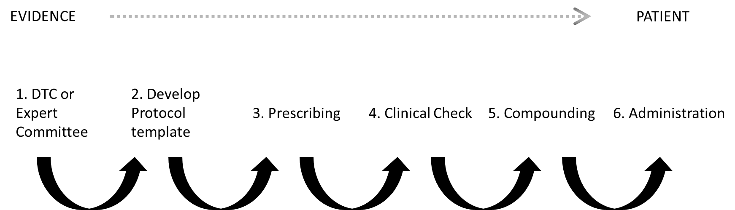

- A submission is made to the hospital Medicine and Therapeutics Committee (MTC) and/or delegated committees for a new protocol or medication to become part of standard treatment for that health service. This is made by clinicians from the health service and is generally based on the published evidence. Approval is generally based on the strength of the evidence and cost of the agents. Some health services separate cancer-based protocols into a separate committee and require approval from MTC to enable the medication to be acquired and the cancer protocol committee to enable usage as part of recognised protocols within the health service
- The protocol, if approved, is then formally documented to guide use in the health service. This documentation includes the protocol (in institutional format with supportive care and monitoring) as well as either a pre-printed standard order form if used (for health services prescribing on paper) or loading of the protocol into the ECMMS if the health service utilises these. For all of these documents, multidisciplinary review of the protocol in the final format (loaded on ECMMS, institutional proforma and/or reference protocol) is of paramount importance to prevent mistakes (Goldspiel, Hoffman et al. 2015). It is strongly recommended for this multidisciplinary review to involve medical, pharmacy and nursing staff as these specialties each have different touchpoints with protocols through their roles of prescribing, dispensing and administering
- Once a patient is diagnosed and an appropriate protocol selected, a credentialed prescriber orders the SACT for the patient, as per protocol with appropriate consideration of relevant patient parameters, such as body surface area (BSA), renal and hepatic function
- The prescribed SACT is checked by a credentialed pharmacist to ensure appropriateness of the therapy for the patient. If a variation to the protocol is detected, actions to clinically assess the appropriateness can be taken. The next section outlines recommendations covering variation management. BOPA have standards covering clinical verification.
- Compounding/dispensing is completed by pharmacy or external providers. This is specifically covered by guidelines produced by pharmacy associations.
- SACT is administered by credentialed staff according to product information or evidence-based guidelines.

Variation management

Sub-optimal management of variations (usually involving insufficient oversight) can lead to patient harm through over or under dosing of patients, each with their specific set of consequences. Appropriate escalation pathways ensure that all staff are supported to make clinically sound decisions and will not accept potentially unwarranted variation without due diligence.
A suggested variation quality framework follows, with escalation pathways as appropriate.
Figure 2: Variations are most often detected during a clinical check
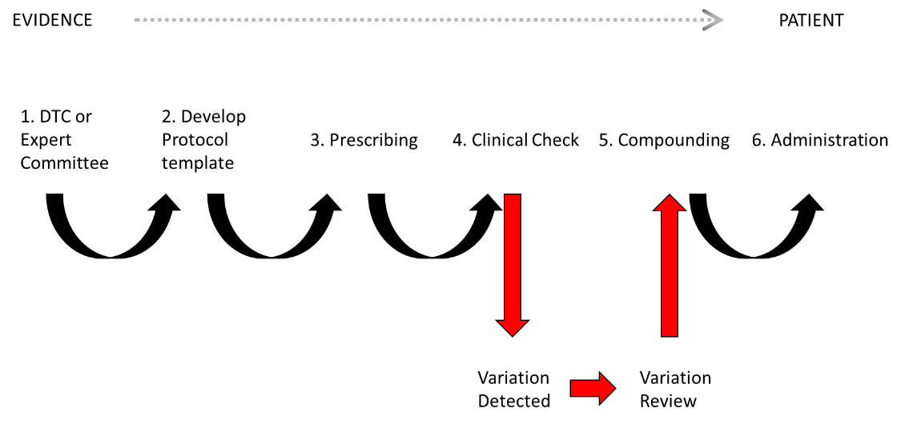

Medical oncologists will often engage with quality mechanisms in the health service prior to prescription of SACT if considering a significant dose modification. This may occur with a group of clinicians looking after the same cancer disease stream, or via a director of oncology/haematology as institutional guidelines/norms allow. These may involve an approval mechanism, with evidence to be provided to support a change in practice. Some services mandate information about variations to be provided at the time of booking the patient for SACT at a Chemotherapy Day Unit.
After prescribing, SACT variations will often be detected at a clinical check by a pharmacist, and this will lead to a process for review, listed below (it is important to note that prescribers will often have escalated appropriately before this point and the escalation caused by the variation being detected will simply be a confirmation that this process has occurred).
When a variation is detected at a clinical check, it is important that clear escalation pathways exist for variations to be examined with sufficient rigor to ensure that optimal patient care is being delivered. This will depend on the magnitude and type of deviation from protocolised care detected.
There are a range of standardly accepted reasons for varying SACT doses to patients, such as documented eviQ adjustments in their protocols (e.g. dose reductions for renal dysfunction). Where these have been approved through a health service’s clinical governance processes, further review is not warranted (except in rare cases of complex patients where multiple factors can affect dosing). For dose adjustments outside these, retrospective peer review can be an important quality check and for discussion/learning around the reasons for such changes.
Definitions of minor and major variations, and of how much modification a protocol can undergo before a major variation becomes an unrelated or new protocol need to be defined to give clarity for clinical staff at the coalface. It is also to give some context as to acceptable variations – such as less than 10% for dose rounding or accepted modification for renal and/or hepatic dysfunction, or previous side effects, and resources that may be considered for reference in these scenarios.
A suggested clinical governance process for clinicians who detect a variation (usually either a pharmacist or a nurse) to follow upon identification of a dose variation is provided below. It is important to note that information about the variation once detected should be sought from the prescriber, MDM records and all available documentation to ensure that further steps are completed with full insight, thus preventing rework and inappropriate escalation. This ensures that the process will be followed with the understanding of the quality processes that have previously been undertaken by the prescriber.
Figure 3: Model Escalation procedure for a variation once detected
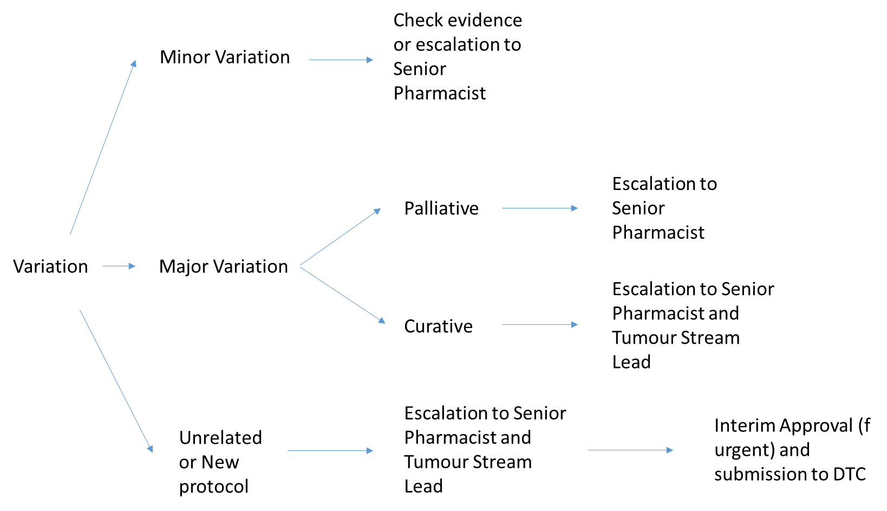
Note: Individual thresholds for minor/major variations and escalation pathways to be set by health service and exclude evidence based accepted recommendations (e.g. eviQ hepatic and renal dysfunction dose modification guidelines)

This is a suggested model and can be adapted to the personnel available in the health service. For example, in a larger health service “Senior Pharmacist” may refer to the Senior Oncology Pharmacist and in a smaller centre, this may involve external consultation or director of pharmacy involvement\. Heads of Unit may wish to also be involved in escalation.
The intention of the audit tool is to capture all variations and to filter a subset of these for later medical consultant peer review.
Table 1: Example variations with recommendations
Variation | Classification | Escalation Pathway
Dose rounding (e.g. <5% to full vial) | Minor variation with evidence | No escalation required
25% dose reduction as per EviQ because of reduced Creatinine Clearance | Minor variation with evidence | No escalation required
50% dose reduction of Doxorubicin with genetic heart defect, but normal Left Ventricular Ejection Fraction and no evidence | Major variation | If palliative intent: Senior Pharmacist  If curative intent: Senior Pharmacist and Cancer Disease Stream Head
Addition of extra SACT agent | New or unrelated protocol* | Escalation to Senior Pharmacist and Cancer Disease Stream Lead
Changing a protocol from 3 weekly to 2 weekly | New or unrelated protocol* | Escalation to Senior Pharmacist and Cancer Disease r Stream Lead
Substitution of SACT agent | New or unrelated protocol* | Escalation to Senior Pharmacist and Cancer Disease Stream Lead
Substitution of anti-nausea agent | Not relevant to escalation pathways | See internal formulary and anti-emetic guidelines
Note: *: there are scenarios when this will be evidence based (e.g. CHOP protocol → CHOEP protocol, changing AC to dose dense version). Please refer to the individual protocol and supporting literature for guidance.
Note: Smaller services with smaller units may have trouble implementing some of these recommendations due to insufficient staff for peer review as suggested above. Strategies for the auditing of these units will need to be developed. Potential solutions may include hub-and spoke models with a regional centre supporting smaller centres (often, the medical practitioners in these situations originate from a hub service) or forming a partnership with a larger tertiary centre for support.

References: refer to literature review references.

Audit tool principles

Audit process
The toolkit provides tools that facilitate auditing of SACT prescribing variations using quality structures internal to the health service.
Figure 4: The VicTAG tool process
Prescribing
VARIATION REPORT
AUTOMATIC FILTER
MANUAL FILTER
DISCUSSION AT CDSG/
MDM
VicTAG TOOL

The process for using the tool involves:
- Creation of a retrospective variation report using the parameters and instructions supporting the tool. This will include health service decisions on scope based upon available resources.
- Utilisation of a VicTAG tool to automatically filter the report to reduce resources required for manual filtering.
- Manual filtering of report to identify prescribing variations that require attention from medical prescribers.
- Discussion at cancer disease stream group (CDSG) meeting/multi-disciplinary meeting (MDM) and/or report to head of unit. Discussion of variations will lead to changes of prescribing patterns if required.
Note: Health services may choose different quality processes to be put into place for the discussion and analysis. The important function of this process is to feedback variations that would be considered outside of prescribing norms to ensure that appropriate oversight has occurred. Health services may also detect administrative issues, such as suboptimal protocol pathways (either electronic or paper) that require modification to match the utilisation of the health service, noting that this would require approval through the relevant pathways of the health service.

Audit parameters
The audit tool has included principles to aid in improving usefulness, efficiency and specificity. A scope and process guide is included as Appendix 1 to aid health services in determining the parameters to be used with the toolkit.
Note: Some of these recommendations have been made to limit the burden of auditing. The restrictions of first cycle inclusion only and excluding clinical trials (due to increased oversight) are recommendations to comply with a resource constrained environment. Ideally, in an environment where resources are available, greater scope is provided by maximising the included variations for analysis, potentially also analysing second and subsequent line treatments as well as clinical trials.
The below table shows parameters that are recommended as mandatory and extension where resources allow. These are the recommended starting points for consideration of the parameters and scope and consideration of the scope and parameters of the audit toolkit should occur at the MDM/CDSG to which the report which be presented for discussion.
Table 2: Minimum scope recommendations for using the toolkit
Mandatory scope | Extension
Curative/adjuvant and neoadjuvant therapy | Palliative/metastatic disease therapy
First cycle | All cycles
All routes (e.g. intravenous, subcutaneous, intramuscular, oral, intraperitoneal, intrathecal etc.)
Standard of care patients | Clinical trials patients

Notes:
- curative/adjuvant and neoadjuvant therapy only – palliative SACT protocols, is intended to prolong survival, but not cure the patient. As cure cannot be compromised by dose reduction in this scenario, adjusting the dose to patient tolerance and wishes is appropriate, and therefore variation is acceptable
- the first cycle of treatment only – by removing subsequent treatments, including variations resulting from toxicity experienced by the patient, a much cleaner set of data will result with variations sampled of more value in auditing and discussion
- all SACT agents via all routes (e.g. intravenous, subcutaneous, intramuscular, oral, intraperitoneal, intrathecal etc.) – all SACT regardless of route engenders the same risks. Include as many routes as possible to ensure that maximal SACT is covered by the audit
  - a possible approach may be to do a manual audit of a small number of capecitabine patients – these patients currently represent most oral SACT patients outside of leukaemia and will provide a reasonable cross-section of coverage in the absence of an ECMMS based approach
- Patients who have failed first line therapy are extended scope– patients who have previously had therapy may require genuine dose adjustments for patient specific factors and this may be a less efficient use of resources
- Clinical trials patients – these patients are held to strict protocols where variation and deviations already have their own approval pathways and auditing in ways that standard of care patients do not. These often have increased protocols for dosing and vigilance to reduce protocol variations so are at reduced risk of issues occurring
- Supportive agents – these agents contribute to patient experience and safety, however, do not contribute to protocol efficacy.
Note: not all these considerations can be included in the automatic phase of tool operation. This is dependent on the information and format of the report from the ECMMS utilised, and on how the information has been programmed into the ECMMS.

Audit parameters
Optimal parameters for auditing depend on the method of audit and the available resourcing, The Project Reference Group consider the following parameters acceptable.
In a setting with an ECMMS that produces reports for review, auditing of all cancer disease streams every 3-6 months is optimal. Cancer disease streams can be audited continuously in a rolling style or processed as a batch.
In settings that operate on paper-based prescribing or ECMMS that don’t support audit functionality, some consideration of auditing parameters needs to occur. To guide health services in stratifying their approach:
- Frequency – 3-6 monthly auditing is optimal. Decreased frequency may be used in resource constrained settings, but no longer than annual is advised.
- Cancer Disease Streams – all is optimal, but in resource constrained environments, targeting different cancer disease streams on a rotational basis may assist (e.g. Breast in this round of audit, Prostate in the next round etc.)
It is important to ensure that there is adequate sampling of cancer disease streams and prescribers if an approach is chosen that does not sample all activity. This will depend on resources available for the audit. Guides to particular ECMMS (Appendix 2) will inform approaches that can be used for each system to maximise effect. General principles that may be used include:
- Limiting cancer disease streams covered by the audit and rotating through cancer disease streams each time an audit is done. Focusing on one cancer disease stream at a time (e.g. Breast) will improve the ability of the audit to find systematic deviation from practice.
  - May need to consider ensuring sufficient depth of audit by checking number of patients per prescribers
If a service can go beyond the limitations listed above, it is encouraged to do so, especially where ECMMS support this. Ideally, all SACT cycles should be monitored for changes. More audits are described in the section “Additional audits to support the quality framework”. These fill out some of the gaps that are not met using the tool.

Tool methodologies

ECMMS based approaches
This section provides guidance on how to optimally audit using the tool for the ECMMS currently in use in Victoria. These approaches have been piloted with the help of health services in Australia to provide a practical guide on auditing dose variations at health services.
Variation reports detail changes from pre-programmed protocols loaded in the system by the health service. Whilst the variations captured by these reports include events that won’t have a detrimental impact on the effectiveness of a treatment (e.g. the addition of extra anti-emetics for a patient with nausea and vomiting), they provide a starting point for extracting variations that should be re-examined considering the evidence and the patient’s situation.
This report can be further filtered to remove most of the variations that don’t require review. This is followed by a manual review, using a list of accepted reasons for variation to provide a very small list for presentation to a group of clinicians working in the cancer disease stream.
Variation reports as a methodology have many advantages:
- reduces time in reviewing patient histories
- Reports all modifications
And some disadvantages:
- Variations are deduced from programmed protocols. These programmed protocols may not be consistent with the established guidelines sources such as eviQ. It is recommended that ECMMS programmed protocols should be assessed against established protocols and any variation approved and documented by the cancer disease stream.
The variations requiring consideration are then manually evaluated, as guided by the exclusion guide on the website. The resultant list will go to an MDM or appropriate auditing committee for consideration.
The tools available are based on reports available from the ECMMS and have varying abilities to consider the dosage change (i.e. ARIA and MOSAIQ can automatically filter for dosage variation % whereas CHARM does not facilitate this).
Instructions for generating reports for the various ECMMS are in Appendix 2 and the corresponding tools are available on the Department of Health website.
Table 3: VicTAG tool availability for various ECMMS
ECMMS | Report instructions in Appendices | Audit tool available on website | Site with VicTAG tool running
CHARM | YES | YES | YES
ARIA | YES | YES | YES
MOSAIQ | YES | NO | YES
Epic | NO | NO | NO
Cerner Oncology | NO | NO | YES
Episoft | NO | NO | NO
Note: there may be appropriate reports to run similar reports/perform similar functions existing in these ECMMS and health services need to judge if these meet their requirements

For discussions about adapting a tool to your ECMMS and other support, please contact Cancer Planning <cancerplanning@health.vic.gov.au>

Paper based approaches
The approach to auditing for health services with paper based prescribing systems differ given the limitations of resourcing and data availability.
The approach is retrospective and focuses on small segments of activity to provide some assurance about prescribing activity whilst being a realistic allocation of resources. It will involve:
- isolation of a particular cancer disease stream/s to be audited
- a targeted time period to be selected
- audit of variations in the first cycle of patient’s current line of treatment (best reflects current practice, whilst minimising individual toxicity/tolerance variations)
The methodology closely mirrors the CHARM approach:
- Select patients for audit from available health service data (suggested sources include clinic appointment list or day unit chemotherapy list).
- Audit cycle 1 of current SACT regimen for variation and whether it is to be escalated for discussion using guideline for exclusion (due to the need to access patient data to decide if a variation has occurred, it will be more efficient to analyse the variation at this point in time and decide if it will get included for escalation).
- Submit list for escalation as per the toolkit process
Sample documents can be found in Appendix 2 and on the Department of Health website.

Additional audits to support the quality framework

- Protocol Audit
  - Random audit of protocols against supporting evidence – checking that transcription and translation from the supporting evidence is correct in versions of the protocol used in house (e.g. on the ECMMS).
- Audit of toxicity management
  - Some agents require specialised monitoring of side effects that are built into protocols. This monitoring can be important to prevent catastrophic complications. (e.g. ATIII monitoring for pegasparaginase dosing).
- Audit of cumulative dosing
  - Some agents (e.g. anthracyclines such as doxorubicin, bleomycin) have lifetime cumulative doses that should not be exceeded to prevent complications for the patient. Note that some ECMMS will have features that support monitoring of cumulative dosing.

Acknowledgements

Steering Committee
- Kathryn Whitfield, Department of Health and Human Services,
- Adam Chapman/Simon Montgomery, Department of Health and Human Services
- Danny Rischin, Peter MacCallum Cancer Centre
- Helen Matthews/James Dwyer, VicTAG
- Sue Kirsa, VicTAG
- Senthil Lingaratnam, Peter MacCallum Cancer Centre
- Leanne Hill, Ballarat Health Service
Project Reference Group
- Adam Chapman/Simon Montgomery, Department of Health and Human Services
- Dishan Herath, Wester Health/Peter MacCallum Cancer Centre
- Stephen Ting, Eastern Health
- Simon Phillips, Hume Regional Integrated Cancer Centre
- Sarah Fotheringham, Eastern Health
- Jim Siderov, Austin Health
- Martin Angliss, Latrobe Regional Hospital
- Patricia Grace, Barwon Health
- Gael Wilder, Alfred Health

MOSAIQ information – Rachel Nixon, Western NSW LHD
Pilot sites: Monash Health (Amanda Tey), Eastern Health, Barwon Health (Pene Nevett), ICON (Maggie Patterson), Peter MacCallum Cancer Centre (Michelle Hong), Latrobe Regional Hospital (Martin Angliss), Ballarat Health Services (Lenny Hill), Cerner

Version History:
v1.0 | Initial version released | 2/7/19
v1.1 | ARIA info added  Minor grammatical/structure changes | 3/12/19
v2.0 | Review of document, update to terminology | 11/6/25

Appendix 1 – Scope and process guide

- Select scope
  - Referring to the Quality Framework (section on Audit Principles) and the scope guide for exclusion, decide as a health service the scope for audit, including decisions on:
    - which cancer disease streams to be included
    - inclusions/exclusions (see Appendix 1)
    - quality processes that will consider the final report
    - interval for re-audit on a rolling basis. Consideration needs to be given to dedicated staffing for the audit process and resources available.
  - An oncology quality and safety committee or relevant local governance group (e.g. medication safety, QUM) would be the ideal group to consider scope for the audit.
- Run report/collect data
  - Using the appropriate instructions for your system, follow the guidance for generating the report. Keep in mind the limitations of the report (i.e. what it will and won’t report) as discussed in the instructions.
- Use tool to facilitate audit
  - Automatic filtering
    - Follow the guidance in the “Instructions for use” tab of the tool to facilitate automatic filtering.
  - Manual filtering
    - Using the guidance from the “Scope guide for exclusion” and previous decisions made about scope, exclude variations that are not suitable for discussion.
- Disseminate report for discussion
  - Disseminate the filtered list for review by the agreed quality mechanism.
- Provide report for record keeping and information
  - Provide report with outcomes of discussion to Head of Unit, Quality unit and others as determined by the health service (including the body that considered the scope for the audit).

Exclusion Guidelines

Automatic Exclusion Guidelines
The audit tool has included principles to improve the usefulness, efficiency and specificity. These are covered in the must include/can include/must exclude categories listed below. “Can include” parameters provide some customisation to allow for health services to provide in depth audits, whilst utilising a reasonable amount of resources.
The audit must include:
- all patients with cancer being treated with SACT protocols via all routes (e.g. intravenous, subcutaneous, intramuscular, oral, intraperitoneal, oral etc.)
- curative (including adjuvant/neoadjuvant) therapy, including appropriate patients with concurrent radiotherapy (the radiotherapy treatment itself is beyond the scope of this audit)
- the first cycle of treatment
Can include:
- palliative intent therapy
- all cycles of treatment
- clinical trials patients
Must exclude:
- Supportive agents
As resources allow, the parameters for “can include” should be included in the audit. Health services with electronic prescribing systems should be able to facilitate increased auditing parameters with the use of automatic filtering provided by the tool.
Note: these parameters are dependent upon the information obtainable from these systems as part of the audit.

Manual Exclusion Guidelines
Variations can be excluded from discussion based on:
- Rounding <10% (larger rounding as acceptable within organisation guidelines)
- Evidence based dose reductions for toxicity (local protocols or if no local protocol, EviQ)
- Evidence based dose alterations due to organ dysfunction
- Variations to Supportive Care (e.g. anti-emetics, steroids if used for nausea) – if not automatically excluded by a filter
- Temporary timing changes caused by patient condition/CDU availability
  - Dose capping as per documented institutional policy or evidence-based guidelines (e.g. obesity, carboplatin dosing based on organisation agreed Cockroft-Gault equation or eGFR)

Appendix 2 – Report instructions for generation
Note: financial support is not available for creation of custom reports. Support may be available for advice on report parameters and customisation of the Excel tool to the report that the health service is able to provide.

CHARM
Method: Using the report generation feature of CHARM, please configure as in Figure 5.
Figure 5: CHARM report parameters for report generation
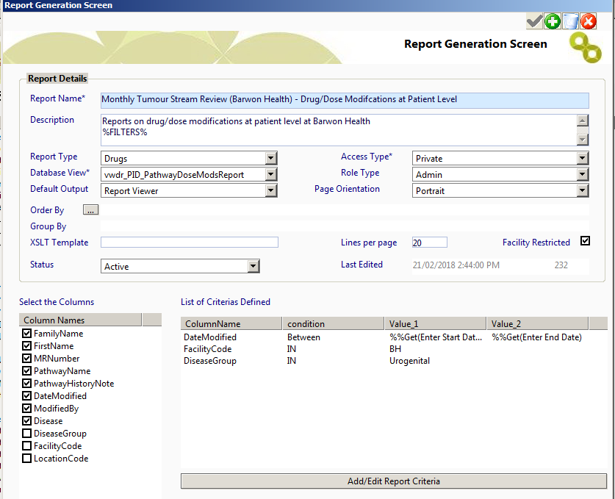
Note:
- The order of selecting the columns (clicking the checkboxes) will influence the order that they are reported in the final report. The macros are currently set up to match with the order DateModified, MRNumber, FamilyName, FirstName, Diseases, PathwayName, PathwayHistoryNote and ModifiedBy
- The use of the condition “equals” (or “like” will allow for close matches) instead of “IN” will potentially remove delays in the CHARM program when changing the DiseaseGroup. (“IN” will test for being part of the text in the field, “equals“ will require an exact match and “like” will allow similar results to be used.
- The DiseaseGroup is modified for each cancer disease stream (with Urogenital listed as an example). It will depend on health service internal definition and labelling of cancer disease streams.
- The FacilityCode will need to be changed to match internal labelling of the health service.
Next step:
- Access the VicTAG Chemotherapy Audit Toolkit CHARM tool and follow the instructions on the “Instructions for Use” tab
Limitations:
- The report does not always give protocol and varied dose, negating any attempt to filter by % (e.g. only report dose variations >5%)
- The report will produce information on any cycle and medication altered. The VicTAG CHARM tool will automatically filter for supportive care, if the “Excluded Terms” worksheet is up to date and includes all desired terms.
- The tool contains a toggle on the “Instructions for use” worksheet that allows for selection of Cycle 1 or All Cycles. Please ensure this toggle is selected to the desired setting before processing data, otherwise the filtering may need to be manually reset.
- The tool is currently dependent on the order of the output fields being maintained to enable the automatic filter to function correctly. The formulas can be edited if you are confident in using Excel.
Tips and tricks
- Please check the Excluded Terms list in the tab with the same name to see if it matches up with supported therapy terms used in your health service. Modifying this list to match terms that should be excluded will make the automatic filtering step more efficient. Add terms by replacing “Palonosetron” from Row 33 downwards (Don’t delete the content of these cells otherwise the filtering will not work).
- The “Data Analysis” tab provides some basic statistics on variations, such as variations in total, variations excluded, including broken down by stage, and variations sent on to further consideration (unfortunately, CHARM report does not provide information on how many cycles/drugs were checked as part of running the report, so an incidence rate cannot be determined).
- If a particular protocol turns up frequently in the report, the protocol may need to be reviewed to ensure that it is being used as intended or can be modified to suit prescriber intention to minimize the need for variations.
Please direct queries or feedback about the tool (including operation and optimisation) to Cancer Planning at cancerplanning@health.vic.gov.au

Acknowledgements - with thanks to Pene Nevett, Barwon Health

ARIA
Method:
The custom report to produce a variation report will need to be installed by Varian.
For Australian sites:
- Create a request in myvarian to be directed to the HD Reports Medonc group
- The ticket should request the report plan_variation_bricc.rpt (Chemotherapy Variation Report) be implemented at your site
- Varian will provide information on the next steps (Please note that there will be a cost for implementation of this Crystal report – Varian can provide a quote for you)
Once the report is installed, use the following procedure:
Figure 6: ARIA report selection for report generation
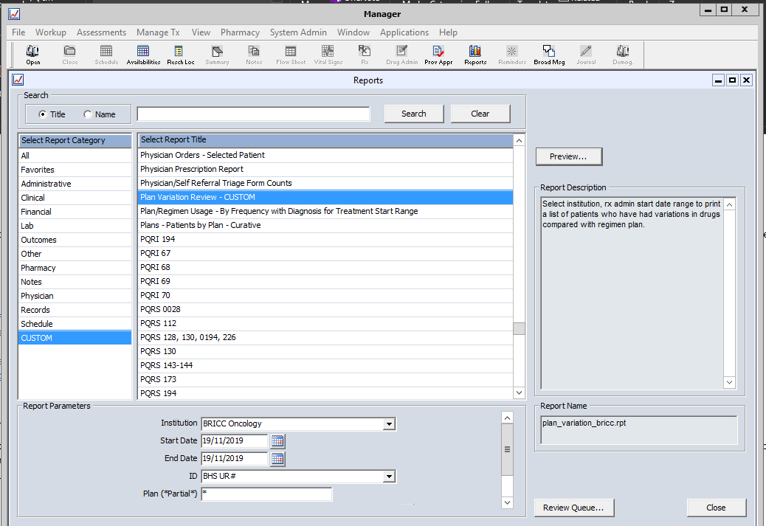

Figure 7: ARIA report parameters for report generation
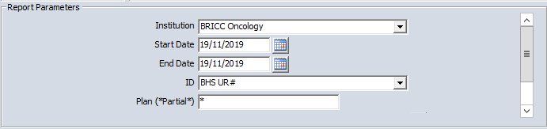
Report should look like Figure 8 (in the initial version, it may look like the column headings are repeated on the left-hand side for each row, followed by the data – the tool takes this into account):
Figure 8: Example ARIA report
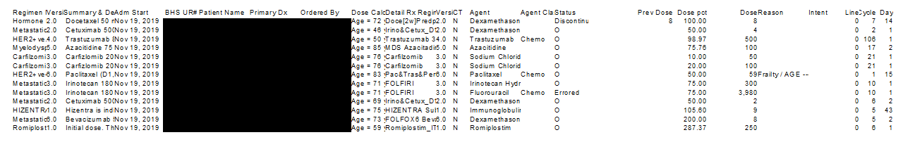
Export as CSV as per Figure 9:
Figure 9: ARIA report export parameters
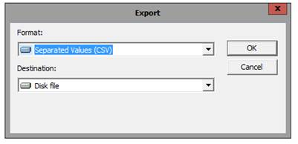
Open with Microsoft Excel and copy data across to tool as directed in the tool
Next step:
- Access the VicTAG Chemotherapy Audit Toolkit ARIA tool and follow the instructions on the “Instructions for Use” tab
  - The report will need to be copied across into the “Data Input” worksheet

Limitations:
- The report will produce information on any cycle and medication altered. The VicTAG ARIA tool will automatically filter for supportive care, if the “Excluded Terms” worksheet is up to date and includes all desired terms.
- The tool contains toggles on the “Instructions for use” worksheet that allows for selection of:
  - Cycle 1 or All Cycles.
  - % variation required to be considered significant (i.e. if 20 is typed in, variations of less than 20% from 100% dose will be filtered out
    - Please ensure these toggles are selected to the desired setting before processing data, otherwise the filtering may need to be manually reset.
- The tool is currently dependent on the order of the output fields being maintained to enable the automatic filter to function correctly. The formulas can be edited if you are confident in using Excel.
Tips and tricks
- Please check the Excluded Terms list in the tab with the same name to see if it matches up with supported therapy terms used in your health service. Modifying this list to match terms that should be excluded will make the automatic filtering step more efficient. Add terms by replacing “Palonosetron” from Row 33 downwards (Don’t delete the content of these cells otherwise the filtering will not work).
- The “Data Analysis” tab provides some basic statistics on variations, such as variations in total, variations excluded, including broken down by stage, and variations sent on to further consideration (unfortunately, the report does not provide information on how many cycles/drugs were checked as part of running the report, so an incidence rate cannot be determined).
- If a particular protocol turns up frequently in the report, the protocol may need to be reviewed to ensure that it is being used as intended or can be modified to suit prescriber intention to minimize the need for variations.
Please direct queries or feedback about the tool (including operation and optimisation) to Cancer Planning at <cancerplanning@health.vic.gov.au>

Acknowledgements - with thanks to Lenny Hill/Jason Wiseman, Ballarat Health Services

MOSAIQ
Method: The Medication Dose History Report includes all dose adjustments for all medications used within a care plan or assigned as an ad-hoc order where the dose is calculated. It is a stock report within MOSAIQ and can be accessed via the report library:
Figure 10: MOSAIQ report selection
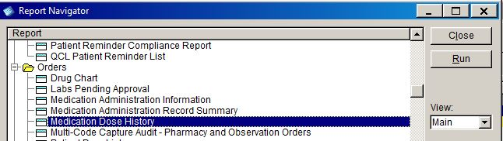
Figure 11: MOSAIQ report parameters
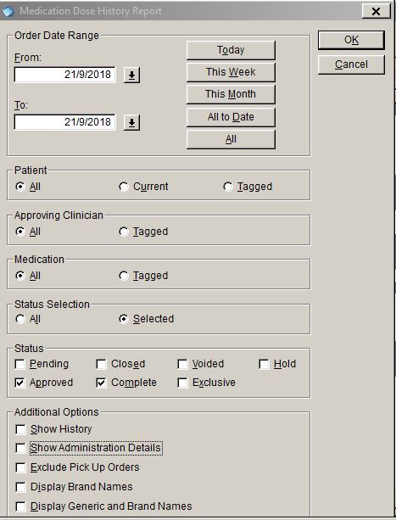
In the original report these filters:

Produce this report:
Figure 11: Example MOSAIQ report
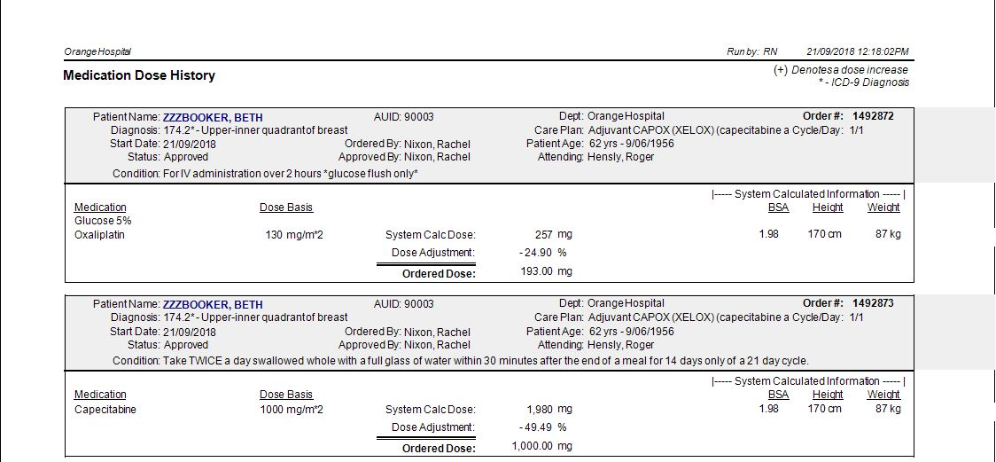

Note:
- A dose adjustment is where the ordered dose varies from the dose calculated by MOSAIQ. For the adjusted dose to be captured by the report the ‘Dose Adj’ tab needs to be used rather than changing the dose basis or the ordering dose on the prescribing page. This opens a further window which allows a reason for the dose adjustment to be entered.
Figure 11: MOSAIQ dose adjustment tab
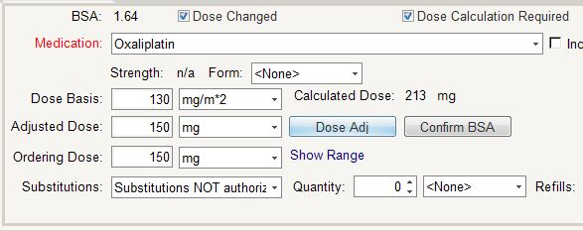

- Allowing prescribers to change of “Dose Basis” or “Ordering Dose” will reduce the functionality of the audit tool.
- The stock report can be filtered so only Cycle 1 Day 1 treatments are displayed.
Limitations:
- This report only considers changes in the dose, not addition or removal of medications or change of medications.
Please direct queries or feedback about the tool (including operation and optimisation) to Cancer Planning at <cancerplanning@health.vic.gov.au>
Acknowledgements - with thanks to Rachel Nixon, Western NSW Local Health District
WNSWLHD use the report, looking at variations of +/- 20% as agreed in the health service. A customised crystal report with the same filters and a changed format were used, with the addition of reasons for dose adjustment added.

Episoft, Cerner Oncology and Epic Beacon

No developed and sharable process exist for Episoft, Cerner Oncology and Epic Beacon. To discuss support for report development at your site please contact Cancer Planning <cancerplanning@health.vic.gov.au>

Note: financial support is not available for creation of custom reports. Support may be available for advice on report parameters and customisation of the Excel tool to the report that the health service is able to provide.

Paper based health services
Refer to Audit Parameters section and Appendix 1 for guidance on selecting scope and evaluating the best group to provide the report for consideration.
For a paper system, the best source for an audit population will vary between health services depending on the infrastructure and systems in place.
Options to source data:
- Chemotherapy Day Unit booking system
- Outpatient Clinic appointment list
- Pharmacy dispensing system
- Other
Each option will have limitations, the clinic appointment list will be the most complete (only missing inpatient treatment) but will be less efficient (i.e. find more patients who aren’t receiving SACT) whereas the chemotherapy day unit booking system will miss both inpatient and oral treatments but be more efficient.
The health service will need to determine the best group to receive and evaluate the information from the report as this group will need to decide the scope and evaluate the report (e.g. MDM/CDSG). The decision around which option to use will need to be made by this group before beginning the audit process, with consideration given to options, resources available for the audit and highlighting the patients receiving SACT that should be reviewed.
Method:
- Identify and analyse possible information sources for strengths and weaknesses. Agree on the source and parameters of audit through the reporting group prior to audit.
  - Parameters include minimum dosage variation for discussion e.g. 10%, Cycle 1 or all patients, curative only or all patients, agents
- Retrieve patient list from selected system.
- Examine patient histories, SACT charts, clinic and pharmacy notes
  - If no dose variations or variations by less than the threshold percentage don’t enter data into the “Paper tool” for patient (however, note that the patient has been audited so coverage can be established)
  - If variation greater than threshold percentage, enter information about patient and variation
  - Review variations for report to MDM/CDSG discussion (exclusion criteria are found in the “Scope guide for exclusion”)
    - If meets exclusion criteria for list as agreed with quality group enter “yes” for exclusion
    - If doesn’t meet exclusion criteria, enter “no” for exclusion
Ensure totals are kept of patients checked from the source, and patients whose SACT cycles have been checked but no variation found. These will form part of the statistical analysis of this data, found in the “Statistics tab” of the tool
- Non-excluded variations would go to MDM/CDSG for review

Figure 12: Example process for paper tool data collection
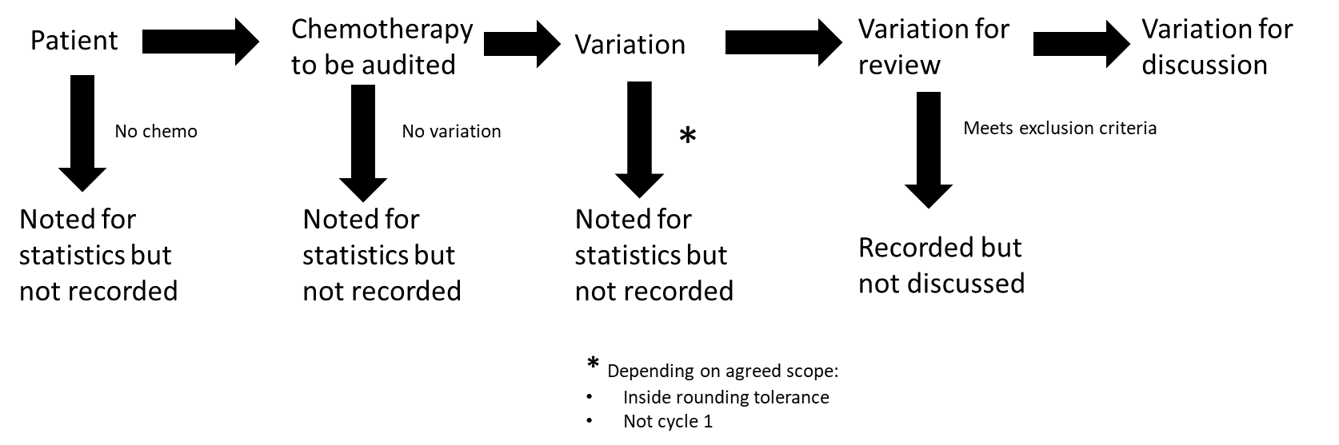
e.g.

Notes:
- Doses are to be matched to internal and/or external (e.g. eviQ) protocols as approved and used by the health service.
- It is unrealistic to expect health services to be able 100% of SACT prescribing without a significant allocation of resources, therefore audits should be targeted as suggested in the Audit Tool Principles section to maximise impact.
- It is strongly recommended that staff resources are allocated separately to this audit activity as it is a significant investment of time.
- The audit period should include acknowledgement of cycle length for common SACT protocols in the cancer disease stream that is being treated to ensure that appropriate coverage is obtained (e.g. for lymphoma, 3 weeks of data would ensure that patients on CHOP are included).
Please direct queries or feedback about the tool (including operation and optimisation) to Cancer Planning at <cancerplanning@health.vic.gov.au>
Acknowledgements: Thanks to John Coutsouvelis (Alfred Health) and Amanda Tey (Monash Health) for input and piloting the paper-based tool.

To receive this document in another format, email the Cancer Planning email <cancerplanning@health.vic.gov.au>.
Authorised and published by the Victorian Government, 1 Treasury Place, Melbourne.
© State of Victoria, Australia, Department of Health, July 2025.
Available at <https://www.health.vic.gov.au/cancer-treatment/chemotherapy-services/chemotherapy-audit-toolkit>

COSA: Cancer Therapy Medication Safety Working Group. COSA guidelines for the safe prescribing, dispensing and administration of systemic cancer therapy. Sydney: Cancer Council Australia. [Version URL: https://wiki.cancer.org.au/australiawiki/index.php?oldid=183289, cited 2018 Oct 16]; SHPA: Coutsouvelis J, Adams J et al. Standard of practice in oncology and haematology for pharmacy services. J Pharm Pract Res 2020; 50: 528-45. https://doi.org/10.1002/jppr.1686 ISOPP: ISOPP Standards for the Safe Handling of Cytotoxics. Journal of Oncology Pharmacy Practice. 2022;28(3_suppl):S1-S126. doi:10.1177/10781552211070933 BOPA: BOPA Standards for Clinical Pharmacy Verification of cancer medicine prescriptions; accessed: <https://www.bopa.org.uk/resources/bopa-standards-for-clinical-pharmacy-verification-of-cancer-medicine-prescriptions-october-2018/> accessed 1/5/23 ASHP: GOLDSPIEL, B., HOFFMAN, J.M., GRIFFITH et al, 2015. ASHP Guidelines on Preventing Medication Errors with Chemotherapy and Biotherapy. Am J Health Syst Pharm, 72(8), pp. e6. ASCO: 2016 Updated American Society of Clinical Oncology/Oncology Nursing Society Chemotherapy Administration Safety Standards, Including Standards for Pediatric Oncology; Michael N. Neuss, Terry R. Gilmore, Kristin M. Belderson, et al. Journal of Oncology Practice 2016 12:12, 1262-1271
2. Relevant Standards/Guidelines for each step in the evidence to patient journey, numbered by relevant step: 4. Standards for Pharmacy Verification of Prescriptions for Cancer Medicines, BOPA. 5. AdPha: SHPA Guidelines for Medicines Prepared in Australian Hospital Pharmacy Departments. Journal of Pharmacy Practice and Research, 40: 133-143. https://doi.org/10.1002/j.2055-2335.2010.tb00521.x ; new Standard of Practice to be released second half 2025 6. COSA: Cancer Therapy Medication Safety Working Group. COSA guidelines for the safe prescribing, dispensing and administration of systemic cancer therapy. Sydney: Cancer Council Australia. [Version URL: https://wiki.cancer.org.au/australiawiki/index.php?oldid=183289, cited 2018 Oct 16; see sections on Responsibilities, competencies and skills of the nurse
The information sources often have nuances about the patient population that can be collected. CDU lists may not have patients that have only oral chemotherapy treatment, whilst appointment lists will contain patients that are not currently on treatment and may miss private patients treated in a public health service. Health services may also have access to documents not considered as part of this guide that can be used to help audit patient populations.

