

VHF case investigation flow chart
Victorian guideline on viral haemorrhagic fevers
OFFICIAL
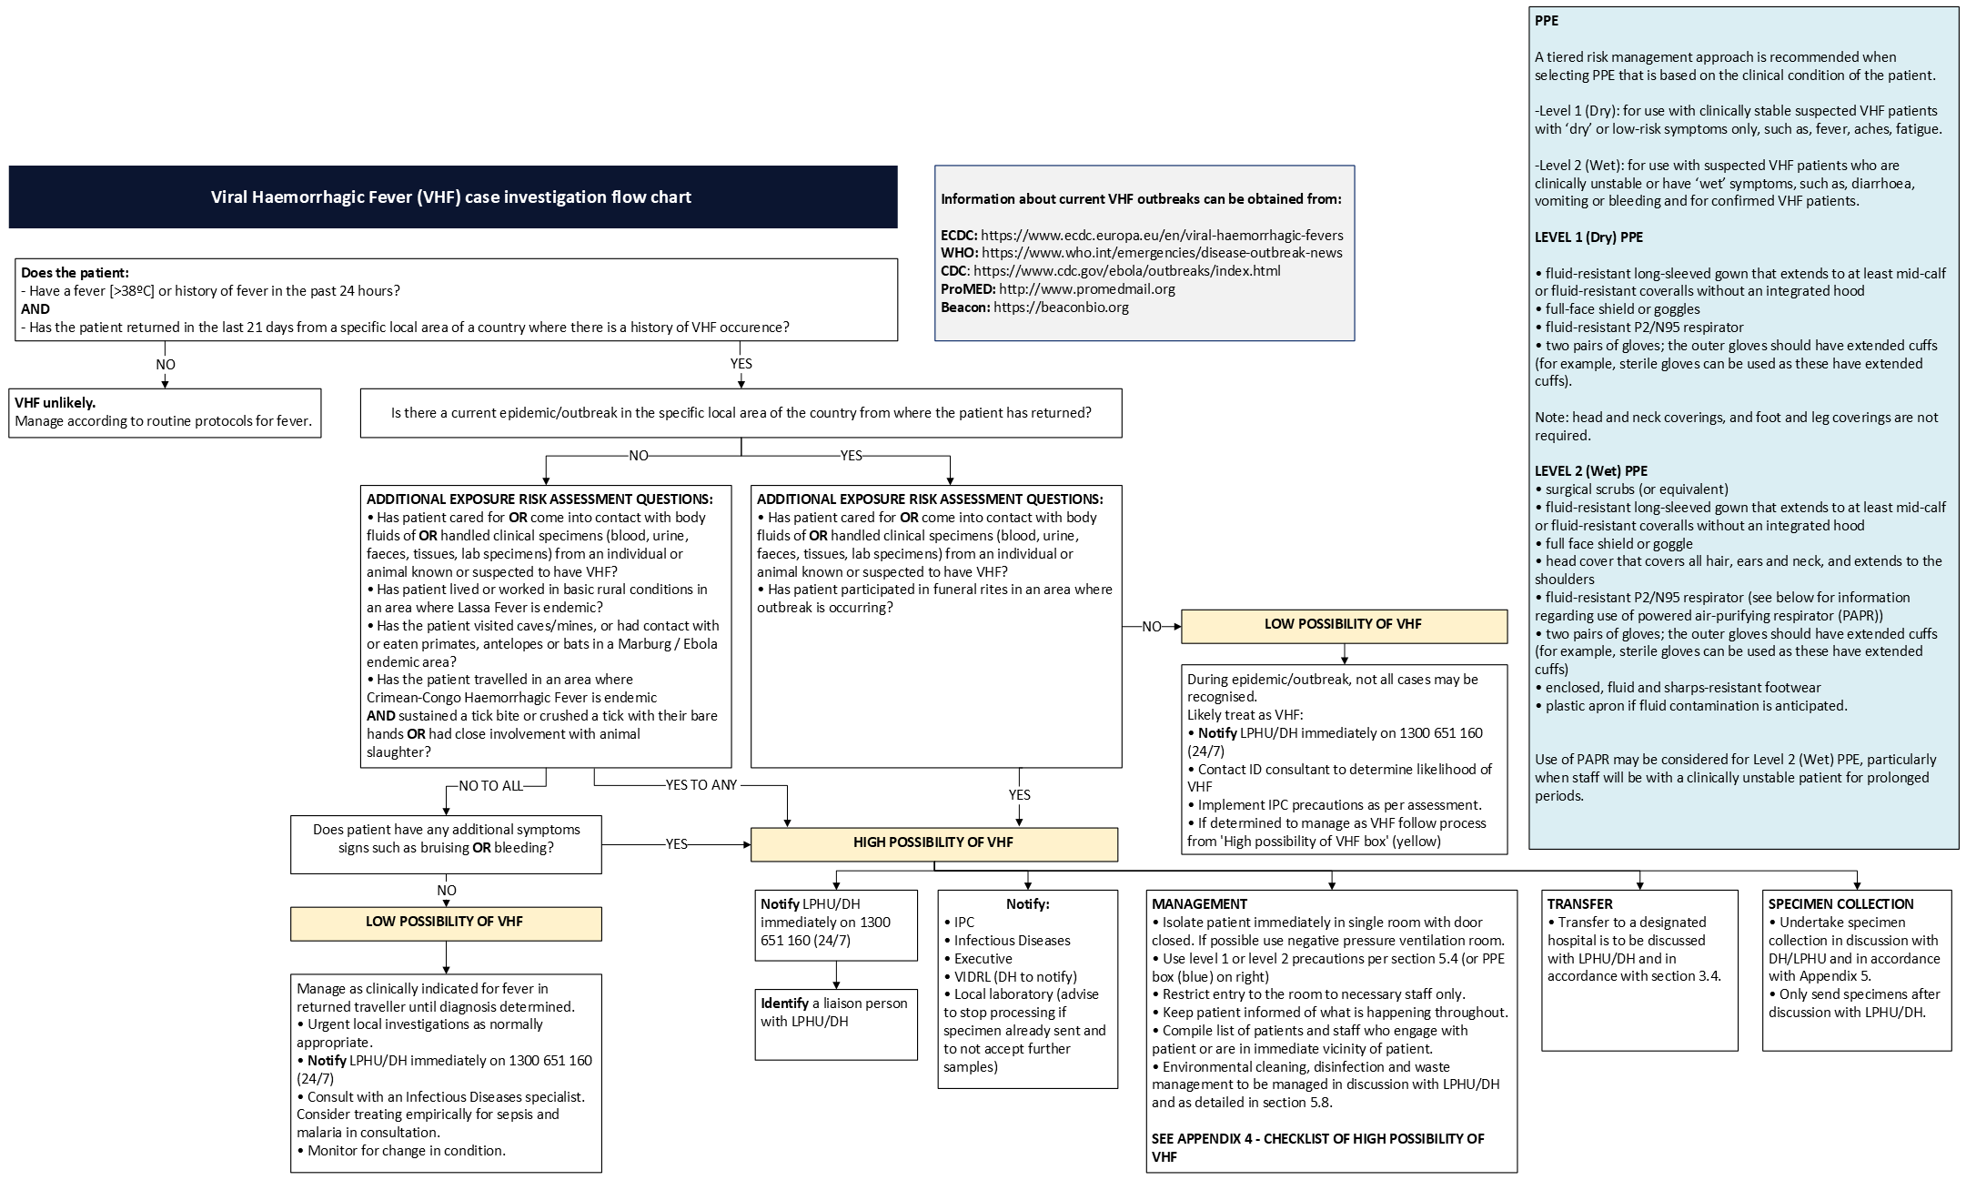
To receive this publication in an accessible format phone Communicable Disease Section on 1300 651 160, using the National Relay Service 13 36 77 if required, or email Communicable Disease Section <infectious.diseases@health.vic.gov.au>.
Authorised and published by the Victorian Government, 1 Treasury Place, Melbourne.
© State of Victoria, Department of Health, December 2025.
Available on Victorian guideline on viral haemorrhagic fevers <https://www.health.vic.gov.au/victorian-guideline-on-viral-haemorrhagic-fevers

