

RSV Mother and Infant Protection Program
Fact sheet for maternity services – Birth dose Beyfortus™ (nirsevimab)
OFFICIAL

Introduction
The National Respiratory Syncytial Virus Mother and Infant Protection Program (RSV-MIPP) commenced in February 2025.
Under this program
- A maternal RSV vaccine (Abrysvo®) is available under the National Immunisation Program for eligible pregnant women.
- The Victorian Government-funded RSV monoclonal antibody (Beyfortus™( nirsevimab) is available during Victoria’s RSV season for infants at highest risk of severe RSV disease.

Maternal immunisation

RSV vaccine (Abrysvo®)
- A single intramuscular dose is recommended during pregnancy between 28- and 36-weeks’ gestation.
- If not vaccinated before 36 weeks, administer the vaccine as soon as possible after 36 weeks, unless the patient is booked for an elective caesarean or induction within 2 weeks.
- The vaccine is free in pregnancy under the National Immunisation Program.

Protection for infants
- Maternal vaccination produces RSV-specific antibodies that cross the placenta and protect the baby at birth.
- Protection is provided from birth to approximately 6 months of age against severe lower respiratory tract disease caused by RSV.
- Infants are not expected to be adequately protected unless they are born at least 2 weeks after maternal vaccination.

Infant passive immunisation
There are no RSV vaccines available for active immunisation of neonates or infants.
Neonates must not receive RSV vaccine.
Eligibility for Beyfortus™ (nirsevimab).
From mid-March to September, neonates are eligible to receive passive immunisation with Beyfortus™ (nirsevimab) if any of the following apply:
- Mother did not receive RSV vaccination during pregnancy.
- Baby was born less than 2 weeks after maternal RSV vaccination.
- The baby is at increased risk of severe RSV, regardless of maternal immunisation status.
- The mother had severe immunosuppression (which may reduce immune response to maternal vaccination)
- The mother received the RSV vaccination in pregnancy, but the infant subsequently underwent a treatment that reduced maternal antibodies (e.g. cardiopulmonary bypass or ECMO).

Table 1. Flow chart to guide which infant should receive nirsevimab in their first RSV season
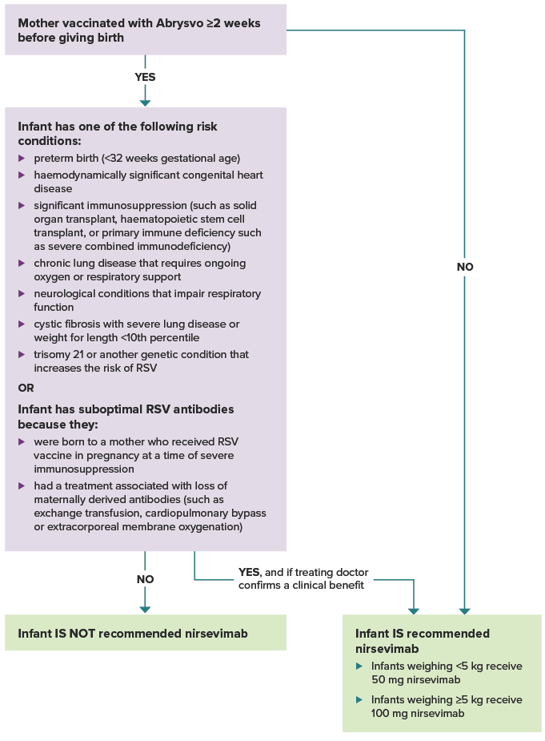

Timing of administration
- For eligible neonates, nirsevimab can be administered by the maternity staff soon after birth.
- It can be co-administered with Vitamin K and Hepatitis B injections.
- If not administered prior to discharge, catch up immunisation can occur via:
  - Specialist Hospital Immunisation Services at the Royal Children’s Hospital or Monash Health (referral is required),
  - General Practice (GP),
  - Aboriginal Health Service, or
  - Local Council Immunisation Services.

Dosage and route of Beyfortus™ (nirsevimab)
- Infants weighing <5 kg, is 50 mg (0.5 mL), by intramuscular injection.
- Infants weighing ≥5 kg, is 100 mg (1 mL), by intramuscular injection.

Australian Immunisation Register (AIR)
- Check maternal immunisation status on the AIR or maternity record prior before administering Beyfortus® (nirsevimab).
- Report all administration of maternal RSV vaccine (Abrysvo®) and RSV monoclonal antibody Beyfortus® (nirsevimab) to the AIR.

Immunisation brand | Immunisation AIR code
ABRYSVO | ABRSV
Beyfortus (Nirsevimab) | BFRSV

References:
The Australian Immunisation Handbook, RSV Australian Government Department of Health and Aged Care
Respiratory Syncytial Virus (RSV) immunisation The Victorian Department of Health
RSV-MIPP decision aids The Victorian Department of Health

To receive this document in another format, email Immunisation Program <immunisation@health.vic.gov.au>
Authorised and published by the Victorian Government, 1 Treasury Place, Melbourne.
© State of Victoria, Australia, Department of Health, January 2026.
Available at Respiratory Syncytial Virus (RSV) immunisation <https://www.health.vic.gov.au/immunisation/respiratory-syncytial-virus-immunisation>

