
Victorian Eyecare Service
Operational guide
August 2025
OFFICIAL



Victorian Eyecare Service
Operational guide


Produced in collaboration with the ACO Eye Health (part of the Australian College of Optometry).
To receive this document in another format, email Community Health <community.health@health.vic.gov.au>
Authorised and published by the Victorian Government, 1 Treasury Place, Melbourne.
© State of Victoria, Australia, Department of Health, October 2025.
ISBN 978-1-76131-925-9 (online/PDF/Word)
Available at Primary care <https://www.health.vic.gov.au/primary-and-community-health/primary-care>.

Contents
Contents 5
Purpose 7
Program overview 7
Service goals and objectives 7
Victorian Eyecare Service (VES) 7
Victorian Aboriginal Spectacles Subsidy Scheme (VASSS) 8
Service streams 8
Metropolitan VES/VASSS 8
Outreach Services 8
Rural VES/VASSS 8
Target group and patient eligibility 9
Diversity and access to eye care 10
Program costs and patient contribution 11
Visiting Optometrist Scheme 12
Information and privacy 12
Complaints 13
Service providers and complaints handling 13
Service agreements and funding 14

Purpose
These guidelines for the Victorian Eyecare Service (VES) have been developed by the Department of Health (the Department) and the Australian College of Optometry (ACO) to support VES providers. The VES is administered by the ACO’s clinical services division, ACO Eye Health, and is delivered across a range of locations and in partnerships with private practice optometrists in rural and regional Victoria. These guidelines apply to all VES providers across Victoria and provide relevant information for partner organisations, networks and individuals.

Program overview
The VES provides statewide subsided eye care services and visual aids to individuals and communities experiencing disadvantage, aiming to improve the provision of eye care and reduce barriers to eye care access.
The VES is complemented by the Victorian Aboriginal Spectacle Subsidy Scheme (VASSS) which aims to further enhance access for Aboriginal and/or Torres Strait Islander Victorians. The VASSS is administered by ACO Eye Health in partnerships with Aboriginal Community Controlled Health Organisations (ACCHOs) and participating private practice optometrists in rural areas.

Service goals and objectives

Victorian Eyecare Service (VES)
The VES supports the provision of functional vision and ocular health assessments and provides subsidised visual aids to people experiencing disadvantage and barriers to care. It promotes the prevention of eye diseases and avoidable vision loss from conditions such as refractive error, age-related macular degeneration, cataract, diabetic retinopathy, and glaucoma.
The VES service targets and funding are guided by government policy directions and annual budgets. VES funding supports two main functions:

Service Provision
- VES services support ready access to direct eye care and visual aids, delivered in a culturally sensitive manner for priority populations.
- Clinical imaging and diagnostic services for ocular conditions are provided at no cost to VES clients for ACO Eye Health provided services.
- The VES builds awareness of services and the importance of eyecare through ongoing health promotion, and community engagement.

Subsidising the cost of visual aids
- Funding is used to directly support the provision of subsidised glasses statewide, direct practitioner support and VES rural development, and claims processing.
- A client may receive one or more pairs of VES subsidised visual aids based on clinical need.
- VES clients pay contributions ranging from $49 depending on clinical need (see section 2.4 for further information).
- People who require and are eligible for VES visual aids can choose to purchase non-VES visual aids with additional cost.
- An eye consultation may not necessarily lead to the prescription of visual aids.

Victorian Aboriginal Spectacles Subsidy Scheme (VASSS)
ACO Eye Health administers the VASSS. This Victorian government funding (since 2010) is additional to the VES, further reduces the co-payment for Aboriginal Victorians. The VASSS assists individuals to access specifically designed community-endorsed frames, along with prescription lenses for a contribution of $10.
The VASSS is delivered through the statewide VES practitioner network and in certain rural areas is supported by the Commonwealth Government’s Visiting Optometrist Scheme (VOS). In Victoria the VOS is administered by Rural Workforce Agency Victoria (RWAV).
The main objective of the VASSS is to improve access to high quality affordable glasses for Aboriginal Victorians. Additional intended outcomes are to:
- Increase uptake of primary eye care by Aboriginal people.
- Identify and diagnose vision-threatening eye diseases (e.g. cataract and diabetic retinopathy).
- Improve care access pathways through onward referral to ophthalmologists for treatable eye disease.
- Involve Aboriginal communities in eye health planning.

Service streams
The VES is delivered across three pathways: Metropolitan VES, Outreach Services and Rural VES.

Metropolitan VES/VASSS
The VES is delivered across seven ACO Eye Health access points/fixed clinics in metropolitan Melbourne – Carlton (head office), Braybrook, Coolaroo, Dandenong, East Reservoir, Knox and Wyndham Vale. These clinics were identified as locations with the highest need.

Outreach Services
The provision of outreach services aims to further reduce barriers to eyecare for people who are unable to access mainstream services. Priority target groups include people living in supported residential services (SRS), or aged care facilities, Aboriginal Victorians, people experiencing homelessness, people with disability, and refugees and seekers of asylum.

Rural VES/VASSS
ACO Eye Health partners with 79 reputable regional and rural private optometry practices located across different Local Government Areas (LGAs) to supply the VES. Out of the 79 participating practices 42 also provide VASSS services. Through these partnerships, access to the VES/VASSS is available in Barwon-South Western, Eastern Metro, Gippsland, Grampians, Hume, Loddon Mallee, North and West Metro, and Southern Metro. Eligible patients can contact these practices directly to organise their eye examinations and access subsided visual aids.
Note: Minor operational differences exist across these three VES pathways. These operational differences largely relate to how appointments and subsidies are processed.

Target group and patient eligibility
The VES targets people experiencing disadvantage and other barriers to eyecare. It is available for residents of Victoria who have:
- A current Pensioner Concession Card in their own name.
- A current Health Care Card in their own name or are listed on the Health Care Card as a dependent.
- A current Department of Veteran Affairs (DVA) Gold Card in their own name.
- An Aboriginal or Torres Strait Islander background (for the VASSS, which is a further subsidy under the VES).
- Child protection involvement in their care.
- Refugees and seekers of asylum.
- People fleeing domestic violence.
Within the target population, the VES focuses on the following groups who may experience difficulty gaining access to eye care services:
- People from culturally diverse backgrounds.
- People experiencing financial disadvantage (including people who experience or are at risk of homelessness).
- People living in rural and remote areas.
- People living in public sector residential aged care, supported residential services, disability accommodation services, youth justice facilities, and older person public housing.
- People with low levels of health literacy
- People who have complex medical and ocular health conditions
- People with mental health illnesses
There are no restrictions based on residency status or visa type. The VES may be available to people experiencing other types of disadvantage and barriers not included in the list above, with eligibility assessed by ACO Eye Health on a case-by-case basis.
Other barriers to access are also considered in the provision of VES services – for example age, gender identity, sexual orientation, faith and spirituality. It must be noted that there may be other groups of people which do not fall in the above categories who may be considered eligible for the VES. Some of the patient groups supported through the VES are:
- People experiencing homeless and job seekers
- People seeking asylum and refugees
- Aboriginal and Torres strait islander peoples
- People eligible for government health and financial assistance
- Individuals with mental health needs and people with disabilities
- Children and young people
- People in custody
- People living with dementia
- Survivors of family violence
- People from culturally and linguistically diverse backgrounds.

Diversity and access to eye care
The VES is committed to respecting the diversity of the Victorian population by addressing perceived or actual barriers to care.
Some suggested barriers as indicated in the Ethnic Communities Council of Victoria (ECCV) Policy Papers include:
- Lack of culturally and linguistically appropriate information.
- Lack of knowledge in navigating Australian systems and services, particularly for migrants who arrive in Australia at an older age.
- Mistrust of mainstream services.
- Age at migration and migration experience, including experiences of trauma.
- Low socioeconomic status.
- Low health literacy.
- Low digital literacy.
- Low level of educational attainment.
- Differing cultural practices and norms.
- Lack of access to information technology, such as devices and internet.
- Living in rural or remote communities.
With a holistic approach to eye care, the VES can be an important first step as people engage with the wider health care system. Working in partnership with other community providers to deliver services to people in disadvantaged communities ensures better outcomes and access to healthcare services, particularly when multiple health and social issues may be present. When a person receives a VES consultation, practitioners may identify referral needs for broader health and wellbeing.
Figure 2 reflects the collaborative approach to the VES within the broader service community and highlights the importance of partnership, networking, liaising and planning across a range of community services to contribute to the health and wellbeing of people in disadvantaged communities.
Figure 2: Patient Centred Care
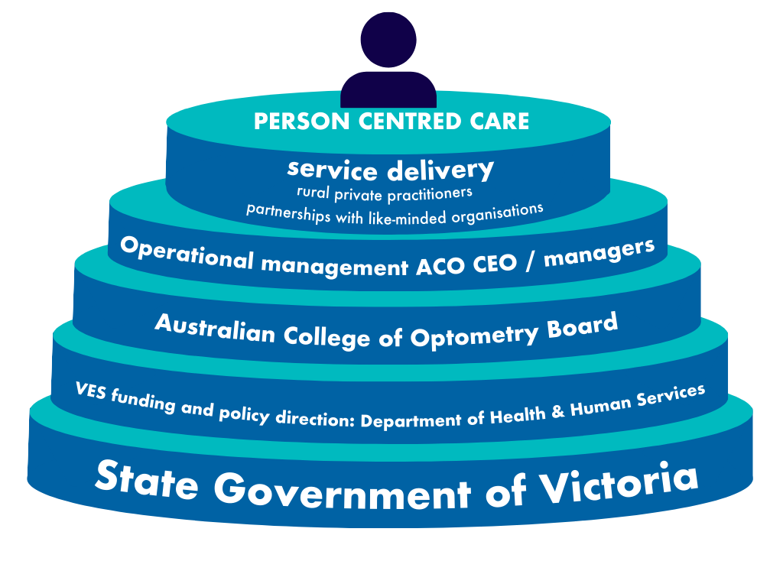

Program costs and patient contribution
When visual aids are dispensed, a subsidised fee is charged and is known as a client contribution. Clients pay contributions, which range from $49 depending on their clinical needs. Variations to client contribution fees charged are dependent on the type of visual aid dispensed. Appendix 1 outlines the current schedule of client contributions which is published on 1 July each year and is subject to change. It is made available through the ACO Eye Health website and to practitioners engaged in VES delivery in rural areas.
Consultation fees for eye examinations for eligible Victorians are bulk billed through Medicare. If a person has had a vision assessment by another optometrist in the previous 3 years, then the person may be charged a consultation fee. This will be no more than the fee rebate available by Medicare (currently 85% of the schedule fee).
Exceptions to this are as follows:
- Visual Functions Clinic: Medicare benefits are not payable for examinations related to occupational purposes. These include occupational colour vision assessments and ocular screenings for employees using laser equipment. Clients or their employers are charged the full scheduled fee, payable at the time of the consultation as this service is outside the scope of VES
- Contact Lens Services: Clients who meet the Medicare requirements for the provision of contact lenses may have their consultations bulk-billed through Medicare. Otherwise, the full scheduled fee is charged at the contact lens appointment.
Should an individual be unable to pay the consumer contribution fee or the VES provider is unable to claim the Medicare rebate for a visual assessment, access to the VES will not be denied on these grounds. The VES will consider ineligible clients requesting financial assistance on a case-by-case basis. A rural practitioner may, at their discretion, provide a gratis consultation if Medicare benefits are not available. In other cases, these patients should be referred to ACO Eye Health where provision of care may be available through block funding.

Visiting Optometrist Scheme
The Visiting Optometrist Scheme (VOS) is a Commonwealth scheme that supports optometrists to deliver outreach optometric services to remote locations. The Rural Workforce Agency Victoria (RWAV) is the current Victorian fund holder for the VOS and manages the delivery of optometry services funded through the VOS program. The VOS is responsible for recruiting optometrists to provide outreach services in regional, rural and remote locations.
ACO Eye Health works with RWAV to deliver eye care services to Aboriginal communities including Lakes Entrance, Orbost, Lake Tyers, Bairnsdale, Sale, Halls Gap, Ballarat, Healesville, Brunswick East, Fitzroy, Thomastown, Frankston Wyndham Vale and Sunbury.

Information and privacy
ACO Eye Health is committed to protecting and preserving the privacy rights of the patients. ACO Eye Health collects information from patients in the course of providing optometry services and products. ACO Eye Health provides de-identified data to the Department of Health for planning, funding, monitoring and evaluating services and functions.
ACO Eye Health is compliant with the following Victorian Legislations:
- Health Records Act 2001 < https://www.legislation.vic.gov.au/in-force/acts/health-records-act-2001/049>
- Privacy and Data Protection Act 2014 < https://www.legislation.vic.gov.au/in-force/acts/privacy-and-data-protection-act-2014/028>
- Privacy Act 1988 <https://www.oaic.gov.au/privacy/privacy-legislation/the-privacy-act>
- Australian Privacy Principles <https://www.oaic.gov.au/privacy/australian-privacy-principles>
- Freedom of Information Act 1982 <https://www.legislation.gov.au/C2004A02562/latest/text>
- Australian Consumer Law <https://consumer.gov.au/>
- Office of the Victorian Information Commissioner <https://ovic.vic.gov.au/>

Complaints
People who access VES are entitled to have complaints investigated objectively and without fear of retribution. ACO Eye Health and private providers must have policies; procedures and processes in place for dealing with and monitoring complaints.

Service providers and complaints handling
Where appropriate, in the first instance complaints should be dealt with by the organisation providing the service.
ACO Eye Health internal complaint mechanisms include a written policy describing how a complaint will be handled and should be made available and explained to all service users, carers and families.
Strategies should be developed to ensure that specific groups, for example people from culturally and linguistically diverse backgrounds, and people with disabilities understand these processes.
ACO Eye Health is also responsible for dealing with complaints lodged by consumers relating to private VES providers. Where a complaint is upheld, ACO Eye Health should review their access and service delivery practices, with a view to making improvements in the service.
People accessing the VES have the right to lodge a complaint about these services. All VES providers should develop and distribute an impartial policy statement and a set of procedures for resolving complaints. A policy should support service providers to:
- Provide information to clients about how complaints are handled
- Learn from their experience of complaints management
- Review the way they do business
- Respond to changes in VES-eligible people’s requirements and changes in management environments.
People who remain dissatisfied or who do not wish to raise the complaint with ACO Eye Health or private provider should have recourse to assistance from the Department or other complaint mechanisms independent of the organisation.
It is likely that some complaints will need to be addressed in a forum that is not associated with, or dependent on, ACO Eye Health or private provider. This may occur when it is not possible to resolve the complaint at the service provider level or when the person does not wish to approach the service provider in the first instance. People who remain dissatisfied or who do not wish to raise the complaint with the service provider, should be advised that they have recourse to seek assistance from the Department, advocate and other resources as listed below.

Department of Health involvement in resolving complaints
It is appropriate for the Department to play a formal role in complaints that cannot be resolved with the service provider or are raised by service users who feel that they are unable to approach the service provider directly. Service users can contact the department via online form or email at health.feedback@health.vic.gov.au
For further information visit the Department of Health feedback and complaints webpage <https://www.health.vic.gov.au/contact-us/submit-a-complaint>.

Service agreements and funding
State government funds are allocated to an organisation through a service agreement between the funded organisation and the Department. The current funding cycle and agreements are for service delivery in the financial years 2025-2029 with annual indexation. Funded organisations are required to comply with the service agreement terms and conditions.
VES recurrent indexed funding provides services to people experiencing disadvantage and other targeted populations. VES funds cannot be used for non-VES purposes. This funding covers direct, and indirect costs (not covered by Medicare) incurred by ACO Eye Health when delivering and administering VES through the three service streams (metro, outreach, and rural):
- Health promotion and community engagement
- Visual aid provision
- Equipment and vehicle maintenance
- Staff and associated costs (such as salary and on-costs, supervision, in-service training and induction)
- Operational support and management costs (overheads)
Other funding may be available from time to time. Examples include service development funding, or minor capital funding. These are one-off payments and where appropriate specific reporting requirements will be negotiated.
Validated quarterly reporting is completed by ACO Eye Health and reported to the Department of Health. ACO Eye Health reports on the agreed BP3 metrics which includes Occasion of Service (OOS), number of unique patients and number of visual aids as per their service agreements and targets. The reports are collated, and aggregate information is sent to the Department of Treasury and Finance.
These quarterly reports provide information about service demand, impact, waiting times and include suggestions to assist with service planning and identifying service gaps. To access reports visit the ACO’s Reports and Publications webpage <https://profession.aco.org.au/reports-and-policies>.

