

Victorian Health Services Performance Monitoring Framework 2025-26
OFFICIAL

To receive this publication in an accessible format phone 9096 7120 using the National Relay Service 13 36 77 if required, or email Accountability <accountability@health.vic.gov.au>
Authorised and published by the Victorian Government, 1 Treasury Place, Melbourne.
© State of Victoria, Department of Health, August 2025.
This publication is copyright. Apart from any use permitted under the Copyright Act 1968 (Cth), no part may be reproduced by any process, nor may any other exclusive right be exercised, without the permission of the Department of Health, 2025.
`ISSN 2209-4172 – Online (pdf / word)
Available at Funding, performance and accountability webpage <https://www.health.vic.gov.au/hospitals-and-health-services/funding-performance-and-accountability>

Contents

Overview 5
1. Scope of the Framework 7
2. Key components of the Framework 8
2.1 The Performance Domains 9
2.2 The Performance Tiers 10
3. The Performance Cycle 12
3.1 Planning and Strategy 13
3.1.1 Statement of Priorities 13
3.1.2 Annual Strategy Meeting 13
3.2 Continuous Improvement 13
3.2.1 Ongoing improvement work 14
3.3 Accountability 15
3.3.1 Health Service Engagement and Formal Performance Meetings 16
4. Formal performance assessments and performance tier changes 17
4.1 Performance Tier Criteria 17
4.2 Performance Tier Escalation and De-escalation 17
4.3 Escalation Options 18
4.4 Performance Tier Change and Notification 18
5. Performance Meeting Approach 19
5.1 Tailored Performance Meetings for Effective Oversight 19
6. Roles and responsibilities 21
6.1 Health services 21
6.2 Department of Health 21
6.2.1 Overarching departmental roles and responsibilities 21
6.2.2 Roles and responsibilities across areas of the department 22
7. Reporting requirements 26
7.1 Specific events – Breaches 26
7.2 Reporting of temporary change to capability level 27
Appendix 1: Coverage of the Framework 28
Appendix 2: Statement of Priorities (SoP) 29
Appendix 3: Initiatives to support performance improvement 31
Appendix 4: Performance Tier Criteria 33
Appendix 5: Implications for health services in each performance tier 35
Appendix 6 - Escalation options and considerations for use 38
Attachment 1 - Health service notification process 40
Attachment 2 - Temporary Capability Change Notification Template 42

Overview
The Victorian Health Services Performance Monitoring Framework (the ‘Framework’) articulates how the Department of Health (‘the department’), as the steward of Victoria’s public health system, oversees the performance of health services to deliver safe, high-quality, accessible, and sustainable healthcare for Victorian patients and communities.
The Framework has progressively incorporated a broader range of performance factors, balancing quantitative and qualitative measures to assess not only target achievement but also continuous improvement and risk management.
In 2024-25, the Framework was substantially revised to reset expectations, strengthen central support, and clarify accountability, this has been further refined in 2025-26. For 2025-26, the Framework builds on these changes with an emphasis on:
- Focusing on core performance priorities: Emphasising access to care, workforce sustainability, financial management, and safety (including culturally safe services), while maintaining adaptability to government priorities.
- Risk-based alignment: Aligning with the department’s risk-response focus through collaborative engagement with health services based on risk, complexity, and performance tier.
- Increasing transparency in performance tier changes: Clearly communicating how performance tiers are determined, the step-by-step process for tier changes, and defined exit criteria to ensure health services understand expectations and outcomes.
- Tailored support to meet the needs of the health service: Adjusting performance monitoring approach to offer greater flexibility, ensuring equitable and relevant expectations. Adopting streamlined escalation processes and fostering proportionate oversight and support.
- Supporting improvement: Through regular engagement, strengthened collaboration and ways of working, access to shared resources and best practices to drive continuous improvement in health service performance.
The Framework adopts a risk-based approach to performance monitoring, enabling the department to assign performance tiers and tailor support based on both performance outcomes and underlying risks.
The remainder of this document is structured as follows:
- Section 1 sets out the scope of the Framework, including its legislative basis in the Health Services Act 1988, its application to publicly funded health services, and links to key policy documents and operating parameters.
- Section 2 outlines key components of the Framework including performance cycle, performance domain and performance tiers.
- Section 3 details each stage of the performance cycle encompassing planning and strategy, continuous improvement and formal accountability.

- Section 4 outlines formal performance assessments and performance tier changes.

- Section 5 outlines performance meeting approach.
- Section 6 details distributed roles and responsibilities across the department, including key points of contact for health services.
- Section 7 specifies formal reporting requirements.

The department is committed to partnering with health services to enhance performance through the Framework. In 2025-26, the department will continue to evaluate the Framework’s effectiveness, engaging with health services as needed to identify and prioritise areas for ongoing improvement.

Scope of the Framework
The Framework applies to all publicly funded health services, as listed in Appendix 1. The term ‘health services refer to the ‘public hospitals’, public health services’, and ‘multi-purpose services’ listed in the Health Services Act 1988, unless otherwise specified. Similarly, the department’ encompasses various areas within and alongside the Department of Health, including independent entities such as Safer Care Victoria and the Office of the Chief Psychiatrist.
The Framework draws its primary authority from, and operates in accordance with, the Health Services Act 1988 (HSA), which defines the roles of Ministers, the department, Secretary, and Boards of Directors in overseeing health service performance. It is published as two interconnected documents: this Framework and the accompanying Victorian Health Services Performance Monitoring Framework Business Rules <https://www.health.vic.gov.au/funding-performance-accountability/performance-monitoring-framework>. The Business Rules detail key performance measures, risk factors, technical specifications, and updates for 2025-26.
The Framework aligns with broader operating parameters set by key policy documents, including:
- strategic priorities and service delivery targets set out in each health service’s Statement of Priorities (SoPs) <https://www.health.vic.gov.au/funding-performance-accountability/statements-of-priorities>, the key service delivery and accountability agreements between health services and the Minister for Health and Ambulance Services
- the Department of Health’s Strategic Plan 2023-27 <https://www.health.vic.gov.au/our-strategic-plan-2023-27> and Outcomes Framework <https://www.health.vic.gov.au/our-strategic-plan-2023-27/our-outcomes-framework>, which reflect the Victorian Government’s priorities and inform the SoPs
- the conditions of health service funding (including detailed program and policy requirements) outlined in the Policy and Funding Guidelines <https://www.health.vic.gov.au/policy-and-funding-guidelines-for-health-services>
- the Victorian Clinical Governance Framework <https://www.safercare.vic.gov.au/best-practice-improvement/publications/clinical-governance-framework>, which articulates expectations of clinical governance to ensure quality and safety of care
- the Mental Health and Wellbeing Outcomes and Performance Framework <https://www.health.vic.gov.au/mental-health/research-and-reporting/mental-health-and-wellbeing-outcomes-and-performance-framework>.
- Service capability frameworks are being introduced for clinical streams across Victoria's health system. Service capability frameworks for Victoria | health.vic.gov.au < https://www.health.vic.gov.au/health-system-design-planning/service-capability-frameworks-for-victoria>

Key components of the Framework
The Framework is built around three key components: the Performance Cycle, Performance Domains, and Performance Tiers, which together drive strategic alignment, improvement, and accountability.

Figure 1: Key components of the Framework

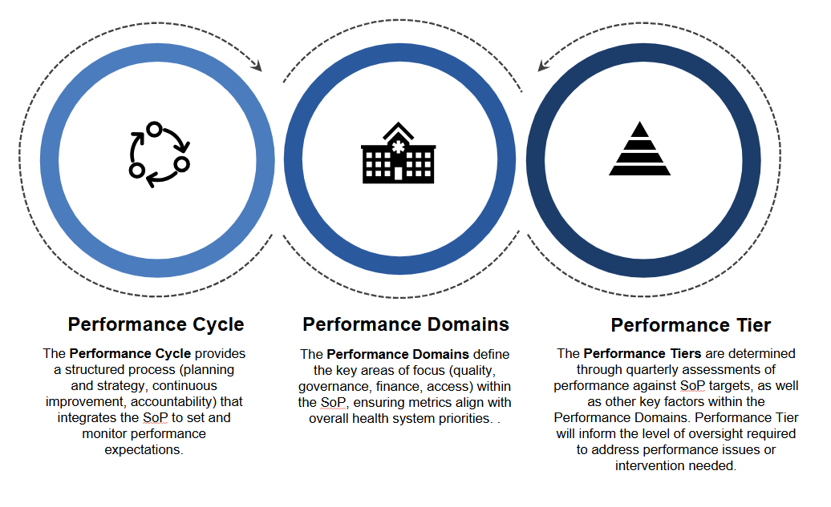The Performance Cycle
The Performance Cycle (Figure 2) drives health service performance through 3 interconnected
stages:

- Planning and Strategy
- Continuous Improvement
- Accountability
Refer to Section 3 for detailed performance cycle process.

Figure 2: The Performance Cycle

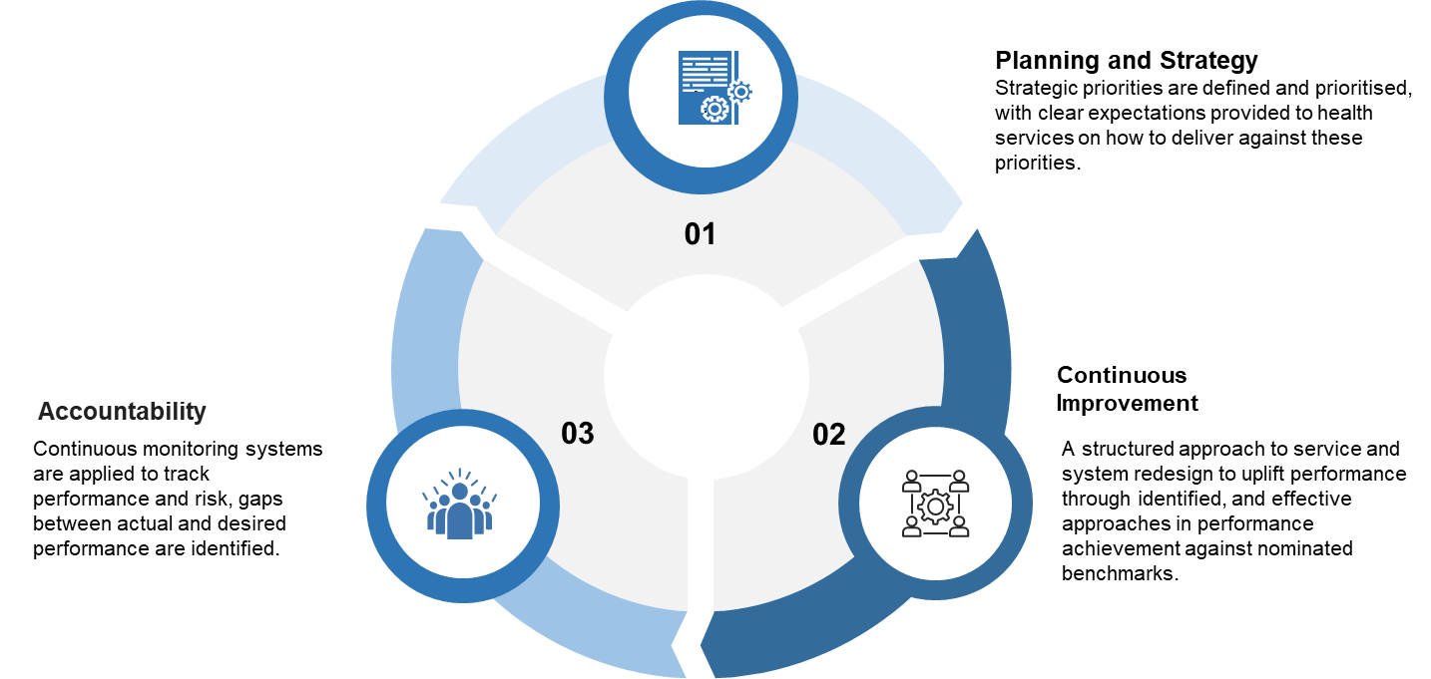

The Performance Domains
The Framework outlines four interdependent performance domains that determine the overall performance of health services. These domains are central to the Framework’s performance cycle and are used to monitor, assess, and guide strategic goals to achieve the best patient outcome (see Figure 3). These domains are:
- High quality and safe care: delivery of safe and high-quality care that improves patient outcomes and involves a positive and culturally safe experience of care for patients.
- Strong governance, leadership and culture: overarching organisational maturity, inclusive of characteristics of board and executive leadership and capability, workforce safety and engagement, and clinical and corporate governance.
- Effective financial management: effective and efficient allocation of resources to deliver safe, cost-effective and sustainable services that are delivered within allocated budgets and achieve value from resources.
- Timely access to care: efficient management of supply and demand to equitably provide the right care, in the right place, at the right time, for all Victorians. This reflects operational capacity and delivery of services and programs as well as service efficiency.

Figure 3: Performance Domains

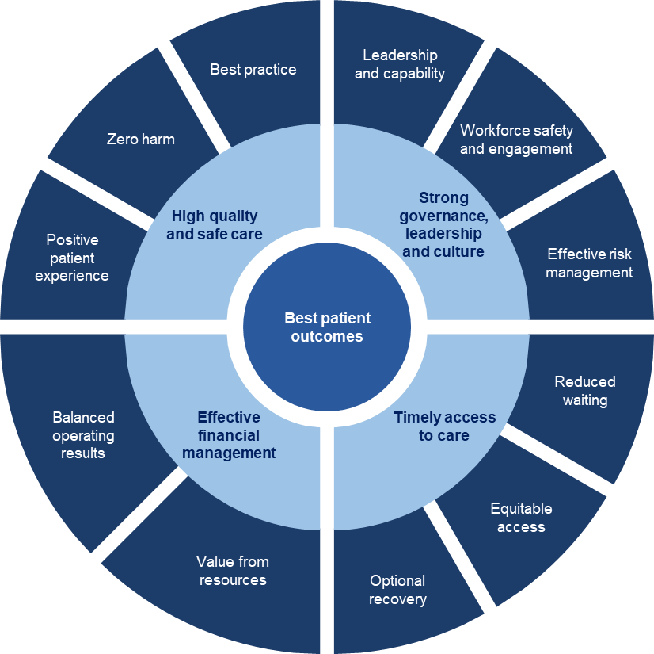

These domains are grounded in relevant legislation and policy. Accordingly, performance across these broader accountabilities will continue to be monitored using a comprehensive suite of quantitative metrics and qualitative intelligence.
The Performance Domains form the foundation of the Statement of Priorities (SoP), to set clear expectations and metrics, ensuring alignment with system priorities. The SoP is designed to articulate a focused set of strategic performance priorities. Health services are accountable for delivering against a defined set of core qualitative and quantitative strategic priorities outlined within the SoP. See Appendix 2 for detailed information on SoP.

The Performance Tiers
Health services are assessed and allocated to one of four performance tiers (see Figure 4) depending on their performance. The levels of autonomy, support, and intervention vary across these tiers in line with health service need. The performance tiers as set out below:
- Enhanced Autonomy: For services excelling across domains, meeting core priorities (balanced budgets, safe care, timely access) and leading system collaboration. They demonstrate sustained improvement and innovation.
- Standard Oversight: For services meeting most targets with credible plans to address gaps, showing improvement and active collaboration.
- Performance Support: For services not aligned with core priorities or not meeting most targets, with poor local performance or significant risks, lacking credible improvement plans or collaboration.
- Mandated Intensive Support: For services with critical, persistent issues (e.g., catastrophic safety or governance failures, significant deficits), requiring intensive intervention.
Refer to Section 4 for formal performance assessments and performance tier changes approach.

Figure 4: Four performance tiers

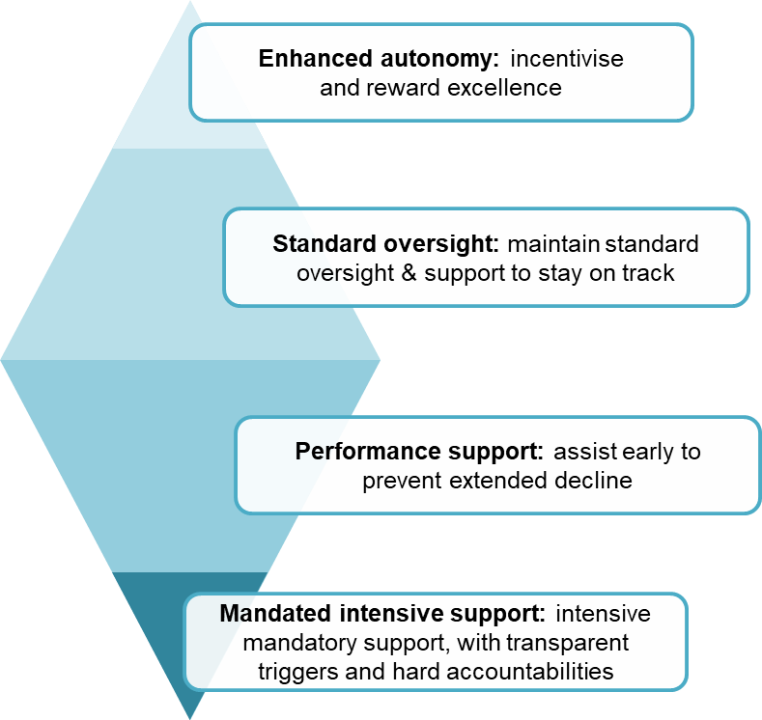

The Performance Cycle
The performance cycle integrates Planning and Strategy, Continuous Improvement, and Accountability to align health services with government priorities and drive health system-wide performance and improvement.
- Planning and Strategy: Health Services will identify strategies that will enable them to achieve government priorities as outlined in the SOP process. The strategies should enable HS to improve or strengthen work in the four performance domains: high-quality and safe care, strong governance and culture, effective financial management, and timely access to care. These are discussed at the annual strategy meeting, with departmental endorsement supporting implementation where needed.
- Continuous Improvement: a structured approach to service and system redesign to uplift performance through identified, and effective approaches to close the gap in performance achievement against nominated benchmarks. Key initiatives include the Timely Emergency Care Collaborative, Planned Surgery Recovery and Reform program, and Safer Care Victoria’s safety and quality programs.
- Accountability: Involves continuous monitoring of performance and risks. Health services are assessed quarterly and assigned to one of four performance tiers (Enhanced Autonomy, Standard Oversight, Performance Support, or Mandated Intensive Support) based on Performance Domains, SoP deliverables and measures and other performance factors.
Engagement with health services for each stage are shown in Figure 5 below.

Figure 5: The performance cycle and ongoing engagement
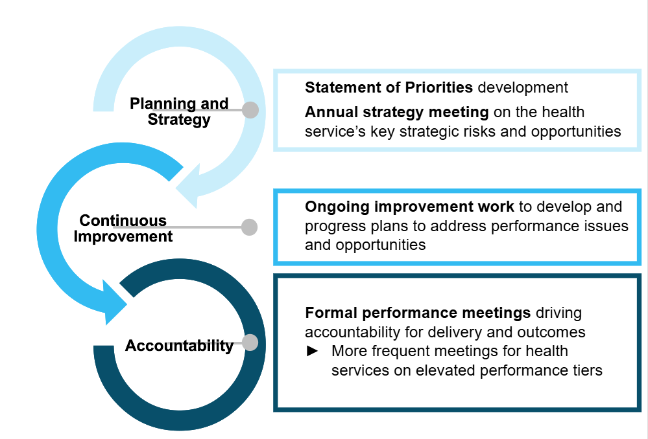

Planning and Strategy
The planning and strategy stage of the performance cycle is where a health service’s operating parameters, priorities and performance strategy are developed through the SoP. The strategy is confirmed through the Annual Strategy Meeting discussions and, where required, supported by departmental authorisations to enable implementation.

3.1.1 Statement of Priorities
The Statement of Priorities (SoP) is the legislated annual service delivery and accountability agreement between each Victorian public health service and the Minister for Health. The SoP is designed to articulate a focused set of strategic performance priorities, rather than serve as a comprehensive performance framework. Health services are accountable for delivering against a defined set of core qualitative and quantitative strategic priorities outlined within the SoP.
It defines how each health service will contribute to the Victorian Government’s health system priorities and the Department of Health’s strategic objectives. The SoP sets out each service’s performance expectations, targets, and funding arrangements for the financial year.
As a member of a Local Health Service Network (LHSN) the health service will also deliver objectives agreed in their Statement of Expectations.
Note: Network accountability arrangements complement and do not replace individual health service accountability requirements such as Statements of Priorities.
See Appendix 2 for further detail on SoP.

3.1.2 Annual Strategy Meeting
The primary objective of annual strategy meeting is to ensure alignment between each health service’s strategic goals and performance objectives. This alignment facilitates effective monitoring and measurable progress throughout the relevant performance monitoring cycle.
The format and timing of these discussions may vary across health services, occurring within a single quarter or spanning multiple quarters, depending on identified areas for improvement or performance priority.
In addition to performance alignment, these meetings serve as a platform to present and explore proposals aimed at advancing innovation and fostering collaboration across the health system. All proposals must demonstrate consistency with government priorities and broader system-wide strategic directions, while also reflecting the specific needs of the health service.

Continuous Improvement
The continuous improvement stage of the performance cycle applies structured approaches to service and system redesign to uplift performance through the science of improvement. Ultimately, health services are accountable for driving, resourcing and achieving their own improvement. However, the department will continue to support improvement where possible by promoting knowledge exchange, aligning efforts across the system, and connecting health service executive and clinical leaders with expert advice. These supports are described below.

Facilitating knowledge exchange and collaboration
Recognising that most improvement will take place at a health service or network level, the department supports system-wide uplift by fostering knowledge exchange and collaboration. This includes facilitating connections between health services through structured mechanisms such as forums, project improvement groups, and strategic initiatives. These platforms enable peer learning, shared problem-solving, and dissemination of best practices.
Initiatives to support performance improvement include the Timely Emergency Care Collaborative, the Planned Surgery Recovery and Reform program, and ongoing safety, quality and workforce wellbeing initiatives led by SCV through its strategic improvement programs. Central work to strengthen peer learning and improvement of financial sustainability and productivity performance will commence, along with a strengthened focus on improvement of cultural safety and equity of access, consistent with the government priorities.
Key areas in the department will maintain leadership roles in oversight of their respective performance domains (e.g. quality and safety with SCV) and output areas (e.g. mental health with the Mental Health and Wellbeing Division) to drive system-wide improvement through strengthened engagement, robust collaboration, and shared innovation.
See Appendix 3: Box 1 an example improvement initiative (Timely Emergency Care Collaborative).

Expert advice, mentoring and review
From 2025, the department will continue exploring opportunities to establish or expand collaborative peer forums that connect services, foster shared learning, and support system-wide improvement.

Often, health services benefit from an external perspective to help diagnose the root causes of performance challenges and unlock ideas to support strategic and operational change. The strongest health service performance improvement expertise in Victoria principally sits in the sector itself – among high performing executives and clinical leaders actively working or having recently worked in health services.

To support senior health service leadership in addressing performance challenges or pursuing improvement, the department will continue to explore opportunities to source expert advice, including from peer health services, or through networked approaches to problem solving.

3.2.1 Ongoing improvement work
The department encourages open dialogue with health services to identify and address performance risks, opportunities for system-wide improvements, and manage issues impacting the sustainability and quality of healthcare delivery.

Key areas of the department (refer to Section 6.2.2) will lead proactive engagement with health services, working collaboratively with health services to navigate complex challenges. This includes leading projects that support health services in delivering inclusive, culturally safe, high-quality, and high-value care for their communities.
Engagement will involve regular communication to monitor progress, identify risks, and uncover opportunities for system improvement initiatives. These interactions will occur outside formal performance meetings, creating a responsive framework for addressing issues as they arise. System improvement initiatives will focus on enhancing healthcare delivery through evidence-based practices, innovative solutions, and cross-departmental collaboration to ensure sustainable outcomes.
This engagement will occur with visibility to the health service’s CEO, with direct involvement determined by their preference, allowing flexibility while maintaining leadership oversight. This approach allow that formal performance meetings remain focused on core performance priorities. Items that are not resolved during these engagements may be escalated to the performance meeting for further discussion and resolution.

Accountability
The accountability stage of the performance cycle involves applying continuous monitoring to track performance and risk, identify gaps between actual and desired performance, and apply effective approaches to close the gap.

Setting Clear Performance Expectations

Health services are expected to report progress against the performance expectations including but not limited to the goals and deliverables in Part A of the Statement of Priorities (SoP), and, where applicable, demonstrate improvement against flagged Part B indicators where there is a significant and sustained deviation from target or a meaningful trend of deterioration. These trends are identified using methods outlined in the Business Rules, which account for seasonal variation, peer comparison, and related performance metrics.
Performance improvement targets should reflect challenging yet achievable trajectories, acknowledging contextual factors such as resource availability or historical challenges. For instance, closing access gaps between Aboriginal and non-Aboriginal patients may require multi-year plans, with interim milestones to track progress.
Regardless of improvement efforts, health services must deliver a baseline against the core government priorities (balanced budgets, safe services (including culturally safe care), timely Access to Emergency Care and Planned Surgery). Failure to meet these standards may trigger an escalation to a higher performance tier.

Continuous monitoring of performance and risk

Performance Oversight teams are responsible for holistic oversight of health services, supported by relevant areas (see section 6.2.2) within the department who provide targeted analysis and insights. Performance Oversight teams integrate insights from multiple sources to ensure a complete view of health service performance.

Performance Oversight teams will utilise quantitative data (e.g. trends, financial metrics) and qualitative data (e.g., third-party reports, cross-agency intelligence) to identify performance risks, inherent vulnerabilities, and emerging concerns. This multi-source approach ensures a robust understanding of risks, and operational challenges by the health service.

3.3.1 Health Service Engagement and Formal Performance Meetings
To ensure the accountability approach is effectively implemented and continuously improved the department will engage with health services through a combination of regular engagements and formal performance meetings.
Health Service Engagements
These are ongoing, flexible engagements led by relevant areas in the department that occur as needed between formal performance meetings. These may include ad-hoc discussions, check-ins, or discussions to address emerging issues, monitor progress, or provide support. Regular health service engagements aim foster collaboration and allow for timely responses to operational or performance concerns without the structured format of performance meetings.
Formal Performance Meetings
These are structured, scheduled meetings focused on addressing unresolved issues escalated from health service engagements. They provide a forum to review performance, discuss risks, and agree on action plans to drive improvement. These meetings are distinct from health service engagements in their formal structure and focus on strategic resolutions.
Refer to Section 5 for the performance meeting approach.

Formal performance assessments and performance tier changes
The Framework establishes a transparent and structured approach to performance assessment, escalation, and accountability to ensure health services deliver safe, high-quality, and sustainable care. Health Services will be assigned a performance tier at the end of each quarter.
Performance tiers are tied to the Performance Cycle’s accountability stage, reflecting performance against Performance Domains, Statement of Priorities (SoP) deliverables, and other factors.

Performance Tier Criteria
Criteria for each of the performance tiers is defined in Appendix 4: Performance Tier Criteria below and is centred around three key considerations:
- Performance against SoP priorities and targets, and other measures:
  - Meeting core government expectations of balanced budgets, safe (including culturally safe) services, and timely emergency care and planned surgery access.
  - Achieving or exceeding specific and contextually relevant improvement targets.
  - Emerging performance concerns are identified using quantitative and qualitative data from a range of sources and other intel. See Appendix 3: Box 2 and Box 3.
- Continuous and Sustained Improvement:
  - Develop action plans in collaboration with the department to address performance gaps
  - Active engagement with key program areas in the department to drive improvement initiatives to achieve key outcomes
  - Implement ongoing innovation and sustained improvement to address identified challenges.
- System collaboration, involving positive contributions to collaborative efforts with system partners to support and drive place-based, regional and statewide priorities.
These criteria focus on delivering core government priorities (e.g. access to care, financial management, safety, and culturally safe services), demonstrating progress along agreed improvement trajectories, and fostering continuous innovation and system-wide collaboration.

Performance Tier Escalation and De-escalation
The Framework defines a clear process for performance tier changes in 2025-26, including escalation and de-escalation:
Escalation
- Triggered by failure to meet performance targets or deteriorating trends, identified through quantitative and qualitative measures (e.g., performance data, risk assessments).
- Involves formal notification, collaborative review for an improvement plan, and defined reassessment timelines and exit criteria.
De-escalation
- Occurs when a health service consistently meets or exceeds targets, demonstrates sustained improvement, and fulfills defined exit criteria outlined in the improvement plan, resolving or mitigating identified risks and completing required milestones.
Implications for health services in each performance tier ensuring health services understand expectations and outcomes are outlined in Appendix 5 - Implications for health services in each performance tier.

Escalation Options
The HSA details the powers of the Minister and Secretary regarding health service performance, which includes ensuring services provided are safe, appropriate and patient-centred. Where risks or performance concerns result in an elevated performance tier, the department will work with the relevant health service to ensure appropriate action is taken to address concerns and minimise risk to patients or service delivery.
For cases where performance does not improve despite support, robust accountability mechanisms should be put in place and escalation options will be considered. These include criteria-based triggers outlined in Appendices 4 & 5 for departmental or Ministerial interventions, such as appointing a board delegate, commissioning independent reviews, or, in extreme cases, suspending services.
See Appendix 6: Escalation options and considerations for use
Interventions are escalated progressively based on the severity and duration of underperformance, with clear communication to health service boards and leadership to ensure accountability and drive improvement. This structured approach reinforces the department’s commitment to supporting health services while upholding oversight to safeguard patient and community outcomes.
Performance Tiers determine the level of autonomy or support provided to a health service ensuring tailored interventions to drive improvement. In line with the criteria for performance tiers, the department may propose change to a health service’s monitoring tier, and the proportionate response required. A discussion is undertaken between the department and the relevant health service to discuss the appropriate performance tier and monitoring approach.

Performance Tier Change and Notification
Post the performance meeting, the department will formalise the assessment by notifying the health service’s board chair of the new performance tier assigned, expectations of the service within this tier, the timeframe for review (including defined exit criteria to leave this tier and progress to the next, if relevant), and any relevant escalation options.
The rationale for the performance tier and associated level of monitoring, support or intervention is documented by the department alongside any agreed actions and timelines for remediation. At a minimum, these actions should specify who is responsible for undertaking the action, what action is required, and when the action should be completed or otherwise reviewed.

Performance Meeting Approach
The key objective of performance meetings is to proactively monitor health service performance and address performance risks, ensuring potential issues are identified and mitigated early. These meetings aim to establish clear ownership of performance outcomes, improvement plans and deliver clear, measurable actions with defined timelines and responsibilities.

Effective engagement
Under this Framework, health services will continue to have performance meetings(as required), with a higher frequency when in escalated performance tiers (see Table 1 below).
To maximise the impact of all formal performance meetings, agendas will be centred around an overarching view of the highest priority strategic issues for the health service’s performance. Key performance measures will be discussed by exception, primarily when there is meaningful deterioration or sustained concerns about levels of performance and improvement.
There will be consistent participation at meetings of all relevant departmental representatives to the agenda, with attendance based on seniority to authorise actions arising from discussion. Performance issues will generally not be raised for the first time during these meetings: instead, the department will engage with health services on performance risks, issues and improvement priorities in between meetings as relevant, so that the formal meetings focus on sign off of agreed actions.
To support this work, departmental roles and responsibilities for performance have been clarified in Section 6 and reflect the distributed but coordinated responsibilities for performance under the department’s new structure.

Tailored Performance Meetings for Effective Oversight
The department will tailor the frequency and focus of performance meetings based on each health service’s performance tier to ensure effective oversight and support. Health services with no immediate concerns may be exempt from performance meetings. Performance meetings may be replaced with alternative engagement mechanisms, such as site visits.
For health services in elevated performance tiers, such as those on Mandated Intensive Support or Performance Support, the department will establish more frequent engagement to address identified performance risks. This may include more frequent meetings, potentially monthly or every six weeks with relevant areas in the department or the performance oversight team to closely monitor performance and track progress against agreed action plans.

Table 1: Performance Tier - Meeting Frequency and Structure
Performance Tier | Meeting Frequency | Agenda  Agendas are shaped around core government priorities
Enhanced Autonomy | May be exempt from quarterly performance meetings ), with the option to replace quarterly meetings with alternative engagements (e.g., site visits or further engagement on innovation/best practice) for services with no immediate concerns. | Focus on innovation, strategic progress and emerging risks that could hinder higher performance.
Standard Oversight |  | Focus on sustaining performance and identifying potential barriers to enable the health service to deliver against core government priorities.
Performance Support | Quarterly meetings as a baseline, with additional meetings (e.g., monthly or every six weeks) based on risk severity to monitor improvement plans. | Focus on progress against improvement plans and barriers to success.
Mandated Intensive Support | Quarterly meetings as a baseline with additional meetings (e.g. Monthly meetings, with the potential for biweekly sessions if risks are critical, focusing on remediation and critical priorities). | Focus on critical performance gaps and remediation actions.

Roles and responsibilities
The section below outlines the roles and responsibilities of health services (Section 6.1) and the different parts of the department (Section 6.2) in implementing the Framework.

Health services
Health services are responsible and accountable for:
- meeting performance expectations set through SoPs and under the Framework, including by:
  - establishing and maintaining a culture of improvement and growing a shared understanding of the science of improvement throughout the service;
  - resourcing and achieving performance improvements required to meet expectations.
- working constructively with the department’s performance oversight processes, including by:
  - promptly reporting to the department any significant emerging risks or potential performance issues including immediate action taken;
  - attending and engaging in performance meetings, with effective implementation of agreed or directed actions between meetings;
  - ensuring accurate and timely submission of data and other information, including implementing agreed action plans and status update reports.
- supporting system-wide improvement, collaborating with other health services and system partners to share knowledge, join up efforts, and improve system-wide performance

Department of Health
The department’s vision is that Victorians are the healthiest people in the world. The department is the steward of the Victorian health care system. It advises government on health strategy, policy, planning, funding allocation and performance oversight of health services.

6.2.1 Overarching departmental roles and responsibilities
The department carries out its performance oversight role by:
- Setting strategic priorities and operating parameters
  - translating core government priorities into health service targets and providing information on departmental policy directions
  - providing health services with timely budgets, targets and financial and policy parameters
  - engaging with health services at senior levels to discuss enabling strategic actions and trade-offs required to drive performance improvement.

- Supporting continuous improvement
  - facilitating sharing of knowledge and expertise between health services and across the sector
  - enhancing board skills and capabilities in clinical governance and other processes to ensure high quality and safe care
  - ensuring departmental staff have effective performance monitoring and quality improvement capabilities, and the tools to contribute to effective performance oversight.
- Continuous monitoring of performance and risk
  - implementing the Framework and associated risk assessment and performance improvement tools transparently and consistently
  - making use of available data and third-party intelligence to maximise the depth and breadth of performance information used to assess health service performance
  - maximising input from across the department and other experts/clinical leaders to create a coherent assessment
- Formally assessing performance and assigning tiers
  - consistently applying the assessment of performance tiers, and appropriate monitoring, intervention and support approaches
  - enacting or advising the Minister for Health and Ambulance Services on options for escalation mechanisms to drive accountability, as appropriate
- Coordinating performance meetings and responses
  - ensuring appropriate, relevant, and consistent representation at performance meetings
  - working across teams and divisions across the department to ensure a cohesive and coordinated approach to implementing the Framework.

6.2.2 Roles and responsibilities across areas of the department
A wide range of areas, divisions and agencies across the department collaborate to support implementation of the Framework and manage risks and issues as they arise. Key areas of the department and their role in implementing the Framework are:

Hospitals Victoria
In 2025-26 HV will lead the implementation of the PMF and will coordinate across the department to ensure a cohesive approach to performance monitoring and improvement. This includes providing health services with operating parameters and a focussed set of priorities that align with core government expectations, and ensuring they have a clear and agreed strategy for uplifting performance.
HV will lead performance meetings with health services and is responsible for coordinating performance and risk assessment, monitoring, and forming an overarching assessment of health services and the system that brings together intelligence and expertise across many performance domains. It is the central point of visibility and strategy for the system as a whole and advises the Minister for Health and Ambulance Services about strategic performance issues.
In addition, HV is the key lead in financial and funding functions and focuses on the broader health sector budget. HV is a crucial enabler of health system sustainability and supports implementation of the Framework by supporting hospitals and health services to drive financial performance, including a focus on improving revenue strategies and greater efficiency.

Hospitals and Health Services division
The Hospitals and Health Services division (HHS) is responsible for ensuring people can access high quality care from hospitals and health services, ambulance services and public aged care.
HHS is also the lead or co-lead for a range of performance domains. These include leadership and capability, equitable access, public sector aged care and the NDIA and aged care sectors’ interface with public health services, emergency care (including ambulance services), planned care (spanning surgery and non-admitted services), system flow, and workforce sustainability.

HHS will continue to be the primary liaison between the Department and public hospitals and health services across the state. With deep expertise in each health service, local health service networks and the needs of local communities.

Safer Care Victoria
SCV is the state authority for overseeing and supporting Victorian health services to provide safe, high-quality care. SCV supports implementation of the Framework by setting expectations about best practice clinical governance; monitoring standards of care; improving the quality of care; assuring processes occur to learn from adverse events, and specifically in relation to reporting Sentinel Events to SCV in line with the Policy and Funding Guidelines and formally reviewing Serious Adverse Patient Safety Events and conducting the Statutory Duty of Candour, and workforce safety, wellbeing and development.
SCV provides clinicians and health services with tools and resources to improve quality and safety and is a key partner in performance conversations with health services in this domain.

Mental Health and Wellbeing division
Mental Health and Wellbeing division (MHW) leads and delivers Victoria’s mental health and wellbeing reform agenda, as set out by the Final report of the Royal Commission into Victoria’s Mental Health System (2021). It stewards the mental health and alcohol, and other drug service sectors and aims to ensure all Victorians have access to high quality mental health and AOD services that are informed by lived experience.
MHW supports implementation of the Framework by leading performance monitoring and improvement of area mental health services and statewide and specialist mental health services, through the aligned but more detailed Performance and Accountability Framework (PAF). The PAF will transition to the Mental Health and Wellbeing Outcomes and Performance Framework in order to support broader insights into, and accountability for, the collective impact of the mental health and wellbeing system’.

Office of the Chief Psychiatrist
Within MHW, the Chief Psychiatrist provides system-wide oversight of Victoria’s public mental health services. Supported by the Office of the Chief Psychiatrist (OCP), the role supports quality and safety in services provided to some of Victoria’s most vulnerable people. The role and functions of the Chief Psychiatrist are set out under the Mental Health and Wellbeing Act 2022 (MHWA).
Responsibilities under the MHWA and which support implementation of the Framework include clinical leadership and quality and safety oversight across Victoria’s public mental health system and mental health and wellbeing services in custodial settings. The activities undertaken by the OCP include assisting services in developing and implementing clinical best practice approaches, undertaking reviews, audits and investigations as required, providing expert clinical advice and promoting the rights of people receiving a mental health and wellbeing service.

eHealth division
eHealth analyses and shares information across the health system, including developing relevant and meaningful measures of patient care and outcomes. eHealth relies on obtaining timely, accurate and high-quality data from health services and is responsible for data management, standards and integrity. It plays a vital role in implementing the Framework by providing performance data and developing additional robust measures of performance.
eHealth is the departmental lead for IT and data security, supporting health services to ensure that information systems and networks they are protected from cyber-attacks, and working directly with them to responding respond to breaches if they arise. ​​​​​​​ ​​​​​​​

System Planning division
System Planning division (SP) leads a joined-up approach in the department to system planning and reform. SP supports implementation of the Framework through its leadership of entity clinical planning and asset management and maintenance, to ensure they align with government reforms and the future shape of the health system.
It works closely with the Victorian Infrastructure Delivery Authority (VIDA) which is responsible for the state’s health infrastructure program. System Planning engages with VIDA to support the implementation of the Framework by reviewing service and capital planning and managing performance and risk associated with health infrastructure and asset management.

Aboriginal Health and Wellbeing division
Aboriginal Health and Wellbeing (AHW) supports implementation of the Framework by advising on policy and strategic issues to improve the health of Aboriginal Victorians and ensure equitable and culturally safe access to services. In doing so, it works in partnership with the Aboriginal community, the Aboriginal community-controlled health sector and broader health system, to achieve a health system that is driven by Aboriginal self-determination.

Community and Public Health division
The Community and Public Health division (CPH) is responsible for advancing public health, improving population health and wellbeing outcomes and equity, preventing disease and injury, and leading the readiness for and response to health threats and broader emergencies.
CPH supports implementation of the Framework by supporting health services with seasonal preparedness and emergency response. CPH also stewards Victoria’s networked public health system which includes functions performed by Local Public Health Units within health services.

7. Reporting requirements

7.1 Specific events – Breaches
The following events must be recorded as a breach and immediately escalated to the department. See Attachment 1: Health service notification process:
Breach Type | Reporting Requirements | Key Contact
Emergency Care Triage Category 1 Failure | Report via standard VEMD process within 24 hours of a breach or becoming aware of one. | Health Service Support and Improvement contact
Emergency Department 24 Hours Waiting Time Failure |  | Health Service Support and Improvement contact
Planned surgery category 1 not treated within recommended time | Notify the department within 24 hours of a breach or becoming aware of a breach.  Health services are required Notification will include the circumstances and response to the breach, including whether patient safety has been compromised. If a health service experiences extended episodes or high volumes of these breaches, the department may implement an alternative interim notification process. | Director, Governance and Accountability, Planned Care Recovery and Reform  plannedcare@health.vic.gov.au
Colonoscopy Category 1 Not Treated Within Recommended Time
Non-compliance with National Safety and Quality Health Service Standards | Notify the Department of Health (Performance Lead) within 24 hours or becoming aware of one.  Performance Lead will coordinate with the Safer Care Victoria to provide support and assistance in responding to and addressing non-compliance. | Health Service Support and Improvement contact
Non-compliance with Aged Care Standards | Notify the Performance Lead as soon as practicable. The Performance Lead will coordinate with the Aged Care Team to provide support and assistance in responding to and addressing non-compliance. | Health Service Support and Improvement contact
‘Specific events’ breaches may be included for discussion at performance meetings.

7.2 Reporting of temporary change to capability level
As outlined in the Policy and Funding Guidelines and in alignment with the recommendations of the 2016 Report of the Review of Hospital Safety and Quality Assurance in Victoria (Targeting Zero) and the Statewide Design, Service and Infrastructure Plan for Victoria’s Health System 2017–2037 (pages 90–91), the Department of Health is developing and implementing capability frameworks to ensure safe, high-quality healthcare delivery across Victoria. To support this initiative, health services are required to promptly report any temporary changes to capability levels, including diversions to the Department of Health.
This applies to all temporary changes in capability (diversions or bypasses) affecting clinical service delivery.
Health services must notify the department of any temporary diversion or bypass upon becoming aware of the need for such a change by completing Attachment 2: Temporary Capability Change Notification Template to document details of the diversion or bypass. Submit the completed template to the designated Health Service Support and Improvement contact for your health service.
For submission of notifications or health service incident management queries please email hsim@health.vic.gov.au at the Dept of Health.

Note: Force Majeure has been replaced by Exceptional Events in the Policy and Funding Guidelines.

Appendix 1: Coverage of the Framework
Victoria’s public hospitals and health services are independent legal entities established under the Health Services Act 1988 (HSA), Ambulance Services Act 1986(ASA) and Mental Health and Wellbeing Act 2022 (MHWA) where applicable. They are governed by boards of directors, who are appointed by the Governor-in-Council on recommendation of the Minister for Health and Ambulance Services. The board oversees the health service on behalf of the Minister for Health and Ambulance Services and in accordance with government policy and its legal obligations.
The Framework captures all publicly funded health service providers including:
- metropolitan and regional health services, defined under the HSA as ‘public health services’ Schedule 2 and Schedule 5 of the Health Services Act 1988
- subregional, local and small rural health services, defined under the HSA as ‘public hospitals’ Schedule 1 (with the exception of Queen Elizabeth Centre and Tweddle Child and Family Health Service Section 40G).
- multi-purpose services – Schedule 1A of the HSA
- Ambulance Victoria
- Oral Health Victoria
- the Victorian Institute of Forensic Mental Health (Forensicare) and
- Parkville Youth Mental Health and Wellbeing Service
Public health services and Dental Health Services Victoria are governed by boards of directors, as are public hospitals. Multi-purpose services are established under Part 4A of the HSA and are governed by boards of directors as set out under section 115E of the HSA. They are subject to similar governance and performance policies as public hospitals but are not required to sign a SoP.
Three denominational hospitals, Calvary Health Care Bethlehem Limited, Mercy Public Hospitals Incorporated and St Vincent’s Hospital (Melbourne) Limited, are subject to similar performance and oversight provisions as public hospitals, as set out in Part 3 and Part 3A of the HSA.
Ambulance Victoria is established under section 23 of the Ambulance Services Act 1986 (ASA) and is governed by a board of directors as set out under section 17 of the ASA.
Forensicare is established under section 328 of the Mental Health Act 2014 which will transition to the Mental Health and Wellbeing Act 2022 (MHWA) on September 1 2023 under section 610. Forensicare is governed by a board of directors pursuant to provisions in the MHWA (Part 14.2).
Parkville Youth Mental Health and Wellbeing Service is established under section 673 of the Mental Health and Wellbeing Act 2022 (MHWA) and governed by a board pursuant to provisions in the MHWA Part 16.1, Division 2).
Health Purchasing Victoria is established under section 129 of the HSA (Part 6 Division 1). Health Purchasing Victoria trading as HealthShare Victoria (HSV) is governed by a board of directors as set out under section 134D of the HSA (Part 6 Division 4). HSV are not in scope as they are not a direct service delivery organisation but a statutory authority performing different functions within the broader health system.

Appendix 2: Statement of Priorities (SoP)
The Statement of Priorities (SoP) is the legislated annual service delivery and accountability agreement between each Victorian public health service and the Minister for Health.
The SoP is designed to articulate a focused set of strategic performance priorities, rather than serve as a comprehensive performance framework. Health services are accountable for delivering against a defined set of core qualitative and quantitative strategic priorities outlined within the SoP.
To support performance oversight, the department applies data analytics and broader system intelligence—drawing on tools such as the Risk Assessment Tool, Monitor, and the PRISM benchmarking report—to assess performance, identify emerging risks, and inform decision-making
This approach enables the department to monitor sector-wide trends while recognising that not all performance measures warrant elevation to core priority status.
To ensure alignment with system-wide reform and performance accountability, core priorities from across the performance domains are elevated into the SoP and structured across four distinct parts:
Part A – Strategic Priorities
This section outlines qualitative commitments aligned with the Department’s Strategic Plan and Ministerial directions. For 2025–26, SoPs are structured around five overarching strategic priorities that reflect the government’s highest health system objectives. These are articulated through mandatory goals and fixed deliverables that each health service must commit to achieving within the financial year.
Each mandatory goal contains a fixed number of set deliverables, with no scope for modification to the prescribed deliverable. Removal of the option to select and deliver on elective priorities.
For health services with increased service capabilities, additional mandatory goals and deliverables may be specified to reflect areas of heightened strategic focus. This ensures that services with greater capacity contribute meaningfully to broader system improvements while remaining accountable to core expectations. This approach supports a differentiated performance model that recognises capability and scale and aligns effort with system-wide reform priorities.
The allocation of additional goals applies to services that meet the following criteria:
- Operate an Emergency Department (excluding Urgent Care Centres)
- Deliver Planned Surgery
- Are a designated Area Mental Health Service

Part B – Performance Priorities
This section sets out quantitative performance metrics across key domains such as financial sustainability, access, safety, and quality. Each metric includes a defined target that health services are expected to meet, forming the basis for performance monitoring and accountability.
In line with this principle, the Department maintains a ‘one in, one out’ policy for managing the set of core priorities. For 2025–26, the priorities have been consolidated into 32 key performance measures. As new measures are developed, they will either remain within PRISM or replace existing SoP measures, ensuring the priority set remains focused and manageable. All measures are reviewed annually to ensure alignment with contemporary issues and the government’s highest strategic priorities.
To support a more constructive and context-sensitive approach to performance monitoring, some targets in Part B of the SoPs have been reframed as improvement-focused rather than static benchmarks. This shift acknowledges the diverse operating environments of health services and aims to:
- Encourage continuous improvement by setting tiered or service-specific trajectories based on current performance levels.
- Recognise local context and resource availability while still upholding minimum standards.
- Promote accountability and transparency through measurable, achievable progress expectations.
- Align with the department’s broader performance framework, which now emphasises dynamic, data-informed targets over uniform thresholds.

Other measures that contribute to the broader analysis of performance will continue to be monitored as part of risk management and will be reported to health services through the PRISM report.
Part C – Activity and Funding:
This section details the agreed service activity levels and associated funding for the financial year. It ensures that service delivery expectations are appropriately resourced and aligned with statewide planning and funding frameworks.
Part D – Service Agreement under the National Health Reform Agreement:
This section constitutes the formal service agreement between each health service and the State of Victoria for the purposes of the National Health Reform Agreement. Funding in this section is updated annually based on revised activity levels determined through the National Health Funding Pool.
Health services are required to publicly report their performance against all components of the SoP through their annual reports, which are tabled in the Victorian Parliament each financial year. This process ensures transparency, reinforces accountability, and supports continuous improvement across the public health system.
Performance Domains
While Parts A and B of the SoP outline the annual high-level strategic performance priorities, health services remain fully accountable for performance across all areas defined by the four domains of:
- High quality and safe care
- Strong governance leadership and culture
- Timely access to care
- Effective financial and asset management

Appendix 3: Initiatives to support performance improvement
Box 1: Improving timely access to emergency care
Through the Timely Emergency Care Collaborative, the department is working in partnership with the Institute for Healthcare (IHI) improvement as well as health services and Ambulance Victoria (AV) to reduce length of stay in emergency departments.
The Collaborative was formally established in November 2022 in response to feedback from health services that improvements in access to emergency care could be gained by focussing on whole of hospital patient flow (rather than ambulance and ED alone) and providing health services with the opportunity to come together to discuss what could be done.
The work takes a whole-of-system approach to improving experiences for patients and staff as well as uplifting performance through continuous improvement. Aspects of this relevant to the PMF include:
- Planning and Strategy: working with the sector to map the drivers of performance across the system – not just within emergency departments. This stage focussed on working with health services to develop a whole of project driver diagram as well as identifying and prioritising improvement ideas. In parallel:
  - An aim statement was developed to set the overarching improvement goal for the project. Health services also developed local aim statements with locally tailored improvement goals aligned to the overarching project aim statement.
  - Measures were developed around the key drivers of emergency performance – the factors that are most likely to shift the dial and impact on patient outcomes and staff experiences. From 2024-25, some of them will replace older measures in the SoP to ensure that measures are meaningful and encourage health services to focus on improving flow across hospitals to reduce pressure on ED. Superseded measures will continue to be captured through PRISM and other government reporting.
- Continuous Improvement: This stage involved implementation of the measurement and improvement strategies, including through:
  - Clinician led development of improvement ideas
  - Regular testing and refinement of improvement ideas within health services
  - Regular reporting of progress, trends and drivers through run charts
  - Accessing expert advice on improvement science in partnership with IHI
  - Sharing existing and new strategies and expertise to avoid having to reinvent the wheel.
- Accountability: this stage involving a new approach to both assessing and responding to health service performance. In particular:
  - Because participating health services were actively working on improvement, there was a significantly reduced need for performance deterioration related to accessing emergency care to be raised during formal meetings. For the most part performance was either already improving or agreed improvement strategies were already in place and could be simply noted.
  - Accountability measurement itself was redesigned, focussing on continuous improvement in performance based on past health service performance. From 2024-25, SoP targets are designed around annual improvement on prior year performance, except where expectations have already been met (in which case the expectation is of sustained improvement), or for indicators where there can be zero tolerance of underperformance (for example, 24-hour breaches in ED).

Box 2: examples of underlying risk factors the department considers in risk monitoring
- workforce supply, capacity, capability and sustainability  - ability to respond to community needs  - clinical governance co-leadership by board and executive  - management of complex care or changes in capability  - board corporate governance  - executive and managerial leadership behaviour and capability | - safety culture  - service sustainability  - financial performance  - delivery of new services or models of care  - complexity of the patient cohort  - competing strategic priorities  - major capital projects  - major asset failure incidents

Box 3: examples of how underlying risk factors can impact performance
Geographical impacts
Health services in rural areas face significant challenges in attracting and retaining skilled staff as well as board directors. There may also be a higher risk of professional isolation for practitioners with limited career options, no back-up cover and no succession planning. Management may find it difficult to manage contracts or performance of clinicians who are difficult to replace.
Recognising these challenges provides a better appreciation of the contextual environment various health services operate in, the impact this has on service delivery, and the type of strategies required by the department (at a system level) and the health service (at a local level) to support improved performance.

Culture
Organisational culture can significantly impact patient safety. Poor culture is directly linked to reduced engagement and collaboration and increased communication breakdown, which are lead indicators of harm and adverse patient outcomes. Ineffective governance and unacceptable leadership behaviour further compound the risk as this causes failure to identify and remediate issues early and successfully.
Monitoring organisational culture allows for early identification of risks to patient safety before they begin manifesting in patient outcomes. Organisational culture informed by data from the People Matter Survey, as well as consumer feedback from the Health Complaints Commissioner and SCV and monitoring of Sentinel Event and VHIMS reporting. Health services are encouraged to monitor their organisational culture through local measures in addition to those in the Performance Monitoring Framework. More information on how best to do this can be found in SCV’s Victorian Safety Culture Guide.

Appendix 4: Performance Tier Criteria
Tier | Performance | Improvement | System collaboration
Enhanced autonomy  All of: | Consistently high performing across core performance domains, including:  - Meeting core government expectations – with balanced operating results (actual finances are breakeven or better), good if not outstanding overall safety and quality (including cultural safety), and achieving statewide standards for emergency and planned surgery access  - Achieving or exceeding local targets – generally meeting or exceeding locally specific and contextually relevant improvement targets agreed with DH  - Strong relative performance – results on priority metrics are typically among the top of peer group, and in the top quartile statewide (where relevant) or nationally (for specialist services, on specific metrics) | Continuous and sustained improvement: innovating to redefine and maintain excellence:  - demonstrated ability to sustain improvement  - evidence of established improvement capability and capacity, and active engagement in local / regional / statewide improvement efforts  - ongoing innovation, with willingness to experiment, fail fast, learn and move on, with long term progress on priority metrics | Effective leadership: plays an active and effective leadership role in working with system partners to support and drive place-based, regional and statewide priorities
Standard oversight  All of: | Overall achievement: short of enhanced autonomy criteria, but operating within acceptable parameters:  - Squarely focused on government priorities – either on track, or with credible plans in progress that will result in balanced operating results, a positive overall safety and quality assessment (including cultural safety), and local standards met for emergency and planned surgery access  - Acceptable local performance – meeting or on track to meet most locally specific and contextually relevant targets agreed with DH, with credible plans underway to remediate areas of challenge (see overleaf) | Improvement underway: credible plans underway to address specific identified areas of challenge, with evidence of effective follow through of actions, and holistic improvement demonstrated within an acceptable timeframe. | Active collaboration: positively contributes to and actively supports efforts with system partners to progress place-based, regional and statewide priorities
Performance support  Any of: | Significant support needs in one or more domains, demonstrated through any of:  - Not meeting core government priorities – not achieving target, requiring robust plans, to achieve core government priorities – including any of: an actual or forecast deficit, OR overall safety and quality (including cultural safety) requiring systemic improvement, OR significantly off-target for local emergency and planned surgery access measures  - Inadequate local performance – not meeting and not on track to meet multiple locally specific and contextually relevant targets agreed with DH, with a dramatic deterioration or sustained poor performance against local targets  - Poor relative performance – multiple core metrics in bottom quartile of peer group / statewide (where relevant) or nationally (for specialist services, on specific metrics)  - Significant underlying risk factors present OR significant outstanding concerns from intelligence analysis | Improvement required: plans to address identified areas of challenge are either not in place, are not being delivered, or are not delivering holistic improvement within an acceptable timeframe | Limited Collaboration: limited positive contribution to partnership-based efforts to progress place-based, regional and statewide priorities
Mandated intensive support  Any criteria for above, plus any of: | Additional complex and serious issues manifesting as critical quality and safety, finance, or governance concerns. This may include any of:  - Longstanding and/or complex issues preventing agreed improvement on any domains (for example, one full year on performance support without improvement), or  - A catastrophic failure in safety, or equivalent overall safety and quality (including cultural safety) assessment, or  - A catastrophic failure in leadership, integrity or governance, or  - A significant deficit and/or significant actual or forecast gap to plan

Appendix 5: Implications for health services in each performance tier
Tier | Autonomy and oversight | Leadership and collaboration | Accountability
Enhanced autonomy | - There will be a reduced expectation for formal performance meetings. Instead, determinations will be made based on trend analysis, with a focus on strategic issues and progress against agreed priorities. | Expectation to share learnings and help drive improvement across the sector  - Share best practice broadly across the sector, and also provide tailored guidance / support to other services, including (optional) peer review – this could include domain-specific expertise and/or holistic excellence in overarching service management  - Prioritisation for system leadership opportunities, driving improvement and new projects across geographies | Ongoing dialogue and collaboration on performance  - No formal levers required to drive performance; continuing dialogue between DH and the health service focussed on innovation and leadership
Standard oversight | - May be exempt from quarterly performance meetings, with the option to replace quarterly meetings with alternative engagements (e.g., site visits or further engagement on innovation/best practice) for services with no immediate concerns. Responsibility to inform the Department regarding how brief periods of unexpected issues/challenges are being managed | Ability to learn from and support other health services  - Share best practice across the sector in particular domains where the service has demonstrated success, and learn from high performing services  - Consideration for system leadership opportunities, driving improvement and new projects across geographies | Targeted management of issues as they arise  - Development and monitoring of action / improvement plans as required for current or emerging issues

Tier | Autonomy and oversight | Leadership and collaboration | Accountability
Performance support | - Increased frequency of formal performance and informal meetings at the discretion of the Department in context to improvement progress.)  - Budgets and financial controls – increased oversight | Opportunity to learn from high performing services  - Opportunity to pair with a high performing health service to receive support and guidance and/or peer review  - Will not receive priority consideration for system leadership opportunities | Early engagement to prevent extended decline  - Development and monitoring of performance improvement plans +/- actions plans with SCV or external agencies as relevant  - Must complete diagnosis of drivers of poor performance and progress improvement plans with clear timeframes for improvement  - Health service and DH to agree defined exit criteria for progression to standard oversight (for example, credible plan underway with demonstration of tangible and sustained improvement in an agreed timeframe)  - Board chairs engaged in performance monitoring processes (no threat of dismissal in this tier); Minister may exercise option to appoint a Board delegate(s)
Mandated intensive support | - Monthly or more frequent performance meetings, mandatory performance improvement plans (see accountability) | Required to reach out for support and learn from high performing services  - Required to pair with a high performing health service to receive support and guidance and/or peer review, with the recipient health service to fund these supports)  - Ineligible for system leadership opportunities | Strong accountability measures with clear and transparent triggers for when these may be enacted  - Development and monitoring of performance improvement plans +/- actions plans with SCV or external agencies as relevant  - Must complete diagnosis of drivers of poor performance and progress improvement plans with agreed timeframes for demonstrating impacts of these  - Health service and DH to agree defined exit criteria for progression to performance support (for example, demonstrated effective action or credible improvement plan underway with demonstration of progress and sustained improvement in an agreed timeframe)  - Option to appoint a delegate to the board and / or commence independent review/DH sanctioned audit following 3 quarters without improvement (or earlier, if there is an immediate and elevated risk and/or an extended period has already been spent in performance support)  - Minister may exercise option to recommend Governor in Council dismiss Board and appoint an administrator following 6 quarters without improvement  - Other Ministerial powers available in exceptional circumstances include providing key directions (for example, to comply with audit recommendations where not covered by Secretary powers, suspend/close select services)

Appendix 6 - Escalation options and considerations for use

Acronyms: Performance support (PS), Mandated intensive support (MIS)
Escalation option | Considerations for use | Relevant tier
Dialogue and collaboration on performance | Continuing strategic dialogue focussed on improvement and innovation | All
Partnerships with another provider | Learning from / leveraging the expertise of a high performing service to support capability uplift and improvement | Encouraged for all  Mandated for MIS
Performance improvement plans | Targeted improvement plans agreed with the department to rectify risk, underperformance or deterioration of performance in a given domain | PS, MIS
Action plans with SCV or external agencies | Action plan addressing a specific issue or opportunity for improvement, including clinical governance; models of care; emergency and planned surgery access | PS, MIS
Direct engagement with Board Chairs | Dialogue focused on improvement and innovation and addressing any areas of concern within the four domains. | PS, MIS
Independent review | Where there is a performance concern that is not being adequately addressed, an independent review could assess clinical practice, governance or financial concerns and make recommendations for improvement | PS, MIS
Department-sanctioned audit | Where the department needs additional line of sight and/or additional detail about an area of concern regarding a health service’s performance or where the service is failing to develop or enact plans to address risk, underperformance or deterioration of performance | MIS (option following 3 quarters in MIS without improvement, or sooner  if there is an immediate and elevated risk and/or an extended period has already been spent in PS)
Limits or controls on expenditure or entering into contracts etc | Where the Secretary considers that the health service is not effectively managing its resources | PS, MIS
Appointment of delegate to board | Where the Minister / Department needs to assess how the Board is functioning and performing, or where the Board could benefit from additional skills expertise | PS, MIS
Suspend services | Where there is a quality and safety risk or event that necessitates a suspension of specific services | MIS
Ministerial direction | Where the Minister wishes to direct the health service as per their legislative authority | MIS
Ministerial censure | Where the Minister issues a censure, which is tabled in each House of the Parliament | MIS
Dismiss board and appoint administrator | Where there is sustained and significant underperformance; or a catastrophic failure in governance; quality and safety or the performance and the Minister has lost confidence in the Board to execute its functions | MIS (Minister may choose to recommend Governor in Council exercise this option following 6 quarters in MIS without improvement, or sooner in circumstances of catastrophic and systemic performance failure)
Closure | Where there is sustained and significant underperformance; or a catastrophic failure in governance; quality and safety or performance and the health service is unlikely to be able to operate sustainably and effectively into the future | MIS
Note: Escalation options may be use for health services on Standard Oversight if deemed necessary.

Attachment 1 - Health service notification process
Health services are required to inform the Hospital and Health Services (HHS) Division in the Department of Health (the department) to seek support for and provide intelligence to the department in relation to critical emerging or high-risk issues. This includes matters related to safety, reputational, media or operational issues.
Early escalation can facilitate rapid response to emerging issues, support timely notification to the Department of Health Secretary and/or Minister for Health or Minister for Ambulance Services, and enable knowledge-sharing and system learning.
- Health service performance issues
Should the following events be realised, the events are recorded as a breach and require escalation to the department:
- Emergency Care Triage Category 1 failure
- Elective Surgery Category 1 admissions
- Colonoscopy Category 1 not treated within recommended time
- Non-compliance with the National Safety and Quality Health Service standards
- Non-compliance with Aged Care Standards
- Significant media issues.
Health services are required to notify the department (via the health performance Director for the relevant geographic catchment) within 24 hours of a breach or becoming aware of a breach. Notification will include the circumstances and response to the breach, including whether patient safety has been compromised.
In the case of 24-hour emergency department breaches, health services are required to report the breach via standard VEMD process within 24 hours of a breach or becoming aware of a breach. The department will track these breaches via an Emergency Department dashboard and will seek further detail on operational factors contributing to breaches and steps taken by a health service in response. Further detail will be provided on reporting required.
- Health system incident management
These incidents may impact one or multiple health services but have an impact on the wider health system and exceed the threshold for management through a health services’ business continuity plan. If there is a health system incident that has a significant impact on patient treatment and outcomes and the ability of services to provide health care to the community, health services are required to notify the department who will assess the severity and scale and determine an appropriate response to support services.
Examples of a health system incidents may include:
- Significant infrastructure failure, such as flooding, washer failures where service delivery or patient care is impacted.
- Supply chain issues, such as pharmaceutical or prosthesis availability impacting safe delivery of services to patients.
- Patient flow restrictions impacting access to services and care in ED, particularly those incidents resulting in delays to ambulance patient transfer (in excess of baseline).
- Health system emergencies
Health services and the health system may be impacted by health emergencies and natural hazard emergencies (such as heatwaves, fires, floods and storms) that have impacts on human health and the health system.
A health emergency is an emerging, imminent or actual threat or risk to the health and wellbeing of the Victorian community that requires a significant and coordinated effort from the health system and others to ensure the effective response to and relief and recovery from the emergency.
How to contact the department
- Health system emergency
During an emergency or if you need to call a Code Brown, please immediately notify the department’s State Emergency Management Centre on 1300 790 733 (24 hrs, seven days a week).
Please ask the call operator to speak to the health - State Duty Officer; and leave your name and phone number. The State Duty Officer will immediately return your call.
- Health system incident and/or health service performance issue
Monday to Friday 8am to 5pm please contact your usual HHS performance lead manager or executive directly by phone or email to notify of any critical emerging or high-risk issues and/or health system incidents.
After hours Monday to Friday from 5pm to 12am please contact the relevant HHS performance Executive Director below directly by phone if the issue is a significant health system incident.
North East, South East Health Services and Statewide Performance– Executive Director | Western Health Services and Aged Care – Executive Director | Ambulance, Emergency Care and Access– Executive Director

For all other times (i.e. from 12am until 8am) including weekends and public holidays please call 1300 528 552 or email hsim@health.vic.gov.au

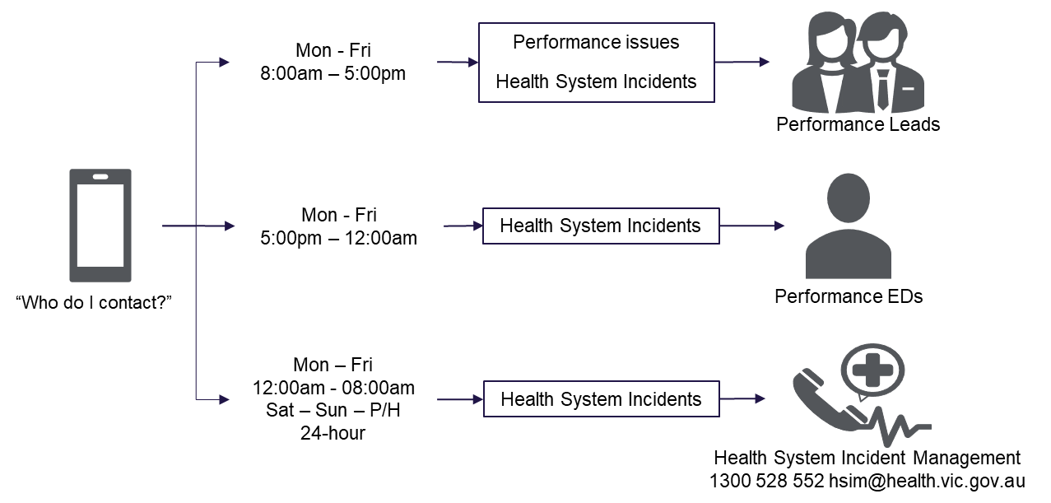

Attachment 2 - Temporary Capability Change Notification Template
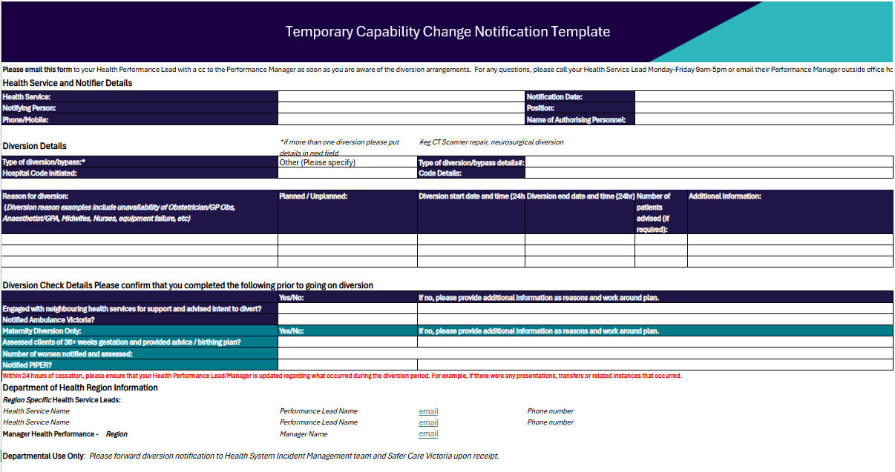

Separate publications allow for amendment of the Business Rules indicators and metrics that support the Framework, as and when necessary, throughout the year.
See the Planned Surgery Recovery and Reform Program <https://www.health.vic.gov.au/planned-surgery-recovery-and-reform-program>
The Mental Health and Wellbeing Act 2022 (MHWA) replaced the existing Mental Health 2014 (MHA) from 1 September 2023.
as set out under section 65S of the HSA
per section 33 of the HSA
As defined under section 59 of the HSA

