**Drug alert**

**Blue ‘M30’ tablets containing extremely potent ‘nitazene’ opioids**

**Nitazenes are novel synthetic opioids that can produce life-threatening toxic effects in very small amounts**

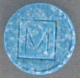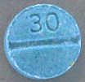

N-desethyl isotonitazene

(sold Sep 2025)

**Opioids** arecentral nervous system depressants, typically producing a range of effects including pain relief, sedation, and respiratory depression (dangerously slow breathing). Respiratory depression often appears more quickly with **novel synthetic opioids** (NSOs), increasing the risk of life-threatening overdose.

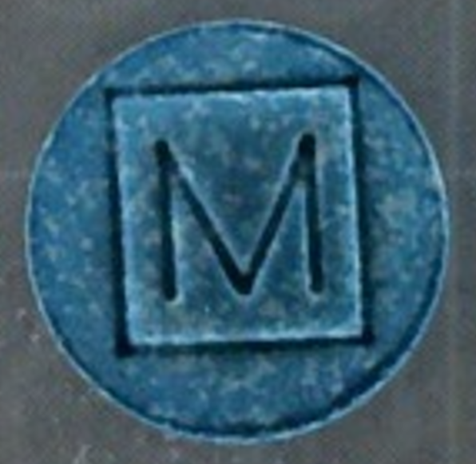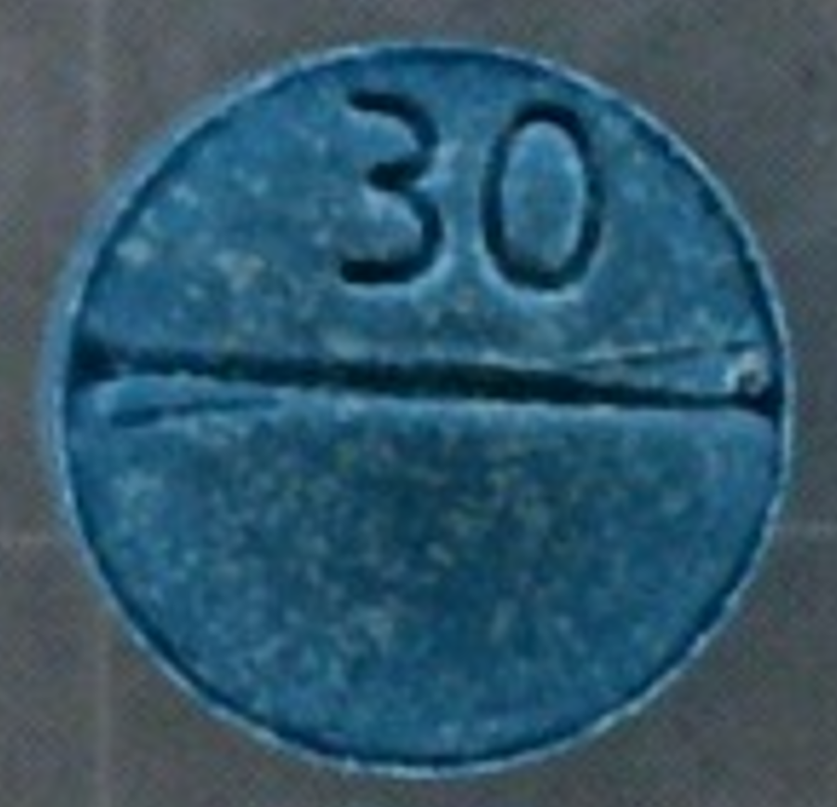

Protonitazene (sold Feb 2025)

**Nitazenes are extremely potent NSOs**, which means they can produce strong effects in very small amounts. They are often **100-200 times as potent as heroin** (sometimes more).

**Any M30 tablet in Australia is likely to be fake**

The Victorian Pill Testing Service recently tested two different blue tablets, both with ‘M’ stamped on one side and ‘30’ on the other. One tablet had been sold in the past two weeks and contained **N-desethyl isotonitazene**. The other tablet (slightly larger in size) was sold in February 2025 and contained **protonitazene**.

**M30s are often sold as ‘oxycodone’**, a pharmaceutical opioid medication.While M30s may look like some forms of genuine oxycodone sold overseas, **there are no pharmaceutical opioids registered in Australia with M30 markings** (and never have been). Tablets with these markings are very likely **fake/counterfeit**.

**Overseas, M30s are a well-known counterfeit product** associated with fatal overdose, often containing fentanyl or nitazenes and sold using terms like “dirty 30s,” “blue 30s,” “fent 30s,” “perc 30s,” or “blue devils.”

**Reduce the risk of harm and get naloxone to reverse opioid overdose**

If you experience adverse drug effects, or are present when someone has an unexpected reaction, **seek help immediately by calling Triple Zero (000)**.

**Signs of opioid toxicity** to look out for include breathing slowly and reduced consciousness (meaning someone is hard to wake up). In some cases, there may also be tiny pupils. More information about opioid overdose symptoms can be found on the [Penington Institute website](https://www.penington.org.au/between-us/between-us-overdose-and-naloxone/) <https://www.penington.org.au/between-us/between-us-overdose-and-naloxone/>.

All alcohol and other drug use comes with risks, so:

* **Get free naloxone and carry it with you** – no matter what drugs you think you’re getting. Naloxone is an easy-to-use medication that can **reverse opioid overdose**. It’s safe to use even if you’re not sure whether someone has taken opioids. [Find an approved pharmacy or health service](https://www.health.vic.gov.au/aod-treatment-services/victorias-take-home-naloxone-program) to get naloxone **free of charge**.   
  <https://www.health.vic.gov.au/aod-treatment-services/victorias-take-home-naloxone-program>
* **Be aware** that other false or contaminated drug products may circulate in Victoria, even if no specific warning has been issued about them. **Use the** [Victorian Pill Testing Service](https://www.vicpilltesting.org.au/) to get free, confidential testing and health advice. <https://www.vicpilltesting.org.au/>
* Make sure you’re in a **safe environment with people you trust**.
* **Remember**, even ‘pure’ drugs can produce serious side effects and death and can interact dangerously with medications/pharmaceutical drugs. Get the facts at: [adf.org.au/drug-facts/](https://adf.org.au/drug-facts/).

Contact **Harm Reduction Victoria’s DanceWize and peer education team** for anonymous support and education from peers. Talk to them by email at [info@dancewize.org.au](mailto:info@dancewize.org.au) or [admin@hrvic.org.au](mailto:admin@hrvic.org.au).

If you or someone you know needs help with alcohol or drug use, call DirectLine on 1800 888 236 or visit [directline.org.au](https://www.directline.org.au/) for information and support to access treatment.