

|  |
| --- |
| Understanding and reporting chemical restraint: a factsheet for prescribing clinicians |
| Office of the Chief Psychiatrist |
|  |

Contents

Purpose 2

Background 2

Definitions 3

Chemical restraint 3

Mental health and wellbeing service 3

Mental Health and Wellbeing Principles 3

Determining when a person is chemically restrained 4

Determining when a person is receiving a mental health and wellbeing service 5

Reporting chemical restraint 5

Illustrative examples 5

1. Intoxication 6

2. Psychosis and section 232 6

3. Deliberate self-harm 6

4. Mental health inpatient setting 7

5. Eating disorder 7

6. Altered mental state 7

7. Lack of capacity due to cognitive impairment 8

8. Young person with potential mental illness 8

Support after chemical restraint 8

Appendix: Determining chemical restraint 10

# Purpose

To provide practical guidance on what constitutes chemical restraint and when it needs to be reported to the Chief Psychiatrist under the *Mental Health and Wellbeing Act 2022*.

# Background

The Mental Health and Wellbeing Act defines and requires the reporting of chemical restraint. It classifies chemical restraint as a form of restrictive intervention, thereby subjecting it to the same safeguards and oversight as for other forms of restrictive interventions such as seclusion and bodily restraint.

Reporting supports clinical governance over chemical restraint. This includes monitoring and identifying areas for continuous improvement to minimise the use of chemical restraint.

Despite having a legal definition, chemical restraint can be open to interpretation in practice. This poses challenges for clinicians in complying with the Act. The situations that are most open to interpretation are those where:

* a medication is administered to both treat and restrict movement, requiring the clinician to determine which was the primary intention for administering the medication
* it is not immediately clear if a mental health service is being provided while medication is administered to restrict movement, especially during situations of agitation or psychological distress.

This factsheet helps prescribing clinicians understand what constitutes chemical restraint and therefore when chemical restraint needs to be reported to the Chief Psychiatrist. It also covers the safeguards of the Mental Health and Wellbeing Act applied to protect people who are chemically restrained.

It gives examples of situations where clinicians are typically required to decide whether administering a medication involves chemical restraint. It also outlines why each situation does or does not require recording as chemical restraint.

A consistent understanding of chemical restraint enables it to be appropriately reported and monitored. It also lays the groundwork for setting targets to support continuous improvement with the intent of reducing chemical restraint over time.

This factsheet complements the [Chief Psychiatrist’s guideline for restrictive interventions](https://www.health.vic.gov.au/chief-psychiatrist/chief-psychiatrists-restrictive-interventions) <https://www.health.vic.gov.au/chief-psychiatrist/chief-psychiatrists-restrictive-interventions> and [reporting directive for restrictive interventions](https://www.health.vic.gov.au/chief-psychiatrist/chief-psychiatrists-restrictive-interventions) <https://www.health.vic.gov.au/chief-psychiatrist/chief-psychiatrists-restrictive-interventions>. Apply it alongside those documents.

Also use this factsheet alongside your health service’s acute behavioural disturbance guidelines (or equivalent) and medication prescribing guidelines. Health services can use this factsheet when developing local policies and resources such as educational materials and clinical guidelines.

# Definitions

## Chemical restraint

The Mental Health and Wellbeing Act defines chemical restraint as a restrictive intervention, whereby chemical restraint means (s 3(1)):

*… the giving of a drug to a person for the primary purpose of controlling the person’s behaviour by restricting their freedom of movement but does not include the giving of a drug to a person for the purpose of treatment or medical treatment.*

Chemical restraint, like other types of restrictive interventions, may only be used:

* as a last resort, after all reasonable and less restrictive options have been tried or considered (s 128(2))
* to prevent imminent and serious harm to a person or another person (s 127 (a)).

## Mental health and wellbeing service

In Pt 1.2.3 of the Act, a mental health and wellbeing service means a professional service:

* performed for the primary purpose of:
  + improving or supporting a person’s mental health and wellbeing; or
  + assessing, or providing treatment, care or support to, a person for mental illness or psychological distress; or
  + providing care or support to a person who is a family member, carer, or supporter, of a person with mental illness or psychological distress.

## Mental Health and Wellbeing Principles

Properly consider the decision-making principles in the Act before and during a restrictive intervention. There are 5 such principles relevant to restrictive interventions:

* no therapeutic benefit to restrictive interventions principle (s 81)
* balancing the harm principle (s 82)
* autonomy principle (s 83)
* care and transition to less restrictive support principle (s 79)
* consequences of compulsory assessment and treatment and restrictive interventions principle (s 80), particularly for those with diverse needs including young people, older people, Aboriginal people, culturally and linguistically diverse people and those with intellectual disability or acquired brain injury.

As outlined in s 131 of the Act, also consider:

* + an advance statement of preferences, if one exists (check CMI/ODS)
  + the likely impact on the person of any restrictive intervention, particularly given past experiences of trauma
  + the views of the person and their nominated support person.

# Determining when a person is chemically restrained

Using any medication is considered chemical restraint when the **primary purpose** is to control a person’s behaviour to prevent harm. But there may be ambiguity when the medication has the effect of both controlling behaviour and treating the underlying cause. Where there is ambiguity, consider the primary purpose, and refer to this document (refer also to the flowchart in the Appendix).

**The person responsible for deciding whether medication is chemical restraint is the treating doctor, as outlined in the Mental Health and Wellbeing Act.**

There are 2 fundamental questions to consider first:

* **Am I giving this medication as part of providing a mental health and wellbeing service (see below ‘Determining when a person is receiving a mental health and wellbeing service’)?**
* **Am I giving this medication to reduce movement?**

If the answer to both is ‘yes’, using the medication may amount to chemical restraint under the Act. The treating doctor must proceed by assessing the primary purpose of using the medication to make a conclusive decision.

Questions to consider when assessing primary purpose are listed below. Each question, on its own, does not provide a final answer about primary purpose. But taken together, the questions initiate a process of reflection for understanding primary purpose in the varied circumstances where sedating medication is used and potentially amounts to chemical restraint.

* **Is the medication I am giving a recognised treatment for mental illness?**

Using medication that (1) is not recognised as a treatment for mental illness and (2) has sedating effects suggests the person is being chemically restrained.

* **Is the medication I am giving recognised as treatment for a person’s identified mental health symptoms or diagnosis?**

Using a medication that is (1) not recognised as treatment for an identified mental health symptom or diagnosis and (2) has sedating effects suggests the person is being chemically restrained.

* **Is the dose of the medication I am giving a recognised dose for the symptoms I am treating?**

Using a dose that (1) exceeds what is recognised for the symptoms being treated and (2) has sedating effects suggests the person is being chemically restrained.

* **Is using this medication intended to increase or replace another form of restraint?**

Using a sedating medication to increase or replace another form of restrictive intervention, such as seclusion or bodily restraint, suggests the person is being chemically restrained.

Where you’re unsure if chemical restraint is being used, reflect on the intention, discuss this with peers and consult the Authorised Psychiatrist. When in doubt, it is best to report to ensure complex examples are brought to the attention of the Authorised Psychiatrist and the local Quality and Safety Committee.

Clearly document in the clinical file your decision-making, clinical rationales and any consultation and consideration of the above questions.

# Determining when a person is receiving a mental health and wellbeing service

Circumstances when a person is receiving a mental health and wellbeing service (and therefore where the Mental Health and Wellbeing Act’s provisions apply) include:

* self-presentations for managing mental health symptoms
* being accompanied by another person, including a family member, carer or support person, who advises of a deteriorating mental state
* being brought in by police or ambulance for a mental health assessment, either under s 232 of the Mental Health and Wellbeing Act or voluntarily
* awaiting transfer as a compulsory patient to a mental health inpatient unit (for example, under an Assessment Order or Temporary Treatment Order)
* initially presenting for medical care and later being assessed as requiring a mental health and wellbeing service that involves ongoing management
* being admitted to a mental health ward for assessment and treatment
* being admitted to a medical ward and receiving physical and mental health assessment and treatment.

A person is not receiving a mental health and wellbeing service simply because they are distressed, have seen a counsellor or had a one-off mental health and wellbeing assessment where no further management is required.

# Reporting chemical restraint

Report all chemical restraint under the Act to the Office of the Chief Psychiatrist.

Complete a ‘MHWA 143 – Authority for chemical restraint’ form. Information from this form is then entered into the CMI/ODS database, making it available to the Office of the Chief Psychiatrist and automatically generating a notification to Independent Mental Health Advocacy about the use of the chemical restraint.

Enter forms for authorising and recording chemical restraint in CMI/ODS as soon as practicable using your service’s existing processes.

More details are in the [Chief Psychiatrist’s reporting directive for restrictive interventions](https://www.health.vic.gov.au/chief-psychiatrist/chief-psychiatrists-restrictive-interventions) <https://www.health.vic.gov.au/chief-psychiatrist/chief-psychiatrists-restrictive-interventions>.

# Illustrative examples

The examples below highlight typical scenarios where it must be determined whether a person is being chemically restrained. They are presented here to guide best practice.

Ultimately the prescriber authorising the medication is responsible for determining the primary purpose of the prescribed medication and clearly documenting the rationale.

De-escalation approaches, Safewards and environmental considerations should always emphasise least restrictive options that uphold everyone’s safety. The examples below assume that these approaches are being used and are actively embedded through comprehensive local clinical governance.

## 1. Intoxication

A 25-year-old with no mental health history presents intoxicated after using recreational methamphetamines. The person is agitated and threatening but needs treatment for distress and to exclude other causes of the presentation. They appear to be an imminent and serious threat to themselves and others and less restrictive means have failed. The person is given sedating medication in line with the hospital’s acute behavioural disturbance guideline to prevent them hurting themselves or others. The prescriber is mindful of the Emergency Department being an environment where there is an elevated risk of harm to self and others, and prescribes a dose intended to reduce movement.

**Classification and rationale:**

Substance intoxication is not reportable under the Mental Health and Wellbeing Act. Determining substance intoxication from mental illness can be complex because they are often comorbid. However, it is important to not apply the Act for those without major mental illness. Regular review of symptoms and background information can help staff to identify comorbid mental illness. If further assessments reveal an underlying, contributing mental illness, administering sedating medication to prevent harm becomes reportable under the Act. The Office of the Chief Psychiatrist’s view is that non–mental health services should have separate mechanisms to identify, monitor and provide thoughtful rationales for restrictive practices for people who are not subject to the Act.

## 2. Psychosis and section 232

A 35-year-old with paranoia, persecutory delusions and persecutory auditory hallucinations is brought in by police under s 232 of the Mental Health and Wellbeing Act. The person has a history of schizophrenia and has been lost to follow-up from their community mental health team. They are distressed and have attempted to leave the ward but cannot give a coherent explanation for why despite attempts by staff to engage and provide reassurance. The person is given a high dose intramuscular antipsychotic to prevent them leaving the hospital and to reinstate treatment for psychosis to reduce movement and symptoms of mental illness. Treating mental illness is anticipated to improve agency and capacity to engage with staff in a more supportive way.

**Classification and rationale:**

Although the antipsychotic was partially given to treat the person’s symptoms, it was primarily given to sedate and restrict their movement and given in a dose and by a route to maximise immediate sedating effect. Therefore, this is reportable under the Act. Given the person is being treated for a mental illness in a designated mental health service and given they were brought under s 232 of the Act, all restrictive interventions need to be reported.

## 3. Deliberate self-harm

A 20-year-old presents to an Emergency Department after engaging in deliberate self-harm. After having their wounds treated, they continue to voice active suicidal intent. They are agitated and distressed and attempt to leave the Emergency Department despite engagement by the local team, including peer workers, mental health clinicians and medical staff. Attempts by their family to de-escalate have also failed. Staff are concerned that the person will act on their stated intent if they leave the hospital. A code grey is called, and the person is offered the choice of either oral or intramuscular benzodiazepine to restrict their ability to leave the department and reduce their distress. They elect to take the oral medication.

**Classification and rationale:**

This is reportable under the Mental Health and Wellbeing Act because the primary purpose of administering the medication is to keep the person in the Emergency Department to enable ongoing treatment. Even though the person voluntarily took the oral medication, the primary purpose was to restrict movement.

## 4. Mental health inpatient setting

A 38-year-old is admitted to a mental health ward after a manic episode with psychotic features on a background of a schizoaffective disorder. There has been high risk-taking, refusal of medication and disinhibited behaviour. The person is agitated, labile and intrusive towards others. After little response to initial antipsychotic medication and the continuation of high-risk behaviours, the treating team decide to administer a long-acting antipsychotic intramuscularly.

**Classification and rationale:**

This is a situation where primary intent must be considered. Mania is a recognised high-risk state for both physical and mental health and mania is a psychiatric emergency. Given that antipsychotic medication is a recognised treatment for this condition and that long-acting high dose medication is indicated as treatment, this is unlikely to be chemical restraint unless the prescriber administers a significantly higher dose than recommended as treatment with the primary intent to restrict movement.

## 5. Eating disorder

A 15-year-old is admitted to a paediatric ward for refeeding on a background of anorexia nervosa, recent weight loss and high distress. Staff assess the person’s physical health to be at risk of serious deterioration and decide to insert a nasogastric tube. The person has had 3 previous admissions in similar circumstances and has been highly distressed when inserting the nasogastric tube. The parents ask for medication to help calm the person. Staff prescribe a benzodiazepine to reduce distress and help the person tolerate the procedure.

**Classification and rationale:**

Given that the primary intent of this medication is to treat psychological distress and enable a life-giving procedure, it is generally not chemical restraint. However, if the medication is given against the person’s will, alongside physical restraint to insert a nasogastric tube, then the primary intent would be to reduce movement and it would therefore be chemical restraint.

## 6. Altered mental state

A 45-year-old presents to an Emergency Department with a headache and fever they have had for 2 days. They have become increasingly confused, and a working diagnosis of meningitis is made. Due to the effects of their acute illness, the person is deemed to lack capacity. They become increasingly agitated and try to leave the hospital, despite attempts at de-escalation from staff and the person’s family. They are given a dose of intravenous benzodiazepine to facilitate a lumbar puncture and intravenous antibiotic treatment.

**Classification and rationale:**

This is not reportable under the Mental Health and Wellbeing Act because it is a purely medical presentation. The Office of the Chief Psychiatrist’s view is that non-mental health services should have separate mechanisms to identify, monitor and provide thoughtful rationales for restrictive practices for people who are not subject to the Act.

## 7. Lack of capacity due to cognitive impairment

An 80-year-old with a history of dementia presents to an Emergency Department with the onset of fluctuating confusion after several days of lower urinary tract symptoms. They are agitated and try to climb over the rails of the hospital bed. Due to the risk of a serious fall, the person is given an antipsychotic to reduce the likelihood that they will attempt to climb out of bed.

**Classification and rationale:**

Delirium and dementia are medical causes of agitation and confusion. They are not reportable under the Mental Health and Wellbeing Act unless there is a comorbid mental health diagnosis. This scenario also applies to situations of cognitive impairment that are not considered mental illnesses, including acquired brain injury, intellectual disability and neurodiverse conditions such as autism spectrum disorder. The Office of the Chief Psychiatrist’s view is that non-mental health services should have separate mechanisms to identify, monitor and provide thoughtful rationales for restrictive practices for people who are not subject to the Act.

## 8. Young person with potential mental illness

A 14-year-old with autism spectrum disorder and ADHD is brought to an Emergency Department by their parents seeking admission for their mental health and because there has been an unexplained change in their behaviour. There has been escalating aggression and property damage, which has increased in frequency over the past month, leading the parents to feel they cannot manage any longer.

The person is difficult to engage and provides little account of their current experience. They do not present with psychotic symptoms but are aroused and fearful. They quickly become increasingly uncooperative, yelling and throwing things. The person is prescribed an intramuscular antipsychotic because less restrictive approaches to managing their distress and risk were unsuccessful. They also required simultaneous physical restraint.

**Classification and rationale:**

Ultimately the treating doctor needs to decide based on whether they believe the person has a mental illness. If assessment suggests potential comorbid mental illness, consider reporting this as chemical restraint because the medication was administered in the process of assessing for a mental health condition. However, should a physical health reason for a change in behaviour be identified, then this would no longer be reportable. The treating doctor needs to decide on likelihood and if the clinical understanding of the situation changes, then from then on, reporting should alter. It is not necessary to retrospectively report.

# Support after chemical restraint

Observation and clinical reviews for a minimum of one hour after administering chemical restraint is required from the time that the first and subsequent doses are administered.

Be mindful of the cognitive effects of the medications that have been administered. The effects of benzodiazepines and other sedating medications can impact on memory, executive functions, concentration and attention.

Give consumers and their support people support and information after chemical restraint. Psychological first aid is an evidence-based approach. Take care to ensure this is conducted in a trauma-informed way to prevent harm.

There may be times where it is not possible or clinically appropriate to offer specific support for the restraint. Document considerations on providing this support at the time of restraint in the clinical file. Arrange for this to be offered at a later time, where possible.

Services should develop a process for support, review and debriefing following all modes of restraint, including transitions from one setting to another (for example, from an Emergency Department to an acute mental health setting).

# Appendix: Determining chemical restraint

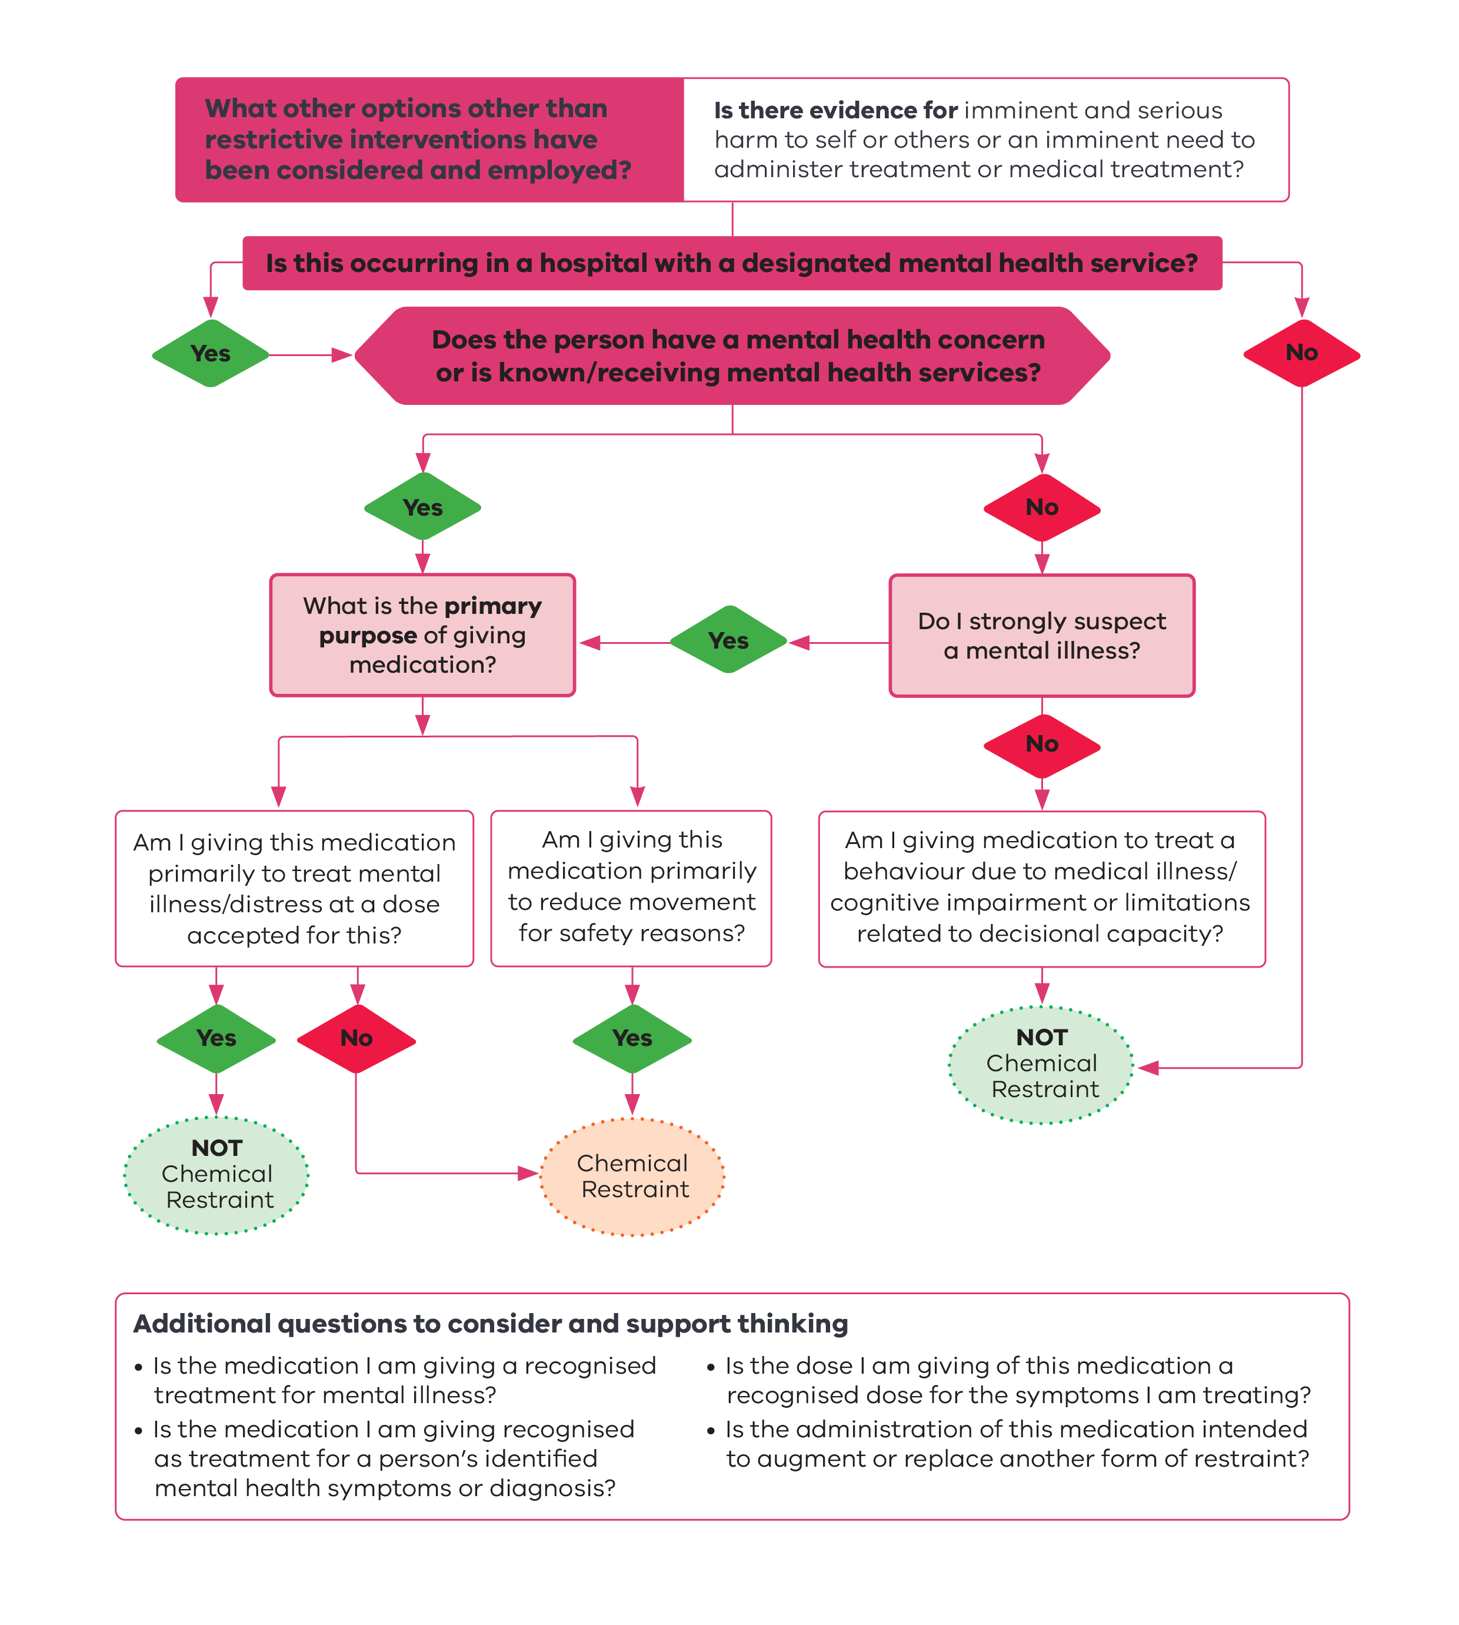

|  |
| --- |
| To receive this document in another format, phone 1300 767 299, using the National Relay Service 13 36 77 if required, or email the Office of the Chief Psychiatrist <ocp@health.vic.gov.au>.  Authorised and published by the Victorian Government, 1 Treasury Place, Melbourne.  © State of Victoria, Australia, Department of Health, July 2025.  ISBN - 978-1-76131-822-1 (online/PDF/Word)  Available at [Chief Psychiatrist guidelines](https://www.health.vic.gov.au/chief-psychiatrist/chief-psychiatrist-guidelines) <https://www.health.vic.gov.au/chief-psychiatrist/chief-psychiatrist-guidelines> |