

|  |  |
| --- | --- |
| **Respiratory Syncytial Virus Mother and Infant Protection Program (RSV-MIPP)** |  |
| Abrysvo® RSV vaccine preparation  **OFFICIAL** |

This fact sheet provides guidance on the Abrysvo® respiratory syncytial virus (RSV) vaccine to support immunisation providers delivering the Respiratory Syncytial Virus Mother and Infant Protection Program (RSV-MIPP).

For more information about the RSV-MIPP, refer to the Department of Health [Respiratory Syncytial Virus immunisation](https://www.health.vic.gov.au/immunisation/respiratory-syncytial-virus-immunisation) <https://www.health.vic.gov.au/immunisation/respiratory-syncytial-virus-immunisation>.

# Abrysvo® immunisation during pregnancy

* A single dose of Abrysvo® RSV vaccine is recommended for pregnant women at 28-36 weeks pregnancy to protect the infant. All women who are already >28 weeks pregnant at the time of program commencement, should be offered immunisation as soon as possible.
* Abrysvo® RSV vaccine can be co-administered with other ante-natal vaccinations including the pertussis, influenza and COVID-19 vaccines.
* For more information of Abrysvo® RSV vaccine, refer to the [Australian Immunisation Handbook](https://immunisationhandbook.health.gov.au/contents/vaccine-preventable-diseases/respiratory-syncytial-virus-rsv) <https://immunisationhandbook.health.gov.au/contents/vaccine-preventable-diseases/respiratory-syncytial-virus-rsv>.

# Abrysvo® RSV vaccine information

* 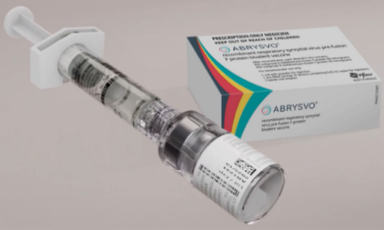Abrysvo® RSV vaccine: 0.5 ml vial

Figure 1. Abrysvo® RSV vaccine

* Presentation: powder and diluent for solution for injection
  + the powder or cake is white.
  + the diluent is a clear, colourless liquid
* Route & dosage:
  + intramuscular (IM) injection into the deltoid muscle
  + 0.5ml (1 dose per vial)

# Storage

Abrysvo® RSV vaccine must be stored in a vaccine refrigerator, between +2ºC to +8ºC.

Use immediately after reconstitution. Do not return to the vaccine refrigerator.

Packet contents

Note: No needles are included in the packs.

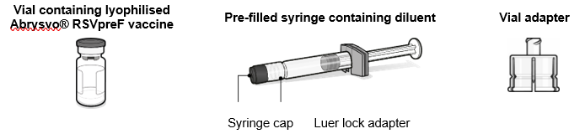

Figure 2: packet contents for Abrysvo RSVpreF vaccine  
  
  
Preparation for administration

#### The lyophilised vaccine (powder) must be reconstituted only with the diluent provided using the vial adapter to form Abrysvo®. Three steps for administration are below. Step 1. Attach vial adapter

* 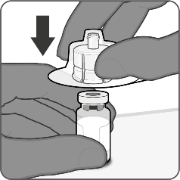Peel off the top cover from the vial adapter packaging and remove the flip-off cap from the vial.
* While keeping the vial adapter in its packaging, centre over the vial’s stopper and connect with a straight downward push. Do not push the vial adapter in at an angle as it may result in leaking. Remove the packaging.

Figure 3: Step 1. Attach vial adapter

#### Step 2. Reconstitute lyophilised vaccine component to form Abrysvo®

* 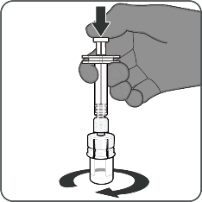For all syringe assembly steps, hold the syringe only by the Luer lock adapter. This will prevent the Luer lock adapter detaching during use.
* Twist to remove the syringe cap, then twist to connect the syringe to the vial adapter. Stop turning when you feel resistance.
* Inject the entire contents of the syringe into the vial. Hold the plunder rod down and gently swirl the vial until the powder is completely dissolved (less than 1 minute). Do not shake.

Figure 4: Step 2. Reconstitute lyophilised vaccine component to form Abrysvo®

#### Step 3. Withdraw reconstituted vaccine

* 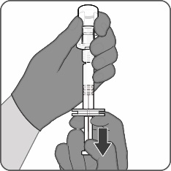Insert the vial completed and slowly withdraw the entire contents into the syringe to ensure a 0.5mL dose of Abrysvo**®** RSVvaccine.
* Twist to disconnect the syringe from the vial adapter.
* Attach a sterile needle suitable for intramuscular injection.

Figure 5: Step 3. Withdraw reconstituted vaccine

|  |
| --- |
| To receive this document in another format or email the [Immunisation Program](https://encoded-592c9deb-987b-4562-aa3c-9fa3d37d83e9.uri/mailto%3aImmunisation%2520Program) [<immunisation@health.vic.gov.au](mailto:%3cimmunisation@health.vic.gov.au)>.  Authorised and published by the Victorian Government, 1 Treasury Place, Melbourne.  **ISBN** 978-1-76131-797-2 **(pdf/online/MS word)**  © State of Victoria, Australia, Department of Health, January 2025. |