

|  |
| --- |
| Community Health Minimum Data Set  CHMDS Bulletin 2023-24 |
| Edition 2 20 September 2023 |
| CHMDS Bulletins must be read in conjunction with the [CHMDS Submission Guidelines](https://www.health.vic.gov.au/community-health/community-health-data-reporting)  To be added to or removed from the distribution list, please send us an email request:  [CHMDS-data@health.vic.gov.au](mailto:CHMDS-data@health.vic.gov.au) |

Contents

2023-24 Quarter 1 Reporting 1

Funding Source & Service Stream Combinations 1

CHMDS Annual Changes 2024-25 2

# 2023-24 Quarter 1 Reporting

CHMDS 2023-24 Quarter 1 reporting is now open.

A reminder that Service Stream 62 Diabetes Education can now be reported for the following funding sources:

* 1 Community Health Program
* 12 Small Rural Primary Health Flexible Services
* 19 Integrated Chronic Disease Management
* 21 Refugee & Asylum Seeker Health Services
* 22 Healthy Mothers Healthy Babies

Please note Diabetes Education must be provided by Credentialled Diabetes Educators to be reported under this service stream.

We encourage providers to start validating Q1 files early to check that any system changes relating to the implementation of Diabetes Education are working as expected, and to have more time to address any critical errors or warnings.

# Funding Source & Service Stream Combinations

Allowable combinations of Funded Activity, Funding Source and Service Stream are outlined in the table starting on pg. 27 of the [CHMDS guidelines](https://www.health.vic.gov.au/sites/default/files/2023-06/community-health-minimum-data-set-submission-guidelines-2023-24.docx). An example from the full table is below:

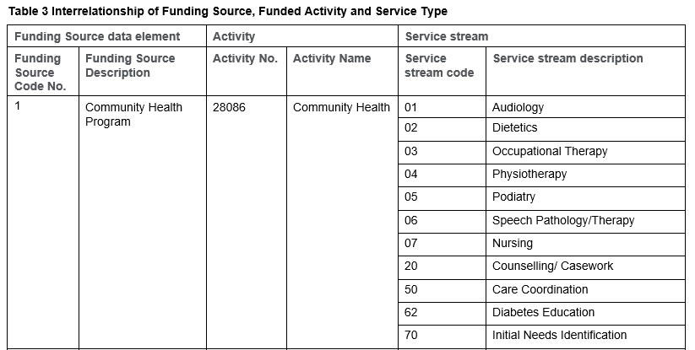

The combinations outlined in this table are included in performance reports and count towards agency targets. Any other combinations are excluded from performance reports and do not count towards targets.

We have reviewed CHMDS validations to ensure providers are alerted to any incorrect combinations at the data submission stage and have an opportunity to revise their data.

This means some providers may notice a few extra ‘Funding source Service stream mismatch’ errors in 2023-24. Analysis of previous data indicates this is only likely to impact a very small number of providers.

# CHMDS Annual Changes 2024-25

Thank you to those who submitted proposals for consideration in the 2024-25 CHMDS Annual Change process. Following consideration by the Change Management Group, proposals meeting the published criteria will be distributed to all stakeholders for feedback in October.

The Change Management Group will then consider this feedback and make recommendations to the CHMDS Data Custodian. Approved changes will be published as specifications for revisions, no later than 31 December, for implementation from Quarter 1, 2024-25.

If you have any questions about CHMDS annual changes, please email:

[CHMDS-data@health.vic.gov.au](mailto:CHMDS-data@health.vic.gov.au)

|  |
| --- |
| To receive this document in another format, email [CHMDS-data@health.vic.gov.au](mailto:CHMDS-dat@health.vic.gov.au)  Authorised and published by the Victorian Government, 1 Treasury Place, Melbourne.  © State of Victoria, Australia, Department of Health, September 2023 |