Contents



Victorian Respiratory Surveillance Report

16 May 2025

About this report 1

Summary 2

Laboratory surveillance 3

Case notifications 3

Testing 8

Community surveillance 9

FluTracking 9

How to use this report 12

Data sources 12

Interpretation of data 12

Definitions 12

### Logo: Victoria State Government | Department of HealthAbout this report

The Victorian Respiratory Surveillance Report summarises the latest surveillance information on COVID-19, influenza and respiratory syncytial virus (RSV) in Victoria. This report provides an overview of the current levels and trends of acute respiratory illness from these conditions in the community. Please see the section on How to use this report for more information.

Measurements of the greatest value for summarising respiratory illness in Victoria are presented in this report. Other systems are also reviewed by the Department of Health to understand patterns of respiratory disease in Victoria which inform the overall summaries presented.

Data are presented as at 14 May 2025 for the week ending 10 May 2025.

Each report reflects the data available at the time the report was prepared. Information may differ from previous reports as new data is received or updated.

Victorian Respiratory Surveillance Report | **Summary** | **16 May 2025** 2

# Summary

In Victoria, activity of RSV, influenza and COVID-19 are increasing but remain at low levels.

Indicators of activity are increasing for RSV, which is typical at this time of year. Influenza indicators have also increased in recent weeks but remain low. Meanwhile, COVID-19 activity has remained at low levels with increases in recent weeks.

COVID-19

**NOTIFICATIONS LAST 12 WEEKS**

**TEST POSITIVITY**

The percentage of tests that were positive increased



**CASE TREND**

Notifications have continued to increase



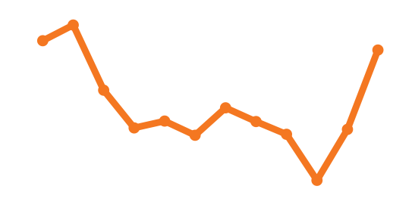

Influenza

**NOTIFICATIONS LAST 12 WEEKS**

**TEST POSITIVITY**

The percentage of tests that were positive increased



**CASE TREND**

Notifications have continued to increase



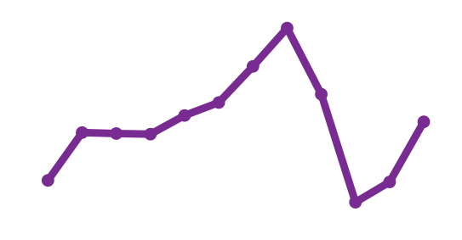

RSV

**NOTIFICATIONS LAST 12 WEEKS**

**TEST POSITIVITY**

The percentage of tests that were positive increased



**CASE TREND**

Notifications have continued to increase



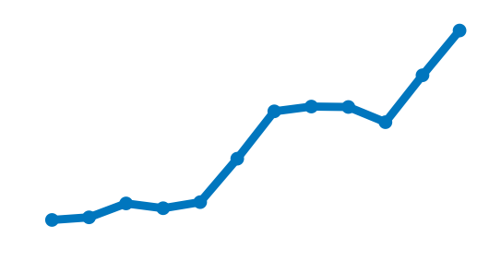

# Laboratory surveillance

#### Case notifications

Laboratory-confirmed cases of COVID-19, influenza and respiratory syncytial virus are notified to the Victorian Department of Health. Notified infections that are diagnosed through laboratory testing are only a subset of the total number of infections in the community. Trends in notifications may be impacted by changes in testing.

###### Summary

In the past week, COVID-19 notifications increased (+43.8%), influenza notifications increased (+30.8%) and RSV notifications increased (+19.8%).



**COVID-19**

**44%** increase





**RSV**

**20%** increase

**31%** increase

**Influenza**

**COVID-19**

**Figure 1:** COVID-19 notified cases by week, Victoria, 12 May 2024 to 10 May 2025

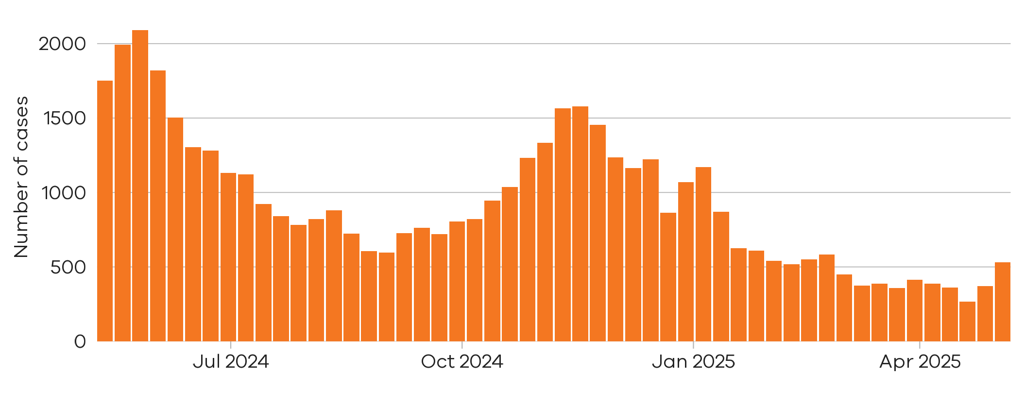

**44%** increase



There were **532** notified COVID-19 cases last week

4 May 2025 to 10 May 2025

There were **370** notified COVID-19 cases two weeks ago

27 Apr 2025 to 3 May 2025

**Figure 2:** COVID-19 trends in notified cases (7-day rolling average), Victoria, 1 January 2023 to 10 May 2025

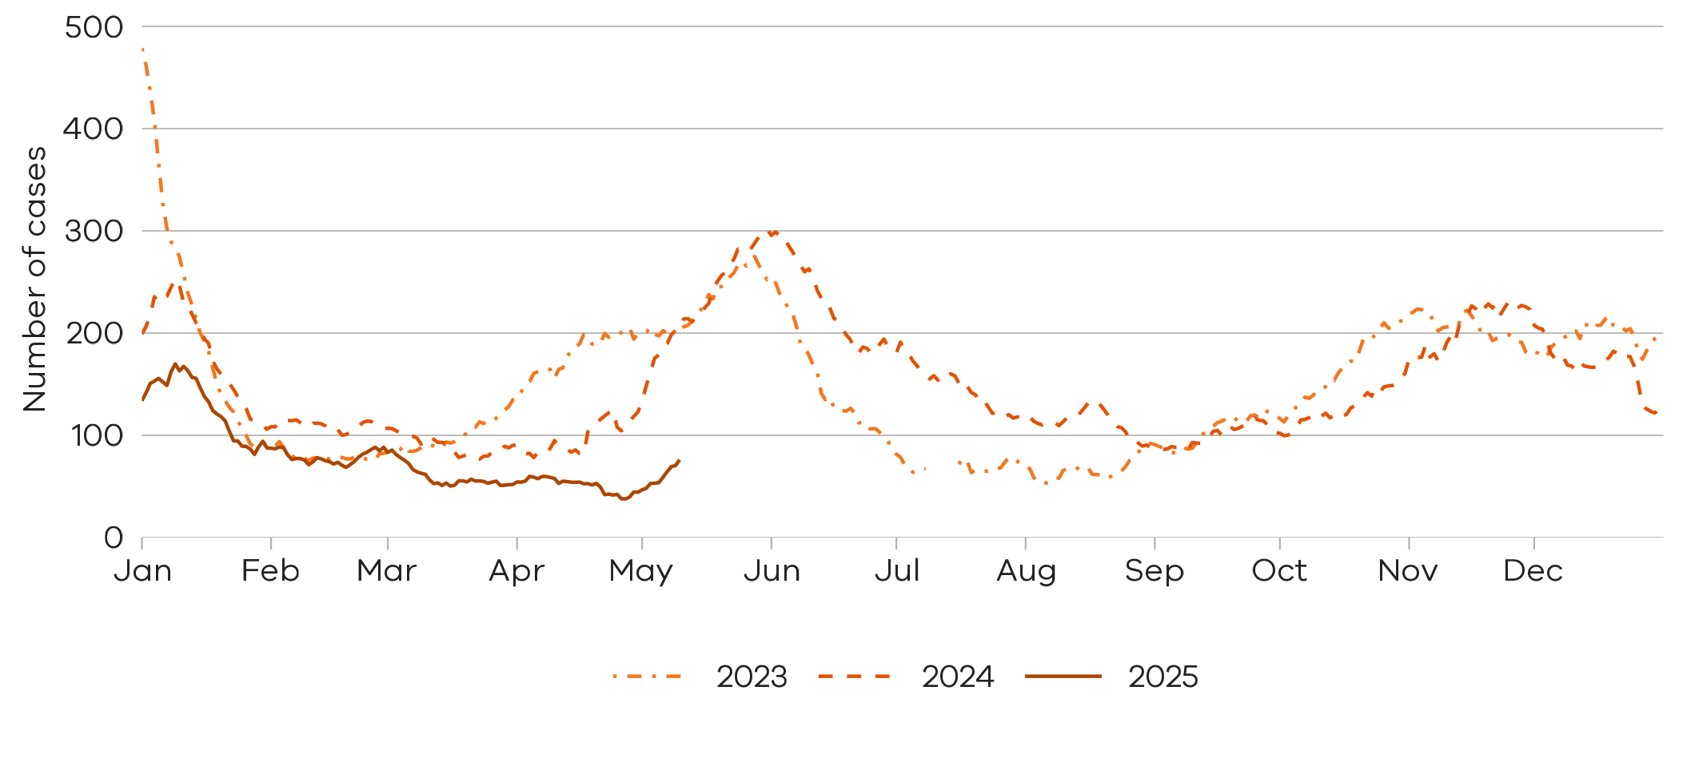



Notified COVID-19 cases are at lower levels compared to the same time in the past two years

**Influenza**

Influenza notifications presented in this report are reported from a subset of laboratories in Victoria, generally comprising around 85% of total influenza notifications.

**Figure 3:** Influenza notified cases by week, Victoria, 12 May 2024 to 10 May 2025

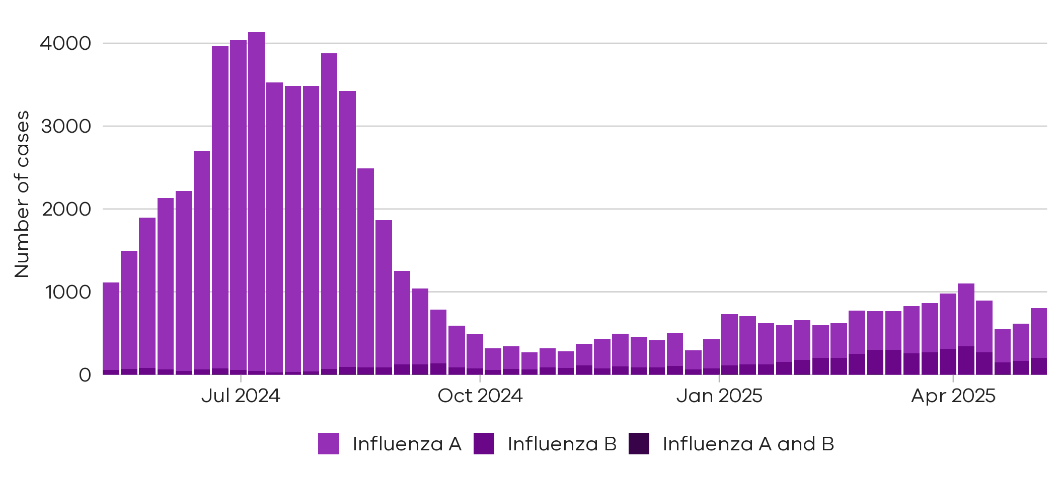

There were **169** cases of influenza B notified two weeks ago

27 Apr 2025 to 3 May 2025

There were **446** cases of influenza A notified two weeks ago

27 Apr 2025 to 3 May 2025

There were**599** cases of

influenza A notified last week

4 May 2025 to 10 May 2025

There were**207** cases of

influenza B notified last week

4 May 2025 to 10 May 2025

**34%** increase



**22%** increase



**Figure 4:** Influenza A trends in notified cases (7-day rolling average), Victoria, 1 January 2023 to 10 May 2025

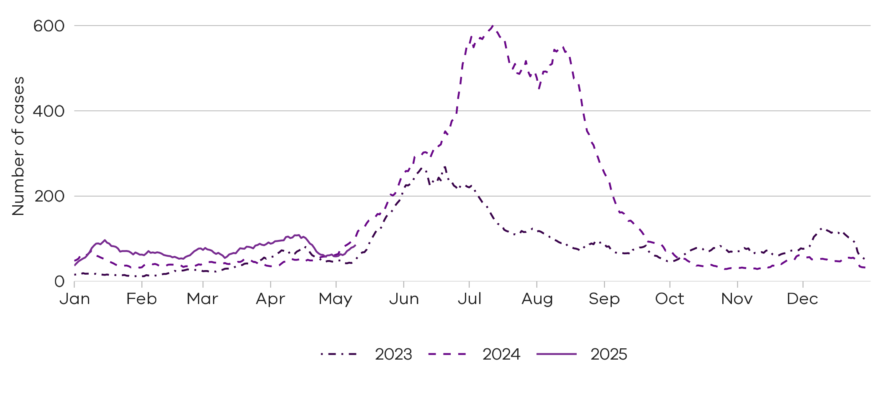



Notified influenza A cases are at similar levels compared to the same time in the past two years

**Figure 5:** Influenza B trends in notified cases (7-day rolling average), Victoria, 1 January 2023 to 10 May 2025

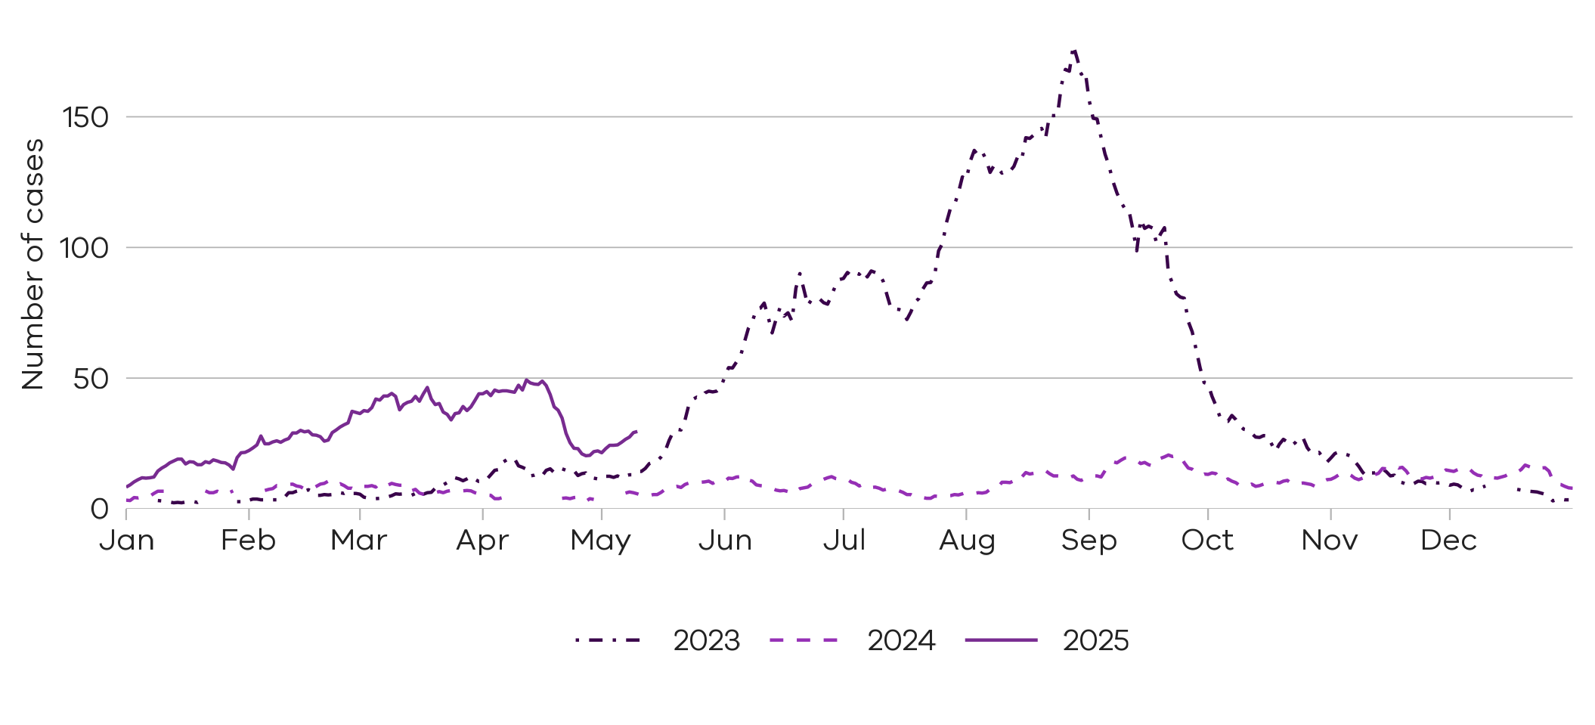



Notified influenza B cases are at higher levels compared to the same time in the past two years

**Respiratory Syncytial virus (RSV)**

RSV notifications presented in this report are reported from a subset of laboratories in Victoria, generally comprising around 85% of total RSV notifications.

**Figure 6:** RSV notified cases by week, Victoria, 12 May 2024 to 10 May 2025

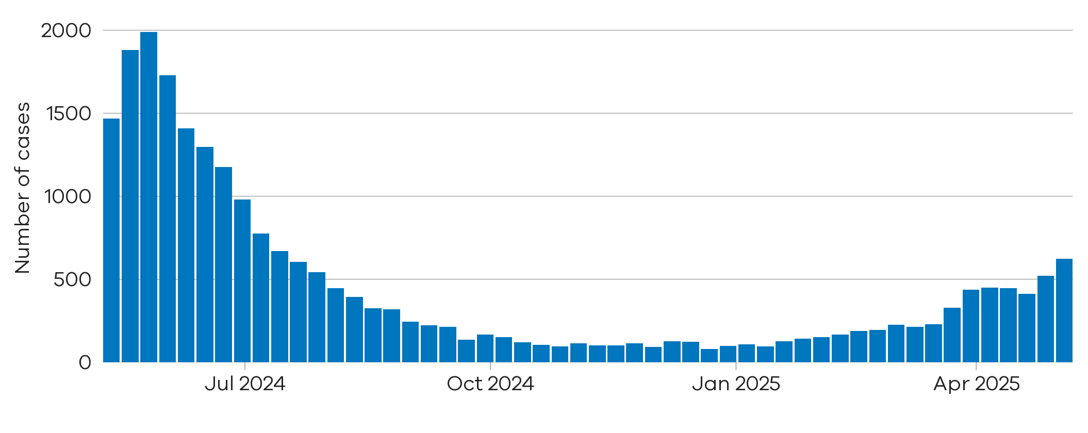

**20%** increase



There were **624** notified RSV cases last week

4 May 2025 to 10 May 2025

There were **521** notified RSV cases two weeks ago

27 Apr 2025 to 3 May 2025

**Figure 7:** RSV trends in notified cases (7-day rolling average), Victoria, 1 January 2023 to 10 May 2025

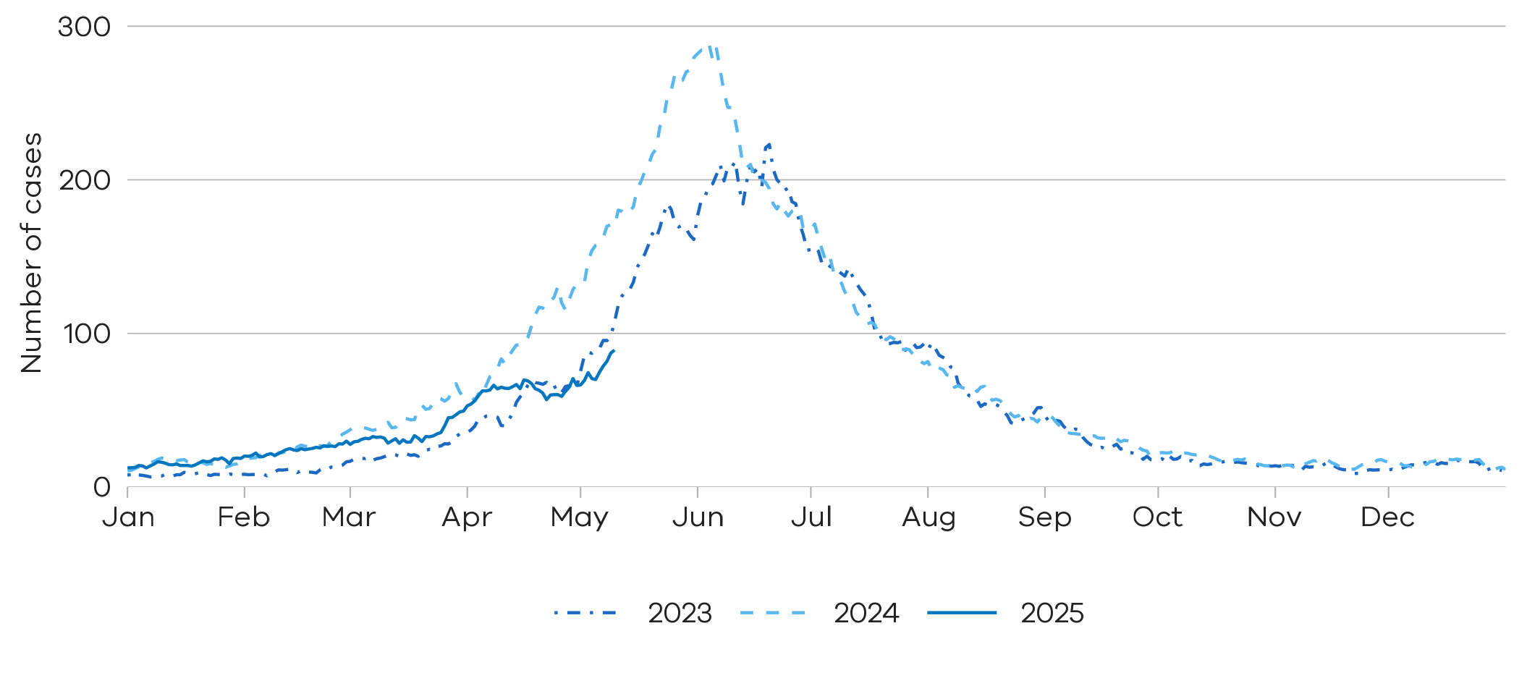



Notified RSV cases are at similar levels compared to the same time in the past two years

##### **Young children and older adults**

Young children and older adults are at greater risk of severe disease from RSV.

**Figure 8:** RSV trends in notified cases by week in young children (under 5 years), Victoria, 12 May 2024 to 10 May 2025

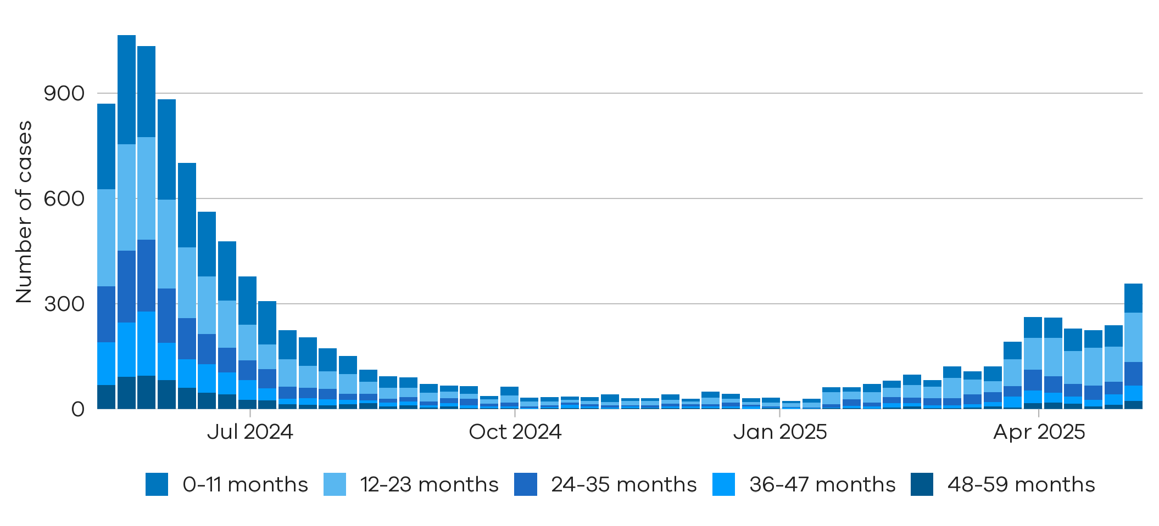



Notified cases of RSV in children under 5 years have increased in the last week

**Figure 9:** RSV trends in notified cases by week in older adults (65+ years), Victoria, 12 May 2024 to 10 May 2025

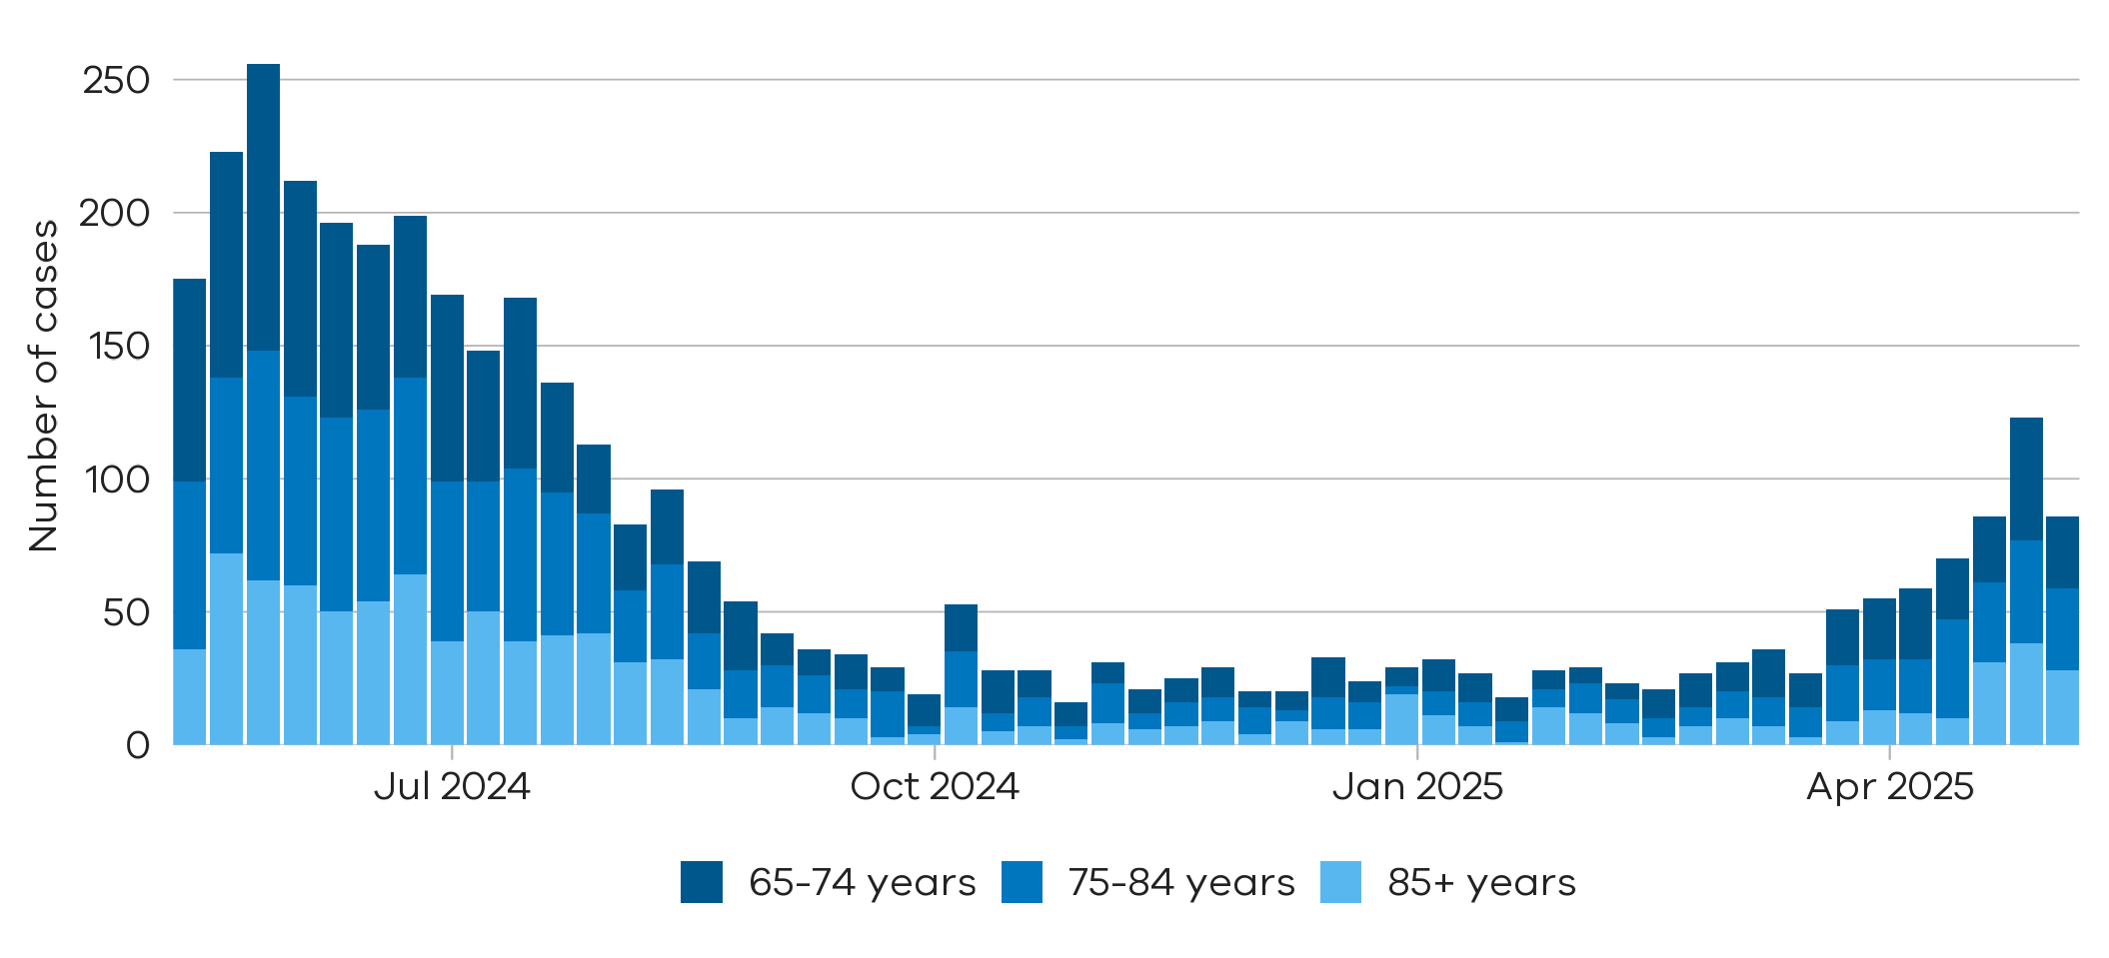



Notified cases of RSV in adults aged over 65 years have increased across April

Testing

Laboratory testing for respiratory illnesses changes over time. Tracking the percentage of tests with the notifiable condition detected (i.e. test positivity) is a useful measure to understand trends in disease surveillance over time.

Test results presented in this report are from selected laboratories. These include private and hospital laboratories and represent tests completed across Victoria.

###### Summary

In the past week, the percentage of COVID-19 tests that were positive increased (2.24% to 4.04%), the percentage of influenza tests that were positive increased (2.89% to 3.51%) and the percentage of RSV tests that were positive increased (4.93% to 5.90%).

**Figure 10:** Weekly test positivity for COVID-19, Influenza and RSV, Victoria, 12 May 2024 to 10 May 2025

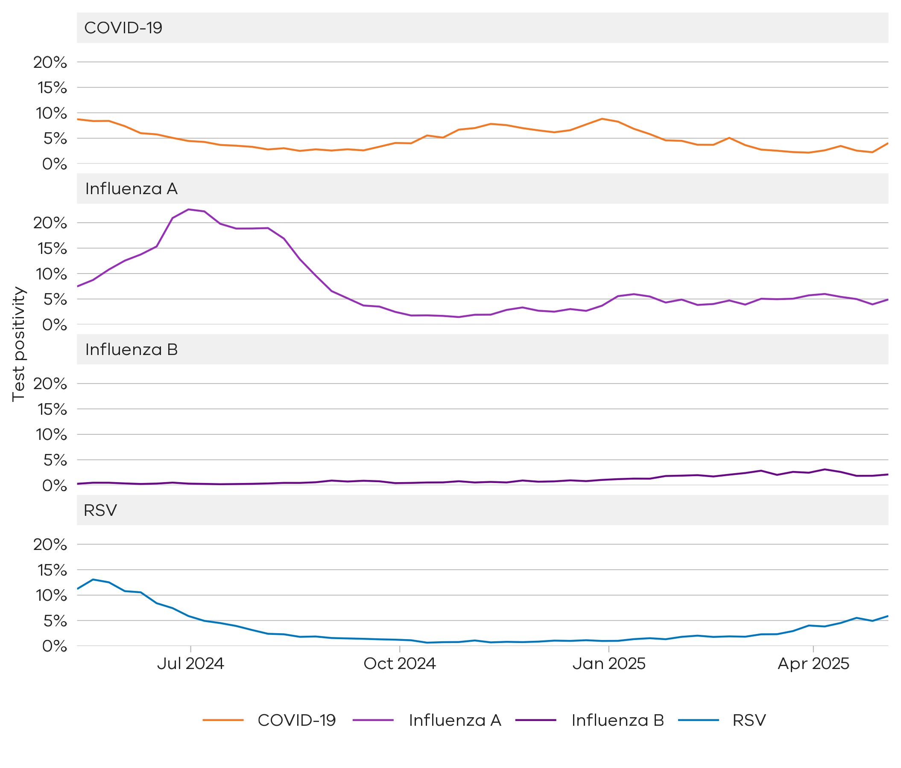

**Figure 11:** Weekly test positivity by age groups for COVID-19, Influenza and RSV, Victoria, 12 May 2024 to 10 May 2025

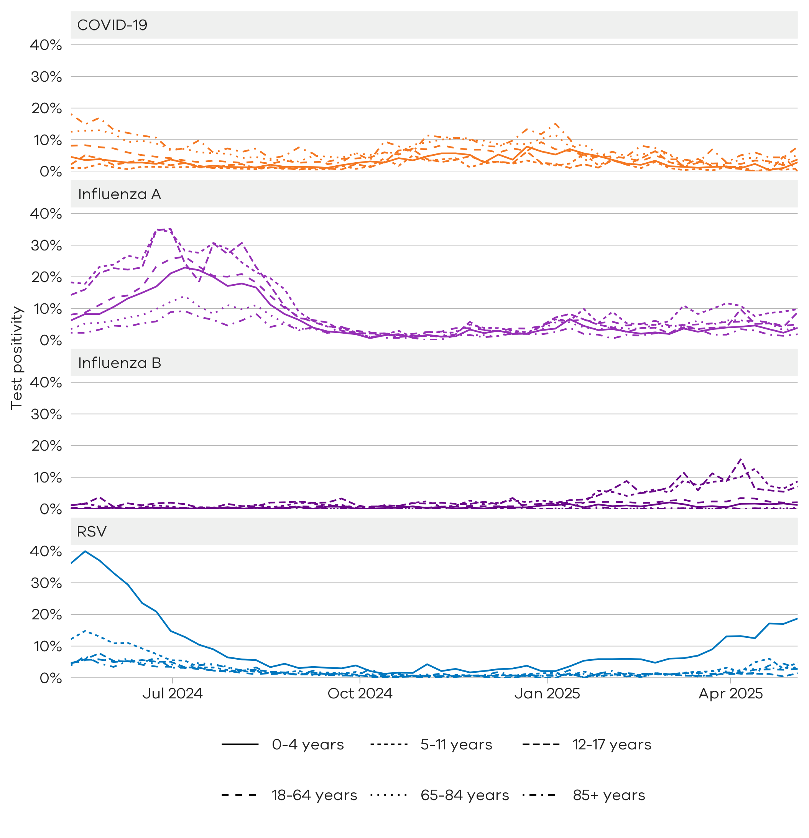

# Community surveillance

Respiratory illnesses are not limited to the notifiable conditions presented above. Understanding the overall burden of respiratory illness in the community is useful to understand broader trends in illness over time.

FluTracking

FluTracking is an online surveillance system across Australia, New Zealand, Hong Kong and Fiji. Volunteer participants complete a simple weekly online survey which collects self-reported information on respiratory symptoms. More information about FluTracking and ways to be involved are available here: www.flutracking.net

###### Summary

In the past week, the percentage of Victorian FluTracking participants reporting respiratory illness (fever and cough) was stable from the previous week.

**Figure 12:** Proportion of FluTracking participants reporting respiratory illness by week, Victoria, 1 January 2023 to 10 May 2025. Respiratory illness is defined as fever & cough.

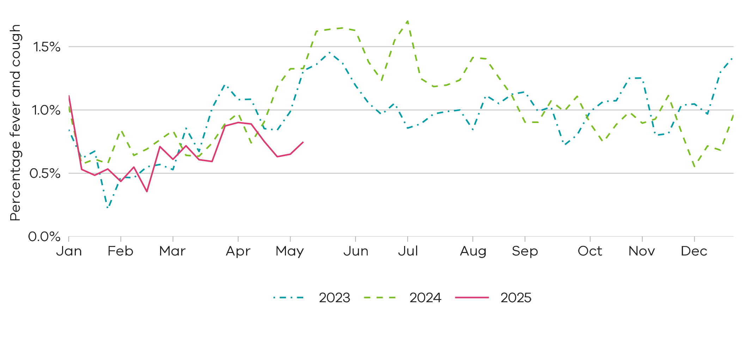



Reported respiratory illness from FluTracking is at slightly lower levels than recent years

## How to use this report

Data sources

All notified cases in Victoria are recorded in the Victorian Public Health Events Surveillance System (PHESS). Under the *Public Health and Wellbeing Act 2008* and *Public Health and Wellbeing Regulations 2019,* the Victorian Department of Health is authorised to collect information from doctors and laboratories about diagnoses of certain health-related conditions in Victoria.

The FluTracking surveillance system collects data from volunteer participants in a weekly survey. FluTracking reports are available here: https://info.flutracking.net/reports/australia-reports/

The Victorian Department of Health continually reviews surveillance methods to monitor respiratory disease in Victoria. Measurements included in this report may be updated or removed accordingly.

Definitions

**Notified cases:** Laboratory-confirmed cases of COVID-19, Influenza, and respiratory syncytial virus are reported according to the CDNA case definitions https://www.health.gov.au/resources/collections/cdna-surveillance-case-definitions Where multiple positive test results are received for the same person within 30 days of the initial test result they are counted as a single case.

Rapid antigen test results are not collected by the Victorian Department of Health, however, remain an important tool for individuals to access treatment and protect their community.

Notified cases represent a subset of the total number of infections for these conditions in the community. The number of notified cases is indicative of trends rather than absolute numbers of cases.

Test positivity: Test positivity is the percentage of total tests where the notifiable condition was detected.

Dates:Case notifications are based on the date the notification was first received by the Victorian Department of Health. Test positivity is based on the date of specimen collection.

Weeks: For the purposes of this report, data are aggregated by week, with the week starting Sunday and ending Saturday.

Authorised and published by the Victorian Government, 1 Treasury Place, Melbourne.

© State of Victoria, Australia, Department of Health, May 2025

**ISSN** 2982-3161 **- Online (pdf/word)**