

|  |
| --- |
| Blood Matters on the Bench and Beyond |
| Issue 22 – May 2025 |
|  |

Welcome to the Blood Matters newsletter for Scientists.

## Blood Matters online events 2025

Blood Matters online events are a regular fixture in our education calendar, continuing to support scientists and our multidisciplinary network of transfusion professionals.

Information will be sent as dates are finalised throughout the year.

## Blood management summit for scientists – save the date

**Wednesday 15 October 2025**

10.00am – 3.30pm (time TBC)

Australian Red Cross Lifeblood, Melbourne Processing Centre, West Melbourne

**Mark the date in your calendar, further details to follow later in the year.**

## ‘STOP the waste’ festive campaign 2024-25 – an all-time low!

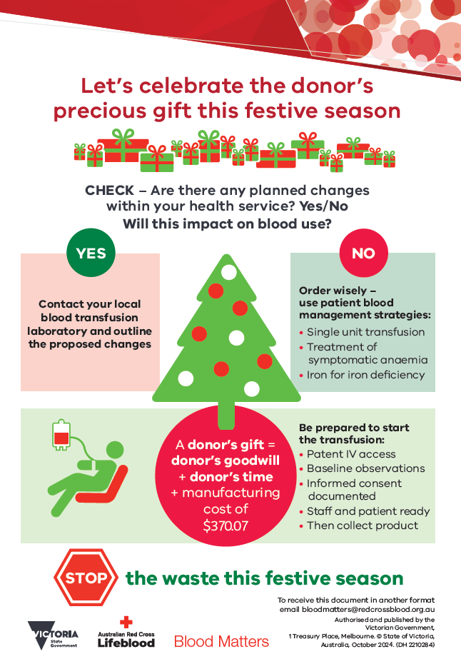Despite increases in RBC issues over the festive period, the number of RBC discarded in Victoria hit an all-time low (640 discarded, with 64,036 issued over the period).

**The average Victorian red cell wastage rate this festive campaign was a remarkable 1.0%.**

The 2024/35 festive period saw a RBC wastage cost reduction of $765,600 from the 2014/15 period. Cumulative savings over the course of the ‘STOP’ the waste’ festive campaign are $5.86 million.

Your diligence and awareness have been major factors in the ongoing success of the ‘STOP the waste’ festive campaign.

**We celebrate your effort and achievement to honour the donor’s gift. Your continued support of the ‘STOP the waste’ campaign is appreciated.**

## National Statement for the Emergency Use of Group A Clinical Plasma for patients with critical bleeding or a major haemorrhage

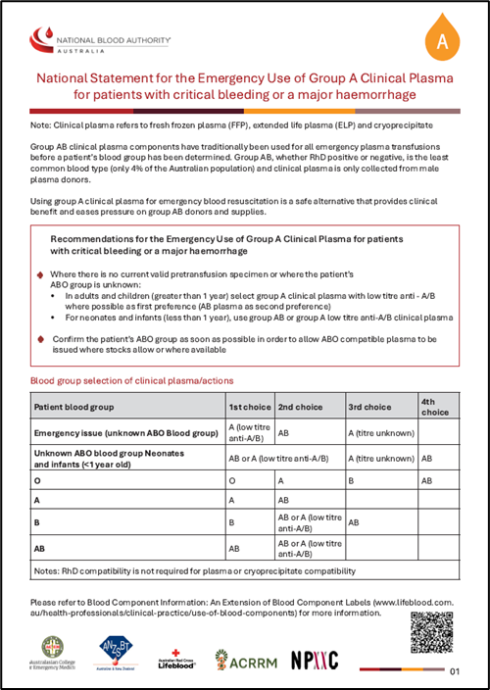Group AB clinical plasma components have traditionally been used for all emergency plasma transfusions, before a patient’s blood group has been determined.

Increasing emergency use of thawed group AB clinical plasma is leading to significant challenges in maintaining adequate supply of this extremely limited resource.

* + - * Group AB is the least common blood group at only 4% of the Australian population
* Clinical plasma is only collected from male donors, and only from collection sites within range of a processing centre
* This small proportion of male group AB plasma donations is also required for production of group AB cryoprecipitate

**Using group A clinical plasma for emergency blood resuscitation is a safe alternative that provides clinical benefit and eases pressure on group AB donors and supplies.**

Recommendations for the Emergency Use of Group A Clinical Plasma for patients with critical bleeding or major haemorrhage
Where there is no current valid pretransfusion specimen or where the patient’s ABO is unknown:
• In adults and children >1 year, select group A clinical plasma with low titre anti-A/B as first preference (AB plasma as second preference)
• For neonates and infants <1 year, use group AB or group A low titre anti-A/B clinical plasma


Further information and supporting information is available in the [National Statement](https://www.blood.gov.au/blood-products/blood-product-management/inventory-management-blood-and-blood-products#national-statement-for-the-emergency-use-of-clinical-plasma)[1].

**Laboratory Information Systems (LIS) may need to be modified to allow issue of group A plasma.**

### Victorian AB plasma issue rates

The proportion of AB plasma issued in Victoria is considerably above the Australian average issue rates. The use of group A (low titre anti-A/B) clinical plasma has been in routine use in other states/territories of Australia prior to the National Statement release.

Table 1: Group AB plasma issues as a proportion of total plasma issues, April 2024 – March 2025.

|  |  |  |
| --- | --- | --- |
|  | Victoria | Australia |
| **FFP** | 18.2% | 12.5% |
| **Cryoprecipitate** | 7.6% | 6.4% |

With less than 2% of the population being able to donate group AB clinical plasma, these rates are disproportionately high and unsustainable.

**As health services implement the National Statement, please review your inventory levels and adjust accordingly.**

## Availability of RHD NIPT for RhD negative pregnant patients

Australian Red Cross Lifeblood are offering an accredited **Non-Invasive prenatal test for fetal RHD (RHD NIPT)** at their Brisbane Red Cell Reference Laboratory, for all non-alloimmunised RhD negative pregnant patients with Medicare. The cost of testing will be billed to Medicare Benefits Schedule (MBS).

The test predicts fetal RhD status, enabling targeted antenatal RhD immunoglobulin (Ig) prophylaxis as per the [National Blood Authority Guideline for the prophylactic use of Rh D immunoglobulin in pregnancy care](https://www.blood.gov.au/guideline-prophylactic-use-rh-d-immunoglobulin-pregnancy-care).[2]

**Referral for RHD NIPT can be made after 15 weeks gestation:**

* Preferably use the [NIPT for fetal RHD request form](https://www.lifeblood.com.au/sites/default/files/resource-library/2025-01/FRM-02742_NIPT_for_fetal_rhd_v3.pdf)3
* A dedicated 6mL EDTA sample sent to Lifeblood’s Brisbane Processing Centre ASAP
  + At refrigerated temperature
  + To be received within 72 hours of collection

[Further information](https://www.lifeblood.com.au/sites/default/files/resource-library/2025-01/NIPT_for_RHD_information_FINAL.pdf)4 available from Lifeblood.

**There is no change to the Non-Invasive Prenatal Analysis (NIPA) for clinically significant fetal blood group antigens provided by Lifeblood for alloimmunised pregnant patients.**

**The two tests have different sample requirements.**

Any queries should be directed to Lifeblood’s Queensland Red Cell Reference Laboratory on 07 3838 9493. Additional information available in communication from Lifeblood dated 20 March 2025 (attached to this email).

## Beriplex AU has replaced Beriplex P/N

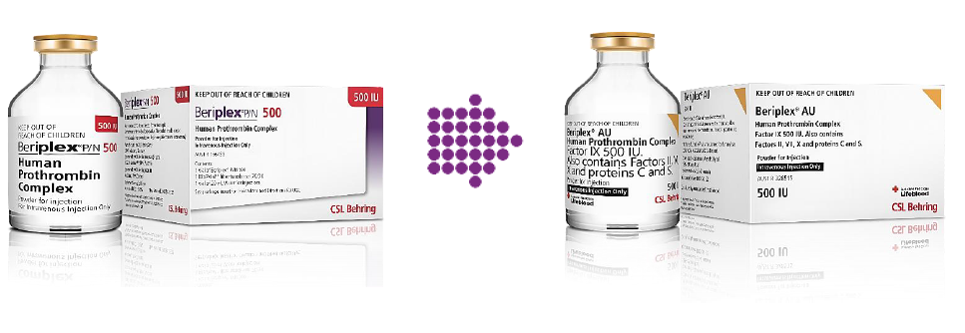Australian Red Cross Lifeblood has advised stocks of Beriplex P/N have been exhausted. Beriplex AU is now being supplied, please update your BloodNet order template if you haven’t already done so.

Lifeblood Customer Letter – Introduction of Beriplex AU 500IU (December 2024)

## National medical scientist certification

The Australian Council for Certification of the Medical Laboratory Scientific Workforce (CMLS) was launched in 2020 as a voluntary national professional certification scheme for Medical Laboratory Scientists.

New applications for certification and renewals are processed by the professional bodies providing CPD. More information and links can be found at [www.cmls.org.au](http://www.cmls.org.au)5.

#### Why become certified?

* Recognition of our professional standing as part of Australia’s health service workforce.
* Certification helps ensure competent professional practice.
* A certified workforce will promote professional development amongst the scientific community.
* As a nationally certified medical scientist you can demonstrate your ongoing commitment to professional development and self-improvement.

Blood Matters can provide support and education to assist in certification of the medical scientific workforce.

## How can Blood Matters help you?

The Blood Matters team are here to assist health services and laboratories with education and provision of resources.

If you have suggestions for tools and resources please contact Rae French or the Blood Matters team via email [rfrench@redcrossblood.org.au](mailto:rfrench@redcrossblood.org.au) <rfrench@redcrossblood.org.au> or [bloodmatters@redcrossblood.org.au](mailto:bloodmatters@redcrossblood.org.au) <bloodmatters@redcrossblood.org.au> or phone 03 9694 3524.

|  |
| --- |
| To receive this document in another format, phone 03 9694 0102, using the National Relay Service 13 36 77 if required, or [email Blood Matters](mailto:bloodmatters@redcrossblood.org.au?subject=Accessible%20document) <bloodmatters@redcrossblood.org.au>.  Authorised and published by the Victorian Government, 1 Treasury Place, Melbourne.  © State of Victoria, Australia, Department of Health, May 2025.  **ISSN** 2652-7278 – **Online (pdf / word)**  Available at [Blood Matters](https://www.health.vic.gov.au/patient-care/transfusion-science-and-blood-stewardship) <https://www.health.vic.gov.au/patient-care/transfusion-science-and-blood-stewardship> |

1. https://www.blood.gov.au/blood-products/blood-product-management/inventory-management-blood-and-blood-products
2. https://www.blood.gov.au/guideline-prophylactic-use-rh-d-immunoglobulin-pregnancy-care

   3 FRM-02742_NIPT_for_fetal_rhd_v3.pdf

   4 https://www.lifeblood.com.au/sites/default/files/resource-library/2025-01/NIPT_for_RHD_information_FINAL.pdf

   5 www.cmls.org.au