

|  |
| --- |
| Mental Health Bulletin 88 |
| Service Recipient Codes – CMI/ODS |
|  |

## Purpose and Scope

To provide an update on the Service Recipient category codes in CMI/ODS as a new group code has been added

## Overview

Service Recipient codes in CMI/ODS are used in the contact data entry screen to provide detail on the person or persons receiving the contact.

## Activity Data Reporting

There are a number of service recipient codes currently in CMI/ODS, however, to ensure accurate reporting of group activity the following service recipient codes are counted as group contacts:

* 2 - Client group
* 9 - Parent/Family/Carer group
* 40 - Client & Family group (new)

The new code to identify Client & Family groups was added to CMI/ODS in March 2025 with a commencement date of 1st January 2025. This code is available to all AMHS to use to accurately record client & family group activity.

## Contact Data Entry

Below is a screen shot of the individual contact data that is entered into CMI/ODS:

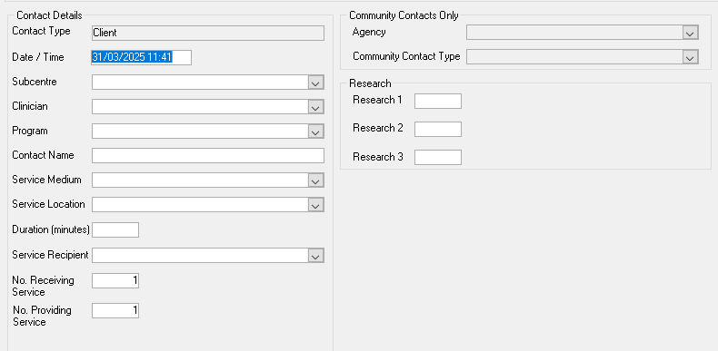

### For More Information

# Further information about the correct use of CMI/ODS , see the sections on; [Registration of Clients, CMI/ODS Service Contacts and Subcentre/Program Maintenance](https://www.health.vic.gov.au/research-and-reporting/bulletins-and-program-management-circulars-pmc). <https://www.health.vic.gov.au/research-and-reporting/bulletins-and-program-management-circulars-pmc>

# For any queries relating to data reporting or program setup please email: [MHDReporting@health.vic.gov.au](mailto:MHDReporting@health.vic.gov.au)

|  |
| --- |
| To receive this publication in an accessible format please [email MHD Reporting](mailto:MHDReporting@dhhs.vic.gov.au) <MHDReporting@health.vic.gov.au>  Authorised and published by the Victorian Government, 1 Treasury Place, Melbourne.  Available at [Bulletins and Program Management Circulars (PMC)](https://www.health.vic.gov.au/research-and-reporting/bulletins-and-program-management-circulars-pmc) - https://www.health.vic.gov.au/research-and-reporting/bulletins-and-program-management-circulars-pmc>  © State of Victoria, Department of Health and Human Services, March 2025 |