

|  |
| --- |
| Cemetery sector newsletter |
| Edition 1, 2025 |
|  |

# In this issue

Contact us 1

Welcome 1

Manager’s message 1

Consumer price index increase to fees 1 July 2025 2

Corinella Cemetery Trust grant project 2

What is the difference between a right of interment fee and an interment fee? 2

Rights of interment purchased for a third party 2

A history of Vaughan cemeteries 3

Did you know? 3

Advertising on the Join a Public Board website 3

Updated Class B trust member application form 4

Free governance training 4

# Contact us

|  |  |
| --- | --- |
| Email outline | [Email](mailto:cemeteries@health.vic.gov.au) <cemeteries@health.vic.gov.au> |
| Telephone outline | Phone 1800 034 280 |
| Internet outline | [Cemeteries and Crematoria website](https://www.health.vic.gov.au/public-health/cemeteries-and-crematoria) <https://www.health.vic.gov.au/public-health/cemeteries-and-crematoria> |
| Mailbox outline | Cemeteries and Crematoria Department of Health  PO Box 4057 MELBOURNE VIC 3001 |

# 

# Welcome

Welcome to the Department of Health’s first cemetery sector newsletter for 2025.

We’d love your suggestions on topics to include in future newsletters. Please let us know!

# Manager’s message

Thank you to the cemetery trusts that have recently been part of the department’s climate risk project.

This work is being led by our colleagues in the Climate Health Victoria team, and the project aims to improve the cemetery sector’s resilience to the impacts of climate change.

Work has also been happening to review the Cemeteries and Crematoria Regulations 2015. The Regulations prescribe requirements for matters like depth of burial, mausoleum construction, forms to use for interments, cremations and exhumations. They set out restricted behaviours and activities within public cemeteries.

Thank you for providing your views on those Regulations that work well and suggested improvements. New Regulations will be made in June 2025.

I would like to take a moment to recognise the thousands of volunteers across Victoria who generously dedicate their time to provide cemetery services. Thank you for being such an important part of your communities.

*Nicole McDonald, Manager*

# Consumer price index increase to fees 1 July 2025

Each year, all cemetery trust fees over $50 that exist on 1 February are automatically increased by the consumer price index (CPI), effective 1 July.

In February 2025, each cemetery trust was notified of the 2025 CPI increase, with a copy of its updated fee schedule.

If your trust has not received the notification letter and updated fee schedule, please [email the department](mailto:cemeteries@health.vic.gov.au) <cemeteries@health.vic.gov.au> or call 1800 034 280.

# Corinella Cemetery Trust grant project

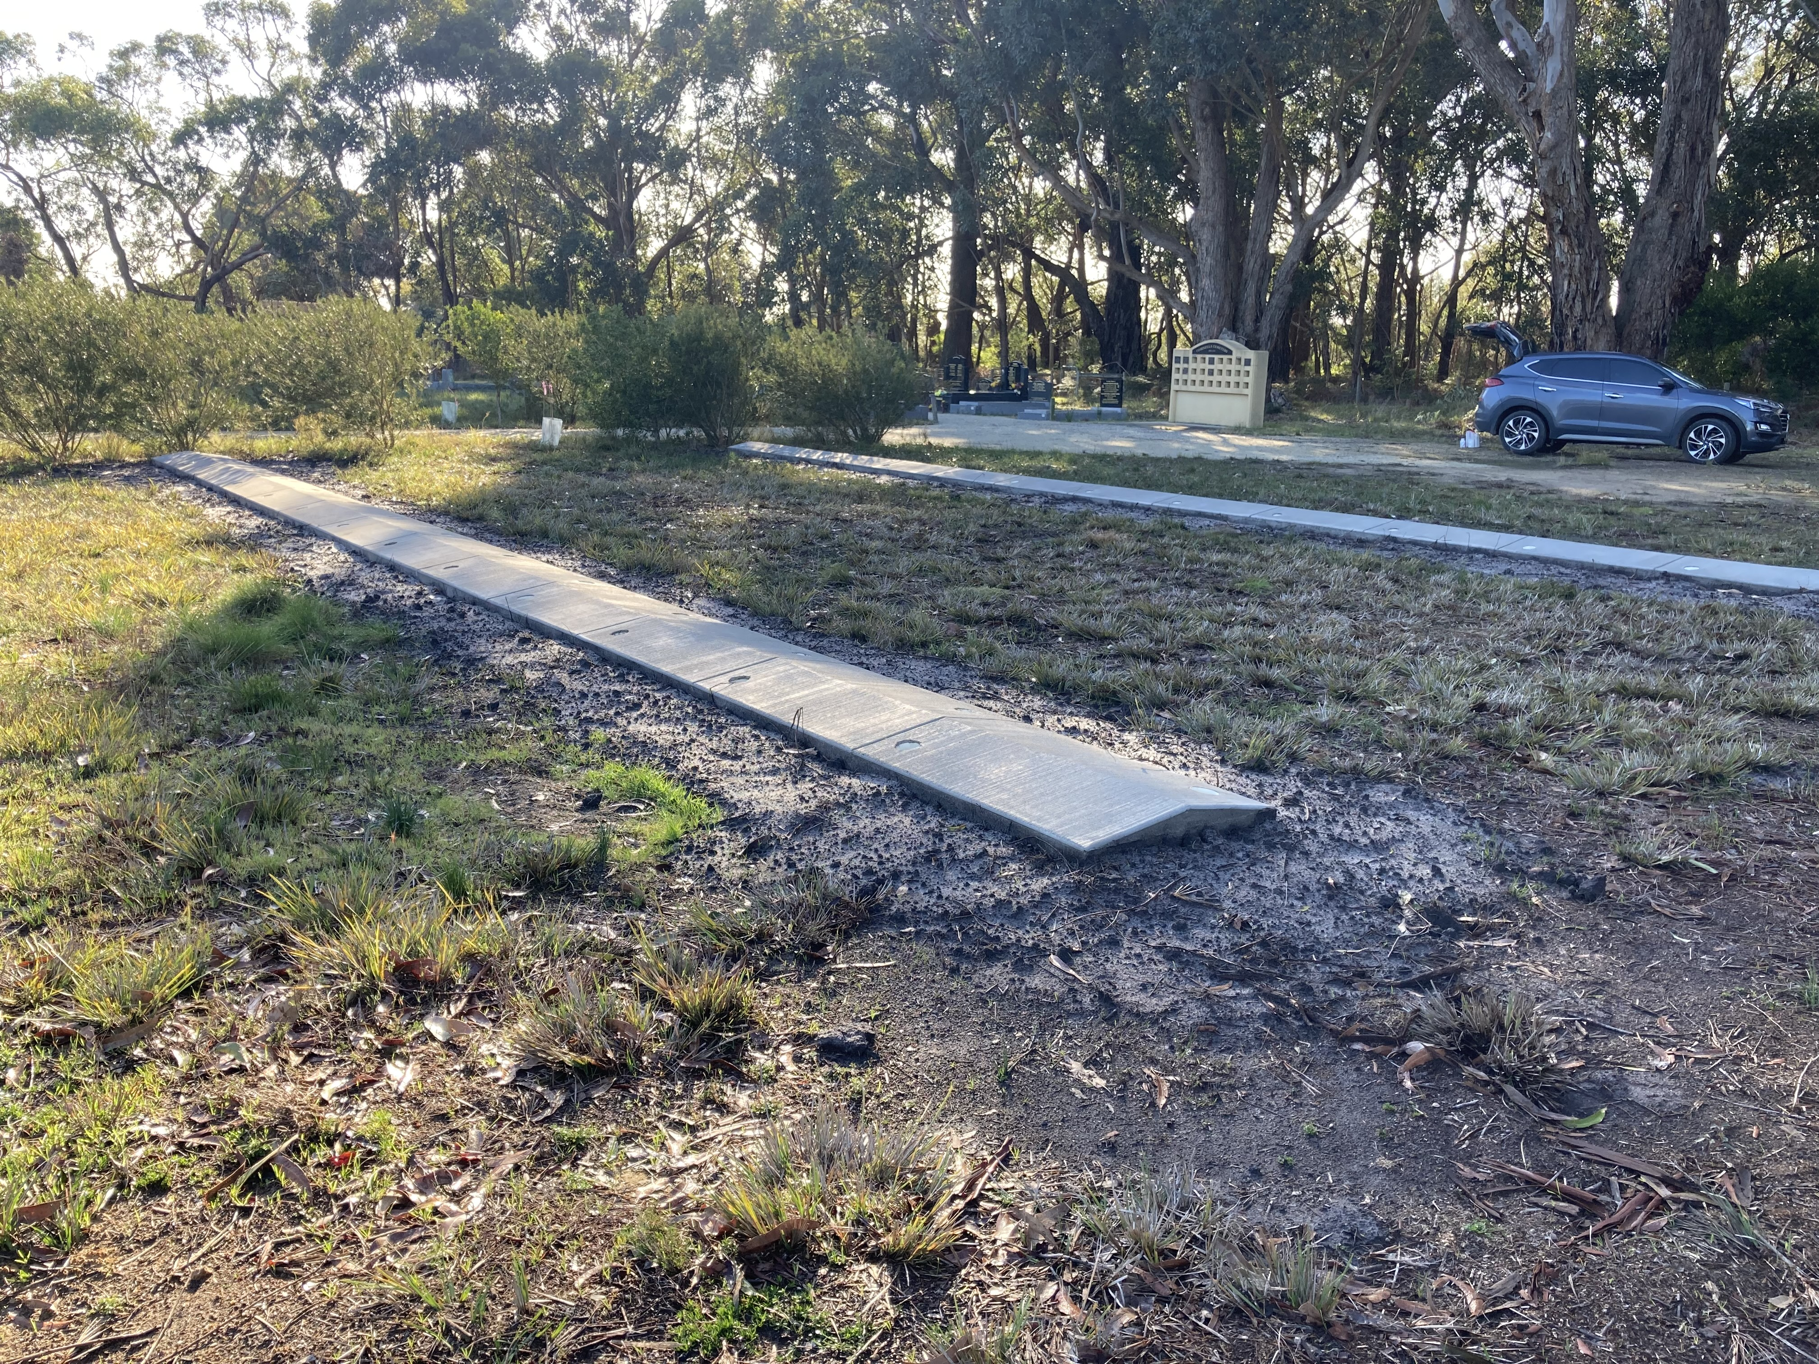

Corinella Cemetery Trust received a grant of $5,225 from the department for 2 new lawn beams. The trust contributed $429 to the project.

With a growing local population, the trust noticed a preference for lawn graves consistent with the natural bush setting of the cemetery. The project has created 50 new burial plots.

This is a great example of a low-cost project that meets community needs and will provide future income for the trust.

# What is the difference between a right of interment fee and an interment fee?

## Gavel with solid fillRight of interment fee

A right of interment fee is the charge to buy a right of interment permit.

Sometimes there is confusion about what the buyer is getting when they pay a right of interment fee. A right of interment is not a tangible item or service; it is a legal entitlement.

A right of interment relates to a specific place of interment – for example, a grave, vault, mausoleum crypt or ashes niche.

A right of interment permits the right of interment holder to determine:

* the human remains (bodily or cremated) that can be interred (buried or placed) in a place of interment in a public cemetery
* the type of memorialisation, if any, to be established at the place of interment subject to any cemetery trust memorialisation policies or specifications.

## Excavator with solid fillInterment fee

An interment fee is the charge to inter remains.

This service involves the physical act of preparing for and interring remains – for example, burying bodily remains in a grave or placing cremated remains in a wall niche.

# Rights of interment purchased for a third party

Many of the difficulties associated with determining who is a right of interment holder can be avoided by clearly documenting, at the time of purchase, who is intended to be the holder.

This is particularly important in situations where the purchaser and the holder are not the same person. Clear communication can help ensure everyone has the same understanding of who will hold the right of interment.

Occasionally, members of the public will approach a cemetery trust to buy a right of interment ‘in the name of’ another person, such as a family member.

In these situations, the trust should clarify whether the purchaser intends for the other person to be the holder of the right of interment.

If this is the intention, the trust will need evidence that the other person consents to being the holder and understands the rights and responsibilities that this brings. This should happen before the trust issues the right of interment.

# Storytelling outlineA history of Vaughan cemeteries

Victoria’s cemeteries are important historical sites. Many of our trust members are enthusiastic about collecting, preserving and sharing information about the sites they care for.

One such trust member, Jeannie Lister from Vaughan Cemetery Trust, has co-authored *A History of Vaughan* with Ken James and Jon Kehrer about the area.

One chapter of the book is devoted to Vaughan’s cemeteries. As was common in areas that experienced high population growth during the 1850s gold rush, burials first occurred on land that had not been formally reserved for cemetery use. The Vaughan Cemetery was created after 125 residents signed a petition to the Chief Secretary in 1858.

The original cemetery register still exists. The entries mentioned in the book offer a glimpse into the lives and societies of earlier years. Examples include the remains of a person found in the Chinese camp, presumably awaiting repatriation to China, listed as ‘Yee Pow, bones in jar’ and entries about miners killed in tunnel accidents. Trustees often waived cemetery fees due to poverty.

The book also mentions the trust’s 2012 installation of a memorial stone to honour those in unmarked graves and the 2017 installation of artworks by local artist Jessie Stanley.

We’d like to share with all trust members this extract from the book: ‘Every one of these 900+ burials was a loved son or daughter, husband or wife, sister, brother, mother, father, grandparent, grandchild, friend or colleague. Cemeteries are very special repositories of the human and social fabric of a community. To plan a better way forward, we must look to the past to learn from successes and failures, and to benefit from the hard won lessons people such as these can teach us.’

# Mop and bucket outlineDid you know?

Did you know that cemetery trusts can enter into agreements to maintain memorials and places of interment?

Under section 111 of the *Cemeteries and Crematoria Act 2003*, a cemetery trust may enter into an agreement with a holder of a right of interment in the public cemetery managed by the trust to maintain a memorial or place of interment that the holder of the right of interment would otherwise be responsible for.

The agreement must be for a specified term that does not exceed 10 years. At the end of the 10 years, the agreement may be renewed for another term up to 10 years.

Cemetery trusts can negotiate and enter into an agreement about costs with the holder of the right of interment. Costs are agreed at the discretion of both parties, and the trust must document the terms of the agreement in its records. Costs for these agreements are not part of the trust’s fee schedule and are not subject to the fee approval or annual CPI increase processes.

# Advertising on the Join a Public Board website

We recently began online advertising for Class B trust member positions on the [Join a Public Board website](https://www.boards.vic.gov.au/) <https://www.boards.vic.gov.au/>. This website is the Victorian Government’s website for appointments to public boards.

The purpose of the ad is to raise community awareness of cemetery trusts and the role of trust members and to encourage people to look up cemetery trusts in their local area that have vacant positions. People who are interested are asked to contact relevant trusts directly for more information.

It is important to use online advertising opportunities. The department is not currently able to fund print advertising in local newspapers and publications for Class B vacancies except in special circumstances. We are currently updating our resources to reflect this change.

# Updated Class B trust member application form

The department has made 2 minor updates to the Class B appointment application form.

## New question

We have added a new question at the top of page 1 asking how applicants heard about the role. This information will help us track the effectiveness of advertising channels and recruitment trends.

Screenshot of new question on form

Screenshot of new question on form

## Chairperson’s declaration

We have made the final section of the form ‘Part G – Chairperson’s declaration’ clearer by having separate tick boxes to indicate whether the application is being endorsed by the chairperson or a trust delegate. This will help us when cross-checking applications against our trust member records.

The updated application form can be downloaded from the [Cemeteries and Crematoria webpage](https://www.health.vic.gov.au/cemeteries-and-crematoria/recruitment-advertising-class-b-cemetery-trusts) <https://www.health.vic.gov.au/cemeteries-and-crematoria/recruitment-advertising-class-b-cemetery-trusts>.

# Free governance training

Free face-to-face governance training workshops for Class A and Class B cemetery trusts are held across Victoria. The workshops are delivered by ICDA, an enterprise of Our Community, on behalf of the department.

To register for an upcoming workshop in your area, visit the [ICDA website](https://communitydirectors.com.au/training/victorian-cemetery-trusts-governance-and-operational-training) <https://communitydirectors.com. au/training/victorian-cemetery-trusts-governance-and-operational-training>.

For help with registrations or to arrange a workshop in your area by request, please contact Our Community:

Phone: 1300 137 475

[Email](mailto:learn@ourcommunity.com.au): <learn@ourcommunity.com.au>

## Class B online training

The department has developed a free online training program called Cemetery Essentials for Class B Cemetery Trusts.

If you would like to take part, please [email](mailto:learn@ourcommunity.com.au) Our Community <learn@ourcommunity.com.au> to request an invitation.

**Please note:** To access the course, participants need to have an email address.

|  |
| --- |
| To receive this document in another format, phone 1800 034 280, using the National Relay Service 13 36 77 if required, or [email the department](mailto:cemeteries@health.vic.gov.au) <cemeteries@health.vic.gov.au>.  Authorised and published by the Victorian Government, 1 Treasury Place, Melbourne.  © State of Victoria, Australia, Department of Health, March 2025.  SSN 2208-8830 (print) 2208-8849 (online/PDF/Word)  Available on the [Cemeteries and Crematoria website](https://www.health.vic.gov.au/cemeteries-and-crematoria/cemetery-sector-newsletters) <https://www.health.vic.gov.au/cemeteries-and-crematoria/cemetery-sector-newsletters>  Printed by Tdc3, Richmond |