

Pre-immunisation checklist
What to tell your immunisation provider before immunisation
OFFICIAL

Please tell your immunisation provider if the person about to be immunised:
- is unwell today
- has a disease which lowers immunity (e.g., severe combined immunodeficiency (SCID), leukaemia, HIV, cancer) or is having treatment which lowers immunity (e.g., oral steroid medicines such as cortisone and prednisone, disease-modifying anti-rheumatic drugs (DMARDs), radiotherapy, chemotherapy)
- is an infant of a mother who was receiving highly immunosuppressive therapy (for example, biological disease modifying anti-rheumatic drugs (bDMARDs) during pregnancy
- has had a severe reaction following any vaccine
- has any severe allergies (to anything)
- has had any vaccine in the past month
- has had an injection of immunoglobulin, or received any blood products, or a whole blood transfusion in the past year
- is pregnant
- is planning a pregnancy or anticipating parenthood
- is a parent, grandparent or carer of an infant aged up to six months
- has a past history of Guillain-Barre Syndrome
- was a preterm baby born at less than 32 weeks' gestation, or weighing less than 2000 g at birth
- is a baby who has had intussusception, or a congenital abnormality that may predispose to intussusception
- has a chronic illness
- has a bleeding disorder
- does not have a functioning spleen
- lives with someone who has a disease which lowers immunity (for example, leukaemia, cancer, HIV),
- or lives with someone who is having treatment which lowers immunity (for example, oral steroid medicines such as cortisone and prednisone, disease modifying anti-rheumatic drugs (DMARDs) radiotherapy, chemotherapy)
- identifies as an Aboriginal and/or Torres Strait Islander person
- is planning travel
- has an occupation or lifestyle factor/s for which vaccination may be needed.

Before any immunisation takes place, your immunisation provider will ask:
- Do you understand the information provided to you about the immunisation/s?
- Do you need more information to decide whether to proceed?
- Did you bring your / your child’s immunisation record with you?

Immunisation providers must report all vaccinations listed on the National Immunisation Program to the Australian Immunisation Register (AIR). The AIR is a national register that records vaccines given to people of all ages in Australia. You may obtain an Immunisation History Statement, a listing of all your vaccinations recorded on the AIR.  Scan this QR code to read about the Australian Immunisation Register <https://www.servicesaustralia.gov.au/australian-immunisation-register>.  (Image description: a QR code that links to Service Australia Australian Immunisation Register webpage.) | 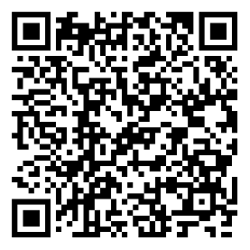

Comparison of the effects of diseases and the side effects of vaccines
Scan this QR code to read the comparison of the effects of diseases and the side effects of vaccines on the National Immunisation Program <https://immunisationhandbook.health.gov.au/resources/tables/table-comparison-of-the-effects-of-diseases-and-the-side-effects-of-vaccines-on-the-national-immunisation-program>.  (Image description: a QR code that links to the Australian Immunisation Handbook Comparison of the effects of diseases and the side effects of vaccines on the National Immunisation Program table.) | 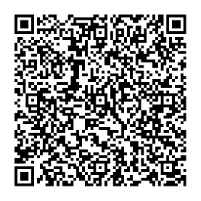
To receive this document in another format, email the Immunisation Program <immunisation@health.vic.gov.au>.
Authorised and published by the Victorian Government, 1 Treasury Place, Melbourne.
© State of Victoria, Australia, Department of Health, February 2025.

