**Drug advice**

**High-dose ecstasy tablets in hot conditions**

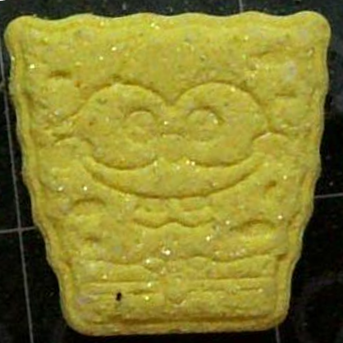**Tablets with large MDMA doses – including a yellow ‘SpongeBob’ pill – may be circulating in Victoria**

**MDMA (‘ecstasy’)** is an empathogen stimulant with effects including euphoria and increased sociability, but also increased body temperature, heart rate and blood pressure.

Recent testing of a ‘**SpongeBob**’ pill (pictured) in Victoria found the pill contained an **unexpectedly high dosage** of MDMA. The tablet is **yellow in colour** with **white and orange flecks**.

**Using MDMA in hot conditions will increase the risk of life-threatening hyperthermia**

Consuming MDMA increases your **core body temperature**. A larger dose can be enough to cause **hyperthermia**, meaning your body is too hot to function normally.

**Hot, crowded and humid environments** increase the risk of severe hyperthermia and can make your ‘normal’ MDMA dose hazardous. **Physical exertion** makes the body even hotter.

Using **other substances** – especially stimulants like cocaine or amphetamines – further increases the chance of hyperthermia or other unpredictable or toxic effects.

**Know the signs – and don’t wait to get help**

**Signs of drug-related hyperthermia** include feeling uncomfortably hot, nausea and vomiting, excessive thirst, confusion, agitation, muscle spasms, seizures or losing consciousness. **Even one sign** is reason to get help.

If you experience any unusual or unexpected effects, or notice someone appearing confused or unwell, **seek urgent medical attention** by calling **Triple Zero (000)** or finding the **First Aid Service** if you’re at a festival. **Don’t delay seeking help** – getting help early can be the difference between life and death.

**Reduce the risk of harm**

All alcohol and other drug use comes with risk, so:

* If you can, **access a** [**pill testing service**](https://www.betterhealth.vic.gov.au/health/healthyliving/pill-testing-service) to get free, confidential, anonymous testing and health advice
* **Start low and go slow** with dosing. If consuming any other substance or redosing, wait until peak effects have passed – you shouldn't need to take as much to maintain the same effect
* **Stay hydrated by sipping water (not alcohol) slowly, but don’t drink too much**
* **Find a cool or shady spot to take breaks from dancing**
* Make sure you’re in a **safe environment with people you trust**
* **Remember**, even ‘pure’ drugs can produce serious side effects and death. Get the facts at: [adf.org.au/drug-facts/](https://adf.org.au/drug-facts/). Always seek information about your medications before mixing with other drugs.

Contact **Harm Reduction Victoria’s DanceWize team** for anonymous support and education from peers. Talk to DanceWize volunteers by email at [info@dancewize.org.au](mailto:info@dancewize.org.au).

If you or someone you know needs help with alcohol or drug use, call DirectLine on 1800 888 236 or visit [directline.org.au](https://www.directline.org.au/) for information and support to access treatment.