# Appendix 3 – Example documentation

### Example CLD form A

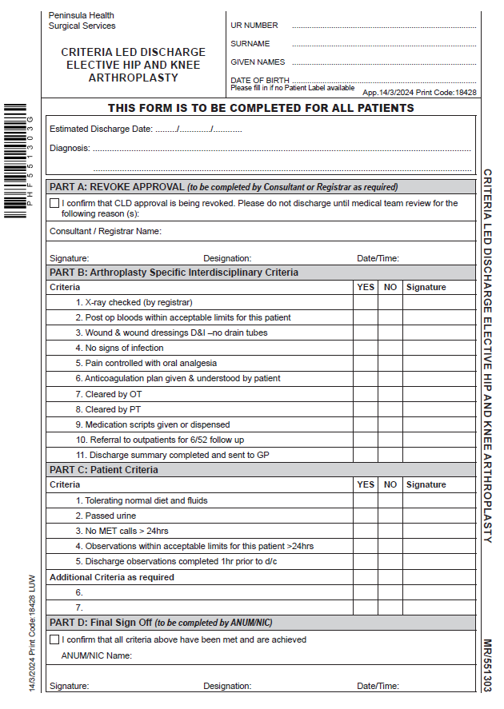

### Example CLD form B

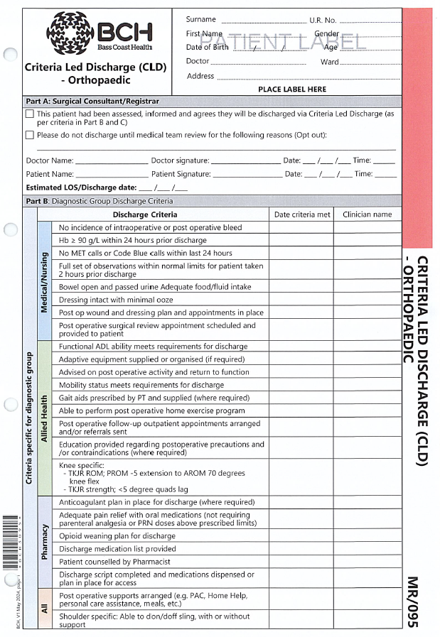

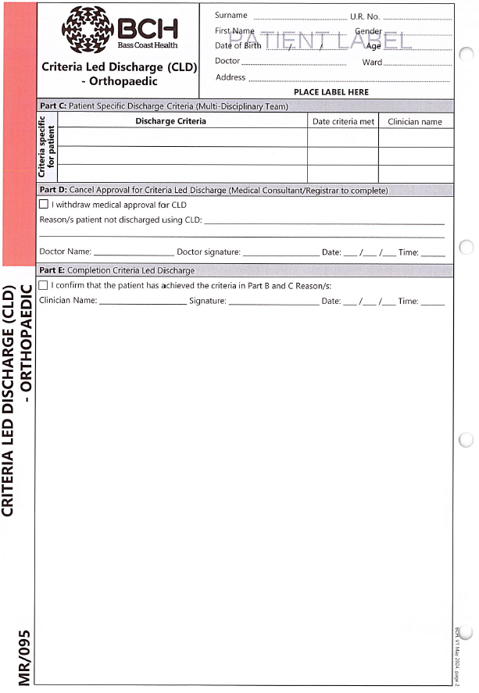

### Example CLD EMR workflow

Figure 1. Robotic Prostatectomy CLD order entry field in the Epic EMR

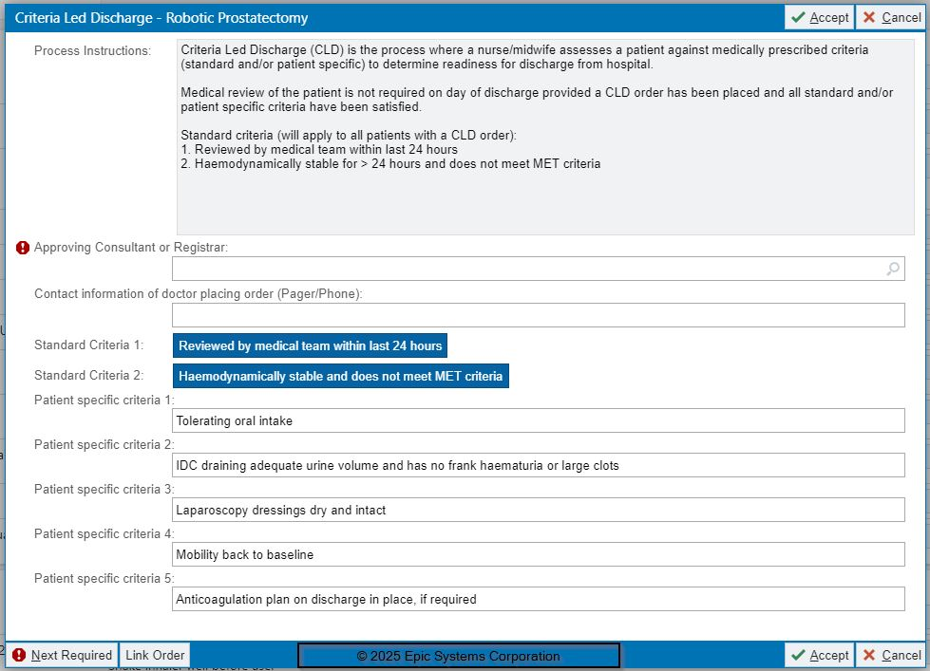

Figure 2. Robotic Prostatectomy CLD order flagged ( clipboard icon) on the Patient Journey board view to alert nurses



Figure 3: Nursing documentation against Robotic Prostatecomy CLD showing same critera met

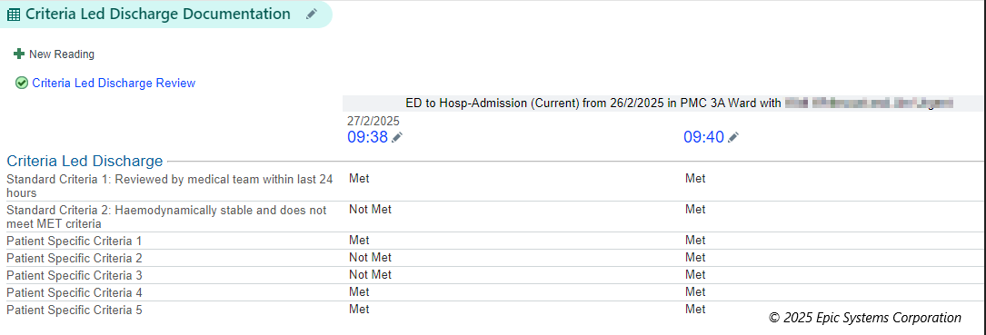

## Example criteria for discharge checklist

