Immunisation evidence request decision aid flow chart
A resource for early childhood education and care services in Victoria
OFFICIAL


An example of reasonable steps services can take to obtain evidence of current immunisation status for children attending early childhood education and care services.

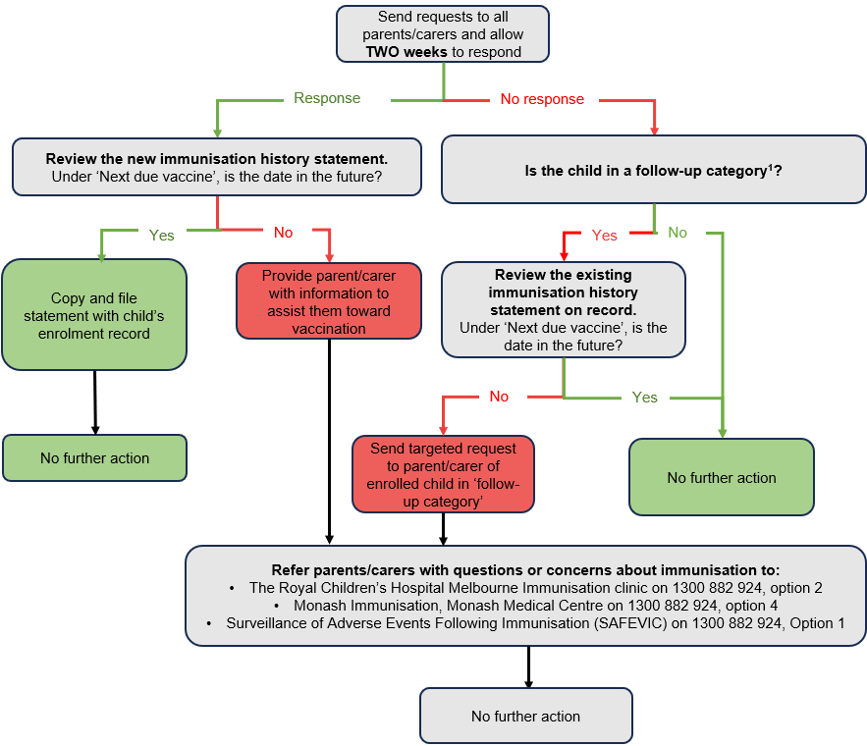

¹Follow-up category indicates the child was flagged by the early childhood education and care services as being due for vaccines.

Step-by-step process:

Step 1: Send requests to all parents/carers of enrolled children. Allow two weeks for a response.
- If an Immunisation History Statement is provided, go to step 2.
- If an Immunisation History Statement is not provided, go to step 3.

Step 2: Review new Immunisation History Statements as they are provided.
Under ‘Next due vaccine’, is the date in the future?
- If ‘yes’, copy and file the statement with the child’s enrolment records. No further action is needed.
- If ‘no’, give the parent information to assist them towards vaccination, go to step 5.

Step 3: Is children in a ‘follow-up category’.
- If ‘yes’, to step 4.
- If ‘no’, no action is required.

Step 4: Review existing Immunisation History Statement on record.
Under ‘Next due vaccine’, is the date in the future?
- If ‘yes’, no further action is needed.
- If ‘no’, send targeted request to parent/carer. No further action is needed, go to step 5.

Step 5: Provide parents/carers with information to assist them toward vaccination.
- The Royal Children’s Hospital Melbourne Immunisation clinic on 1300 882 924, option 2
- Monash Immunisation, Monash Medical Centre on 1300 882 924, option 4
- Surveillance of Adverse Events Following Immunisation (SAFEVIC) on 1300 882 924, Option 1

Whose records to review for a possible follow up request for immunisation evidence
Who | Why
Children whose families have Commonwealth Child Care Subsidy (CCS) suspended when a reminder is due to be issued. | One reason for having the subsidy suspended is that a child is behind on immunisations.
Children who are enrolled in a service, but do not attract the CCS subsidy:  - families who exceed the income threshold  - families paying full fees for other reasons | These families are not prompted about vaccinations by CCS reminders. Therefore, an additional reminder by the service may beneficial.  It is recommended that, at the point of enrolment, services make a note of children who will be due for a vaccine/s in the coming year.
Children enrolled under the ‘support period’ provision | These families have or may be experiencing vulnerability or disadvantage and may benefit from additional support.

To receive this document in another format, email the Immunisation Program, Community and Public Health Division, Department of Health <immunisation@health.vic.gov.au>.
Authorised and published by the Victorian Government, 1 Treasury Place, Melbourne.
© State of Victoria, Australia, Department of Health, July 2024.
ISBN 978-1-76131-617-3 (pdf/online/MS word)
Available at: Immunisation evidence request decision aid flowchart: <https://www.health.vic.gov.au/publications/immunisation-evidence-request-decision-aid-flow-chart>

