Reporting Restrictive Interventions
to the Chief Psychiatrist
Chief Psychiatrist’s reporting directive – April 2024
OFFICIAL

Reporting Restrictive Interventions to the Chief Psychiatrist
Chief Psychiatrist’s reporting directive – April 2024

To receive this document in another format, phone 1300 767 299, using the National Relay Service 13 36 77 if required, or email OCP (Health) <ocp@health.vic.gov.au>.
Authorised and published by the Victorian Government, 1 Treasury Place, Melbourne.
© State of Victoria, Australia, Department of Health, April 2024.
In this document, ‘Aboriginal’ refers to both Aboriginal and Torres Strait Islander people. ‘Indigenous’ or ‘Koori/Koorie’ is retained when part of the title of a report, program or quotation.
ISBN 978-1-76131-369-1 (online/PDF/Word)
Available at Chief Psychiatrist’s restrictive interventions <https://www.health.vic.gov.au/chief-psychiatrist/chief-psychiatrists-restrictive-interventions>

Key Message
- The Chief Psychiatrist oversees the use of restrictive interventions as defined by the Mental Health and Wellbeing Act 2022.
- Designated mental health services are required to report the use of restrictive interventions to the Chief Psychiatrist.
- The Act defines restrictive intervention to mean seclusion, bodily restraint or chemical restraint.
- The reporting of chemical restraint is a requirement that applied from 1 September 2023, when the Act commenced.
- Emergency departments and urgent care centres in designated mental health services must begin reporting their use of restrictive interventions from April 1, 2024.

1 Purpose
The purpose of this directive is to inform designated mental health services about their obligations under the Mental Health and Wellbeing Act 2022 (the Act) to report the use of restrictive interventions to the Chief Psychiatrist.
The directive:
- defines restrictive interventions
- outlines the specific details about restrictive interventions that must be reported
- outlines the process that must be followed to satisfactorily report restrictive interventions.
The directive also highlights new reporting obligations on the use of chemical restraint that applied on 1 September 2023, when the new Act commenced.
The directive should be used alongside the Chief Psychiatrist’s Guideline on Restrictive Interventions, which provides information about the obligations and considerations for services in the development of local policies and procedures relating to restrictive interventions.

2 Chief Psychiatrist’s statutory role
The Chief Psychiatrist is an independent statutory officer with powers and responsibilities prescribed by the Act to uphold the quality and safety of clinical mental health services in Victoria’s mental health and wellbeing system.
As part of their oversight and leadership role, the Chief Psychiatrist:
- monitors clinical mental health service providers to ensure compliance with the Act
- investigates incidents when the safety or wellbeing of a person was endangered while receiving a mental health and wellbeing service
- reviews and audits service provision to find and resolve quality and safety issues
- publishes guidelines on clinical best practice
- promotes the rights of people receiving a mental health and wellbeing service.

3 Changes under the Mental Health and Wellbeing Act
On 1 September 2023 new statutory powers and responsibilities were granted to the Chief Psychiatrist. Their jurisdiction was broadened to include the oversight of chemical restraint and mental health and wellbeing services provided in custodial settings.
These changes were recommended by the Royal Commission into Victoria’s Mental Health System. They came into effect through the replacement of the Mental Health Act 2014 with the Mental Health and Wellbeing Act 2022.
The redefined role of the Chief Psychiatrist resulted in new compliance requirements for mental health and wellbeing services that are overseen by the Chief Psychiatrist.
This includes:
- Designated mental health services being required to report the use of chemical restraint to the Chief Psychiatrist.
- Mental health and wellbeing service providers in custodial settings being required to report to the Chief Psychiatrist the use of chemical restraint, sexual safety incidents, and the death of people under their care.
- The introduction of the defined term ‘mental health and wellbeing service’ has broadened the scope of oversight to locations such as medical wards and emergency departments.
This new reporting requirement applies to the provision of mental health and wellbeing services in custodial settings by Forensicare and Orygen. This would extend to other mental health service providers in custodial settings as services are established.

4 Definitions
In the Act (section 3(1)):
- restrictive intervention means ‘seclusion, bodily restraint or chemical restraint’
  - seclusion means ‘the sole confinement of a person to a room or any other enclosed space from which it is not within the control of the person confined to leave’
  - bodily restraint means ‘physical restraint, or mechanical restraint, of a person’
- physical restraint means ‘the use by a person of their body to prevent or restrict another person's movement but does not include the giving of physical support or assistance to a person in the least restrictive way that is reasonably necessary to—
(a) enable the person to be supported or assisted to carry out daily activities; or
(b) redirect the person because they are disoriented’
- mechanical restraint means ‘the use of a device to prevent or restrict a person's movement’
  - chemical restraint means ‘the giving of a drug to a person for the primary purpose of controlling the person's behaviour by restricting their freedom of movement but does not include the giving of a drug to a person for the purpose of treatment or medical treatment’.

5 Reporting restrictive interventions
Designated mental health services must submit to the Chief Psychiatrist restrictive intervention data from the previous month via the Office of the Chief Psychiatrist SharePoint portal <https://dhhsvicgovau.sharepoint.com/sites/OCP> by the 10th of each month.
If there are issues accessing the SharePoint portal, services can email the Office of the Chief Psychiatrist for assistance at OCP@health.vic.gov.au
The submitted data must:
- be a scanned copy of the CMI/ODS report (known as registers)
- be signed by the Authorised Psychiatrist or delegate to confirm that they have reviewed and verified the data
- include registers for seclusion and all forms of bodily restraint (physical and mechanical) and chemical restraint.
Appendix 1 of this directive provides detailed instructions to assist with this submission process. Appendix 2 provides detailed instructions on using CMI/ODS.

5.1 Reporting exceeded benchmarks
If the use of restrictive practices exceeds a benchmark, services must complete an exceeded benchmark report and submit it to the Office of the Chief Psychiatrist via the SharePoint portal <https://dhhsvicgovau.sharepoint.com/sites/OCP>.
Table 1 below defines the benchmarks for different forms of restrictive interventions and age groups.
The information required in the report should include:
- a rationale for the use of the restrictive intervention/s
- details of the least restrictive options tried or considered
- consideration of age and co-morbidities that may affect the use of the restrictive intervention/s
- details of additional supports utilised or trialled, such as Aboriginal Health Liaison Officers or Koorie Mental Health Officers, Lived and Living Experience workers, gender specific safety supports, the use of interpreters, and other trauma informed support in order to prevent the use of restrictive interventions
- supports provided to the consumer after the restrictive intervention, including supports from persons with lived experience of mental illness
- details of the experience of care review (a separate process to the post intervention support)
Table 1: Benchmarks for different types of restrictive interventions and age groups
Age group | Seclusion | Bodily restraint | Prone restraint
Adult (18 and over and under 65) | Equal to or greater than 12 hours | Equal to or greater than 4 hours | Equal to or greater than 3 minutes
Aged/child/youth  (Equal to or over 65/ under 18) | Equal to or greater than 4 hours | Equal to or greater than 1 hour | Equal to or greater than 3 minutes
Services are also expected to contact the Office of the Chief Psychiatrist contemporaneously to discuss factors that may be contributing to an exceeded benchmark of the key performance measure for seclusion as published in the Victorian Health Services Performance Monitoring Framework Indicator Business Rules. These benchmarks are outlined in Table 2 below.
Table 2: Benchmarks for seclusion rates in CAMHS, adult and older persons inpatient settings*
Key Performance Measure | Target
Rate of seclusion episodes per 1,000 occupied bed days - Inpatient (CAMHS) | ≤ 5
Rate of seclusion episodes per 1,000 occupied bed days - Inpatient (adult) | ≤ 8
Rate of seclusion episodes per 1,000 occupied bed days - Inpatient (older persons) | ≤ 5
* Adapted from Victorian Health Services Performance Monitoring Framework Indicator Business Rules 2023-2024

5.2 Forms for authorising and recording restrictive interventions
The use of restrictive interventions must be authorised and recorded through the completion of the following forms:
- MHWA 140 – Authority for use of restrictive interventions*
- MHWA 141 – Authority for urgent physical restraint
- MHWA 142 – Restrictive interventions observations
- MHWA 143 – Authority for chemical restraint
These forms are available on the Department of Health website.
*A future version of this form will be called ‘Authority for use of bodily restraint or seclusion’

5.3 Reporting adverse events
An adverse event is an incident that results in harm to a patient. Adverse events can occur during a restrictive intervention and include musculoskeletal injuries, pressure injuries, compromise of the airway and excessive sedation requiring transfer to another part of the hospital for higher level care, such as a medical ward and intensive care unit.
Services are expected to recognise an adverse event that has occurred as a consequence of using a restrictive intervention and to report this as a clinical incident in the Victorian Health Incident Management System (VHIMS).
Adverse event incidents that achieve a rating of ISR 1 or 2 should be reported to the Office of the Chief Psychiatrist. An ISR 1 incident should be reported within 24 hours by phoning 1300 767 299 or emailing ocp@health.vic.gov.au an ISR 2 incident should be reported within 72 hours (but preferably earlier) by email as above.
The ISR 1 or 2 rated adverse event may arise unexpectedly (e.g., excessive sedation requiring a transfer of care arising in the course of treatment) and should also be reported. The clinician from the Office of the Chief Psychiatrist reviewing the incident will liaise with the service to determine what further information is required.
Adverse events relating to restrictive interventions that are rated ISR 3 or 4 do not currently require reporting to the Chief Psychiatrist.

6 Reporting requirements for chemical restraint
Chemical restraint is permitted in Victoria’s mental health and wellbeing system within the legal parameters set out in the Act. Chemical restraint must be:
- recorded in all parts of designated mental health services
- be reported to the Chief Psychiatrist, as described in section 5 of this directive.
This requirement applies to chemical restraint for the purpose of transportation within or between designated mental health services.

7 Determining what is chemical restraint
When determining what is chemical restraint within the meaning of the Act and therefore what is reportable to the Chief Psychiatrist, the four questions in Box 1 need to be considered.
Box 1: Determining what is chemical restraint
- Is this practice taking place in a Designated Mental Health Service?*
- Is the person receiving a mental health and wellbeing service?
- Is there a permitted reason for this practice? That is, to prevent imminent and serious harm to that person or another person or to administer treatment or medical treatment to that person (see below).
- Is the primary purpose of the ‘giving of a drug’ to control behaviour by restricting freedom of movement?
If the answer to all of these questions is ‘yes’, the practice constitutes chemical restraint and is therefore reportable to the Chief Psychiatrist.
*May also include for the purpose of transporting a person to or from a designated mental health service (s139)
Where it is difficult to determine whether medication use constitutes chemical restraint, the Office of the Chief Psychiatrist should be contacted for further guidance at OCP@health.vic.gov.au

8 How the Office of the Chief Psychiatrist uses the submitted data
The Office of the Chief Psychiatrist administration team review the data that is submitted on restrictive interventions. Registers are cross checked with the exceeded benchmark reports provided by health services. Information is stored on an incident management system and excel spreadsheets in secure locations.
All exceeded benchmark reports and registers are sent to the Senior Clinical Adviser who holds the restrictive intervention portfolio. If deemed urgent, the exceeded benchmark will be discussed with a Deputy Chief Psychiatrist. The Senior Clinical Adviser or Deputy Chief Psychiatrist may contact the Authorised Psychiatrist for further information and/or explanation.
The Senior Clinical Adviser will provide feedback to the service on a monthly basis regarding the status of reports and highlighting any clinical or reporting concerns.

Appendix 1: How to submit data on restrictive interventions to the Office of the Chief Psychiatrist
The Office of the Chief Psychiatrist data sharing portal is used for submitting data on restrictive interventions to the Office of the Chief Psychiatrist. This includes monthly registers and benchmark reports.
Access and deauthorisation to the portal is gained by contacting the Office of the Chief Psychiatrist by email at ocp@health.vic.gov.au.
The instructions and illustrations below outline how the portal can be used to meet reporting obligations relating to the use of restrictive interventions.

The portal landing page
On the Office of the Chief Psychiatrist landing page, services can access their portal by clicking on the ‘Data Sharing Portal’ menu item in the ribbon and clicking on the relevant service provider name. Services do not have access to other service reports.

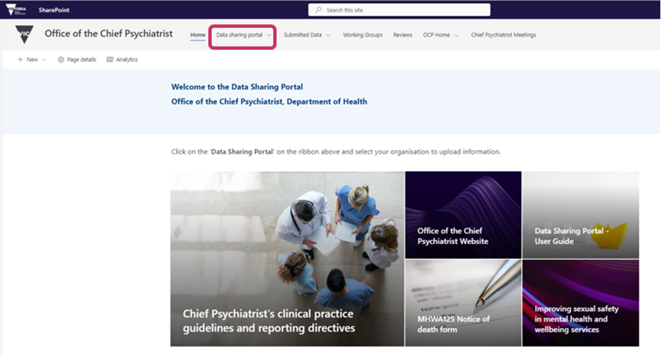

The main areas of the portal
The data sharing portal has three main areas:
- Upload a form – this area is used to upload sexual safety notification and reportable death notification forms.
- Upload data – this area is used to upload restrictive intervention registers, exceeded benchmark forms and failure to comply with the MHWA forms using the pre-set forms in SharePoint.
- Submitted data – this area is to review any data previously uploaded using the upload data buttons.
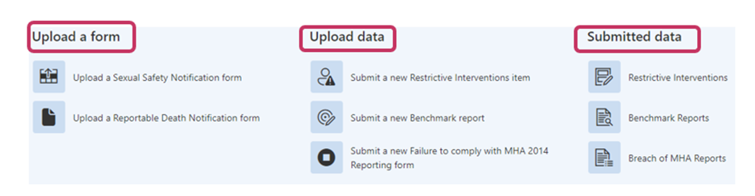

Submitting a restrictive interventions item
The ‘Submit a restrictive interventions item’ function allows services to submit both monthly registers and exceeded benchmark reports.
Step 1: Log on to the data sharing portal and select your health service from the ‘Data Sharing Portal’ dropdown menu, as shown below:

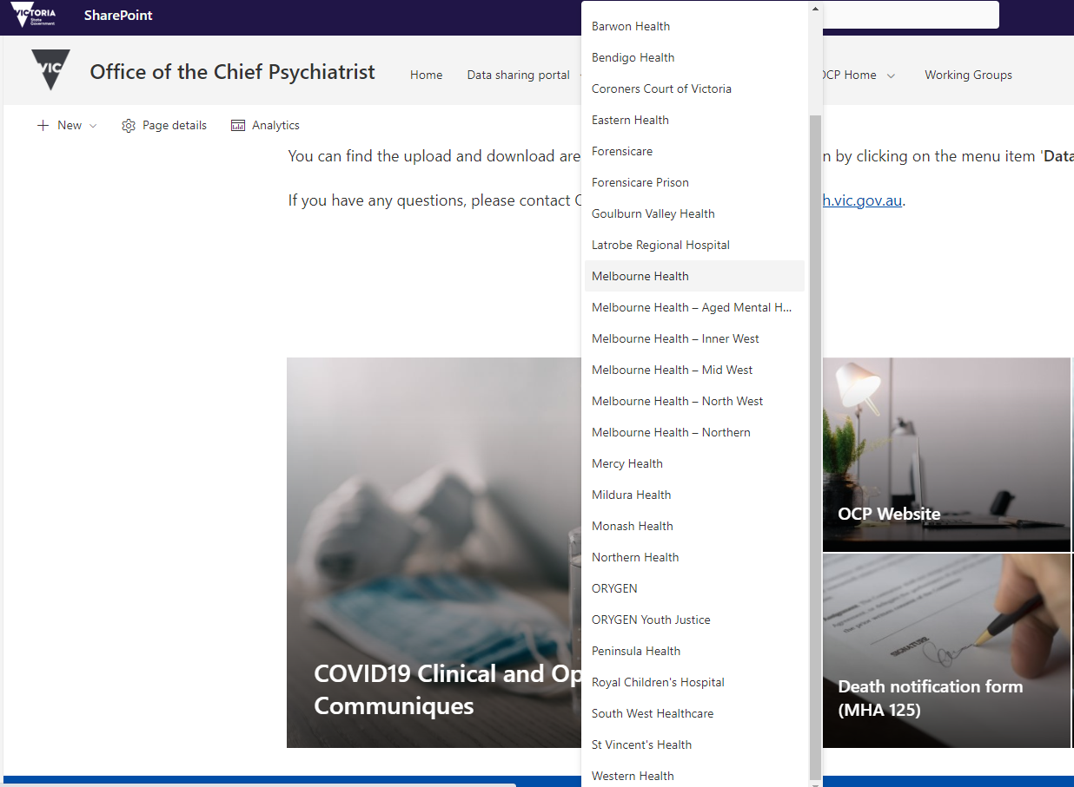

Step 2: You will now see the following screen and can select ‘Submit a new Restrictive Interventions Register (seclusion, bodily restraint, chemical restraint)’

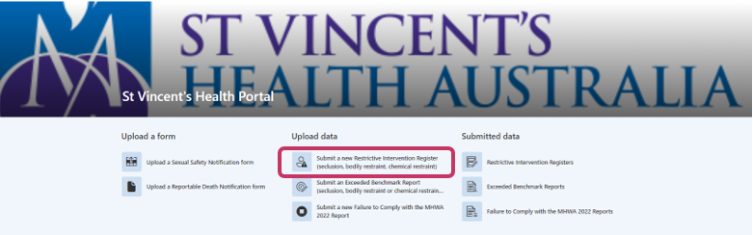
Step 3: From here you will be taken to an online form to complete.

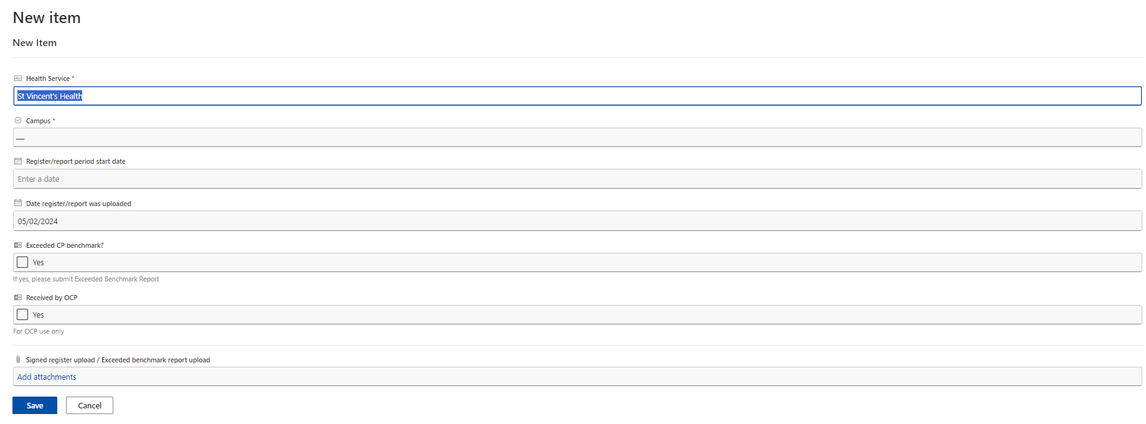

The fields on this page have the following meanings:
- Health Service is a pre-populated field with your health service name.
- Campus is only available for those health services with multiple campuses.
- Upload type provides an option to submit a monthly register or a benchmark report.
- Register/report period start date is the date the item begins.
- Date register report was uploaded is the date the item was submitted – this field defaults to the current date.
- Exceeded CP benchmark is a yes/no field to indicate if a restrictive intervention episode in the register exceeded the benchmarks of the Chief Psychiatrist
- Received by OCP is a field for OCP use only to indicate whether the item has been processed by OCP staff
- Signed Register upload/add attachments to upload the PDF register with AP signature on all relevant pages

Step 4: Once the form is complete and all files uploaded using the ‘add attachments’ option, click on Save. This will take you to the list of completed restrictive interventions items that have been uploaded onto the Portal as seen below.

Submitting a new benchmark report
The ‘Submit an Exceeded Benchmark report (seclusion, bodily restraint, chemical restraint)’ function in the portal is where services submit reports for a restrictive intervention that exceeded the benchmarks.
Step 1: Log on to the data sharing portal and select your health service from the ‘Data Sharing Portal’ dropdown menu, as shown below:

Step 2: You will now see the following screen and can select ‘Submit a new Benchmark report’:
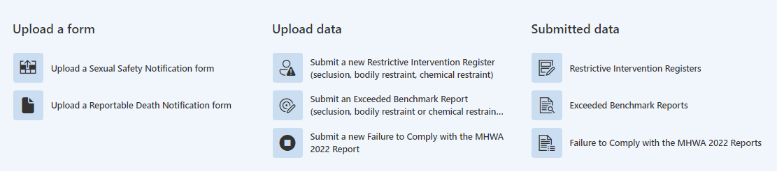
Step 3: From here you will be taken to an online form to complete.
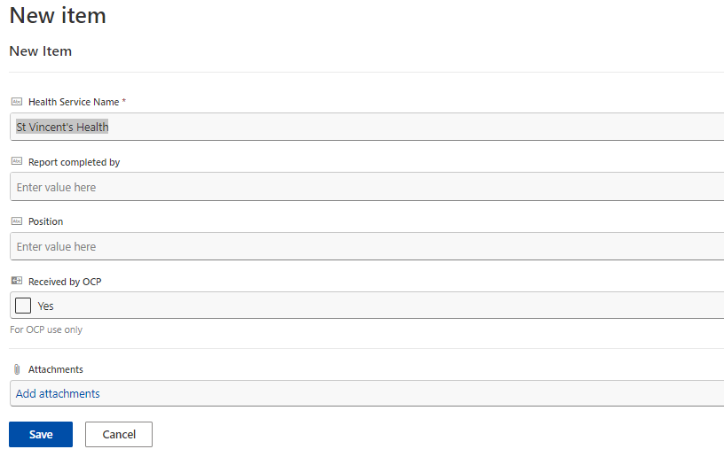
The fields on this page have the following meanings:
- Completed by is the name of the person completing the form
- Position is the position of the person completing the form
- Processed by OCP is a field for OCP use only to indicate whether the item has been processed by OCP staff
- Attachments is to enable the attachment of all reports relating to the reporting period
Step 4: Once the form is complete and all files uploaded using the ‘add attachments’ option, click on Save. This will take you to the list of completed restrictive interventions items that have been uploaded onto the portal as seen below.

Appendix 2: When you should be using the Client Management Interface – Operational Data Store (CMI-ODS)
Clinical staff need to complete the relevant MHWA form depending on the type of restrictive intervention. All the necessary data fields for CMI are contained on the MHWA form. These forms are then provided to the admin team who perform data entry into CMI. Data should be entered onto CMI twice a day however forms should not be given to admin for data entry until the episode of the restrictive intervention has been completed.
The reports can be accessed by logging onto CMI/ODS and selecting Reports from the menu:
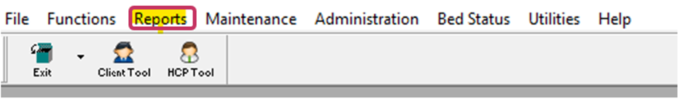
A drop-down box will appear under Reports and the user should select Chemical Restraint Register or Seclusion / Bodily Restraint Register:
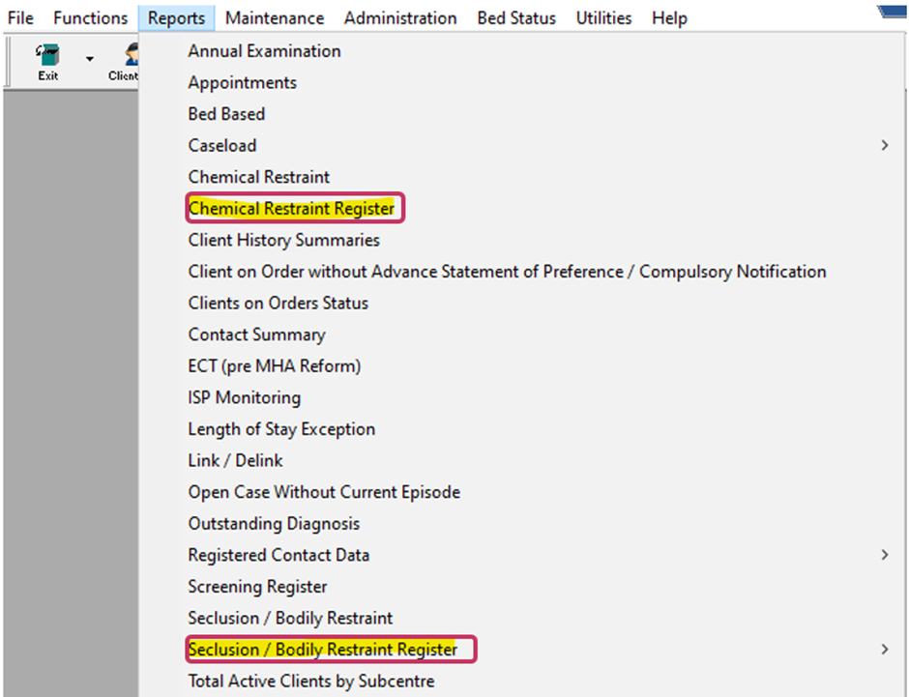

When you click on the relevant Register report the following screen will appear in which you identify the Month and Year that you require:
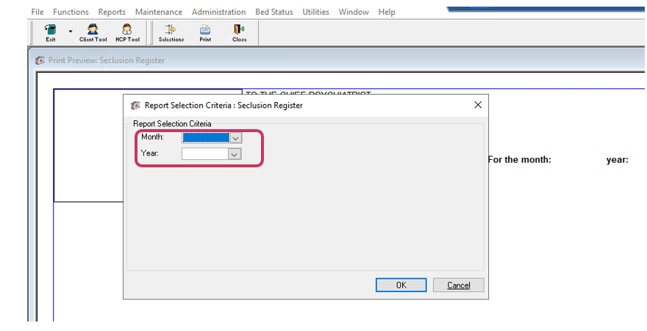
This will populate the register on screen for all consumers who have had the specific restrictive intervention entered into CMI/ODS. There is only the option to ‘Print’ as can be seen from the highlighted icon above. This register is to be printed and signed by the Authorised Psychiatrist each month after ensuring that all data entry for that month has been performed. There is currently no option to create a csv or excel file as the registers require a signature.
