Serious Transfusion Incident Reporting (STIR) annual report 2021–22
Blood Matters program

Serious Transfusion Incident Reporting (STIR) annual report 2021–22
Blood Matters program

To receive this document in another format, phone 03 9694 0102, using the National Relay Service 13 36 77 if required, or email Blood Matters <bloodmatters@redcrossblood.org.au>.
Authorised and published by the Victorian Government, 1 Treasury Place, Melbourne.
© State of Victoria, Australia, Department of Health, September 2023.
ISSN 2651-8872 (online/PDF/Word)
Available at Blood Matters Serious Transfusion Incident Reporting <https://www.health.vic.gov.au/patient-care/serious-transfusion-incident-reporting-system>

Contents
Acknowledgements 7
Abbreviations and acronyms 8
Executive summary 10
Key messages 11
Introduction 13
Method 16
Withdrawn reports 16
Validation and reconciliation 17
Severity rating 18
Demographics 18
Sentinel events 20
Future 20
Clinical reports 20
Febrile non-haemolytic transfusion reactions (FNHTR) 21
Allergic/anaphylactic reactions 23
Hypotensive reactions 25
Acute transfusion reaction – other 26
Acute haemolytic transfusion reaction (AHTR) 26
Delayed haemolytic transfusion reaction (DHTR) 27
Delayed serologic transfusion reaction (DSTR) 28
RhD isoimmunisation 29
Transfusion-associated circulatory overload (TACO) 30
Transfusion-related acute lung injury (TRALI) 32
Transfusion-associated dyspnoea (TAD) 32
Transfusion-transmitted infection, bacterial 33
Transfusion-transmitted infection, other 33
Transfusion-associated graft vs host disease (TA-GVHD) 33
Posttransfusion purpura (PTP) 33
Procedural reports 34
Incorrect blood component transfused (IBCT) 34
Procedural – other 40
Near miss 40
Wrong blood in tube (WBIT) 41
Errors using EMRs 43
RhD immunoglobulin errors 45
Delayed administration of RhD immunoglobulin (Ig): 46
Cell salvage 47
Laboratory errors 47
Victorian Health Incident Management System (VHIMS) reporting 47
References 50
Appendix 1: STIR Expert Group members 52
Appendix 2: STIR publications and promotions 53
Appendix 3: Imputability and severity scores 54
Appendix 4: Case studies 55
Appendix 5: STIR timeline 56

Acknowledgements
The Serious Transfusion Incident Reporting (STIR) program is part of the work of the Blood Matters program, which is a collaboration between the Victorian Department of Health and Australian Red Cross Lifeblood (Lifeblood).
STIR is founded on the principle that providing haemovigilance information supports the community by promoting better transfusion practice.
Public and private health services in Victoria, Tasmania, Australian Capital Territory and Northern Territory support and contribute to the program. This participation enables STIR to provide information and recommendations for best practice.
Blood Matters recognises and appreciates the generous in-kind support of the STIR Expert Group, whose input is invaluable in reviewing the incidents and providing recommendations and direction for the work.

Abbreviations and acronyms
Abbreviation | Definition
ABO | the most important of the blood grouping systems
AHTR | acute haemolytic transfusion reaction
ANZSBT | Australian and New Zealand Society of Blood Transfusion
ATR | acute transfusion reaction
BloodNet | BloodNet is a web-based system that allows staff in health facilities across Australia to order blood and blood products from Australian Red Cross Lifeblood. The systems ensures that ordering is standardised, quick, easily and secure. It is also used to report transfer of blood and blood products between health services and attribute reason for discard if applicable.
COVID-19 | Coronavirus SARS-CoV2, an infectious disease caused by a coronavirus, causing respiratory illness in those infected
Cryo | cryoprecipitate
DAT | direct antiglobulin test
DHTR | delayed haemolytic transfusion reaction
DSTR | delayed serologic transfusion reaction
ED | emergency department
EMR | electronic medical record
FFP | fresh frozen plasma
FNHTR | febrile non-haemolytic transfusion reaction
FY22 | financial year 2022, 1 July 2021 to 30 June 2022
FY23 | financial year 2023, 1 July 2022 to 30 June 2023
Hb | haemoglobin
HDFN | haemolytic disease of the fetus and newborn
HDU | high dependency unit
HLA | human leucocyte antigen
HSE | handling and storage errors
IAT | indirect antiglobulin test
IBCT | incorrect blood component transfused
ICU | intensive care unit
ID | identification
IT | information technology
IU | international units
IV | intravenous
LDH | lactate dehydrogenase
Lifeblood | Australian Red Cross Lifeblood
NBA | National Blood Authority
NSQHS | National Safety and Quality Health Service
PTP | post-transfusion purpura
PTS | pneumatic tube system
RANZCOG | Royal Australian and New Zealand College of Obstetricians and Gynaecologists
RBC | red blood cells
RBRP | right blood, right patient
RhD admin | RhD administration
RhD Ig | RhD immunoglobulin
RhD iso | RhD isoimmunisation
SDC | Statutory Duty of Candour
SHOT | Serious Hazards of Transfusion – haemovigilance program in the UK
SR | severity rating
STIR | Serious Transfusion Incident Reporting
TACO | transfusion-associated circulatory overload
TAD | transfusion-associated dyspnoea
TA-GVHD | transfusion-associated graft versus host disease
TRALI | transfusion-related acute lung injury
TTI | transfusion-transmitted infection
VAHI | Victorian Agency for Health Information
VHIMS | Victorian Health Incident Management System
WBIT | wrong blood in tube

Executive summary
This year’s report includes 186 validated investigations, 60 procedural events and 126 clinical events.
There was one sentinel event reported (case study 11), in which the patient received ABO-incompatible red cells and developed associated haemolysis and acute kidney injury.
Wrong blood in tube events (WBIT) (22), followed by incorrect blood component transfused (IBCT) (15), are the most-reported procedural events. Good positive patient identification can largely prevent both these event types. Health services should include education on positive patient identification in all education for all groups of staff.
More health services are beginning to use electronic medical records (EMR). These systems need to be set up to reduce user error. EMRs can improve safety; however, if they are difficult to use or not easily understood, work-arounds can reduce that safety factor.
This year, there were two reports of WBIT in which an EMR was in use (case study 14 and case study 15). The Australian and New Zealand Society of Blood Transfusion has a guideline for health services setting up an EMR to use in transfusion:
- Guidelines for the implementation and use of electronic medical records for transfusion <https://anzsbt.org.au/wp-content/uploads/2021/07/FINAL-Guidelines_For_The_Implementation_And_Use_Of_Electronic_Medical_Records_For_Transfusion_-July-2021-1.pdf>
The next section sets out key messages from received and validated STIR investigations.
We thank all health services that report to STIR for their ongoing support.

Key messages
Area | Recommendation
Patient identification | Patient identification (ID) remains an area in need of improvement, as per WBIT reports. Patient ID must be a part of all education as a key safety aspect of any procedure.
Blood administration | Two-person independent checking at the patient side is a must for transfusion. This process allows for each staff member to check each item required in the checking process and be certain the product they have is intended for this patient and is the correct product. Situations where one staff member checks some items and the other staff member checks other items has led to missed information and ABO-incompatible transfusion in the past. See case study 11.
Blood collection processes – blood fridges /pneumatic chutes (secondary dispense sites) | Blood collection at these secondary dispense sites need to be completed correctly, again patient and product identification is important at this point to ensure the correct product for the correct patient is collected. See case study 10 and case study 11.
National antibody registry | An Australian antibody database that all laboratories can access may help reduce the number of delayed haemolytic reactions in patients. It may also remove the need for patients who know they have an antibody from having to communicate this to clinical staff, who must then pass the information on to the laboratory.
Fit for purpose information technology (IT) systems | Both clinical and laboratory systems rely more and more on IT systems to support work and safety. IT alerts should be relevant, understandable to the user, not easily overridden and have associated actions. These should be regularly reviewed and updated where appropriate (SHOT 2022).
Patient safety culture | Fostering a strong and effective safety culture that is ‘just and learning’ is vital to ensure a reduction in transfusion incidents and errors, thus directly improving patient safety (SHOT 2022).
Pre-transfusion patient assessment | Assessing patients for risk factors for things such as TACO or previous confirmed reactions to blood components prior to transfusion is necessary to reduce the risk of further reactions. If required, slowing the transfusion rate, closer monitoring or administering premedication should be considered.
Communication | All communication needs to be clear and concise. This includes at handovers, between the laboratory and clinical areas, and with the patient.  Transcription of results into medical records should not occur routinely. When looking for blood group results, go to the primary source or documentation direct from the pathology service. When checking results, take the time to read them and be sure you have understood them.  Several errors occurred this year due to misreading of results. See case study 19.
Appropriate management of anaemia | Consideration of patient blood management strategies to reduce the need for transfusion improves patient safety by decreasing the number of times a patient may need to be transfused. See case study 6.

Introduction
The Blood Matters program celebrated its 20-year anniversary in August 2022 with a combined virtual and in-person forum. While STIR is younger than the Blood Matters program, it celebrated 15 years in 2022. STIR continues to provide information on reactions and errors occurring with blood transfusion in four Australian jurisdictions.
STIR focuses on serious reactions. Less severe reactions are not reportable to STIR. During 2022, we reviewed the reporting criteria for transfusion reactions. We made changes to align with other haemovigilance reporting systems, including the National Blood Authority (NBA) haemovigilance reporting.
We regularly review all aspects of the STIR program. Table 1 sets out the many strengths and some weaknesses of the program.
Table 1: Strengths and weaknesses of the STIR program
Strengths | Weaknesses
Led by a multidisciplinary team of healthcare professionals with interest and experience in transfusion. The broad range of specialties include medical, scientist and nursing. Team members are from different healthcare settings (public, private, regional, metropolitan) | Voluntary reporting system
Open to all health services in the STIR reporting jurisdictions that transfuse blood and blood products | Relies on health services to recognise and report transfusion reactions and events
Four jurisdictions report to STIR (Victoria, Tasmania, Australian Capital Territory, Northern Territory) through memorandums of understanding | Data is not national, but does encompass four jurisdictions
All reports from health services are reviewed and validated to ensure they are transfusion related
Lessons from STIR investigations are shared regularly with health services through bulletins, annual reports, education sessions and conferences
Focus is on serious transfusion reactions | As only serious reactions are reported to STIR and reporting is voluntary, it is difficult to determine frequency of reactions
Includes near miss events
Health services have continued to deal with the effects of COVID-19 during this financial year. We acknowledge the ongoing stress of this. Despite this challenge, health services continued reporting to STIR.
Not all health services currently registered with STIR report incidents, but about one-third consistently provide reports. Haemovigilance systems in some countries require mandatory reporting, while STIR remains a voluntary system.
Three severity rating (SR) 1 incidents were reported in the 2022 financial year (FY22):
- two clinical reactions
- one both procedural and clinical.
These incidents resulted in, or have the realistic potential to result in, an unexpected death or a permanent and disabling injury.
When a serious procedural event occurs, the health services should undertake a comprehensive review and put in place corrective actions to minimise or eliminate further risk. While serious clinical events may not be able to be avoided, good patient blood management can reduce the need for transfusion in the first place.
The UK Serious Hazards of Transfusion (SHOT) has some useful information on how to investigate and address these events, including a focus on system resilience <https://www.shotuk.org/wp-content/uploads/myimages/PSIRF-and-impact-on-haemovigilance-in-England-final-230323.pdf>.
BloodSafe in South Australia has developed an investigation tool for wrong blood in tube events <https://www.sahealth.sa.gov.au/wps/wcm/connect/public+content/sa+health+internet/resources/wrong+blood+in+tube+investigation>.
Investigations of serious events often seek to recognise factors that led to the event and identify improvements to prevent it from happening again. This should include a proactive approach to understand how staff respond and adapt to problems and how this can affect safety.
STIR received 216 notifications from 38 health services for the period 1 July 2021 to 30 June 2022 (FY22). Of these notifications, 186 were validated: 126 as clinical reactions and 60 as procedural errors. Figure 1 shows the number of validated reports from 2010.
Figure 1: Number of validated clinical and procedural reports and health services reporting each financial year, FY2010–FY2022
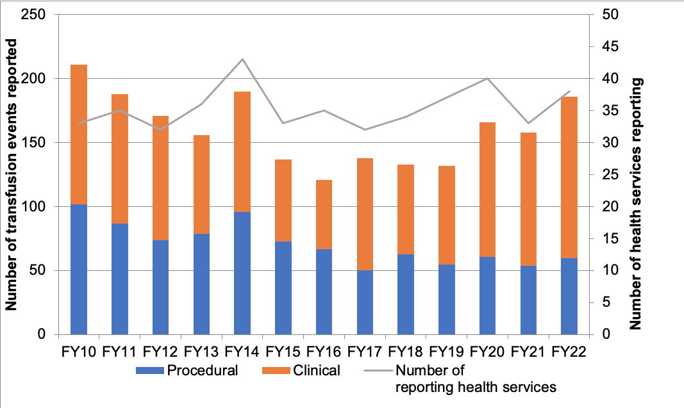
The National Blood Authority (NBA), via BloodNet, provides data on blood component issues for the year (Table 2). This can then be used to estimate the frequency of clinical reactions for Victorian health services (Table 3).
Table 2: Total blood issues per jurisdiction 2021–22 (FY22)
Components issued 2021–22 | Victoria | Tasmania | Australian Capital Territory | Northern Territory
Red cells | 179,070 | 13,153 | 10,112 | 4,959
Platelets | 36,041 | 2,511 | 1,465 | 922
FFP | 21,057 | 2,980 | 652 | 825
Cryoprecipitate | 32,109 | 2,209 | 3,426 | 1,132
Total | 268,277 | 20,853 | 15,655 | 7,838
Table 3: Estimated frequency of clinical reactions per component in Victoria (n = 111)
Component | Blood issued (Vic.) | Validated clinical events | Frequency
Red cells | 179,070 | 81 | 1:2,211
Platelets | 36,041 | 22 | 1:1,638
FFP | 21,057 | 15 | 1:1,404
Cryoprecipitate | 32,109 | 1 | 1: 32,109
Number of validated clinical events greater than total reported (n=111) as some reactions involved more than one component

Method
Reporting to STIR requires multiple steps at both the health service level and at Blood Matters.
Health services should review the event/reaction and determine the type of event or reaction, to check it meets STIR reporting criteria before notification. Refer to the STIR guide <https://www.health.vic.gov.au/publications/blood-matters-serious-transfusion-incident-reporting-guide>.
Blood Matters completes validation steps to ensure the notified event meets the STIR criteria and sufficient information is available to expert reviewers. If events are not determined to be assessable or excluded, the health service reporter is contacted by STIR.
Figure 2 outlines the steps required to validate and report back.
Figure 2: Steps in the reporting and validation of health service notifications
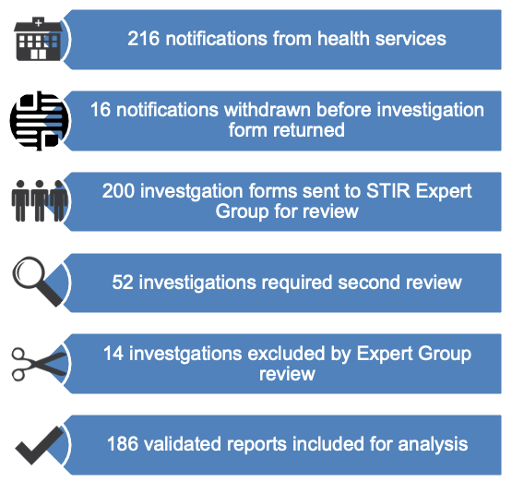

Withdrawn reports
Not all notifications become validated reports. Some notifications are withdrawn by the health service. Other reports are excluded by the expert reviewers due to not being related to the transfusion or to incomplete or insufficient information available to validate the investigation. The reasons for withdrawal are outlined in Table 4.
Table 4: Reasons for withdrawal of notifications to STIR by financial year(FY) from 2010 to 2022
Financial year | Duplicate notification | Not in scope | Deemed not transfusion related by health service | Not completed | Excluded after expert review | Total STIR notifications | Total withdrawn n (%)
FY10 | 2 | 5 | 2 | 8 | - | 211 | 17 (8)
FY11 | 4 | 5 | 5 | 8 | - | 188 | 22 (12)
FY12 | - | 12 | 6 | 3 | - | 171 | 21 (12)
FY13 | 2 | 4 | - | 4 | - | 166 | 10 (6)
FY14 | 1 | 6 | 4 | 16 | - | 227 | 27 (12)
FY15 | 9 | 11 | 6 | 8 | 4 | 175 | 38 (22)
FY16 | 6 | 11 | 5 | 5 | 4 | 152 | 31 (20)
FY17 | 5 | 4 | 2 | 1 | 5 | 155 | 17 (11)
FY18 | 3 | 5 | - | 2 | 15 | 158 | 25 (16)
FY19 | 5 | 16 | 3 | 1 | 14 | 171 | 39 (23)
FY20 | 9 | 11 | 4 | 2 | 22 | 214 | 48 (22)
FY21 | 2 | 3 | 2 | 2 | 14 | 180 | 23 (13)
FY22 | 5 | 6 | 4 | 1 | 14 | 216 | 30 (14)

Validation and reconciliation
A member of the Expert Group reviews all investigations returned to STIR. The member assigns reaction or event type, severity and imputability for each event. For more severe reactions where the health service or the reviewer assigned a SR 1 or SR 2, the entire Expert Group reviews the investigation to ensure consistency in reporting.
Expert review of the information provided may lead to a change in the type of incident or in the severity rating assigned. This is shown in Table 5 and Table 6.
Information on change to incident type or severity are emailed to the reporters. The reporter is also notified if the reaction is deemed unrelated to the transfusion, or the information provided is not sufficient to allow the Expert Group to validate the incident.
Table 5: Changes to clinical incident type following STIR Expert Group review
Original incident type | Validated as:  Febrile non-haemolytic | Validated as:  TACO
Acute haemolytic | 1 | 1
Bacterial | 1 | ˗
TRALI, TACO, TAD | ˗ | 1
ATR, TAD | 1 | ˗

Severity rating
Severity ratings are assigned for each investigation, except RhD administration errors, near-miss and wrong blood in tube (WBIT) incidents. In these events there is the potential for severe outcomes, but they have either been avoided by finding the error before the blood or blood product reached the patient or the potential future impact is unknown. Table 6 reports on the changes that have occurred to severity rating after expert review.
Table 6: Changes to the severity rating following expert review
Incident type (number) | Incident severity rating submitted as | Incident severity rating validated as
Acute haemolytic transfusion reaction (1) | SR3–2 | SR1
Allergic/anaphylactic reaction (3) | SR4 | SR3
Allergic/anaphylactic reaction (3) | SR4 | SR2
Allergic/anaphylactic reaction (1) | SR3–2 | SR1
Febrile non-haemolytic transfusion reaction (10) | SR4 | SR3
Febrile non-haemolytic transfusion reaction (3) | SR4 | SR2
DHTR (1) | SR4 | SR3
DSTR (1) | SR4 | SR3
TACO (4) | SR4 | SR3
TACO (2) | SR4 | SR2
RhD isoimmunisation (1) | SR4 | SR1

Demographics
Figure 3 shows the number of registered and reporting health services and total number of reports for each jurisdiction.
Figure 3: Number of validated reports per reporting jurisdiction
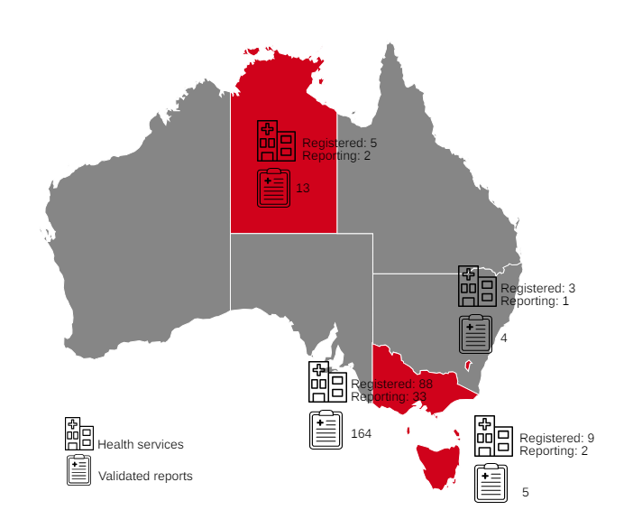
Table 7 shows the demographics for FY22 validated reports, excluding RhD-related incidents (administration errors and isoimmunisation). Considering all notification categories, the mean age was 55 years, with 89 (52 per cent) females and 82 (48 per cent) males. For all RhD-related incidents, the average age was 31 years.
Red blood cells (RBCs) remain the most-reported component associated with reactions and incidents.
Table 7: Demographics for all validated reports (excluding RhD-related incidents)
Demographic | Statistic
Age | Average 55 (range 0–95 years)
Sex | Male: 82 (48%)  Female: 89 (52%)
Blood component notifications | Red cells: 106  Platelets: 24  Fresh frozen plasma: 14  Cryoprecipitate: 1  Multiple components: 7
Other | Includes WBIT n = 19, near miss n = 1

Sentinel events
Sentinel events are broadly defined as wholly preventable adverse patient safety events that result in serious harm or death to individuals. All health services are required to report such adverse patient safety events to state health departments in accordance with the Australian national sentinel event list. Reportable events include haemolytic blood transfusion reaction resulting from ABO incompatibility that leads to serious harm or death.
There was one sentinel event reported this year. This was an ABO-incompatible RBC transfusion administered to a patient in isolation in the emergency department (ED). The incorrect blood component transfused section case study highlights this event.
Effective 30 November 2022, relevant health service entities are required to provide a patient with a Statutory Duty of Candour (SDC) when they have suffered a serious adverse patient safety event while receiving health care. Events reported to STIR with a SR 1 or 2 would generally meet this criterion.

Future
STIR continues to review reporting forms to ensure information provided is useful and aids validation. Data obtained will continue to be used to inform transfusion safety, through education, bulletins, reporting jurisdictional data to the NBA and advice to governance bodies.

Clinical reports
Clinical reactions to blood components remain the largest proportion of reports received by STIR. This year 126 (68 per cent) of all validated reports were clinical. The types of reactions are shown in Figure 4. Table 8 shows the breakdown of the types of validated acute transfusion reactions (ATR).
The type of reaction by blood component is shown in Table 9 with RBCs contributing to most-reported reactions.
Figure 4: Validated clinical reactions FY22
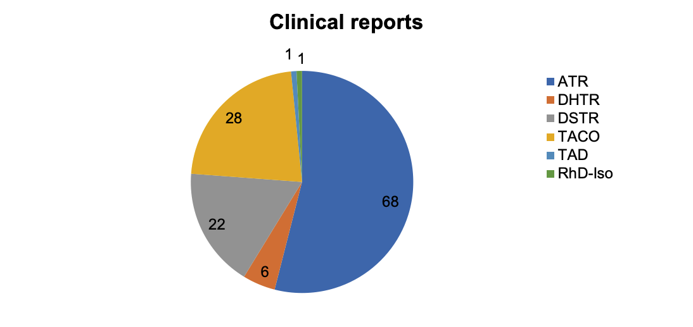
Table 8: Types of validated ATR clinical reports
Reaction | Number (68)
Allergic/anaphylactic/anaphylactoid | 33
Febrile non-haemolytic transfusion reaction (FNHTR) | 31
Acute haemolytic (AHTR) | 2
Hypotensive | 1
Other | 1
Table 9: Validated acute reaction type by blood component
Blood component | FNHTR | Allergic/ Anaphylactic | Hypotensive | AHTR | TACO | TAD
Red cells | 26 | 6 | 1 | 2 | 20 | 1
Platelets | 2 | 12 | - | - | 6 | -
FFP | 3 | 10 | - | - | - | -
Cryo | - | 1 | - | - | - | -
Multiple | - | 4 | - | - | 2 | -

Febrile non-haemolytic transfusion reactions (FNHTR)
The STIR reportable definition for FNHTR changed on 1 July 2022 (FY23). Reporting criteria is a temperature of ≥ 39°C and/or 2°C rise from baseline, increased from a temperature of > 38.5°C or 1.5°C rise from baseline. This will align with national haemovigilance reporting to the NBA, and other international haemovigilance programs.
The reporting guidelines were updated to represent the more serious FNHTRs, rather than mild reactions. Mild or moderate reactions should continue to be investigated and managed by the treating health service. The reaction should be reported to STIR if the fever is associated with other serious signs and symptoms.
FNHTR are a largely unavoidable and unpredictable risk of transfusion. Initial treatment should always be to stop the transfusion and have the patient medically assessed. Where reactions are mild and respond well to treatment, it may be possible to restart the transfusion at a slower rate with increased monitoring. This will help avoid wasting the blood component. However, if the reaction occurs again with the same bag, stopping the blood and performing more investigations is recommended.
Lifeblood states FNHTR occur in 0.1 per cent to 1 per cent of transfusions with universal leucocyte depleted blood components. This year, 31 (24 per cent) clinical events reported were FNHTR. It is one of the more commonly reported acute reactions to STIR. Table 10 provides the data summary of FNHTR and Table 11 outlines the severity and imputability.
Fever related to transfusion can occur for several reasons, with FNHTR being the most benign. FNHTR is generally a diagnosis of exclusion, ensuring other more serious reactions have not been responsible for the signs and symptoms displayed. There is no definitive diagnostic tool for FNHTRs. Patients may require investigation of fever if there is no clear cause.
This may include:
- investigation for a possible incompatibility causing a haemolytic reaction (post-transfusion group and screen, full blood count, haptoglobin, bilirubin)
- bacterial cultures of both patient and blood bag to identify bacterial contamination
- chest X-ray to look for infection.
It is generally accepted that the pathophysiological mechanism of FNHTR has two main factors:
- antibodies against human leucocyte antigen (HLA) produced in transfused patients, or
- cytokines released from blood components during storage.
Risk factors for FNHTRs include patient sex and transfusion history. FNHTR is more likely to occur in multiparous women and in patients with a history of multiple blood transfusions. A history of massive transfusion, lymphoma or leukaemia are independent risk factors for development of FNHTRs according to Menis et al. 2015.
Recent trials have demonstrated that routine preventive treatment with antipyretics is not useful in preventing FNHTRs. Results were varied in previous trials. It is important to assess the need for premedication for each patient on an individual basis (Wang et al. 2022).
The SHOT annual report 2022 states premedication is not a one-size-fits-all cocktail suitable for all eventualities. Treatment of transfusion reactions and prophylaxis for those with recurrent reactions must be tailored to the type of reaction (allergic versus febrile) and its severity (SHOT 2021).
Table 10: Data summary – febrile non-haemolytic transfusion reaction, n = 31
Characteristic | Number (%)
Age: < 1 year | -
Age: 1–18 years | 1 (3%)
Age: 19–29 years | 1 (3%)
Age: 30–49 years | 1 (3%)
Age: 50–69 years | 10 (32%)
Age: 70–79 years | 9 (29%)
Age: 80+ years | 9 (29%)
Sex: male | 15 (48%)
Sex: female | 16 (52%)
Implicated blood component: red cells | 26 (84%)
Implicated blood component: FFP | 3 (10%)
Implicated blood component: platelets | 2 (6%)
Table 11: Severity rating and imputability febrile non-haemolytic transfusion reaction
Severity rating | Imputability:  certainly | Imputability:  probably | Imputability:  possibly | Total
SR 1 | - | - | - | -
SR 2 | - | - | 5 | 5
SR 3 | 1 | 5 | 7 | 13
SR 4 | - | 3 | 10 | 13
Total | 1 | 8 | 22 | 31

Allergic/anaphylactic reactions
Allergic transfusion reactions comprise 26 per cent (n = 33) of clinical reactions reported to STIR this year. Anaphylactoid/anaphylactic reactions comprised 18 per cent (n = 6) of these as outlined in Table 12. Tables 13a and 13b outline the severity rating and imputability of allergic and anaphylactic reactions respectively, Table 14 looks at the reported signs and symptoms and Table 15 includes the reported treatments.
Table 12: Data summary – allergic/anaphylactic
Characteristic | Allergic, n = 27 (%) | Anaphylactic, n = 6 (%)
Age: < 1 year | - | -
Age: 1–18 years | 10 (37%) | 2 (33%)
Age: 19–29 years | 2 (7%) | -
Age: 30–49 years | 4 (15%) | 1 (17%)
Age: 50–69 years | 5 (19%) | 2 (33%)
Age: 70–79 years | 4 (15%) | 1 (17%)
Age: 80+ years | 2 (7%) | -
Sex: male | 15 (56%) | 4 (67%)
Sex: female | 12 (44%) | 2 (33%)
Implicated blood component: cryoprecipitate | 1 (4%) | -
Implicated blood component: fresh frozen plasma | 7 (26%) | 3 (50%)
Implicated blood component: platelets | 12 (44%) | -
Implicated blood component: red cells | 6 (22%) | -
Implicated blood component: multiple components | 1 (4%) | 3 (50%)
Table 13a: Allergy – severity rating and imputability
Severity rating | Imputability:  certainly | Imputability:  probably | Imputability:  possibly | Total
SR 1 | - | - | - | -
SR 2 | 2 | 4 | 2 | 8
SR 3 | 1 | 14 | 1 | 16
SR 4 | 1 | 2 | - | 3
Total | 4 | 20 | 3 | 27
Table 13b: Anaphylactic – severity rating and imputability
Severity rating | Imputability:  certainly | Imputability:  probably | Imputability:  possibly | Total
SR 1 | 1 | - | - | 1
SR 2 | 1 | 1 | 1 | 3
SR 3 | 1 | 1 | - | 2
SR 4 | - | - | - | -
Total | 3 | 2 | 1 | 6
Table 14: Allergic transfusion reactions by reported signs and symptoms
Signs and symptoms | Allergy (%) n=27 | Anaphylactic (%) n=6
Itching/rash | 20 (74%) | 6 (100%)
Dyspnoea/difficulty breathing | 9 (33%) | 1 (17%)
Restlessness/anxiety | 9 (33%) | 1 (17%)
Tachycardia | 8 (30%) | 2 (33%)
Hypotension | 6 (22%) | 5 (83%)
Respiratory wheeze | 5 (19%) | -
Hypertension | 5 (19%) | -
Nausea/vomiting | 4 (15%) | -
Fever | 2 (7%) | -
Chest pain/discomfort | 2 (7%) | -
Chills | 1 (4%) | 1 (17%)
Rigours | 1 (4%) | -
Back pain | 1 (4%) | -
Table 15: Reported treatments for allergic/anaphylactic
Treatment | Allergy, n = 27 (%) | Anaphylactic, n = 6 (%)
Steroids | 17 (63%) | 3 (50%)
Antihistamines | 15 (56%) | 2 (33%)
Inotropes/pressor agents | 4 (15%) | 6 (100%)
Intravenous (IV) fluids | 5 (19%) | 4 (67%)
Oxygen | 5 (19%) | 2 (33%)
Antipyretics | 2 (7%) | 1 (17%)
Intubation | 1 (4%) | -
Other – assisted ventilation | 1 (4%) | 1 (17%)

Case study 1: Anaphylaxis with multiple products in a bleeding patient.
An 81-year-old patient was admitted with a bleeding duodenal ulcer. The bleeding was embolised and the patient sent to the intensive care unit (ICU) post procedure. Post procedure RBCs and FFP were administered simultaneously due to rebleeding. The patient became hypotensive requiring noradrenaline support. A raised erythematous rash was noted on the back and torso, and evidence of bronchospasm, with wheeze and decreased air entry on auscultation. Adrenaline and noradrenaline infusions were started and hydrocortisone also given.
STIR Expert Group review: anaphylactic/anaphylactoid reaction, certainly, SR2

Comments
Allergic and anaphylactic reactions can occur with any transfusion episode. It is important that staff are aware of the possibility of reactions in patients and assess the patient carefully. Follow health service procedures for management of anaphylaxis.

Hypotensive reactions
While hypotensive transfusion reactions are described in the literature, they are not commonly reported to or validated by STIR. For FY22, STIR validated one case. The SHOT annual report 2022 included 13 hypotensive reactions.
Hypotensive transfusion reactions manifest as a sudden isolated drop in blood pressure during transfusion. It is diagnosed by excluding other possible causes. Usually hypotension occurs rapidly, within 15 minutes of starting the transfusion, and rapidly resolves when the transfusion is stopped. Hypotension usually occurs alone. It can occur with other mild symptoms or hypotension-related symptoms, which distinguishes it from other transfusion reactions that can be accompanied by hypotension (Kwon 2022).
Factors that have been reported to be associated with hypotensive transfusion reactions include cardiac surgery, filtration of blood components, platelet transfusion, use of angiotensin converting enzyme (ACE) inhibitors, and autologous RBC transfusion. Prior to Australia implementing universal leukodepletion a commonly reported causes of hypotension was the use of bedside leucodepletion filters in patients taking ACE inhibitors. The use of albumen in patients taking ACE inhibitors also has the potential to cause hypotension.
Management includes eliminating other more serious causes of a transfusion reaction that may include hypotension, for example acute haemolytic, bacterial contamination, TRALI.

Case study 2: Hypotension with red cell transfusion
A patient attending for wash out and debridement of an infected hip joint was given an RBC transfusion approximately two weeks after the initial surgery. The patient became hypotensive and was treated with intravenous fluids and steroids (treated as a possible allergic reaction) and a code blue was called. There were no other signs and symptoms noted. The patient BP did not improve initially but increased to pre-transfusion levels with ongoing monitoring and fluids. The patient went on to have a further bag of RBC without a problem.
STIR Expert Group review: Hypotensive, possibly, SR3

Comments
As noted by the reviewer, there are many other factors which could contribute to this hypotensive event such as age, anaemia or underlying cardiovascular issues (not reported).

Acute transfusion reaction – other
Reactions are classified as ‘ATR – other’ when the information provided indicates the transfusion is likely the cause of signs and symptoms, and no other causes are indicated. These reactions do not fit into other transfusion reaction categories. There was one ‘ATR – other’ validated in FY22.

Acute haemolytic transfusion reaction (AHTR)
Acute haemolytic transfusion reactions (AHTR) are characterised by fever, a fall in haemoglobin (Hb), rise in bilirubin and lactate dehydrogenase (LDH) and a positive direct antiglobulin test (DAT). They generally present within 24 hours of transfusion (SHOT 2022).
In this reporting period there were two AHTRs reported to STIR as summarised in Table 16. SHOT 2022 reported 11 acute haemolytic reactions.
Investigation includes a serological crossmatch with the implicated component to identify antibodies against low incidence red cell antigens.
Table 16: Data summary – acute haemolytic
Characteristic | AHTR case 1 | AHTR case 2
Age | 30–49 years | 50–69 years
Sex | female | male
Implicated blood component | red cells | red cells
Severity rating | SR 3 | SR 1
Imputability | certainly | certainly
As above, case 2 was reported as SR1 and the health service reported this event under the Sentinel event program. Refer to case study 11 IBCT for further information.

Delayed haemolytic transfusion reaction (DHTR)
STIR defines DHTR as occurring more than 24 hours and less than three months following a transfusion. DHTR need to have a demonstrated clinically significant antibody against RBCs and clinical and/or laboratory features of haemolysis. For example, a fall in Hb or failure to increment, rise in bilirubin and/or LDH.
Hyperhaemolysis can occur. This is severe haemolysis affecting both the transfused red blood cells and the patient’s own red blood cells causing a decrease in Hb to below pre-transfusion levels. This may be either acute or delayed.
Delayed haemolytic reactions are reported less commonly than delayed serologic reactions. Some haemolytic reactions may not be recognised at the time they occur if the haemolysis is relatively mild and the haemoglobin and markers of haemolysis are not monitored. Table 17 summarises reports of delayed haemolytic and serological reactions. Tables 18a and 18b include the severity ratings and imputability for DHTR and delayed serological reactions respectively.
Table 17: Data summary – delayed haemolytic and serologic reactions
Characteristic | Delayed haemolytic reaction, n = 6 (%) | Delayed serologic reaction, n = 22 (%)
Age: < 1 year | - | -
Age: 1–18 years | - | 1 (5%)
Age: 19–29 years | - | -
Age: 30–49 years | 1 (17%) | 4 (18%)
Age: 50–69 years | - | 5 (23%)
Age: 70–79 years | 3 (50%) | 8 (36%)
Age: 80+ years | 2 (33%) | 4 (18%)
Sex: male | 2 (33%) | 10 (45%)
Sex: female | 4 (67%) | 12 (55%)
Implicated blood component: red cells | 6 (100%) | 21 (95%)
Implicated blood component: platelets | - | 1 (5%)
Table 18a: Severity rating and imputability – delayed haemolytic reaction
Severity rating | Imputability:  certainly | Imputability:  probably | Imputability:  possibly | Total
SR 1 | - | - | - | -
SR 2 | 3 | 1 | - | 4
SR 3 | - | - | 1 | 1
SR 4 | 1 | - | - | 1
Total | 4 | 1 | 1 | 6
Table 18b: Severity rating and imputability – delayed serologic reaction
Severity rating | Imputability:  certainly | Imputability:  probably | Imputability:  possibly | Total
SR 1 | - | - | - | -
SR 2 | - | - | - | -
SR 3 | 1 | - | - | 1
SR 4 | 17 | 4 | - | 21
Total | 18 | 4 | - | 22

Delayed serologic transfusion reaction (DSTR)
DSTR is defined by STIR as occurring within 24 hours to three months after a transfusion, with demonstration of clinically significant antibodies against red blood cells. (Described in the ANZSBT guidelines for transfusion and immunohaematology laboratory practice, 1st edition, revised January 2020). For DSTR to be validated the implicated antibody is new and there are no clinical or laboratory features of haemolysis. This term is synonymous with alloimmunisation.
The recommendation that health services use group O RhD positive emergency RBCs for some patient groups has raised concern about the risk of RhD alloimmunisation in RhD-negative patients who receive RhD positive RBCs.
All health services following the National recommendations to include group O RhD positive emergency use RBCs may report any RhD alloimmunisation to STIR. See Emergency use of group O red blood cells <https://www.health.vic.gov.au/patient-care/emergency-use-of-group-o-red-blood-cells> and National Blood Authority Group O negative red blood cell management <https://www.blood.gov.au/group-o-negative-red-blood-cell-management>.
Alloimmunisation can occur with any red cell transfusion, and all events should be reported to STIR. Table 19 lists the antibodies that have been implicated in the reported DHTRs and DSTRs.
Table 19: Antibodies implicated in delayed haemolytic and serologic reactions
Antibody | Haemolytic (number) | Serologic (number)
Jkª | 1 | 4
Jk^{b} | 1 | ˗
E | ˗ | 7
c | ˗ | 2
C | 1 | 2
C^{w} | 1 | 1
D | ˗ | 1
f | 1 | ˗
Fyª | 1 | ˗
K | 1 | 3
Kpª | 1 | ˗
Luª | 1 | ˗
M | 1 | ˗
Not documented | 1 | 3
Note: Number is greater than reports as some reports had more than one antibody identified.

Case study 3: Development of anti-D after transfusion of RhD positive platelets
A 46-year-old RhD-negative female was admitted with chronic liver disease requiring ascitic tap. Last known transfusion was a bag of RhD positive pooled platelets. Previous history of transfusion or pregnancy was unknown. Pre-transfusion testing three months after the transfusion showed a new anti-D antibody. It was not noted in the report if the woman had been offered RhD Ig post-transfusion.
STIR Expert Group review: DSTR, probably

Comments
Although platelets do not express Rh antigens, they contain small numbers of intact red blood cells or fragments, which can cause alloimmunisation in the recipient. Alloimmunisation to the RhD antigen may occur when platelets obtained from RhD positive donors are transfused to RhD-negative recipients (Dunbar 2020).
In this instance, the woman may not have required RhD immunoglobulin (Ig), but when RhD positive platelets are transfused to a RhD-negative female of childbearing potential (including female children), the use of RhD Ig should be considered for prevention of RhD immunisation. One 250 IU dose of RhD Ig, given intramuscularly, provides sufficient cover for six weeks of platelet transfusions (Lifeblood 2023).

RhD isoimmunisation
Isoimmunisation to the RhD antigen continues to occur in some pregnancies despite routine antenatal RhD Ig prophylaxis for RhD-negative females. In some cases, this may be due to errors in prophylaxis. Reporting these events helps us to understand why it occurs and provide information for health services to improve their systems to avoid errors.
The SHOT annual report 2022 had 52 RhD isoimmunisation events, 16 of which occurred in women with no previous pregnancy. It was noted that although incidents reported remained consistent, available data indicated RhD isoimmunisation in pregnancy remains under reported.
In this reporting period there was one report of RhD isoimmunisation to STIR.

Case study 4: RhD isoimmunisation, with uncertain prophylaxis
This incident occurred in a woman who had one previous live birth of a RhD positive infant. A RhD antibody (titre 1:1024) was found at testing when the woman attended with a molar pregnancy. The reporting health service found she had received both prophylactic RhD immunoglobulin doses during her first pregnancy but were unable to find evidence of RhD immunoglobulin administration post-delivery. No blood transfusions were required at delivery. There were no reported signs of haemolytic disease of the fetus and newborn (HDFN) in the first pregnancy.
STIR Expert Group review: RhD isoimmunisation, probably, SR1

Comments
This received a SR1 rating due to the potential to cause serious consequences in any future pregnancies.
The most robust evidence demonstrates Anti-D administration at 28 and 34 weeks during pregnancy to all RhD-negative women (who have not actively formed their own Anti-D) will result in a reduction of alloimmunisation from about 1 per cent to 0.35 per cent (RANZCOG 2021).
RhD immunoglobulin has been available in Australia since 1967. Prior to this, the incidence of RhD alloimmunisation in RhD-negative women following two deliveries of RhD positive, ABO-compatible infants was approximately 16 per cent, and HDFN due to anti-D was a significant cause of morbidity and mortality. Following routine postpartum administration of RhD Ig, the rate of alloimmunisation dropped to approximately 2 per cent. A further reduction in the sensitisation rate to about 0.2 per cent was achieved by introducing routine antenatal prophylaxis in 2002 (RANZCOG, 2021).
Case study 8 has further information on RhD Ig use in patients who receive an RhD incompatible transfusion (RhD positive blood component given to a RhD-negative patient).

Transfusion-associated circulatory overload (TACO)
It can be challenging to distinguish TACO from TRALI or from underlying pathology in patients with respiratory signs and symptoms. TACO is characterised by pulmonary hydrostatic (cardiogenic) oedema, whereas TRALI presents as pulmonary permeability oedema (noncardiogenic).
The pathophysiology of both syndromes is complex and incompletely understood. A two-hit model is generally assumed to underlie disease pathology in both TACO and TRALI. The first hit represents the clinical condition of the patient, and the second hit is conveyed by the transfused component (Semple et al. 2019).
The estimated frequency of TACO varies from 1 per cent in hemovigilance reports, up to 8 per cent in post-operative elderly patients, and up to 11 per cent in critically ill patients (Semple et al. 2019).
Transfusion delays (n = 13) and TACO (n = 8) continue to be the leading causes of transfusion-related deaths in the SHOT annual report 2022. These two categories together accounted for 21 of 35 (60 per cent) deaths reported by SHOT.
STIR has not received reports of deaths associated with TACO to date. However, patients have been reported as requiring ICU or high dependency unit (HDU) admission. In FY22, four patients needed ICU or HDU admission due to TACO.
Both TACO and TRALI present with the onset of acute respiratory distress (hypoxemia) within six hours of a blood transfusion and demonstrate infiltrates on a frontal chest X-ray indicative of the presence of pulmonary oedema (Semple et al. 2019).
Table 20 summarises the TACO cases reported with Table 21 indicating the severity rating and imputability.
Table 20: Data summary – TACO
Characteristic | TACO, n = 28 (%)
Age: < 1 year | 2 (7)
Age: 1–18 years | 3 (11)
Age: 19–29 years | 1 (4)
Age: 30–49 years | 3 (11)
Age: 50–69 years | 4 (14)
Age: 70–79 years | 2 (7)
Age: 80+ years | 13 (46)
Sex: male | 15 (54)
Sex: female | 13 (46)
Implicated blood component: red cells | 20 (71)
Implicated blood component: platelets | 6 (21)
Implicated blood component: multiple | 2 (7)
Table 21: Severity rating and imputability – TACO
Severity rating | Imputability:  certainly | Imputability:  probably | Imputability:  possibly | Total
SR 1 | - | - | - | -
SR 2 | 1 | 7 | 4 | 12
SR 3 | - | 9 | 6 | 15
SR 4 | - | - | 1 | 1
Total | 1 | 16 | 11 | 28

Case study 5: TACO in a patient with pre-existing risk factors and rapid infusion rate
An 81-year-old female with symptomatic anaemia (Hb 69g/L) was transfused a bag of RBCs over one hour (260 mL given). Following transfusion, the patient developed chest pain/discomfort, dyspnoea, tachycardia and hypertension, and was treated with oxygen, diuretic, glyceryl trinitrate patch and hydrocortisone.
The patient had a history of stage 3 chronic kidney disease and cardiomegaly. Previous chest X-rays indicated some congestion. Posttransfusion chest X-ray was consistent with pulmonary oedema.
STIR Expert Group review: TACO, possibly, SR3

Comments
The reviewer noted that the patient may have already had an increased risk of overload prior to the transfusion commencing. Respiratory difficulties earlier in the day attributed to anaemia and may have been related to a degree of pre-existing overload.
The patient had several risk factors for overload that do not appear to have been taken into consideration when determining the infusion rate of one hour.
In 2017, STIR developed TACO awareness materials based on SHOT assessment tools, to assist clinical staff assess and recognise patients at risk. A slower transfusion rate may have reduced the risk of overload in this patient. Refer to the 2016–17 section on the STIR website <https://www.health.vic.gov.au/patient-care/serious-transfusion-incident-reporting-system-stir>.

Case study 6: TACO in a patient receiving transfusion prior to elective surgery
A 76-year-old female was admitted for an elective surgical procedure. The patient was transfused a bag of RBCs for anaemia (Hb 76 g/L) prior to the surgery. Three hours into the transfusion (180 mL given) she developed flank pain, wheezing with shortness of breath and mild fever (37.4 °C). The transfusion was ceased, and the patient treated with oxygen and diuretics. Chest X-ray showed acute pulmonary oedema. It was also noted that brain natriuretic peptide (BNP) was tested and abnormal (no actual result given).
The patient had a negative fluid balance of 60 mL at the time of transfusion but had been receiving intravenous fluids at an eight hourly rate in the pre-transfusion period. The patient also had a history of cardiomyopathy and ischaemic heart disease.
STIR Expert Group review: TACO, probably, SR2

Comments
Although the rate of transfusion appears to have been slow, the patient still developed a degree of overload. It is important to monitor at-risk patients more closely to ensure that treatment can begin quickly if overload does occur.
This patient may have benefited from haemoglobin optimisation prior to this elective procedure. This is not always possible but is beneficial to reduce the need for transfusion in elective procedures.

Transfusion-related acute lung injury (TRALI)
The diagnosis of TRALI is a strictly noncardiogenic reaction without evidence of left arterial hypertension. Circulatory overload must be excluded. In addition, there should be no temporal relationship to an alternative risk factor for acute lung injury, for example, pneumonia, sepsis, aspiration, multiple trauma, or acute pancreatitis (Semple et al. 2019).
TRALI is rarely reported to STIR. Where it is reported, cross-validation with Lifeblood is undertaken.
There were no TRALI events validated in FY22.

Transfusion-associated dyspnoea (TAD)
STIR defines TAD as respiratory distress (the most prominent clinical feature) within 24 hours of transfusion that does not meet the criteria of TRALI, TACO, or allergic reaction. It should not be explained by the patient’s underlying condition or any other known cause. Confirming TAD is difficult in most instances with few reports received (Table 22). There are no clear diagnostic markers to differentiate TAD from other causes and is a diagnosis of exclusion.
Table 22: Data summary – TAD
Characteristic | TAD case 1
Age | 1–18 years
Sex | male
Implicated blood component | red cells
Severity rating | SR3
Imputability | possibly

Transfusion-transmitted infection, bacterial
Although a small number of notifications of bacterial contaminations are sent to STIR, they are rarely validated. In some instances, by the time the health service has reviewed the reaction and completed all investigations, it is clear the reaction is not bacterial contamination.
Where it is reported, cross-validation with Lifeblood is undertaken.
This year there were no validated bacterial infections.

Transfusion-transmitted infection, other
There were no reports to STIR of viral or other infections in this year.
Where this is reported, cross-validation with Lifeblood is undertaken.

Transfusion-associated graft vs host disease (TA-GVHD)
There were no reports of TA-GVHD to STIR this year.
The Australian and New Zealand Society of Blood Transfusion (ANZSBT) has a guideline for the prevention of transfusion-associated graft versus host disease (2011). This guideline is currently under review and is expected to be published later in 2023.
Irradiation reduces the risk of TA-GVHD. Although STIR has received reports associated with incorrect blood component transfused (IBCT) where patients have not received irradiated blood components where they should have, there have been no reported cases of TA-GVHD.

Posttransfusion purpura (PTP)
There have been no reports of posttransfusion purpura this year.
There was one report to SHOT of PTP for 2022, the first since 2018 and the eighth case in 10 years. NBA data indicates there have been two reports since the 2015–16 report, and none in the latest published report (2019–20).
This is a rare but serious reaction. The Lifeblood website has more information on PTP <https://www.lifeblood.com.au/health-professionals/clinical-practice/adverse-events/PTP>.

Procedural reports
Procedural errors continue to be regularly reported to STIR. Many cause little or no harm to the patient. However, they may indicate systemic issues with steps in the transfusion chain that should be addressed. This is an area where health services can make changes to mitigate risk of reoccurrence and work towards improvements, unlike clinical reactions that are frequently unpredictable.
Financial year 2021–22 had 60 procedural investigations validated. The number and types of procedural reports are shown in Figure 5.
Figure 5: Validated procedural reports FY22
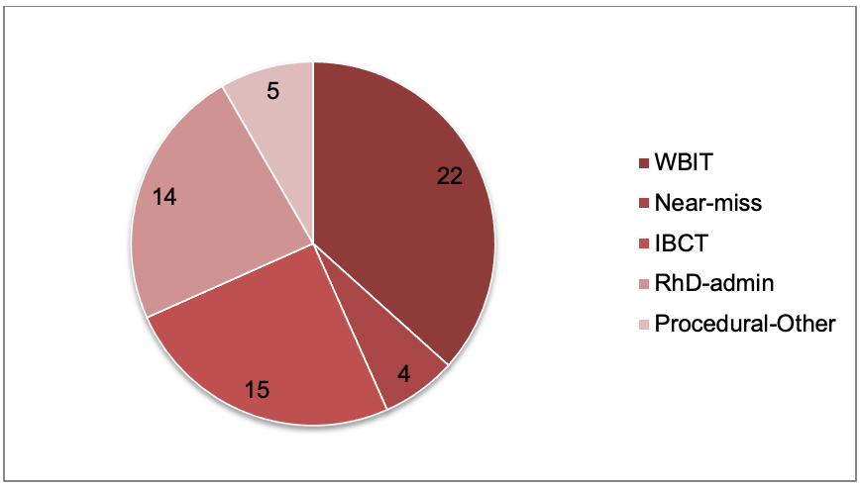

Incorrect blood component transfused (IBCT)
In the SHOT annual report 2022, there were six reported ABO-incompatible transfusions, five related to red cells, one to FFP, resulting in two deaths and one major morbidity, the other three events reported as causing no clinical reaction (two red cells, one FFP).
No deaths were reported to STIR following procedural errors, however, there have been serious outcomes for patients. All IBCT events should be treated seriously, as the health service system has failed to prevent the event from occurring. When investigating, it is important to always ask, ‘Could this event happen again?’. Often events are attributed to human error that cannot be completely eliminated. It is important to understand the factors that led to the error, to minimise or control these factors and reduce the risk of recurrence. Where there is a problem within the system, improvements to prevent further errors are needed.
There were 15 IBCT events validated for FY22. This is an increase on the number of reports received over the past 10 years. Events included one ABO-incompatible transfusion that was also reported as an AHTR.
Table 23 shows the types of IBCT events that were reported. Table 24 shows the areas where these occurred.
Figure 6 shows the number and types of IBCT over time. This year has seen an increase in reported and validated IBCT events. Inappropriate transfusion can include such things as unnecessary transfusions, incorrect product given and transfusion of an expired blood product.
Table 23: Types of IBCT events FY22
Event | Count
ABO incompatible | 1
ABO compatible | 3
Specific requirements not met | 6
Antigen-antibody incompatibility, including RhD | 2
Inappropriate | 3
Table 24: Where events occurred.
Location | Count
Ward | 7
Emergency department | 6
ICU | 1
Day unit | 1
Operating theatre | 1
Blood bank | 1
Note: Some investigations included more than one location where the event occurred
Figure 6: Reported IBCT categories – FY10–FY22
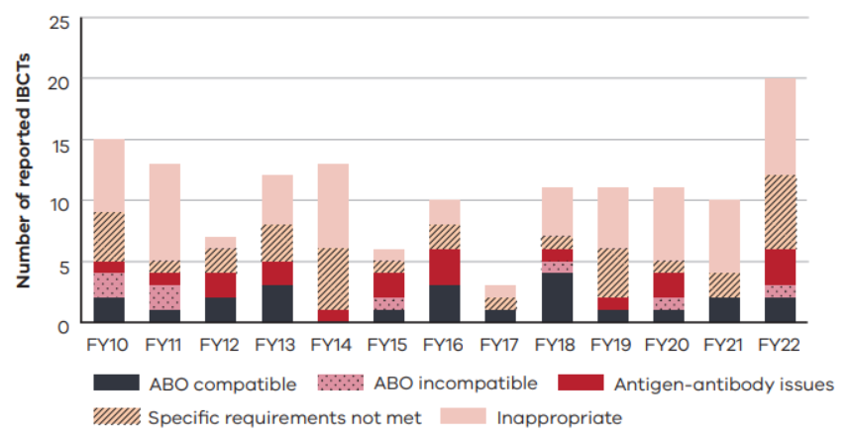
Note: This includes reports classified as IBCT and procedural other. For FY22, IBCT (15) and procedural other (5).

Case study 7: Incorrect RhD group dispensed and administered
A bag of group A RhD positive RBCs was crossmatched, dispensed and administered to an AB RhD-negative patient. The patient had been admitted for a stem cell transplant scheduled for the same day as the transfusion.
An electronic crossmatch was used to select a bag of RBCs for the patient. The scientist mistakenly chose a group A RhD positive bag, instead of the intended group A RhD-negative bag. When the electronic crossmatch was performed, the computer highlighted the discrepancy in both ABO and RhD group in one alert. The scientist was expecting to see an alert due to the ABO discrepancy. They did not read the full alert and missed the RhD group incompatibility. The bag was dispensed by a second scientist who also missed the discrepancy in RhD group.
On the ward the nurses were unsure and distracted about the appropriateness of transfusing the patient on the day of their transplant. During the bedside checks they did not note or check on the discrepancy in RhD group and administered the blood.
At the time of the report to STIR the patient had not developed an anti-D antibody.
STIR Expert Group review: IBCT – RhD incompatible. Errors in both dispensing and administration of the component contributed to the event. IBCT, certainly, SR4

Comments
There were multiple opportunities to discover the error and prevent this event. Staff distractions and incomplete checks, both in the laboratory and at the patient bedside, allowed the IBCT to occur.
All laboratory alerts should be concise and clear. In this case, the fact that the scientist was expecting to see an alert meant they did not read the full alert when it occurred.
On the ward the reason for transfusion and any considerations around the patient and timing of transfusion should be dealt with prior to the component arriving on the ward. Then the checking process would be given full attention, ensuring all checks are performed correctly and any errors identified.

Case study 8: RhD-negative patient received RhD positive blood
A similar incident occurred at another health service where an AB RhD-negative elderly male presented to the ED with rectal bleeding and was crossmatched and administered a bag of group A RhD positive RBC.
It is unclear how the error occurred. The transfusion record shows two staff checked the bag but RhD discrepancy was not identified. The patient did not experience a transfusion reaction but did receive RhD Ig to try and prevent alloimmunisation to RhD. Posttransfusion antibody screen was positive for anti-D, and this was thought to be due to prophylactic RhD Ig administration.
STIR Expert Group review: IBCT, certainly, SR4

Comments
In response to the ongoing shortage of O RhD-negative RBC, the NBA released a National statement for the emergency use of group O RBC in March 2023. In Victoria, Blood Matters worked alongside Safer Care Victoria to ensure appropriate education and promotion of the new guidelines.
The recommendation is to issue group O RhD positive RBCs in an emergency where the patient’s blood group is unknown for females over 50 years and males over 18 years. This change could mean that patients in these cohorts receive O RhD positive RBC in emergencies while waiting for patient blood group and/or crossmatched RBCs. A percentage of these people will be RhD negative, with the possibility of developing a RhD antibody as a result.
Studies show the risk of RhD antibody development in patients where RhD positive emergency RBCs are used is low risk. The risk of RhD alloimmunisation in emergency patients with unknown blood group receiving O RhD positive blood is 3–6 per cent (Selleng 2017). In RhD-negative trauma patients receiving group O RhD positive RBC, RhD alloimmunisation varies between 21–42 per cent (Seheult 2022; Ji 2022; Yazer 2020; Yazer 2019). Information on emergency use of group O RBCs is available on the Blood Matters website <https://www.health.vic.gov.au/patient-care/emergency-use-of-group-o-red-blood-cell>.
In RhD-negative women of childbearing age (≤50 years), where a RhD positive RBC bag is either unintentionally or intentionally transfused, consideration should be given to administration of RhD Ig prophylaxis to reduce the risk of HDFN if the woman is to become pregnant with an RhD positive fetus in the future.
The need for RhD prophylaxis in an elderly male (case study above) could be questioned. While there is a chance of developing an RhD antibody, there are also risks associated with the use of RhD Ig. Development of an anti-D antibody would mean this man would require RhD-negative blood component support in the future. If he was to be transfused with RhD positive blood components there is a risk of a haemolytic transfusion reaction (acute or delayed).
In this instance, there was no intent to provide an RhD negative male with RhD positive blood, it occurred in error rather than in relation to a specific reason to provide RhD positive blood to an RhD negative patient (for example, due to inventory constraints). This may be the rationale behind providing RhD Ig to the patient in this case.
Where it is determined there is a need for RhD Ig prophylaxis following transfusion of RhD positive blood to a RhD negative patient:
- this should occur as soon as possible after the transfusion, ideally within 72 hours
- the recommended dose (CSL Behring) is 100 IU per mL RhD positive RBC
- dosage may be large and where three or more vials are required, consideration of intravenous RhD Ig (Rhophylac) should occur. The CSL Behring website <https://www.cslbehring.com.au/products/products-list> provides more information
- a maximum dose of 15,000 IU is sufficient in the case of larger incompatible transfusions (>300 mL)
- for platelets a single dose of 250IU is sufficient for a single transfusion, or up to six weeks of transfusion if ongoing transfusions are required.

Case study 9: Non-irradiated product to patient with newly diagnosed leukaemia – special requirements not met
A patient was admitted with a new diagnosis of leukaemia for induction chemotherapy. The patient had been an inpatient for approximately three weeks, with multiple blood bank specimens taken, but no requirement for transfusion. The patient required ICU admission due to sepsis and while in the ICU the first transfusion was given (Hb 66g/L).
The medical officer completed an electronic order for irradiated blood components. The scientist completing the request did not see the requirement for irradiation included in the order. The laboratory information system had no information that the patient required irradiated components, so did not alert the scientist who crossmatched non-irradiated RBCs.
The prescription did not state irradiated components. The nursing staff were unfamiliar with this requirement and gave the blood as ordered and dispensed.
STIR Expert Group review: IBCT – not specific requirements, certainly, SR4

Comments
The health service had a means for medical staff to order irradiated products from the blood bank, but the scientists completing the order missed this. It is noted in similar events that often information such as patient diagnosis or treatment, is not always provided and these can assist to determine if irradiation is required.
Communication between clinical and laboratory staff is important to highlight new patients who may require special components, such as irradiated or cytomegalovirus negative components. Despite being in the health service for three weeks, the patient information had not been added to the laboratory information system.
The prescription should include any need for special components or modifications. This allows the nursing staff, who may be unaware of these needs, to check they have the most appropriate component for the patient.

Case study 10: Blood components for different patient than given, labels removed
An ED, not a trauma service, received an ambulatory patient who had been involved in a motor vehicle accident with potential crush injuries. There was evidence of splenic laceration with signs of active bleeding on computed tomography scan. Transfer to a tertiary service was arranged.
An order for one bag of RBC and one bag of FFP was made prior to transfer. The health service does not have an after-hours transfusion service on site and only has emergency use RBCs available (no emergency use FFP). The medical officer and nurse seemed to be unaware of this.
The nurse found both RBCs and FFP in the satellite fridge and collected one bag of each (assuming they were for emergency use). The nurse did not perform checks at the fridge. Both the RBC and FFP bags had labels (luggage tags) for a different patient who had attended the day prior. FFP and RBCs had been requested for the patient (the previous day), who was thought to be bleeding, but had not needed transfusing. The components had been correctly returned to the blood fridge, on the shelf below the emergency RBCs.
In the ED, the nurse noted the tags attached to the components but removed them without reading them. Two nurses (one the nurse who had collected the blood components) are reported to have performed the bedside checks.
The RBC bag was group O RhD positive (although the patient this had been cross matched for was B RhD positive), the FFP bag was group B. Fortunately, the patient who received both components was O RhD positive, therefore both red cells and FFP were compatible for this patient. This was not known at the time of administration. The staff involved did not question the RhD group of the RBC bag at the time of transfusion. The policy at this health service is to give group O RhD negative RBCs in an emergency when the patient blood group is unknown.
The nurses did question the blood group of the FFP but were told by a medical officer this was ok to give.
A pre-transfusion specimen had been collected and sent to the off-site laboratory but was rejected due to a labelling error (zero tolerance). The patient blood group was only available after the transfusion event.
STIR Expert Group review: IBCT– ABO compatible, certainly, SR4

Comments
In this case, the nurse who collected the components was convinced she had taken them from the correct area in the blood fridge.
The ED was busy, and this type of emergency was unusual for this ED. The two nurses involved were experienced nurses who worked across several areas, including a higher-acuity ED.
The nurses assumed there were differences in labelling and checking in this ED compared with other health service areas, but they did not confirm or question the work practices.
Checks of ‘emergency blood’ were poorly done. One nurse involved advised there is a checklist for routine transfusions to named patients, but not one for emergency bags. The health service has since developed an emergency blood checklist using the label attached to the emergency product.
On investigation, it was found that removal of the emergency tags prior to transfusion had become routine practice. The health service policy is to attach patient ID labels to the tags on the emergency blood bags posttransfusion and send to blood bank to document the recipient of the blood. However, this had transformed into removing the tags prior to the transfusion and not using them in any part of the checks. Had the nurses involved used them in the checking process, they would have noted the different patient details on the tag.
There is now improved separation of crossmatched and emergency blood in the health service satellite blood fridge. A smart blood fridge that requires patient and staff identification and staff credentialling to gain access is being considered. The blood fridge will limit entry and removal of components based on patient and product identification or the emergency drawer for emergency RBC when patient identity or blood group is unknown.

Case study 11: ABO-incompatible transfusion to patient in ED (isolation, pneumatic chute, checking) – sentinel event
A patient with a haematologic condition was attending a day area for blood test and medical review. While in the day area, the patient was found to have a rapid, irregular pulse and a medical emergency was called. The patient was in rapid atrial fibrillation and was sent to the ED for further assessment prior to admission.
In the ED, the patient was put into isolation for suspected COVID-19. The patient had both anaemia and thrombocytopenia and was prescribed platelets and RBC.
The platelet bag was sent to the ED via a pneumatic tube system (PTS) and administered to the correct patient without incident. As the patient had a known antibody, a full indirect antiglobulin test (IAT) crossmatch was performed to prepare the RBC for transfusion, which took some time.
Meanwhile another patient with a haematologic condition was admitted to the ED. This patient also required RBC transfusion. As they had no antibodies, an electronic crossmatch was performed and RBCs dispensed and sent to the ED via the PTS, arriving ahead of blood for the first patient.
The blood was collected from the PTS and taken to the first patient’s room. Outside the room two nurses performed blood checks. This checking procedure was interrupted on several occasions by other staff with questions. Checking outside the room, even for patients in isolation, did not follow local health service guidelines.
At the completion of the checks, one nurse went into the room to commence the transfusion. At this point, the nurse did not do a patient identity check, even though the patient was conscious and alert.
The transfusion was started, and the error picked up when the patient complained of feeling unwell and went on to have a haemolytic reaction, with acute renal failure. The patient spent an extended period in hospital due to an AHTR and acute renal failure. His renal function has since improved.
The health service has reviewed its staff education and local policies to enforce uninterrupted bedside checks. It is in the process of reviewing systems available to electronically assist bedside checking.

Procedural – other
This category includes reports of events as shown in Table 25. This year there were five validated procedural – other reports.
Table 25: Types of validated procedural other events FY22
Category | Number
Delayed, under or over transfusion | 2
Right blood, right patient (RBRP) | 2
Handling and storage errors (HSE) | 1
Errors relating to information technology (IT) | ˗

Case study 12: Procedural other, administration time greater than four hours
A report was received of an RBC transfusion given over four hours and 45 minutes. The transfusion was interrupted by the need to re-site the IV cannula and anxiety of the patient leading to a slower transfusion rate.
There was a change of shift during the transfusion. Handover did not include the transfusion start and expected stop time. The health service policy is for transfusions to be completed within four hours of removal from storage. ANZSBT guidelines suggest that up to four hours and 30 minutes from start to finish is appropriate, to allow time for collection of the component and pre-transfusion checking. In this instance, the delays and lack of communication between staff meant the extra time taken to complete the transfusion was not noted until after the transfusion had finished.
STIR Expert Group review: Procedural – other, SR4. The reviewer noted there was no adverse patient outcome. The event occurred because protocols were not adhered to. This highlights human error issues with complicated clinical situations and inadequate handover.

Comments
Although this event was initially reported as a near miss, the transfusion did take place. Hence the final validation made this a procedural error – other.
It is important to adjust the transfusion rate (if safe to do so) and finish time if there are interruptions (replacing IV cannula) or changes during the transfusion. Communication of start and assessed stop time is important in clinical handover.

Near miss
Near-miss events are an opportunity to find where there are potential risks in the transfusion chain without causing harm to the patient and are valuable to improve practice. This year there were four reports of near-miss events as shown in Table 26.
Table 26: Types of validated near-miss events FY22
Event | Count
Labelling/documentation | 1
Inappropriate component issued | 3

Wrong blood in tube (WBIT)
WBIT continues to be one of the most often reported procedural events to STIR, as shown in Figure 7. Eight reports came from the maternity area this year (Figure 7). This continues to be an area where WBIT events are reported regularly.
WBIT errors may be picked up in the laboratory or by clinical staff, as shown in Table 27. Of concern some WBIT events may not be recognised at the time, known as silent WBIT errors. While clinical staff may think the laboratory will be able to pick up an error, this will only occur if the laboratory have a historical group for the patient, and the group is different from the blood specimen collected.
Of note, there is the potential a number of these WBIT events could have resulted in an ABO-incompatible transfusion if the historic blood group was not on record and the patient had needed a blood transfusion. In one instance (case study 16) an incorrect blood group had been assigned to a patient and not identified for three years.
Eight reports of WBITs associated with the incorrect use of an EMR, have been received. Poor or lack of patient ID remains a key factor in most WBIT reports.
Figure 7: Location of WBIT errors

Table 27: How the WBIT was recognised
Category | Number (%)
Recognised prior to testing | 6 (27%)
Discrepancy noted when comparing sample results with historical record | 15 (68%)
Recognised post-testing but prior to issue | 2 (9%)
Significant change in MCV compared with prior testing | -
Recognised post-issue but prior to transfusion | -
Other (patient reported no blood taken, self-reported by midwife, pathology staff requested recollect – all noted also by historical record) | 3 (14%)
Total incidents | 22
Number is greater than incident number as some reported more than one way of recognition of WBIT.
While the events reported mostly state the specimen collection as routine (17 of 22), only eight of the 17 occurred within business hours (8 am to 8 pm).
The STIR Expert Group provided a bulletin highlighting where specimen collection can go wrong, the potential impact and methods for addressing the issue. Refer to Wrong blood in tube (WBIT): what can we do to reduce errors? <https://www.health.vic.gov.au/sites/default/files/2023-09/blood-matters-stir-bulletin-10-wrong-blood-in-tube-sep-2023.pdf>
BloodSafe in South Australia and SHOT UK have both developed investigation tools for investigating WBIT events. Refer to the BloodSafe investigation tool for wrong blood in tube events <https://www.sahealth.sa.gov.au/wps/wcm/connect/public+content/sa+health+internet/resources/wrong+blood+in+tube+investigation>.

Case study 13: Distraction during process and labelling away from bedside
A staff member identified the patient, then collected a blood sample, but did not use three identifiers as per hospital policy. The request slip only included handwritten patient details (name and date of birth). There was no medical record number on the form at the time of identification.
The staff member took the specimens away from the patient’s bedside to label them. They decided to place a preprinted label on the request before labelling tubes so the third patient identifier, a medical record number, was included. The staff member was interrupted by a nurse asking about another patient when they were collecting the identification label. The staff member collected a patient identification label for the patient being discussed and put the incorrect label on the request slip and labelled the tubes as per the incorrect patient. There was no check of the patient information, or positive patient identification against the patient ID band or stated ID.
The mistake was detected as there was a historic blood group recorded in the laboratory information system. The patient’s historical group was group O RhD positive, the sample group A RhD positive, ABO incompatible for this patient.

Comments
Sample collection and labelling must occur as a continuous uninterrupted process at the patient side. Incomplete patient identifiers on the request must be remedied before collection of the sample.
While the staff member may have correctly asked the patient to state their name and date of birth, they did not have all three identifiers available to complete the process.
Sample labelling either with handwritten information or preprinted labels should occur at the patient side, immediately after collection. Unlabelled specimens should not leave the patient side, nor should they be left unattended.
Distractions occur regularly and, in this case, contributed to the error by changing the staff member’s focus to another patient, whose details were then used to label both request and specimens.
There was the potential for this patient to receive an incompatible blood transfusion if they did not have a historic blood group on record.

Case study 14: Historic WBIT
A patient who required a blood group and antibody screen prior to a surgical procedure was found to have a mismatch with a previously recorded historic blood group. The laboratory required a recollection which confirmed the current blood group O RhD positive was correct for this patient. The historic blood group had been taken three years prior and was group B RhD positive.

Comment
This is not the first time this type of historic WBIT has been reported to STIR. In this instance the original, and wrong, blood group was ABO incompatible with the patient’s actual blood group. Fortunately, the patient had not required a transfusion three years previously when the blood group was incorrect.

Case study 15: WBIT during pandemic Code Brown
A patient reported no blood tests had been taken in the morning prior to review on the medical round. However, results were available for this patient in the laboratory records. These results were inconsistent with earlier blood biochemistry results. Consequently, the medical staff contacted the pathology department to report a WBIT and cancel all results.

Comments
In answer to the question ‘What contributed to the incident?’, it was found that patient identification processes were not followed, and the sample was not labelled at the patient side. The health service noted this occurred during the Code Brown pandemic response. During this time staffing resources were stretched with inadequate senior staff to supervise a junior nurse.
We have not received many reports as a result of COVID-19 response and its effect on transfusion incidents. However, the reduced staffing, supervision and education opportunities, along with increased workload and fatigue, may contribute to some of the reports we receive. The processes health services have in place to reduce errors need to be easy to remember and follow for stretched staff. New and junior staff still need support and education to ensure they can perform their role safely.
Ideally, processes need to have resilience to work in all situations, with minimal ongoing education required.

Errors using EMRs
If set up and used correctly, EMRs could improve patient safety. The system should take the clinician through an easy-to-follow step by step collection and administration process to reduce the risk of bypassing inbuilt safety steps.
System safety should not rely on education of staff to ensure all steps are completed.
See the ANZSBT Guidelines for the implementation and use of electronic medical records for transfusion <https://anzsbt.org.au/wp-content/uploads/2021/07/FINAL-Guidelines_For_The_Implementation_And_Use_Of_Electronic_Medical_Records_For_Transfusion_-July-2021-1.pdf > (2021) and Blood Matters audit report (2021) for more information.

Case study 16: Incorrect use of EMR and labelling away from the patient side
A staff member opened the wrong patient medical record in the EMR when they printed the specimen request and labels. Patient identification checks were not done with the patient or against the EMR request.
The blood group and antibody screen sample blood bank received met zero tolerance requirements with both the request and sample were labelled consistently. The sample blood group result was group B RhD positive, the patient’s historic blood group was group O RhD positive.
The EMR specimen request and labels were printed away from the bedside for the incorrect patient. The investigation form indicates the collector was distracted while printing and attaching labels to blood samples and there was no check of labels against patient details.

Comment
Labels should be printed at the patient side, at the time of sample collection, so specimen labelling occurs at the patient side. This allows a final check with the patient ensuring the labels used are correct for the patient bled.
Printers used in a central location by several staff increase the risk of the wrong labels being collected and used on the blood specimens.
Safety aspects of the EMR are reduced if staff need to move away from the patient side to collect request forms or specimen labels. Specimens should not be left unlabelled and unattended or removed from the patient side until they are correctly labelled.

Case study 17: EMR allows two patient charts open concurrently.
A cord blood for blood group and direct antibody test (DAT) was received by the laboratory with both the specimen and request labelled with maternal identification labels instead of baby identification. The specimen was not tested, and a recollection was requested.
On investigation the collector had two EMR charts (mother and baby) open on one device at the bedside. Blood was collected from the intended patient (baby) but labels incorrectly printed from the mother’s EMR, with no further patient ID checks of the labels to the patient.

Comments
An EMR must support best practice. Having two medical records open at the same time allows patient identification errors to occur. Only one medical record should be able to be open at a time to assist in making sure work occurs in the correct medical record.
Adequate checks at the bedside would have alerted the staff member to the labelling error prior to sending the specimens to the blood bank.
Blood Matters has produced a poster and lanyard cards called ‘The ABCD of blood sampling’ to promote getting it right the first time and preventing WBITs. This includes labelling all samples before leaving the sample circle; that is, the immediate space around the patient bedside (Figure 8). Samples should not be left unlabelled or unattended at any time.
Figure 8: The sample circle
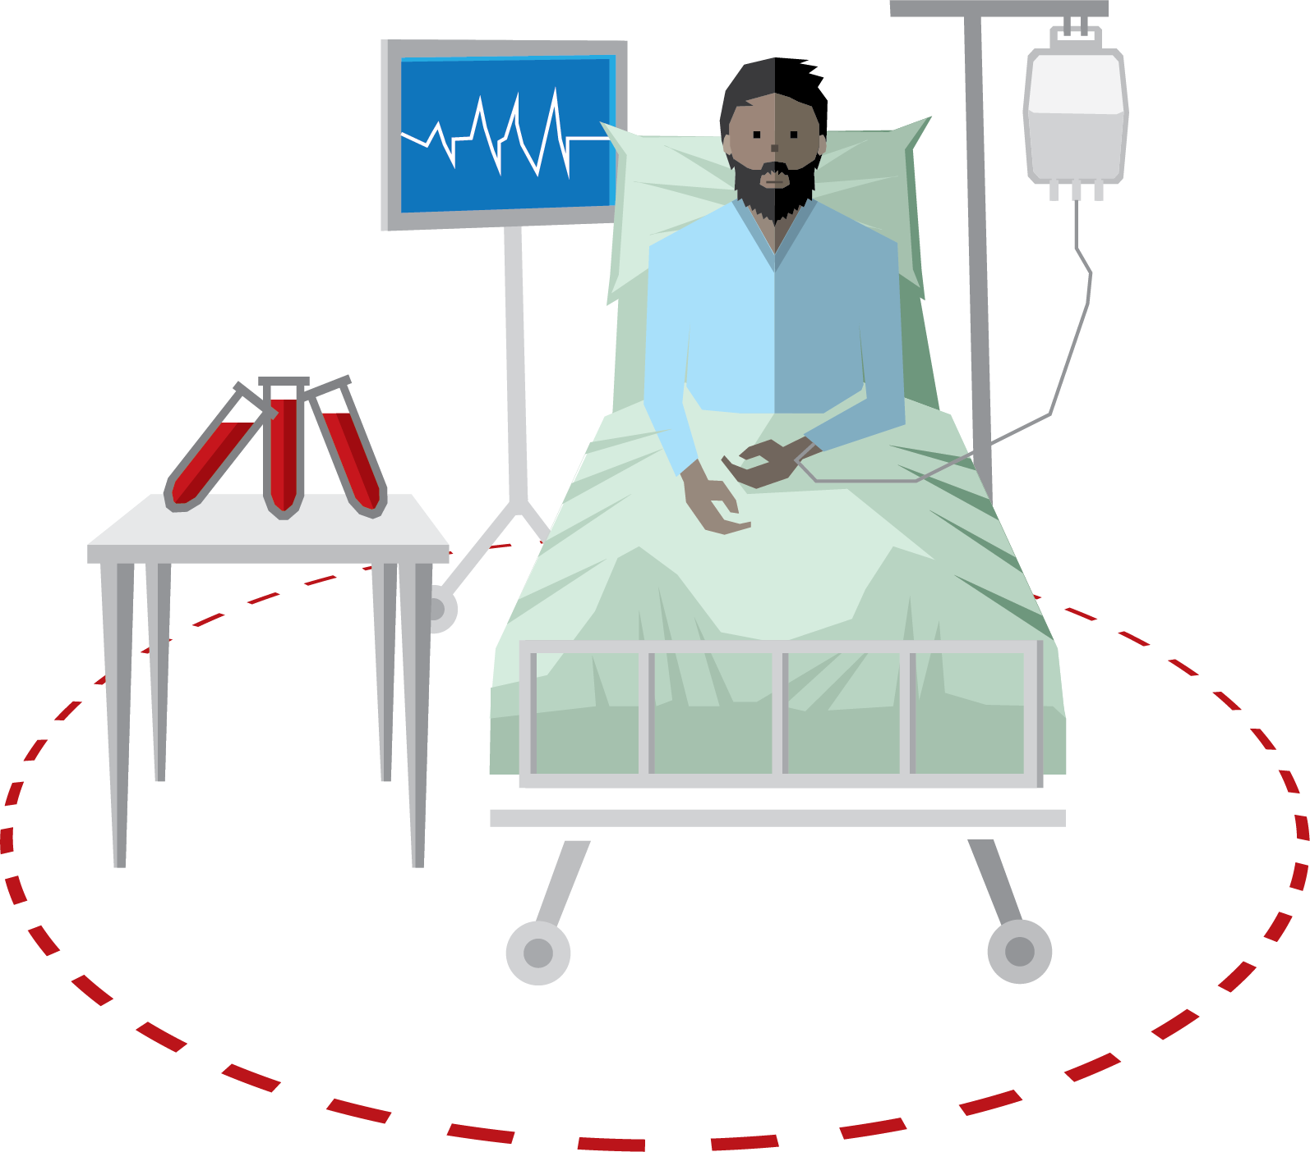
Samples may be labelled using printed addressograph from the EMR at the patient side, or pre-printed labels collected and taken to the patient side with all other equipment, or handwritten patient details on the sample.
Patients should be involved in the process by asking, where possible, to state their name and date of birth and checking this matches their ID band (along with the medical record number), the request form and the labelled samples. As seen in many of these case studies not asking the patient to self-identify or labelling away from the patient side leads to errors in sample and request labelling and associated WBIT events that have the potential to lead to ABO-incompatible transfusions.

RhD immunoglobulin errors
RhD immunoglobulin (Ig) errors continue to occur, representing 24 per cent (n = 14) of procedural reports this year. Tables 28 and 29 outline the intended administration indication and types of incidents.
Table 28: RhD Ig errors – intended administration indication (n = 14)
Intended administration indication | Number (%)*
Antenatal prophylaxis | 6 (50%)
Sensitising event | 2 (17%)
Postnatal | 4 (33%)
*Note: these areas do not include: RhD Ig given instead of Pertussis Ig (1), and near miss due to transcription error of blood group into EMR (1).
Table 29: Types of RhD Ig incidents
Type of incident | Number (%)
Administered, not required (Rh negative mother with known RhD-negative baby) | 1 (7%)
Administered, not required (RhD positive woman) | 1 (7%)
Administered, not required (woman with immune Anti-D) | -
RhD Ig dose omitted | 6 (43%)
Delay in administration (> 72 hours) | 3 (21%)
Wrong or inadequate dose | 1 (7%)
Other: near miss (RhD positive patient prescribed RhD Ig) | 1 (7%)
Other: Patient administered RhD Ig instead of pertussis | 1 (7%)

Delayed administration of RhD immunoglobulin (Ig):

Case study 18: Indeterminant baby blood group
An RhD negative woman who had received appropriate RhD Ig prophylaxis during the pregnancy gave birth to a baby with an indeterminant blood group. The pathology report indicated this and that RhD Ig should be administered. In this situation usual practice is to report the baby’s blood group as RhD positive to trigger administration of RhD Ig, however this was not done. When the error was found the woman was administered RhD Ig, 4 days post birth.
STIR Expert Group review: RhD administration error, certainly

Comments
Training of staff to ensure they follow processes as per protocol for reporting and follow-up is important to ensure errors are not repeated. The concern expressed by the Expert Group was that due to the delay in RhD Ig administration, there was a risk this woman could develop an anti-D antibody that could affect future pregnancies.

Case study 19: Possible misread negative DAT as indicating baby RhD negative
RhD Ig was not administered to an RhD negative mother after the birth of an RhD positive baby. The health service reported that it was possible a staff member misread the neonatal blood group and DAT (initial DAT negative), while the baby’s blood group was RhD positive. The baby was in Special Care Nursery and the mother asked about the baby's blood group which was followed up by the midwife. After checking the baby’s blood group, a dose of RhD Ig was administered to the woman day 6 post-delivery.
STIR Expert Group review: RhD administration error, certainly

Comments
The health service is investigating improving the format of the pathology report to ensure the blood group and DAT are clearly defined and separated.
STIR has received a small number of reports over the years of misread blood group results that can lead to these types of errors. It is important that pathology results are clear in both electronic and paper formats. Staff must take the time to read and understand the content.

Case study 20: Incorrect immunoglobulin administered
Staff correctly recognised that an RhD negative woman needed RhD Ig after the delivery of a RhD positive baby. An error in collection of the product from a hospital blood fridge and incorrect checking procedure at the time of administration led to Normal immunoglobulin being given instead of the ordered RhD Ig. The error was found 11 days later during an audit of RhD Ig administration by the transfusion nurse. Consultation with the laboratory haematologist occurred, and the woman was brought back to be given a dose of RhD Ig.
Expert Group review: RhD administration error, certainly

Comments
When administration of RhD Ig is omitted for a RhD negative woman delivering a RhD positive baby there is potential for development of an RhD antibody which could result in haemolytic disease of the fetus and newborn (HDFN) in future pregnancies.
Checking procedures must be followed to ensure the correct product is administered every time.

Cell salvage
Cell salvage remains a reportable category in STIR. No reports related to cell salvage have been received.

Laboratory errors
Health service transfusion laboratories are rarely reported as contributors to errors reported to STIR. The SHOT annual report 2022 noted an 11 per cent increase in reported laboratory errors since 2021.
In FY22, STIR had 10 procedural investigations where the laboratory was indicated as a contributor to the event. It is rare that the laboratory is the only source of the error. Errors that may begin in the laboratory are not always picked up by clinical staff when checking the product against the patient.

Victorian Health Incident Management System (VHIMS) reporting
The Victorian Agency for Health Information (VAHI) developed a new Victorian Health Incident Management System Minimum Dataset (VHIMS MDS) for the collection of clinical, occupational health and safety (OH&S) incidents, near misses and hazards over 2018–19. All Victorian public health services are required to collect and submit adverse events to VAHI to support statewide reporting with the aim to improve quality and safety.
Incidents related to blood fit under ‘clinical incident type’, where an event resulted, or could have resulted, in unintended or unnecessary harm to a person receiving clinical care.
For the purposes of VHIMS, incidents related to blood products involving red cells, FFP, platelets, cord blood, anti-D and cryoprecipitate are reportable, in addition to albumin, immunoglobulin and recombinant products. Each incident is assigned a subcategory related to the process and associated problem. There is a detailed taxonomy for incident classification. However, there are no definitions or descriptions of what each category may include.
STIR is in consultation with VAHI for the ongoing development of the VHIMS MDS.
The following section shows the taxonomy extracted from VHIMS minimal data set (MDS). Note that problem is dependent on process.

Clinical event type: Blood products

Blood product type:
- Albumin/plasma protein
- Anti-D
- Cord blood
- Cryoprecipitate
- Fresh Frozen Plasma -FFP
- Immunoglobulin
- Platelets
- Recombinant products, rVIIa, VIII and IX
- Red cells

Process:
- Administration
- Blood preparation
- Delivery/transportation
- Dispensing
- Ordering
- Prescribing
- Storage
- Wastage

Problem:
- Contamination
- Contraindication
- Delayed
- Expired
- Given not signed for
- Omitted
- Signed and not given
- Transfusion reaction
- Transfusion without indication
- Wrong administration set used
- Wrong amount
- Wrong blood/blood product
- Wrong rate
- Wrong storage
- Wrong time

Clinical event type: Consent related to blood products

Problem:
- Inappropriately obtained
- Incomplete
- Not obtained
- Subject not fully informed

Clinical event type: Investigations related to pathology

Process:
- Testing/sampling

Problem:
- Wrong blood in tube

References
ANZSBT 2011, Guidelines for prevention of transfusion associated graft-versus-host disease. <https://anzsbt.org.au/wp-content/uploads/2018/06/PreventionofTA-GVHD.pdf >.
ANZSBT 2021, Guidelines for the implementation and use of electronic medical records for transfusion
Blood Matters 2021, Implementation and use of electronic medical records (EMR) in blood management and transfusion practice
Dunbar NM 2020, Does ABO and RhD matching matter for platelet transfusion? Haematology
Dunbar NM, Kaufman RM, WBIT Study Investigators, and The Biomedical Excellence for Safer Transfusion (BEST) Collaborative 2022, ‘Factors associated with wrong blood in tube errors: An international case series – The BEST collaborative study’, Transfusion, vol. 62, pp. 44–50.
Ji Y, Luo G and Fu Y 2022, ‘Incidence of alloimmunization in D-negative individuals receiving D-positive red blood cell transfusion: A systematic review and meta-analysis’, Vox Sanguinis, vol. 117, no. 5.
Kwon SS, Kim S and Kim HO 2022, ‘Incidence and characteristics of hypotensive transfusion reaction: 10-year experience in a single center’, Transfusion, vol. 62, no. 11, pp 2245–53.
Lifeblood 2023, ‘Febrile non-haemolytic transfusion reactions (FNHTR)’, <https://www.lifeblood.com.au/health-professionals/clinical-practice/adverse-events/FNHTR>.
Lifeblood 2023, Blood component information: an extension of blood component labels, 2023 edition.
Menis M, Forshee RA, Anderson SA, et al. 2015, ‘Febrile non-haemolytic transfusion reaction occurrence and potential risk factors among the U.S. elderly transfused in the inpatient setting, as recorded in Medicare databases during 2011–2012’, Vox Sang, vol. 108, pp. 251–61.
Wang H, Ren D, Sun H and Liu J 2022, ‘Research progress on febrile non-hemolytic transfusion reaction: a narrative review’, Annals of Translational Medicine, vol. 10, no. 24, p. 14.
SHOT 2021, SHOT annual report 2021, <https://www.shotuk.org/shot-reports/report-summary-and-supplement-2021/>.
SHOT 2022, SHOT annual report 2022, <https://www.shotuk.org/wp-content/uploads/myimages/SHOT-REPORT-2022-FINAL-Bookmarked.pdf>.
Semple JW, Rebetz J and Kapur R 2019. ‘Transfusion -associated circulatory overload and transfusion-related acute lung injury’, Blood, vol. 133, no. 17, pp. 1840–53.
Selleng K, Jenichen G, Denker K, Selleng S, Müllejans B and Greinacher A 2017, ‘Emergency transfusion of patients with unknown blood type with blood group O Rhesus D positive red blood cell concentrates: a prospective, single-centre, observational study’, Lancet Haematology, vol. 4, no. 5, e218–e224.
Seheult JN, Callum J, Delaney M, Drake R, Dunbar NM, Harm SK, Hess JR, Jackson BP et al., The Biomedical Excellence for Safer Transfusion Collaborative 2022, ‘Rate of alloimmunisation in trauma does not depend on the number of RhD positive units transfused: The BEST collaborative study’, Transfusion.
Yazer MH, Delaney M, Doughty H, Dunbar NM, Al-Riyami AZ, Triulzi DJ, Watchko JF, Wood EM, Yahalom V and Emery SP 2019, ‘It is time to reconsider the risks of transfusing RhD negative females of childbearing potential with RhD positive red blood cells in bleeding emergencies’, Transfusion, vol. 59, pp. 3794–98.
Yazer MH, Triulzi DJ, Sperry JL, Seheult JN 2021, ‘Rate of RhD-alloimmunization after the transfusion of multiple RhD-positive primary red blood cell containing products’, Transfusion, vol. 61, suppl 1, S150–S158.

Appendix 1: STIR Expert Group members
Name | Title and affiliation
Dr Mandy Davis (Chair) | Consultant Haematologist, Alfred Health, Victoria
Dr Giles Kelsey | Consultant Haematologist, Melbourne Health, Victoria
Ms Christine Akers | Transfusion Nurse, Blood Matters Program, Victoria
Ms Linley Bielby | Manager, Blood Matters Program, Victoria
Dr Philip Crispin | Consultant Haematologist, The Canberra Hospital, Australian Capital Territory
Assoc. Prof. Erica Wood | School of Public Health and Preventative Medicine, Monash University, Victoria
Ms Bridget Glazebrook | Data Manager, Blood Matters Program, Department of Health, Victoria
Dr Chris Hogan | Director Pathology Services, Austin Health
Dr Ellen Maxwell | Director of Haematology, Melbourne Pathology
Dr Tina Noutsos | Haematologist, Royal Darwin Hospital, Northern Territory
Assoc. Prof. Merrole Cole-Sinclair | Director of Haematology, St Vincent’s Hospital, Victoria
Dr Linda Saravanan | Haematologist, Melbourne Pathology
Ms Mary Comande | Blood Bank Scientist, Royal Children’s Hospital
Dr James Daly | Medical Director of Pathology Services, Australian Red Cross Lifeblood
Ms Kaylene Bastin | Education Co-ordinator, Blood Matters Program, Victoria
Dr Kobie von Wielligh | Haematologist, Australian Red Cross Lifeblood
Ms Rae French | Scientist, Blood Matters Program, Victoria
Ms Meryanda Jodoin | Transfusion Clinical Nurse Consultant, Quality & Risk, Bendigo Health
Dr Anna Hutchinson | Haematologist, Royal Hobart Hospital, Tasmania
Ms Glenda Mann | Blood Bank Scientist, Cabrini Health, Victoria (resigned)

Appendix 2: STIR publications and promotions
Bulletins:
- Update to transfusion reaction STIR reporting definitions, September 2022
Conferences:
- Blood 2021: ‘Improving blood safety with haemovigilance reporting to the Serious Transfusion Incident Reporting (STIR) Victoria’ (poster) September 2021
- Blood 2021: ‘An update on wrong blood in tube (WBIT) events from the Serious Transfusion Incident Reporting (STIR) program’ (oral presentation) September 2021
- RANZCOG: ‘RhD Immunoglobulin (RhDIg): are we following the guidelines?’ (poster) October 2022
Other:
- Haemovigilance webinars – ‘Sharing international Haemovigilance experiences’, August 2022
- Haemovigilance webinars – ‘Improving safety and quality through data, WBIT’, September 2022

Appendix 3: Imputability and severity scores
Imputability scores
Imputability/causality | Definition
Not assessable | When there is insufficient evidence for an imputability definition
Excluded | When there is conclusive evidence that the cause of the incident is attributable to other causes and not the transfusion
Possibly | When the evidence is indeterminate for attributing the incident to either the transfusion or other causes
Probably | When the evidence is clearly in favour of attributing the incident to the transfusion
Certainly | When the evidence is conclusively attributable to the transfusion
Severity scores
Severity | Incident
1 | Relatively infrequent, clear-cut events that occur independently of a patient’s condition; commonly reflect health service system and process deficiencies; result in, or have the realistic potential to result in, an unexpected death or a permanent and disabling injury of psychological harm to a person and includes reportable sentinel events
2 | Events that result in a temporary loss of function (sensory, motor, physiological or intellectual) which is unrelated to the natural course of the patient’s illness and differ from the expected outcome of the patient’s management
3 | Events that result in a person requiring increased treatment, but not hospitalisation or an increased length of stay
4 | Events that result in minor injury requiring only first aid treatment or no injury

Appendix 4: Case studies
Area | Description
Allergic reactions | Case study 1: Anaphylaxis with multiple products in bleeding patient
Hypotensive reactions | Case study 2: Hypotension with red cell transfusion
Delayed reactions | Case study 3: Development of anti-D after transfusion of RhD positive platelets
RhD isoimmunisation | Case study 4: RhD isoimmunisation, with uncertain prophylaxis
TACO | Case study 5: TACO in a patient with pre-existing risk factors and rapid infusion rate
TACO | Case study 6: TACO in a patient receiving transfusion prior to elective surgery
IBCT | Case study 7: Incorrect RhD group - dispensed and administered.
IBCT | Case study 8: RhD negative patient received RhD positive blood
IBCT | Case study 9: Non-irradiated product to patient with newly diagnosed leukaemia
IBCT | Case study 10: Blood components for different patient than given, labels removed
IBCT | Case Study 11: ABO incompatible transfusion to patient in ED (isolation, pneumatic chute, checking) – sentinel event
Procedural other | Case study 12: Procedural other, administration time greater than four hours
WBIT | Case study 13: Distraction during process and labelling away from bedside
WBIT | Case study 14: Historic WBIT
WBIT | Case study 15: WBIT during pandemic Code Brown
WBIT | Case study 16: Incorrect use of EMR and labelling away from bedside
WBIT | Case study 17: EMR allows two patient charts open concurrently
RhD Ig administration | Case study 18: Indeterminant baby blood group
RhD Ig administration | Case study 19: Possible misread negative DAT as indicating baby RhD negative
RhD Ig administration | Case study 20: Incorrect immunoglobulin administered

Appendix 5: STIR timeline
Year | Action
2006 | Pilot July to October  First notification received 16 September 2006  Nine incident categories
2008 | First STIR report developed and published, covering 1 January 2006 to 31 December 2007  Four jurisdictions reporting
2011 | Move to electronic notification and report forms
2013 | NSQHS Standard 7: ‘Blood and blood products’ developed, encourages haemovigilance reporting
2014 | Commenced annual STIR report
2015 | Commenced RhD Ig and cell salvage reporting (1 January 2015)  Change to WBIT reporting to exclude mismatch in labelling (zero tolerance)
2017 | Review of all forms  Commenced reporting of delayed serological transfusion reaction and transfusion-associated dyspnoea (1 July 2017)
2018 | First STIR bulletin sent to health services and interested parties
2020 | Commenced reporting of RhD isoimmunisations and hypotensive reactions (1 July 2020)
2021 | Included questions re EMR in investigation forms (1 July 2021)

