Dehydration
Standardised care process
Contents
Objective 2
Why the 2
Definitions 2
Team 2
Acknowledgement 2
Brief standardised care process 3
Recognition and assessment 3
Interventions 3
Referral 3
Evaluation and reassessment 3
Resident involvement 3
Staff knowledge and education 3
Full standardised care process 4
Recognition 4
Assessment 4
Interventions 5
Referral 5
Evaluation and reassessment 6
Resident involvement 6
Staff knowledge and education 6
Nomogram to determine recommended fluid intake 7
Evidence base 8

Objective
To promote evidence-based practice in the assessment and management of dehydration for older people who live in residential care settings.
Why the detection and management of dehydration is important
Dehydration is common in older people (Mentes & Gaspar 2020). It can contribute to adverse health outcomes such as falls, fractures, heart disease, confusion, delirium, heat stress, constipation, kidney failure, pressure ulcers, poor wound healing, suboptimal rehabilitation, infection, seizures, drug toxicity, and reduced quality of life (Hooper et al. 2015, p. 5). Dehydration in older people is preventable (Gaspar 2011). The risk of dehydration is increased in people living in aged care facilities (Bunn, Hooper & Welch 2018).

Definitions
Dehydration: depletion of total body water caused by pathological loss of fluid, inadequate fluid intake or a combination of both (Gaspar & Mentes 2020, p. 158).

Team
Manager, registered nurses (RNs), enrolled nurses (ENs), personal care attendants (PCAs), leisure
and lifestyle staff, general practitioner (GP), allied health professionals (such as a speech pathologist,
physiotherapist, occupational therapist and exercise physiologist), residents and/or family/carers.

Acknowledgement
This standardised care process (SCP) has been developed for public sector residential aged care services (PSRACS) by the Australian Centre for Evidence Based Care (ACEBAC) at La Trobe University through the Department of Health and Human Services Strengthening Care Outcomes for Residents with Evidence (SCORE) initiatives. This SCP is one of a series of priority risk areas reviewed based on the best available evidence in 2023.

Brief standardised care process

Recognition and assessment
- Identify residents at risk of dehydration.
- Conduct a comprehensive assessment:
– on admission
– at any time there is a change in the resident’s condition or symptoms of dehydration present.

Interventions
If no dehydration is identified, implement and maintain strategies to prevent dehydration.
If dehydration is indicated by the assessment:
- establish its severity and a treatment goal
- review daily intake, increasing oral fluids as tolerated
- document and monitor fluid intake and output
- review and revise prevention strategies currently in place
- monitor symptoms by repeating the above assessment
- refer to a GP if there is no improvement or symptoms are severe.

Referral
- GP
- Occupational therapist
- Speech pathologist
- Dietitian
- Pathologist

Evaluation and reassessment
- Monitor the resident until their symptoms are relieved.
- Monitor urine-specific gravity and colour.
- Continue preventative interventions.
- Monitor the resident’s functional ability.
- Monitor the resident for changes in their condition and/or symptoms of dehydration or over-hydration.

Resident involvement
- Involve the resident in identifying their preferred fluids and daily intake goal.
- Educate the resident about the importance of adequate fluid intake.

Staff knowledge and education
- Causes of dehydration in older people
- Maintaining adequate hydration
- Signs and symptoms of dehydration
- Fluid volumes of drinking utensils

Full standardised care process

Recognition
Be aware of residents who are at risk of dehydration. Risk factors include:
- increasing age (65 years and over, risk further increases at 85 years and over), being female, age-related physiological changes
- limitations in oral intake due to:
  - reduced thirst sensation
  - dysphagia, modified fluids and food
  - reluctance to drink to manage incontinence
  - poor mobility reducing access to fluids
- reliance on staff to assist with oral intake
- fluid loss through diarrhoea, vomiting, diuretics, fever, sweating, heat and humidity
- health status that affects cognitive functioning, such as sedation, delirium, dementia, depression
- acute illness, multiple comorbidity, end of life
- polypharmacy and medications, such as diuretics, laxatives, lithium, psychotropics.

Assessment
Conduct an assessment:
- on admission
- at any time there is a change in the resident’s condition or symptoms of dehydration.
The assessment includes:
- history of dehydration
- medical history
- current medications
- cognitive status
- continence status
- mobility status
- usual hydration habits and current fluid intake pattern (for example, amount, type of fluid, preferred temperature of fluid)
- ability to access and drink fluids
- functional ability and need for aids such as straws, modified cups.

Conduct a physical assessment that includes:
- lying/standing blood pressure (low blood pressure and/or postural hypotension may be an indicator of dehydration), temperature, pulse rate, respiration rate, capillary refill rate
- calculating the resident’s BMI (Body Mass Index)
- monitoring fluid input and urine output over a 24-hour period (output should be greater than 700 mL)
- urinalysis (colour – greenish-brown, specific gravity – greater than 1.029)
- dehydration is indicated when blood pathology/results indicate the blood urea nitrogen/creatinine ratio is greater than 25 and/or serum sodium is greater than 150 mmol/L
- identifying observable symptoms of dehydration, such as:
– dry oral mucosa and dry furrowed tongue
– sunken eyes
– muscle weakness and/or increased physical frailty
– constipation and/or small amounts of dark, concentrated urine
– non-fluent speech
– change in mental status (confusion, disorientation, altered consciousness, headache) and drowsiness.

Interventions
If no dehydration is identified, implement and maintain strategies to prevent dehydration:
- Calculate and document an individualised daily fluid intake goal (see the nomogram overleaf to determine the recommended water intake).
- Provide preferred fluids (but limit alcohol).
- Always have fluid available.
- Offer fluids regularly through the waking day (for example, each one and a half hours and during fluid rounds).
- Offer a variety of fluids over the day (for example, hot drinks, cold drinks, juice, milk, soups, icy poles). Caffeinated drinks can be included in the daily intake but not as the only source of fluid.
- Encourage the resident to drink small amounts throughout the day.
- Increase assistance as required and allocate adequate time to staff to facilitate this.
- Provide aids (for example, straws, modified cups), ensuring they are always used.
- Standardise the amount of fluid given with medications – for example, 180 mL per administration.
- Involve family/carers to encourage fluid intake.
- Promote pleasurable and social opportunities for fluid intake (afternoon tea, non-alcoholic happy
- hour, drinks/ice-cream trolley).
- Prompt recognition and communication of symptoms of dehydration among staff.
If the assessment indicates dehydration:
- Establish its severity.
- Establish a treatment goal if the resident has reached the end-of-life phase.
- Review prevention strategies already in place.
- Review the daily intake goal, increasing oral fluids as tolerated.
- Document and monitor the resident’s fluid intake and output.
- Refer to a GP to consider blood tests and withholding renal toxic, renally excreted or diuretic medicines.
- Monitor symptoms by repeating the above assessment, for example:
  - daily if there is no or only marginal improvement in fluid intake
  - in seven days if the daily intake goal is being achieved.
If severe symptoms are present or if mild symptoms do not improve:
- refer to a GP for medical assessment, diagnosis (including underlying causes) and treatment
- implement a treatment plan as prescribed by the GP
- in conjunction with the GP, review the resident’s daily fluid intake goal.

Referral
- GP
- Occupational therapist if available for advice regarding appropriate drinking aids
- Speech pathologist
- Dietitian
- Pathologist

Evaluation and reassessment
- Monitor the resident until their symptoms are relieved.
- Monitor urine-specific gravity and colour.
- Continue preventative interventions.
- Monitor the resident’s functional ability – for example, how much assistance the resident needs to access, pour and drink fluids.
- Monitor the resident for changes in their condition and/or symptoms of dehydration.
- Monitor the resident for symptoms of overhydration – that is, unexplained weight gain, peripheral oedema, neck vein distension, shortness of breath.

Resident involvement
- Involve the resident to identify their preferred fluids and daily intake goal.
- Provide education regarding the importance of adequate fluid intake.

Staff knowledge and education
- Causes of dehydration in older people
- Maintaining adequate hydration
- Signs and symptoms of dehydration
- Fluid volumes of drinking utensils

Nomogram to determine recommended fluid intake
Instructions to determine the recommended fluid intake of residential care residents:
- Find the person’s height on the left-hand scale and their weight on right-hand scale.
- Connect these two points with a straight edge.
- Where the line crosses the middle scale, read the recommended water intake.

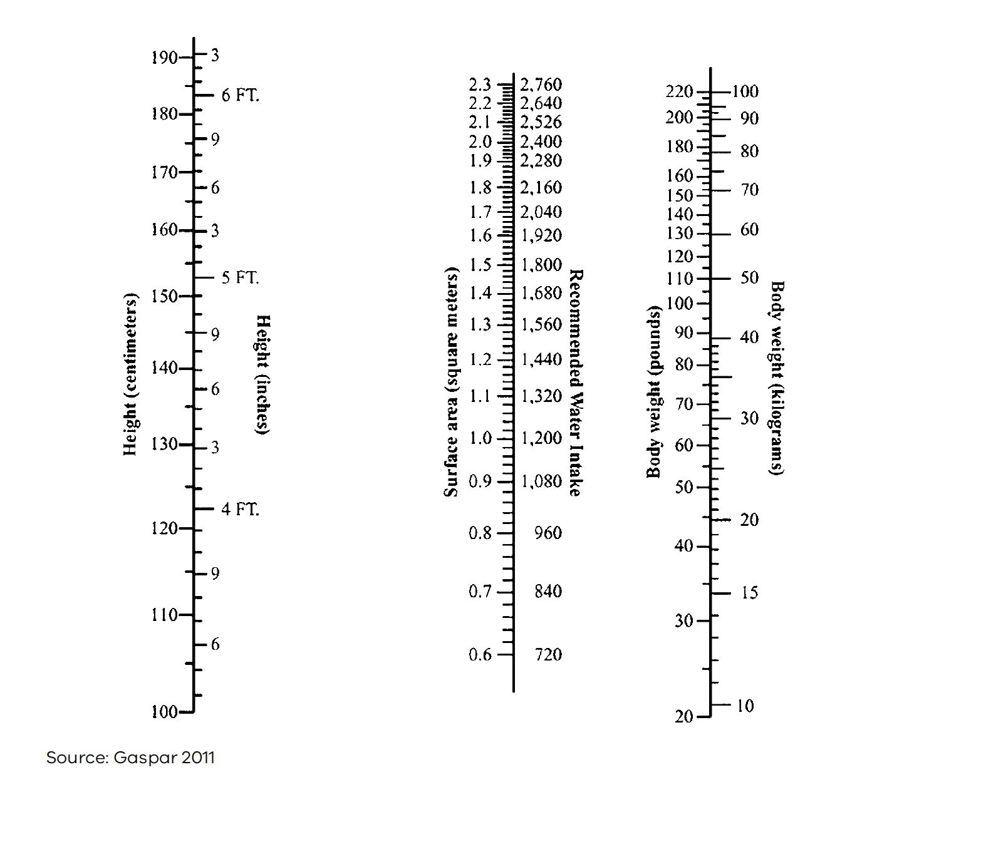

Evidence base
Brennan, M, O’Keefe, S & Mulkerrin, E 2019, ‘Dehydration and renal failure in older persons during heatwaves – predictable, hard to Identify, but preventable?’, Age and Ageing, vol. 48, pp. 615–18.
Bunn, D, Hooper, L & Welch, A 2018, ‘Dehydration and malnutrition in residential care: recommendations for strategies for improving practice derived from a scoping review of existing policies and guidelines’, Geriatrics, vol. 3(77), pp. 1–13.
Canadian Agency for Drugs and Technologies in Health 2017, Prevention of dehydration in geriatrics in long-term care: guidelines, CADTH, Ottawa.
Department of Health 2012, Strengthening care outcomes for residents with evidence (SCORE), Ageing and Aged Care Branch, State Government of Victoria, Melbourne.
Gaspar, P 2011, ‘Comparison of four standards for determining adequate water intake of nursing home residents’, Research and Theory for Nursing Practice: An International Journal, vol. 25(1), pp. 11–22.
Gaspar, P, Scherb, C & Rivera-Mariani, F 2019, ‘Hydration status of assisted living memory care residents’, Journal of Gerontological Nursing, vol. 45(4), pp. 21–31.
Gaspar, P & Mentes, J 2020, ‘Ch 12: Managing oral hydration in the older adult’ in M Boltz, E Capezuti, D Zwicker & T Fulmer, 2020. Evidence-based geriatric nursing protocols for best practice. Springer, New York.
Hooper, L, Abdelhamid, A, Attreed, N, Campbell, W, Channell, A, Chassagne, P & Hunter, P 2015, ‘Clinical symptoms, signs and tests for identification of impending and current water-loss dehydration in older people’, Cochrane Database of Systematic Reviews, Issue 4. CD009647.
Mentes, J & Gaspar, P 2020, ‘Hydration management’, Journal of Gerontological Nursing, vol. 46(2), pp. 19–32.
Minooee, S 2019, Evidence Summary: Oral hydration for the older person, The Joanna Briggs Institute EBP Database, JBI@Ovid. JBI1143.
Volkert, D, Beck, A, Cederholm, T, Cruz-Jentoft, A, Goisser, S, Hooper, L & Bischoff, S, 2019, ‘European Society for Clinical Nutrition and Metabolism guideline on clinical nutrition and hydration in geriatrics’, Clinical Nutrition, vol. 38, pp. 10–47.

Important note: This standardised care process (SCP) is a general resource only and should not be relied upon as an exhaustive or determinative clinical decision-making tool. It is just one element of good clinical care decision making, which also takes into account resident/patient preferences and values. All decisions in relation to resident/patient care should be made by appropriately qualified personnel in each case. To the extent allowed by law, the Department of Health and the State of Victoria disclaim all liability for any loss or damage that arises from any use of this SCP.

Authorised and published by the Victorian Government, 1 Treasury Place, Melbourne.
© State of Victoria, Department of Health, April 2023. (2308532)
ISBN 978-1-76096-812-0 (pdf/online/MS word)
Available from the department’s Standardised care processes webpage <https://www.health.vic.gov.au/residential-aged-care/standardised-care-processes>.

