Cemetery land development costing model user guide
OFFICIAL

Introduction
This is a step-by-step guide to using the department’s Cemetery land development costing model (the costing model) <https://www.health.vic.gov.au/cemeteries-and-crematoria/class-b-cemetery-trust-fee-setting>.
The costing model has been designed to assist cemetery trusts to capture the costs associated with the development of cemetery land for the sale of rights of interment (ROIs) for bodily remains and cremated remains (ground or niche walls). The costing model helps cemetery trusts incorporate development costs into fees as well as the cost of shared infrastructure, such as toilet blocks, roads, pathways and communal gardens.
The costing model calculates the development cost of each type of ROI. The cost proposed by the costing model can be used as the Land Value figure in a fee justification model submitted to the department as part of a fee application.
Note: The costing model is not designed to assess the financial viability of a development project.
The costing model has three sections:
- Section A – Project specifics
- Section B – Project expenditure
- Section C – Development cost per right of interment
Instructions for completing each section of the costing model are provided below followed by two examples.

First steps
- Download the costing model from the department’s website and save to the computer hard drive or other storage device.
- Note the instructions at the top of the spreadsheet to complete only the rows and columns highlighted in grey. All other fields are automatically populated and cannot be edited.
- Enter the name of the cemetery trust and the name of the development project or cemetery area.

Section A – Project specifics
Instructions for completing each row in Section A are detailed in the following table.
Total development area | Insert the total area of the cemetery that is going to be developed (metres squared).
Estimated land value | Insert the estimated total dollar value of the land being used.  When determining the value of the development site, cemetery trusts should consider the cost to the trust of replacing the land at the current land value. Cemetery trusts can reference similar (undeveloped) land values from within the local area. Cemetery trusts should consider the effect of the location of the land to ensure that estimated replacement costs are cost effective and not inflated.  Example: A cemetery trust identifies a hectare (10,000 square metres) of undeveloped land in the local area has a conservative value of $100,000, which equates to $10 per square metre. The cemetery trust is planning to develop a total of 350 square metres so, based on the comparative cost of $10 per square metre, the cemetery trust enters $3,500 (350 x $10) as the estimated land value.
Allowance for variation in cost | The default allowance for cost variation is set at 15 per cent. This can be amended to another figure. Any change to the default figure must be explained in supporting documents.
Number of ROI – Bodily remains | Insert the total number of ROIs for bodily remains the development will create.
Average area per plot | Insert the average size of each plot for bodily remains (metres squared).
Number of ROI – Cremated remains (ground) | Insert the total number of in-ground ROIs for cremated remains the development will create.
Average area per plot | Insert the average size of each plot for cremated remains (metres squared).
Number of ROI – Cremated remains (niche wall) | Insert the total number of niche wall ROIs the development will create.
Total area of niche walls | Insert the total land size of all niche walls (metres squared).
Shared infrastructure | Insert total area for shared infrastructure such as paths, walkways, gardens, gazebos, roads and toilets (metres squared).

Section B – Project expenditure
Instructions for completing each row in Section B are detailed in the following table.
Planning costs – All areas | Include all costs relating to planning. Examples include drafting, council fees/permits, surveying, consultants, legal and market research.
Development costs – Burial areas (bodily and cremated remains) | Include all costs relating to the development of the burial areas for bodily and cremated remains. Examples include materials, capital equipment, labour and contractors.
Development costs – Niche wall areas | Include all costs relating to the development of niche wall areas. Examples include materials, capital equipment, labour and contractors.
Shared infrastructure | Include all costs relating to the development of shared infrastructure. Examples include materials, capital equipment, labour and contractors.
Marketing – All areas | Include all costs relating to marketing. Examples include advertising.
Total project costs | Total costs of the project including allowances for cost variations. This total is automatically calculated.

Section C – Development cost per right of interment
This section automatically populates information from the costing model to calculate the development cost for five categories of ROI:
- ROI bodily remains
- ROI cremated remains – in-ground – perpetual tenure
- ROI cremated remains – in-ground – 25 year tenure
- ROI cremated remains – niche wall – perpetual tenure
- ROI cremated remains – niche wall – 25 year tenure
Note: There are no fields to manually complete in this section.

Submission
When applying to the department to establish fees for the sale of ROIs, the costs calculated in Section C can be used in the Land Value column of the department’s Interactive fee justification model <https://www.health.vic.gov.au/cemeteries-and-crematoria/class-b-cemetery-trust-fee-setting>.
The completed costing model should be submitted with the fee justification model as part of the cemetery trust’s application. The Excel spreadsheet can be emailed to the department or printed out and sent by post.
Email: cemeteries@health.vic.gov.au
Post: Cemetery Sector Governance Support Unit
Department of Health
GPO Box 4057
MELBOURNE VIC 3001

Examples

Example 1 – New lawn section
This example is demonstrated in Figure 1 below.
The total area proposed for development is 330 square metres. This includes 310 square metres for 100 burials (two lawn beams at 155 square metres, each with a capacity for 50 interments) and 20 square metres for walkways and gardens/plants.
A notional land replacement value of $1,000 has been determined by the trust.
The trust is using the department’s recommended 15 per cent for variation in costs.
The planning costs include drafting at $1,000.
The development costs for the graves include materials ($7,000), labour ($8,000), and the hire of excavating equipment ($700).
A contractor has quoted $12,500 to complete all walkways and garden beds.
The trust has no marketing costs planned.
As there are only burial plots being developed, the model identifies that the cost per burial ROI is $344.
The trust enters $344 in the Land Value column of the fee justification model and submits a copy of the costing model with its fee application to the department.
Figure 1 – Example 1 – New lawn section
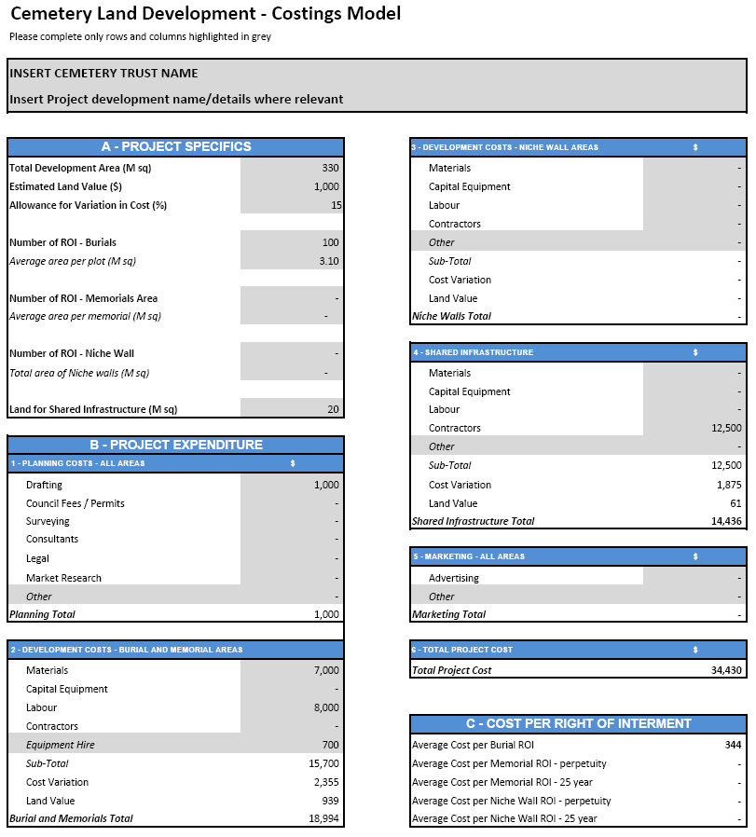

Example 2 – New area with multiple interment types
This example is demonstrated in Figure 2 below.
The trust plans to develop an area measuring 16 x 25 metres (a total of 400 square metres). The plans are for a mix of burial spaces for bodily and cremated remains as well as niche walls for cremated remains.
There will be 80 grave plots measured at an average of 2.44 metres x 1.22 metres (2.98 square metres).
There will also be 200 in-ground memorial spaces for cremated remains measuring 0.75 metres x 0.75 metres (0.56 square meters).
There will be five niche walls, each holding 50 niches with each wall taking up approximately five square metres of land (5 square meters x 5 walls equals a total of 25 square meters).
Land in the area is valued at approximately $200,000 per hectare. This equates to $20 per square metre, making the total land value $8,000.
The trust also wishes to build a toilet block for visitors measuring approximately 20 square metres.
The trust is using the department’s recommended 15 per cent for variation in costs.
The planning costs include surveying ($1,500), drafting ($900) and the engagement of a solicitor ($2,000).
The development costs for the graves and in-ground memorial spaces include materials ($38,000), labour ($45,000), capital equipment ($700) and the costs of renting an excavator for two weeks ($3,300).
The niche walls have been quoted at $5,500 each by a local contractor for a total of $27,500. The toilet block has been quoted at $25,000 including labour and materials. The trust has no marketing costs planned.
After all the figures have been entered and calculated, the model identifies the following development costs per ROI:
Burial | $973
Cremated remains (ground) – Perpetuity | $235
Cremated remains (ground) – 25 year | $141
Cremated remains (niche wall) – Perpetuity | $192
Cremated remains (niche wall) – 25 year | $115
The trust enters these costs in the Land Value column of the fee justification model and submits a copy of the costing model with its fee application to the department.
Figure 2 – Example 2 – New area with multiple interment types
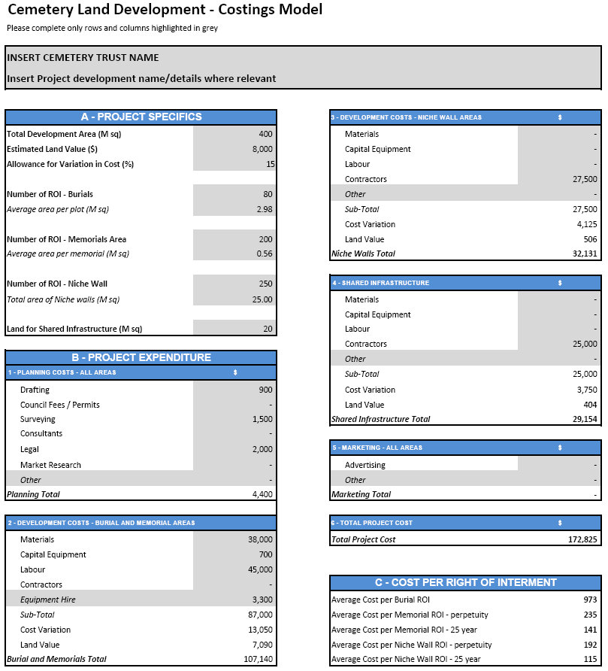

To receive this document in another format, phone 1800 034 280, using the National Relay Service 13 36 77 if required, or email the department <cemeteries@health.vic.gov.au>.
Authorised and published by the Victorian Government, 1 Treasury Place, Melbourne.
© State of Victoria, Australia, Department of Health, December 2023.
ISBN 978-1-76069-209-4 (pdf/online/MS word)
Available at Class B cemetery trust fee setting <https://www.health.vic.gov.au/cemeteries-and-crematoria/class-b-cemetery-trust-fee-setting>

