Ban on smoking and vaping at certain Victorian Government buildings
Factsheet for visitors

By law, smoking and the use of e-cigarettes (vaping) is banned within four metres of an entrance to certain Victorian Government buildings.

Where does the ban apply?
Smoking and vaping is banned within four metres of entrances (pedestrian access points) to Victorian Government buildings occupied either wholly or in part by:
- Parliament, but not electorate offices
- Victorian courts
  - Supreme Court
  - County Court
  - Magistrates’ Court
  - Children’s Court
  - Coroners Court
- public service bodies³
  - Victorian Government departments
  - Victorian Public Sector Commission
  - administrative offices
- special bodies.
The diagram below shows an example of where the smoking and vaping ban applies.
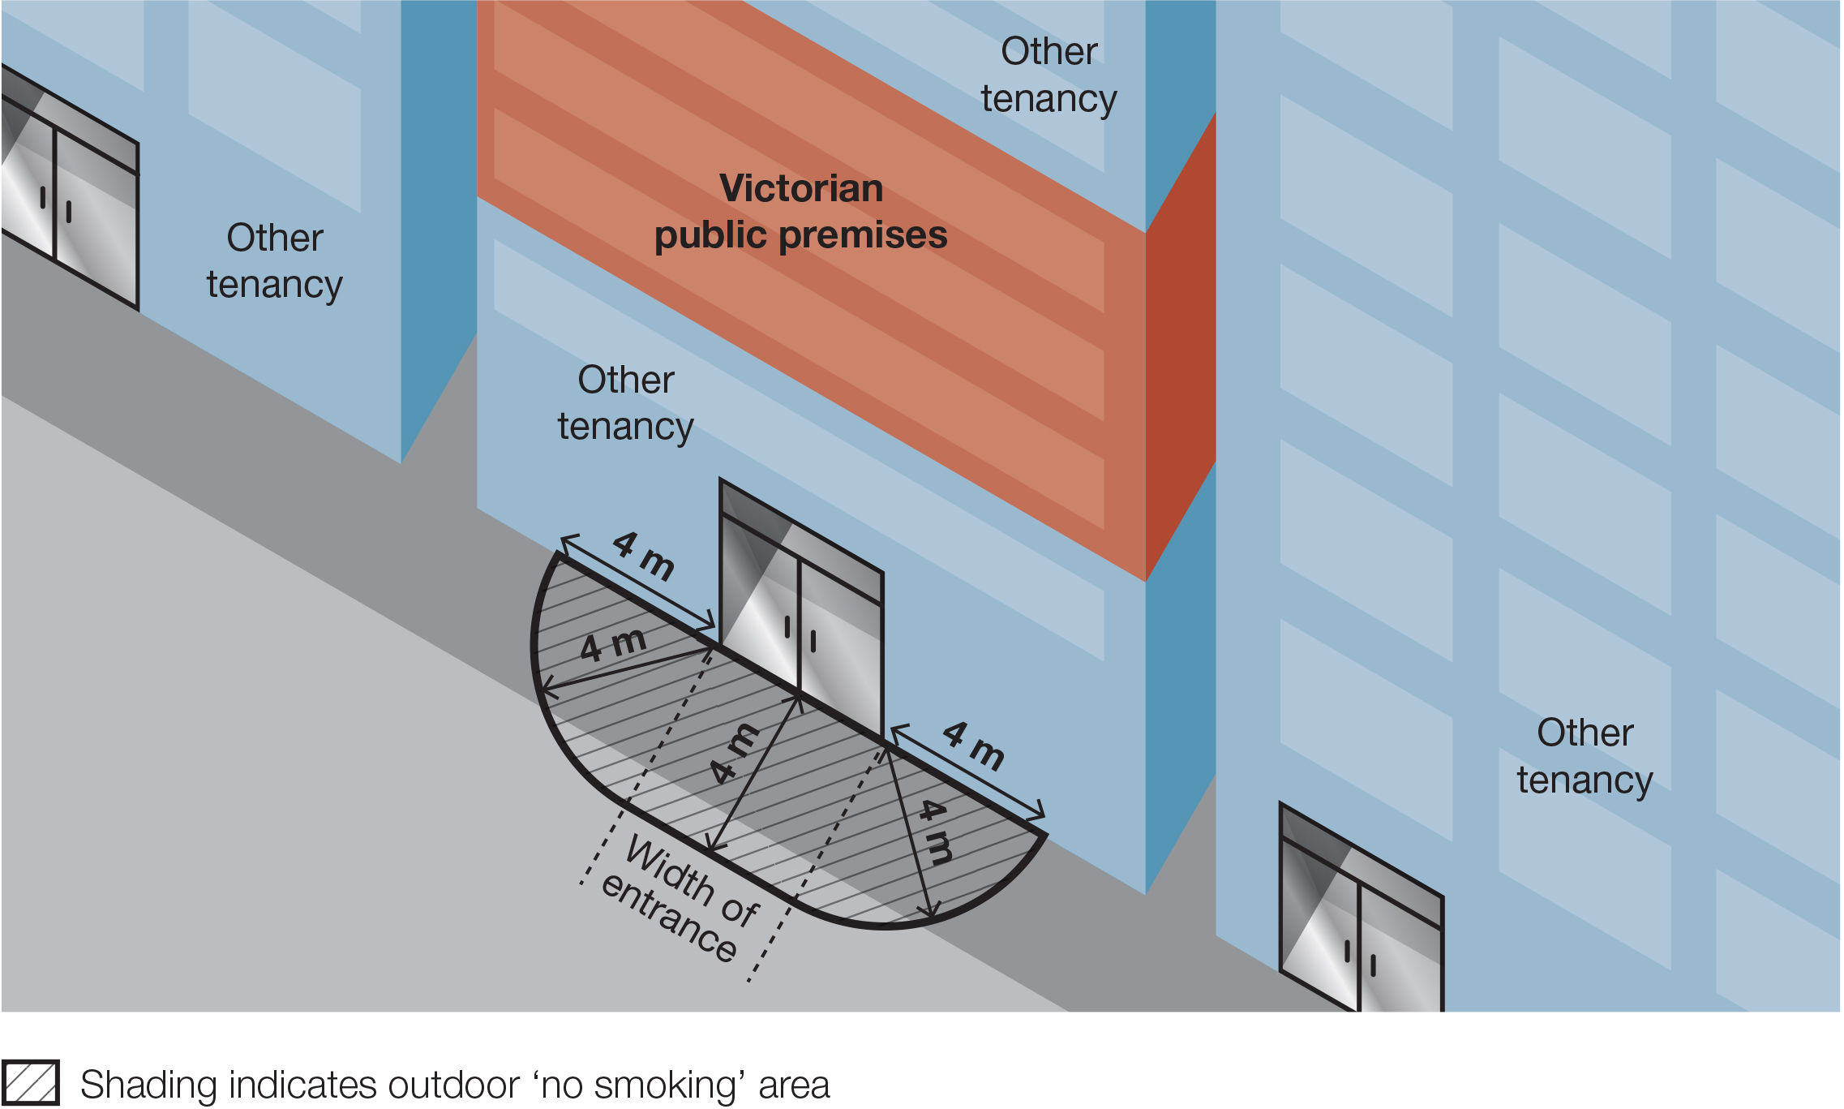

What are the administrative offices?
There are eight administrative offices within the meaning of the Public Administration Act 2004.
Administrative offices
Environmental Protection Authority
Local Government Investigations & Compliance Inspectorate
Office of the Chief Parliamentary Counsel
Office of the Governor
Public Record Office Victoria
Regional Rail Link Authority
Victorian Government Architect
Victorian Government Solicitor’s Office
Family Safety Victoria
Latrobe Valley Authority
Level Crossing Removal Authority
Melbourne Metro Rail Authority
North East Link Authority
Office of Projects Victoria
Safer Care Victoria
Victorian Agency for Health Information
Western Distributer Authority

What are the special bodies?
There are fifteen special bodies within the meaning of the Public Administration Act 2004.
Special bodies
Department of the Parliament of Victoria
Electoral Boundaries Commission
Mental Health Complaints Commissioner
Mental Health Tribunal
Office of the Health Complaints Commissioner
Office of the Ombudsman
Office of the Victims of Crime Commissioner
Office of the Victorian Information Commissioner
Victorian Civil and Administrative Tribunal (VCAT)
Victorian Auditor-General’s Office
Victorian Electoral Commission
Victoria Police (including all Victorian Police Stations)
Independent Broad-based Anti-corruption Commission
The Commission for Children and Young People
The Victorian Inspectorate

Why does the ban exist?

The purpose of the smoking and vaping ban is to:
- protect the community from exposure to second-hand tobacco smoke and the aerosol from e-cigarettes
- further de-normalise smoking and vaping in the community. The more people see smoking and vaping in public places the more they will tend to think smoking and vaping is okay, rather than harmful
- support people who have quit or are trying to quit smoking and vaping.
Where does the ban not apply?
The ban does not apply:
- to entrances of Commonwealth Government buildings, such as Centrelink or Medicare offices
- to entrances of Local Government buildings, such as municipal libraries
- to an emergency exit that is locked to entry
- to a person walking through the smoke-free and vape-free area
- to a person in a motor vehicle that is driving or being driven through the smoke-free and vape-free area
- to a person in an area that is separated from the smoke-free and vape-free area by a road
- to a person in an outdoor drinking area located within the smoke-free and vape-free area
- to a person at a residential premises (at privately owned homes and land).

How will people know about the ban?
Signs will be displayed in the smoke-free and vape-free area.

How will the ban be enforced?
There is strong community support for banning smoking and vaping at public places. This means most people will voluntarily comply with the smoking and vaping ban and expect others to do so.
Inspectors authorised under the Tobacco Act 1987 may provide information about and, when necessary, enforce the ban. The first priority of the inspector is to make sure smokers and vapers understand the ban.
Inspectors may not be available to respond to every complaint but, where circumstances allow, may attend in response.

What penalties might apply?
The maximum penalty for someone breaking this law is five penalty units, with an infringement penalty of one penalty unit.

How can I find out more?
For more information:
- visit the tobacco reforms website <www.health.vic.gov.au/public-health/tobacco-reforms>
- call the Tobacco Information Line on 1300 136 775
To view the legislation visit the Victorian Government’s legislation website <www.legislation.vic.gov.au> and search Tobacco Act 1987.
DISCLAIMER: Please note that any advice contained in this factsheet is for general guidance only. The Department of Health does not accept any liability for any loss or damage suffered as a result of reliance on the advice contained in this factsheet. Nothing in this factsheet should replace seeking appropriate legal advice.
To receive this document in another format, phone 1300 136 775, using the National Relay Service 13 36 77 if required, or email tobacco.policy@health.vic.gov.au
Authorised and published by the Victorian Government, 1 Treasury Place, Melbourne.
© State of Victoria, Australia, Department of Health, November 2023.
Except where otherwise indicated, the images in this document show models and illustrative settings only, and do not necessarily depict actual services, facilities or recipients of services.
ISBN 978-1-76131-086-7 (pdf/online/MS word)
Available at tobacco reforms website <www.health.vic.gov.au/public-health/tobacco-reforms>

Section 5RH(1) of the Tobacco Act 1987.
A pedestrian access point in relation to premises is defined in the Tobacco Act 1987 as a door or gate by which a pedestrian can enter or exit the premises.
Within the meaning of the Public Administration Act 2004.
For current penalty unit values, visit the Department of Treasury and Finance website <www.dtf.vic.gov.au/financial-management-government/indexation-fees-and-penalties>

