

|  |
| --- |
| Transferability of fit testing records |
| 17 November 2023 |

## Updates

|  |  |
| --- | --- |
| **Version/Date** | **Changes** |
| Version 1, 11 October 2021 | This document replaces the previous Fit Test Certificate template to reflect current practice in the sector and includes advice in Appendix 1. |
| Version 2, 17 November 2023 | Weblinks updated and minor changes to content regarding recording of fit test results. |

This document should be read in conjunction with:

* *Victorian Respiratory Protection Program guidelines* <https://www.health.vic.gov.au/quality-safety-service/victorian-respiratory-protection-program>

**Introduction**

Healthcare workers (HCWs) are mobile and may work across multiple sites or health services. The Fit Testing Card template (appendix 1) has been created for health services to guide the development of written evidence of respiratory protective equipment (RPE) fit testing results for healthcare workers (HCWs) who have been fit tested as part of their respirator protection program.

The Respiratory Protection Program (RPP) Guidelines state that a copy of the fit test results should be provided to HCWs who have been fit tested. This enables portability of fit testing results and avoids multiple retests unless required by RPP Guidelines, section 5.9 of RPP Guidelines and any associated guidance.

Data should be captured and recorded on each individual who undergoes fit testing.

The template is a guide only and can be adapted by a health service to reflect their approach to the recording and retention of fit test results.

Written evidence, in the form of a certificate, card or other format should be provided to HCWs who can then provide this evidence to other employers, agencies, or universities. A copy of the fit test results should be retained as part of the HCWs personnel record.

The certificate or card is a tool for health services and HCWs to enable a certified process for recognising that the HCW has been fit tested. It confirms that HCWs are using the correct mask, eliminates any confusion about which respirator a HCW should use and verifies the date of the last fit test.

As health services have different approaches to the recording of fit test results (e.g. in the form of a letter, card, certificate, upload to personnel file or some other record), it is suggested that HCWs take a photo of their results so that they have a backup record and can show this to any other health service that they may work in.

The overall fit factor is the most important item and must be recorded for all HCWs fit tested. Health services are **strongly encouraged** to record the fit factors for the individual exercises. Although this is not a requirement, recording all Fit Factor results may assist with the recognition of fit test results by other health services if HCWs are moving between health services and sites. The recording of both the overall Fit Factor and the results of individual exercises is preferred. For further information, refer to the guidance document, *Transferability of fit test records*  <<https://www.health.vic.gov.au/quality-safety-service/victorian-respiratory-protection-program>>

## Recording fit testing results

The results of a fit test should be verified by an authorised person. An example is below.

### **Individual healthcare worker’s details:**

|  |  |
| --- | --- |
| Name: |  |
| Occupation: |  |
| Organisation where fit test was conducted: |  |
| Date of fit test: |  |
| Fit Test conducted by: |  |

An authorised person is a person that can verify the internal record of an individual’s fit testing results at the organisation (e.g., occupational hygienist, infectious disease team member, fit tester, RPP administrator, health and safety professional or HR).

Authorised by:

|  |  |
| --- | --- |
| Authorised Person: | Date: |
| Role: | Signature: |

**Consent prior to fit testing**

Before a healthcare worker presents for fit testing, they should be provided with information regarding the fit test process and a copy of a pre-test screening questionnaire (the primary purpose of which is to identify any medical or allergic reactions to materials in the respirators).

#### Appendix 1: SAMPLE FIT TEST CARD

Please note: It is recommended that the following information is recorded on the fit test card for each healthcare worker fit tested. Health services may format the appearance of the card to their specific requirements.

**Front side of card**



**Rear of card**

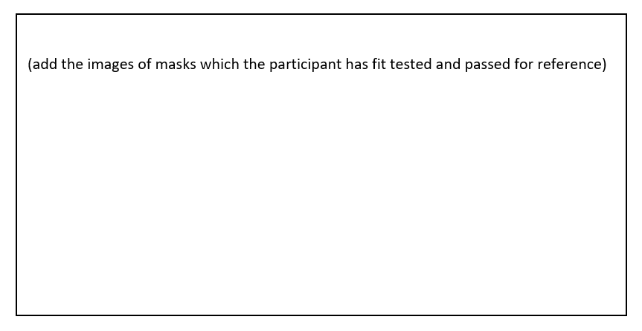

#### Appendix 2: Alternate example of a fit test card

|  |  |  |  |  |
| --- | --- | --- | --- | --- |
| Respirator name and type | Image of Respirator type | Y = Pass N= Fail  Blank= not tested | Overall Fit Factor >100 | Comments (add comments about fit/mask) |
| *Industree Trident Regular size respirator*  *(A Flat fold P2 respirator)* |  |  |  |  |
| 3M AURA 1870+ respirator  (*A Flat fold P2 Respirator)* | 3M Aura Respirator & Surgical Mask 1870+ N95 Single Mask PPE |  |  |  |
| *3M 1860 (Regular)*  *(A Flat fold P2 respirator)* |  |  |  |  |
| *BYD DE2322*  *(Medium)*  *(An ear loop P2 respirator)* | See the source image |  |  |  |
| *3M 1860 (Small) respirator*  *(A Flat fold P2 respirator)* |  |  |  |  |
| *Other: Please specify* |  |  |  |  |

|  |
| --- |
| To receive this document in another format email [Victorian Respiratory Protection Program](mailto:VicRPP@health.vic.gov.au) <[VicRPP@health.vic.gov.au](mailto:VicRPP@health.vic.gov.au)>  Authorised and published by the Victorian Government, 1 Treasury Place, Melbourne.  © State of Victoria, Australia, Department of Health, 17 November 2023  **ISBN** 978-1-76096-703-1 **(pdf/online/MS word)**  Available at [Victorian Respiratory Protection](https://www.health.vic.gov.au/quality-safety-service/victorian-respiratory-protection-program) Program <https://www.health.vic.gov.au/quality-safety-service/victorian-respiratory-protection-program> |