Yellow fever vaccination centre – Change of details form
Adding a practitioner or change of details for an approved yellow fever vaccination centre
OFFICIAL

Privacy Collection Statement
The Department of Health (the department) is committed to protecting your privacy. The information collected about you and your business within this application form and subsequent yellow fever vaccine stamp number will be used by the department for the following purposes:
- Assessing the eligibility of the applicant immunisation provider to access yellow fever vaccine.
- Verifying the accuracy of any information provided.
- Facilitating communication between the nominated immunisation provider, Sanofi (supplier of yellow fever vaccine), and the department.
- Monitoring and evaluating immunisation programs including, but not limited to auditing of uploaded vaccination information and follow up with providers in relation to anomalies and ensuring the data integrity of the Australian Immunisation Register (AIR) in line with Section 10 of the Australian Immunisation Register Act 2015.
We are required to share your information and details with third party (Sanofi) to manage and facilitate an account and supply of yellow fever vaccine. Sanofi will use the information you provide for:
- establishing your account on their systems
- ordering and distributing vaccines
- cold chain management issues or breaches
- communicating with you about your account, recalls or any other vaccine ordering or distribution related activities.
Any information provided to Onelink will be handled in accordance with its privacy policy, available at <https://www.onelinkonline.net/about-us/>.
For more information on the department’s privacy collection, please refer to the department’s privacy policy or visit our website on <https://www.health.vic.gov.au/privacy>.
You may access and update the information that you provide to the department. The department can be contacted by email at <immunisation@health.vic.gov.au>.

Medical practice details
Name of medical practice:
Vaccine delivery address:
Yellow fever stamp number:

Change of details
If any of the below details have changed for the above yellow fever vaccination centre, please provide the update if applicable below:
New name of medical practice:
New vaccine delivery address:
New telephone number:
New email address:
New fax number:
New name of contact for administrative requirements relating to yellow fever vaccination
(practice manager or other):
Other:

Change of responsible practitioner
If the responsible medical or nurse practitioner for the above yellow fever vaccination centre has changed, please provide the new responsible practitioner details below:
Name of new responsible practitioner:
Ahpra registration number:
Ahpra registration expiry date:
☐ Responsible practitioner’s Yellow Fever Vaccination Course certificate attached.

Changes to practitioners who are prescribing the yellow fever vaccine
1 | Name:
 | Ahpra registration number:
 | Ahpra registration expiry date:
 | ☐ Add (Yellow Fever Vaccination Course certificate attached) ☐ Remove
2 | Name:
 | Ahpra registration number:
 | Ahpra registration expiry date:
 | ☐ Add (Yellow Fever Vaccination Course certificate attached) ☐ Remove
3 | Name:
 | Ahpra registration number:
 | Ahpra registration expiry date:
 | ☐ Add (Yellow Fever Vaccination Course certificate attached) ☐ Remove
4 | Name:
 | Ahpra registration number:
 | Ahpra registration expiry date:
 | ☐ Add (Yellow Fever Vaccination Course certificate attached) ☐ Remove

Acknowledgement of responsibility
As the responsible practitioner of this yellow fever vaccination centre (please acknowledge - tick boxes):

Cold chain management and storage protocols
☐ I have reviewed the National Vaccine Storage Guidelines – Strive for 5, available at <https://www.health.gov.au/resources/publications/national-vaccine-storage-guidelines-strive-for-5>.
☐ I have downloaded the Victorian Cold Chain protocols, available at <https://www.health.vic.gov.au/immunisation/cold-chain-management>.
☐ A purpose-built vaccine refrigerator must be used for vaccine storage. The refrigerator may also be used for the storage of other medicines. If the refrigerator is not in the dispensary, it must be fitted with a lock.
☐ Temperature monitoring of the vaccine refrigerator is compliant with the National Vaccine Storage Guidelines – ‘Strive for 5’, available at <https://www.health.gov.au/resources/publications/national-vaccine-storage-guidelines-strive-for-5?language=en>, and Victorian Department of Health requirements for Automated temperature monitoring and back-to-base alarm systems, available at <https://www.health.vic.gov.au/immunisation/national-vaccine-storage-guidelines>.
☐ The front of the vaccine refrigerator is raised so that it tilts back slightly (aiding the shutting of the door).
☐ The vaccine refrigerator power point has a sign above it stating: ‘Vaccine refrigerator – do not turn off or disconnect’.
☐ The vaccine refrigerator is placed against an interior wall of the building, allowing for air circulation around the back and sides of the unit. The refrigerator is placed out of direct sunlight/UV light.
☐ There is alternative monitored storage available onsite (ice/gel packs, coolers with minimum maximum thermometers or another purpose-built vaccine refrigerator and data logger) and off site (for instance a hospital/pharmacy) in the event of a prolonged power outage or mechanical breakdown. See Vaccines – Power outage strategies or refrigerator failure, available at <https://www.health.vic.gov.au/immunisation/vaccines-power-outage-strategies-or-refrigerator-failure>.
☐ An annual vaccine storage self-audit will be conducted using the tool provided in Appendix 2 -National Vaccine Storage Guidelines: Strive for 5, available at <https://www.health.gov.au/resources/publications/national-vaccine-storage-guidelines-strive-for-5>.
☐ The facility has a documented Vaccine Management Protocol. Refer to Appendix 1 -National Vaccine Storage Guidelines: Strive for 5, available at <https://www.health.gov.au/resources/publications/national-vaccine-storage-guidelines-strive-for-5>.
☐ All Staff receiving vaccine deliveries, monitoring of the vaccine refrigerator and administering vaccines have been trained Cold Chain Management. Training includes manual temperature monitoring of the vaccine refrigerator, receiving deliveries, storage of vaccines, use of a data logger, identifying and reporting vaccine Cold Chain breaches.
☐ Vaccine coordinator and a backup person responsible for Cold Chain management have completed the Cold Chain Clinical staff/Vaccine Coordinator eLearning module, available at <https://vic-immunisation-learning.com/immunisation/>, and provided their certificate of completion to the immunisation unit. The vaccine coordinator and a backup person responsible for Cold Chain management will be the same for your yellow fever stamp number and government funded vaccine account.

Immunisation records
☐ I confirm, this medical practice is registered with the Australian Immunisation Register to report all vaccinations administered.

Dealing with adverse reactions
☐ I confirm, this practice has all the equipment, medicine, and procedures in place to deal with an immediate severe adverse event following immunisation, including anaphylaxis.
☐ I confirm, all practitioners will report adverse events following vaccination to SAEFVIC – Victoria’s vaccine safety service <https://www.safevac.org.au/Home/Info/VIC>.

Travel health advice
☐ I confirm, all practitioners listed in this application have internet access to up-to-date travel advisory and travel health information during business hours.

Online course training
☐ I confirm, all relevant practitioners will complete the Yellow Fever Vaccination Course every three years.
☐ I confirm, all relevant practitioners will supply their Course completion certificate to the Immunisation Unit.

Change of circumstance
☐ I confirm, the Immunisation Unit will be notified if this service intends to cease provision of yellow fever vaccinations or if circumstances change in relation to the practice which will alter our capability to adhere to the requirements in this document. Changes may include but are not limited to, a change of responsible applicant, change of address, or a change of the practice name. Please contact immunisation@health.vic.gov.au.

Attachment B: Conditions that apply to an approved yellow fever vaccination centre.
☐ I confirm, I have read, signed, and dated Attachment B (below).

Name and signature of responsible practitioner:
Name: | Signature: | Date:
Please submit the completed form to immunisation@health.vic.gov.au

Attachment B: Conditions that apply to an approved yellow fever vaccination centre
In the conditions appearing below:
- ‘Appointment’ means appointment as a yellow fever vaccination centre.
- ‘Practice’ means a medical practice appointed by the Department of Health, Victoria, as a yellow fever vaccination centre.
- ‘Applicant’ means the medical practitioner or nurse practitioner applying to have the medical practice approved as a yellow fever vaccination centre and who takes responsibility for the practice continuing to meet WHO and Australian and Victorian Government requirements for yellow fever vaccination.
- ‘Accredited practitioner’ means a medical practitioner or nurse practitioner who has achieved accreditation through successful completion of the Yellow Fever Vaccination Course.
- ‘Nurse Practitioner’ means a registered nurse educated and authorised to function autonomously and collaboratively in an advanced and extended clinical role.
- The applicant acknowledges that the Victorian Government is not liable for any costs incurred by the practice as a result of provision of yellow fever vaccination.
- All practitioners at the practice who administer or supervise administration of the yellow fever vaccine are accredited.
- The practice will issue an International Certificate of Vaccination or Prophylaxis against yellow fever in line with WHO and Australian Government requirements.
- The vaccine administered has been approved by WHO.
- A person who has received the yellow fever vaccine must be provided with a certificate in the form specified in Annex 6 of the IHR.
- The certificate is signed by the clinician, who shall be a medical practitioner or other authorised health worker (nurse practitioner), supervising the administration of the vaccine. Either the medical practitioner (or other authorised health worker), or the nurse administering the vaccine under the delegation of the prescribing practitioner, may complete and sign the International Certificate of Vaccination or Prophylaxis.
- The certificate bears the official stamp of the administering centre using the model shown below and includes the unique Victorian identification number issued by the Immunisation Unit, Department of Health, Victoria, and specifies Victoria for the approved yellow fever vaccination centre.
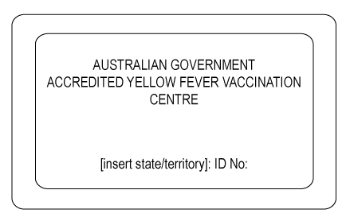
*Stamp not to scale
- The certificate is an individual certificate and not a collective one. Separate certificates must be issued for each child.
- The certificate is signed by the person vaccinated. A parent or guardian shall sign the certificate when the child is unable to write. If the person vaccinated is illiterate, their signature shall be their mark and the indication by another that this is the mark of the person vaccinated.
- The certificate is printed and completed in English or French. The certificate may also be completed in another language on the same document in addition to either English or French. The certificate must be dated correctly in the sequence of day, month and year, with the month written in letters.
- The certificate is valid for the duration of the life of the person vaccinated. The validity dates are to be recorded as the date 10 days after the vaccination date until ‘lifetime.’
- An equivalent document issued by the Armed Forces to an active member of those Forces shall be accepted in place of an international certificate if:
  - the document embodies medical information substantially the same as that required by the international certificate; and
  - the document contains a statement in English or French and where appropriate in another language in addition to English or French recording the nature and date of the vaccination.
- Any exemption to vaccination will consist of a dated and signed medical exemption letter on letterhead stationery from an approved yellow fever vaccination centre. The letter should clearly state that yellow fever vaccine is contraindicated on medical grounds and display the centre’s official stamp. Medical exemption letters should be written for the current trip only. The Medical Contraindications to Vaccination section of the International Certificate of Vaccination or Prophylaxis also needs to be completed, stamped and signed.
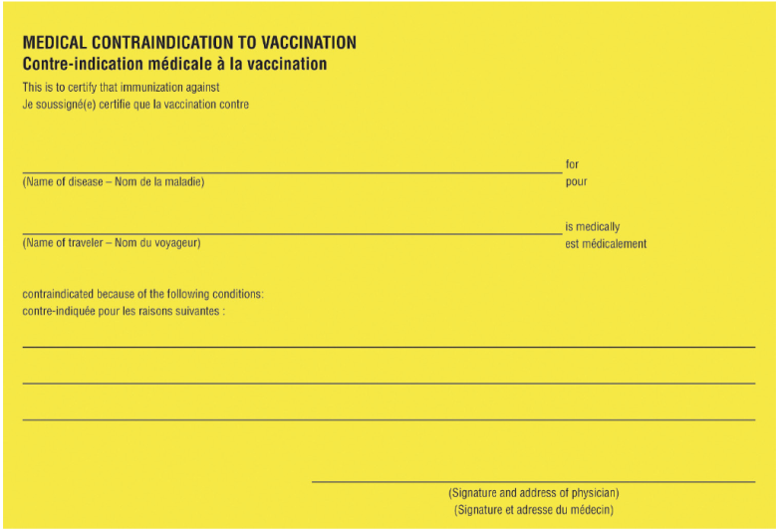
- In addition to the certificate, it is important that a record of yellow fever vaccination is made in the Australian Immunisation Register (the AIR), including the batch number. The AIR allows for a permanent and accessible record of vaccination. Batch numbers are recorded in the AIR by selecting the Batch Number field under the Vaccine/Brand field when recording or updating an immunisation encounter.
- Patients referred to the practice for yellow fever vaccination will only be provided with relevant travel advice. Other non-urgent medical problems or their complications identified during the consultation will be managed only with the consent of the referring doctor or will be returned to the referring doctor for treatment.
- Changes relating to the particulars of the practice, including any change of name or address, shall be immediately notified to the Immunisation Unit, Department of Health, Victoria. At the discretion of the Immunisation Unit, the appointment may be transferred to a new address without any requirement to reapply.
- If the Applicant leaves the practice, another medical practitioner or nurse practitioner must agree to take responsibility for the practice continuing to meet clinical standards for yellow fever vaccination by completing the relevant form and forwarding to the Immunisation Unit, Department of Health, Victoria, within seven days.
- The practice will notify the Immunisation Unit, Department of Health, Victoria, if it intends to cease provision of yellow fever vaccinations or if circumstances change which will alter its capability to adhere to the requirements in this document within seven days.
- The practice will notify the Immunisation Unit, Department of Health, Victoria, of all medical practitioners and nurse practitioners accredited to administer the yellow fever vaccine, and if they leave the practice, within seven days.
- All relevant practitioners will complete the Yellow Fever Vaccination Course every three years and the completion certificate is to be provided to the Immunisation Unit, Department of Health, Victoria, within seven days.
- The practice will participate in periodic surveys distributed by the Immunisation Unit, Department of Health, Victoria, related to yellow fever vaccine provision.
- Details of the practice, such as the name of the practice, address and telephone number, will be included in lists of approved yellow fever vaccination centres on the Immunisation Unit, Department of Health, Victoria website.
- The practice will, from time to time, allow a person or persons authorised in writing by the Department of Health, Victoria, to enter premises used by the practice for the purposes of conducting yellow fever vaccinations to ensure compliance with all specified conditions. The practice will provide all records relating to yellow fever vaccinations to that person or persons upon request, with an adequate timeframe given by the Department of Health, Victoria, to allow for the accessing of records.
- A breach of any of the above conditions by the practice may, at the discretion of the Immunisation Unit, Department of Health, Victoria, result in
  - a probationary period, subject to the conditions set by the Victorian Government, or
  - withdrawal of the appointment.
- The appointment may be immediately withdrawn in the case of a breach of patient safety, evidence-based practice or medical ethics.
- On being notified in writing by the Immunisation Unit, Department of Health, Victoria that the appointment to provide yellow fever vaccinations has been withdrawn, the practice shall cease to conduct vaccinations on the date stipulated in the notification.
- If the medical practice, of which I am the responsible practitioner, is appointed as an approved yellow fever vaccination centre, I hereby agree to the above conditions.

Name and signature of responsible practitioner:
Name: | Signature: | Date:
Please submit the completed form to immunisation@health.vic.gov.au

To receive this document in another format, email the Immunisation Unit <immunisation@health.vic.gov.au>.
Authorised and published by the Victorian Government, 1 Treasury Place, Melbourne.
© State of Victoria, Australia, Department of Health, September 2021.
Available at Yellow fever vaccination centres <https://www.health.vic.gov.au/immunisation/yellow-fever-vaccination-centres>

