Resource Categories Derivation
Version 5
Victorian Cost Data Collection
Local and national purpose, descriptions, and application
(previously cost buckets)
OFFICIAL

To receive this document in another format, phone 9096 2404 or email VCDC Team <VCDCassist@health.vic.gov.au>.
Authorised and published by the Victorian Government, 1 Treasury Place, Melbourne.
© State of Victoria, Australia, Department of Health, August 2023.

Resource Categories Derivation
Version 5
Victorian Cost Data Collection

Contents
Introduction 5
Purpose 5
About the VCDC 5
National requirement 6
Objective of costing 6
What is used to derive the categories? 7
Using the cost general ledger 7
Resource categories 9
Formation 9
Main resource categories 10
Information resource categories 11
Excluded resource categories 11
Resource categories 12
National cost buckets 14
Overview 14

Introduction
The resource categories are designed to provide a summarised level of the types of expenses used in the treatment of patients, into a range of generic groups.
Resource categories (previously cost buckets) are associated major groups enabling the ease of comparison for analysis, reporting and benchmarking objectives. The categories are aggregated from the Victorian standard Chart Of Accounts cost centres and account code lists.
Any lower-level analysis can be derived from details through the individual cost centre and account codes.
Resource categories (or cost buckets) are used as the main level for interpreting allocated costs to activities. The types of categories may be derived differently from health service, the department, nationally and internationally depending on its intended use and groups required.

Purpose
The purpose of the cost groups provides:
- consistent interpretation of cost data for reporting, analysis, and benchmarking,
- improvement to the accuracy of allocated costs and ease of auditing, and
- provide hospitals a standard set of cost centres and account codes for the product costing process thereby improving the consistency and comparability of the resultant cost data.

About the VCDC
The Victorian Cost Data Collection (VCDC) for the public sector, collected through the health services, is the primary data collection used in the development of funding models.
It is an annual and voluntary collection of public hospital data. To ensure it is robust, once submitted to the department, the VCDC undergoes extensive validation, quality assurance checks and reporting to allow benchmarking. Each yearly collection includes a reconciliation from the annual report to submission to the department and a data quality statement (DQS). The DQS is a signed declaration confirming adherence to the national and local requirements including the standards and acknowledging the validity and completeness of the data submitted.
The cost data is also used to:
• Refine the existing Victorian funding models
• Assist in the development of future funding models
• Enable analysis of cost data across health services
• Inform development of budget proposals
• Analyse the cost of health care
• Perform comparative benchmarking
• Inform best practice quality improvement initiatives and
• Meet the cost data requirements of the National Health Reform Agreement (NHRA), via the National Hospital Cost Data Collection (NHCDC).

National requirement
As part of the NHRA, Victoria uses the VCDC as the base data for submission to the Independent Hospital Pricing Authority’s (IHPA) NHCDC.
The NHCDC collects patient level cost data across the Commonwealth for the purposes of calculating national cost weights and determining the National Efficient Price (NEP) and National Efficient Cost (NEC).

Objective of costing
Victorian public hospitals are required to report costs for all hospital activity, regardless of funding source, and are expected to maintain patient level costing systems that monitor service provision to patients and determine accurate patient-level costs. Health services report costed data annually to the Victorian Cost Data Collection (VCDC).
The collection acquires cost data from metropolitan, regional, and sub-regional health services as per the Victorian health policy and funding guidelines.
To understand the resource usage of a health services’ activities and assist in measuring their attributes, all expenditure is to be allocated to the appropriate patients. That is, all expenses in the finance general ledger system that has been used in delivering the care to patients, regardless of any funding source, is to be included in the cost general ledger and allocated. However, to ensure that the patients resource usage reflect full cost recovery, the inclusion of expenses which are incurred on behalf of an organisation by a third party, that directly contribute to delivery of that organisation’s services, are also included in the cost ledger.
The resource categories have evolved since their inception to take into consideration changes in reporting requirements, a need to expand groups of costs or identify certain types of costs. When using comparative data spanning several years, all prior year resource categories have been remapped to the most recent groupings. This ensures comparisons can be consistently applied.

What is used to derive the categories?

Using the cost general ledger
The cost ledger transforms the organisation’s financial general ledger to structure financial information in a way that enables patient level costing. The cost ledger thus provides the framework for relating the organisations expenses to utilisation for the purpose of patient level costing. The key principle supporting this framework is the concept of matching expenses to the services consumed by patients in a way that emphasises the interrelationship between the expense and the services consumed.
The costing general ledger uses the cost centre and account codes to define the structure that is used in the derivation of the resource categories. The types of services/departments and their expenses are obtained from the general ledger where the Chart of Account structure is maintained.

Cost centres
A cost centre is a business unit that is only responsible for the costs that it incurs. These are generally grouped into cost areas (or departments) to reflect the appropriate role of the service. For example, cost centres within the ranges Y0002 - Y0030 would be grouped as area Anatomical Pathology. These are further categorised as either direct (patient care) area or overhead (indirect) area.
Reporting these areas to the VCDC is by the grouped cost centre code, that is, in the example above the grouped code may be Y0002 which will include all the cost centres with the range of Y0002 – Y0030.
Each area is then assigned to a generic group identifying the type of service known as a service cost group. These could be either:
AlliedHealth | all allied health services
CCU | Coronary Care Unit
ED | Emergency department including Urgent Care Centres, Short Stay Units
ICU | Intensive Care Unit including High dependency Units
Imaging | all imaging services
Medical | all medical and surgical specialties
Nursing | all wards and nurse related areas including patient catering
Other | all other programs such as Mental Health Services incl RACS, Aged Care Services, Primary Health, Other Programs, Research
Pathology | all pathology services
Pharmacy | all pharmacy services
TheatreNonOR | all Theatre non-operating room services
TheatreOR | all operating room
HITH | Hospital in the Home
PNDC | Post-natal domiciliary care
PROS | prostheses
NBA | National Blood Authority blood products
ExclCap | all capital expenses excluded
ExclOth | specific items and special purpose funds
COVID | all patient care areas related to treating COVID
COVIDex | all COVID expenses not to be allocated to patients

For a list of service groups mapped to cost areas refer to Attachment 1.

Account codes
The Account Code is a six-digit field used to classify financial activities and balances within the General Ledger . These are aggregated into like expenses such as SWNurs (salary and wages Nursing) including such expenses like Basic Pay, Sick Pay, Overtime/Recall, Penalties, Public Holiday Penalties, Allowances.
For costing purposes, all in-scope expenditure incurred by or on behalf of the health service related to day-to-day delivery of services is to be recognised. That is all corporate and shared services which contribute to an organisation’s day to day production of final utilisations are included in patient costing and in determining the full cost of those resources.
The expenses allocated are also not to be offset by any revenue or funding source unless there is evidence to support that the compensation effectively reflects the substance of the transaction, such as where goods and services provided by the hospital are reimbursed by another organisation.
Further details regarding the standards and guidelines for patient level costing, refer to the Victorian Activity Based Costing (VicABC) documentation and the relevant version of the Australian Hospital Patient Costing Standards (AHPCS) developed by the Independent Hospital Pricing Authority (IHPA).
Reporting these account codes is grouped to an account type. These could either be:
SWAdmin | Salary and Wages - Administration
SWAdminOc | Salary and Wages oncosts - Administration
SWAH | Salary and Wages - Allied Health
SWAHOc | Salary and Wages oncosts - Allied Health
SWAHFFS | Salary and Wages fee for service - Allied Health
SWHMO | Salary and Wages HMO
SWHMOFFS | Salary and Wages fee for service - HMO
SWHMOOc | Salary and Wages oncosts - HMO
SWHotel | Salary and Wages - Hotel service
SWHotelOc | Salary and Wages oncosts - Hotel service
SWMed | Salary and Wages - Medical
SWMedFFS | Salary and Wages fee for service - Medical
SWMedOc | Salary and Wages oncosts - Medical
SWMedSup | Salary and Wages - Medical Support
SWMedSupOc | Salary and Wages oncosts - Medical Support
SWNurs | Salary and Wages - Nursing
SWNursOc | Salary and Wages oncosts - Nursing
SWOther | Salary and Wages - Other salary
SWOtherOc | Salary and Wages oncosts - Other salary
SWSess | Salary and Wages - Sessional staff
SWSessFFS | Salary and Wages fee for service - Sessional staff
SWSessOc | Salary and Wages oncosts - Sessional staff
Appl | Appliances
Blood | Blood products
DeprecB | Depreciation - Building
DeprecE | Depreciation - Equipment
DeprecR | Depreciation - Right of Use
Equip | Equipment
ExclCap | Capital - excluded
Exclude | Other excluded expenses
GS | General goods and services
Hotel | Hotel Services
Imag | Imaging services
Lease | Leases
MS | Medical supplies
OnCosts | General salary and wages on costs
Path | Pathology services
PharmNPBS | Pharmacy Non-PBS
PharmPBS | Pharmacy PBS
PharmS100 | Pharmacy S100
Pros | Prostheses expenses
PtTransport | Patient Transport expenses

For a list of account codes mapped to account types refer to Attachment 2.

Resource categories
For reporting purposes, the cost areas submitted by health services to the VCDC are mapped to a service cost group. This combined with the account types determines the final allocation to a resource category.

Formation
- Resource categories must be viewed in conjunction with the VCDC COA cost centre and account code map for the financial year the cost data represents.
- Resource categories consider an area (cost centre)/ account type combination to ensure comparisons and analysis are more relevant. Any lower-level analysis can be derived from details through the individual area (cost centre) and account type (expense code) maps.
- There are 34 main resource categories and 9 information resource categories. Refer to table 1 and 2 below.
- Expenses related to salary and wages administration, nursing, allied health, medical including HMO or sessional staff and other staff are now mapped to single salary resource categories of Admin, Nursing, AlliedHealth, Medical or Other respectively.
  - This eliminates the assumption where for example, only sessional staff in a surgical defined cost centre provide surgical services. Any lower-level analysis can be derived from details through the individual cost centre and account code maps.
- There are a few areas where the expenses are fully contained within a specific service structure such as ED, ICU, CCU, Imaging, Pathology, Pharmacy, Theatre OR, Theatre Non OR, HITH and PNDC. Those specific areas have been split between their salary and wages and supplies except for prostheses, national blood authority, depreciation, COVID, and expenses relating to transfer pricing and assets.
- Information buckets are purely derived to provide a further breakdown of expenses related to specific resources. These costs are also found in the mainstream cost buckets as specified in table 2 below.

Main resource categories
Table 1 lists the current resource categories. Further details on what cost centre and account code combinations are used to derive these resource categories are at Attachment 3.
Table 1: VCDC resource categories
 | Resource category | Description
Main Resource categories | Admin | Administration Salaries & Wages
 | AlliedHealth | Allied Health Salaries
 | AlliedHealthSuppl | Allied Health Supplies
 | CCU | Coronary Care Unit Salaries
 | CCUSuppl | Coronary Care Unit Supplies
 | ED | Emergency Department Salaries
 | EDSuppl | Emergency Department Supplies
 | Exclude | Exclude costs
 | ICU | Intensive Care Unit Salaries
 | ICUSuppl | Intensive Care Unit Supplies
 | Imaging | Imaging Services Salaries
 | ImagingSuppl | Imaging Services Supplies
 | Medical | Medical Salaries & Wages
 | MedicalSuppl | Medical Supplies
 | Nursing | Nursing
 | NursingSuppl | Nursing Supplies
 | Other | Other
 | OtherSuppl | Other Supplies
 | Pathology | Pathology Salaries
 | PathologySuppl | Pathology Supplies
 | Pharmacy | Pharmacy Salaries
 | PharmacySuppl | Pharmacy Supplies
 | TheatreNonOR | Theatre Non-Operating Room Salaries
 | TheatreNonORSuppl | Theatre Non-Operating Room Supplies
 | TheatreOR | Theatre Operating Room Salaries
 | TheatreORSuppl | Theatre Operating Room Supplies
 | HITH | Hospital In The Home Salaries
 | HITHSuppl | Hospital In The Home Supplies
 | PNDC | Post Natal Domiciliary Care Salaries
 | PNDCSuppl | Post Natal Domiciliary Care Supplies
 | PROS | Prostheses
 | NBA | National Blood Authority
 | COVID | Established COVID cost centres
 | COVIDEx | Established COVID cost centres

Information resource categories
The information resource categories (or previously known as the information/supplementary buckets) are defined to provide further dissection of the main resource categories to assist in more granular analysis and understanding of the data.
Predominately these have been derived based on the account type groups (as defined above) regardless of the cost area or service cost group it has been reported under.
Table 2 below lists the various information resource categories that have been derived. For a more detailed list of inputs, refer to the tables at Attachment 3.
Table 2: Information buckets
Information resource categories | Account Type | Main resource category
Pharmacy PBS | PharmacyPBS | Pharmacy
Pharmacy S100 | PharmacyS100 | Pharmacy
Pharmacy Non PBS | PharmacyNPBS | Pharmacy
Appliances | Appl | Various non S&W buckets
Patient Equipment | Equip | Various non S&W buckets
S&W On-costs | OnCosts | Various S&W buckets
Patient Transport | PtTransport | Various non S&W buckets
S&W Fee for Service | FFS | Various S&W buckets
Exclude | Exclude | Various

For further details please refer to the Victorian activity-based costing documentation and Data Definition Specification reference file.
For ease of analysis and reporting the resource categories could be aggregated to higher groups. The aggregated levels can be found at Attachment 4.

Excluded resource categories
There are several areas (cost centres) account codes that are mapped to this resource category which can be found in any cost centre and are excluded from any total costs and use in any analysis, reporting and funding developments. These have been specifically identified for possible inclusion in future years based on local and/or national policy and reporting requirements.
Table 3 lists the of account codes that map to an exclude VCDC account type.
Table 3: Exclude cost bucket account codes
DHHS Finance COA |  |  | VCDC Account Type - Submitted
Account Code | Account Description | Type
22091 - 22100 | Grants Received on Behalf of and Paid to Other Agencies | E | Exclude
22101 - 22105 | Capital Grants Received on Behalf of and Paid to Other Agencies | E | Exclude
38900 Series | Assets Given Free of Charge (including Assets Donated) | E | Exclude
40000 Series | Depreciation & Amortisation | E | Deprec
41000 Series | Asset Additions | E | Exclude
43000 Series | Written down value of assets disposed | E | Deprec
43100 Series | Written down value of investment assets disposed | E | Deprec
44000 Series | Devaluation of Assets | E | Exclude
60000 Series | Transfer Pricing Accounts - Patient Expenses | E | N/A
61000 Series | Transfer Pricing Accounts - Other Expenses | E | N/A

Resource categories
Table 4: Main resource categories
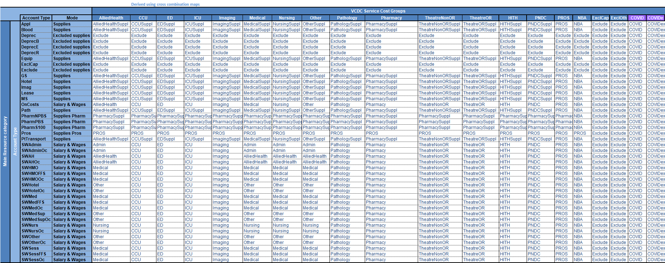
Table 5: Information resource categories
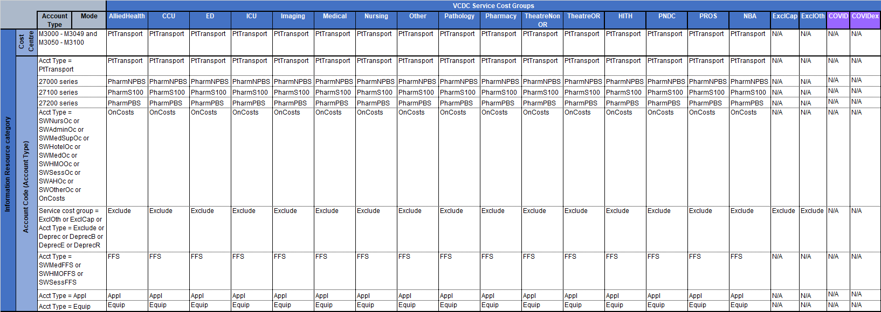

National cost buckets

Overview
As part of the NHRA, Victoria uses the VCDC as the base data for submission to the Independent Health and Aged Care Pricing Authority’s (IHACPA) National Hospital Cost Data Collection (NHCDC).
The NHCDC is the annual collection of public hospital cost data from a range of public hospital facilities nationally. The objective of the NHCDC is to provide all governments with a robust dataset developed using nationally consistent methods of costing hospital activity.
The dataset is used for benchmarking, funding and planning hospital services and is the primary dataset used to develop the National Efficient Price (NEP) and produce weights for the funding of public hospital services on an activity basis, as well as to develop the National Efficient Cost (NEC) for block funded hospitals. More information about the NEP, NEC and activity-based funding is available on IHACPA’s website.
To ensure consistency in the approach to costing nationally, NHCDC data is subject to the Australian Hospital Patient Costing Standards (the Standards), available on IHPA’s website. The Standards prescribe the set of line items and final cost centres that hospital costs are mapped to for the costing process, to ensure that there is a consistent treatment of costs between hospitals. These costs are allocated to and reported under the NHCDC defined cost buckets.
For details relating IHACPA’s specific elements of the costing process and reporting requirements please visit the IHACPA website for costing. <https://www.ihacpa.gov.au/health-care/costing>

AHPCS Part 1 Standards defines Third party as expenses are those expenses incurred by a third party on behalf of an organisation for the production of the organisation’s outputs. Third party expenses are not recorded in an organisation’s general ledger as they are not incurred by that organisation

