A/Prof David Anderson
Ambulance Victoria
375 Manningham Road, Doncaster
VIC 3108

21 August 2023

To whom it may concern.

We are writing to update you on the use of blood components by Ambulance Victoria (AV) paramedics. As you may know, we currently carry a limited supply of four units of red blood cells (RBC) on each of the five ambulance helicopters around the state (Air Ambulance Victoria, AAV) with local arrangements at each helicopter base location for stock provision, circulation, and governance. These processes have been in place for over a decade and are subject to scrutiny and frequent revision. We are usually able to meet the needs of critically unwell regional/rural trauma patients requiring blood components via dispatch of a helicopter, however weather and resourcing priorities may affect availability.

Until recently, if helicopter support was unavailable for a ground-based MICA Paramedic team who required blood components for a critically unwell patient, paramedics may request blood components from a local health service under ad-hoc arrangements. Helicopter paramedics (AAV) may also on occasion require further blood components from local health services if their supplies are exhausted, for example in the instance of a trapped patient.

Unfortunately, these informal processes may result in concern for the health service and AV staff, unclear clinical guidance, component wastage due to incorrect storage and lack of appropriate governance, traceability and audit. The lack of established procedures to facilitate access to blood components can also result in local health services being caught off-guard with regard to inventory management.

In 2022, a pilot Memorandum of understanding (MOU) was established between AV and Bendigo Health, whereby a formal pathway is followed for any request for blood components, minimising risk of wastage and allowing audit and oversight. While we have since established similar procedures with other regional sites, it is not possible to develop an individual workflow for every health service in Victoria.

AV have standardised the procedure whereby blood components will be requested from health services. Ad-hoc requests will be replaced by AV paramedics requesting all blood components through Adult Retrieval Victoria (ARV). The ARV Clinical Coordinator (ARV CC, a consultant physician) will assess each case and determine the most suitable health service to request supply of blood components. The ARV CC will contact that health service and arrange for blood component pickup at an agreed time and location. The procedure details appropriate cold chain management, actions for unused blood components, traceability and audit processes.

The location of emergency use group O RBC across Victoria will be accessed by the ARV CC through secure information-sharing with the existing Blood Matters’ database. Please ensure Blood Matters is kept informed of any changes to your emergency group O RBC inventory holdings, including at satellite locations.

No changes have been made regarding the use or administration of blood components by paramedics. This notification outlines a formalisation of processes to minimise the risk of blood component wastage, enable blood component traceability and to ensure appropriate governance and audit. This process is in-line with AV’s overarching ethos of high-quality health care. We do not expect these arrangements to change the frequency with which blood components are administered at AV.

This new process will go live on Monday 21st August 2023 at 7am.

Some frequently asked questions have been answered on the following page. Further discussion is welcomed, please contact us if further details are required.

Kind regards,

A/Prof David Anderson
Medical Director, Ambulance Victoria

Dr Jason McClure
Director, Adult Retrieval Victoria

Frequently Asked Questions

Should our health service expect an increase in requests for blood components to be provided to AV crews?

No. We don’t anticipate increased blood component utilisation. This procedure is being established so we can better track blood component use, maintain cold chain requirements, minimise blood component wastage, and audit clinical practice.

Will there be a request for blood components other than red blood cells?

The most common request will be for 2 or 4 units of red blood cells (RBC) (depending on inventory holdings). If there was a need for other components, then this would be at the request of the ARV Clinical Coordinator (a critical care physician).

What training and accreditation do AV MICA Paramedics have?

All AV MICA Paramedics are registered health practitioners, credentialled to use blood components within the AV Clinical Practice Guidelines, and have completed the BloodSafe Clinical Transfusion Practice course, that aligns with National Safety and Quality Health Service (NSQHS) Standards.

https://www.blood.gov.au/clinical-transfusion-practice-course

In addition, MICA Paramedics have completed a separate AV online learning package that discusses transport of blood components, preparation of transfusions, maintenance of cold chain, documentation, crossmatching/using uncrossmatched blood, and managing adverse reactions specific to the context of the out of hospital environment.

How do you expect the blood components to be packaged?

In line with the National Safety and Quality Health Service (NSQHS) Standards, the ARV Clinical Coordinator will request the preparation of the blood components as follows:
- Option 1 – 2 units RBC, 1 x Lifeblood R3 blood shipper (or equivalent)
- Option 2 – 4 units RBC, 2 units in 2 x Lifeblood R3 blood shippers (or equivalent)
Lifeblood R3 blood shippers are validated for 8 hours 25 minutes transport time.
A flowchart for this procedure will be provided to all sites across Victoria.
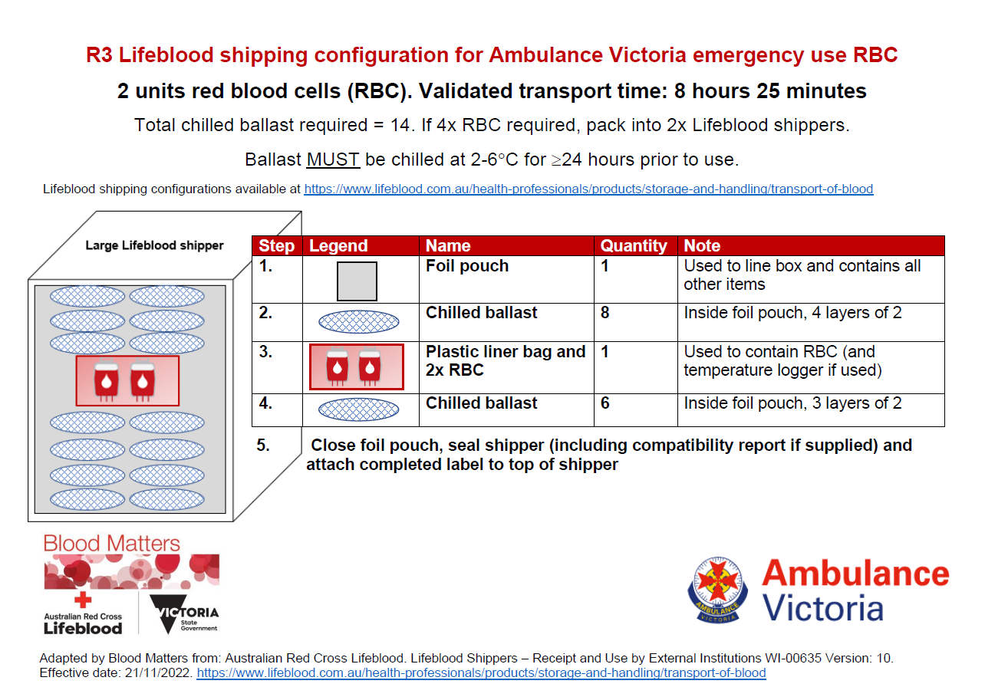
What will happen to any unused blood components?
In the first instance, then MICA Paramedic will liaise with the receiving / destination hospital regarding potential for ongoing use of the component(s), incorporation into local supply if there is an established relationship with the original provider or return to the original provider. If clarification is required, the MICA Paramedic or health service should contact the ARV Clinical Coordinator.

At the completion of the case, or if a care plan changes (e.g., a patient departs a scene via ambulance prior to delivery of components, or the patient was to die before blood components are delivered), the MICA Paramedic will ensure any unused blood components are maintained within its R3 shipper and returned to the providing health service.

How will this process be monitored?
Once the paramedic completes the patient care record and blood administration paperwork it will be sent to our Air Ambulance management team for audit. Any adverse patient outcome or process fault will be reviewed according to AV Clinical Governance policies. Health services can report any concerns to patientreview@ambulance.vic.gov.au

How will we know the fate of the blood components for traceability requirements?
To ensure traceability, AV will update the original health service regarding the fate of the units at the end of each case. Any questions can be directed to patientreview@ambulance.vic.gov.au

