R3 Lifeblood shipping configuration for Ambulance Victoria emergency use RBC
2 units red blood cells (RBC). Validated transport time: 8 hours 25 minutes
Total chilled ballast required = 14. If 4x RBC required, pack into 2x Lifeblood shippers.
Ballast MUST be chilled at 2-6°C for ≥24 hours prior to use.
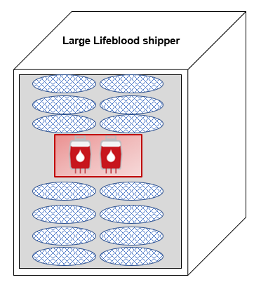
Lifeblood shipping configurations available at https://www.lifeblood.com.au/health-professionals/products/storage-and-handling/transport-of-blood

Step | Legend | Name | Quantity | Note
1. |  | Foil pouch | 1 | Used to line box and contains all other items
2. |  | Chilled ballast | 8 | Inside foil pouch, 4 layers of 2
3. | 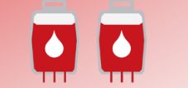 | Plastic liner bag and 2x RBC | 1 | Used to contain RBC (and temperature logger if used)
4. |  | Chilled ballast | 6 | Inside foil pouch, 3 layers of 2

5. Close foil pouch, seal shipper (including compatibility report if supplied) and attach completed label to top of shipper

