Recording Contacts in CMI/ODS & FAQ
Reviewed August 2023 with update to Appendix 5
Program Management Circular

OFFICIAL

Contents
Contents 1
Key Message 3
Purpose 3
Contact Definition 3
Service Contacts 3
Community Services Contacts 4
Service Hours Definition & Targets 5
Timeliness of Data Entry 5
Appendix 1 - Recording Contacts - FAQ 7
1. What are mental health consumer service contacts? 7
2. Can client service contacts be recorded if using an electronic device? 7
3. What is the correct way to record client service contacts where there are many contact events on the same day for the same client? 8
4. When entering a contact for a phone call, what is the service location? 9
5. Could you please provide an example for Service Recipient – 10 Interagency case planning? 9
6. Could you please provide an example for Service Recipient – 99 InterAMHS case planning? 10
7. If a client is seen by a HCP (employed by an ambulatory mental health unit) within an acute inpatient or residential unit, should a consumer service contact be recorded? 10
8. If a clinician from a community team use ‘Zoom’ to see an inpatient how would this be recorded? 10
9. How do you record ‘Group’ client service contacts? 11
10. When a client or a client’s family member, carer or other external health care professional directly participating in travelling in a vehicle with a HCP, can a service contact be recorded? 14
11. Can contacts be recorded against a deceased client record? 14
12. Why does the department follow up contacts over 8 hours in data validation reports? 14
13. Are contacts under 5 minutes reportable? 14
14. Can Carer Peer Support Workers report consumer contacts if the contact is for the carer, rather than the consumer? 15
15. If education is provided to others can you confirm when this can be recorded as a contact 15
16. Are there instances where review of a client file or preparing external correspondence for clients would be a reportable contact? 15
17. How should I record telehealth contacts? 16
Appendix 2: Designated Mental Health Services 17
Appendix 3: Flowchart – Client Service Hours 18
Appendix 4: Flowchart – Community Service Hours 19
Appendix 5: Community Speciality Mental Health Service Development Services 20

Key Message
There are two service contact subsets, client/consumer service contacts and community service contacts.
Mental health service contact type and duration is defined from a client/consumer or service recipient perspective and is not intended to account for clinician time.
A mental health community service contact is also defined from the perspective of the recipient that is the external service provider or community group
Service hours are derived from service contacts.

Purpose
- To explain the concept of reportable service contacts.
- To clarify the reporting requirements and improve the consistency and quality of a service contacts data submitted to the Client Management Interface/Operational Data Store (CMI/ODS).

Contact Definition
There are two categories of contacts recordable in CMI:
- Service contacts and
- community service contacts.

This Program Management Circular focuses on service contacts, outlines subcategories, and outlines reporting requirements.

Service Contacts
‘A service contact can include either face-to-face, telephone or video link service delivery modes. Service contacts would either be with a client, carer or family member or another professional or mental health worker involved in providing care and do not include contacts of an administrative nature (for example, telephone contact to schedule an appointment) except where a matter would need to be noted on a patient’s record and meets the criteria for recording contacts (see Consumer Service Contacts above).’
A Service Contact is from the perspective of the client. Service Contacts can be broken down into two types: client and group contacts.

1. Client Service Contacts
Client Service contacts are a subcategory of Service Contacts and can be further broken down into a service contact for one client and a service contact for group contacts. For a client service contact to be reported into CMI/ODS, it must meet all of the following criteria:

- Clinically significant in nature
- For a patient or consumer
- Provided by a Health care professional (HCP) who is employed within a specialist public mental health service Ambulatory Health Unit (AHU)
- Requires a dated entry in the health record or triage record of the patient/consumer

Reportable activity which is clinically significant in nature includes activity which directly contributes towards assessment of a client’s condition; or towards the therapeutic needs of a client’s condition. It is inclusive of preventative activity that supports the needs of a client’s dependents, and supportive activity for a client’s family, support person, or carer.
Client service contact type and duration is defined from a client or service recipient’s perspective. It is acknowledged that client service contacts are a portion, and not a complete account of a HCPs clinical commitment time.
There are three subsets of service client contacts:
- Unregistered Contacts (“B” type contacts)
- Registered Contacts (“A” type contacts)
- Case Contacts (“E” type contacts, which CMI automatically converts when “A contacts” are entered for clients in an open case)

For further information about client service contacts, including detailed explanations and examples of common inclusion and exclusions, please refer to the Contacts Data Definitions.

2. Group Contacts
‘A service contact is regarded as a group session where two or more clients are present at the service contact with or without their carer(s)/relative(s) and the service contact is noted in their medical records.
A service contact is also regarded as a group session where the carer(s)/relative(s) of two or more patients/clients are present at the service contact without the respective patients/clients and service contact is noted in the patient’s/client’s individual record’.

Community Services Contacts
Community contacts are provided by mental health services to community organisations or external service providers. The focus of the service is the external service provider, group or organisation rather than the individual client or client group.
A community services contact is defined from the perspective of the recipient.

Community Service Contacts are also a subcategory of Service Contact and are known as “C” type contacts. These are community-centred contacts which are reportable when a service is provided by the mental health service to another service provider, group or organisation rather an individual consumer or consumer group. This service is typically provided in a non-mental health specific setting.
While reportable community service contacts may not require a dated entry into a client’s health record, it is expected that the activity reported is reflected in local recordkeeping that meets legislative and regulatory requirements including Public Record Office Victoria (PROV) standards.
There are six subsets of service community contacts:
- Primary consultation
- Secondary consultation
- Tertiary consultation
- Community development
- Community education
- Specialty MH service development

For further information about community services contacts, including detailed explanations and examples of common inclusion and exclusions, please refer to the Contacts Data Definitions document.
To assist with identifying client service contacts and community contacts please refer to Appendices 3 & 4.

Service Hours Definition & Targets
Service Hours are the same as service contact hours, except they are adjusted for group contact sessions to measure from a Health Care Professional (HCP) perspective. The formula definition for service hours are available within the quarterly Service hours – Mental Health performance indicator reports. Service hour contact targets are set each financial year for services. Penalties for mental health services not meeting targets are outlined in the Policy and Funding Guidelines.

Where more than one staff member participates in a group activity, the service contact is recorded by only one nominated staff member. The other staff participation is noted in the number of service providers.

Timeliness of Data Entry
All service contacts are due by the 10th day of the following month.
If difficulties are anticipated in meeting a data submission due date, the service must notify mhdreporting@health.vic.gov.au and advise: -
- the data reporting period impacted, and why the service is unable to submit the data by the deadline
- when the issue was first identified, what steps have been taken resolve the issue, and what are the plans to avoid this issue reoccurring
- When the service expects to be able to resume timely reporting of data

The department will review late data exemption requests on a case-by-case basis. It is at the department’s discretion as to whether data submitted late will be included for reporting, and whether any penalties outlined in the Policy and Funding Guidelines are applicable.

About Management Circulars
The information provided in this circular is intended as general information and not as legal advice. Mental health service management should ensure that policies and procedures are developed and implemented to enable staff to collect and use health information in accordance with relevant legislation.

To receive this publication in an accessible format email MHD Reporting <MHDReporting@health.vic.gov.au>
Authorised and published by the Victorian Government, 1 Treasury Place, Melbourne.
© State of Victoria, Department of Health May 2016, September 2022, reviewed August 2023.
ISBN 978-1-76131-030-0 (pdf/online/MS word)
Available at Bulletins and Program Management Circulars (PMC) <https://www.health.vic.gov.au/research-and-reporting/bulletins-and-program-management-circulars-pmc>.

Appendix 1 - Recording Contacts - FAQ

1. What are mental health consumer service contacts?
Mental health consumer service contacts, i.e.
Contact Types: A – Registered client contact
B – Unregistered client contact
C – Community contact
E – Case contact
are a subset of all contacts recorded on the CMI and transmitted to the ODS. These contacts meet the criteria of a service contact as outlined above, and measure service received from a client perspective, not an HCP perspective.
An HCP’s time spent on clinically important activities not accounted for by service contacts (e.g. such as case review meetings or on quality improvement activities), may be recorded as a Contact Type D- Non-reportable contact. Type D contacts are not reported to the Department of Health via the ODS but may be important information locally.

2. Can client service contacts be recorded if using an electronic device?
Electronic communication such as videoconference/teleconference is regarded as synchronous communication, that is participants/recipients are online and available at the same time. Read and respond communications may be considered to be a reportable contact if they meet consumer service contact criteria.
Asynchronous electronic communication devices include answering machine, email, SMS, text messaging, voicemail. Generally, it is considered the information exchange is ‘asynchronous’ where the participant/recipient are not required to be available or online at the same time, but rather read and respond as their availability permits.

If the client service contact criteria is met and the service medium is via electronic communication, it is considered a service contact. These contacts must be recorded with Service Medium of “Other synchronous” or “Other asynchronous” and the service duration recorded is from the perspective of the service recipient. If there is a continuous communication exchange between the HCP and participant/recipient, then “Other Synchronous” service medium should be used, and service duration should reflect this total period. Otherwise, discrete contacts are recorded for each communication exchange using service medium of “other asynchronous”.

NOTE: information communicated in relation to appointment scheduling is not regarded as a service contact as it does not meet the criteria, however this may be recorded as “Contact Type D – Non-reportable contact”.

3. What is the correct way to record client service contacts where there are many contact events on the same day for the same client?

Scenario A: (representing continuous events)
Event | Date of service contact | Duration | Scenario
1 | 01/01/2021 | 09:00-09:30 | Client A is seen by clinician Z
2 | 01/01/2021 | 09:31-09:49 | Client A and family is seen by clinician Z.
3 | 01/01/2021 | 09:50-10:00 | Client A is seen by clinician Z.
*Also refer to appendix 3 flowchart
The events may be regarded as a continuation of the one client service contact as Client A has been involved in all three events with no change to ‘service medium’, ‘service location’ and “Number Providing service”.
Therefore, group all Client A service contacts together recording “Service Recipient = 3. Client and family” and duration of all events, i.e., 60 minutes.
The other option is to record the events separately.
As the only change between these contacts is service recipient and the client is present in all three, from a reporting perspective these can be combined.

Scenario B: (representing continuous events, however key data elements differ)

Event | Date of service contact | Duration | Scenario
1 | 01/01/2021 | 09:00-09:30 | Client A is seen by clinician Z and at end of session asks Client A to be seated in the Waiting Area.
2 | 01/01/2021 | 09:31-09:49 | Clinician Z telephones Clinician Y (from another AMHS) for further information.
3 | 01/01/2021 | 09:50-10:00 | Client A is seen by clinician Z.

While it is regarded that there is a continuous service contact in relation to time, there is a change to:
- Client A - not involved in Event 2
- Service Medium

Event 2 requires a separate contact to be recorded.
Option to either group Events 1 and 3 data or record as separate events.

Scenario C: (representing separate time interval events)

Event | Date of service contact | Duration | Scenario
1 | 01/01/2021 | 09:00-09:30 | Client A is seen by clinician Z
2 | 01/01/2021 | 10:00-10:30 | Client A and family is seen by clinician Z.
3 | 01/01/2021 | 14:00-14:20 | Client A is seen by clinician Z.

Where there is a time interval of service contact between HCP and participant/recipient of the service, separate contacts should be recorded.

4. When entering a contact for a phone call, what is the service location?
According to the Contact Data Definition: The Service Location is defined as: ‘where the service was provided in terms of the location of the clinical worker providing the service. In the case of contacts provided by telephone, this will usually differ from the location of the client at the time the service is received’. Therefore, the service location would be where the clinician is who is making/receiving the call.

5. Could you please provide an example for Service Recipient – 10 Interagency case planning?
Intra and inter are prefixes. ‘Intra’ means within, or inside one group (e.g., intra-agency would be within the same agency). In contrast ‘inter’ means between two groups (inter-agency would be between two different agencies).

Interagency Case Liaison refers to contacts between separate Designated Mental Health Services (DMHS) about a specific registered or unregistered consumer in which the purpose of the contact is to coordinate the care activities of the two agencies regarding that specific consumer. (See Appendix 1 for a list of DMHS).
Consumer A is currently managed by service A. It has been determined that service B (another mental health agency) provides a specialist program and would benefit the consumer. The HCPs between agencies/services liaise in case planning for the transfer of the consumer. The HCP at Service A must record the contact activity as “interagency case planning”.

6. Could you please provide an example for Service Recipient – 99 InterAMHS case planning?
Please refer above for definition of ‘inter’.
Inter-AMHS case planning refers to contacts between different Area Mental Health Services (AMHS) within the same Designated Mental Health Service (DMHS) about a specific registered or unregistered consumer in which the purpose of the contact is to coordinate the care activities between the two Area Mental Health Services within the same Designated Mental Health Service regarding that specific consumer.
AMHS A and AMHS B are part of the same DMHS. Consumer A is currently managed by AMHS A and it has been determined that AMHS B, provides a specialist program and would benefit the consumer. The HCPs in each agency/service liaise in case planning for the transfer of the consumer. The HCP at AMHS A must record the contact activity as “inter-AMHS case planning”.

7. If a client is seen by a HCP (employed by an ambulatory mental health unit) within an acute inpatient or residential unit, should a consumer service contact be recorded?
Regardless of service setting (i.e., acute inpatient or residential unit) of the client, the client service contact is recorded by the ambulatory HCP if it meets the criteria as outlined in the Client Service Contacts information in this document as well as in the Contacts Data Definitions. HCPs employed as an inpatient or residential unit clinician should not record service contacts.
For example, PARC in-reach service contacts should be recorded as per Subcentre PMC (‘Subcentre name’ data item business rule) at Bulletins and Program Management Circulars (PMC) for public mental health services | health.vic.gov.au.

8. If a clinician from a community team use ‘Zoom’ to see an inpatient how would this be recorded?
NOTE: The service location is from the clinician perspective. In-reach done via teleconference will be harder to identify in the data as in-reach as the clinician will not be at the inpatient unit.
Telehealth - Medium 3 - Teleconferencing
Service Location: Wherever the clinician is at the time of teleconference
Service Recipient: 4 - Client

9. How do you record ‘Group’ client service contacts?
Guidelines:
- A group may consist of both registered (Contact Type A/E) and unregistered (Contact Type B) clients

- Groups must be clinical in nature (treatment oriented or with therapeutic value) before a contact can be recorded.

- Only one contact can be recorded for each individual client attending the (treatment/clinical) group.

- The ‘Service recipient’ is ‘Client group’ (Code 2) for each client participant in the group (registered or unregistered), or ‘service recipient’ is ‘parent/family/carer group (Code 9)’ for each client the contact is for.

- The number of clinicians providing direct service to the group is recorded in the ‘Number providing service’ data item on the contact sheet, for each client contact associated with that group, registered or unregistered.

- The total number of individual clients (registered or unregistered) attending or associated with that group is individually recorded in the ‘Number receiving service’ data item on the contact sheet.

- The duration of the contact is recorded in minutes and is defined as the duration of client involvement at the group. Duration is not related to the time spent by clinician(s) with the group. If any individual client fails to attend the full duration of the group, the duration for that client must be recorded as the number of minutes the client attended, not the (intended) duration of the group.

- Breaks for refreshments, rest (or similar personal activities) do not constitute therapeutic value or technique, and their duration is excluded from the total duration of the group.

- If a registered client attends a group with another unregistered client in a support capacity (partner, parent, family member, advocate, friend, or carer), the contact for that group attendance is recorded as ‘unregistered’ as the registered client is not attending as the focus of the group, but as a support to another unregistered client who is the focus of the group.

  - For example, a mother who is receiving (or has previously received) service from an adult mental health team as a registered consumer, attends a group with her child or children, where the focus of the group is on the unregistered child or children – provided by CAMHS clinician(s). The contact with the mother’s attendance at that group is recorded as ‘unregistered’ against the child, as she is not the focus of the group. The fact that the mother has her own State-wide UR number is irrelevant for activity reporting of her attendance at the group conducted by CAMHS clinicians.

Scenario 1: (One HCP and many client participants)
*see also flow chart at appendix 3
Health care professional  (HCP) | Participants | HCP A conducts a group session for the duration of 60 minutes with many client participants.
(1 HCP) | (4 participants)
HCP A records a service contact for each client that participates in the session. As duration is from the perspective of the client, the actual duration is recorded, i.e. 60 minutes duration for each client.

Scenario 2: (Many HCPs and one patient/client)
Health care professionals (HCP) | Participants | HCPs (A, B, C, D) review a client and the service contact duration is 60 minutes.
(4 HCPs) | (1 participant)

While it is not a ‘client group’, the following reporting method is recommended: A nominated HCP (HCP A) records a service contact for the client that participates in the session. As duration is from the perspective of the client, 60-minute duration is recorded. The participant details include:
- ‘Number Providing Service’ = 4,
- ‘Number Receiving Service’ = 1

The other HCPs may choose to record contacts as Type D, unreportable.

Scenario 3: (Many HCPs and many client participants)
Health care professionals (HCP) | Participants | HCPs (A, B, C, D) conduct a session involving five clients and the service contact duration is 60 minutes.
(4 HCPs) | (5 participants)

The following reporting method is recommended: A nominated HCP (in this instance, HCP A) records a service contact for each client that participates in the session. As duration is from the perspective of the patient/consumer, 60-minute duration is recorded. The participant details include:
- ‘Number Providing Service’ = 4,
- ‘Number Receiving Service’ = 5.

Tip:
- If this is a regular group session for all participants, HCPs may rotate recording the activity for the session.
- If needed for internal purposes, HCP’s B, C and D can record the session as type D – Non reportable contacts

Scenario 4: (One group splits into many groups within the same session)

Health care professionals (HCP) | Participants | HCPs (A, B, C) conduct a session involving 9 clients and the service contact duration is 60 minutes.  Within the session, 3 focus groups are convened (each with 3 clients) and a HCP.  All clients and HCPs attend for the full duration, and end together.
(3 HCPs) | (9 participants)

While the original group session has been split into many groups, it is considered for ease of reporting, the following applies. The focus groups would normally assemble at the end of the session.

Option 1: (Recommended)
The following reporting method is recommended: A nominated HCP (in this instance, HCP A) records a service contact for each client who participates in the session. As duration is from the perspective of the patient/consumer 60-minute duration is recorded.

The participant details include:
- ‘Number Providing Service’ = 3,
- ‘Number Receiving Service’ = 9.

Tip:
- If this is a regular group session for all participants, HCPs may rotate recording the activity for the session.
- If needed for internal purposes, HCP’s B, C and D can record the session as type D – Non reportable contacts

Alternative Option:
To allow activity to be recorded equally between the HCPs, rather than “HCP A” reporting a contact for all 9 clients, each HCP reports a contact against 3 consumers. This still results in one contact against each of the nine clients, with each contact details as:
- ‘Number Providing Service’ = 3,
- ‘Number Receiving Service’ = 9
- ‘Duration = 60 minutes.

10. When a client or a client’s family member, carer or other external health care professional directly participating in travelling in a vehicle with a HCP, can a service contact be recorded?
If a client or client’s family member, carer or other external health care professional directly participating is travelling in a vehicle with a HCP, a service contact (Contact type: A, B, C, E) is recorded if it meets the criteria of a client service contact.
The duration recorded relates to the direct participation and does not include the travel time.
Travel time may be recorded as a non-reportable contact (Contact type D) as it may be required for internal purposes.

11. Can contacts be recorded against a deceased client record?
Reportable post-mortem contacts may still be attributed to the client (type A contacts), but not a case (type E contacts). Administrative staff must check the CMI case and manually close any open community episodes to ensure post-mortem contacts are not recorded against an open case.
Note: CMI will prevent post-mortem contacts from being recorded where the service recipient includes the client.

12. Why does the department follow up contacts over 8 hours in data validation reports?

The department submits contact data to the Commonwealth as part of the NMDS process. As part of this process each contact which is over eight hours is flagged as a potential error. Each instance is then required to be confirmed as a legitimate contact which meets the National standards before it can be accepted. Contacts of this length are rare and can have a significant impact on the data for both the agency and the State, so ensuring accuracy is of a high priority to the department.

13. Are contacts under 5 minutes reportable?
If a contact is under 5 minutes in duration and meets the criteria for a service contact it is reportable however all contacts will be required to be confirmed as legitimate through the data validation process. This is because the department submits contact data as part of the NMDS process. As part of this process each contact which is under five minutes is flagged as a potential error. Each instance is then required to be confirmed as a legitimate contact which meets the national criteria before it can be accepted. To reduce the administrative burden for both the health service and the department, please only record these short contacts if they meet the definition of a consumer contact:
• Are clinically significant in nature
• Are for a patient or consumer
• Require a dated entry in the clinical record or triage record of the patient/consumer

14. Can Carer Peer Support Workers report consumer contacts if the contact is for the carer, rather than the consumer?
Carer Peer Support Workers (PSW) are an emerging workforce and part of the mental health treating team. Carer PSWs draw on lived experience, knowledge, and skills to support the carers of clients.
Provided the contact meets the criteria of a service consumer contact, these contacts are reportable as registered contacts where the contact is about the consumer carer relationship, or as unregistered contacts where the carer is the sole subject of the contact.
If the carer is the sole subject of the contact, the contact should be reported as an unregistered contact.

15. If education is provided to others can you confirm when this can be recorded as a contact
According to the Contact Data Definitions:
Code 4 - Community development: Refers to activities directed at developing and promoting community action relating to mental health issues. Interagency liaison between a mental health agency and an external agency for the purpose of improving services for a specific group or within an area must be coded as community development.
Note that this is not to be recorded as Interagency Case Liaison. Interagency Case Liaison refers to contacts between agencies about a specific registered or unregistered client in which the purpose of the contact is to coordinate the activities of the two agencies regarding that specific client.

16. Are there instances where review of a client file or preparing external correspondence for clients would be a reportable contact?
The definition of a reportable contact must meet the following criteria:
- clinically significant in nature
- provided by specialised mental health service or Psychiatric Disability Rehabilitation Support Service (PDRSS) Health Care Professional (HCP) employed by an ambulatory health care unit, regardless of service setting
- for a patient or client
- requires a dated entry in the clinical record of the patient/client (or would have required a dated entry in the clinical record of the patient/client had that patient/client already been registered).

If all criteria above are met then this would be considered to meet the criteria for recording a client service contact.

17. How should I record telehealth contacts?
As public health physical distancing measures are in place, community mental health services will increasingly provide service coordination and client engagement through emerging telehealth / video conference infrastructure for electronic face to face mental health consultations, where clinically appropriate.
- Reportable contacts delivered through this medium are to be recorded as
“3 – Video conference/teleconference”
- Instant messaging services, contact medium are to be recorded as
“5 – Other Synchronous”
- Where contacts are provided through letter or email only, contact medium are to be recorded as
“6 – Other Asynchronous”

Reminder: Duration for contacts, is the duration the service recipient is engaged

Appendix 2: Designated Mental Health Services

DESIGNATED AREA MENTAL HEALTH SERVICES
Albury Wodonga Health | Alfred Health
Austin Health | Ballarat Health Services
Barwon Health | Bendigo Health Care Group
Eastern Health | Goulburn Valley Health
Melbourne Health | Mercy Public Hospitals Incorporated
Monash Health | Latrobe Regional Hospital
Mildura Base Hospital | Peninsula Health
South West Healthcare | St Vincent’s Hospital (Melbourne) Ltd
The Royal Children’s Hospital | The Victorian Institute of Forensic Mental Health

Designated mental health services

Appendix 3: Flowchart – Client Service Hours
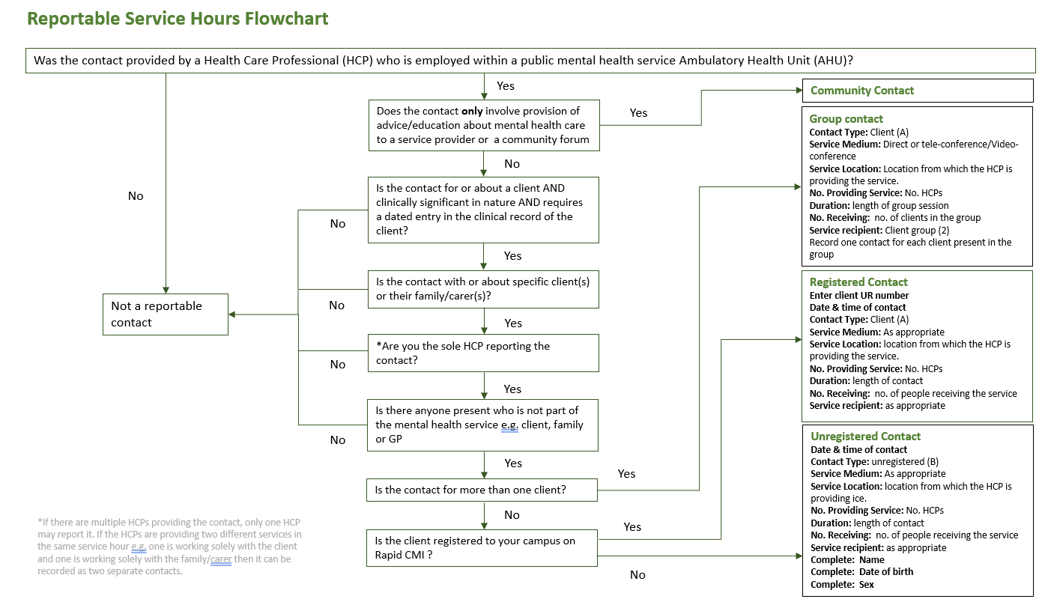

*Appendix 3 is a flow chart or decision tree identifying if a contact is to be reported for registered or unregistered consumers. It also identifies how to record group and individual contacts. This is consistent with previous advice. Refer also the PMC Contact Data Definitions

Appendix 4: Flowchart – Community Service Hours

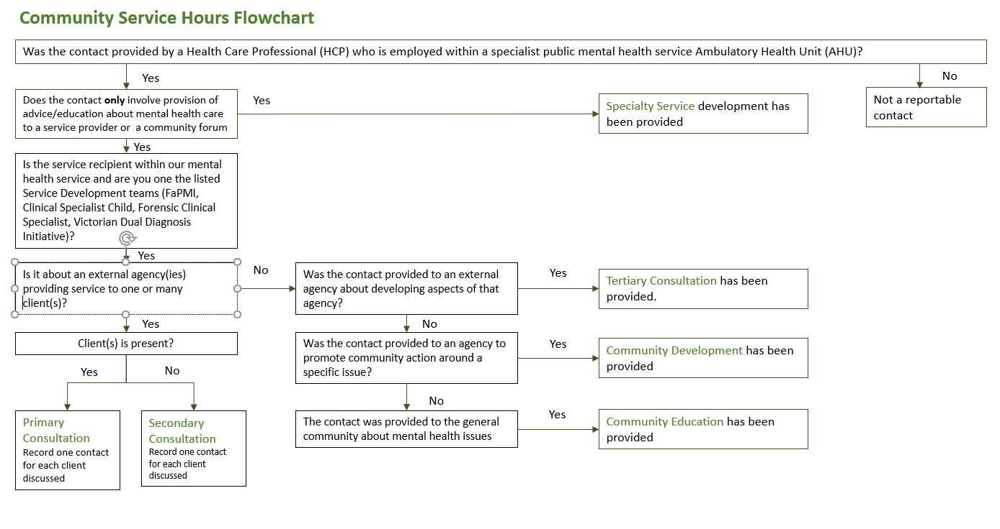

*Appendix 4 is a flow chart / decision tree showing the types of community contacts and when and how to record these in accordance with previous advice – see also the PMC Contact Data Definitions found at https://www.health.vic.gov.au/research-and-reporting/bulletins-and-program-management-circulars-pmc

Appendix 5: Community Speciality Mental Health Service Development Services

As identified in the Contact Data Definition document, the following specialist services are eligible to report community contact type “Specialty Mental Health service development”.

- FaPMI – Family where a Parent has a Mental Illness (Program Guidelines July 2016)
- Forensic Clinical Specialist
- Clinical Specialist Child (Program Guidelines 2016)
- Victorian Dual Diagnosis Initiative (NEXUS)
- Victorian Dual Disability Initiative (VDDS)
- Autism Spectrum Disorder Co-ordinators (MH Bulletin 59 – CAMHS and Adult)
- Family Violence Clinical Specialists (MH Bulletin 47)
- Personality Disorder Co-ordinators (MH Bulletin 39)
- Enhanced Integrated Model for Eating Disorders (MH Bulletin 67)
- HYDDI – Homeless Youth Dual Diagnosis Initiative (MH Bulletin 73)

Services should ensure that local CMI/ODS Subcentre and Program configuration is setup correctly to report this type of community contact type. Where services are unsure of the correct Subcentre/Program setup for the above programs, please refer to the CMI/ODS Subcentre/Program Program Management Circular or contact MHDReporting@health.vic.gov.au.

