Department of Health

Performance Support Program – Class B Cemetery Trusts
2021-22 Annual Report

Summary of Performance Support Program

As part of the Class B Cemetery Trust Performance Support Program, performance reviews were undertaken of nine (9) Class B Cemetery Trusts in the financial year 2021/22. Each review assessed the Trust’s governance systems, processes and practices, and identified opportunities to strengthen existing practices.
- This annual report provides a summary of the common themes identified through the performance reviews in the 2021-22 year. These findings should be considered by other trust members and staff to determine whether there are similar areas for improvement at their Trust. (Refer Appendix A for summary of findings per scope area over the past five years)

Risk Management
Issue? Why is this important? Action?

Several trusts do not perform adequate risk management activities.
Failure to identify/assess risks may prevent the Trust from taking action to remove or mitigate potential risks resulting in potential financial or reputational impact on the Trust.
Identify, assess, document and manage key risks for the Trust and strategies in place to mitigate risks by developing the following:
- Risk Management Strategy
- Risk Register
- Fraud Policy
- Protective Data Security Plan Refer to:
Fraud and protected disclosures (health.vic.gov.au) Sample Risk Register (health.vic.gov.au)
Victorian Protective Data Security Framework - health.vic

Financial strategy and budget

Issue? Why is this important? Action?

Several trusts had no financial budget, forecast or strategy in place to plan and manage the long-term viability of the Trust.
Cemetery trusts must consider the costs of operating and maintaining a cemetery into perpetuity.
A long-term financial strategy and budget will help Trusts to manage their resources more effectively and efficiently.
Develop and document a long-term financial strategy to assist in managing the long-term sustainability of the Trust, which may include:
- Financial Objectives
- Budget Positions
- Regular reporting of actual vs forecast
- Investment strategy
Refer to Cemetery Sector Governance Support Program newsletter. Edition 2, 2020 at Cemetery sector newsletters | health.vic.gov.au)
A budget template and guidelines is also available at Class B cemetery trust financial reporting and financial procedures (health.vic.gov.au)

Record of Cemetery Trust Assets

Issue? Why is this important? Action?

Several trusts had no listing of assets that are owned by the trust. In addition, there was no annual review/stocktake of whether trust assets were still in possession by the trust.
An Asset Register includes:
  - Purchase date
  - Cost
  - Disposal date (if applicable)
  - Disposal proceeds (if applicable)
  - Depreciation (if applicable)
  - Book value
A listing of trust assets will improve accountability for and security of assets. It will assist in their safekeeping and may reduce the likelihood of loss or theft.
An annual check will confirm that assets remain in possession of the trust.
A listing may also be useful to identify assets
that require insurance.
Develop and document a listing or register of assets held by the trust and perform an annual stocktake to confirm their existence.
Check with the Victorian Managed Insurance Agency if unsure if an asset is covered.
Refer to:
Cemetery Trusts | Victorian Managed Insurance
Authority (vmia.vic.gov.au)
Financial guidelines for Class B Cemetery Trusts at Class B cemetery trust financial reporting and financial procedures | health.vic.gov.au

Contract Management

Issue?
Why is this important?
Action?

Several trusts had no documented policies and procedures around contract management. In particular, a requirement for a formal assessment to measure the performance of contractors.
Policies and procedures around contract management provides guidance to the Trusts and their employees. It also provides a framework to assess contractors’ performance.
The Trust should consider adopting the procurement and contract management policies, guides and tools provided on the DH website.
Refer to:
Policy templates (health.vic.gov.au)

Class B cemetery trust compliance for public construction
procurement (health.vic.gov.au)

Instrument of Delegation

Issue? Why is this important? Action?

Several trusts do not have an Instrument of Delegation in place to delegate the Trust’s authority to employees or Trust members to undertake functions and powers under the Act.
An Instrument of Delegation is required when the Trust wants to delegate its functions and powers.
The Trust should create its own Instrument of Delegation.
Refer to:
Sample Instrument of Delegation and Fact sheet Guidelines on “delegating cemetery trust powers” available at Class B cemetery trust governance (health.vic.gov.au)

Conflict of Interest

Issue? Why is this important? Action?

Several trusts do not have policies and procedures for managing conflict of interest.
A conflict of interest is a conflict between your duty as a trust member and your private interests. This conflict exists if your private interests influence, or are seen to influence, your decisions or actions as a trust member.
Cemetery trust members have a duty to place the public interest above their own interests. This helps to maintain the public’s confidence in the ability of trust members to act in the best interests of the trust and Victorian communities.

Under clause 9 of schedule 1 of the Act, trust members are required to disclose any interest that could conflict with the proper performance of their duties.
The trust should document its Conflict of Interest policy and procedure. A conflict of interest register must also be maintained by the Trust.

Refer to:
Conflicts of interest and duty for directors of public entities practice guide

Customer Management

Issue? Why is this important? Action?

Several trusts do not have a formal complaint management process.
A complaints register includes:
- Date received
- Details of complaint
- Complainant details
- Outcomes/findings from investigations
- Actions taken to resolve
- Date resolved
A formal complaint management process will assist the Trust to more effectively address customer complaints, identify causes, prevent recurrences and minimise the Trust’s risk of reputational damage.
The trust should document its complaint management process.
This also includes the establishment of a central
register to record details of complaints.
Refer to:
A guide to managing complaints is available at Cemeteries and crematoria complaints (health.vic.gov.au)
A complaint policy template is available at Policy templates (health.vic.gov.au)

Document Management

Issue? Why is this important? Action?

Several trusts have inadequate procedures for managing records including the security of storage, retention and disposal of Trust documents, which resulted in the loss of key documents.
The policy should include processes for ensuring compliance with Public Records Office Victoria Standards and legislative requirements including the Cemeteries and Crematoria Act 2003 (the Act) and the Privacy and Data Protection Act 2014
Inadequate management and security over trust records (such as interment records, financial records and other sensitive data) increases the risk of highly sensitive customer and Trust information being lost or misplaced.
This may result in the trust being in breach of the Act and privacy legislation. It may also result in reputation losses to the Trust.
The trust should develop a document management policy.
Refer to:
Topic 23 in the Class B Cemetery Trust Manual at Cemeteries and crematoria (health.vic.gov.au)
Cemeteries - Class B Trusts | PROV
Victorian Protective Data Security Framework (health.vic.gov.au)

Human Resource Management

Issue? Why is this important? Action?

Several trusts have issues in relation to Human Resource management particularly in the following areas:
- Establishment of formal employment contract
- Process for assessing staff performance
A contract of employment formally documents the obligations and expectations on the employee so if an employee fails to meet the terms and conditions of employment the trust can rely on the contract.
It is important to establish a process for assessing staff performance to ensure all the roles and responsibilities are adequately and effectively executed. This will also help with timely identification and resolution of issues regarding staff performance.
The trust should ensure a job description is created and an employment contract is completed for its employees.
The trust should introduce processes to evaluate staff performance on a regular basis, i.e. annually.
Refer to:
Position descriptions available at Class B cemetery trust governance (health.vic.gov.au)
Topic 8 in the Manual for Victorian Class B Cemetery Trusts available at Cemeteries and crematoria (health.vic.gov.au)

Interments

Issue? Why is this important? Action?

Several trusts have no evidence that supporting documentation required for interments has been sighted.
Sighting evidence of the medical cause of death before authorising an interment is an important responsibility of a cemetery trust under the Act.
The Trust should maintain evidence that the required documentation has been sighted before the interment. The following information may be included on the Interment Authorisation form:
- Type of supporting documentation sighted
- Signature and name of person sighting
- Date evidence was sighted

Refer to Section 116 of the Act for appropriate
supporting documentation.

Appendix A: Summary of findings per scope area from 2017 to 2022

The table below lists the number of findings identified over the last five years in each of the major scope areas:
Areas of weakness | Possible consequences of  not taking action
Management of Trust Finances – ongoing viability of Cemetery Trust | Trust does not use its resources effectively and efficiently and lacks sufficient funds for cemetery operations and to maintain the cemetery in perpetuity.
Risk Management – Performing and documenting risk assessments (Financial and Non-Financial) | Trust may not know or foresee risks that could result in potential financial or reputational impact on the Trust.
Governance – Proper authorisation for Trust officers or members to undertake functions and exercise powers under the Act.  (Instrument of Delegation) | Trust officers or members (the Secretary in particular) may undertake duties and exercise powers for which they do not have the appropriate authority.
Contract Management – Establishing formal performance processes with contractors | Risk that roles and requirements of contractors are not clearly agreed, and the Trust will not have a legal remedial arrangement in the event of a contract dispute or performance issues.

Trusts should focus on the following key risk areas:

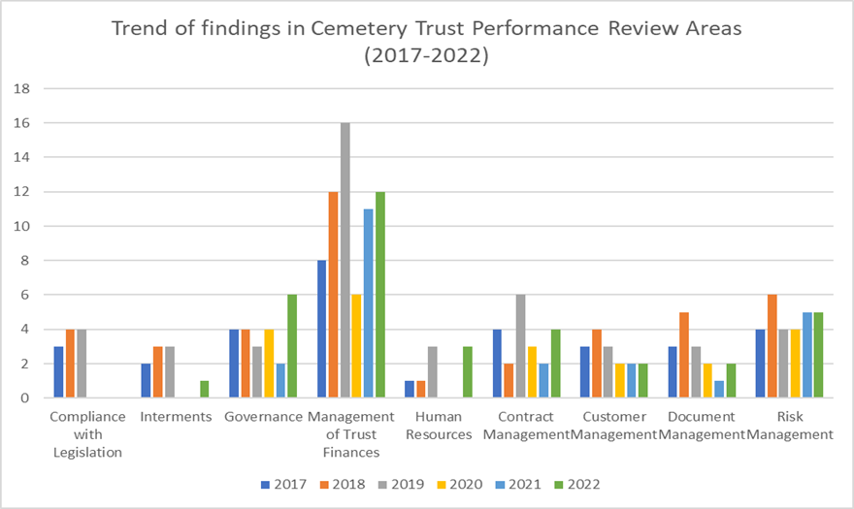

Appendix B. Finalising the Performance Support
Program Review report

The process flow chart below describes the steps that the Trust should follow
Trust must assign a reasonable time to complete the management action and be aware of the following:
- Leaving a high or medium risk finding unresolved may lead to serious consequences if the risk eventuates
Suggested target date and action:
- DH recommends that High and Medium risk actions should be completed within 8 months
- Where the action involves documenting processes or creating policies, the Trust should go to the DH website to identify whether there are templates available to be used, or seek assistance from another Cemetery Trust
after receiving the draft report from NTT:
Fieldwork
completion
Assign appropriate Trust member to Action
Finalise Report with
NTT
Review report and
amendments
Insert Target
Completion date
Discuss Trust Action plan and completion date with NTT
Insert relevant Trust Action Plan in the recommendation section

Note: Under section 12A(1)(i) of the Cemeteries and Crematoria Act 2003 (the Act) Class A cemeteries are required to provide leadership, assistance and advice as requested to Class B cemetery trusts

Appendix C. Useful References and Templates available to Trusts
Guidelines and Manuals
- Financial Guidelines Class B Cemetery Trusts
- Manual for Victorian Class B Cemetery Trusts
- Secretary’s Directions to Cemetery Trusts
DH has developed and published guidelines, templates and reference guides for Trusts to review, adapt and implement according to their needs. These are available on the Cemetery Trust Governance Page on the DH website Class B cemetery trust governance (health.vic.gov.au) and the Policy Template Page Policy templates (health.vic.gov.au)
Templates
•

•
•
•
•
Budget, cash management, gifts benefits and hospitality, memorialisation, monumental mason
Fraud, Corruption Control and Protected Disclosure Framework
Instrument of Delegation Protective Data Security Plan
Procurement
- Complaints
o

o
Guide for managing complaints available at Cemeteries and
crematoria complaints (health.vic.gov.au)
Complaints Policy
•
Right of Interment
o o o

Guidelines for public construction procurement in Victoria
Purchasing and Tendering Policy
Contractor Policy
- Permit
- Fact Sheet
The Right of Interment Permit and Fact Sheet is available at
Right of interment (health.vic.gov.au)

August 2023

Together we do great things

