Victorian Integrated Non-Admitted Health Minimum Data Set (VINAH MDS) manual 2023-24
Section 5d – HealthCollect portal manual transmission process
18th edition, July 2023
Version 1.0
OFFICIAL

To receive this publication in an accessible format email HDSS helpdesk <hdss.helpdesk@health.vic.gov.au>.
Authorised and published by the Victorian Government, 1 Treasury Place, Melbourne.
© State of Victoria, Australia, Department of Health, July 2023.
Except where otherwise indicated, the images in this document show models and illustrative settings only, and do not necessarily depict actual services, facilities or recipients of services. This document may contain images of deceased Aboriginal and Torres Strait Islander peoples.
In this document, ‘Aboriginal’ refers to both Aboriginal and Torres Strait Islander people. ‘Indigenous’ or ‘Koori/Koorie’ is retained when part of the title of a report, program or quotation.

ISBN 978-1-76131-150-5 (pdf/online/MS word)
Available at VINAH minimum data set <https://www.health.vic.gov.au/data-reporting/victorian-integrated-non-admitted-health-vinah-dataset>

Contents
Introduction 1
General information about the HealthCollect portal 2
How to obtain a HealthCollect log in and password 2
Logging into the HealthCollect portal 2
Username and password 2
Accessing context and tab menus 2
Changing your password 3
Changing ‘Edit My Details’ instructions 4
Reset your password 4
VINAH MDS data submission via HealthCollect portal 5
Introduction 5
VINAH Home 5
VINAH Production context, functions and announcements 5
VINAH data submission process 6

Introduction
The HealthCollect portal is a web-based interface that agencies use to submit various statistical and financial data collections to the Department. The HealthCollect portal is the mechanism through which all VINAH MDS data is submitted to the Department. This section of the VINAH MDS manual provides advice on how to submit VINAH MDS data via the HealthCollect portal.
Diagram 1: File Submission Process
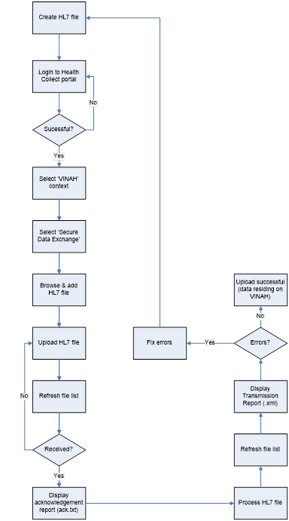

General information about the HealthCollect portal

How to obtain a HealthCollect log in and password
To obtain a HealthCollect log in and password:
Visit the HDSS website at: <http://www.health.vic.gov.au/hdss/healthcollect.htm>
Under the title ‘HealthCollect portal access’, click on the ‘HealthCollect portal user request form’ link.
You will be taken to the ‘HealthCollect Portal User Request’ online form which explains information prior to completing.

Logging into the HealthCollect portal
Please note: DH only supports Microsoft Edge
- Open Microsoft Edge.
- Type in address: https://www.healthcollect.vic.gov.au and press ‘Enter’.

Username and password
Enter your ‘UserName’ and ‘Password’ details in the boxes provided and then click on the ‘Logon’ button. Remember, passwords are case-sensitive.
Please note: All diagrams used are sample diagrams; however all use the same concept. Please refer to the diagram below.
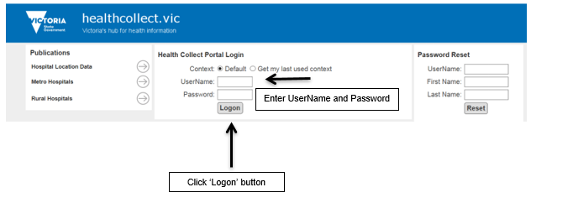

Accessing context and tab menus
The context of the HealthCollect portal is found as a series of tabs located across the top of the screen and the functions listed on the left hand side. Each user will have access to different contexts depending on the collections for which they are responsible. VINAH MDS data is submitted through the VINAH Production context.
Under each context you will have access to functions applicable to that context. For example, the default context has ‘Home’ and ‘My Account’ functions.
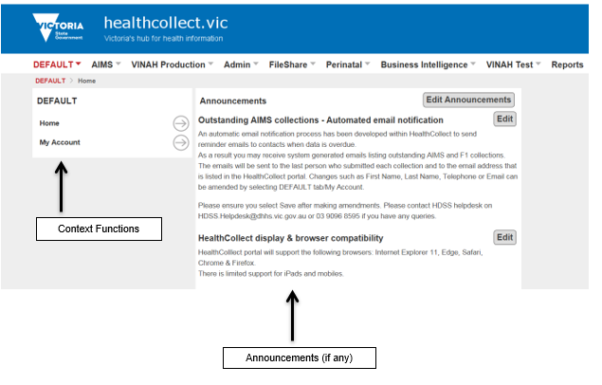

Changing your password
The first time that you log in it is recommended that you change your password. Please note: passwords are alphanumeric and case sensitive.
- Select the ‘Default’ tab link and then select the ‘My Account’ option from the ‘Context Functions’ area. The ‘Change Password’ text box will appear on the right-hand side of the screen.
- Type the current password in the ‘Enter current password’ box.
- Type the new password in the ‘Enter new password’ box.
- Re-type the new password in the ‘Confirm new password’ box.
- Click ‘Change Password’.
- Click ‘Log Off’ to log out of the HealthCollect portal.
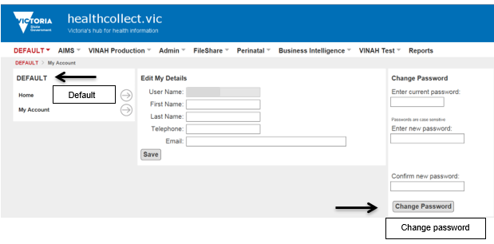

Changing ‘Edit My Details’ instructions
‘Edit My Details’ allows the user to change their first name, last name, telephone and email contact, and is accessible from the ‘Default’ context and found under ‘Functions’.
- Log onto the HealthCollect Portal (refer to the ‘Logging into the HealthCollect portal’ section).
- Check that you are in the ‘Default’ context.
- Click on ‘My Account’.
- Click on ‘First Name’, ‘Last Name’, ‘Telephone’ or ‘Email’ field.
- Type in the new details.
- Click ‘Save’.
- Click ‘Log Off’.
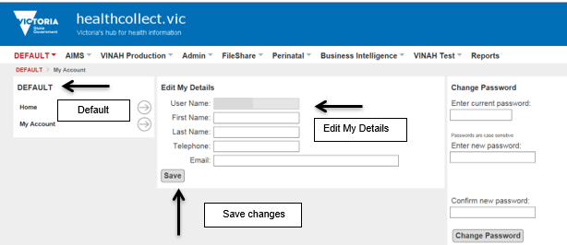

Reset your password
In the instance you have lost or forgotten your password, you can reset your password.
To reset your password, type your UserName, First Name and Last Name into the ‘Password Reset’ tab and click on the ‘Reset’ button. An email containing a new password will be sent to the email account that is linked to your UserName. You will then be able to use your new password to log in to the HealthCollect portal.
The first time that you log in, it is recommended that you change your password. Refer to the section ‘Changing your password’.
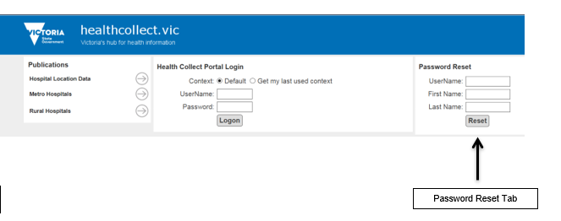

VINAH MDS data submission via HealthCollect portal

Introduction
The information below will guide you on how to submit the VINAH MDS extract file produced from your software system.
The scope of these instructions includes those software applications that produce an HL7 extract file for manual upload.

VINAH Home
The VINAH Production and VINAH Test tabs on the HealthCollect portal page provides access to the following functions:
Home
Secure Data Exchange

VINAH Production context, functions and announcements
The context of the HealthCollect portal is found as a series of tabs located across the top of the screen and the functions are listed on the left hand side. Each user will have access to different contexts depending on the collections for which they are responsible. Please refer to the diagram below.
The VINAH home page posts any announcements that have been set by the VINAH administrator, including the VINAH Server Processing Status report.
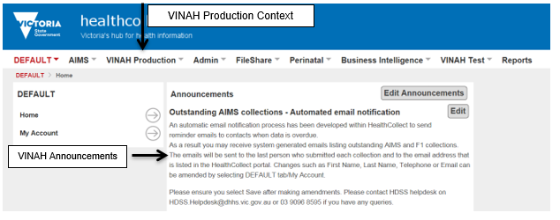

VINAH data submission process
- To submit your VINAH data select the ‘VINAH Production’ context tab link and then select ‘Secure Data Exchange’ from the ‘Context Functions’ area.
- Click the ‘Choose File’ button and locate your HL7 submission file from your local computer.
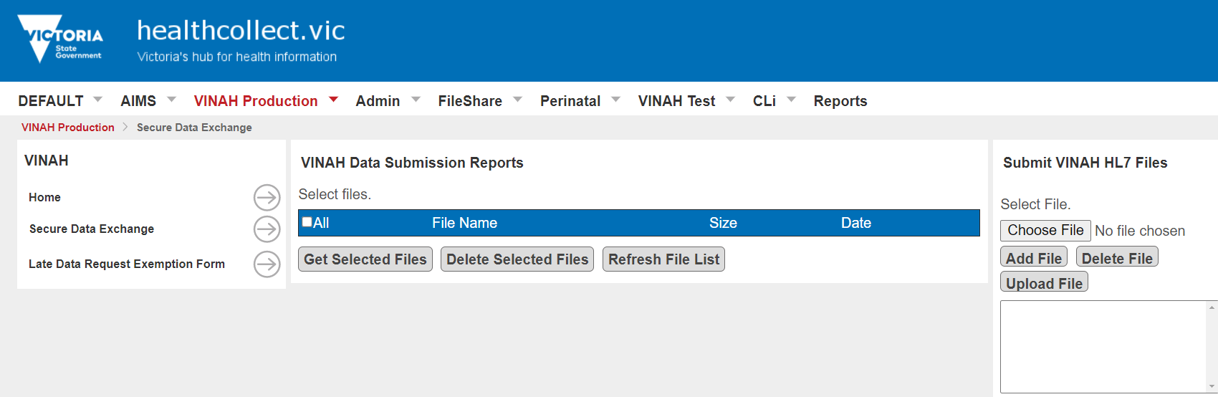
- Click on the file and select ‘Open.
- Click the ‘Add File’ button and the file name will appear in the list box below the button – this may take some time depending upon the file size.
Once the filename appears in the list box click the ‘Upload File’ button.
Note: if you have added a file in error, you can remove it prior to uploading by selecting the file so that it is highlighted, then click the ‘Delete File’ button. The file will no longer appear in the list box.
- A successful transmission will see green text appear below the list box, stating ‘File [File name] posted successfully’. Your file has now been sent to DH for processing by the VINAH validation engine.
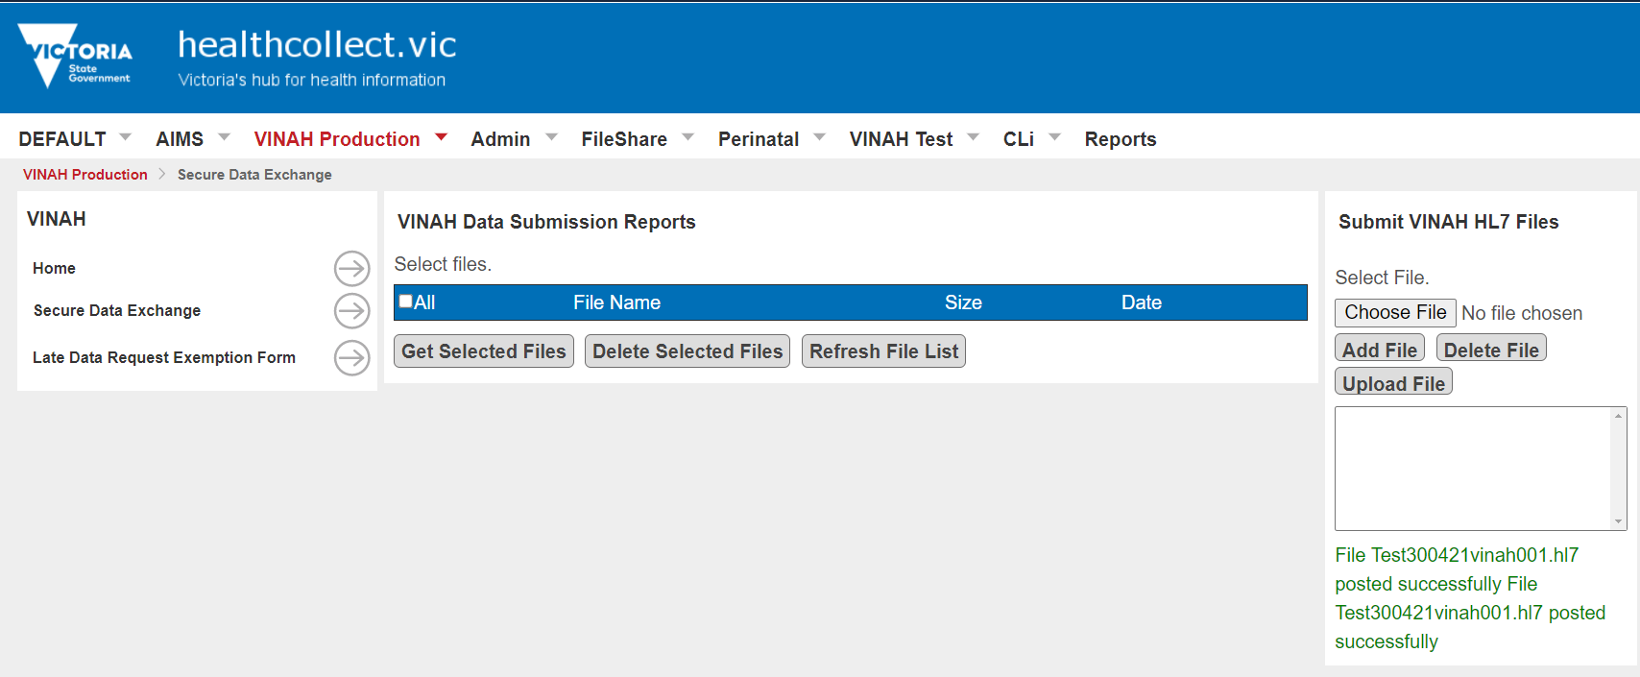
- To confirm that the VINAH validation engine has received the file, a small acknowledgement file (also known as the ‘.ack file’) is sent back to you and will be visible in the ‘VINAH Data Submission Reports’ section.
- Click ‘Refresh File List’ to check for new files sent back to you from the VINAH validation engine.
- After a short delay, a file with the extension ‘.ack.txt’ will appear in the list. This file should otherwise be named the same as the file submitted.
- You can view this file by checking the box next to the file name and clicking ‘Get Selected Files’.
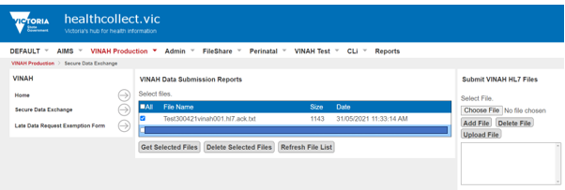
- This acknowledgement file simply tells you that the VINAH validation engine has received your file and has added it to the queue to be processed. The acknowledgment file will also give you an indication as to how long it will take to process your file depending on system load.
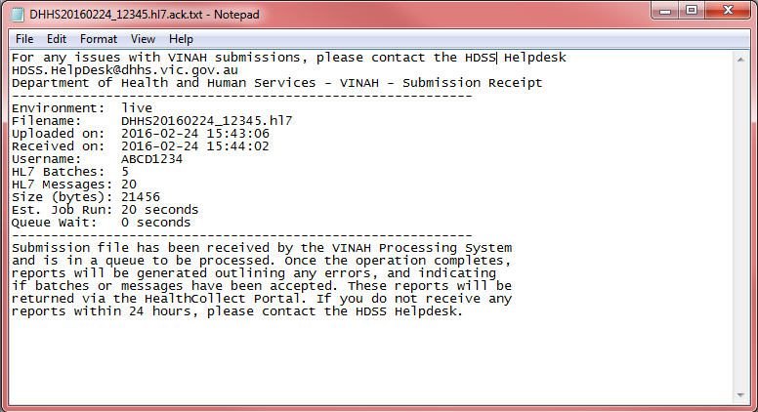
- Once the VINAH validation engine has processed the data, a submission report is prepared that contains detailed information about which messages and batches have been accepted/not accepted as well as listing any validation errors.
- This report is returned with the file extension ‘.xml’ and will be accessible from the ‘VINAH Data Submission Reports’ section. Users should note that the report may take some time to be returned depending upon the current system usage.
- There is no email notification of the completion of processing at this time. Users should review the estimated processing time that is provided in the acknowledgement file and log back into the portal to check for a submission report. Please note that the estimated processing time is calculated on a worst-case scenario, so actual processing time may be less.
- Once the report has been received, you can view this file by checking the box next to the file name and clicking ‘Get Selected Files’.
- Please note: many software systems load this error file into the Patient Administration System (PAS) application where users will be able to read and process submission errors.
- The default edit report is machine-readable and intended for use as above. A human-readable edit report can be produced by transmitting the appropriate value in the header of the submission file. For more information see Section 5 or contact your software vendor.

Sample default edits report
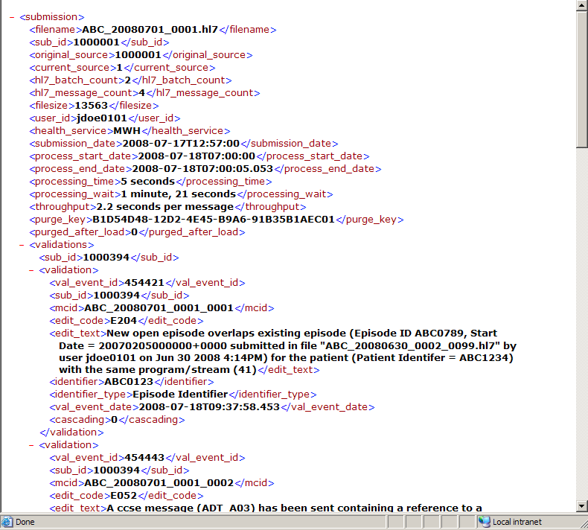

If unsure of how to proceed once you have received the submission report, please contact the HDSS Helpdesk or your software vendor for support.
Email: HDSS helpdesk <hdss.helpdesk@health.vic.gov.au>

