Update to Victorian Government department food purchasing
Information for catering providers
Victorian Government departments have changed the way that they purchase food and drinks for the benefit of people and the planet.
When catering for government funded meetings, functions and events, staff of Victorian Government departments are required to:
- select healthier food and drink options
- consider businesses that deliver social and environmental outcomes
Catering providers have an opportunity to position their businesses to meet increased demand for healthier food and drinks, and more inclusive and sustainable business practices.

What are healthier food and drink options and how do I know if my business provides them?
Within the Victorian Government’s Healthy Choices: food and drink classification guide, food and drinks are classified as GREEN, AMBER or RED based on nutritional value.

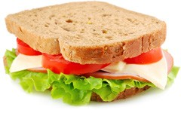
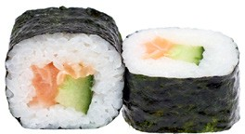
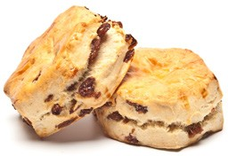
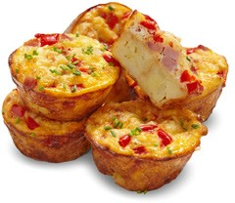
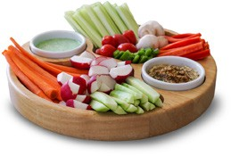
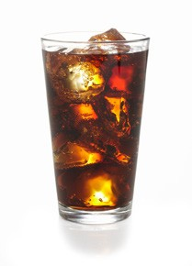
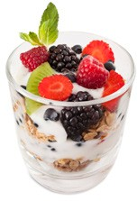
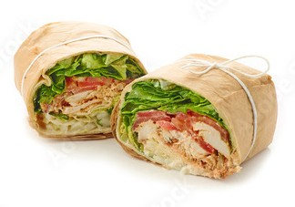
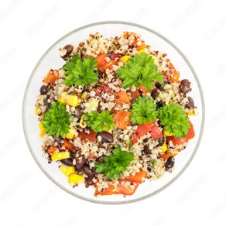
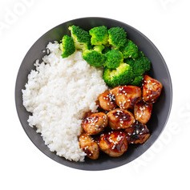

Food and drinks classified GREEN and AMBER are healthier options and will be selected by staff ordering catering for government funded meetings, functions and events. Examples of GREEN and AMBER foods and drinks include sandwiches, wraps, frittatas, sushi, fresh fruit, fruit scones, water, coffee and tea.

Food and drinks classified RED are unhealthy options and will be avoided by staff. Examples of RED foods and drinks include mini-pies, sausage rolls, Danish pastries, sweet biscuits, cakes and slices, large muffins, sports drinks and soft drinks.

Healthy Eating Advisory Service (HEAS)
The Healthy Eating Advisory Service (HEAS) is a free, Victorian Government-supported service that supports a wide range of organisations to supply healthier foods and drinks. Through HEAS, caterers can:
- use the online tool Food Checker <https://foodchecker.au/https://foodchecker.heas.health.vic.gov.au> to do free recipe, product and menu assessments and receive instant feedback on whether foods and drinks are classified as GREEN, AMBER or RED
- receive free phone and email support to assess menus and identify healthier alternatives
- explore online resources including training, fact sheets and recipes, as well as case studies that demonstrate how healthy change can be good for business
- apply to be listed on the Catering for Good Directory.
The Catering for Good Food Directory <https://heas.health.vic.gov.au/catering-for-good> has been developed to help Victorian organisations access healthier and more sustainable catering options.
Organisation staff can search the Directory to find catering businesses that have:
- assessed their menu options using FoodChecker – allowing for green and amber menu items to be showcased on the Directory
- identified their social benefit supplier status, where relevant
- identified their sustainable business practices.
Visit the HEAS website <https://www.heas.health.vic.gov.au> or phone 1300 22 52 88 for more information.

Social and environmental outcomes for catering businesses

Delivering social outcomes
Delivering social outcomes means generating social value above and beyond the value of the goods and services being provided. Social value means benefit to all Victorians.
Social benefit suppliers can notify government staff of their social benefit supplier status when they are ordering food and drinks.
Catering businesses who would like further information and key contacts about social procurement and creating inclusive employment opportunities can visit the Buying for Victoria website
<https://www.buyingfor.vic.gov.au/implementing-social-procurement-buyers>.

Delivering environmental outcomes
Delivering environmental outcomes means taking steps to reduce the impacts on the natural environment (for example, carbon emissions, pollution, waste) through sustainable business practices.
A range of information and resources are available below and in the ‘further information and contacts’ section to support catering businesses to deliver environmental outcomes.

Sustainable business practice considerations
When purchasing catering for government funded meetings, functions and events, staff of Victorian Government departments may ask the following questions of caterers and other food businesses to identify sustainable business practices:
- Do you consider your environmental impact by considering the sustainability of your processes? For example, through implementing an organisational sustainability policy, plan, strategy or circular business model.
- Do you provide food on or in reusable or returnable, non-disposable serving platters or containers?
- Do you recycle to the maximum extent possible?
- Do you provide a variety of vegetarian and/or vegan options?
- Do you provide advice on appropriate food ordering quantities to customers to help avoid food waste due to overordering?
- Do you implement strategies to reduce food waste and compost any remaining organic waste, ideally on-site?
- Do you donate food from cancelled orders, unused products and excess food to local charities or food rescue organisations and/or implement other food waste minimisation strategies?
- Do you preference locally grown produce where possible?
- Do you vary the menu based on the use of seasonal produce?
- Do you use renewable energy or implement other practices to reduce greenhouse gas emissions?
- Do you avoid providing individually wrapped or packaged foods?
You may also wish to consider promoting any sustainable business practices or policies on your website.

Banned single-use plastics
Single-use plastics:
- make up a third of the litter we see in our environment – they are difficult and costly to clean up
- are a poor use of resources – they are often used for only a few minutes and generate a significant amount of waste that is difficult to recycle
- pollute the environment – harming wildlife and contaminating our food and water

The following single-use plastics are now banned in Victoria: single-use plastic drinking straws, cutlery, plates, drink stirrers and cotton bud sticks made from conventional, degradable and compostable plastics, including bioplastic and oxo-degradable materials. The ban also applies to food service items and drink containers made from expanded polystyrene.
All businesses and organisations in Victoria are required to comply with the ban. Visit the Sustainability Victoria website <https://www.sustainability.vic.gov.au/plastics>

Further information and contacts
For more support on providing healthier foods and drinks, visit the Healthy Eating Advisory Service <https://www.heas.health.vic.gov.au> or phone 1300 22 52 88.
For further information on:
- social procurement, visit the Buying for Victoria website <https://www.buyingfor.vic.gov.au/implementing-social-procurement-buyers> or contact the Department of Government Services <https://www.vic.gov.au/department-government-services>
- the impacts of climate change on health, visit the Better Health Channel <https://www.betterhealth.vic.gov.au/health/HealthyLiving/climate-change-and-health>
Further information on sustainable business practices:
Single-use plastics ban:
- Sustainability Victoria website <https://www.sustainability.vic.gov.au/plastics>
- Business Victoria website <https://business.vic.gov.au/business-information/sustainability>
Energy efficiency in hospitality:
- Sustainability Victoria website <https://www.sustainability.vic.gov.au/energy-efficiency-and-reducing-emissions/in-a-business/by-sector/energy-efficiency-in-hospitality>
- Department of Energy Environment and Climate Action website <https://www.energy.vic.gov.au/for-businesses/ways-to-save-for-hospitality-businesses>
Sustainable food:
- Sustainability Victoria’s shop sustainably for food resource: <https://www.sustainability.vic.gov.au/recycling-and-reducing-waste/at-home/avoid-waste/shop-sustainably/food>
- Marine Stewardship Council (MSC): <https://www.msc.org/what-you-can-do/eat-sustainable-seafood/fish-to-eat>.
- The Sustainable Seafood Guide <https://goodfish.org.au>
Reducing food waste:
  - OzHarvest website <https://www.ozharvest.org/fight-food-waste>
  - New South Wales Environment Protection Authority website <https://www.lovefoodhatewaste.nsw.gov.au/business/ways-reduce-business-food-waste>
Donating food:
  - Donating food - Health.vic: <https://www.health.vic.gov.au/food-safety/donating-food>
  - Food for Change: <https://foodforchange.org.au/rescue/donate-food>
  - Food Bank Victoria <https://www.foodbank.org.au/?state=vic>
  - Second Bite <https://secondbite.org/donate-food>
  - Fareshare <https://www.fareshare.net.au/donate-food-melbourne>
  - OzHarvest <https://www.ozharvest.org/food/give-food>
Grants and funding:
  - Sustainability Victoria website <https://www.sustainability.vic.gov.au/grants-funding-and-investment/grants-and-funding>

To receive this document in another format, phone 1300 761 874, using the National Relay Service 13 36 77 if required, or email Good Food Policy <GoodFoodPolicy@health.vic.gov.au>.
Authorised and published by the Victorian Government, 1 Treasury Place, Melbourne.
© State of Victoria, Australia, Department of Health, July 2023.

ISBN 978-1-76131-196-3 (pdf/online/MS word)
Available at the department’s healthy and more sustainable food procurement webpage <https://www.health.vic.gov.au/public-health/healthy-and-more-sustainable-food-procurement>

Note that in certain circumstances, departments may request single-use plastic drinking straws for people who need them due to a disability or for medical reasons.

