|  |
| --- |
| Sustainability in Healthcare update |
| #38 May 2023 |

The department produces quarterly sustainability updates to inform health services on sustainability initiatives being implemented across the health care sector, as well as key sustainability issues of interest. We welcome items of interest from health services.

# Financial Reporting Direction 24 – Environmental Reporting

The Victorian Government has introduced a significant enhancement to environmental reporting requirements to improve transparency, support management of climate-related risks and implementation of the [Whole of Victorian Government emissions reduction pledge](https://www.climatechange.vic.gov.au/__data/assets/pdf_file/0034/522799/WoG-sector-pledge-full-colour.pdf). This has included expanding the scope and application of Financial Reporting Direction 24 *Reporting of environmental data by government entities* (FRD 24), which came into effect 1 July 2022 for the 2022-2023 reporting year.

To support health services in meeting their reporting requirements, two FRD24 workshops were run by the Department of Health in conjunction with the Department of Energy, Environment and Climate Action (DEECA) in March. Over 70 attendees participated in the workshops, which focused on the new requirements, the expanded Environmental Data Management System, and the refresh of the Environmental Reporting Guidelines (due for publication in mid-2023).

A range of support materials are being made available, with materials progressively updated on the Department of Treasury and Finance (DTF), DEECA and department websites. Training sessions on the Environmental Data Management System are being run throughout May (details are below).

## FRD24 2022-23 model report

The 2022-23 model report has now been released, including guidance and example disclosure for FRD24. The model report is provided to assist Victorian government departments and other public sector entities with the planning and preparation of disclosures in their annual reports. This is available on the [Department of Treasury and Finance DTF website](https://www.dtf.vic.gov.au/financial-reporting-policy/model-report) <https://www.dtf.vic.gov.au/financial-reporting-policy/model-report>.

## Environmental Data Management System training

Eden Suite, the developers of the EDMS, are running three different themed training sessions for health service users throughout May. Invitations for each session have been sent out to EDMS and Sustainability contacts: Refresher sessions were held in early May, with reporting and advanced reporting sessions occurring over the next two weeks. For further information please email .

* Session 1: Refresher (45 minutes): May 2nd and 4th
  + will cover EDMS concepts and terms, navigation, searching for and updating assets/devices/organisations and where data is sourced from.
* Session 2: Reporting (45 minutes): May 9th and 11th
  + will cover preparation for reporting, including GHG inventory report, profile charts, performance reports on water, waste and energy, and the public environment report used for annual reporting.
* Session 3: Advanced Reporting (30 minutes): May 16th and 18th
  + covers advanced reports for the supplier, device asset report, multi comparison report, combined view, supplier verification report, solar report, direct data entry via email and data upload.

# Zero Emission Vehicle Update

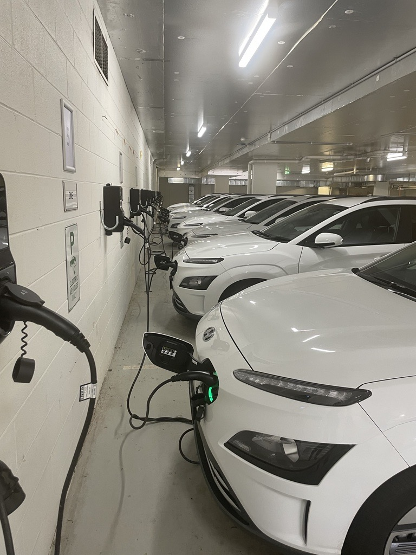The pilot Zero Emissions Vehicle (ZEV) Program is well into its delivery phase. The aim of the program is to support the uptake and transition of 400 small passenger vehicles within the government fleet to 100 per cent battery electric vehicles. The program includes installation of associated charging infrastructure along with education and training resources to support fleet managers and drivers through the transition. As part of the ZEV Program many health services have received the extended range Hyundai Kona ZEV. This model has a driving range of 480kms which enables staff to make long range trips for outpatient work or meetings without the need to charge enroute. The extended driving range reduces ’range anxiety’ by boosting driver confidence that the ’tank is full‘, which is particularly important for drivers in regional areas.

Figure :Hyundai Kona electric vehicles charging at Warrnambool hospital.

Many health services have joined the program as the next step to greening their fleet operations with some sites powering the ZEVs with onsite renewable energy.

In addition to reducing emissions, the ZEVs will also deliver ongoing cost savings due to lower maintenance and running costs than petrol or diesel predecessors.

Health services that are part of the ZEV Program include:

Barwon Health, Bendigo Health, Dhelkaya Health, Eastern Health, Grampians Health, Heathcote Health, Kilmore District Health, Rochester and Elmore District Health Services, Royal Melbourne Hospital, South West Healthcare, and the Western District Health Service.

To support community interest and adoption of sustainable transport, the ZEVs will be available for public purchase at the end of their lease.

# Energy efficiency programs

The Victorian Health Building Authority (VHBA) is delivering a $16 million grant program to undertake energy efficiency audits and implement selected energy efficiency projects in local, small rural, and multi-purpose health services across regional Victoria. The program will support the degasification, or electrification, of engineering infrastructure, where initiatives are also shown to deliver efficiency savings.

Barwon Southwest is the first region to progress, with VHBA now reviewing tenders to appoint a company to conduct energy efficiency audits. Targeted health services will be contacted directly by VHBA. The next region to progress will be Gippsland.

The types of projects that could be supported include:

* LED upgrades,
* building tuning and modifications to Building Management Systems to allow more detailed reporting and monitoring,
* minor HVAC and engineering infrastructure upgrades,
* window-tinting, and
* solar arrays.

The program is also investing $4 million in energy efficiency and solar at Ambulance Victoria, Dental Health Services Victoria, and Forensicare. VHBA will provide funding of up to $2.5 million for Ambulance Victoria to install solar, convert gas appliances to electric, install heat pumps and undertake energy audits. VHBA has also supported energy audits at Dental Health Services Victoria and Forensicare to identify initiatives for subsequent implementation.

For further information on the program please e-mail [ian.winneke@health.vic.gov.au](mailto:ian.winneke@health.vic.gov.au).

# 2023 Premier’s Sustainability Awards

Entries for the 2023 Premier’s Sustainability Awards are now open.

These influential awards celebrate Victoria’s sustainability success stories, unearthing remarkable advancements and achievements on the path towards a circular economy and a more sustainable future.

In their 21st year, the Awards continue to reflect the innovative approach and deep commitment to sustainability in Victoria across industry, business, and the community.

There are 12 awards to enter, rewarding industry leaders and community champions in six categories, linked to the globally accepted United Nations Sustainable Development Goals:

* Circular economy innovation
* Future energy
* Healthy and fair society
* Sustainable places
* Thriving environment
* Waste and recycling solutions

We encourage health services to submit entries to showcase their achievements.

An information session is being held by Sustainability Victoria on **Thursday 8 June at 11 am**, with entries closing on **Friday 30 June 2023 at 5 pm.** Further information is available at the [Sustainability Victoria website <](https://www.sustainability.vic.gov.au/about-us/awards-we-administer/premiers-sustainability-awards)https://www.sustainability.vic.gov.au/about-us/awards-we-administer/premiers-sustainability-awards>

Global Green and Healthy Hospitals (GGHH) Network

The department encourages public health services to join the GGHH network and access the many benefits, including networking and support from a community of sustainable healthcare colleagues across Australia, New Zealand and globally.

If you have any questions or would like support becoming a member please contact Stephanie Caruso, CAHA Sustainable Healthcare Program Manager and GGHH Pacific Region Coordinator. For more information visit the [GGHH website](https://www.caha.org.au/globalgreen_healthyhospitals1) <https://www.caha.org.au/globalgreen_healthyhospitals1>.

Key contacts

For enquiries, please email [sustainability@health.vic.gov.au](mailto:sustainability@health.vic.gov.au) and the relevant team member will respond. For EDMS related queries please email [edms@health.vic.gov.au](mailto:edms@health.vic.gov.au).

|  |
| --- |
| To receive this document in another format, phone 9595 2898, using the National Relay Service 13 36 77 if required, or [email the Sustainability team](mailto:email%20the%20Sustainability%20team) <sustainability@health.vic.gov.au>.  Authorised and published by the Victorian Government, 1 Treasury Place, Melbourne. © State of Victoria, Australia, Department of Health.  May 2023, ISSN 2207-0893 (Online)(pdf)  Available at the [department’s website](http://www.health.vic.gov.au/sustainability)<www.health.vic.gov.au/sustainability>. |