

|  |
| --- |
| Blood Matters on the Bench and Beyond |
| Issue 13 – February 2023 |
| OFFICIAL |

Welcome to the Blood Matters newsletter for Scientists. It will be distributed throughout the year to share information that may be helpful to you, and to let you know of upcoming activities which may be of interest.

## Blood Matters online events 2023

Blood Matters online events have become a regular fixture in our education calendar, continuing to support scientists and our multidisciplinary network of transfusion professionals.

### O positive blood for emergency transfusion: the Queensland experience

### Wednesday 29 March 2023

3.00pm – 4.00pm (AEST)

Virtual education session via Webex

**Registration is required,** [**Click here to register**](https://lifeblood.webex.com/weblink/register/rccd7819eb7f7d85ed5ff6df5ad6bf5ed)

Dr Rakin Chowdhury, Haematology Fellow, Pathology Queensland discussing:

State-wide review of O positive blood for emergency transfusion and rates of alloimmunisation to red cell antigens

* Analysis of emergency transfusions after implementation of policy to use O positive blood in female patients ≥50 years and male patients >16 years of age
* Rates of alloimmunisation before and after emergency transfusion

## National Blood Authority (NBA) National Statement for the Emergency Use of Group O Red Blood Cells

The NBA, National Blood Transfusion Committee (Australian Red Cross Lifeblood), Australian and New Zealand Society of Blood Transfusion, National Pathology Accreditation Advisory Council, Australian College of Rural and Remote Medicine and Australian College of Emergency Medicine have developed and published a joint national statement for the emergency use of group O red blood cells.

The national statement is now available from the NBA webpage [Group O negative red blood cell management | National Blood Authority](https://www.blood.gov.au/group-o-negative-red-blood-cell-management)

## Emergency use group O RBC in Victoria

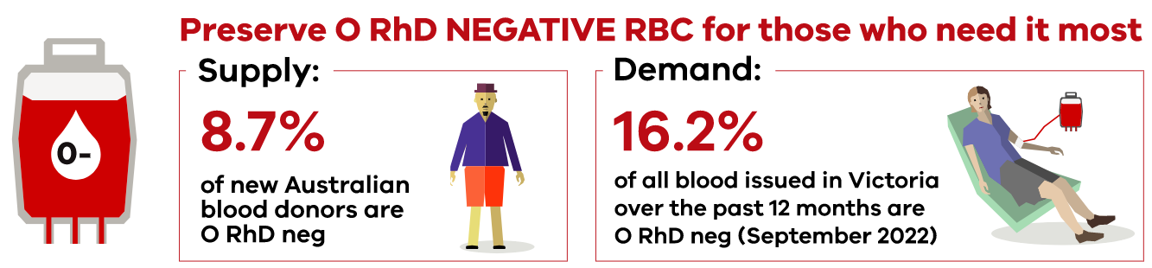

Blood Matters in collaboration with Safer Care Victoria have developed resources and support tools to assist Victorian health services with appropriate utilisation of emergency use group O red blood cells, in line with the national statement.

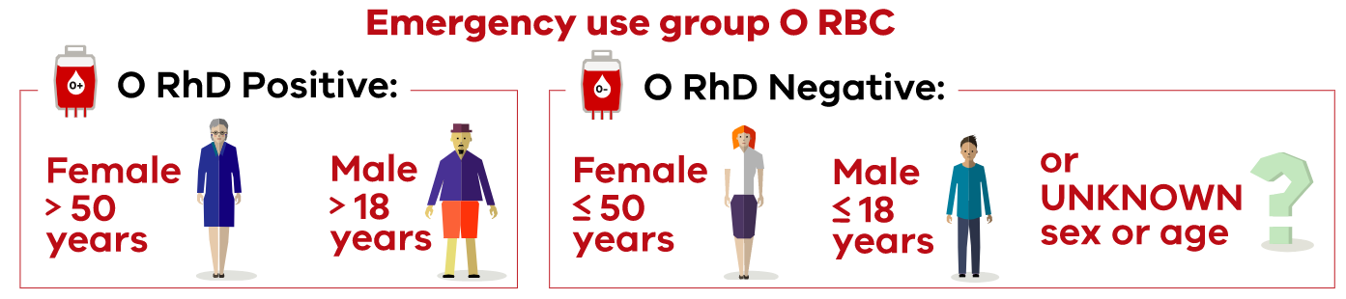

We are currently seeking final approval for release of these resources and anticipate their distribution by the end of February 2023. We will notify you as soon as they are available.

Should you have any questions please contact the Blood Matters team at: [Bloodmatters@redcrossblood.org.au](mailto:Bloodmatters@redcrossblood.org.au)

## ‘STOP the waste’ festive campaign 2022-23

We are approaching the end of the festive season (Nov-Feb).

**This year to date we have seen an increase in wastage, particularly with O RhD negative red blood cells**.

Inventory management is a complex task, with many factors influencing whether blood components are used or discarded. We appreciate all your efforts in keeping blood wastage to a minimum, and ask that particular consideration is given to timely rotation of red blood cells and reviewing inventory levels to reflect usage.

## National certification of the medical scientist profession

The Australian Council for Certification of the Medical Laboratory Scientific Workforce has simplified its acronym to CMLS. Join now at [www.cmls.org.au](http://www.cmls.org.au/).

#### Why become certified?

* Demand recognition of our professional standing as part of Australia’s health service workforce.
* Certification will be the best benchmark available to assure competent professional practice.
* With a certified workforce there will be more obligation on the employer to ensure staff have professional development opportunities afforded to them.
* As a nationally certified medical scientist you can demonstrate your ongoing commitment to professional development and self-improvement and be recognised as passionate, progressive and pro-active.

[Click here to view a short video about the certification scheme](https://www.youtube.com/watch?v=6Zc4QQJEijs)

A Blood Matters education session was held in May 2021 which included information about the certification scheme. [Click here for to view meeting recording](https://urldefense.com/v3/__https:/lifeblood.webex.com/recordingservice/sites/lifeblood/recording/3d6d869b9a801039b77f005056baad9d/playback__;!!FNSAje27EPQO!9z4B_6kTDzMvUPqe14jyDtZuJza4nzuaLDPUzZhE7LJH45b0vpBE8c-eKrkcEPPKP-NdJ8UR$) (the certification presentation begins at time point 20:38).

Blood Matters is committed to providing support and education to assist in the early stages of this scheme.

## How can Blood Matters help you?

The Blood Matters team are here to assist health services and laboratories through education and providing resources.

If you have suggestions for tools and resources that could assist in day to day activities and towards achieving accreditation please let Rae French or any of the Blood Matters team know by email to at [rfrench@redcrossblood.org.au](mailto:rfrench@redcrossblood.org.au) or [bloodmatters@redcrossblood.org.au](mailto:bloodmatters@redcrossblood.org.au) or phone 03 9694 3524.

|  |
| --- |
| To receive this document in another format, phone 03 9694 0102, using the National Relay Service 13 36 77 if required, or [email Blood Matters](mailto:bloodmatters@redcrossblood.org.au?subject=Accessible%20document) <bloodmatters@redcrossblood.org.au>.  Authorised and published by the Victorian Government, 1 Treasury Place, Melbourne.  © State of Victoria, Australia, Department of Health, February 2023.  **ISSN** 2652-7278 – **Online (pdf / word)**  Available at [Blood Matters](https://www2.health.vic.gov.au/hospitals-and-health-services/patient-care/speciality-diagnostics-therapeutics/blood-matters/transfusion-science-blood-stewardship) <https://www2.health.vic.gov.au/hospitals-and-health-services/patient-care/speciality-diagnostics-therapeutics/blood-matters/transfusion-science-blood-stewardship> |