Emergency use group O red blood cells (RBC)
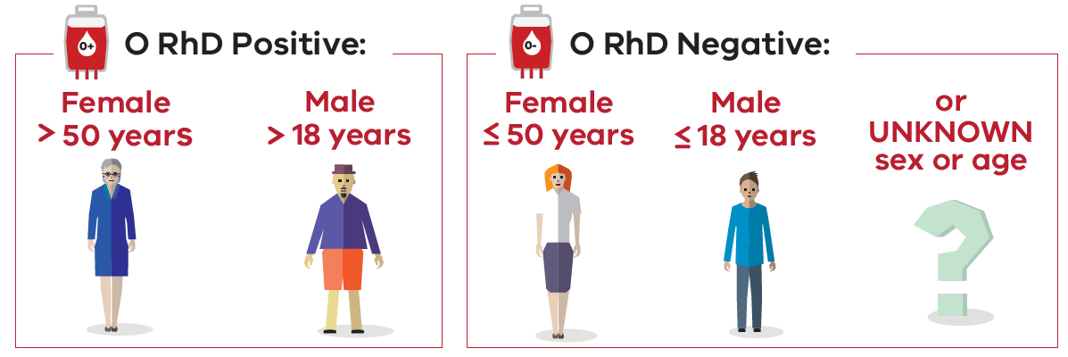
- Emergency use RBC are NOT RISK FREE
Use group specific/crossmatched blood wherever possible
- CHECK for a valid group and screen/crossmatch and transfusion history
- Take a pretransfusion sample BEFORE giving emergency blood
- MOVE to group specific/crossmatched RBC ASAP
- ASSESS the clinical requirement for holding emergency use group O RBC
- ROTATE emergency use group O RBC on a regular basis
- AUDIT emergency group O RBC use
- INVESTIGATE incidents of inappropriate emergency group O RBC use and/or wastage
- REPORT antibody formation/transfusion reactions after emergency group O RBC use to local and state haemovigilance program
- PRESERVE O RhD negative blood for those that have no alternative

To receive this document in another format, phone 9694 0102, using the National Relay Service 13 36 77 if required, or email Blood Matters <bloodmatters@redcrossblood.org.au>.
Authorised and published by the Victorian Government, 1 Treasury Place, Melbourne.
© State of Victoria, Australia, Department of Health, January 2023.
Available at Blood Matters Program website <https://www.health.vic.gov.au/patient-care/blood-matters-program>

