
Community report on the investigation in Barwon Heads for cancer and autoimmune disease 2019–2021
OFFICIAL

Community report on the investigation in Barwon Heads for cancer and autoimmune disease 2019–2021

To receive this document in another format phone 1300 650 172, using the National Relay Service 13 36 77 if required, or email the Environmental Health Unit (Health) <Environmental.HealthUnit@health.vic.gov.au>.
Authorised and published by the Victorian Government, 1 Treasury Place, Melbourne.
© State of Victoria, Australia, Department of Health, March 2023 (2212326)
ISBN 978-1-76131-124-6 (pdf/online/MS word)
Available at the Department of Health website <https://www.health.vic.gov.au/chief-health-officer/cancer-rates-on-the-bellarine-peninsula>

Contents
Why were the studies conducted? 8
Drysdale 8
Barwon Heads 8
What action was taken? 8
What was found? 9
Drysdale 9
Barwon Heads 9
What is cancer? 10
What are autoimmune diseases? 10
What are disease clusters and how are they investigated? 11
How was the possibility of a disease cluster in Barwon Heads investigated? 12
Results of the investigation 13
Cancer 13
Autoimmune disease 14
Environmental studies 14
Conclusion 15
Further information on the Victorian Department of Health investigation in Barwon Heads for cancer and autoimmune disease 2019–2021 16
How relevant to Barwon Heads was the data used in the three studies? 16
The difficulties with, and limitations of, epidemiological studies 16
What do we know about mosquito control around Barwon Heads? 18
Further reading 19

[Break out box text:
There is no evidence of an increased risk of cancer or autoimmune disease for residents of Barwon Heads on the Bellarine Peninsula.
March 2023
Adjunct Clinical Professor Brett Sutton, Victoria’s Chief Health Officer
End of break out box text.]
A series of three studies undertaken between 2019 and 2021, all reviewed by an independent body of experts and assessed by a Senate inquiry, found no elevated risk of cancer in Barwon Heads on the Bellarine Peninsula. In addition, enquiries made at local hospitals in 2019 to specialist clinicians whose practices cover the peninsula found that none of them had detected an increase in the incidence of any autoimmune disease.
The investigation was initially launched by the Department of Health in January 2019 in response to community concerns of a possible cancer cluster among students attending the Drysdale Campus of Bellarine Secondary College. In this case, the concern was about the historical use of the insecticide dieldrin in nearby farming areas until approximately 1987. Dieldrin is considered a likely human carcinogen (cancer-causing substance).
Subsequently, local residents in Barwon Heads expressed concern about their perception of a high incidence of cancer and autoimmune disease in their area. They were worried that chemicals used in mosquito control programs, particularly during the 1980s and 1990s, could have caused a possible increase in both groups of illnesses.
The department commissioned two further studies from Cancer Council Victoria. The investigation reached the conclusion that there was no substantive evidence of increased incidence of cancer (other than breast cancer; see further commentary on this below), or for autoimmune disease for people living in the Barwon Heads area compared with all Victorians.
This document summarises the results of these studies and responds to the issues raised by community members. It also provides general background information on cancer, autoimmune disease, disease clusters and their investigation.
The full reports of the studies are available on the Department of Health’s website <https://www.health.vic.gov.au/chief-health-officer/cancer-rates-on-the-bellarine-peninsula>.

Why were the studies conducted?

Drysdale
After media reports of a potential cancer cluster on the Bellarine Peninsula in December 2018, the Department of Health and the Chief Health Officer conducted an investigation beginning in January 2019. The media reports raised the possibility that students and staff at the Drysdale Campus of Bellarine Secondary College may have been exposed to and affected by the pesticide dieldrin, a likely human carcinogen, which was used on nearby potato fields until 1987.

Barwon Heads
Residents of Barwon Heads then raised concerns within their community and through the media about an increase in cancer and autoimmune disease incidence, particularly among young people who had lived in the area and attended the primary school in Barwon Heads in the 1980s and 1990s. They were worried about a possible link with chemicals used by local councils for mosquito control, in particular organophosphate and pyrethroid insecticides.

What action was taken?
Table 1: Action taken in response to the potential cluster
2019 | Chief Health Officer’s disease incidence study, covering Bellarine Peninsula 2010 to 2014.
2019 | Cancer Council Victoria disease incidence study, covering Barwon Heads 2001 to 2016.
2021 | Cancer Council Victoria disease incidence study, covering Barwon Heads 1982 to 2019.
2019 & 2021 | All three studies were reviewed by four professional health academics with expertise in epidemiology, risk assessment, toxicology and cancer. Known as the Expert Advisory Group, they were drawn from the University of Newcastle, the University of Sydney, the University of Melbourne and RMIT University.
2021 | The whole investigation process was assessed by Senate’s Community Affairs References Committee.
In addition, data were drawn from historical soil analyses across the Bellarine Peninsula, some as early as 1987. They included analyses commissioned by the Victorian Schools Building Authority at the Bellarine Secondary College in September 2018 and at the Barwon Heads Primary School in February 2019.

What was found?

Drysdale
In January 2019 an assessment of cancer incidence was made by the Chief Health Officer using data for the Bellarine Peninsula from the then newly published Australian Cancer Atlas. It found no evidence of higher rates than expected of total cancer nor of the specific cancers cited in the media – the blood cancers non-Hodgkin’s lymphoma, chronic lymphocytic leukaemia and multiple myeloma – in any geographical area of the Bellarine Peninsula, including that containing the Bellarine Secondary College.
Dieldrin is not known to result in any of the cancers cited. In addition, a soil analysis at the Drysdale Campus of the Bellarine Secondary College commissioned by the Victorian Schools Building Authority and undertaken in September 2018 showed dieldrin, where present, to be well below health investigation guideline levels. Thus, there was little likelihood of any future increased cancer risk.

Barwon Heads
None of the epidemiological (disease incidence) studies conducted found a higher incidence than expected of total cancer or of liver, prostate, testis, blood, bone marrow, lymphatic system, brain or central nervous system cancer in the Barwon Heads area between 1982 and 2019.
The sole exception was a slightly elevated incidence of breast cancer found in the 2021 study by the Cancer Council Victoria. This was considered by the Expert Advisory Group to be consistent with the high socioeconomic status of the area. High socioeconomic status is a known risk factor for breast cancer. None of the chemicals used for mosquito control in the Barwon Heads area are known to cause breast cancer.
There are no clinical reports from local specialists of increasing incidence of autoimmune disease in the area.

What is cancer?
Cancer occurs when cells begin to multiply in an uncontrolled way. The body, with all its tissues and organs, is constructed from cells of many different types. The growth, numbers and combinations of these cells are tightly regulated so that lungs, liver, heart and all other body parts form in the right places, at the right time, at the right size, and from the right cells and tissues. Cells are also programmed to die once their job is done. The cells lining our gut, for instance, live about three to five days, the cells in our liver between 200 and 300 days, and heart muscle cells more than four years.
Cell regulatory systems can be disrupted in several ways – physically, by radiation such as UV and x-rays; biologically, by microbes such as viruses; and chemically, by compounds known as carcinogens. Some people can have a higher risk of cancer due to inherited changes in ‘cancer susceptibility genes’, such as the BRCA1 and BRCA2 genes involved predominantly in breast and ovarian cancer, and because of health-related factors such as cigarette smoking, alcohol consumption and being overweight or obese.
Cancers are classified and named based on the types of cells and tissues in which they first start – for instance, lung cancer, breast cancer or leukaemia (cancer of white blood cells). Depending on the type of cancer, the time lag between when cells begin to grow and divide uncontrollably and when this begins to affect a person’s health is typically five to 10 years, but it can vary from months in some blood cancers to decades in some solid tumours such as lung cancer. It is important to note that different cancers are essentially different diseases with differing risk factors, causes and treatments.
Cancer is more common than most people think. Figures from the Victorian Cancer Registry – where all diagnosed cancers in Victoria must be registered by law – show that two out of five men and one out of three women will develop some form of cancer by the age of 75 years. The risk increases as the body and its cellular systems age.

What are autoimmune diseases?
Autoimmune diseases occur when our immune system, instead of acting to rid our body of foreign microbes and substances, mistakenly begins to attack the body itself. Susceptibility to autoimmune disease tends to run in families and so could have a genetic basis. It is likely that a combination of genetics, lifestyle and environmental factors plays a role in triggering autoimmune conditions. Women are more prone to autoimmune disease than men, particularly during child-bearing years, suggesting a role for sex hormones. Common autoimmune diseases include coeliac disease, lupus, inflammatory bowel disease and psoriasis.

What are disease clusters and how are they investigated?
A disease cluster is a higher-than-expected number of people in the same area diagnosed with the same disease over a particular period of time.
Disease clusters related to a local cause are rare and becoming rarer. Our tightening health and safety rules and regulations, and controls on hazardous substances, act to minimise exposure to anything that could potentially initiate a cluster.
When a disease cluster does occur, however, it can be a serious problem because of the potential risk to health and the community anxiety involved. So, the Department of Health takes all concerns over disease clusters very seriously.
The department receives about three or four reports a year from groups of people concerned about an unusual pattern of incidence of disease in their community. The process of investigating these reports is to probe more deeply in stages until a reasonable answer is found.
Typically, an investigation begins with a preliminary assessment that involves drawing together any available clinical and environmental information relating to the geographical area of concern; this includes interviewing local people, particularly those who have reported the problem. Most investigations end at this point because the existence of a cluster due to a local hazard does not make scientific sense. In other words, the elements of the perceived cluster – including the hazard, exposure to the hazard and disease it can cause, the disease latency period and the disease of concern – do not fit together. An investigation may also end because there is not a real increase in cases above what is expected.
If the preliminary assessment shows a possible local cause, then there are three further stages of investigation laid out in a protocol the department follows. Each stage is assessed thoroughly before moving onto the next, if no satisfactory answers have been found. The second stage involves a more detailed assessment of the available data with the help of experts. The third stage involves obtaining and assessing further data, and the fourth, if necessary, includes undertaking or commissioning specific research studies.
Concerns about a cancer cluster, in particular, are difficult to assess, partly because cancer can take years or even decades to develop. Epidemiologists (the scientists who track disease) generally have to resort to using historical data not necessarily gathered for the purpose of identifying a cluster, and this can complicate the investigation. The role of historical data in the Barwon Heads and Bellarine investigations is discussed below.
Table 2: Investigating disease clusters
Stage 1 | Preliminary assessment of available clinical and environmental information
Stage 2 | More detailed assessment involving relevant experts (such as the Cancer Council)
Stage 3 | Obtaining and assessing further data
Stage 4 | Commissioning specific research studies
Our experience over decades has shown that most investigations are resolved with a stage 1 or 2 assessment.

How was the possibility of a disease cluster in Barwon Heads investigated?
The media reports in December 2018 to do with Bellarine Secondary College sparked an initial study directed by the Chief Health Officer in January 2019. It used data from the Australian Cancer Atlas, which had been published only a few months earlier. The atlas included data covering the Bellarine Peninsula between 2010 and 2014.
[Break out box text:
Australian Cancer Atlas data
Details of cancers diagnosed in Australia and their survival outcomes can be obtained from the Australian Cancer Database, maintained by the Cancer Data and Monitoring Unit of the Australian Institute of Health and Welfare. The database combines information collected by each of the eight state and territory cancer registries in Australia. It includes all cancer cases notified by hospitals and pathology laboratories in all states and territories, as well as those notified by general practitioners, cancer screening registers and nursing homes in some, but not all, states and territories. It is a legal requirement for cancer to be notified to the appropriate registry across Australia, hence cancer is one of the few diseases with almost complete coverage in Australia. The dataset includes details of the usual residence of any person in whom cancer was diagnosed.
End of break out box text.]
This epidemiological study found no evidence of a cancer cluster. What’s more, there is no known link between dieldrin and the cancers that were of concern. In addition, the results of soil analysis conducted at the Drysdale campus in 2018 for the Victorian Schools Building Authority showed dieldrin at low levels, so extremely unlikely to cause any ongoing problems.
The concern at Bellarine Secondary College may have added to local perceptions of a high incidence of cancer and autoimmune disease among young people of that area, and of this being related to exposure to pesticides used in mosquito control.
In 2019 and 2021, the Department of Health commissioned two further detailed epidemiological studies of the Barwon Heads area from Cancer Council Victoria using the Victorian Cancer Registry. The Victorian Schools Building Authority had already commissioned an extensive chemical analysis of the soil of the local primary school, similar to the one that had previously been undertaken at Bellarine Secondary College. The department also used data from soil analyses at several other places across the peninsula.

Results of the investigation

Cancer
An independent Expert Advisory Group made up of four eminent academics with widespread knowledge of the field reported that all three epidemiological studies were appropriate and of a high standard.
None of the studies found evidence of a statistically significant increase in the incidence of cancer in the Barwon Heads area beyond what was expected, with the exception of a slightly elevated incidence of breast cancer determined in the more extensive 2021 Cancer Council investigation.
As assessed by members of the Expert Advisory Group, none of the products used to control mosquitoes in the area have been associated with breast cancer. The group suggested that the elevation in the level of breast cancer was related to a known risk factor – the high socioeconomic status of the area.
The overall number of cancers (all types combined) in Barwon Heads was slightly less than expected (see Figure 1).
Figure 1: Cancer standardised incidence ratios in Barwon Heads from 1982 to 2019
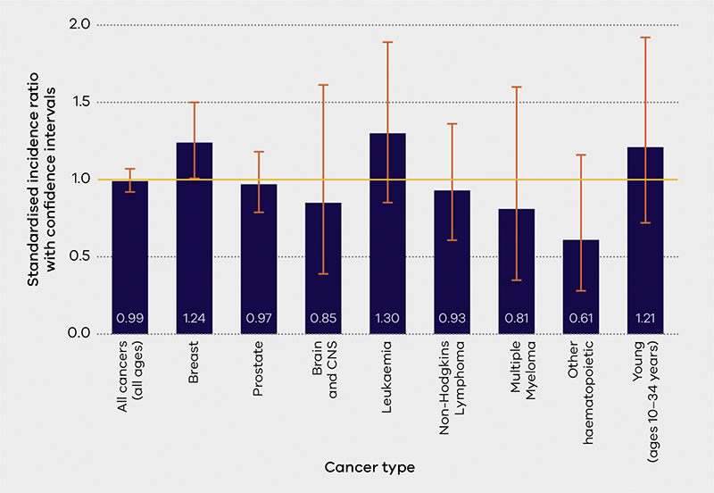
Note: Data for testis and liver cancer and Hodgkin’s lymphoma have not been represented because the observed number of cases was less than five. The confidence interval is represented as orange error bars and the standardised incidence ratio of 1 is shown as a yellow line.
A standardised incidence ratio of 1 indicates that the number of cancer cases observed equals the number of cancer cases expected and is shown as an orange line. Standardised incidence ratios and confidence intervals are explained later in this report in the “Further information on the Victorian Department of Health investigation in Barwon Heads for cancer and autoimmune disease 2019–2021” section.

Autoimmune disease
The lack of a central repository of data relating to autoimmune disease in Victoria made it unfeasible to undertake similar epidemiological studies. However, the department has received no clinical reports of increased rates of autoimmune disease on the Bellarine Peninsula. It also reviewed the scientific literature and found the rates of inflammatory bowel disease, a common autoimmune disease of concern to residents, were similar to those reported in Canada and New Zealand. Specialists at local hospitals across a broad spectrum of autoimmune diseases were contacted, and there were no reports of any unusual increases in the area.

Environmental studies
The Bellarine Secondary College soil analysis included tests for organochlorine pesticides (which includes dieldrin). The Barwon Heads Primary School soil analysis was additionally tested for organophosphate pesticides (including the insecticide temephos) and polycyclic aromatic hydrocarbons (including benzopyrene) as well as many other chemicals such as arsenic and the heavy metals (including cadmium, chromium, copper, mercury, lead, nickel and zinc).
At Bellarine Secondary College, organochlorine pesticides were either non-detectable or at such low concentrations as to cause no health or environmental concerns at any of the 20 sites where samples were taken. At Barwon Heads Primary School, the analyses showed that no chemical substances tested for in the soil at any of the 29 sites exceeded the national criteria for protecting human health and the environment.

Conclusion
Victoria’s Chief Health Officer concluded there is no substantive evidence of an increased risk of cancer (other than breast cancer, with known explanation), or for autoimmune disease, for residents of Barwon Heads on the Bellarine Peninsula.
The Senate’s Community Affairs References Committee reviewed the available scientific evidence and came to the view that:
1. The cases of concern to the community did not represent a cancer cluster.
2. There was no scientifically plausible cause of a cancer cluster in Barwon Heads.
3. Any further epidemiological or chemical exposure studies would be of little value to the community.

Further information on the Victorian Department of Health investigation in Barwon Heads for cancer and autoimmune disease 2019–2021

How relevant to Barwon Heads was the data used in the three studies?
The initial study by the Chief Health Officer used data from the Australian Cancer Atlas, which had just been published. This data was of high quality and was readily available.
The data used covered the whole Bellarine Peninsula. This was because of the uncertainty of the boundaries of any possible impacts from the use of dieldrin when the area was used for agriculture and because students attending the secondary school could have been drawn from anywhere across the peninsula.
Although the analysis provided a useful overview, the report had some limitations. The most significant were twofold:
- that the data for the Atlas were collected using geographic areas much larger than local areas, such as Barwon Heads alone, and so would include people from outside the specific areas under consideration
- that, although the data was relevant to the young people at Bellarine Secondary College, it related only to the time between 2010 and 2014, and so would include only those living on the peninsula known to have a new diagnosis of cancer in those five years.
The concerned residents argued that the period when people were most likely to have been exposed to carcinogens was in Barwon Heads between 1980 and 2000, and that any cancer triggered then would likely be diagnosed anywhere between five years and several decades later.
The two Cancer Council Victoria investigations were commissioned in part to address these limitations. Given that the area of concern was now limited to Barwon Heads, the Victorian Cancer Registry was asked to provide data on a much finer geographic scale than the atlas, and over a much longer time scale, initially 2001 to 2016, and later 1982 to 2019.
Even so, there is no way to track and account for people who moved into or out of the Barwon Heads area during the time studied. Also, in a coastal resort such as Barwon Heads, it was almost impossible to include people who visited the area seasonally (overwhelmingly during summer) – although, as was pointed out to the Senate inquiry, these people would have far less chance of an exposure to any disease-causing agent than year‑round residents.

The difficulties with, and limitations of, epidemiological studies
One difficultly relating to epidemiological analysis of cancer clusters is that the geographical distribution of cancer is not even. Some areas will have more cases, others fewer, partially reflecting the distribution of risk factors. Even within the same area, the number of cancers varies over time. Some years have more cases than others, simply by chance. This means there will be times and places where there seems to be more cancer cases than normal. This can seem even more pronounced if the area is small and with fewer people. It’s like zooming in on a digital image. The picture becomes grainier – a few dots or cases can appear to make a huge difference.
People are very good at seeing patterns and they rightly become concerned if they identify an area where there is a greater incidence of cancer than they would expect. Teasing out if such a noticeable increase in local cases is due to a local cause or to the natural variation (and clustering in time or space) related to chance is essential. This is a major purpose of a cancer cluster investigation.
Judgements about how such an analysis is undertaken and interpreted are very important. That’s why the assistance of epidemiologists such as those at Cancer Council Victoria, who have significant experience and expertise, is sought. Putting together the right data over space and time allows the Cancer Council Victoria epidemiologists to calculate the number of cases that they would normally expect for different cancers in a small area such as Barwon Heads, taking into account the population’s age and sex characteristics.
The observed number of people with certain cancers can then be compared with the expected number of cases. This is usually done by calculating the ratio of the two – that is, observed/expected. This is called the standardised incidence ratio (SIR).
An SIR of 1 indicates that the number of cancer cases observed is equal to the number of cancer cases expected. If the SIR is greater (or less) than 1, then the observed number of cases is higher (or lower) than the expected number of cases (see Figure 2).
Figure 2: Standardised incidence ratio
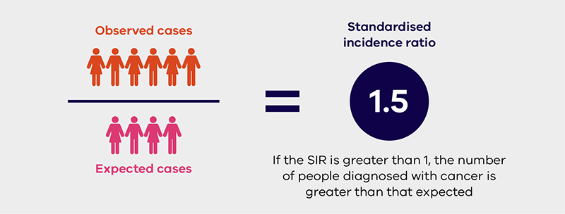
In order to deal with natural variation in cancer incidence relating to chance, a 95 per cent confidence interval is calculated around the SIR to indicate a range of values within which the true value of the SIR is likely to lie. Confidence intervals help scientists to understand how likely it is that an apparent increase (or decrease) in risk is due to chance, rather than being a true increase (or decrease) in the risk of getting the disease.
If the lower limit of the confidence interval is greater than 1, the result is considered statistically significant and regarded as elevated. If the confidence interval includes 1, then this result is not considered as statistically significant and not regarded as elevated because it could be reasonably explained by chance alone. This occurred in the analysis of leukemia in the years 1982–2019, where the SIR was 1.30 but the confidence limits were 0.85–1.89 (see Figure 3). The Expert Advisory Group advised that, based on evidence from the Victorian Cancer Registry, residents of Barwon Heads are not living in an area of high incidence of leukaemia.
Figure 3: SIR and confidence intervals for leukemia and breast cancer between 1982 and 2019
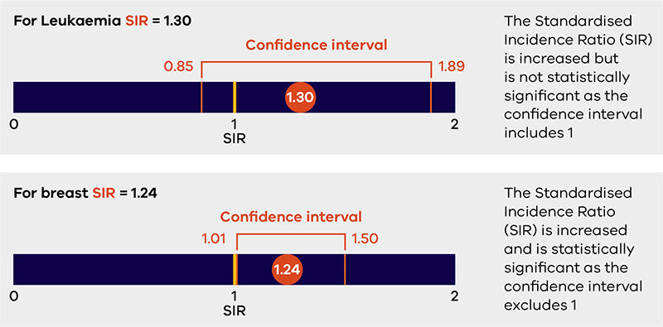
If the evidence for an increase of disease incidence in a population is statistically significant, then health authorities consider further analysis to consider feasible causes in the environment as well as other important risk factors that may not have been taken into account (such as socioeconomic status or smoking rates). The consideration of feasible causes is where environmental and toxicology studies come in, helping to determine if people have had enough exposure to a harmful agent known to be linked to specific cancers or other conditions
A statistically significant increase in an SIR needs an explanation. It may be because the investigation did not consider certain known risk factors for that cancer. This was the case with breast cancer where the influence of socioeconomic status was not taken into account. The Expert Advisory Group considered the small increase found by the investigation to be related to the area’s higher socioeconomic status – a known risk factor – rather than a local carcinogen. None of the chemicals used in the mosquito control program are known to cause breast cancer.
Note that while the 95 per cent confidence interval is the generally accepted scientific standard, it does not exclude the possibility that the increase is due to chance.
There are several other limitations to epidemiological studies in addition to the data sampling difficulties mentioned earlier. For instance, an association between the level of a chemical in the environment and the incidence of a particular disease does not necessarily mean that one caused the other. It could be sheer coincidence, or the relationship might be more complex.

What do we know about mosquito control around Barwon Heads?
Barwon Heads is surrounded by mosquito breeding habitat in the form of a river, six wetland areas and two lakes. The local government has been involved in active mosquito control since at least 1984, with the aim of minimising the risks of mosquito-borne disease and the irritation of biting insects. The control program has been managed by the City of Greater Geelong since 1993, when that council was formed. Records from the smaller local councils that existed before that time are limited. The City’s detailed written records began in 2005. City officials were, however, able to make several relevant general statements.
The findings summarised in the Senate inquiry are as follows:
- Control was primarily targeted at mosquito larvae, using chemical and biological agents applied to the water bodies in forms such as pellets, liquid and sand.
- The mosquito control program moved over time towards almost exclusively biologically based controls such as the bacterium Bacillus thuringiensis israelensis, insect growth regulators and, occasionally, synthetic pyrethroids. None of these are recognised as carcinogenic, or even particularly poisonous, because they specifically disrupt insect biological systems rather than human ones.
- Chemical pesticides that target adult mosquitoes were used only intermittently in seasons when mosquitoes were a particular problem.
- The only pesticides known to be employed were the organophosphate temephos, used against larvae for four years in the mid-80s and in a trial in 1998, and phenothrin, a synthetic pyrethroid, used sporadically against adult mosquitoes from 1988 to 2005 and then in 2007, 2010 and 2012. Neither has been shown to be carcinogenic or to cause autoimmune disease.
- The spraying technique known as fogging was occasionally used to apply pyrethrum (a natural chemical from the chrysanthemum flower) and phenothrin but ceased in 2010.
- The change in practice over time and the former occasional use of temephos and synthetic pyrethroids is consistent with other programs around Australia.
According to the experts consulted during the Senate inquiry:
- None of the chemical pesticides used against mosquitoes in the program are known to cause cancer or autoimmune disease.
- All the products sprayed break down relatively rapidly in the environment, so there is little or no chance of exposure to a multi-substance cocktail.
- If hormone disrupters resulted from any breakdown of temephos, they would be at very low levels. Also, they are not known as a cause of cancer.

Further reading
Links to all the reports discussed in this document are available on the department’s website <https://www.health.vic.gov.au/chief-health-officer/cancer-rates-on-the-bellarine-peninsula>.
The reports available include:
- Chief Health Officer’s report – Cancer rates on the Bellarine Peninsula
- Cancer Council Victoria Bellarine Peninsula Cancer Incident Report October 2019
- Expert Advisory Group – Opinion provided to the Department of Health and Human Services, 25 October 2019
- Cancer Council Victoria Bellarine Peninsula Cancer Incidence Report: Update 15 March 2021
- Report of Expert Advisory Group on Management of potential cancer cluster investigations 9 April 2021
- The Senate Community Affairs References Committee – Investigations into a possible cancer cluster on the Bellarine Peninsula, Victoria.
The City of Greater Geelong’s website also contains detailed information and FAQs about the investigation into the Bellarine cancer cluster concern <https://www.geelongaustralia.com.au/mosquitoes/news/item/8d687a5ff8046d9.aspx>.
The National Health and Medical Research Council has published an overview of cancer cluster investigations <https://www.nhmrc.gov.au/sites/default/files/images/ps0006_statement_cancer_clusters.pdf>.

