Emergency issue of blood
Onsite transfusion service
OFFICIAL

To be read in conjunction with Emergency use group O red blood cells (RBC) communique.
Do not delay an urgent transfusion to wait for crossmatched units. On notification the transfusion laboratory will provide the most appropriate blood and blood components, with laboratory haematologist advice as required.
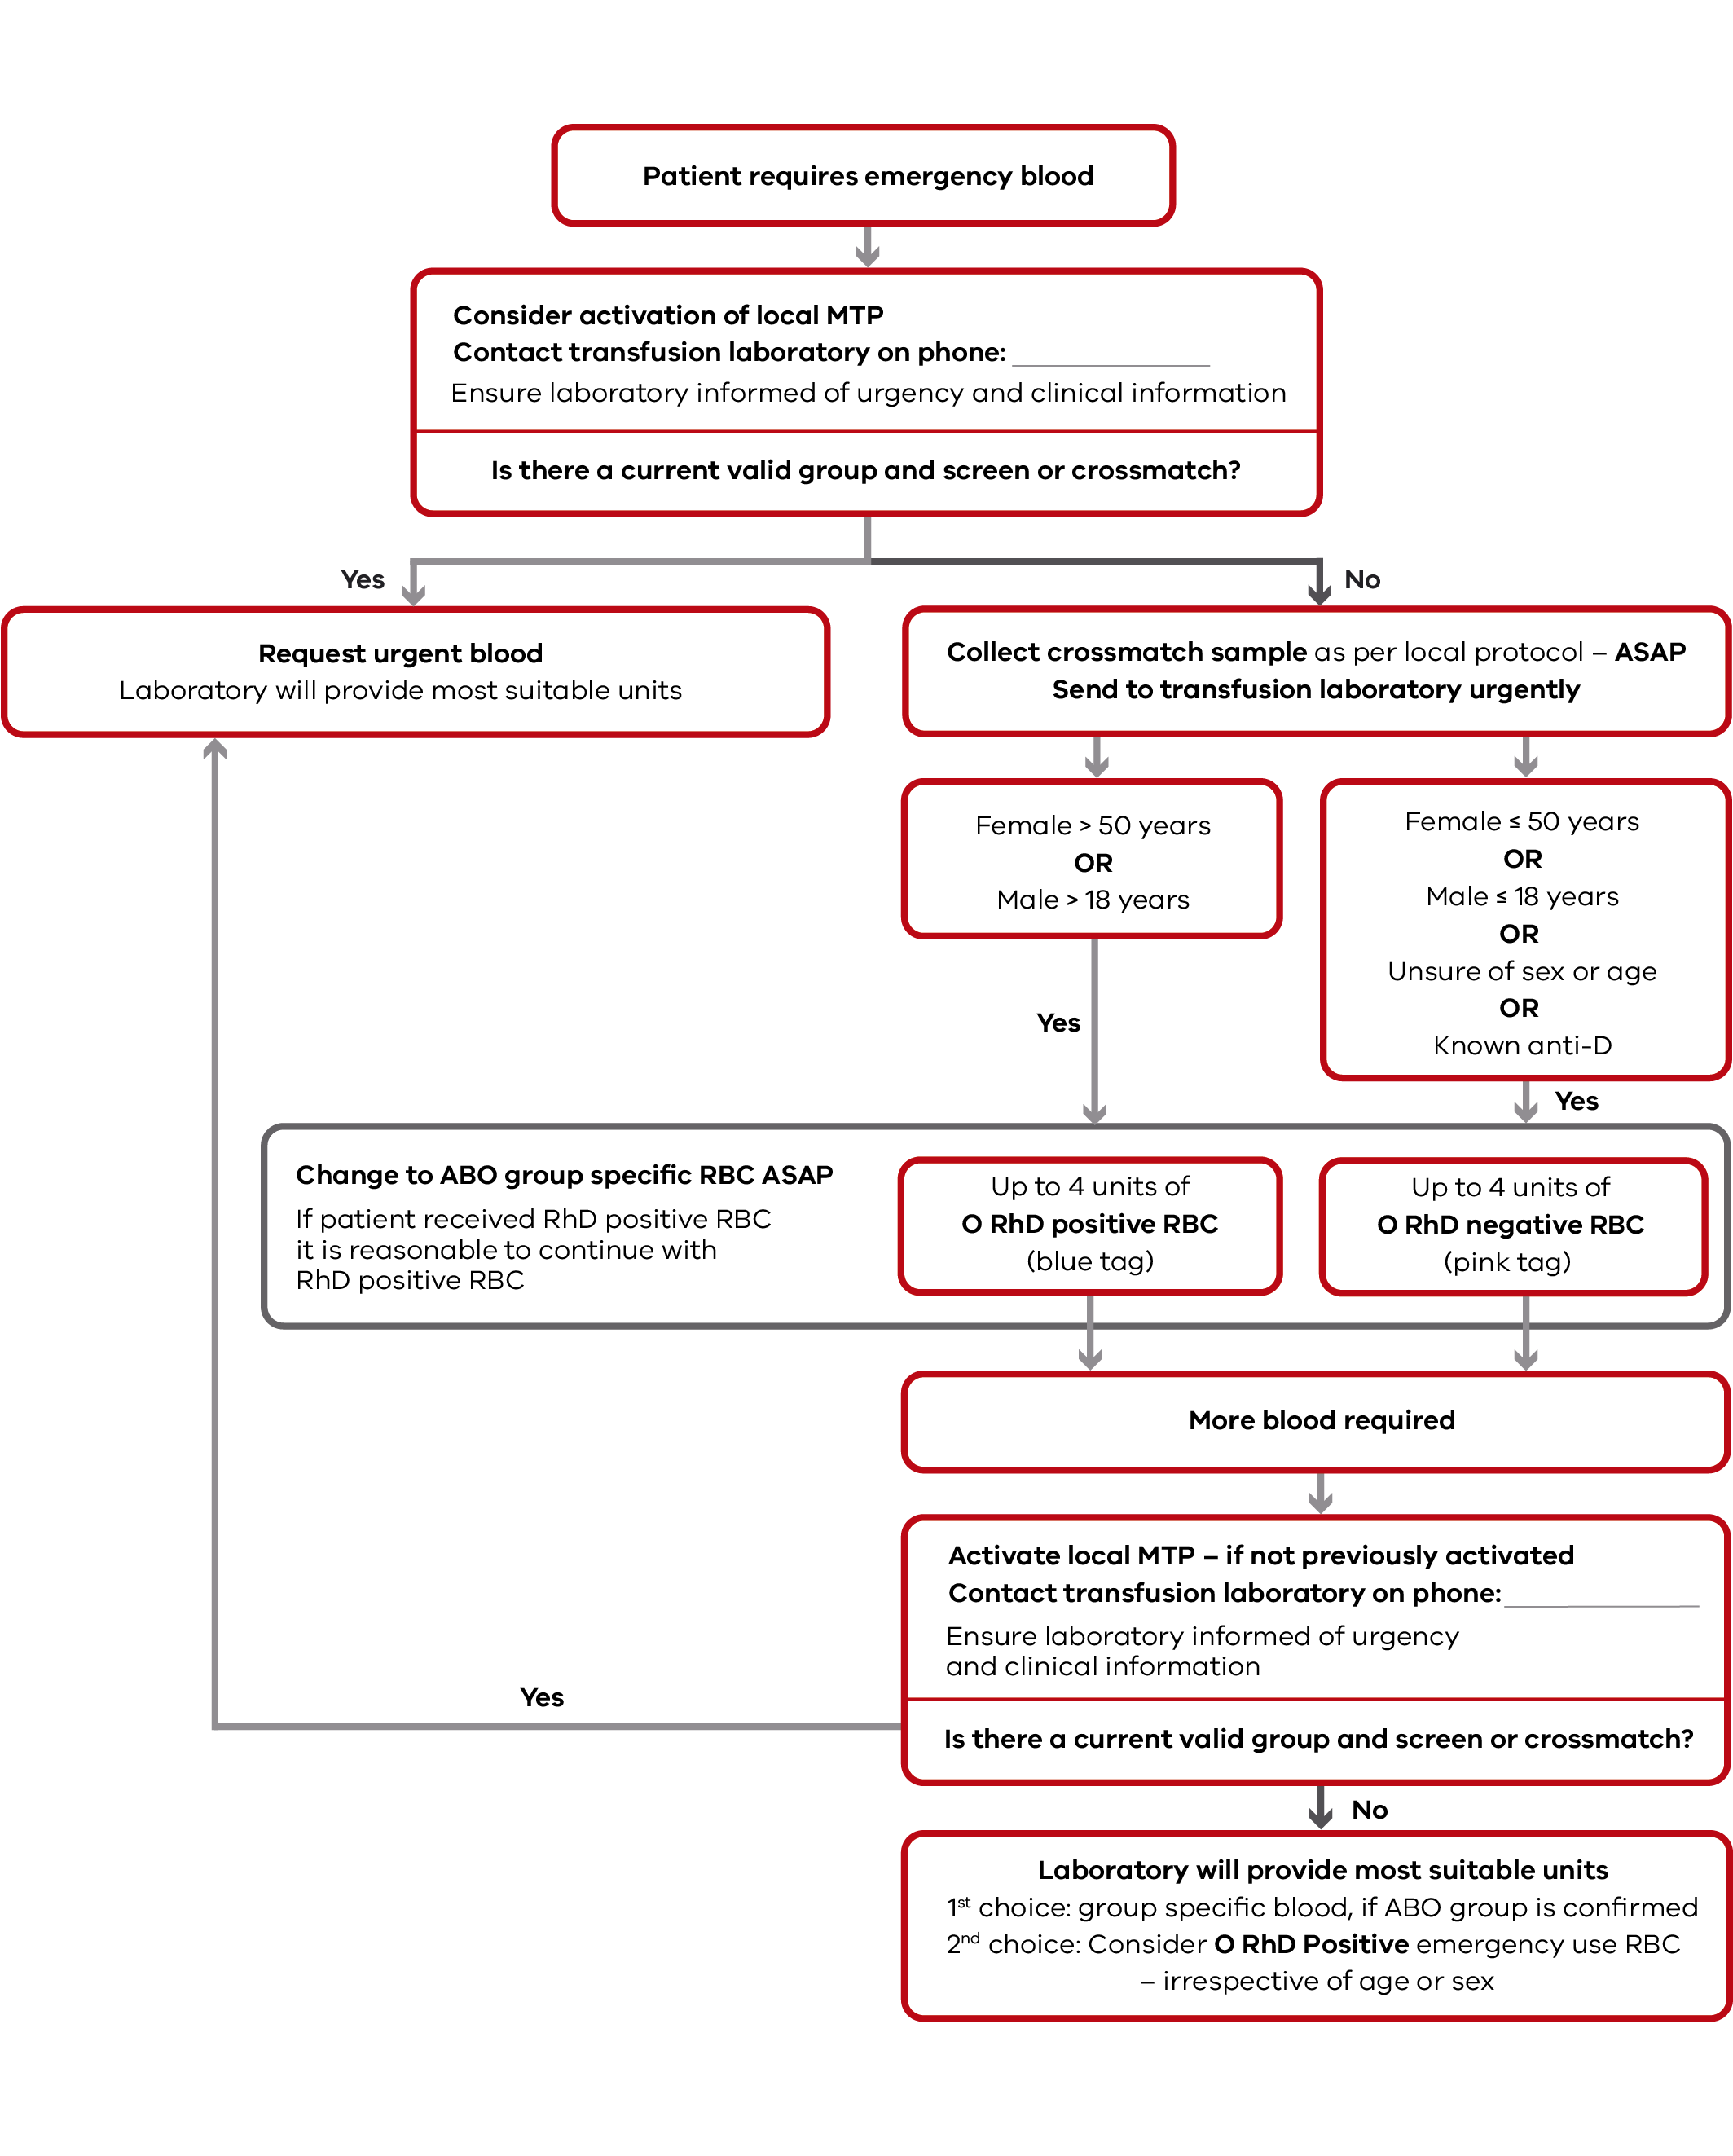

To receive this document in another format, phone 9694 0102, using the National Relay Service 13 36 77 if required, or email Blood Matters <bloodmatters@redcrossblood.org.au>.
Authorised and published by the Victorian Government, 1 Treasury Place, Melbourne.
© State of Victoria, Australia, Department of Health, January 2023.
Available at Blood Matters Program website <https://www.health.vic.gov.au/patient-care/blood-matters-program>
(DH 2210297)

