Social media pack
Secondary School Immunisations 2023
OFFICIAL

The purpose of this social media pack is to support Victorian secondary schools to communicate to parents and carers as well as secondary school students on the importance of receiving their immunisations, as part of the Secondary School Immunisations Program (SSIP).
The Victorian Department of Health Immunisation Unit website <https://www.health.vic.gov.au/
immunisation/information-for-local-councils> provides resources to deliver the SSIP including information for students who may need to complete their adolescent vaccinations due to missed vaccines.
Students can also learn about the immunisations they need and why these are important on the Victorian Department of Health Better Health Channel website <https://www.betterhealth.vic.gov.au/
health/healthyliving/immunisation-in-secondary-schools#immunisation-for-secondary-school-students-is-important>.

Post text | Accompanying asset  (use attached jpeg)
Immunisation protects people from harmful diseases. If your child is aged 10 to 19, they can receive free vaccinations at school as part of the Secondary School Immunisation Program.  Immunisations are safe and effective, and administered by a council nurse at secondary schools.  You will be provided with information about these immunisation sessions by your child’s school and must return a card to the school providing or declining your consent.  Your child can also receive immunisations at your GP, a local council immunisation service and in some pharmacies.  Due to interruptions to school-based learning in 2020 and 2021, and the ongoing effects of the COVID-19 pandemic in 2022, some students may have missed getting important vaccines at school.  Parents and carers should advise the school and nurse of any immunisations their child has missed, and any vaccines they have received outside of school.  Learn more about the Secondary School Immunisation Program in Victoria at: www.betterhealth.vic.gov.au/health/healthyliving/immunisation-in-secondary-schools | 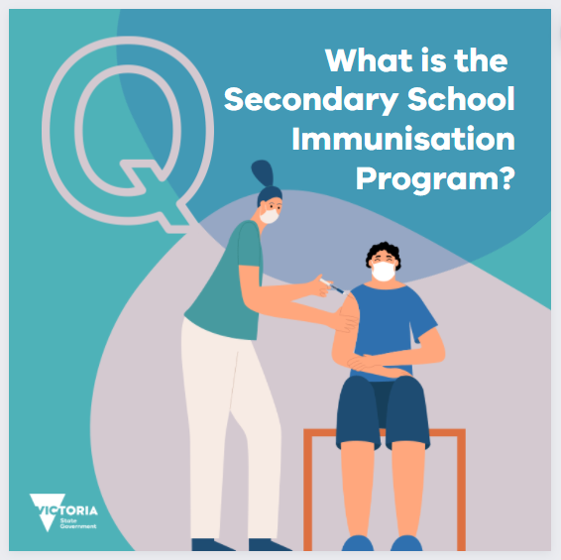
Immunisation saves lives and is a proven and safe way to protect against diseases.  The protection provided by some childhood immunisations fades over time and needs to be boosted in adolescence.  Secondary school students are at an age when some vaccines will be most effective and provide protection before possible exposure to a disease.  Making sure your child receives their secondary school immunisations will help to keep them healthy and well through secondary school and into adulthood.  Local councils provide the Secondary School Immunisation Program. For adolescents not attending school, vaccinations are available from your local GP or other immunisation provider.  Learn more:  www.betterhealth.vic.gov.au/health/healthyliving/immunisation-in-secondary-schools | 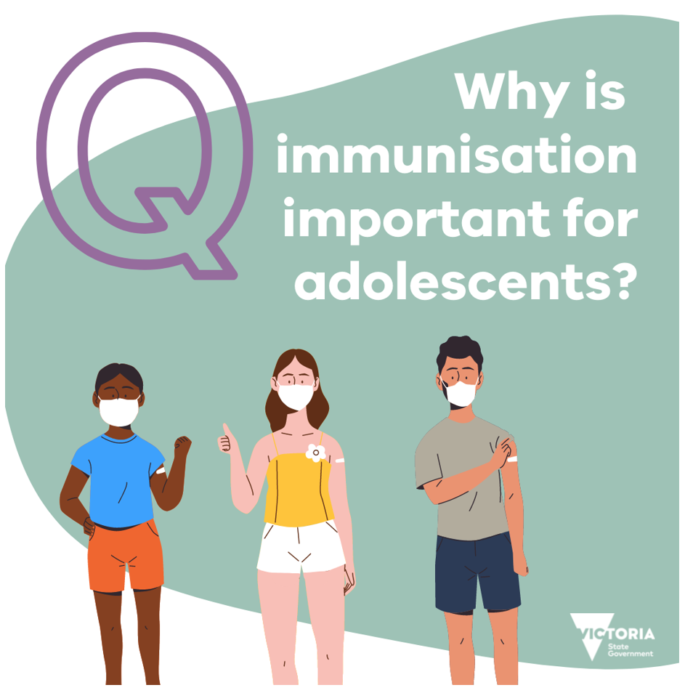
Some vaccines are routinely provided free of charge to all Victorian secondary school students.  Students in Year 7 (or aged 12-13) receive the human papillomavirus (HPV) vaccine and the diphtheria, tetanus and pertussis (whooping cough) combined vaccine.  Students in Year 10 (or aged 15-16) receive the Meningococcal ACWY vaccine.  Your child’s school will support your local council to deliver these important immunisations, as part of the Secondary School Immunisations Program (SSIP). They will communicate with you about upcoming immunisation sessions and you will receive information about a consent card which you must return to the school providing or declining your consent for your child to be immunised.  Learn more: www.betterhealth.vic.gov.au/health/healthyliving/immunisation-in-secondary-schools | 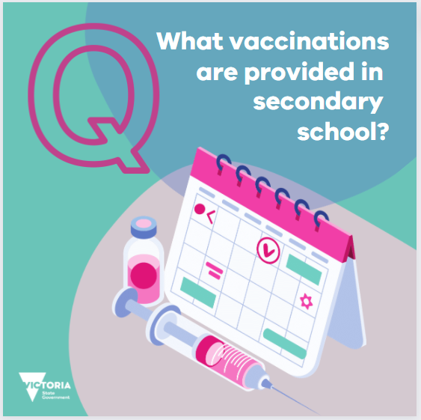
If you have a child in Year 7 or Year 10 at secondary school in 2023, look out for immunisation information and a consent form coming home with your child.  Students who are eligible for vaccination must take the form home and have it completed and signed by their parent or guardian. You must return the completed consent section to the school for your child to receive immunisation.  You can say no to the offer of free, school-based immunisation for children. If you wish to do so, you should return the consent section of the form to the school, marked as 'declined'.  When they bring the information and consent form home, take time to talk with your child about vaccination – why it’s important and how you both feel about it. If you have any questions that are not answered by the information provided with the consent form, contact your GP or your local council immunisation service.  Learn more about secondary school immunisation at: https://www.betterhealth.vic.gov.au/health/healthyliving/immunisation-in-secondary-schools | 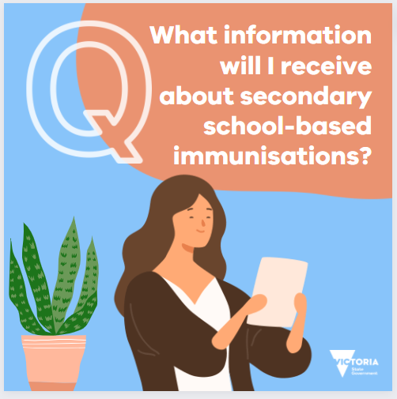
Yes. The vaccine development process is very thorough. All vaccines used in Australia are rigorously tested by the Therapeutic Goods Administration before and after they are approved.  Even once vaccines are in use they continue to be monitored for safety and effectiveness.  Immunisations are the best way to keep your child safe from harmful diseases. And when you protect your child from these diseases, you also protect others in your family and community who cannot be immunised by limiting the spread of disease.  At school-based immunisation sessions, students are vaccinated by immunisation nurses who are specially qualified to provide this service. Your local council works with your child’s school to provide a safe environment for students, staff and the immunisation team.  More information: www.betterhealth.vic.gov.au/health/healthyliving/Immunisation-common-questions | 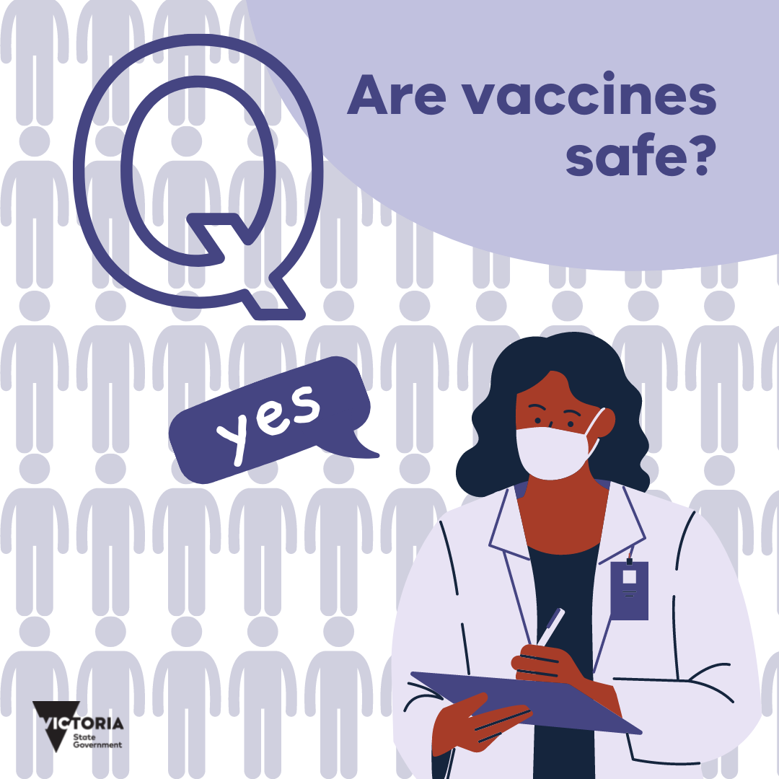
Secondary school immunisations are usually provided to students in Year 7 and Year 10. Due to interruptions to school-based learning in 2020 and 2021, and the ongoing effects of the COVID-19 pandemic in 2022, some students may have missed getting important vaccines at school.  If your child missed out on their school-based vaccinations last year, speak to your school, GP or local council immunisation service about how they can catch up.  To see if your child is due for any vaccines, check your child’s immunisation history statement on the Australian Immunisation Register using your MyGov account. If your child is over 14 they will need to access their immunisation history statement themselves through their own MyGov account or the Medicare mobile app.  Learn more about school-based vaccinations and why they’re important: www.betterhealth.vic.gov.au/health/healthyliving/immunisation-in-secondary-schools#immunisation-for-secondary-school-students-is-important | 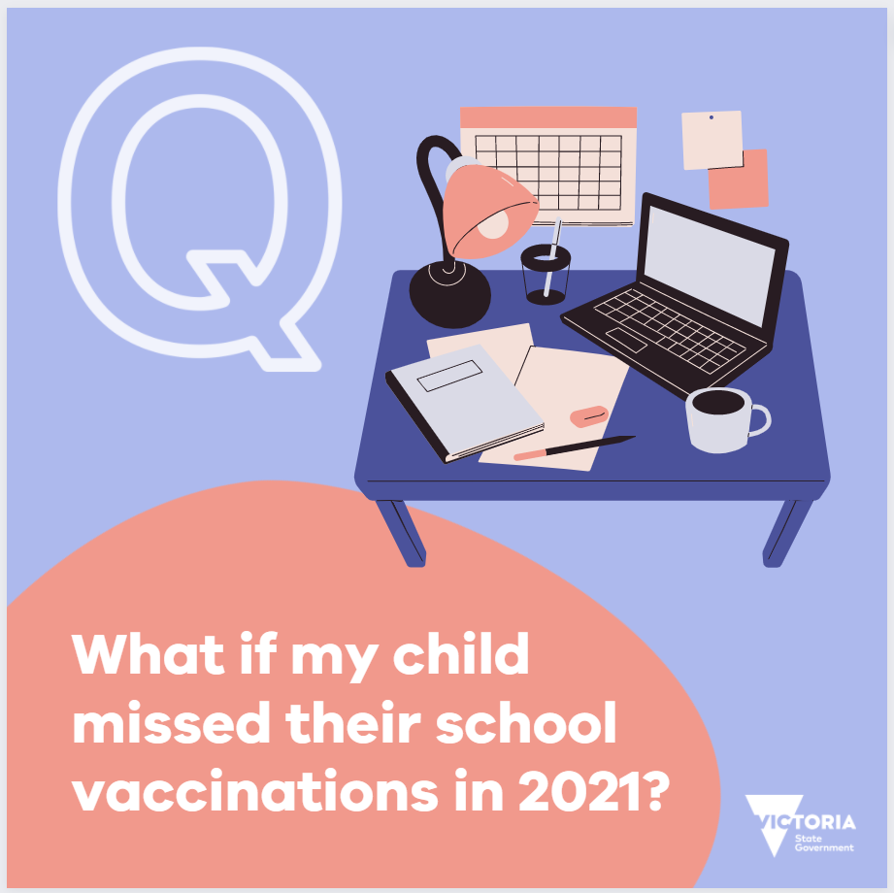
The human papillomavirus (HPV) vaccine schedule has changed from 2 doses to 1 for most people. Worldwide scientific evidence shows that 1 dose will give just as much protection as 2 doses, and protects against 90% of cervical cancers, over 95% of HPV-related cancers and over 90% of genital warts.  The eligibility age for free catch-up vaccination has also increased from 19 to 25 years of age.  For more information visit https://www.betterhealth.vic.gov.au/health/healthyliving/human-papillomavirus-hpv-immunisation | 