Mosquito and mosquito-borne disease weekly report 2022/2023
Report number: 13
Reporting week: 22/01/23-28/01/23
Report issued date: 31/01/23
OFFICIAL
Contents
Summary 2
Human mosquito-borne diseases notifications 2
Notifications 2
Japanese encephalitis virus 3
Ross River virus 3
Mosquito surveillance 4
Mosquito abundance 4
Mosquito species of concern 7
Mosquito viral detections 7

Summary
This report contains a range of indicators relating to mosquito-borne diseases actively monitored by the Department of Health (the department). The department conducts mosquito surveillance throughout the Victorian mosquito breeding season, which in inland areas typically occurs from early November through to late April the following year, with coastal areas typically starting earlier and ending later. For reporting purposes, the 2022/2023 season is defined as commencing from 1 July 2022.
The indicators used in this report are sourced from the following surveillance systems:
- Human surveillance (notified confirmed and probable cases and/or modelled predictions of vector-borne disease)
- Mosquito surveillance (adult mosquitoes)
The report will be issued weekly. Some indicators may not be updated for every report. The report contains information collected in the week prior. There is a time delay from mosquito field collection to reporting. This is due to the cumulative time between trap collection, specimen transit time to Melbourne, and from individual mosquito species identification to polymerase chain reaction (PCR) testing within the laboratory.

Human mosquito-borne diseases notifications
In 2022/2023 there are five mosquito-borne viruses which have been identified to pose public health risk in Victoria with the potential for local transmission. These are Japanese encephalitis virus (JEV), Murray Valley Encephalitis virus (MVEV), Ross River virus (RRV) and Barmah Forest virus (BFV), West Nile virus Kunjin strain (WNV/kun) (otherwise known as Kunjin virus). Cases of infection with these viruses are notified to the department by pathology services and in some cases medical practitioners under the Victorian Public Health and Wellbeing Regulations 2019. The laboratory diagnosis of mosquito-borne diseases is complex, and often requires follow up testing at several weeks interval before the confirmed or probable case definition is met.
RRV and BFV are endemic to parts of Victoria, and cases of infection with these viruses are expected every summer. The department closely monitors case numbers and geographical distribution to identify areas of increased risk.

Notifications
Mosquito-borne disease notification from previous week
CONDITION | Confirmed | Probable | YTD ª
Japanese encephalitis virus infection | 0 | 0 | 1
Ross River virus infection | 0 | 12 | 71
Barmah Forest virus infection | 0 | 0 | 4
Kunjin virus infection | 0 | 0 | 0
Murray Valley encephalitis virus infection | 0 | 0 | 0
Note: ª YTD: Year to date total cases (confirmed/probable) reported since 1/7/2022.

Japanese encephalitis virus
There were no cases of JEV infection reported last week.

JE epidemic curve
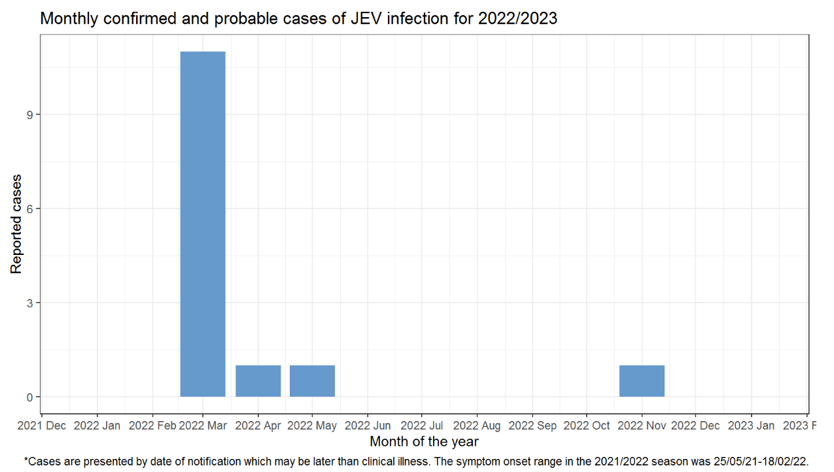
Figure 1 Japanese encephalitis virus epidemic curve

Ross River virus

There were 12 probable/confirmed case of RRV infection notified last week. All cases reside in regional areas.

RRV epidemic curve
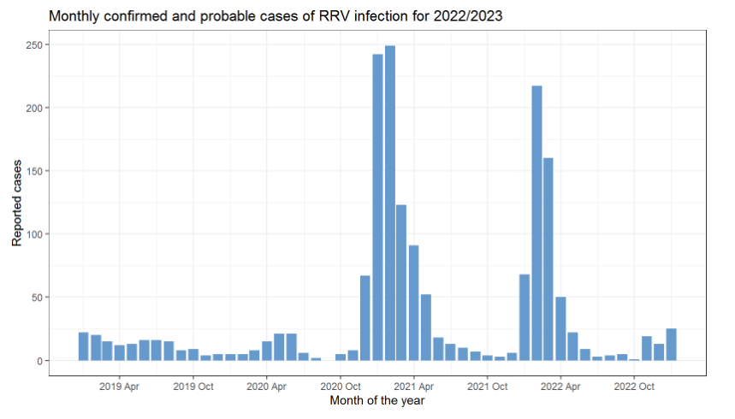
Figure 2 Ross River virus epidemic curve

Mosquito surveillance
Approximately 15 councils in high-risk areas for mosquito-borne diseases currently participate in the state-wide mosquito surveillance program. Mosquitoes trapped as part of this program are submitted to the Agriculture Victoria Research laboratory at the Department of Jobs, Precincts and Regions (DJPR) for mosquito species identification, counting and viral testing. These data are reported to the department for monitoring and analysis.

Mosquito abundance
This section details the abundance of mosquitoes in Victoria by LGA. The count average for all trapping sites within the previous week is reported by LG
Table 1: Average number of mosquitoes per trap site per week by LGA, 2022-2023
LGA by Week |  |  |  |  |  |  |  |  |  |  |  |  |  |  |  |  |  |  |  |  |  |  |  |  | 2022 |  |  |  |  |  |  |  |  |  |  |  |  |  |  |  |  |  |  |  |  |  | 2023
 |  |  |  |  | Aug |  |  |  |  |  |  |  |  |  |  | Sep |  |  |  |  |  |  |  |  | Oct |  |  |  |  |  |  |  |  |  |  | Nov |  |  |  |  |  | Dec |  |  |  |  | Jan
 |  |  |  |  | w32 |  | w33 |  | w34 |  |  | w35 |  | w36 |  | w37 |  | w38 |  |  | w39 |  | w40 |  | w41 |  | w42 |  | w43 |  | w44 |  |  | w45 |  | w46 |  | w47 |  | w48 |  | w49 |  | w50 | w51 | w52* | w1* | w2 | w3 | w4
Greater Shepparton |  |  |  |  |  |  |  |  |  |  |  | 8 |  |  |  | 8 |  |  |  |  | 26 |  |  |  | 140 |  | 84 |  | 200 |  | 1262 |  |  | 2068 |  | 653 |  | 1872 |  | 1604 |  | 478 |  | 225 | 170 | 57 | 93 | 231 | 663 | 135
Horsham |  |  |  |  |  |  | 1 |  |  |  |  | 6 |  | 2 |  | 2 |  |  |  |  | 11 |  | 18 |  | 136 |  | 138 |  | 176 |  | 900 |  |  | 1464 |  | 1831 |  | 1701 |  | 930 |  | 1063 |  | 179 | 294 | 254 | 69 | 176 | 203
Moira |  |  |  |  |  |  |  |  |  |  |  |  |  |  |  | 3 |  |  |  |  |  |  | 1 |  | 2 |  |  |  | 613 |  |  |  |  | 1248 |  | 59 |  |  |  | 586 |  |  |  | 50 | 113 | 77 | 43 | 70 | 42 | 14
Mildura |  |  |  |  | 6 |  |  |  |  | 4 |  |  |  | 18 |  | 21 |  | 56 |  |  | 125 |  | 120 |  | 375 |  | 277 |  | 179 |  | 461 |  |  | 2087 |  |  |  | 998 |  | 624 |  | 1455 |  | 845 | 4833 | 1000 | 1474 | 1663 | 874 | 131
Greater Bendigo |  |  |  |  |  |  |  |  |  |  |  |  |  |  |  |  |  |  |  |  | 9 |  |  |  |  |  | 259 |  | 262 |  | 133 |  |  | 1426 |  | 1956 |  | 1324 |  |  |  | 2297 |  | 285 | 1519 |  | 44 | 121 | 229 | 71
Greater Geelong |  |  |  |  | 19 |  |  |  |  |  |  |  |  |  |  |  |  | 203 |  |  |  |  | 86 |  |  |  |  |  |  |  |  |  |  | 463 |  |  |  | 680 |  | 972 |  |  |  | 449 | 425 |  | 56 | 40 | 52 | 61
Campaspe |  |  |  |  |  |  |  |  |  | 1 |  |  |  | 2 |  |  |  |  |  |  |  |  |  |  | 94 |  |  |  | 553 |  |  |  |  | 2319 |  | 839 |  | 3768 |  | 621 |  | 6019 |  | 35 | 1214 |  | 20 | 181 | 660 | 278
Wodonga |  |  |  |  |  |  |  |  |  | 2 |  |  |  |  |  |  |  |  |  |  |  |  | 48 |  | 53 |  | 147 |  |  |  | 516 |  |  | 1242 |  | 3593 |  |  |  | 1995 |  | 439 |  | 176 | 658 | 171 | 95 | 108 | 72
East Gippsland |  |  |  |  |  |  |  |  |  |  |  |  |  | 29 |  | 19 |  |  |  |  |  |  | 26 |  | 108 |  |  |  |  |  |  |  |  | 31 |  | 245 |  | 277 |  | 377 |  | 427 |  | 700 | 80 | 60 | 40 | 20 | 3
Frankston |  |  |  |  |  |  |  |  |  |  |  |  |  | 4 |  |  |  |  |  |  | 26 |  |  |  |  |  |  |  |  |  |  |  |  |  |  |  |  | 855 |  |  |  |  |  | 131
Swan Hill |  |  |  |  |  |  |  |  |  |  |  |  |  |  |  |  |  | 9 |  |  | 17 |  | 126 |  | 212 |  | 268 |  | 715 |  | 884 |  |  | 3327 |  | 1043 |  | 111 |  | 1598 |  | 575 |  | 514 | 1958 | 400 | 177 | 175 | 134 | 68
Gannawarra |  |  |  |  |  |  |  |  |  |  |  |  |  |  |  |  |  |  |  |  |  |  |  |  | 477 |  | 1228 |  | 493 |  |  |  |  | 1291 |  | 2189 |  | 145 |  | 1081 |  | 160 |  | 27 | 659 | 8 | 9 | 447 | 49 | 10
Wellington |  |  |  |  |  |  |  |  |  |  |  |  |  |  |  |  |  |  |  |  |  |  |  |  |  |  |  |  | 123 |  |  |  |  |  |  | 756 |  | 728 |  |  |  |  |  | 976 | 207 | 1355 | 1118 | 1438
Loddon |  |  |  |  |  |  |  |  |  |  |  |  |  |  |  |  |  |  |  |  |  |  |  |  |  |  |  |  |  |  | 11929 |  |  | 8371 |  | 3488 |  | 670 |  | 1591 |  | 2440 |  | 535 | 1681 |  | 156 | 368 | 631 | 300
Surf Coast |  |  |  |  |  |  |  |  |  |  |  |  |  |  |  |  |  |  |  |  |  |  |  |  |  |  |  |  |  |  |  |  |  | 34 |  |  |  | 1586 |  |  |  | 375 |  |  | 129 |  |  | 62 |  | 23
Yarra City |  |  |  |  |  |  |  |  |  |  |  |  |  |  |  |  |  |  |  |  |  |  |  |  |  |  |  |  |  |  |  |  |  | 4192 |  | 3450 |  | 5938
Wangaratta |  |  |  |  |  |  |  |  |  |  |  |  |  |  |  |  |  |  |  |  |  |  |  |  |  |  |  |  |  |  |  |  |  |  |  |  |  |  |  |  |  |  |  | 160 | 100 | 60 | 32 | 69 | 59 | 70
Indigo |  |  |  |  |  |  |  |  |  |  |  |  |  |  |  |  |  |  |  |  |  |  |  |  |  |  |  |  |  |  |  |  |  |  |  |  |  |  |  |  |  |  |  | 194 | 561 |  | 170 | 669 | 895 | 178
 | Key |  | Low (<50) |  |  | Moderate (50-99) |  |  |  |  |  |  | High (100-999) |  |  |  |  |  |  | Very high (1,000-9,999) |  |  |  |  |  |  |  | Extreme (10,000+)

Mosquito species of concern
In inland areas Culex annulirostris is considered the major species of concern for transmission of RRV, BFV, WNV/Kunjin, and MVEV. It is also believed to be a major vector for JEV.
Aedes camptorhynchus is the major vector of RRV and BFV in coastal saltwater habitats.
A sample of trapped mosquitoes are examined to estimate the proportion of different species. The availability and accuracy of this representative sample is influenced by the number of mosquitoes captured, the condition of the mosquitoes at time of examination, and other factors.
At the time of reporting complete species data was not available.

Mosquito viral detections
Captured mosquitoes are submitted for PCR testing to detect RRV, BFV, MVEV, JEV and WNV/Kunjin.
This section lists all viral detections in trapped mosquitoes for the 2022/2023 season.

Table 2: Viral detections in trapped mosquitoes
Trap collection date | Notification date | LGA | Virus detected
29/11/2022 | 6/12/2022 | Loddon | BFV
29/11/2022 | 6/12/2022 | Campaspe | BFV
30/11/2022 | 6/12/2022 | Horsham | RRV
6/12/2022 | 9/12/2022 | Gannawarra | BFV
6/12/2022 | 12/12/2022 | Mildura | BFV
7/12/2022 | 16/12/2022 | Campaspe | BFV
7/12/2022 | 16/12/2022 | Campaspe | BFV
20/12/2022 | 22/12/2022 | Greater Bendigo | RRV
20/12/2022 | 22/12/2022 | Campaspe | RRV
20/12/2022 | 22/12/2022 | Mildura | RRV
20/12/2022 | 22/12/2022 | Mildura | BFV
20/12/2022 | 29/12/2022 | Swan Hill | BFV
20/12/2022 | 29/12/2022 | Swan Hill | BFV
21/12/2022 | 29/12/2022 | Campaspe | RRV
28/12/2022 | 4/1/2023 | Mildura | RRV
20/12/2022 | 6/1/2023 | Loddon | RRV
20/12/2022 | 6/1/2023 | Loddon | BFV
4/1/2023 | 6/1/2023 | Loddon | RRV
4/1/2023 | 6/1/2023 | Loddon | RRV
4/1/2023 | 6/1/2023 | Swan Hill | RRV
3/1/2023 | 6/1/2023 | Wellington | RRV
30/12/2022 | 10/1/2023 | Horsham | RRV
4/1/2023 | 10/1/2023 | Mildura | RRV
5/1/2023 | 10/1/2023 | Greater Bendigo | RRV
4/1/2023 | 10/1/2023 | Mildura | MVEV
5/1/2023 | 10/1/2023 | Greater Bendigo | MVEV
10/1/2023 | 13/1/2023 | Mildura | MVEV
10/1/2023 | 13/1/2023 | Mildura | MVEV
10/1/2023 | 13/1/2023 | Indigo | MVEV
10/1/2023 | 13/1/2023 | Loddon | MVEV
10/1/2023 | 13/1/2023 | Indigo | RRV
10/1/2023 | 13/1/2023 | Greater Geelong | BFV
11/1/2023 | 18/1/2023 | Wodonga | WNV/Kunjin
17/1/2023 | 20/1/2023 | Mildura | WNV/Kunjin
17/1/2023 | 20/1/2023 | Mildura | WNV/Kunjin
17/1/2023 | 20/1/2023 | Mildura | WNV/Kunjin
17/1/2023 | 20/1/2023 | Mildura | MVEV
17/1/2023 | 20/1/2023 | Mildura | MVEV
17/1/2023 | 20/1/2023 | Mildura | MVEV
17/1/2023 | 20/1/2023 | Mildura | MVEV
17/1/2023 | 20/1/2023 | Mildura | MVEV
17/1/2023 | 20/1/2023 | Mildura | MVEV
17/1/2023 | 20/1/2023 | Mildura | RRV
17/1/2023 | 20/1/2023 | Loddon | MVEV
17/1/2023 | 20/1/2023 | Loddon | MVEV
17/1/2023 | 20/1/2023 | Greater Bendigo | RRV
17/1/2023 | 20/1/2023 | Wellington | RRV
17/1/2023 | 24/1/2023 | Campaspe | MVEV
17/1/2023 | 24/1/2023 | Greater Shepparton | MVEV
17/1/2023 | 24/1/2023 | Campaspe | RRV
18/1/2023 | 24/1/2023 | Indigo | MVEV
18/1/2023 | 24/1/2023 | Indigo | MVEV
17/01/2023 | 27/01/2023 | Indigo | MVEV
24/01/2023 | 27/01/2023 | Mildura | WNV/Kunjin
24/01/2023 | 27/01/2023 | Mildura | MVEV
24/01/2023 | 27/01/2023 | Mildura | MVEV
24/01/2023 | 27/01/2023 | Mildura | MVEV
24/01/2023 | 27/01/2023 | Campaspe | MVEV
24/01/2023 | 27/01/2023 | Loddon | MVEV
24/01/2023 | 27/01/2023 | Indigo | MVEV

Murray Valley encephalitis virus (MVEV) detections in mosquitoes
This map highlights all LGAs with MVEV detections in trapped mosquitoes for the 2022/2023 season.
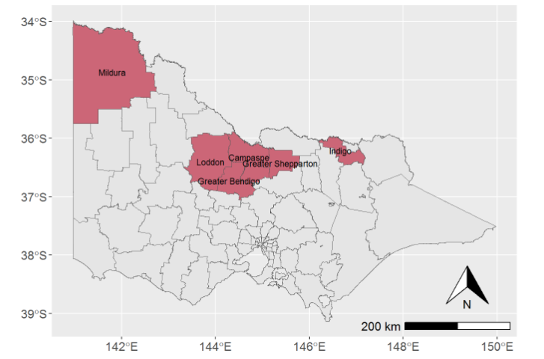
Figure 3 MVE detections in mosquitoes for the 2022/2023 season

Ross River virus (RRV) detections in mosquitoes
This map highlights all LGAs with RRV detections in trapped mosquitoes for the 2022/2023 season.
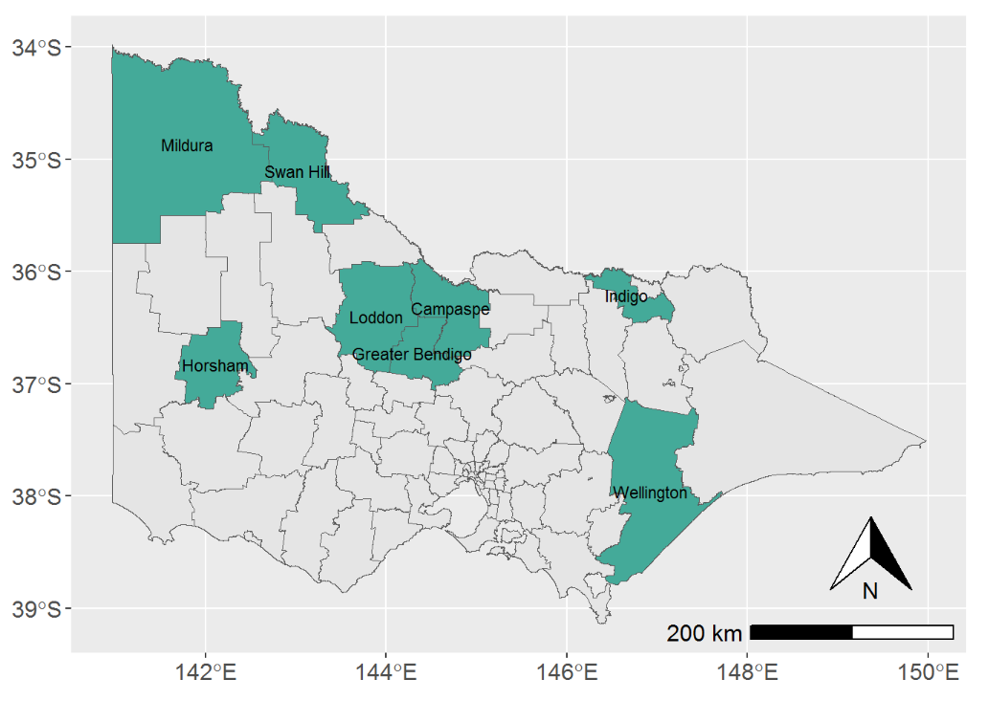
Figure 4 RRV detections in mosquitoes for the 2022/2023 season

Barmah Forest virus (BFV) detections in mosquitoes
This map highlights all LGAs with BFV detections in trapped mosquitoes for the 2022/2023 season.
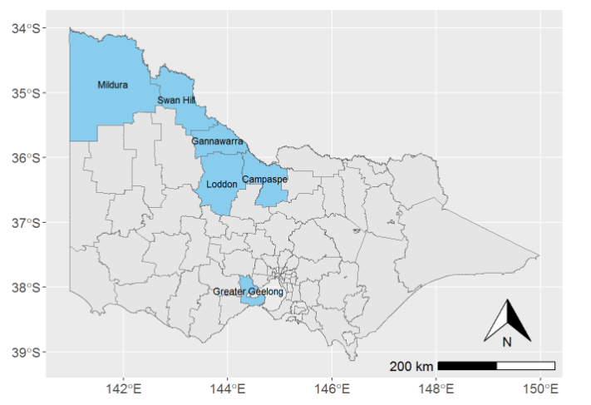
Figure 5 BFV detections in mosquitoes for the 2022/2023 season

West Nile virus (WNV)/Kunjin detections in mosquitoes
This map highlights all LGAs with WNV/Kunjin detections in trapped mosquitoes for the 2022/2023 season.
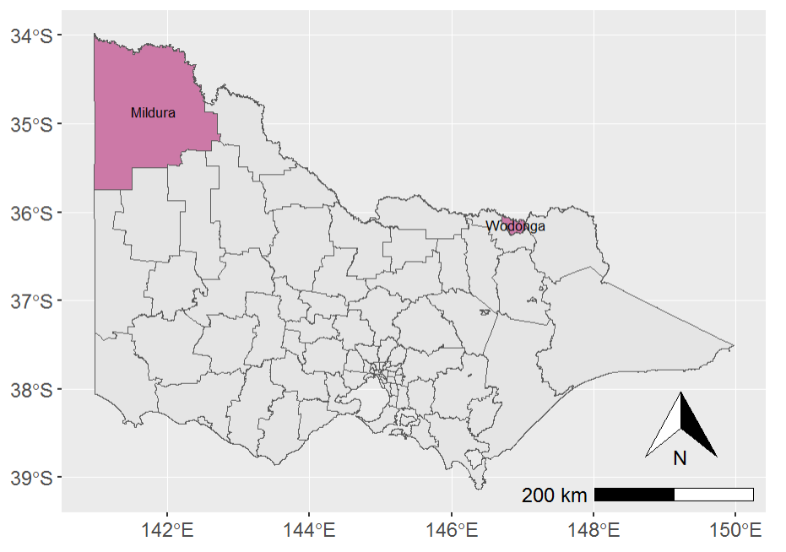
Figure 6 WNV/Kunjin detections in mosquitoes for the 2022/2023 season
To receive this document in another format, phone 1300 651 160, using the National Relay Service 13 36 77 if required, or email the departments Communicable Disease Section <infectious.diseases@health.vic.gov.au>.
Authorised and published by the Victorian Government, 1 Treasury Place, Melbourne.
© State of Victoria, Australia, Department of Health, November 2022.
ISBN/ISSN number (online/PDF/Word) or (print)
Available at the departments website <https://www.health.vic.gov.au/infectious-diseases/vector-borne-infectious-disease-control>

