Mosquito and mosquito-borne disease weekly report 2022/2023
Report number: 9
Reporting week: 25/12/22 - 31/12/22
Report issued date: 03/01/23
OFFICIAL
Contents
Summary 2
Human mosquito-borne diseases notifications 2
Notifications 2
Japanese encephalitis virus 3
Ross River virus 3
Mosquito surveillance 4
Mosquito abundance 4
Mosquito species of concern 6
Mosquito viral detections 6
Contact 7

Summary
This report contains a range of indicators relating to mosquito-borne diseases actively monitored by the Department of Health (the department). The department conducts mosquito surveillance throughout the Victorian mosquito breeding season, which in inland areas typically occurs from early November through to late April the following year, with coastal areas typically starting earlier and ending later. For reporting purposes, the 2022/2023 season is defined as commencing from 1 July 2022.
The indicators used in this report are sourced from the following surveillance systems:
- Human surveillance (notified confirmed and probable cases and/or modelled predictions of vector-borne disease)
- Mosquito surveillance (adult mosquitoes)
The report will be issued weekly. Some indicators may not be updated for every report. The report contains information collected in the week prior. There is a time delay from mosquito field collection to reporting. This is due to the cumulative time between trap collection, specimen transit time to Melbourne, and from individual mosquito species identification to polymerase chain reaction (PCR) testing within the laboratory.

Human mosquito-borne diseases notifications
In 2022 there are five mosquito-borne viruses which have been identified to pose public health risk in Victoria with the potential for local transmission. These are Japanese encephalitis virus (JEV), Murray Valley Encephalitis virus (MVEV), Ross River virus (RRV) and Barmah Forest virus (BFV), West Nile virus Kunjin strain (WNV/kun) (otherwise known as Kunjin virus). Cases of infection with these viruses are notified to the department by pathology services and in some cases medical practitioners under the Victorian Public Health and Wellbeing Regulations 2019. The laboratory diagnosis of mosquito-borne diseases is complex, and often requires follow up testing at several weeks interval before the confirmed or probable case definition is met.
RRV and BFV are endemic to parts of Victoria, and cases of infection with these viruses are expected every summer. The department closely monitors case numbers and geographical distribution to identify areas of increased risk.

Notifications
Mosquito-borne disease notification from previous week
CONDITION | Confirmed | Probable | YTD ª
Japanese encephalitis virus infection | 0 | 0 | 1
Ross River virus infection | 0 | 0 | 36
Barmah Forest virus infection | 0 | 0 | 2
Kunjin virus infection | 0 | 0 | 0
Murray Valley encephalitis virus infection | 0 | 0 | 0
Note: ª YTD: Year to date total cases (confirmed/probable) reported since 1/7/2022.

Japanese encephalitis virus
There was one case of JE confirmed last week, in a person who resides in Campaspe Shire LGA. Initial testing and notification to the department occurred in November 2022 and the case is included in the November total, in Figure 1.

JE epidemic curve
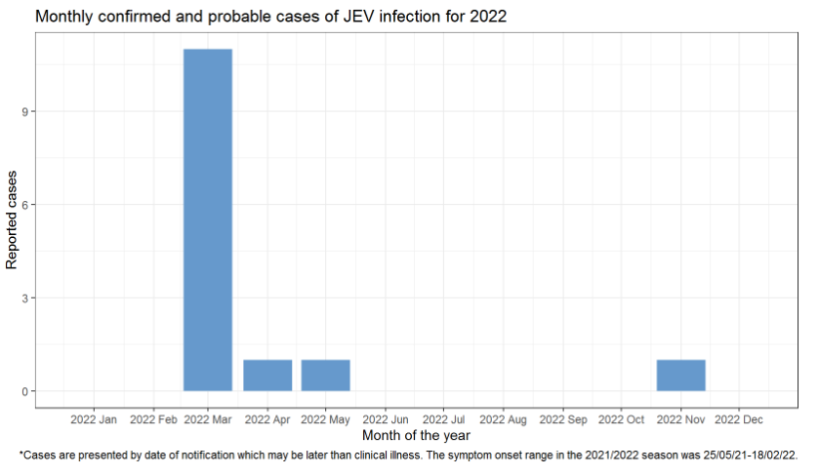
Figure 1 Japanese encephalitis virus epidemic curve

Ross River virus
There were no cases of RRV notified in the last week.

RRV epidemic curve
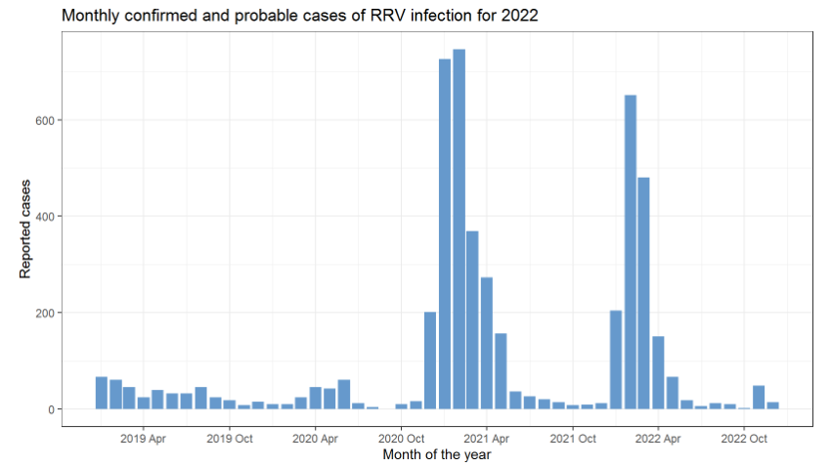
Figure 2 Ross River virus epidemic curve

Mosquito surveillance
Approximately 15 councils in high-risk areas for mosquito-borne diseases currently participate in the state-wide mosquito surveillance program. Mosquitoes trapped as part of this program are submitted to the Agriculture Victoria Research laboratory at the Department of Jobs, Precincts and Regions (DJPR) for mosquito species identification, counting and viral testing. These data are reported to the department for monitoring and analysis.

Mosquito abundance
This section details the abundance of mosquitoes in Victoria by LGA. The count average for all trapping sites within the previous week is reported by LGA.
Table 1: Average number of mosquitoes per trap site per week by LGA, 2022-2023

LGA by Week |  |  |  |  |  |  |  |  |  |  |  |  |  |  |  |  |  |  |  |  |  |  |  |  | 2022
 |  |  |  |  | Aug |  |  |  |  |  |  |  |  |  |  | Sep |  |  |  |  |  |  |  |  | Oct |  |  |  |  |  |  | Nov |  |  | Dec
 |  |  |  |  | w32 |  | w33 |  | w34 |  |  | w35 |  | w36 |  | w37 |  | w38 |  |  | w39 |  | w40 |  | w41 | w42 |  | w43 | w44 | w45 |  | w46 | w47 | w48 | w49 | w50 | w51 | w52*
Greater Shepparton |  |  |  |  |  |  |  |  |  |  |  | 8 |  |  |  | 8 |  |  |  |  | 26 |  |  |  | 140 | 84 |  | 200 | 1262 | 2068 |  | 653 | 1872 | 1604 | 478 | 225 | 170
Horsham |  |  |  |  |  |  | 1 |  |  |  |  | 6 |  | 2 |  | 2 |  |  |  |  | 11 |  | 18 |  | 136 | 138 |  | 176 | 900 | 1464 |  | 1831 | 1701 | 930 | 1063 | 179 | 294
Moira |  |  |  |  |  |  |  |  |  |  |  |  |  |  |  | 3 |  |  |  |  |  |  | 1 |  | 2 |  |  | 613 |  | 1248 |  | 59 |  | 586 |  | 50 | 113
Mildura |  |  |  |  | 6 |  |  |  |  | 4 |  |  |  | 18 |  | 21 |  | 56 |  |  | 125 |  | 120 |  | 375 | 277 |  | 179 | 461 | 2087 |  |  | 998 | 624 | 1454 | 845 | 4833 | 1000
Greater Bendigo |  |  |  |  |  |  |  |  |  |  |  |  |  |  |  |  |  |  |  |  | 9 |  |  |  |  | 259 |  | 262 | 133 | 1426 |  | 1956 | 1324 |  | 2296 | 285 | 1519
Greater Geelong |  |  |  |  | 19 |  |  |  |  |  |  |  |  |  |  |  |  | 203 |  |  |  |  | 86 |  |  |  |  |  |  | 463 |  |  | 680 | 972 |  |  | 425
Campaspe |  |  |  |  |  |  |  |  |  | 1 |  |  |  | 2 |  |  |  |  |  |  |  |  |  |  | 94 |  |  | 553 |  | 2319 |  | 839 | 3768 | 621 | 6019 | 35 | 1214
Wodonga |  |  |  |  |  |  |  |  |  | 2 |  |  |  |  |  |  |  |  |  |  |  |  | 48 |  | 53 | 147 |  |  | 516 | 1242 |  | 3593 |  | 1995 | 439 | 176 | 658
East Gippsland |  |  |  |  |  |  |  |  |  |  |  |  |  | 29 |  | 19 |  |  |  |  |  |  | 26 |  | 108 |  |  |  |  | 31 |  | 245 | 277 | 377 | 427 | 700
Frankston |  |  |  |  |  |  |  |  |  |  |  |  |  | 4 |  |  |  |  |  |  | 26
Swan Hill |  |  |  |  |  |  |  |  |  |  |  |  |  |  |  |  |  | 9 |  |  | 17 |  | 126 |  | 212 | 268 |  | 715 | 884 | 3327 |  | 1043 | 111 | 1598 | 575 | 514 | 1958
Gannawarra |  |  |  |  |  |  |  |  |  |  |  |  |  |  |  |  |  |  |  |  |  |  |  |  | 477 | 1228 |  | 493 |  | 1291 |  | 2189 |  | 1081 | 160 |  | 659
Wellington |  |  |  |  |  |  |  |  |  |  |  |  |  |  |  |  |  |  |  |  |  |  |  |  |  |  |  | 123 |  |  |  | 756 | 728 |  |  | 1220 | 207
Loddon |  |  |  |  |  |  |  |  |  |  |  |  |  |  |  |  |  |  |  |  |  |  |  |  |  |  |  |  | 11929 | 8371 |  | 3488 | 670 | 1591 | 2440 | 535
Surf Coast |  |  |  |  |  |  |  |  |  |  |  |  |  |  |  |  |  |  |  |  |  |  |  |  |  |  |  |  |  | 34 |  |  | 1586 |  | 375 |  | 129
Yarra City |  |  |  |  |  |  |  |  |  |  |  |  |  |  |  |  |  |  |  |  |  |  |  |  |  |  |  |  |  | 4192 |  | 3450 | 5938
Wangaratta |  |  |  |  |  |  |  |  |  |  |  |  |  |  |  |  |  |  |  |  |  |  |  |  |  |  |  |  |  |  |  |  |  |  |  | 160 | 100 | 75
Indigo |  |  |  |  |  |  |  |  |  |  |  |  |  |  |  |  |  |  |  |  |  |  |  |  |  |  |  |  |  |  |  |  |  |  |  | 194 | 373
 | Key |  | Low (<50) |  |  | Moderate (50-99) |  |  |  |  |  |  | High (100-999) |  |  |  |  |  |  | Very high (1,000-9,999) |  |  |  |  |  |  | Extreme (10,000+)
*Mosquito counting and speciation was limited over the holiday period.

Mosquito species of concern
In inland areas Culex annulirostris is considered the major species of concern for transmission of RRV, BFV, WNV/Kunjin, and MVEV. It is also believed to be a major vector for JEV.
Aedes camptorhynchus is the major vector of RRV and BFV in coastal saltwater habitats.
A sample of trapped mosquitoes are examined to estimate the proportion of different species. The availability and accuracy of this representative sample is influenced by the number of mosquitoes captured, the condition of the mosquitoes at time of examination, and other factors.
Mosquito speciation was limited over the last week, due to public holidays.

Mosquito viral detections
Captured mosquitoes are submitted for PCR testing to detect RRV, BFV, MVEV, JEV and WNV/Kunjin.
This section lists all viral detections in trapped mosquitoes for the 2022/2023 season.

Table 2: Viral detections in trapped mosquitoes
Trap collection date | Notification date | LGA | Virus detected
29/11/2022 | 6/12/2022 | Loddon | BFV
29/11/2022 | 6/12/2022 | Campaspe | BFV
30/11/2022 | 6/12/2022 | Horsham | RRV
6/12/2022 | 9/12/2022 | Gannawarra | BFV
6/12/2022 | 12/12/2022 | Mildura | BFV
7/12/2022 | 16/12/2022 | Campaspe | BFV
7/12/2022 | 16/12/2022 | Campaspe | BFV
20/12/2022 | 22/12/2022 | Greater Bendigo | RRV
20/12/2022 | 22/12/2022 | Campaspe | RRV
20/12/2022 | 22/12/2022 | Mildura | RRV
20/12/2022 | 22/12/2022 | Mildura | BFV
20/12/2022 | 29/12/2022 | Swan Hill | BFV
20/12/2022 | 29/12/2022 | Swan Hill | BFV
21/12/2022 | 29/12/2022 | Campaspe | RRV

To receive this document in another format, phone 1300 651 160, using the National Relay Service 13 36 77 if required, or email the departments Communicable Disease Section <infectious.diseases@health.vic.gov.au>.
Authorised and published by the Victorian Government, 1 Treasury Place, Melbourne.
© State of Victoria, Australia, Department of Health, January 2023.
Available at the departments website <https://www.health.vic.gov.au/infectious-diseases/vector-borne-infectious-disease-control>

