Physical restraint
Standardised care process
Contents
Objective 2
Why alternatives to physical restraint are important 2
Definitions 2
Team 3
Acknowledgement 3
Brief standardised care process 4
Recognition and assessment 4
Interventions 4
Referral 4
Evaluation and reassessment 4
Resident involvement 5
Staff knowledge and education 5
Full standardised care process 6
Recognition 6
Assessment 6
Interventions 6
Referral 7
Evaluation and reassessment 7
Resident involvement 7
Staff knowledge and education 7
General communication and de‐escalation interventions 8
Strategies for alternatives to restraint 8
Evidence base 11

Objective
To promote evidence-based practice in seeking alternatives to physical restraint for older people who live in residential care settings.
Why alternatives to physical restraint are important
A restraint-free care environment is the recommended standard of care (Marin 2019).
Physical restraint is most often used to address responsive behaviours and prevent falls. However, the evidence indicates restraint does not prevent falls or fall-related injuries (Department of Health 2015) and is likely to exacerbate behaviours.
The use of physical restraint has ethical, legal, and clinical consequences. It violates a resident’s right to freedom and dignity. There is evidence that its use is associated with adverse physical, psychological, and social outcomes and increases the risk of death (Department of Health 2015).
Restraints should only be used as a last resort, after all alternate strategies have been tried
and following discussion with the person, their substitute decision maker, and their doctor (Aged Care Quality and Safety Commission 2020).
Assessing the resident and the situation, then implementing appropriate alternative strategies can replace the need for restraint.

Definitions
Physical restraint: ‘refers to methods that physically and mechanically restrict an individual’s movement in a way that the individual cannot control or easily remove a restrictive device’
(Marin 2019, p. 1).
The Quality of Care Principles 2014 (amended 2019) define restraint as: ‘any practice, device or action that interferes with a consumer’s ability to make a decision or restricts a consumer’s free movement’ (Australian Government 2019).
The principles define physical restraint as: ‘any restraint other than:
- a chemical restraint; or
- the use of medication prescribed for the treatment of, or to enable treatment of, a diagnosed mental disorder, a physical Illness or a physical condition’ (Australian Government 2019).
Examples of physical restraint devices include lap belts, bed rails, Posey restraints or similar, chairs with tables attached, and chairs or mattresses that are difficult to get out of such as tip-back chairs, water chairs, bean bags and curved edge mattresses. Devices that are categorised as extreme restraint and should never be used in residential aged care are: criss-cross vests, leg or ankle restraints, manacles/shackles, and soft wrist/ hand restraints (DoHA 2012, p. 25).
Responsive behaviours: a term originating from, and preferred by, people with dementia that represents how their actions, words and gestures are a response, often intentional, to something important to them. All behaviour has meaning and responsive behaviours are often a form of communication of an unmet need for an older adult living with dementia, complex mental illness, substance use and/or other neurological disorder (Behavioural Supports Ontario 2020).

Team
Manager, registered nurses (RNs), enrolled nurses (ENs), personal care attendants (PCAs), leisure and lifestyle staff, general practitioner (GP), allied health professionals (such as a physiotherapist, occupational therapist and exercise physiologist), residents and/or family or carers.

Acknowledgement
This standardised care process (SCP) has been developed for public sector residential aged care services (PSRACS) by the Australian Centre for Evidence Based Care (ACEBAC) at La Trobe University through the Department of Health and Human Services Strengthening Care Outcomes for Residents with Evidence (SCORE) initiatives. This SCP is one of a series of priority risk areas reviewed based on the best available evidence in 2020.

Brief standardised care process

Recognition and assessment
On admission, and when behaviour change occurs, identify residents at risk of restraint.
Conduct an assessment that includes:
- cognitive assessment using the Psychogeriatric Assessment Scale – Cognitive Impairment Scale (PAS)
- medical history
- history of their responsive behaviours
- assessment of the resident’s usual routines, likes, dislikes and preferences
- pain assessment
- assessment of the resident’s communication ability
- a screen for delirium
- medication review
- mental state assessment
- falls risk assessment
- psychosocial needs assessment
- assessment of the resident’s physical environment.
If indicated by this assessment, develop an individualised care plan and/or falls prevention plan.

Interventions
- Identify and address the reason why a resident might be restrained.
- If at any time the resident exhibits responsive behaviours:
  - ensure the safety of the resident and others
  - conduct an assessment (see above)
  - assess the resident’s behaviour to identify the reason for the behaviour and develop response strategies using the Addressing responsive behaviours flow chart.
- If at any time the resident falls or there is a change in their condition affecting the risk of falling, repeat the falls risk assessment and review the falls prevention plan.
- Implement appropriate alternatives to restraint based on the findings from the behaviour
and falls risk assessments.

Referral
- GP for medical assessment of falls risk factors and reversible causes of behaviours
- Lifestyle coordinator or activities worker
- Occupational therapist
- Physiotherapist
- Dementia Support Australia for responsive behaviours

Evaluation and reassessment
- Ongoing evaluation of behaviour interventions:
  - if at any time a behaviour exacerbates or a new behaviour presents, repeat the behaviour assessment using the flow chart.
- Ongoing evaluation of falls prevention strategies:
  - if at any time the resident falls or their condition changes, repeat the falls risk assessment
and review falls prevention strategies.

Resident involvement
Involve the resident and/or their family or carer in:
- developing and implementing alternative strategies
- discussions about the risks of physical restraint.

Staff knowledge and education
- Ethical, legal and professional issues relating to physical restraint
- Alternatives to restraint
- Falls prevention
- Dementia and responsive behaviours

Full standardised care process

Recognition
On admission or when behaviour change occurs identify residents who present with factors that increase the risk of restraint use.
Identify practice-based risk factors for restraint use (staff shortages, philosophy of care, absence of a policy/procedure for managing behaviours).

Assessment
Conduct an assessment including:
- cognitive assessment using the Psychogeriatric Assessment Scales – Cognitive Impairment Scale (PAS)
- medical history: Is there a diagnosis of dementia? Is there a history of delirium?
- history of responsive behaviours
- assessment of the resident’s usual routines, likes, dislikes and preferences
- physical assessment (including constipation, sensory impairment)
- pain assessment
- assessment of the resident’s communication ability
- screen for delirium (see SCP: delirium)
- screen for medicines that increase agitation
- mental state (mood disorders, psychosis) assessment
- falls risk assessment
- resident’s psychological coping strategies, cultural needs, meaningful activity, boredom, level of stimulation
- resident’s physical environment (noise, lighting, visual cueing).
If cognitive impairment is indicated and/or there is a history of responsive behaviours:
- develop (with the resident’s family/carer) a more detailed personal history specific to what triggers behaviours, how they present and what reduces them
- identify the frequency, severity and level of distress of the behaviour
- identify the level of risk the behaviour presents to the resident or to others
- develop and implement (with the resident’s family/carer) an individualised care plan to minimise the responsive behaviour presenting
- ensure the resident’s family/carer is aware of the risks of restraining and not restraining and that your policy is to use restraint only as a last resort
- contact the substitute decision maker if physical restraint is implemented.
If a risk of falling is identified, develop and implement an individualised falls prevention plan.

Interventions
The focus of intervention is to address the reason a resident might be restrained (usually to prevent falls and/or the resident is exhibiting responsive behaviours) and to identify appropriate alternatives to using physical restraint. A combination of interventions may prove more successful than a single intervention.
- If at any time the resident exhibits responsive behaviours:
  - ensure the safety of the resident and others
  - repeat the above assessment (except the falls risk component)
  - assess the resident and the behaviour to try to identify the reason for the behaviour and develop response strategies using the Addressing responsive behaviours flow chart.
- If at any time the resident falls or there is a change in their condition affecting the risk of falling, repeat the falls risk assessment and review the falls prevention plan.
- Implement appropriate communication and de-escalation strategies and alternatives
to restraint based on the findings from the behaviour and falls risk assessments (see page 6 for strategies for alternatives to restraint).

Referral
- GP for medical assessment of falls risk factors and reversible causes of behaviours
- Lifestyle coordinator or activities worker
- Occupational therapist to assess the need for assistive devices
- Physiotherapist to assess special seating considerations for comfort and to revise safe mobility and transfer plan
- Dementia Support Australia for behaviours that have not responded to interventions

Evaluation and reassessment
- Responsive behaviours:
  - ongoing evaluation of behaviour interventions
  - if at any time a behaviour exacerbates or a new behaviour presents, repeat the behaviour assessment using the flow chart.
- Falls prevention:
  - ongoing evaluation of falls prevention strategies
  - if at any time the resident falls or their condition changes, repeat the falls risk assessment and review falls prevention strategies.

Resident involvement
- Involve the resident and/or their family/carer in:
  - developing and implementing alternative strategies
  - discussing the risks surrounding physical restraint.
- Obtain informed consent from the resident or substitute decision maker if restraint Is implemented as a last resort

Staff knowledge and education
- Ethical, legal and professional issues relating to physical restraint
- Alternatives to restraint
- Falls prevention
- Dementia and responsive behaviours

General communication and de‐escalation interventions
- Individualise the resident’s routine: make their daily routine as close as possible to their routine at home (for example, showering, sleeping patterns).
- Be aware of and respect the resident’s communication needs.
- When you approach the resident, be calm, call the resident by their preferred name, identify yourself, give verbal reassurance (‘You are in a safe place and we are here to help’).
- Use non-threatening behaviour: make eye contact, adopt non-threatening gestures
and stance, come to the resident’s level without standing over them.
- Minimise invasion of the resident’s personal space.
- Tell the resident what you are going to do before you do it.
- Communicate slowly, clearly and simply. Use concise language or instructions.
- Use distraction, reminiscence or orientation techniques if appropriate.
- Leave the resident if it is safe to do so and return later.
- Ensure a flexible routine: enable care to be provided in line with resident’s normal routines and to discontinue care when necessary and return later.
- Individualise the intervention to the behaviour in line with the resident’s preferences, interests and ability.
- Allow the resident to do as much as they can and give them choices within their abilities (promote self-care and self-determination within the limits of their ability).
- Review the entire care plan for the impact of restraint on usual activities, such as toileting, meals, leisure activities.
- Where possible, let the resident suggest alternatives and choices.
- Ask the resident to tell you what the problem is, allow time for them to respond and actively listen to them.
- If they are upset at something that has happened, apologise if this is reasonable.
- Document the trigger and avoid or modify events that previously caused the resident distress if possible.
- Validate the resident’s concerns: listen and acknowledge their concerns and acknowledge their feelings (‘I can see you’re upset’; ‘What can I do to help?’).
- Ensure a calm environment: minimise noise and invite the resident to talk to you in a quieter area with less stimulation (away from other residents) while ensuring your own safety.
- Involve family/carer members: seek information from family/carer, identify the level of involvement they wish to have; and allow family/ carer to stay with the resident if wanted.
- Recognise the emotional impact of physical restraint for the resident and the family/carer.

Strategies for alternatives to restraint

Physical environmental strategies Personal areas
- The bed height is adjusted to meet the resident’s needs. The brakes are applied.
- Mobility aids, call bell, desired food and fluid, and other personal/comfort Items are close at hand.
- Seating meets the needs of the resident.
- Provide familiar objects from the resident’s home.
- Initiate an appropriate ‘alarm’ system to alert staff to risky behaviours (falls, wandering in an unsafe area).

Indoor areas
- Indoor areas are clutter-free and reduce glare in corridors.
- Install non-slip or carpet flooring in frequented areas.
- Display appropriate signage and other visual reminders to aid orientation.
- Provide safe areas for residents to wander.
- Provide quiet areas and, where possible, reduce overstimulation from environmental noise and bright lighting.

Outdoor areas
- Increase the ease of access to a safe and protected outdoor area.

Social and emotional environmental strategies
- Encourage visitors (staggered if indicated) and promote appropriate staff–resident interaction.
- Promote continuity of staff.
- Offer relaxation activities such as therapeutic touch, massage or music therapy.
- Assist with reality orientation.
- Provide sensory aids and appropriate stimulation.
- Decrease sensory overload.

Psychosocial strategies
Develop and implement individualised psychosocial strategies such as:
- rehabilitation and/or exercise
- continence program
- physical, occupational and recreational therapies
- night-time activities
- individual and small group activities
- activities for promoting success using previously learned skills
- facilitating safe wandering behaviour
- regularly changing the seating arrangement (for residents who are not independently mobile) to provide variety and social stimulation as per resident preference
- falls prevention program.

Care approach
- Ensure increased supervision and observation by all staff.
- Conduct regular evaluations of behaviour and monitor conditions that may alter behaviour.
- Ensure person-centred care (knowing the residents as individuals).
- Instil individualised routines such as for toileting and naps.
- Check ‘at risk’ residents regularly.
- Improve communication strategies.

Physiological strategies
- Conduct a comprehensive health examination.
- Conduct a comprehensive medication review.
- Treat infections.
- Treat exacerbations of chronic disease.
- Manage the resident’s pain.
- Offer non-pharmacological alternatives to sedation.
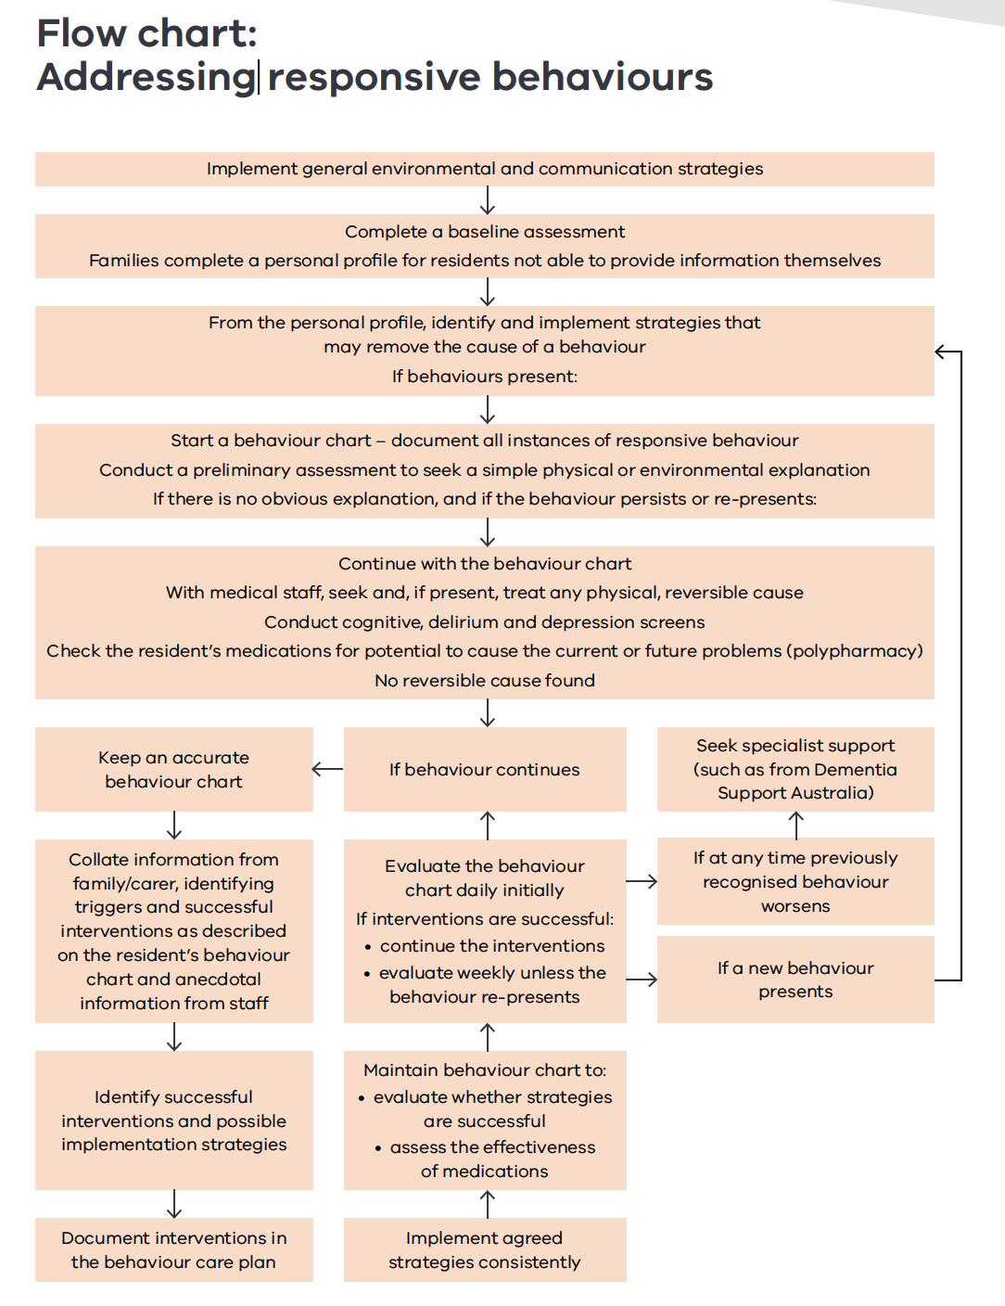

This flowchart outline steps in addressing responsive behaviours.

Evidence base
Aged Care Quality and Safety Commission 2020, Minimising restraint – residential care facilities, <https://www.agedcarequality.gov.au/media/88888>
Australian Government 2020, Quality of care principles 2014: Section 96-1 of the Aged Care Act 1997, <https://www.legislation.gov.au/Details/ F2020C00096/5516c648-b626-48af-87fa- c660b8548581> Australian Medical Association 2001 (revised 2015),
AMA position statement. Restraint in the care of people in residential aged care facilities, AMA, Barton.
Behavioural Supports Ontario 2020, Behaviour change in older adults, <https://www.behaviouralsupportsontario.ca/32/behaviour_ change_in_older_adults/>
Burns, K, Jayasinha, R & Brodaty, H 2014, Managing behavioural and psychological symptoms of dementia (BPSD): a clinician’s field guide to good practice, Dementia Collaborative Research Centre, Sydney.
Burns, K, Jayasinha, R, Tsang, R & Brodaty, H 2012, Behaviour management – a guide to good practice. Managing behavioural and psychological symptoms of Dementia (BPSD), Dementia Collaborative Research Centre, Sydney.
Dementia Training Australia 2017, Responsive behaviours quick reference cards, <https://dta.com. au/app/uploads/downloads/responsive-behaviours- dementia-reference-cards-template.pdf>
Department of Health 2012, Strengthening care outcomes for residents with evidence (SCORE), Ageing and Aged Care Branch, State Government of Victoria, Melbourne.
Department of Health 2015, National Aged Care Quality Indicator Programme, Resource manual for residential aged care facilities. Part A: Handbook. Australian Government, Canberra.
Department of Health and Ageing (DoHA) 2012, Decision-making tool: responding to issues of restraint in aged care, Commonwealth of Australia, Canberra.
Marin, T 2019, Evidence Summary. Physical restraint residential aged care (effectiveness and use), The Joanna Briggs Institute EBP Database, JBI@Ovid. JBI1115.

Important note: This standardised care process (SCP) is a general resource only and should not be relied upon as an exhaustive or determinative clinical decision-making tool. It is just one element of good clinical care decision making, which also takes into account resident/patient preferences and values. All decisions in relation to resident/patient care should be made by appropriately qualified personnel in each case. To the extent allowed by law, the Department of Health and the State of Victoria disclaim all liability for any loss or damage that arises from any use of this SCP.

Authorised and published by the Victorian Government, 1 Treasury Place, Melbourne.
© State of Victoria, Department of Health, August 2022. (2205215)
ISBN 978-1-76096-815-1 (pdf/online/MS word)
Available from the department’s website at <https://www.health.vic.gov.au/residential-aged-care/standardised-care-processes>.

