Recording diagnoses in CMI/ODS

Program Management Circular
OFFICIAL

Contents
Definitions 2
Key Message 4
Purpose 4
Background 4
Recording Diagnoses 5
Bed Based Services 6
Acute 6
Non-acute and residential 6
Community Ambulatory Services 7
Other 7
About Management Circulars 7
Appendix 1 – ECT Diagnosis event 8
Appendix 2 - Other types of Diagnosis events 12

Definitions
DEFINITIONS – MENTAL HEALTH SETTINGS
Acute Bed Based Services  (Acute Inpatient Units) | Bed based settings in which the focus of care is upon ‘short-term inpatient management and treatment during an acute phase of illness’. (Victoria's Mental Health Services)  These services are specialist mental health units within public or private hospitals/health services.
Admission  (Australian Institute of Health and Welfare)  <Meteor Identifier 327206> | ‘The process whereby the hospital accepts responsibility for the patient's care and/or treatment. Admission follows a clinical decision based upon specified criteria that a patient requires same-day or overnight care or treatment. An admission may be formal or statistical’
Case  (PMC Registration of mental health consumers in CMI/ODS) | A period of clinical care that commences from the point of assessment within a mental health service and may progress to include a period of ongoing care within a framework of multidisciplinary care in community, outpatient/ambulatory, inpatient and/or residential mental health service settings.
Community (Ambulatory) Mental Health Services  (Australian Institute of Health and Welfare)  <Meteor Identifier 699980> | ‘A specialised mental health service that provides services to people who are not currently admitted to a mental health admitted or residential service. Services are delivered by health professionals with specialist mental health qualifications or training. Ambulatory mental health services include:’  - Community-based crisis assessment and treatment teams,  - day programs,  - mental health outpatient clinics provided by either hospital or community based services,  - child and adolescent outpatient and community teams  - social and living skills programs,  - hospital based consultation and liaison and in reach services to admitted patients in non-psychiatric and hospital  - same day admitted patient mental health care services  - home based treatment services  - hospital based outreach services.
Diagnosis  (Australian Institute of Health and Welfare)  <Meteor Identifier 327224> | A diagnosis is the decision reached, after assessment, of the nature and identity of the disease or condition of a patient or recipient of residential care (resident). Diagnostic information provides the basis for analysis of health service usage, epidemiological studies and monitoring of specific disease entities.
Episode | A period of time during which a specific type of treatment and care is provided (may be admitted, ambulatory or residential). A consumer may participate in a number of episodes in a case management period.

DEFINITIONS – MENTAL HEALTH SETTINGS Cont’d
Outcome Measures  (Australian Mental Health Outcomes and Classification Network)  <AMHOCN> | A range of consumer and clinician tools/measures used to measure whether a change has occurred for a consumer as a result of mental health care.
Residential (Bed Based) Mental Health Services  (Australian Institute of Health and Welfare)  <Meteor Identifier 373049> | ‘A service that is considered by the state, territory or Australian Government funding authorities as a service that:  - has the workforce capacity to provide specialised mental health services; and  - employs suitably trained mental health staff to provide rehabilitation, treatment or extended care on-site:  - to consumers residing on an overnight basis;  - in a domestic-like environment; and  - encourages the consumer to take responsibility for their daily living activities.  These services include those that employ mental health trained staff on-site 24 hours per day and other services with less intensive staffing (but the trained staff must be on site for a minimum of 6 hours a day and at least 50 hours per week)’.
EPISODES OF CARE BY MENTAL HEALTH SERVICE SETTING:
Acute Episodes of Care | Admissions that occur in acute bed based services (inpatient units).  Includes child, youth, adult and aged mental health inpatient units, hospital in the home (HiTH) and specialist inpatient units such as neuropsychiatry, eating disorder and parent/infant units
Community Episodes of Care | Periods of care provided by ambulatory (community based) mental health services.
ECT | When a course of ECT has been approved by the Mental Health Tribunal a diagnosis is required for each course and treatment.
Non-Acute & Residential Episodes of Care | Admissions that occur in non-acute & residential bed based settings.  Includes Secure Extended Care Units, Prevention and Recovery Care Units (PARCs), Community Care Units (CCUs), and psycho-geriatric nursing homes.

Key Message
An admission diagnosis event is required for all non-acute and residential episodes of care.

A separation diagnosis event is required for all acute, non-acute and residential episodes of care.

A community diagnosis event is required for all community episodes of care

Diagnosis events should be recorded against the community, inpatient, residential or non-acute episode in CMI.

Purpose
To provide advice about when to record diagnoses in CMI/ODS for persons receiving treatment in public mental health services.

Background
CMI/ODS is the Victorian public mental health client information management system and comprises:
- Client Management Interface (CMI) – the CMI is the local client information system used by each public mental health service

- Operational Data Store (ODS) – the ODS manages a set of select data items from each CMI and is used to:
  - allocate a unique (mental health) registration number for each client, known as the statewide unit record (UR) number
  - share select client-level data between Victorian public area mental health services (AMHS) to support continuity of treatment and care
  - ensure the legal basis for providing treatment is evident to all public mental health service providers where a client may be unable or unwilling to consent to treatment
  - meet the various reporting requirements of the Department of Health
  - support the statutory functions of the Chief Psychiatrist and the Mental Health Tribunal.

Recording Diagnoses
Recording diagnoses assists in the clinical management of individual clients and provides essential information to guide the Department of Health in developing policies and priorities for resource allocation. It is also a mandatory data element in national minimum datasets as specified under the National Health Care Agreement to which the State of Victoria is a signatory.

Diagnoses represent the major or principal condition and other primary conditions, complications or co-morbidities and associated conditions treated or investigated during the relevant episode of care. Diagnoses for admitted inpatient episodes must be coded in accordance with the Australian Coding Standards, and advice as published from time to time on the Independent Hospital & Aged Care Pricing Authority (IHACPA) Australian Classification Exchange (ACE). You will need to register via the IHACPA ACE website <https://ace.ihacpa.gov.au> and the Department of Health Victorian ICD Coding Committee queries database < https://www.safercare.vic.gov.au/data-reports/clinical-coding-and-classifications/victorian-icd-coding-committee-queries-database>The table outlines when and which Diagnosis Events to use.

Diagnosis Event | Usage/Service Setting | Timeframe | Used for Reporting
Admission | Non-acute and residential admissions with a length of stay greater than 30 days.  Use the admission date as the diagnosis date and choose the corresponding episode.  Diagnosis for outcome measures is required for length of stay over 30 days on 91 day review and discharge. | Six weeks of the end of the admission month | Yes
*Assessment | Local use only | N/A | No
*Case Summary | Local use only | N/A | No
Community | Community episodes of care.  Record the diagnosis against the relevant community episode.  Use the episode start date for the initial diagnosis.  Use the episode end date for the diagnosis date for the last community episode in a closed case. | - Within four weeks of the end of the month of the episode start; and  - At least every 12 months for episodes longer than 12 months; and  - At episode end if the last episode closed in a case is a community episode. The date that the episode ended is to be used as the date of the diagnosis event, | Yes
Death | Clients who have passed away whilst in community setting |  | Yes
ECT Course | For patients commencing a course of ECT. | Refer to appendix 1 | Yes

Diagnosis Event | Usage/Service Setting | Timeframe | Used for Reporting
ECT Treatment | For each treatment of ECT. If recorded as per instructions in appendix 1 this will auto-populate. | Refer to appendix 1 | Yes
*ISP/Review | Local use only | N/A | No
Separation | Clients who have been separated (discharged) from an inpatient, non-acute and residential episode of care | 10th day of second month following separation | Yes
*CTO/RCTO | Local use only | N/A | No

*NOTE: The recording of a diagnosis against Assessment, Case Summary or CTO/RCTO is not required by the department but may be recorded for local purposes.

Bed Based Services

Acute
Every admitted episode of care must have a separation diagnosis event by the 10th day of the second month following separation. This requirement is aligned with the Victorian Admitted Episodes Dataset (VAED) reporting requirements for admitted episodes and is intended to assist health services in their compliance with the reporting requirements of both systems. Services may need to record diagnoses earlier to facilitate analysis of their outcome measurement data.
An ECT diagnosis is required to be recorded for each course and treatment of ECT. This diagnosis is to be entered into the ECT function of CMI/ODS and the diagnosis event will automatically populate according to whether you chose an ECT course or ECT treatment (please see appendix 1).

Non-acute and residential
A non-acute or residential episode must have an admission diagnosis event assigned within six weeks of the end of the admission month. The admission diagnosis event is only required for episodes with a length of stay longer than 30 days (does not normally apply to PARC as their length of stay is usually up to 28 days).
A non-acute or residential episode must also have a separation diagnosis event recorded by the 10th day of the second month following separation.

Community Ambulatory Services
A community episode must have a community diagnosis event within four weeks of the end of the month of the episode start.
Ongoing community episodes are required to have that diagnosis reviewed and updated at intervals no further apart than 12 months.
Clients whose community episode of care has ended require a community diagnosis event within four weeks of the end of the month of the episode end.

Other
Where diagnoses are required for reporting to:
- Chief Psychiatrist (for example, Reportable Death Records),
- outcome measures
diagnoses already entered into CMI/ODS are adequate for reporting to Chief Psychiatrist and outcome measures.
Where diagnoses are required for each collection occasion of outcome measures, it is best practice for clinical staff to review the diagnosis and add a diagnosis to the diagnosis screen.

About Management Circulars
The information provided in this circular is intended as general information and not as legal advice. Mental health service management should ensure that policies and procedures are developed and implemented to enable staff to collect and use health information in accordance with relevant legislation

To receive this publication in an accessible format email MHD Reporting <MHDReporting@health.vic.gov.au>
Authorised and published by the Victorian Government, 1 Treasury Place, Melbourne.
© State of Victoria, Department of Health May 2015, reviewed November 2022.
ISBN 978-1-76131-008-9 (pdf/online/MS word)
Available at Bulletins and Program Management Circulars (PMC) <https://www.health.vic.gov.au/research-and-reporting/bulletins-and-program-management-circulars-pmc>.

Appendix 1 – ECT Diagnosis event

How to add diagnosis for ECT consumers

An ECT course is added by going to Function, Client, ECT Course Treatment. Enter the consumer details and search. When you find your consumer, select them from the search results. You can now add a course of ECT

When you have completed the details of the ECT Course a prompt will appear – “You must specify a Diagnosis”. This will then allow you to enter a diagnosis event for ECT.
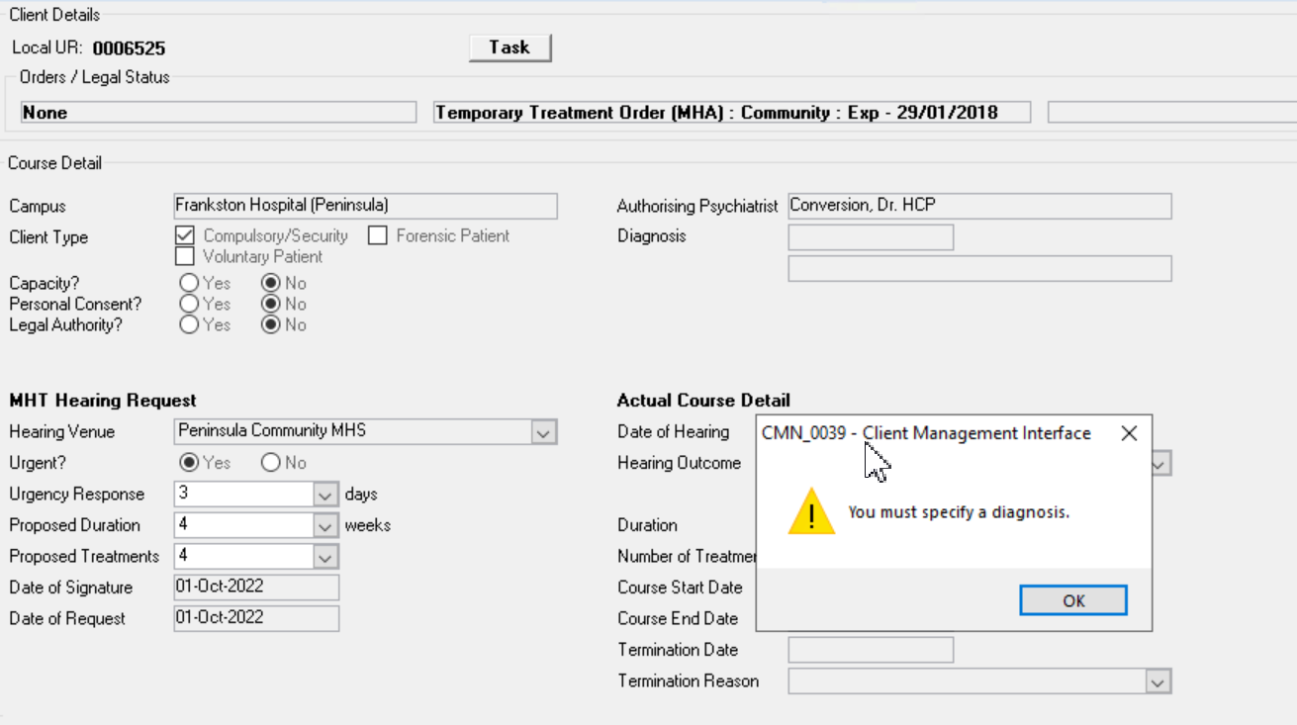
Click OK to close the message and click on the Options menu (top left-hand corner)
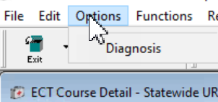
Click on Diagnosis and the Diagnosis summary window will appear.
Click on Add
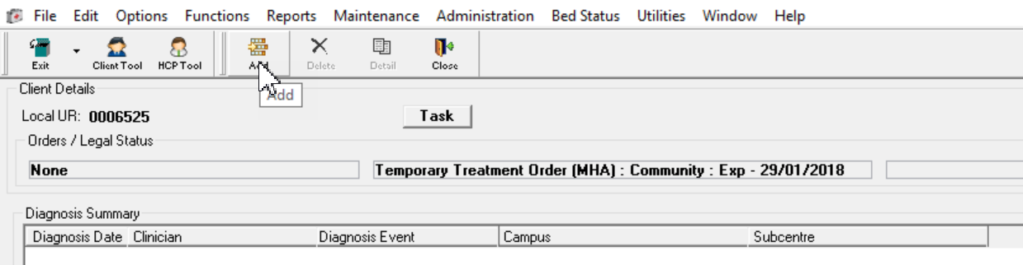
The diagnosis detail window will open, note the Diagnosis Event will default to an ECT Course As that is the function you chose to perform.
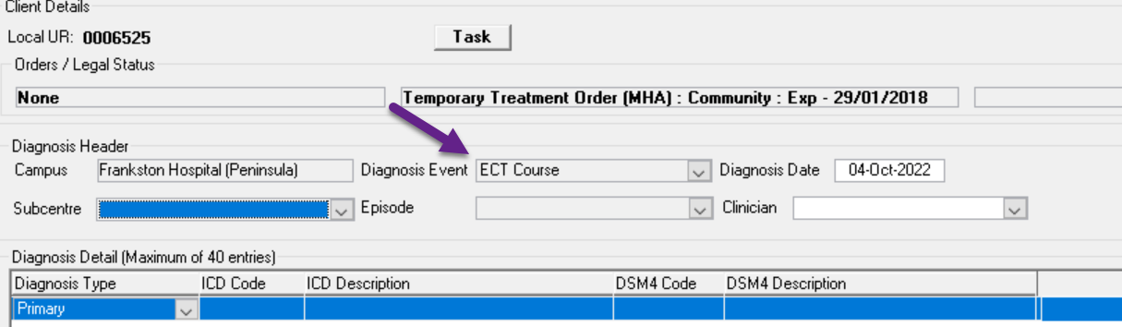
Add the diagnosis and save.
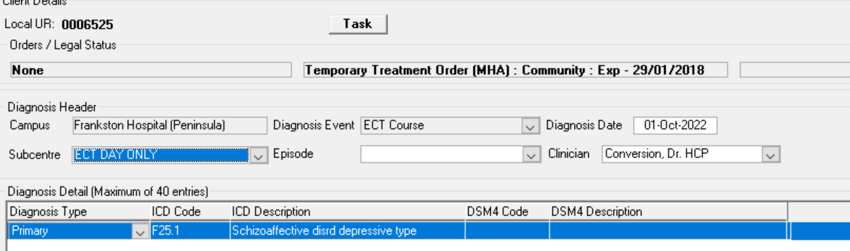
Close this event screen and the summary, return to the ECT function
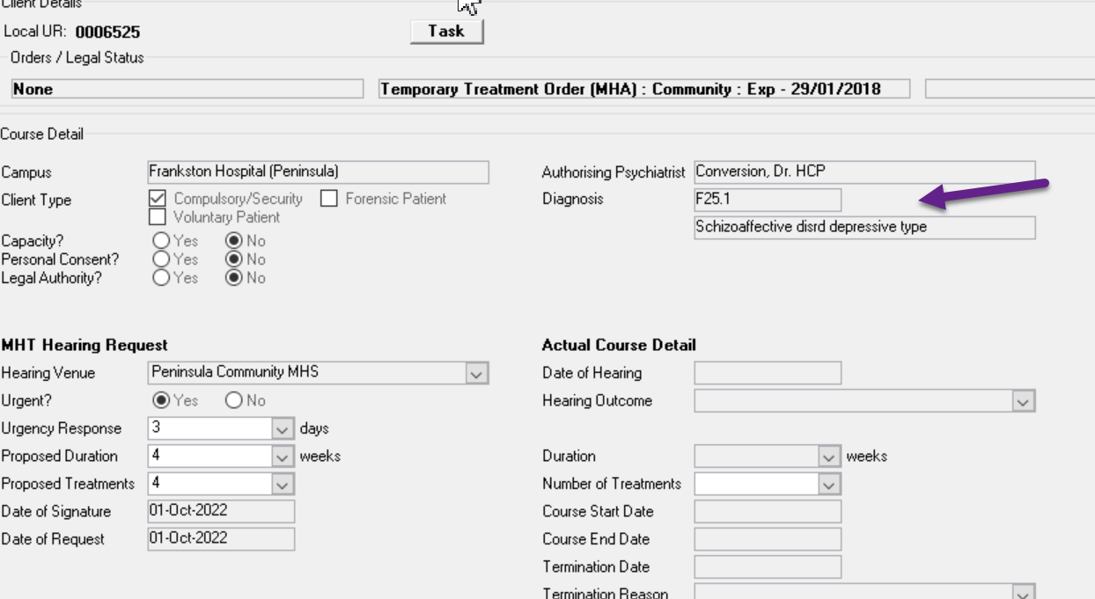
Diagnosis has saved.
Complete the course details and save and close, return to the summary window.

Click on Add Treatment on the header
Another screen will appear and you can enter the relevant details.
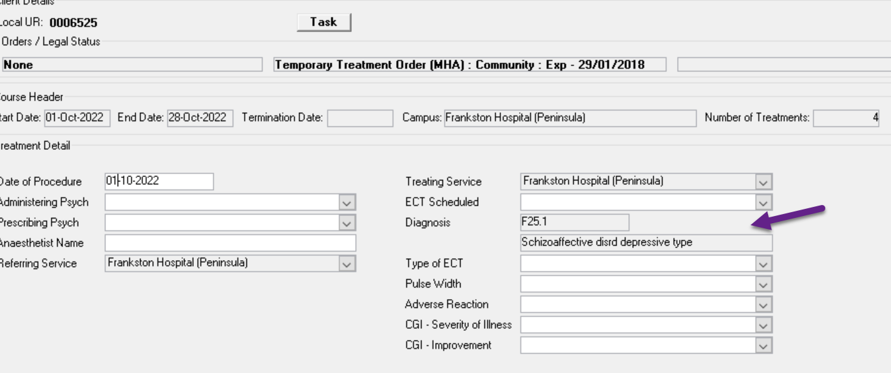
You will notice the diagnosis has defaulted through the system. If a second diagnosis has been given and needs to be recorded –
As before - Click on the options menu top left-hand side of the treatment window, click on Diagnosis.
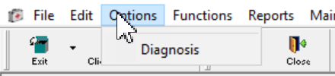
The Diagnosis Event is now displayed as ECT Treatment
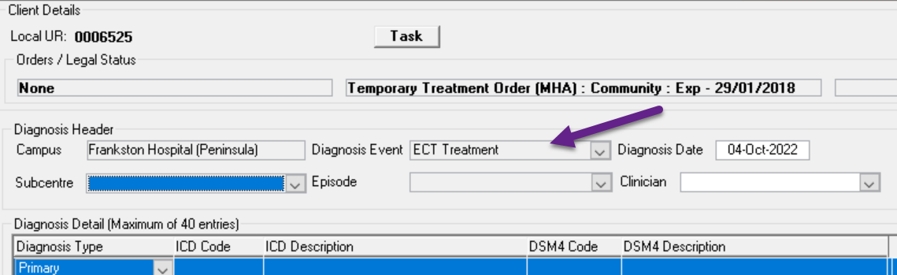
Add the diagnosis and Save
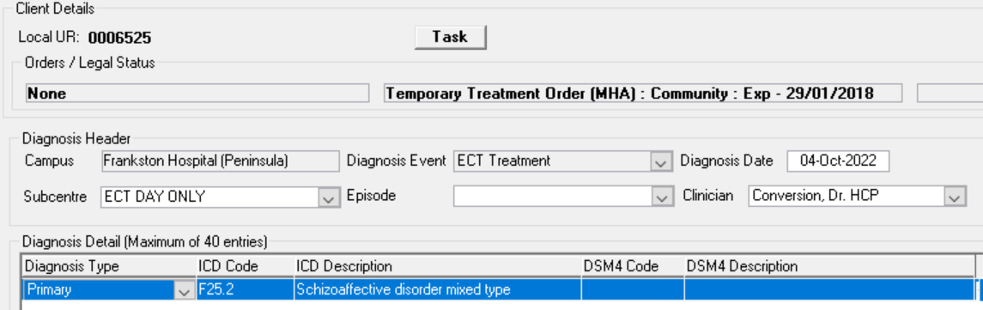
Returning to the ECT treatment screen, you will notice there is no change in the diagnosis.
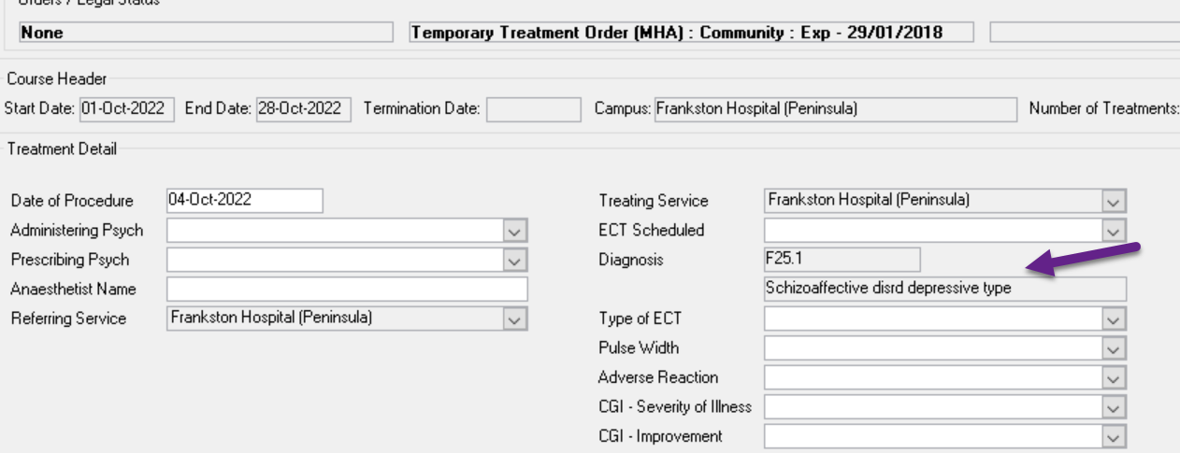
Complete the details and Save, you will notice the second diagnosis is displayed.

Appendix 2 - Other types of Diagnosis events

Separation Diagnosis Event:
When adding a diagnosis for a consumer who has been separated after an admitted episode, go to
- Function,
- admission
- Search for your consumer
- When the screen opens for that consumer, go to Options
- Choose diagnosis
- Add
After clicking Add another screen will appear:
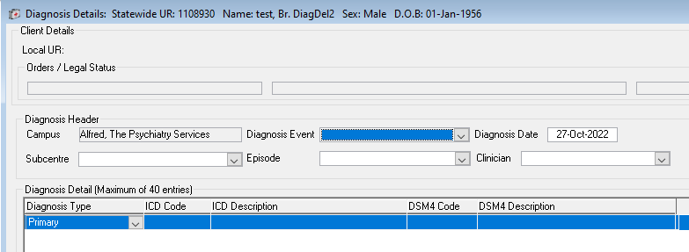
In this screen you choose the relevant information from the drop down lists:
- Subcentre
- Diagnosis event – it is here that you identify which type of diagnosis event you are entering as identified earlier in the Diagnosis Event table – in this instance it will be a separation diagnosis event
- Episode – be sure to select the correct episode as more than one may appear in the drop down list
- Diagnosis date – usually the discharge date
- Clinician – choose the relevant person from the drop down list

Diagnosis Date: this will be the date of discharge from the acute inpatient unit.

Alternatively you can choose to go;
- Function
- Diagnosis
- Search for consumer, select consumer
- Click on Add
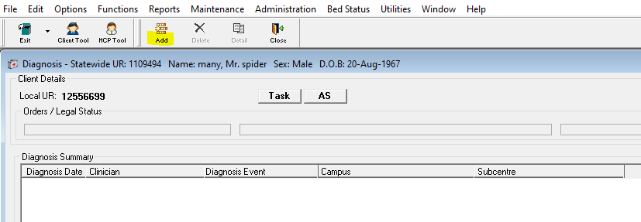
When you click Add another screen opens which you need to complete
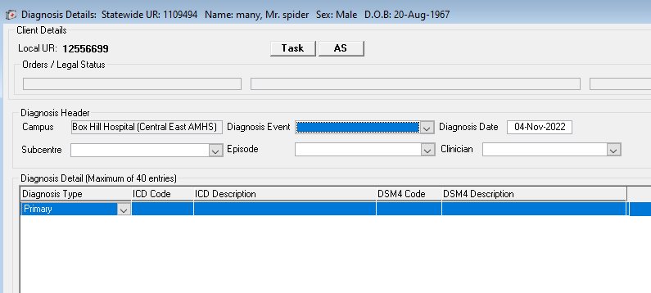
As indicated above you need to complete:
- Subcentre
- Diagnosis event – it is here that you identify which type of diagnosis event you are entering as identified earlier in the Diagnosis Event table – in this instance it will be a separation diagnosis event
- Episode – be sure to select the correct episode as more than one may appear in the drop down list
- Diagnosis date – usually the discharge date
Clinician – choose the relevant person from the drop down list.

Admission to non-acute or residential service diagnosis event
Follow the steps above for acute inpatient separation but instead of choosing a ‘Separation’ diagnosis event, choose ‘Admission’ diagnosis event.

Community diagnosis event
To enter a diagnosis for a community episode of care you can choose either of the options below:
- Function
- Case Summary
- Search for consumer
Once the Case Summary screen opens you can choose:
- Options
- Diagnosis
- Add
After clicking Add another screen will appear:
In this screen you choose the relevant information from the drop down lists:
- Subcentre
- Diagnosis event – it is here that you identify which type of diagnosis event you are entering as identified earlier in the Diagnosis Event table – in this instance it will be a community diagnosis event
- Episode – be sure to select the correct episode as more than one may appear in the drop down list
- Diagnosis date: this will depend on whether you are adding a diagnosis for the commencement of the episode in which case you would add the episode start date. If you are entering a review diagnosis then the date would reflect the date of review and if the episode is closing, the diagnosis event date would be the date the episode is closed. If entering a diagnosis because there has not been a diagnosis entered for 12 months, then enter the date 12 months after commencement, e.g. episode commenced ono 1.1.2022, diagnosis date will be 1.1.2023.
- Clinician

As indicated above, you may choose to access the Diagnosis screen by:
- Function
- Diagnosis
- Search for client
- Then follow steps above

