Mosquito and mosquito-borne disease weekly report 2022/2023
Report number: 5
Reporting week: 27/11/22 - 03/12/22
Report issued date: 05/12/22
OFFICIAL
Contents
Summary 2
Human mosquito-borne diseases notifications 2
Notifications 2
Japanese encephalitis virus 3
Ross River virus 3
Mosquito surveillance 4
Mosquito abundance 4
Mosquito species of concern 6
Mosquito viral detections 7
Contact 7

Summary
This report contains a range of indicators relating to mosquito-borne diseases actively monitored by the Department of Health (the department). The department conducts mosquito surveillance throughout the Victorian mosquito breeding season, which in inland areas typically occurs from early November through to late April the following year, with coastal areas typically starting earlier and ending later. For reporting purposes, the 2022/2023 season is defined as commencing from 1 July 2022.
The indicators used in this report are sourced from the following surveillance systems:
- Human surveillance (notified confirmed and probable cases and/or modelled predictions of vector-borne disease)
- Mosquito surveillance (adult mosquitoes)
The report will be issued weekly. Some indicators may not be updated for every report. The report contains information collected in the week prior. There is a time delay from mosquito field collection to reporting. This is due to the cumulative time between trap collection, specimen transit time to Melbourne, and from individual mosquito species identification to polymerase chain reaction (PCR) testing within the laboratory.

Human mosquito-borne diseases notifications
In 2022 there are five mosquito-borne viruses which have been identified to pose public health risk in Victoria with the potential for local transmission. These are Japanese encephalitis virus (JEV), Murray Valley Encephalitis virus (MVEV), Ross River virus (RRV) and Barmah Forest virus (BFV), West Nile virus Kunjin strain (WNV/kun) (otherwise known as Kunjin virus). Cases of infection with these viruses are notified to the department by pathology services and in some cases medical practitioners under the Victorian Public Health and Wellbeing Regulations 2019.

Notifications
Mosquito-borne disease notification from previous week
CONDITION | Confirmed | Probable | YTD
Japanese encephalitis virus infection | 0 | 0 | 0
Ross River virus infection | 0 | 1 | 26
Barmah Forest virus infection | 0 | 1 | 2
Kunjin virus infection | 0 | 0 | 0
Murray Valley encephalitis virus infection | 0 | 0 | 0
Note: ª YTD: Year to date total cases (confirmed/probable) reported since 1/7/2022

Japanese encephalitis virus
There were no cases of JEV notified last week.

JE epidemic curve
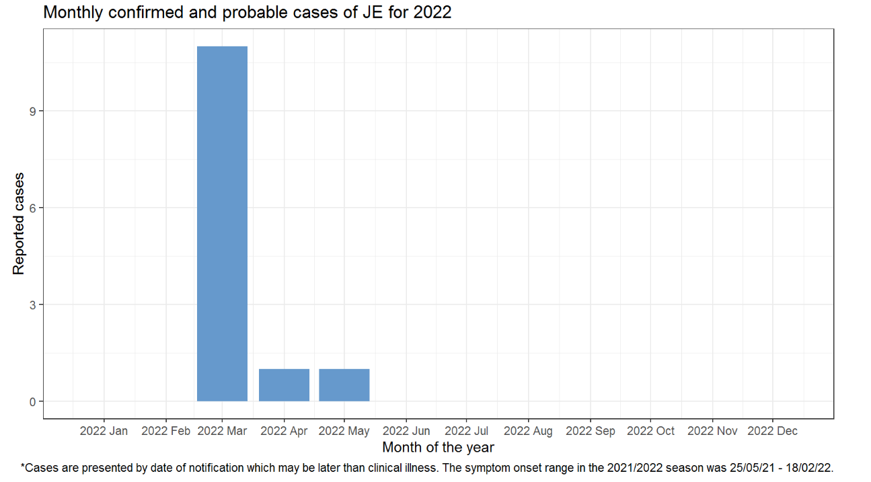
Figure 1 Japanese encephalitis virus epidemic curve

Ross River virus
There was one probable case of RRV notified in the last week, in a person who resides in a regional area.

RRV epidemic curve
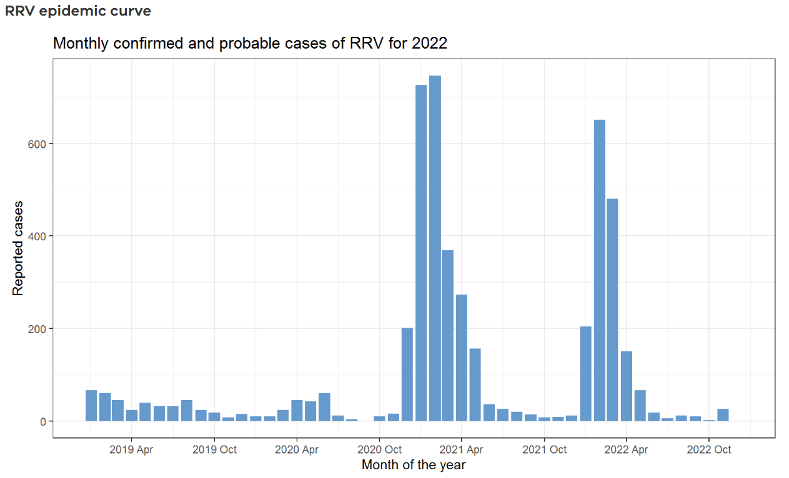
Figure 2 Ross River virus epidemic curve

Mosquito surveillance
Approximately 15 councils in high-risk areas for mosquito-borne diseases currently participate in the state-wide mosquito surveillance program. Mosquitoes trapped as part of this program are submitted to the Agriculture Victoria Research laboratory at the Department of Jobs, Precincts and Regions (DJPR) for mosquito species identification, counting and viral testing. These data are reported to the department for monitoring and analysis.

Mosquito abundance
This section details the abundance of mosquitoes in Victoria by LGA. The count average for all trapping sites within the previous week is reported by LGA. There has been a total of 55 trapping sites surveyed during the last week.
Table 1: Average number of mosquitoes per trap site per week by LGA, 2022-2023
LGA by week |  |  |  |  |  | 2022
 |  |  |  | Jul |  |  |  |  |  | Aug |  |  |  |  |  |  |  |  | Sep |  |  |  | Oct |  |  |  |  | Nov
 |  |  |  | w28 |  | w29 | w30 |  | w31 | w32 |  | w33 |  | w34 |  | w35 |  | w36 | w37 | w38 | w39 | w40 | w41 | w42 | w43 | w44 | w45 | w46 | w47 | W48
Greater Shepparton |  |  |  |  |  |  |  |  |  |  |  |  |  |  |  | 9 |  |  | 8 |  | 26 |  | 171 | 91 | 221 | 1,203 | 2,086 | 614 | 1,836 | 1,607
Moira |  |  |  |  |  |  |  |  |  |  |  |  |  |  |  |  |  |  | 4 |  |  | 1 | 3 |  | 568 |  | 1,137 | 63
Horsham |  |  |  |  |  |  |  |  | 1 |  |  | 1 |  |  |  | 10 |  | 2 | 2 | 5 | 13 | 24 | 156 | 155 | 178 | 948 | 1,258 | 1,961 | 1,824 | 460
Mildura |  |  |  | 3 |  |  | 1 |  |  | 6 |  |  |  | 6 |  |  |  | 23 | 31 | 67 | 132 | 127 | 342 | 297 | 185 | 434 | 1,991 |  | 979
Greater Bendigo |  |  |  |  |  | 1 |  |  |  |  |  |  |  |  |  |  |  |  |  |  | 9 |  |  | 256 | 255 | 194 | 1,386 | 2,021 | 1,647
Greater Geelong |  |  |  |  |  |  | 90 |  |  | 23 |  |  |  |  |  |  |  | 57 | 103 | 158 | 131 | 132 | 104 | 29 |  |  | 397 |  | 680
Campaspe |  |  |  |  |  |  |  |  | 1 |  |  |  |  | 1 |  |  |  | 3 |  | 14 |  |  | 88 |  | 472 |  | 2,394 | 723 | 2,255 | 659
Wodonga |  |  |  |  |  |  |  |  |  |  |  |  |  | 3 |  |  |  |  |  | 5 |  | 57 | 58 | 181 |  | 645 | 1,062 | 3,189
East Gippsland |  |  |  |  |  |  |  |  |  |  |  |  |  |  |  |  |  | 28 | 21 |  |  | 26 | 108 |  |  |  | 33 | 278
Frankston |  |  |  |  |  |  |  |  |  |  |  |  |  |  |  |  |  | 4 |  |  | 29
Swan Hill |  |  |  |  |  |  |  |  |  |  |  |  |  |  |  |  |  |  |  | 11 | 19 | 101 | 219 | 253 | 943 | 806 | 3,186 | 1,093 | 156 | 1,624
Gannawarra |  |  |  |  |  |  |  |  |  |  |  |  |  |  |  |  |  |  |  |  |  |  | 486 | 930 | 330 |  | 781 | 1,646 | 191
Wellington |  |  |  |  |  |  |  |  |  |  |  |  |  |  |  |  |  |  |  |  |  |  |  |  | 86 | 450 | 318 | 676 | 474 | 1,475
Loddon |  |  |  |  |  |  |  |  |  |  |  |  |  |  |  |  |  |  |  |  |  |  |  |  |  | 12,825 | 7,926 | 3,530 | 630 | 1,541
Surf Coast |  |  |  |  |  |  |  |  |  |  |  |  |  |  |  |  |  |  |  |  |  |  |  |  |  |  | 40 |  | 1,586
Yarra City |  |  |  |  |  |  |  |  |  |  |  |  |  |  |  |  |  |  |  |  |  |  |  |  |  |  | 2,047 | 3,223 | 5,951
Key | Low (<50) | Moderate (50-99) | High (100-999) |  | Very high (1,000-9,999) |  |  | Extreme (10,000+)

Mosquito species of concern
In inland areas Culex annulirostris is considered the major species of concern for transmission of RRV, BFV, WNV/Kunjin, and MVEV. It is also believed to be a major vector for JEV.
Aedes camptorhynchus is the major vector of RRV and BFV in coastal saltwater habitats.
A sample of trapped mosquitoes are examined to estimate the proportion of different species. The availability and accuracy of this representative sample is influenced by the number of mosquitoes captured, the condition of the mosquitoes at time of examination, and other factors.
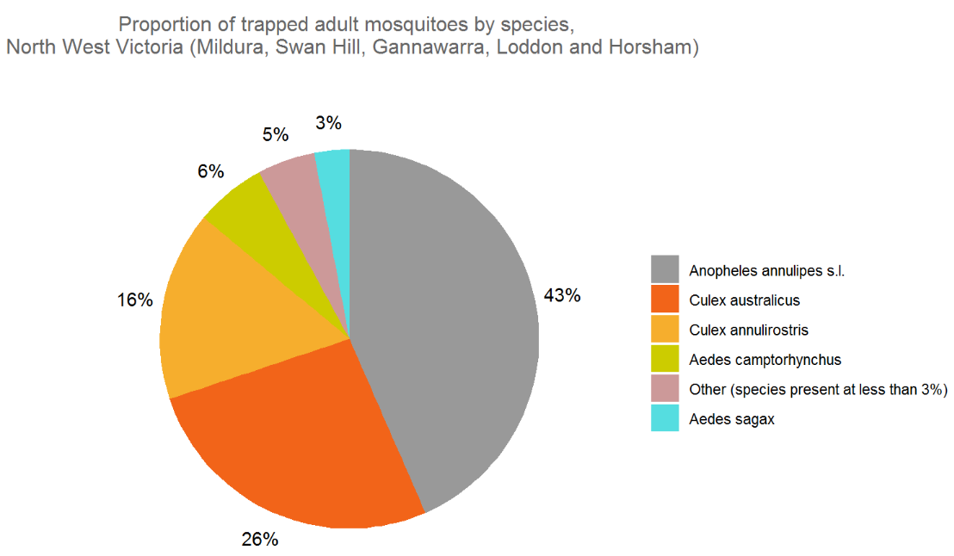
Figure 3 North West Victoria - proportion of trapped adult mosquitoes by species
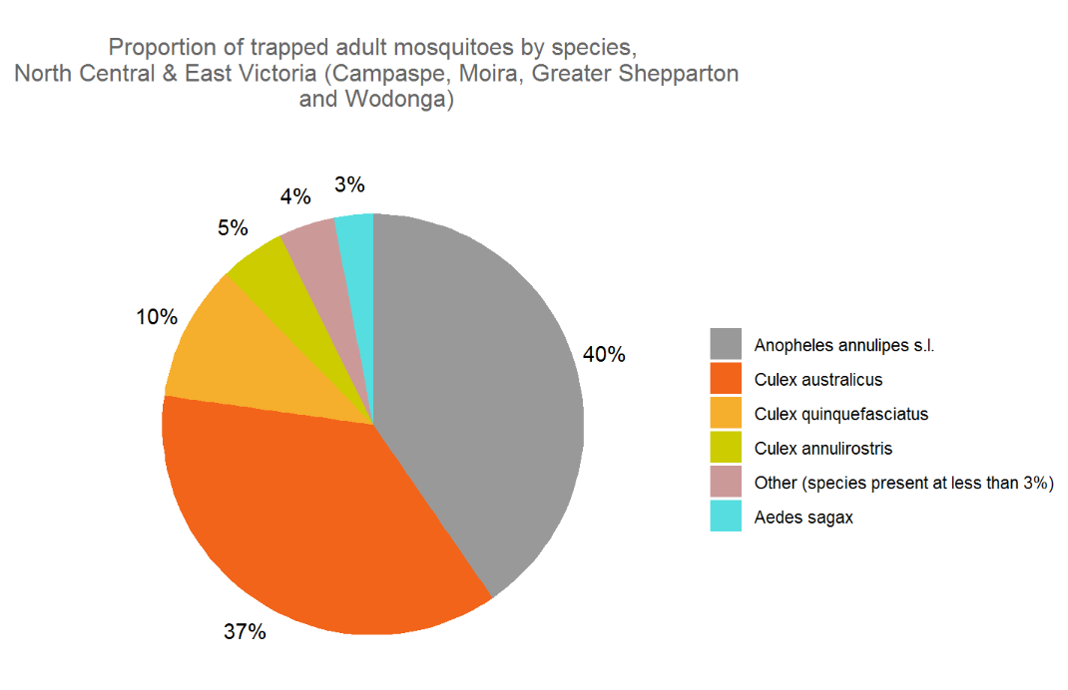
Figure 4 North Central & East Victoria - proportion of trapped adult mosquitoes by species

Mosquito viral detections
Captured mosquitoes are submitted for PCR testing to detect RRV, BFV, MVEV, JEV and WNV/Kunjin.
There were no viral detections last week.

To receive this document in another format, phone 1300 651 160, using the National Relay Service 13 36 77 if required, or email the departments Communicable Disease Section <infectious.diseases@health.vic.gov.au>.
Authorised and published by the Victorian Government, 1 Treasury Place, Melbourne.
© State of Victoria, Australia, Department of Health, November 2022.
ISBN/ISSN number (online/PDF/Word) or (print)
Available at the departments website <https://www.health.vic.gov.au/infectious-diseases/vector-borne-infectious-disease-control>

