Diverse Communities Mental Health & Wellbeing Toolkit
Tell us what would improve the mental health and wellbeing of culturally and linguistically diverse communities, LGBTIQ+ people and people with disability
OFFICIAL

To receive this document in another format or in a translated version, phone 03 9821 6151, using the National Relay Service 13 36 77 if required, or email the Diverse Communities Team on <mhwd.diversity@health.vic.gov.au>.
Authorised and published by the Victorian Government, 1 Treasury Place, Melbourne.
© State of Victoria, Australia, Department of Health, November 2022.
Except where otherwise indicated, the images in this document show models and illustrative settings only, and do not necessarily depict actual services, facilities or recipients of services.
ISBN 978-1-76131-066-9 (pdf/online/MS word)
Available on the Department of Health website at <https://www.health.vic.gov.au/mental-health-wellbeing-reform/diverse-communities-mental-health-and-wellbeing-framework-and-blueprint>

Contents
About the Community Engagement Toolkit 5
What is this Community Engagement Toolkit (the Toolkit) about? 5
When is feedback due? 5
How will your ideas and feedback be used? 6
How do you use the toolkit? 6
Privacy collection notice 7
The Toolkit 8
Part 1: Tell us about you 9
Part 2: Priority areas 9
Question 1: Your most important priority areas 9
Question 2: Why are these important to you? 11
Question 3: What’s missing? 14
Part 3: The vision 15
Instructions 15
Question 1: What’s happening in the future? 15
Question 2A: Describe your picture 18
Question 2B: Summarise your vision 18
Part 4: How do we get there? 19
Question 1: What are the three most important steps that will help this vision be turned into a reality? 19
Part 5: Thank you 20

About the Community Engagement Toolkit

What is this Community Engagement Toolkit (the Toolkit) about?
The Victorian Government is working on improving and supporting the mental health and wellbeing of people from diverse communities.
By ‘Diverse Communities’ we mean:
- people with disability
- LGBTIQ+ people
- culturally and linguistically diverse communities.
The government wants to hear from diverse communities in different ways. This toolkit is an opportunity for you to share your experiences and ideas about mental health and wellbeing in your community. To answer the toolkit questions you can either:

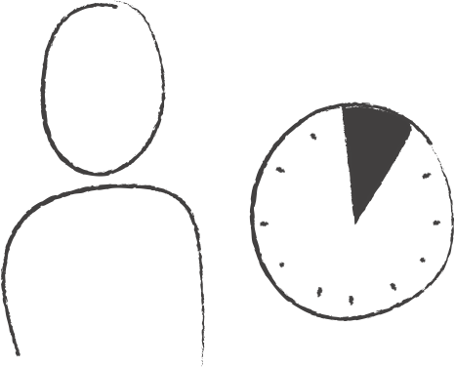
- Fill out this toolkit on your own. Allow yourself one hour.

OR

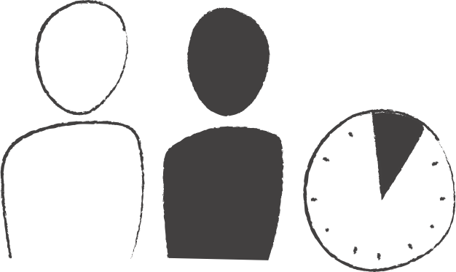
- Fill out this toolkit with help from someone you know. Allow yourself one hour.

OR
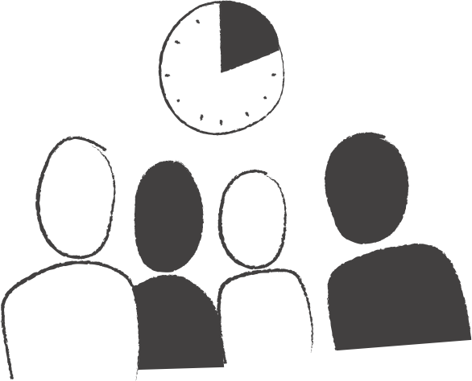
- Use it in a conversation with a group of others from your community or organisation and complete it together. Allow your group two hours or for a good conversation.

When is feedback due?
Please send us your feedback by Wednesday 18 January 2023.

How will your ideas and feedback be used?
Your completed toolkit will go to the Diverse Communities Team who are part of the Department of Health in the Victorian Government.
The Diverse Communities Team is creating a plan to support diverse communities to have good mental health. This is known as the Diverse Communities Framework and Blueprint for Action.
The Framework will guide the government’s work over the next 10 years, and the Blueprint will identify the actions the government will focus on in the next two years.
The ideas and feedback you give in this toolkit will help this team write the plan which will define how the Department of Health’s resources are spent. This includes time and money.

How do you use the toolkit?
You can either:
- Edit the document as a Word Document. Then email it to mhwd.diversity@health.vic.gov.au with the subject line ‘Community Toolkit’.
OR
- Print off a copy and write and draw on the toolkit. Please then either scan the pages or take a photo and email them to mhwd.diversity@health.vic.gov.au with the subject line ‘Community Toolkit’.
You can answer as many or as few questions as you like. Please send all feedback to us by Wednesday 18 January 2023.

Privacy collection notice
The Department of Health (the department) are committed to protecting your privacy. The department will collect and handle personal information in this toolkit for the purposes of developing the new Diverse Communities Framework and Blueprint for Action. Participation in these engagements is voluntary.
If your feedback or contribution relates to other mental health and wellbeing reforms, we may pass on your feedback (without your name or contact information) to the relevant team within the department working on those reforms. Collated and reasonably de-identified responses will be provided to the Victorian Government’s Diverse Communities Working Group comprised of representatives from LGBTIQ+, multicultural and disability peak bodies, community organisations and services and people with lived and living experiences to inform the guidance they provide to the Victorian Government regarding the Framework and Blueprint.
Responses and reasonably de-identified quotes or excerpts from responses may be used in material that will be:
- published publicly, and
- used internally by the Department of Health and other departments and agencies in the Victorian Government to inform the new Victorian Diverse Communities Framework and Blueprint for Action and related mental health and wellbeing reforms across different systems.
You are asked not to include any personally identifying or sensitive health information about anyone else in your responses to questions. The department will take reasonable steps to ensure there is no personally identifying information in responses before collating them and before it publishes any of their contents, and will always remove contact information such as name, email or address details before publishing any part of a response or submission.
If you do not provide us with the information requested in the engagement, this may limit the department’s ability to use your response in the development of the new Framework and Blueprint. As responses are not intended to be identifying, it will not be possible for you to access or correct your response.
If you have any questions regarding this engagement, please contact mhwd.diversity@health.vic.gov.au. For more information on the department’s privacy practices, please refer to the department’s privacy policy, available on our website at https://www.dhhs.vic.gov.au/publications/privacy-policy.
Please note, by completing and returning this toolkit to the department you are acknowledging and accepting the terms of this Privacy Collection Notice and consenting to your responses being handled as set out in this Notice.

The Toolkit
There are three parts to this toolkit:
Part 1: Tell us about you (5 minutes)
Part 2: Priority areas (25 minutes)
Part 3: The vision (25 minutes)
Part 4: How do we get there? (5 minutes)

This is a Victorian Department of Health Framework, so please focus on your responses on things that the department can change, such as:
- Public hospitals
- Public mental health services
- Statewide and specialist mental health services
- Community health services
- State-funded mental health and wellbeing programs and organisations
The Department of Health cannot influence Federally or interstate funded programs such as general practitioners (GPs), Medicare and the National Disability Insurance Scheme (NDIS).

Thank you for sharing your experience and ideas with us.

Part 1: Tell us about you
Only share what you want the Department of Health to know.

- How many of you are filling out this toolkit?
- Which diverse communities do you identify with or work with? Tick or highlight all that apply:
☐ LGBTIQ+ people
☐ People from culturally and linguistically diverse communities
☐ People with disability
- How would you describe yourself or your group? Tick or highlight all that apply:
☐ Community member/s (you don’t work in mental health services or diverse community organisations)
☐ Community organisation staff or volunteer/s that work with diverse communities
☐ Mental health services staff or volunteer/s
☐ Other:
- What else would you like us to know about you?

Part 2: Priority areas
Communities have spent a lot of time telling the Victorian Government what some of the challenges are for diverse communities. These include challenges in getting the right support for their mental health and wellbeing and how to promote good mental health and wellbeing.
From these conversations and research (especially the Royal Commission into Victoria’s Mental Health System), there were some things that the Government can focus on improving in the next 10 years.

Question 1: Your most important priority areas
On the following page is a list of the priority areas. Tick or highlight the priority areas you think are most important for the Victorian Government to focus on to improve mental health in your communities in the next 10 years. You can tick or highlight one or more of the priority areas.

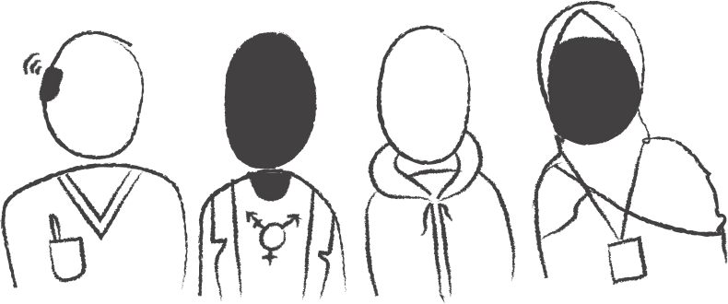
☐ 1. Ensure all mental health treatment, care and support is safe, inclusive, accessible and responsive to diverse communities.

☐ 2. Resource (with time and money) mental health services that specialise in supporting diverse communities.

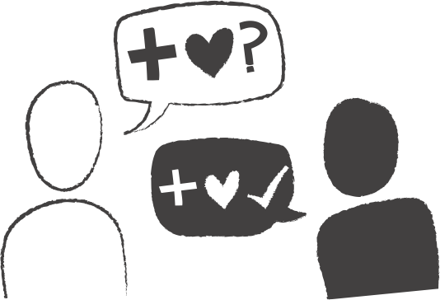
☐ 3. Better support the strengths of diverse communities and build on their roles in supporting mental health and wellbeing in their communities.

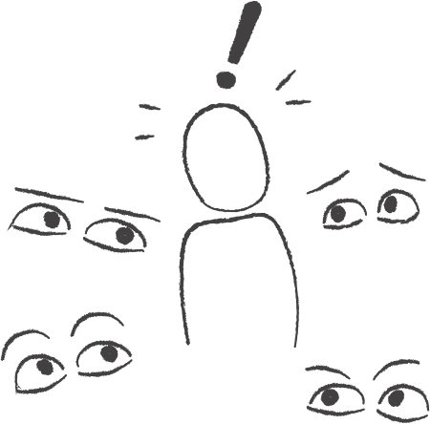
☐ 4. Address stigma about mental health and mental illness and address discrimination against diverse communities.

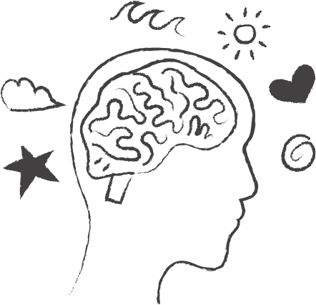
☐ 5. Improve how good mental health and wellbeing is promoted, and how suicide is prevented and responded to.

☐ 6. Increase representation and participation of diverse communities in mental health services and the mental health system.

Question 2: Why are these important to you?
Write down why the priority areas you ticked are so important to your community. Write down the top three reasons you think it’s important.
Here are some things you could write down:
- The barriers that exist in this area and what the Victorian Government should do to fix them.
- What individuals or groups are doing to work toward this.
- Where you’ve seen this done well.
- The impact this has on communities when this is achieved.

1. Ensure all mental health treatment, care and support is safe, inclusive, accessible and responsive to diverse communities.

2. Resource (with time and money) mental health services that specialise in supporting diverse communities.

3. Better support the strengths of diverse communities and build on their roles in supporting mental health and wellbeing in their communities.

4. Address stigma about mental health and mental illness and address discrimination against diverse communities.

5. Improve how good mental health and wellbeing is promoted, and how suicide is prevented and responded to.

6. Increase representation and participation of diverse communities in mental health services and the mental health system.

Question 3: What’s missing?
Do you think there is something missing from the list of priority areas?
If you think something is missing that the Department of Health can change, please add your suggestions below:

Part 3: The vision

Instructions
We’re going to ask you to imagine a better future of mental health for diverse communities and then describe this in pictures or words.

Imagine you are in the year 2033.
The Victorian Government has been working hard with communities and services to make things better for diverse communities.
Imagine that you and your communities now have the opportunity to have good mental health and wellbeing in all areas of your life. When things are hard or tough, people can get the support they need.
On the following pages, describe your answer to this question:
How has the world changed in 2033 for the mental health and wellbeing of you and your community?

Question 1: What’s happening in the future?
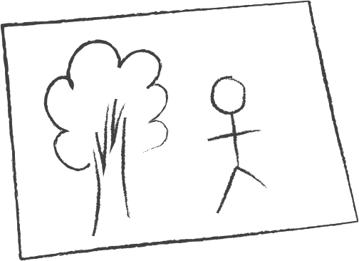
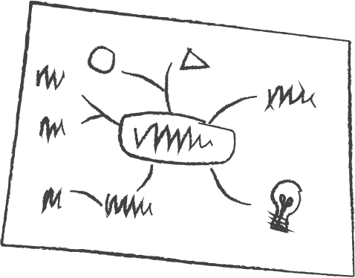
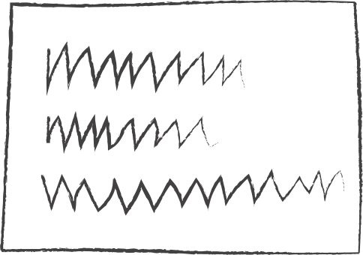
Either draw a picture or write some words to describe what is happening in this better future.
This could be anything you like, such as:
- Some sentences
- A drawing
- A poem
- A mind map or brainstorm
- Photos from the internet
If you are in a group, each person could create one page, or you could work on it together.
If you are not sure where to start, try imagining yourself in 2033 and answering these questions:
- What has changed for diverse communities to be leading happier and healthier lives?
- How has society changed to reduce stigma and discrimination?
- What is different about the way people access and receive help and support?
- What do people in health services say and do when you are seeking support?
- What sorts of programs and activities are available in your area or community that keep you well?
Draw or write your vision on this page:

Question 2A: Describe your picture
If you included a picture, describe the key elements of the picture below so we can understand it:

Question 2B: Summarise your vision
Summarise your vision in three sentences to help us understand what is most important to you and your community:

Part 4: How do we get there?
An important part of the work of the government is to plan the steps that will help us to get to the vision of a better future. This will support the government to create the ‘Blueprint’. This is a plan of action for the next two years.
Think about the vision you created above where diverse communities have good mental health and wellbeing and can access supports when times are difficult.

Question 1: What are the three most important steps that will help this vision be turned into a reality?
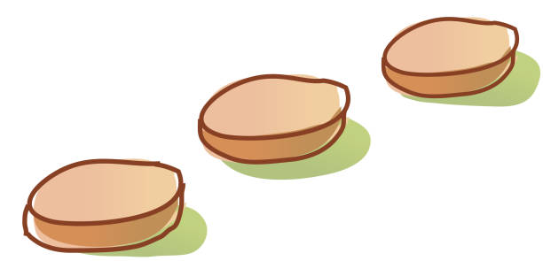
Add a few details of how these steps will happen: who is responsible, what existing or new roles are needed, and what are communities, services and government doing? How can we check that the government and services are working well along the way?
Your vision for 2033
Today in 2022
Step 2
Step 1
Step 3

We’d like you to think about what we all need to do to get to your vision of the future in 2033. Please add in details of what those steps are and how we can make them happen:

Step 1:

Step 2:

Step 3:

Part 5: Thank you
Thank you for sharing your time, experience and ideas with us. This will help make the Diverse Communities Mental Health and Wellbeing Framework and Blueprint better.
There are other ways you can stay involved – have a look at the website for the engagement next steps and to see the development of the Framework, or go to <www.health.vic.gov.au/mental-health-wellbeing-reform/diverse-communities-mental-health-and-wellbeing-framework-and-blueprint>

This definition of diverse communities is taken from the Royal Commission into Victoria’s Mental Health System. We recognise that there are other forms of diversity and intersectionality.
“A set of negative and often unfair beliefs that a society or group of people have about something.” The Britannica Dictionary. britannica.com/dictionary/stigma
“A set of negative and often unfair beliefs that a society or group of people have about something.” The Britannica Dictionary. britannica.com/dictionary/stigma

