Victorian Alcohol and Drug Collection
VADC Bulletin 2022-23
Edition 22: 14 November 2022
OFFICIAL

VADC Bulletins must be read in conjunction with the VADC Data Specification, available here
VADC documentation - health vic
Contents
1. Annual Change Proposals for VADC 2023-24 2
2. Server Outage 2
3. Data Quality Review 2
4. Data submission 2
5. Troubleshooting MFT login problems 3
6. MFT intermittent issue 4
7. EOC/DTAU Specifications for 2022-23 4
8. Service Event Statement 4
9. Funded activity letters for 2022-23 4

1. Annual Change Proposals for VADC 2023-24
The VADC team would like to thank services for their feedback on the Proposals for revisions to VADC for 2023-24. The closing date for feedback was on 7 November 2022. All feedback to proposals will now be collated and presented to the VADC Change Management Group to inform their final recommendations for changes to VADC effective 1 July 2023.

2. Server Outage
The server issue affecting VADC Test and VADC Production was rectified on Monday 7th of November. We apologise for the inconvenience caused & would like to extend thanks for your patience on this matter. In recognition of this disruption we have extended the October 2022 data submission to Wednesday 30th of November 2022.
If your service and/or staff are affected by the current floods, we understand this may be a difficult time so happy to review submission timelines when the situation in your area has improved. Please contact the VADC team to discuss.

3. Data Quality Review
A Data Quality (DQ) review for FY22/23 is currently underway to identify services reporting
- Unusual ACSO Identifiers
- Unusually high volume of supplementary values for VADC data elements
(e.g. Indigenous status, sex at birth etc)
Upon completion of the DQ activity, we will reach out to the relevant services for clarification.
Thank you to the services who have responded to date on the outcomes of the DQ review of the ACSO Identifier and resubmitted data as necessary.

4. Data submission
A reminder service providers are responsible for ensuring data submitted to the department is a true and accurate representation of actual service activity. Please check the feedback validation report after each file submission and if there are errors, please correct the errors & resubmit the file.
Note: Only error free data will be accepted into the VADC database.
If there is no reportable service activity, nor open Service Events for a reporting period, a blank file submission that includes outlet code, reporting period and extract date is still required.
REMINDER: Service providers won’t be able to submit prior financial year data after the consolidation date of 1st January 2023. If service providers want to submit prior financial year data before the consolidation date, please provide the following information and email the VADC data team at vadc_data@health.vic.gov.au
- What is the reason for prior year data resubmission?
- Reporting period(s) affected
- How many client & service events affected?

5. Troubleshooting MFT login problems
Please refer to the quick checklist below or the MFT User Guide (see link below) to ensure you are logging in correctly.
https://www.health.vic.gov.au/publications/vadc-managed-file-transfer-mft
- Did you start your browser in INCOGNITO mode (Chrome) or NEW InPrivate Window (EDGE)? Your login will not work if you are not in the correct browser mode.

- The fields in the first window that appears must be BLANK when you click ‘GET MFA CODE’ (shown below).

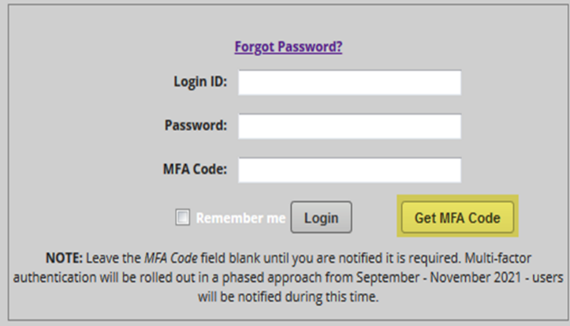
- After you receive your MFA security code via email or text, DO NOT copy & paste your security code into the MFA Code field, you must manually type it in.

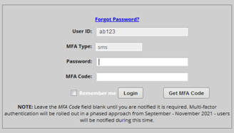

- Change your Password. Please select ‘Forgot Password’ & follow the prompts.
(MFT does not notify you when your password needs to be changed). Passwords can only be changed once every 24 hours.

Three unsuccessful login attempts will lock you out for 24 hours. If this happens, please do not try & login again for 24 hours.

6. MFT intermittent issue
A recent notification was sent out to service providers about an intermittent issue with the MFT portal.
What is the problem?
Files may not be automatically transferred into the BACKUP folder after you download your report from the PICKUP folder.
Instead, the files may remain in the PICKUP folder, so it is difficult to identify which files have already been downloaded from the list of files.
The problem does NOT affect normal file processing and if you try to download the file again, it should move to the BACKUP folder. If you still experience this problem, please email vadc_data@health.vic.gov.au

7. EOC/DTAU Specifications for 2022-23
As previously advised the EOC and DTAU Derivation Rules Specification for 2022-23 are available here: https://www.health.vic.gov.au/funding-and-reporting-aod-services/funding-of-alcohol-and-other-drug-services
The documents are located under the heading Downloads.
If you have any questions about the EOC and DTAU Derivation Rules Specifications, please email: aod.enquiries@health.vic.gov.au

8. Service Event Statement
Please use the Service Event Statement (SES) in conjunction with the DTAU Derivation Rules – Plain English Guide and EOC & COT Derivation Rules (see link above) to check indicative funding units allocated
We have made an improvement to the SES to prevent more than one indicative funding unit displaying next to a service event. For example, service events that have met the EOC rules will show a EOC value = 1 but COT & DTAU will be reported as 0 or a blank value.

9. Funded activity letters for 2022-23
Funded activity letters for this financial year won’t be issued unless there has been an update.
An updated funded activity letter is issued where there is a new activity or new catchment area. If you have any questions about this, please email aod.enquiries@health.vic.gov.au

To receive this document in another format email: vadc_data@health.vic.gov.au

Authorised and published by the Victorian Government, 1 Treasury Place, Melbourne.
© State of Victoria, Australia, Department of Health, November 2022

