Allied Health Clinical Supervision Reflective Practice Record

Date of this session: |  | Duration of session:
Supervision method: |  | Next session date:
Supervisee: |  | Clinical supervisor:
Supervisee signature: |  | Supervisor signature:
Follow up / updates since last supervision session:

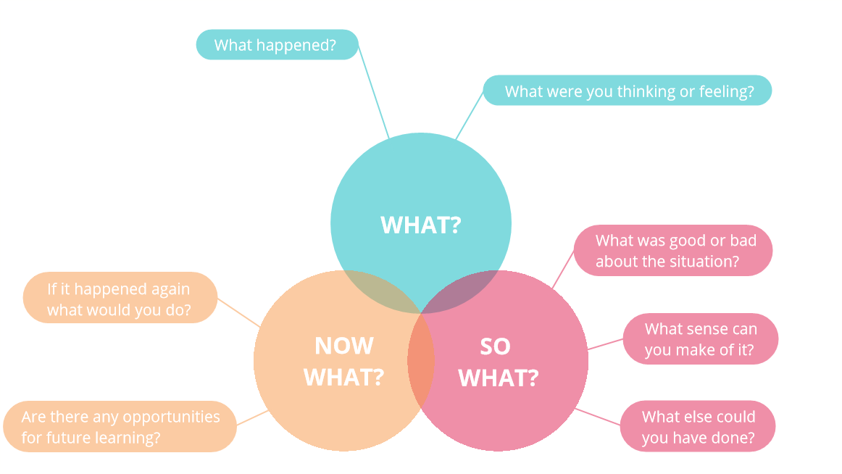
What?
What happened? What were you thinking or feeling?
So What?
What was good or bad about the situation? What sense can you make of it? What else could you have done?
Now What?
If it happened again what would you do? Are there any opportunities for future learning?
SMART Goal(s) For My Learning
What am I going to aim to achieve? You may like to keep in mind the 'To... Through... By…' format for structuring learning goals introduced in the “Getting Started with Clinical Supervision” learning module

To receive this publication in an accessible format phone (03) 9096 7324,
using the National Relay Service 13 36 77 if required, or alliedhealthworkforce@health.vic.gov.au

Authorised and published by the Victorian Government, 1 Treasury Place, Melbourne.
© State of Victoria, Department of Health, Oct 2022.
Available at the Department of Health website < https://www.health.vic.gov.au/allied-health-workforce/victorian-allied-health-clinical-supervision-framework>.

