Schedule B: Operational Plan – SAMPLE ONLY
COAG s19(2) Exemptions Initiative – Memorandum of Understanding – 2022–2025 Schedule B – Operational Plan

As agreed under the bilateral Memorandum of Understanding (MoU), all sites are required to provide a new or updated annual operational plan to the Commonwealth for the 2022-2025 period. This template has been developed to assist sites to meet the reporting requirements.

PART A: SITE DETAILS
An ‘Eligible Site’ is a health facility at an approved location from which services are traditionally provided by the state health authority – including hospitals and their outreach services, Multipurpose Services (MPS), and community clinics – and is one that has been listed under its practice name in the directions made under section 19(2) of the Health Insurance Act 1973 (the HI Act).

Contact details for the site and other key contact personnel

Name of Facility:
Physical Address:
Mailing Address:
Phone Number:
Fax Number:
Site Contact Person: | Example Director of Nursing | Tel/Mob/Email
Medical Director: | Example Dr Medical Officer  Director of Medical Services | Tel/Mob/Email
Finance Contact |  | Tel/Mob/Email
Operational or Health Service Manager | Example:  A/DON – Unit Manager | Tel/Mob/Email

Other Key Contacts
If there are any additional contacts, please attach relevant information where necessary.
Name: Example Chief Executive Officer
Position: Health Service Chief Executive
Organisation: Name of Health Service
Tel/Mob:
Email:

Site Description
Please provide a description of the health service/hospital profile information regarding the size of the site, current staffing arrangements and the types of services being provided.
Description of the health service/hospital profile
Example only
Name: example Primary Health Centre
[SITE NAME] is a multi-purpose health service located in MMM 5 and is comprised of a 24-bed acute inpatients unit and an eight-bed residential aged care unit, and provides the following health services which include:
- urgent care services
- community and primary healthcare
- mental health
- dental
- outreach specialists
- outreach service

There is limited public transport to access specialist primary care appointments which are over an hour away.

Clinics available
Antenatal
Child health
Healthy bladder
Hearing health
Fracture
High risk foot
Outpatients
Women's health

Medical and allied health services
Cardiac Rehabilitation
Dietician
Fracture Clinic
High Risk Foot Clinic
Occupational therapy
Outpatients Clinic
Physiotherapy
Podiatrist
Speech pathologist
Social work
Radiology

Outreach services
Alcohol, tobacco and other drug service
Clinical nurse
Mental health
Social work
Home Care Support Packages
HACC PYP

Community and primary health
Alcohol, tobacco and other drug service
Antenatal classes
Chronic disease management program
Early discharge midwifery service
Family care program
Health education and promotion
Hearing Health Clinics
High Risk Foot Clinic
Immunisation
Lactation consultation
Mental health
Needle and syringe program
Oral health
Positive Parenting Program (PPP)
Post acute care
School based immunisation program
School screening

Staff Arrangement
- VMO Medical x 8 FTE
- Nursing x 47 FTE
- Managerial & Clerical x 10 FTE
- Operational x 29.5 FTE
- Allied Health x 5 FTE
- Health Workers x 3.5 FTE

[SITE NAME] is located in …… and is part of the XXXXX Health Service [SITE NAME] has a population of 1,732 persons (ABS Stat release 2011).
The Socio-Economic Indexes for Areas (SEIFA) indicate that parts of the [SITE NAME] are the most socially disadvantaged areas in Victoria. 16.6% of the population, lived in areas with the highest levels of disadvantage in Victoria.
The following tables provide additional support to the levels of disadvantage experienced by the community:

Table 1: Median weekly personal and family income and housing indicators by locality
Locality | Median personal weekly income | Median family weekly income | Average persons per bedroom | Average household size
Example name 1 (L) | 576 | 1171 | 1.1 | 2.4
Example name 2 (L) | 558 | 1237 | 1.1 | 2.4
Example name 3 | 653 | 1348 | 1.1 | 2.1
AREA NAME | 499 | 1182 | 1.1 | 2.5
Example name (L) | 407 | 959 | 1.1 | 2.2
Source: ABS, Census 2011, Urban Centres and Localities data; via http://www.abs.gov.au/websitedbs/censushome.nsf/home/datapacks Table B02.

Table 2: Number of motor vehicles report per dwelling by UCL, 2011
Locality | Vehicles per dwelling |  |  |  |  |  | Total Dwellings
Locality | 0 | 1 | 2 | 3 | 4+ | Not Stated | Total Dwellings
Area name | 93 | 243 | 189 | 56 | 17 | 41 | 639
Example name 1 | 184 | 731 | 421 | 81 | 27 | 48 | 1492
Example name 2 | 11 | 87 | 79 | 18 | 7 | 7 | 209
Example name 3 | 13 | 108 | 120 | 16 | 12 | 9 | 278
Example name 4 | 4 | 47 | 59 | 15 | 5 | 0 | 130
Source: Census 2011 Datapacks.
[SITE NAME] is designated a General Practice Workforce Shortage (DWS).

There is no public transport available …….. for the residents of TOWN and surrounds to access specialist appointments in health service as required.

There is [or isn’t] a fee for service private general practice provider: There are [NUMBER OF 0 -3 etc] private medical practices in [SITE NAME]. The private general practices are fee for service practices, 15 minute appointments vary in costs for each practice from $68.00 to $75.00, and for 30 minute appointments $112.00 to $115.00. The practices do bulk bill some clients if they are aware of the client’s financial situation.

[SITE NAME] provides overflow services when the GP’s have no appointments, are closed (especially over the weekend), after hours, on public holidays and cover the Christmas/New Year closure period.

Consistent with the ageing population, demand for services from [SITE NAME] is likely to significantly outstrip population growth and will present significant workforce challenges in the future. Projected demand for bed days is expected to almost triple, due to a combination of a more than doubling of demand and a mild projected increase in length of stay. Essentially, this means sicker people will present and the expected growth in the demand of services will be related to chronic disease and its complications.

Source:
Table 3: Recent and Projected urgent care centre ACTIVITY, [SITE NAME] 2011/12-2026/27
Triage Category | 2012/13 | 2016/17 | 2021/22 | 2026/27
Triage 1 | 37 | 47 | 52 | 56
Triage 2 | 421 | 478 | 464 | 455
Triage 3 | 1779 | 2577 | 3287 | 3949
Triage 4 | 3789 | 5360 | 6754 | 8056
Triage 5 | 2213 | 1397 | 58 | 0

Recent and project demand for community-based services – e.g. waitlist for allied health, community nursing services.
As one of the tourist destinations in Victoria with many international visitors, means [SITE NAME] is generally the first point of contact for most visitors to the area. Reasons for accessing our service ranges from seeking medical care due to an inability to access the local general practitioners (GPs) or a lack of knowledge on how to access local GPs.
In the next decade the region expects to continue to be reliant upon the tourism industry, which is expected to continue to place additional burdens on [SITE NAME].
Or (information to be tailored to meet the specific requirements of the site)
As a site where population increase is affected by fly in fly out/drive in drive out (FIFO/DIDO), additional burdens on [SITE NAME] have not been factored in as per normal service delivery, and it is not expected to change over the next decade (what period).
Table 1 and 2 indicate the projected growth from the Tourism Forecasting Committee (TFC) perspective based on estimated visitor nights in [SITE NAME] and the steady growth in visitor nights to the region 2011 -2015.
Table 1 Estimated Visitor Nights, [SITE NAME] Victoria 2010 – 2020
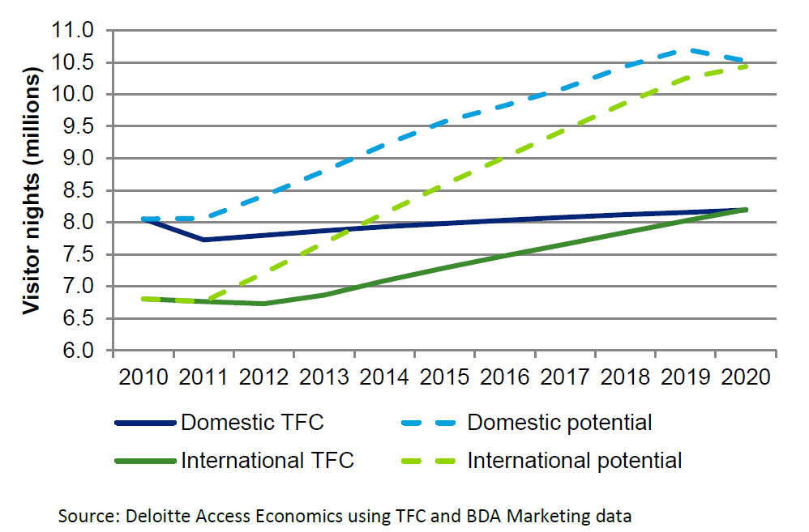
Table 2 region Visitor Nights Year Ending June 2011 – June 2015
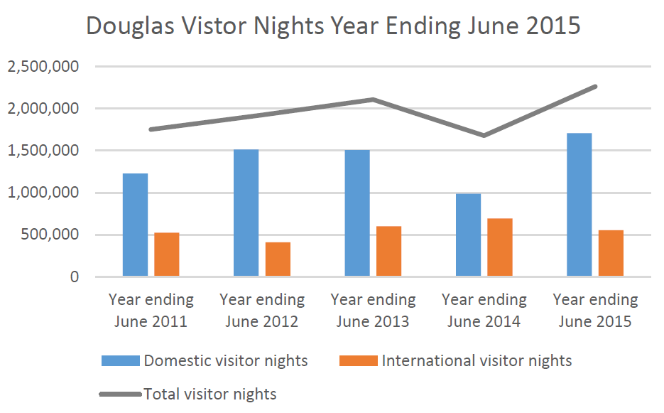
Source: Tourism [NAME OF SOURCED INFORMATION],
Annual Report 2014/15

After analysing the period August 2016 to August 2017, it was identified 11,023 presentations were recorded. As many as 10,641, of which 2045 patients identified as Aboriginal and or Torres Strait Islander categorised between 3-5 presentations, could have been treated by primary health care providers. The data highlights the financial burden to [SITE NAME] and the state when a large portion of attendances delivered is for primary health care occasion of service types.
Additionally, you can add the burden of service delivery for outlier towns which may utilise the service, an overview of the site’s demographic and rationale for the reasons outliers access [SITE NAME].

Site Operational Model
What service types will be billed to Medicare?
Eligible Services are those Medicare Benefits Schedule (MBS) services which are specified in the directions under section 19(2) of the HI Act. Such services may include categories of Non-Admitted Patients Services, non-referred services (including eligible nursing and midwifery services), eligible allied health and dental services, specified diagnostic imaging services, and pathology services.
A list of claimable MBS Groups, Sub-groups and Items is in the directions, available at:
[link to directions on FRL].
A reminder as you develop your Operational Plan:
- It is a Medicare requirement that practitioners and health professionals must have a separate provider number for each location at which they provide services. Only one provider number can be issued per site.
- To apply for an initial or additional provider number for practitioners and health professionals, refer to the forms available on the Services Australia website:
www.servicesaustralia.gov.au/health-professionals?context=60090
- You will be required to submit a list of provider numbers billing under the Initiative in each Site Annual Report.
Service types to be billed to MBS
For example: Sessional services, on call services, after hours services, out-patients, Emergency Department (ED) presentations with primary health care needs, diagnostic imaging services, and pathology services related to eligible ED presentations, Approved allied health ambulatory and community based services, Approved nursing ambulatory and community based services, Outreach clinics (off hospital site) by eligible services emergency services.

PART A-APPENDIX A: MBS details
What are the arrangements that will be used for billing and receipts of MBS rebate?
[SITE NAME] will act as the billing agent and claims will be transmitted electronically to Medicare. All revenue generated under the COAG 19(2) exemptions initiative will be receipted using the guidelines and follow the financial management process as per the HS policy. Cost centre XXXXXX will be set up and used exclusively for billing and receipting.

MBS rebates
Identify the breakdown of how the MBS revenue will be spent
Please provide a description and percentage breakdown on how the intended MBS rebate will be spent. (Please note that a minimum of 70% of the total MBS rebate must be retained by the facility for reinvestment in new and additional services at the facility and a maximum of 30% of the total MBS rebate can be expended on administration). Please refer to the expenditure guide below. As an example your site may have 90% reinvested of the MBS revenue in the facility for additional services and capital improvements (15% to provide additional prenatal services, 10% to conduct additional outreach services, 40% to increase after-hours services and 25% to include in a pool to improve the emergency department’s triage area), and 10% for administration costs.

How will the MBS rebate generated from the Initiative be used? Please tick all that apply:
Support for locum cover
Employing additional salaried doctors and nurses
Employing allied health professionals
Professional development
Recruitment and retention incentives
Capital improvements to the site that will assist in increasing access to primary care
Equipment to support primary care services
Additional services to enhance primary care
Administration costs
What additional services are proposed to be provided using the intended MBS revenue:
For example only
- Target opportunities and operational models that will provide continuum of care cycles for patients who choose Site Name as their “medical home” and reduce the burden of attendances on the urgent care and emergency department for primary health care services.
- Continue and invest in more primary health care services, health promotion and programs.
- Target a collaborative approach to Chronic Disease Management Plans and an integrated multidisciplinary team approach.
- Target palliative care to address and support the ageing population in …….
- Target Chronic Disease Management service provision, promotional activities, groups and community interaction.
Administrative support for new services and Medicare 19(2) Program deliverables

If the MBS rebate is being used to establish new initiatives for the area, please provide further details below.
Examples of services new and existing could be:
  - Targeted health screening programs
  - Expanding primary health care services to meet community needs
  - Enhance existing services operating in [urgent care or outpatients]
  - Establish nurse practitioner, eligible midwives, allied health roles
  - Community engagement and liaison
  - Chronic Disease Management
  - Men’s health
  - Women’s health
  - Mental health, youth and adult
  - Health promotion
  - Early intervention
  - Preventative intervention

Which of these new/enhanced primary health care services will be billed against the MBS?
As has been highlighted in this application there are many areas of need for primary health care in [SITE NAME], the social and economic disadvantage, the ageing population, Aboriginal and Torres Strait Islander community, tourism and FIFO/DIDO and to be able to effectively and proactively respond to the needs, [SITE NAME] will continue to develop additional programs, service delivery models and health promotion activities that target the areas of need and enhance the services already being provided.
All new initiative proposals and submissions will be tabled at the oversight committee meetings. The proposals will be reviewed and recommendations will be provided prior to progressing with internal approval processes.

Expenditure Guide:
Reinvestment into the site:
- Support for locum cover
- Employing additional salaried doctors and nurses
- Employing allied health professionals
- Professional development
- Capital improvements to the site
- Equipment to support primary health care services
- Additional or enhanced services from the site (please identify the services)

Incentives
- Recruitment and retention incentives

Administration costs
- Cost associated with the administration of the Initiative.

What governance arrangements will be in place for the distribution of how the Medicare rebate will be spent?
For example only
[Name of Health Service or site billing office] will transmit claims electronically to Medicare. Monthly reconciled reports will be generated outlining the revenue generated [(and if) amounts journaled to [SITE NAME]] to be expended as per the initiative terms and outlined in this application. The oversight committee will be provided with [monthly, quarterly, bi-annual] reports.
- This committee can be a newly established committee or this agenda can be added to an existing meeting.
Information to add could be:
  - Terms of reference
  - Committee structure /participants (community participants included)
  - Meeting frequency
  - If the committee will take submissions relating to the use of the funds and will provide an endorsement or not before the approval process is undertaken
  - Financial Reports distributed to committee

Outline the procedures in place for the collection of data for reporting purposes to ensure effective and accurate reporting as per the MoU between Victoria and the Commonwealth
Please note: expenditure to administer the initiative must be capped at 30% of revenue generated. You will be required to provide information on administration expenditure in your Site Annual Report.
List data collection of data procedures

Data collection processes from both manual and automated systems will be developed to capture financial and non-financial information to monitor this initiatives progress.

A template [or some mechanism developed] has been developed for monthly financial reporting which will be compiled by the site [or finance team] and forwarded to the over revenue officer [or appropriate appointed officer who will be populating the financial component of the report] who will produce financial reports for the oversight committee and additionally provided to the annual statutory reporting to the Commonwealth.

A template [or some mechanism developed] has been developed to capture patient contact numbers and to report on the progress of the new or enhanced services as developed in the Operational Plan.

PART B: STAKEHOLDER CONSULTATION AND ENDORSEMENT
For the purpose of applying for a new, or supporting an existing, approval of a site as an Eligible Site, it is necessary to consult with all Primary Health Care/Medical Practitioners who will provide services to the community and privately practising Primary Health Care/Medical Practitioners who will be affected by the Initiative. Please also consult with all other relevant stakeholders who may be affected by the Initiative at this site.
All privately practising stakeholders must be given the opportunity to express their written support or otherwise in this application, noting that establishing stakeholder support is either a requirement before directions under section 19(2) of the HI Act may be made by the Commonwealth to allow a site to become an Eligible Site or a requirement for a site to be retained as an Eligible Site once directions under section 19(2) of the HI Act are made to include that site as an Eligible Site. Stakeholders are to be provided with 20 working days to provide their support, or indicate their grounds for lack of support. Failure by a stakeholder to respond within this timeframe will be accepted as indicating support.

Local privately practising Primary Health Care/Medical Practitioners who may be materially affected by the Initiative.
All persons consulted must complete the attached form indicating support, or provide their own written letter of support - refer to Appendix A. Where a category of practitioner does not exist in the locality, please indicate N/A.

Categories of Practitioner Consulted: | Yes | No | N/A
All Local General Practitioners
Contracted/Visiting Medical Practitioners
Any Aboriginal Medical Service in the Area
Other private primary health care providers, including allied health
Other: (please list all)

Other stakeholder groups

All persons consulted must complete a the attached form indicating support, or provide their own written letter of support - refer to Appendix B. Where a category of stakeholder does not exist in the locality, please indicate N/A.
Stakeholder Groups Consulted: | Yes | No | N/A
Primary Health Network
Local Community Representative eg: Consumer Advisory Boards
Local Council representative
Royal Flying Doctor Service
Other: (please list all)

If you answered no to any of the above, why?

AGREEMENT OF THE PARTIES
All parties agree to:
- Cooperate with the data collection and reporting processes as agreed between the Victorian Government and the Commonwealth. Each operational plan should be reviewed annually, or at any other time if a party to the agreement believes that there is a need.
- Notify the Victorian Government and Commonwealth of any relevant issues relating to General Practice that arise as a result of the implementation of the s19(2) Exemption. The following issues should be monitored locally as these may be incorporated into the next program evaluation.
  - Impact on retention of small rural hospitals and health services
  - Impact on primary health care services in all eligible locations
  - Impact on non-medical services in eligible locations
  - Impact on GPs and salaried medical officers in eligible locations, including remuneration and retention
  - Impact on private GPs using hospital facilities
  - Assessment of the additional services that assisted in recruitment and retention, e.g. locum provision: and
  - Outcomes of the Initiative’s funding
- Implement the COAG section 19(2) Exemptions Initiative in accordance with the purpose, policy objectives and principles of the MoU between Victoria and the Commonwealth.

Declared and signed by the undersigned below for and on behalf of their organisation:

Organisation declaration Organisation declaration
Name:  Role:  Organisation:  Signature:  Date: | Name:  Role:  Organisation:  Signature:  Date:
Organisation declaration | Organisation declaration
Name:  Role:  Organisation:  Signature:  Date: | Name:  Role:  Organisation:  Signature:  Date:
Organisation declaration | Organisation declaration
Name:  Role:  Organisation:  Signature:  Date: | Name:  Role:  Organisation:  Signature:  Date:

CHECKLIST

Tasks | Completed
All sections of the Operational Plan template complete.
Sign off to agreement by all relevant parties.
Copies of consent forms for all primary health care providers attached.
Copies of consent forms for all other relevant stakeholders attached.

Please forward completed application and attachments to:
Health Services Improvement Team
Health Services and Aged Care, Improvement and Engagement Branch
Email: healthservicesimprovement@health.vic.gov.au

State Office Contact

For further enquiries contact:
Commonwealth
COAG s19(2) EXEMPTIONS INITIATIVE

PART B - APPENDIX A: Support Form for privately practising Primary Health Care Providers, including GPs
The Council of Australian Governments Improving Access to Primary Care in rural and remote areas Initiative (the Initiative) supports rural and remote hospitals and health services in small communities, by increasing access to Commonwealth funding and ensuring that eligible jurisdictions increase support for primary health care in these areas. Jurisdictions which have signed a Memorandum of Understanding with the Commonwealth for the Initiative may bulk bill the Medicare Benefits Schedule for eligible persons requiring primary health care services who present to Eligible Sites. This ability to bulk bill is granted through an exemption under subsection 19(2) of the Health Insurance Act 1973.
Please indicate your support of the Initiative in respect of the proposed site by doing either of the following, within 20 working days:
- ticking the ‘Yes’ box corresponding to each point before signing and dating below; OR
- providing a letter to Victorian Department of Health indicating support for the site to be listed as an Eligible Site under the Initiative.
If you do not support the Initiative, please provide a letter to the Victorian Department of Health indicating lack of support, including your reason/s, within 20 working days. Please note that any lack of support will be given due weight by the Jurisdiction in seeking the Commonwealth’s agreement to a site gaining access to the Initiative. Your written communication will be provided to the Commonwealth and may be a factor in the Commonwealth’s decision.

I understand the context and policy objectives of the COAG s19(2) Exemptions Initiative | □ Yes | □ No
I understand the legislative basis of a section 19(2) exemption and the effects intended by the granting of an exemption under this initiative. | □ Yes | □ No
I understand the implications for myself, my practice, and my patients, of a section 19(2) exemption being granted in respect of the locality within which I practise and I have sought relevant advice. | □ Yes | □ No
Noting the above, I give my free and informed consent for the Victorian Government, to seek a section 19(2) exemption for the locality of (locality name) | □ Yes | □ No

Name:
Occupation/Specialty:
Practice Location:
Employer:
Email/Telephone:
Signature
Date:

COAG s19(2) EXEMPTIONS INITIATIVE
PART B - APPENDIX B: Support Form for Relevant Stakeholders (other than Primary Care)

The Council of Australian Governments Improving Access to Primary Care in Rural and Remote Areas Initiative (the Initiative) supports rural and remote hospitals and health services in small communities, by increasing access to Commonwealth funding and ensuring that eligible jurisdictions increase support for primary health care in these areas. Jurisdictions which have signed a Memorandum of Understanding with the Commonwealth for the Initiative may bulk bill the Medicare Benefits Schedule for eligible persons requiring primary health care services who present to Eligible Sites. This ability to bulk bill is granted through an exemption under subsection 19(2) of the Health Insurance Act 1973.
Declarations
Please indicate your support of the Initiative in respect of the proposed site by doing either of the following, within 20 working days:
- ticking the ‘Yes’ box corresponding to each point before signing and dating below; OR
- providing a letter to the [Jurisdiction] indicating support for the site to be listed as an Eligible Site under the Initiative.
If you do not support the Initiative, please provide a letter to the [Jurisdiction] indicating lack of support, including your reason/s, within 20 working days. Please note that any lack of support will be given due weight by the Jurisdiction in seeking the Commonwealth’s agreement to a site gaining access to the Initiative. Your written communication will be provided to the Commonwealth and may be a factor in the Commonwealth’s decision.

I understand the context and policy objectives of the COAG s19(2) Exemptions Initiative | □ Yes | □ No
I understand the legislative basis of a section 19(2) exemption and the effects intended by the granting of an exemption under this initiative. | □ Yes | □ No
I understand that Victoria, is required to seek my support before applying to the Commonwealth for a section 19(2) exemption. | □ Yes | □ No
Noting the above, I give my free and informed consent for the Victorian Government to seek a section 19(2) exemption for the locality of (locality name) | □ Yes | □ No

Name:
Organisation:
Email:
Telephone:
Signature:
Date:

